SUPPLEMENTAL FIGURES
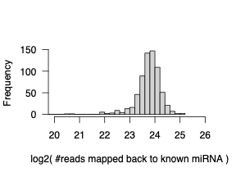
Supplemental Figure 1. Read Counts aligned to known miRNAs for each patient sample.

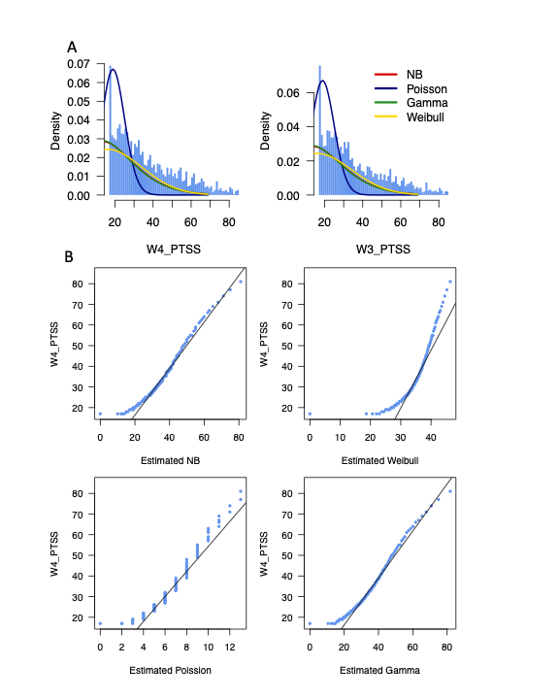
Supplemental Figure 2. The Bayesian Information Criterion (BIC) is used to assess the goodness of fit of each distribution to PTSS.

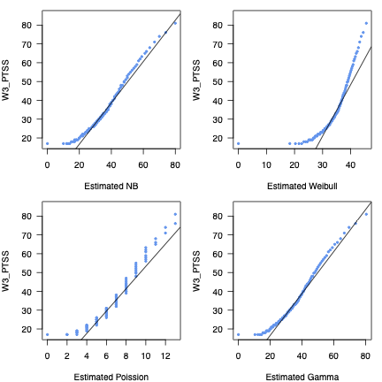
Supplemental Figure 3. The Q-Q plot is utilized to evaluate the goodness of fit for various distributions in wave 2.

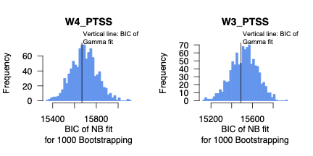
Supplemental Figure 4. BIC distributions obtained from negative binomial fitting for 1,000 bootstraps of data from wave three and four PTSS. The vertical line in the plot represents the BIC value in gamma fitting. To calculate the p-value, we determined the fraction of the 1,000 bootstrapped datasets where the negative binomial fitting resulted in a higher BIC compared to the gamma fitting.

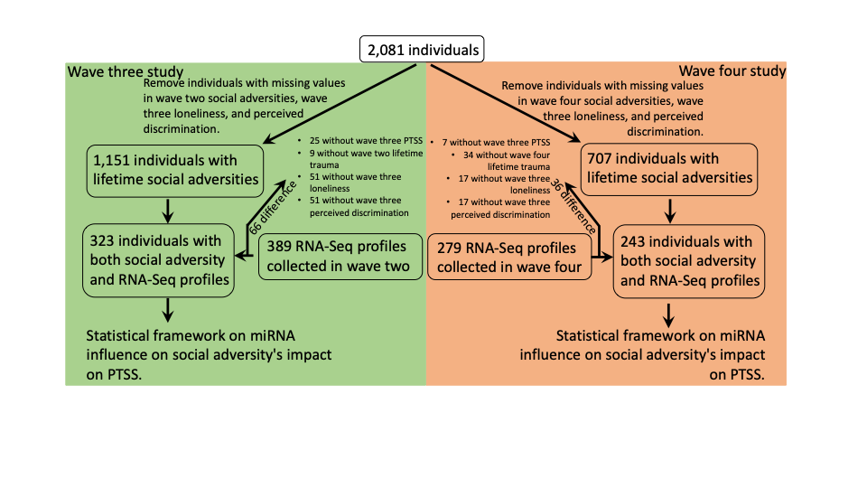
Supplemental Figure 5. The workflow for selecting individuals to assess the modulatory effects of miRNA signatures on the relationship between social adversity and PTSS.

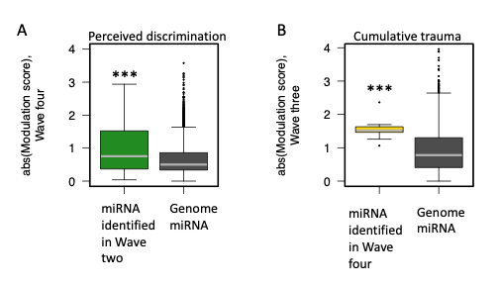
Supplemental Figure 6. The consistency in identifying miRNA across different waves to modulate the association between social adversity and PTSS is notable. A. the miRNA identified in modulating wave three's perceived discrimination and PTSS also displayed a significant modulating profile (defined as z-score in NB regression) when investigating wave four, in comparison to genome-wide miRNA. B. Similar to A, but present the miRNA identified in wave four’s cumulative trauma and PTSS, and its consistence with wave three results. ‘***’ represents Wilcoxon test p < 1e-3 compared with genome miRNA modulation profiles.

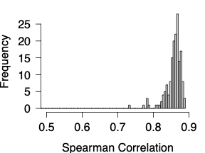
Supplemental Figure 7. Spearman correlation for each miRNA between wave 2 and wave 4 across all individual samples.

Supplemental Table 1. The Bayesian Information Criterion (BIC) is used to assess the goodness of fit of each distribution to PTSS.

 | Negative Binomial | Poisson | Gamma | Weibull
Wave 3 | 15520.13 | 22602.24 | 15488.97 | 15708.3
Wave 4 | 15697.2 | 22928.32 | 15668.05 | 15872.22

Supplemental Table 2. Prediction of PTSS in wave three based on factors from wave two.
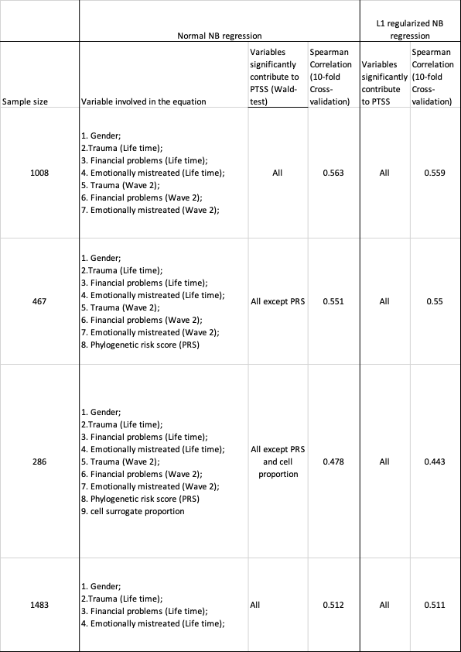

Supplemental Table 3. Prediction of PTSS in wave three based on factors from wave two and wave three.
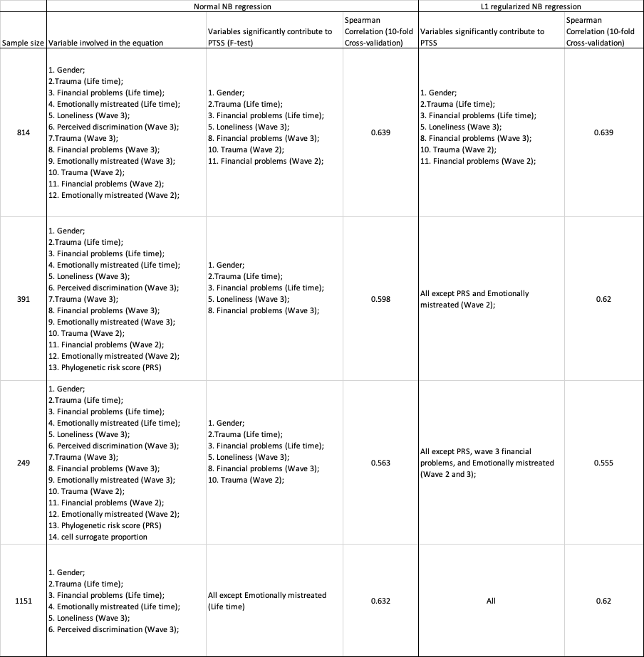

Supplemental Table 4. Prediction of PTSS in wave four based on factors from wave three and wave four.
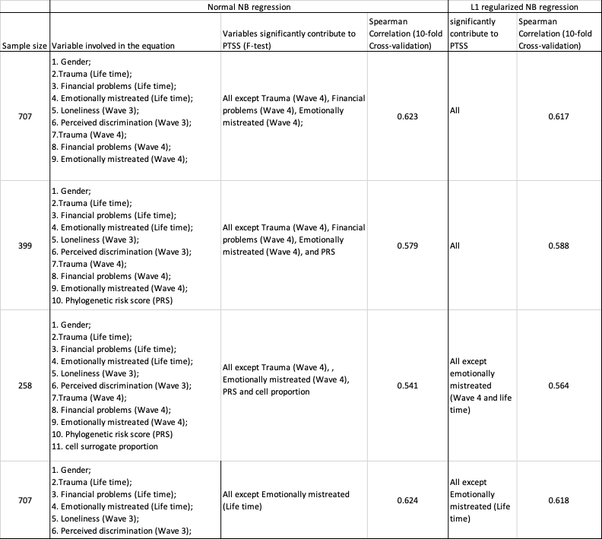

Supplemental Table 5. PTSS correlation between waves.
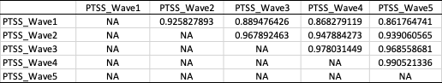

Supplemental Table 6. The identified miRNAs play a main effect in PTSS in wave three.
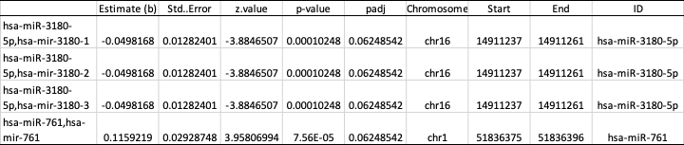

The estimate (b) represents the main effects of each miRNA on PTSS. A positive value indicates a positive association between miRNA expression and PTSS, while a negative value indicates a negative association.

Supplemental Table 7. The identified miRNA potential modulating the association between financial problem and PTSS in wave three.
The estimate (c) represents the modulatory effects of miRNA on PTSS. If the coefficient c is positive, it implies that higher miRNA expression levels are associated with increased PTSS in the context of a given social adversity. Conversely, if c is negative, higher miRNA levels are associated with reduced PTSS in the context of a given social adversity, suggesting a protective relationship.

Supplemental Table 8. The 74 identified miRNAs potential modulating the association between perceived discrimination and PTSS in wave three.
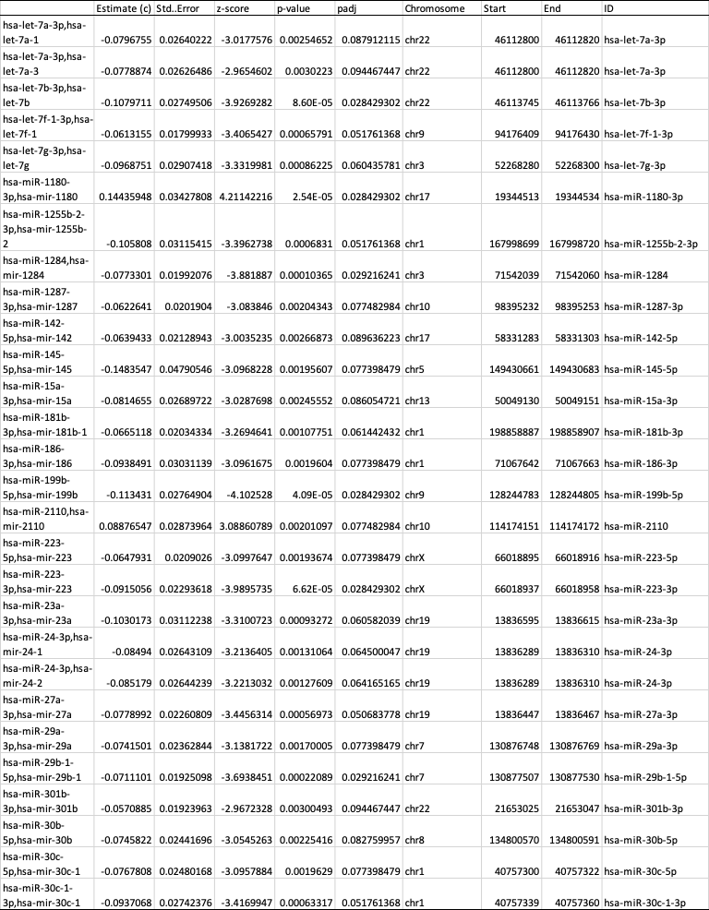

Following Supplemental Table 8.
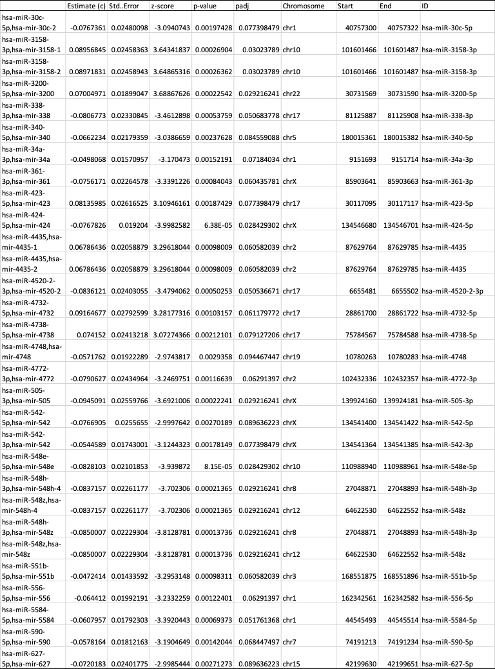
Following Supplemental Table 8.
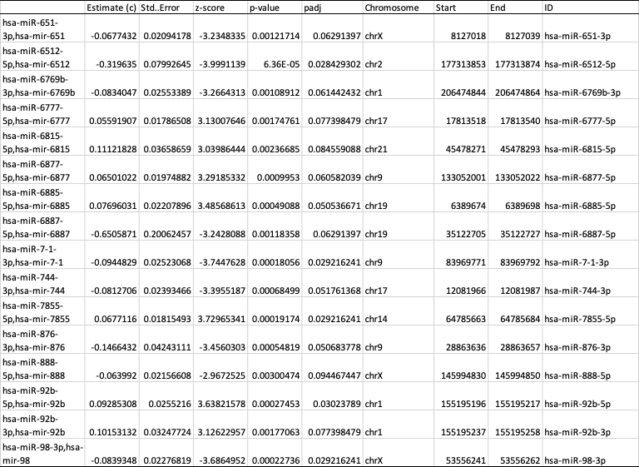

The estimate (c) represents the modulatory effects of miRNA on PTSS. If the coefficient c is positive, it implies that higher miRNA expression levels are associated with increased PTSS in the context of a given social adversity. Conversely, if c is negative, higher miRNA levels are associated with reduced PTSS in the context of a given social adversity, suggesting a protective relationship.

Supplemental Table 9. The identified 10 miRNAs potential modulating the association between cumulative trauma and PTSS in wave four.
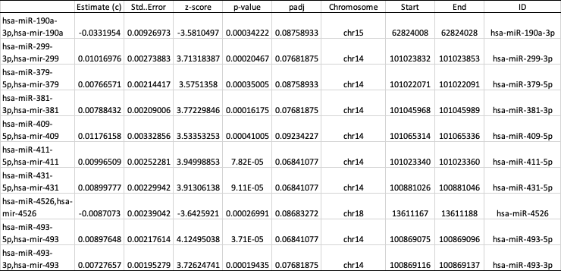

Supplemental Table 10. Literature evidence supports the identified miRNAs, which have previously been reported to be associated with conditions or traits related to PTSD.
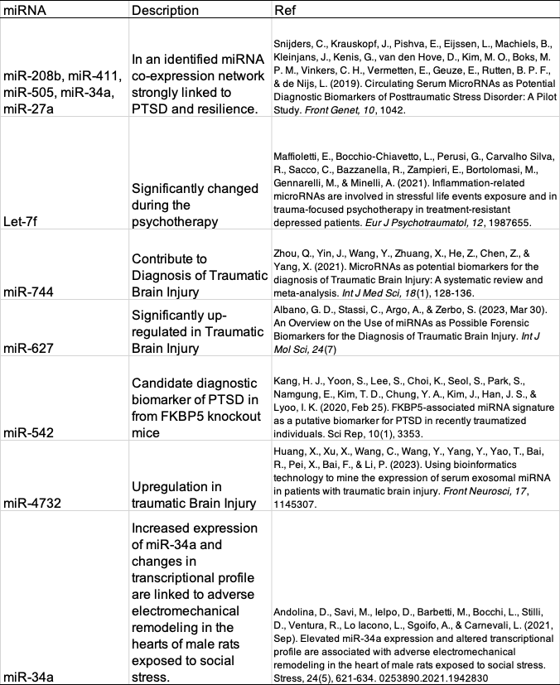

Following Supplemental Table 10
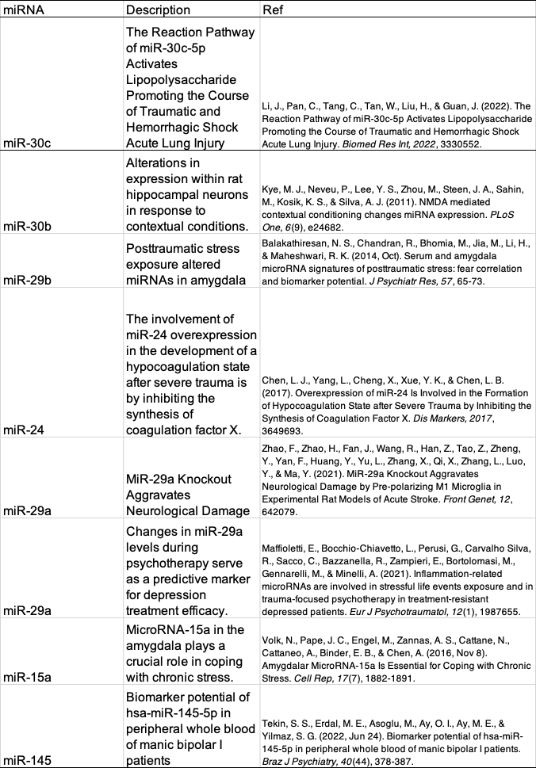
Following Supplemental Table 10
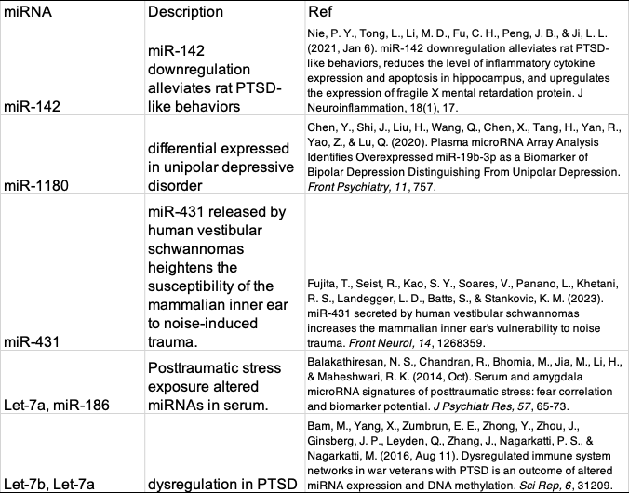

Supplemental Table 11. The KEGG pathway enrichment results for the identified miRNAs potentially modulating the association between social adversity and PTSS.
