Supplementary Material

Figures

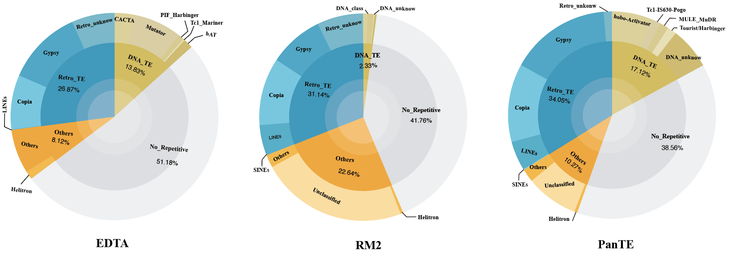
Supplementary Fig. 1|Annotation percentage of various TE families in the grapevine genome (GCF_030704535.1) using TEs identified through different methods.

Tables

Supplementary Table 1. Details of the simulation and the performance of each method: see Supplementary_tables.xlsx.

Supplementary Table 2. Evaluation metrics for TE classification globally.
 | ClassifyTE | Deep-TE | TERL | PanTE | RepeatModeler2 (RepeatClassifier)
Precision | 0.544 | 0.418 | 0.111 | 0.876 | 0.910
Recall | 0.547 | 0.418 | 0.311 | 0.813 | 0.619
F1-score | 0.545 | 0.418 | 0.164 | 0.843 | 0.737

Supplementary Table 3. Evaluation metrics for TE classification per family: see Supplementary_tables.xlsx.

Supplementary Table 4. Recall for TE libraries generated by different methods. The number in () represents the true positive TE sequences with respect to the reference TE Library.
Species | Reference TE  Library Size | EDTA | RepeatModeler2 | PanTE
Human | 737 | 0.182 (134) | 0.262 (193) | 0.225 (166)
Rice | 2431 | 0.540 (1313) | 0.160 (388) | 0.306 (743)
Arabidopsis | 2723 | 0.151 (412) | 0.046 (124) | 0.087 (238)
Grapevine | 556 | 0.561 (312) | 0.214 (119) | 0.603 (335)
Maize | 2053 | 0.478 (981) | 0.122 (251) | 0.399 (819)

Supplementary Table 5. Recall for genome annotation using TEs identified through different methods.
Methods | Maize | Arabidopsis | Grapevine | Rice | Human
PanTE | 0.99 | 0.88 | 0.99 | 0.95 | 0.93
RepeatModeler2 | 0.97 | 0.82 | 0.96 | 0.92 | 0.93
EDTA | 0.99 | 0.82 | 0.98 | 0.97 | 0.93

Supplementary Table 6. Recall for genome annotation using TEs per family identified through different methods: see Supplementary_tables.xlsx.

Supplementary Table 7. TE libraries for various species generated by different methods.
EDTA
Species | No. of TE Sequences | Average TE Length | No. of Low-frequency TEs (<10 Repeats)
Arabidopsis | 1122 | 2680 | 488
Human | 5809 | 2236 | 1680
Maize | 17915 | 1855 | 6685
Rice | 10585 | 2040 | 3710
Grapevine | 3549 | 1565 | 792
RepeatModeler2
Species | No. of TE Sequences | Average TE Length | No. of Low-frequency TEs (<10 Repeats)
Arabidopsis | 472 | 1442 | 4
Human | 969 | 626 | 5
Maize | 1214 | 1256 | 9
Rice | 2057 | 981 | 14
Grapevine | 1216 | 1564 | 83
PanTE
Species | No. of TE Sequences | Average TE Length | No. of Low-frequency TEs (<10 Repeats)
Arabidopsis | 1299 | 2030 | 148
Human | 1850 | 1333 | 86
Maize | 3851 | 1939 | 85
Rice | 4655 | 1070 | 257
Grapevine | 5864 | 1107 | 216

Supplementary Table 8. Overlap of identified TEs between each pair of methods. The numbers on the diagonal represent the number of TEs identified by each corresponding method. The numbers off the diagonal represent the overlapping TEs with respect to the TEs detected by the method labelled in each row. For example, in Arabidopsis, EDTA detected 1122 TEs, of which 126 were also detected by RepeatModeler2 and 333 were detected by PanTE.
Arabidopsis
 | EDTA |  | RepeatModeler2 |  | PanTE
EDTA | 1122 |  | 126 |  | 333
RepeatModeler2 | 184 |  | 476 |  | 261
PanTE | 382 |  | 296 |  | 1299
Human
 | EDTA |  | RepeatModeler2 |  |  | PanTE
EDTA | 5809 |  | 126 |  |  | 175
RepeatModeler2 | 219 |  | 969 |  |  | 382
PanTE | 433 |  | 531 |  |  | 1850
Rice
 | EDTA |  | RepeatModeler2 |  |  | PanTE
EDTA | 10585 |  | 608 |  |  | 1173
RepeatModeler2 | 955 |  | 2057 |  |  | 958
PanTE | 2464 |  | 1565 |  |  | 4655
Maize
 |  | EDTA |  | RepeatModeler2 |  |  | PanTE
EDTA |  | 17915 |  | 1993 |  |  | 4140
RepeatModeler2 |  | 733 |  | 1214 |  |  | 756
PanTE |  | 1922 |  | 705 |  |  | 3851
Grapevine
 |  | EDTA |  | RepeatModeler2 |  |  | PanTE
EDTA |  | 3507 |  | 658 |  |  | 1261
RepeatModeler2 |  | 471 |  | 1216 |  |  | 785
PanTE |  | 1312 |  | 983 |  |  | 5864

Supplementary Table 9. Runtime of each method across different species genomes. ¹The runtime of PanTE when applied to a rice pangenome to generate a pan-library of TEs. ²The runtime of panEDTA when performed on the individual genomes used to construct the pangenome to aggregate a pan-library. The number in () under each species represents its genome size.
 | RepeatModeler2 | PanTE | EDTA | PanTE  (Pangenome)¹ | panEDTA (Individual Library Aggregation)²
Arabidopsis (129Mb) | 31.38 h | 6.12 h | 18.45 h | \ | \
Rice (374Mb) | 66.70 h | 26.82 h | 52.20 h | 50.40 h | 372.68 h
Grapevine (472Mb) | 24.45 h | 37.25 h | 123.80 h | \ | \
Maize (2100Mb) | 35.87 h | 53.58 h | 524.78 h | \ | \
Human (3000Mb) | 14.23 h | 50.80 h | 606.77 h | \ | \
Wheat (4900Mb) | 52.63 h | 76.80 h | 1003.98 h | \ | \

Supplementary Table 10. The annotation percentage of the grapevine genome (GCF_030704535.1) by integrating multiple individual TE libraries.
No. of Individual Libraries | RepeatModeler2 (%) | EDTA (%) | PanTE (%)
1 | 58.24 | 57.03 | 61.99
2 | 61.25 | 60.40 | 64.20
3 | 62.89 | 62.10 | 65.03
4 | 64.03 | 62.88 | 65.66
5 | 64.90 | 64.28 | 67.00
6 | 65.43 | 65.50 | 67.91
7 | 66.27 | 66.29 | 68.54
8 | 66.65 | 66.70 | 68.74

Supplementary Table 11. Links of rice genomes.
Link | Genome Number
https://ftp.ensemblgenomes.ebi.ac.uk/pub/plants/release-58/fasta/oryza_nivara/dna/ | 1
https://www.sciencedirect.com/science/article/pii/S1674205221002306 | 2
https://ftp.ensemblgenomes.ebi.ac.uk/pub/plants/release-58/fasta/oryza_glumipatula/dna/ | 1
https://ftp.ncbi.nlm.nih.gov/genomes/all/GCF/000/231/095/GCF_000231095.2_ObraRS2/ | 1
https://ftp.ncbi.nlm.nih.gov/genomes/all/GCA/000/338/895/GCA_000338895.3_OmerRS3/ | 1
https://www.ncbi.nlm.nih.gov/datasets/genome/GCF_034140825.1/ | 1

Supplementary Table 12. Recall for rice genome annotation (GCF_034140825.1) using pan-libraries of TEs generated through different methods. *PanTE was applied directly to the graph-based rice pangenome. The number in () represents the true positive TE regions identified with respect to the reference TE regions in the genome.
Mapping Parameters | panEDTA | PanTE* | Reference TE Regions (bp)
-div 20 | 0.866 (278399 bp) | 0.963 (309377 bp) | 321315
-div 40 | 0.939 (425501 bp) | 0.984 (445875 bp) | 453246

