Supporting Information
MXene-derived TiO₂ nanoparticles coated with C/N shell for photocatalytic hydrogen generation under solar light
Daria Baranowska^{1,2}*, Bartosz Środa^{1,2}, Tomasz Kędzierski^{1,2}, Zhang Bowen³, Liu Xiaoguang³, Ewa Mijowska^{1,2*}, Beata Zielińska^{1,2}
¹Department of Nanomaterials Physicochemistry, Faculty of Chemical Technology and Engineering, West Pomeranian University of Technology in Szczecin, Piastow Ave. 42,
71-065 Szczecin, Poland
²Center for Advanced Materials and Manufacturing Process Engineering (CAMMPE), West Pomeranian University of Technology in Szczecin, Szczecin, Poland
³School of Chemistry and Materials Science, Shandong Agricultural University, Shandong, China
Corresponding authors: *daria_baranowska@zut.edu.pl, emijowska@zut.edu.pl

Materials and Methods
Preparation of MXene – 48% HF
The synthesis of MXene – 48% HF followed the same procedure as the fabrication of MXene described in the manuscript, except that 40% HF was replaced with 48% HF.
Preparation of C/N@TiO₂ – 48% HF
The sample was prepared by mixing 5wt% MXene – 48% HF with 95wt% gCN, followed by grinding the mixture using a mortar and subsequently heating it at 600 ℃ for 4 hours under air conditions using a muffle furnace.

Results and discussion
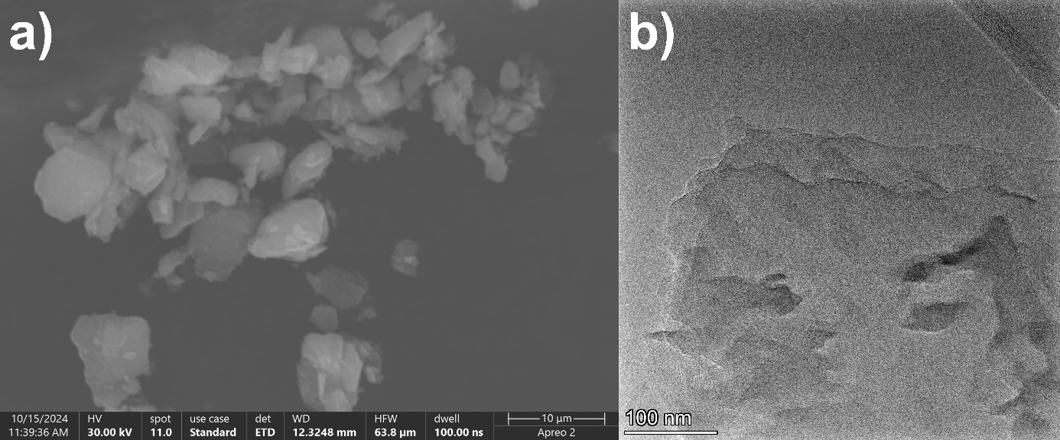
Fig. S1. (a) SEM and (b) TEM of graphitic carbon nitride (gCN).
Fig. S2. (a) Raman spectra, (b) nitrogen adsorption-desorption isotherms, (c) pore size distribution of gCN, TiO₂_MXene, and C/N@TiO₂.
Fig. S3. Mott-Schottky plots of (a) gCN, (b) TiO₂_MXene, and (c) C/N@TiO₂ performed at different frequencies.
Fig. S4. Hydrogen evolution from water splitting catalyzed by (a) gCN, MXene, TiO₂_MXene_550, C/N@TiO₂_X_550 – amount dependence of MXene and gCN calcinated under air conditions at 550℃, (c) gCN, MXene, TiO₂_MXene_600, and C/N@TiO₂_5_T – temperature dependence of mixture of 5wt% MXene and 95wt% gCN calcinated under air conditions at different temperatures. Comparison of photogenerated hydrogen under simulated solar light exposure catalyzed by (b) gCN, MXene, TiO₂_MXene_550, and C/N@TiO₂_X_550 – amount dependence of MXene and gCN calcinated under air conditions at 550℃, (d) gCN, MXene, TiO₂_MXene_600, and C/N@TiO₂_5_T – temperature dependence of mixture of 55wt% MXene and 95wt% gCN calcinated under air conditions at different temperatures.
Fig. S5. Hydrogen evolution from water splitting catalyzed by C/N@TiO₂ – 40 % HF and C/N@TiO₂ – 48 % HF.

Table S1. Comparison of performance of C/N@TiO₂ toward photocatalytic H₂ generation with other reported photocatalysts in the current state of the art.
Material | Energy bandgap [eV] | BET surface area [m²/g] | Parameters of photocatalytic H₂ evolution reaction |  |  |  | H₂ production [µmol/h/g] | Ref.
Material | Energy bandgap [eV] | BET surface area [m²/g] | Lamp | Light | Sacrificial agent | Co-catalyst | H₂ production [µmol/h/g] | Ref.
C/N@TiO₂ | 3.1 | 25 | 150 W Xe | simulated solar light | 16 % TEOA | - | 9415 | This work
C-TiO₂/g-C₃N₄ | - | 129 | 300 W Xe | ≥420 nm | 10 % TEOA | 2 wt% Pt | 1409 | 4
C-TiO₂/g-C₃N₄ | 2.6 | 80 | 300 W Xe | ≥420 nm | 10 % TEOA | 2 wt% Pt | 1146 | S1
C-TiO₂@g-C₃N₄ | 3.1 | 53 | 300 W Xe | ≥420 nm | 10 % methanol | - | 36 | S2
g-C₃N₄/Au/C-TiO₂ | 2.9 | - | 300 W Xe | ≥420 nm | 10 % TEOA | - | 129 | S3
g-C₃N₄/TiO₂ | 2.8 | 176 | 250 W | ≥420 nm | 10 % TEOA | - | 1041 | S4
B-TiO₂/g-C₃N₄ | 2.7 | 97 | 300 W Xe | - | 10 % TEOA | - | 809 | S5
d-Ti₃C₂/TiO₂/g-C₃N₄ | 2.7 | 34 | 300 W Xe | ≥420 nm | 10 % TEOA | 3 wt% Pt | 1620 | S6
g-C₃N₄-TiO₂/rGO | 2.6 | - | 250 W Xe | 200-800 nm | 5% glycerol | - | 23143 | S7
 |  |  |  |  | 5% TEOA | - | 8510 | S7
M-ZnS@g-C₃N₄/TiO₂ | 3.1 | 374 | 300 W Xe | ≥400 nm | 10 % TEOA | - | 422 | S8
g-C₃N₄/Ti₃C₂ MXene | 2.4 | - | 300 W Xe | ≥420 nm | 10 % TEOA | - | 727 | S9
g-C₃N₄@Ti₃C₂ QDs | 2.6 | 40 | 300 W Xe | A.M. 1.5G | 15 % TEOA | - | 5112 | S10
g-C₃N₄/Ti₃CN MXene | 2.0 | - | 300 W Xe | - | 10 % TEOA | 2 wt% Pt | 7630 | S11
g-C₃N₄/p-Ti₃C₂T_{X} | 2.5 | - | 350 W Xe | ≥400 nm | 10 % TEOA | - | 18 | S12
TiO₂/Ti₃C₂/g-C₃N₄ | 2.8 | - | 300 W Xe | - | 10 % TEOA | - | 1150 | S13
Ti₃C₂ MXene-derived TiO₂/g-C₃N₄ | 2.7 | 129 | 300 W Xe | - | 10 % methanol | 3 wt% Pt | 11600 | S14

References
[S1] C. Yang, J. Qin, Z. Xue, M. Ma, X. Zhang, R. Liu, Rational design of carbon-doped TiO2 modified g-C3N4 via in-situ heat treatment for drastically improved photocatalytic hydrogen with excellent photostability, Nano Energy, 41, 2017, 1-9, 10.1016/j.nanoen.2017.09.012.
[S2] Y. Zou, J.-W. Shi, D. Ma, Z. Fan, L. Lu, C. Niu, In situ synthesis of C-doped TiO2@g-C3N4 core-shell hollow nanospheres with enhanced visible-light photocatalytic activity for H2 evolution, Chemical Engineering Journal, 322, 2017, 435-444, 10.1016/j.cej.2017.04.056.
[S3] Y. Zou, J.-W. Shi, D. Ma, Z. Fan, C. Niu, L. Wang, Fabrication of g-C3N4/Au/C-TiO2 Hollow Structures as Visible-Light-Driven Z-Scheme Photocatalysts with Enhanced Photocatalytic H2 Evolution, ChemCatChem, 2017, 9, 3752, 10.1002/cctc.201700542.
[S4] M.A. Alcudia-Ramos, M.O. Fuentez-Torres, F. Ortiz-Chi, C.G. Espinosa-González, N. Hernández‐Como, D.S. García-Zaleta, M.K. Kesarla, J.G. Torres-Torres, V. Collins-Martínez, S. Godavarthi, Fabrication of g-C3N4/TiO2 heterojunction composite for enhanced photocatalytic hydrogen production, Ceramics International, 46, 1, 2020, Pages 38-45, 10.1016/j.ceramint.2019.08.228.
[S5] J. Pan, Z. Dong, B. Wang, Z. Jiang, C. Zhao, J. Wang, C. Song, Y. Zheng, C. Li, The enhancement of photocatalytic hydrogen production via Ti3+ self-doping black TiO2/g-C3N4 hollow core-shell nano-heterojunction, Applied Catalysis B: Environmental, 242, 2019, 92-99, 10.1016/j.apcatb.2018.09.079.
[S6] M. Zhang, J. Qin, S. Rajendran, X. Zhang, R. Liu, Heterostructured d-Ti3C2/TiO2/g-C3N4 Nanocomposites with Enhanced Visible-Light Photocatalytic Hydrogen Production Activity, ChemSusChem 2018, 11, 4226, 10.1002/cssc.201802284.
[S7] H. Y. Hafeez, S. K. Lakhera, S. Bellamkonda, G. R. Rao, M.V. Shankar, D.W. Bahnemann, B. Neppolian, Construction of ternary hybrid layered reduced graphene oxide supported g-C3N4-TiO2 nanocomposite and its photocatalytic hydrogen production activity, International Journal of Hydrogen Energy, 43, 8, 2018, 3892-3904, 10.1016/j.ijhydene.2017.09.048.
[S8] C. Zhang, Y. Zhou, J. Bao, J. Fang, S. Zhao, Y. Zhang, X. Sheng, W. Chen, Structure regulation of ZnS@g-C3N4/TiO2 nanospheres for efficient photocatalytic H2 production under visible-light irradiation, Chemical Engineering Journal, 346, 2018, 226-237, 10.1016/j.cej.2018.04.038.
[S9] H. Xu, R. Xiao, J. Huang, Y. Jiang, C. Zhao, X. Yang, In situ construction of protonated g-C3N4/Ti3C2 MXene Schottky heterojunctions for efficient photocatalytic hydrogen production, Chinese Journal of Catalysis, 42, 1, 2021, 107-114, 10.1016/S1872-2067(20)63559-8.
[S10] Y. Li, L. Ding, Y. Guo, Z. Liang, H. Cui, J. Tian,
Boosting the Photocatalytic Ability of g-C3N4 for Hydrogen Production by Ti3C2 MXene Quantum Dots, ACS Applied Materials & Interfaces, 2019, 11, 44, 41440-41447, 10.1021/acsami.9b14985.
[S11] F. Xu, Z. Li, D. Fan, C. Zhao, X. Yang, Construction of g-C3N4/Ti3CN MXene Schottky heterojunctions for boosting photocatalytic hydrogen production, Surfaces and Interfaces, 51, 2024, 104658, 10.1016/j.surfin.2024.104658.
[S12] F. Xu, D. Zhang, Y. Liao, G. Wang, X. Shi, H. Zhang, Q. Xiang, Synthesis and photocatalytic H₂-production activity of plasma-treated Ti₃C₂T_{x} MXene modified graphitic carbon nitride, J Am Ceram Soc, 2020, 103, 849-858, 10.1111/jace.16798.
[S13] V. Q. Hieu, T. C. Lam, A. Khan, T.-T. T. Vo, T.-Q. Nguyen, V. D. Doan, D. L. Tran, V. T. Le, V. A. Tran, TiO2/Ti3C2/g-C3N4 ternary heterojunction for photocatalytic hydrogen evolution, Chemosphere, 285, 2021, 131429, 10.1016/j.chemosphere.2021.131429.
[S14] S. S. A. Shuaib, Y. Lu, Q. Wang, Y. Chen, M. Cai, Y. Wei, S. Sun, Ti3C2 MXene-Derived TiO2/g-C3N4 Heterojunctions for Highly Efficient Photocatalytic H2 Generation, ChemCatChem 2025, e202402152, 10.1002/cctc.202402152.

