Appendix A: Step-by-step guide for assessing the FLR function in Hermes
This step-by-step guide provides an overview of the steps to be taken in Hermes for the assessment of the FLR function.
- Open Gold Client
- Search patient in Sectra QR (Dicom Nodes) by entering patient ID
- Select correct study and study date
  - Studydescription: GALWEGSCINTIGRAFIE – LIVER REMNANT
- Transfer the following series to storage (Default transfer)
  - LD CT romp 3.0 B31s or CT LD 3.0 I31s 3
  - HIDA (galweg) dyn1
  - HIDA (galweg) SPECT SC romp [Recon – AC] or Galwegscintigrafie [1st WB Recon – AC] or Galwegscintigrafie LR SPECT [Recon – AC]
If seriesdescription is not conclusive about the series, transfer all series to storage
- Select Storage
- Search patient by entering patient ID
- Select patient
- Select correct study and series (see above)
- Open with Hermes Hybrid Viewer PDR 6.1.3 (Applications@Hermes HV NM Processing Hepatobiliary Liver Remnant)
  - Sometimes a message pops up, indicating that there are different frames of reference (see figure 7) Force referential
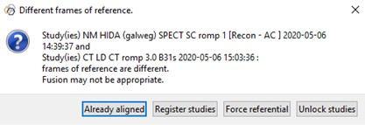
Figure 7: Message of different frames of reference
  - Sometimes a WARNING message from String Macther pops up: Missing string matching! (see figure 8) Select String Matching Select the correct label (SPECT, CT) for the series descriptions (see figure 9) OK Continue
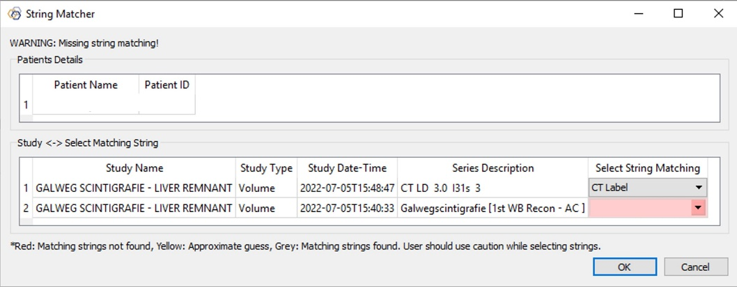
Figure 8: WARNING message from String Matcher
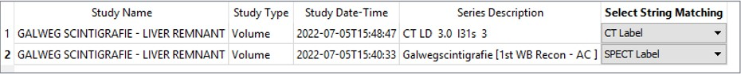
Figure 9: Correct labels for the series descriptions
- Check whether blood pool is immediately visible on the planar images (upper left box)
  - If not save patient (right-click on planar images) advanced skip at start fill in the number of images you want to skip till blood pool is immediately visible this series is saved as Geometric Mean
  - Load the series again with Geometric Mean instead of HIDA (galweg) dyn1
- Check whether height and weight is filled in
  - If not update height and/or weight in Patient Information (see figure 10) Apply OK
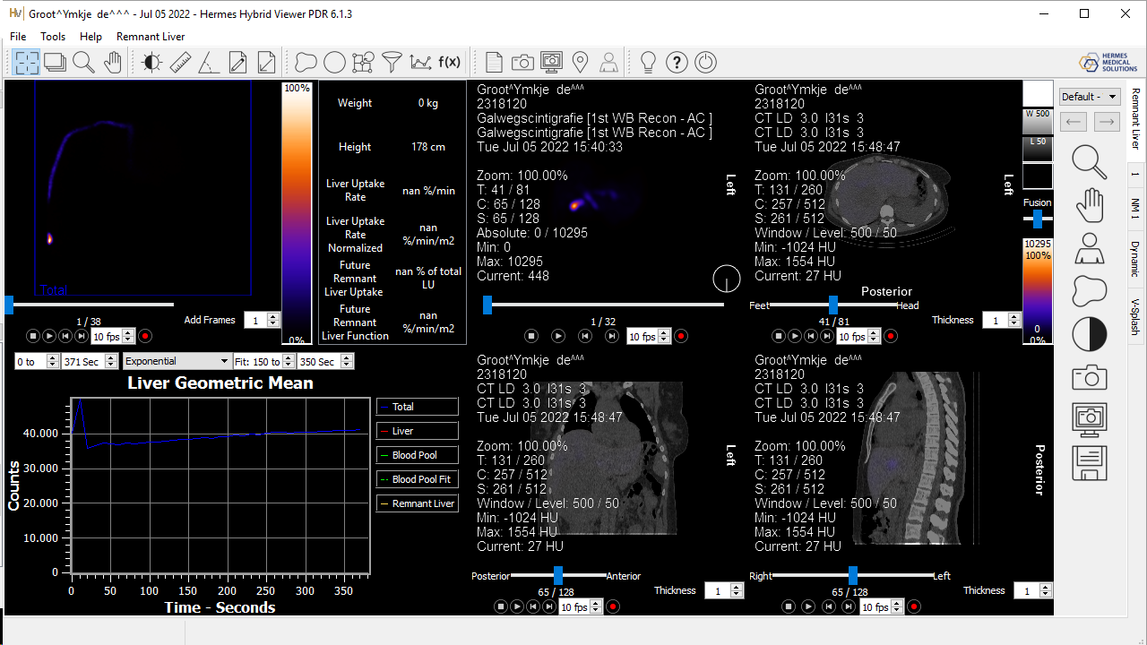
Figure 10: Symbol of Patient Information
- Open ROI tool (see figure 11)
Figure 11: Symbol for ROI tool
  - Draw a ROI for the Blood Pool on the planar images (the ROI delineates the homogeneous uptake in the heart)
  - Choose a ROI for the Liver on the planar images (ROI must generously encompass the liver and the ROIs of the Blood Pool and Liver should not overlap)
    - If not satisfied, edit the ROI by right-clicking on the ROI of the liver edit ROI draw till satisfied with the ROI for the liver
  - Skip the step to draw the ROI for the Remnant Liver
  - Draw Constraint 1 on the axial SPECT/LDCT (upper right box)
    - Use contrast-enhanced CT as reference in identifying the liver segments
  - Draw Constraint 2 on the coronal SPECT/LDCT (lower middle box)
    - When segments 2-3 are to be resected, constraint 2 delineates the borders of these segments. For assessments involving other segments, constraint 2 encompasses the whole liver
  - Use VOI tool to identify the liver and liver remnant based on thresholding
    - Choose an absolute threshold for the Liver Volume and double-click on the liver on the axial SPECT/LDCT (this VOI must accurately represent the volume of the liver)
      - A lower threshold will result in a larger Liver Volume
    - Fill for the Remnant Volume the same absolute threshold in, uncheck the ‘Relative to Max’ option and double-click on constraint 1 on the axial SPECT/LDCT
      - Check while scrolling through the SPECT/LDCT whether the Remnant Volume accurately represents the FLR
    - If stasis in the biliary ducts is visible, apply a masking VOI
      - Masking Volume double-click on the stasis inside the liver on the axial SPECT/LDCT
- Read the FLR function and normalized FLR function
  - FLR function SPECT – Future Remnant Liver Function (%/min)
  - Normalized FLR function SPECT – Future Remnant Liver Function Normalized (%/min/m²)
- Save a screenshot of the Hermes tab

