Natural mineral modulated single atom catalyst for effective water treatment

Xiongbo Dong¹, Zitong Chen¹, Aidong Tang², Dionysios D. Dionysiou³, Huaming Yang^{1,4}*
1. Engineering Research Center of Nano-Geomaterials of Ministry of Education, China University of Geosciences, Wuhan 430074, China.
2. School of Chemistry and Chemical Engineering, Central South University, Changsha 410083, China
3. Environmental Engineering and Science Program, Department of Chemical and Environmental Engineering, University of Cincinnati, Cincinnati, OH 45221, USA
4. School of Minerals Processing and Bioengineering, Central South University, Changsha 410083, China

* Corresponding authors: Huaming Yang
* E-mail address: hm.yang@cug.edu.cn

This file includes:
Supplementary Notes (1 to 5)
Supplementary Figures (1 to 28)
Supplementary Tables (1 to 8)
References

Supplementary Note 1. The evaluation methods of BPA concentration and transformation products.
The concentration of BPA was determined using a high-performance liquid chromatograph (HPLC, Agilent1260, USA) equipped with a UV detector at a wavelength of 220 nm. A welchrom 4.6 mm × 250 mm TC-C18 column was utilized as the stationary phase and the isocratic mobile phase was composed of 70% v/v acetonitrile and 30% v/v Milli-Q water. The sample injection volume was 40 μL, and the flow rate was 0.5 mL min⁻¹.
Supplementary Note 2. Calculation of turnover frequencies (TOF).
In detail, the turnover frequency (TOF) per Co atom basis for BPA removal was calculated according to equation:¹
TOF = R_{d}/C_{C0}
where R_{d} denotes the initial degradation rate of BPA after the addition of PMS. C_{C0} denotes the molarity of Co atom (mol/L) in catalysts.
For Example, the initial degradation rate of BPA in p-CoN₃Si₁@D/PMS system was 50.9 µM/min. Therefore, the TOF by p-CoN₃Si₁@D was calculated as 50.9 µM/min/(0.02 g/L × 0.05 wt%/58.9 g/mol) = 299.8 min⁻¹.
Based on the above calculation methods, the TOF by p-CoN₄, Co²⁺, and Co₃O₄ were calculated as 0.72 min⁻¹, 4.74 min⁻¹, and 1.81 min⁻¹, respectively.
Supplementary Note 3. Electrochemical measurements.
The ITO electrode modified with p-CoN₃Si₁@D or p-CoN₄ powder was first prepared. Nafion solution (5.0 wt% isopropanol in DI water, 0.02 mL), isopropanol (0.50 mL), DI water (0.48 mL), and p-CoN₃Si₁@D (or p-CoN₄) powder (2 mg) were mixed and dispersed after 60 min ultrasonication. 5 µL of above suspension was dropped onto the surface of ITO electrode, and dried at 60 ºC under vacuum overnight. Linear sweep voltammogram (LSV) and chronoamperometric curves were performed on an electrochemical workstation (CHI 660E, Shanghai Chenhua Instrument Co., China). The counter, reference, and working electrodes were platinum-wire electrode, saturated calomel electrode, and a modified ITO, respectively. LSV measurements were recorded at the potential scan rate of 10 mV s⁻¹ from 0.35 to 1.0 V. Chronoamperometric curves data were obtained at 0.00 V.

Supplementary Note 4. EXAFS fitting methods.
The obtained XAFS data were processed in Athena (version 0.9.26) for background, pre-edge line, and post-edge line calibrations. Then, Fourier transformed fitting was carried out in Artemis (version 0.9.26). The k³ weighting, k-range of 3-12 Å⁻¹, and R range of 1-3 Å were used for the fitting of Co foil. 2-10 Å⁻¹ and R range of 1-2.8 Å were used for the fitting of Co sample.
For Wavelet Transform analysis, the χ(k) exported from Athena was imported into the Hama Fortran code. The parameters were listed as follow: R range, 1-4 Å; k range, 0-13 Å⁻¹ (0-10 Å⁻¹ for Co sample); k weight, 2; Morlet function with κ=10, σ=1 was used as the mother wavelet to provide the overall distribution.
Supplementary Note 5. Computational methods.
Method and Model
The CoN₄ and CoSi₁N₃ surfaces were built, where the vacuum space along the z direction was set to be 27 Å, which was enough to avoid interaction between the two neighboring images. Then, one HSO₅⁻ was loaded on the surface. All atoms were relaxed adequately. The first principles calculations in the framework of density functional theory were carried out based on the Cambridge Sequential Total Energy Package known as CASTEP². The exchange–correlation functional under the generalized gradient approximation (GGA) with norm-conserving pseudopotentials and Perdew–Burke–Ernzerhof functional was adopted to describe the electron–electron interaction^{3,4}. An energy cutoff of 750 eV was used and a k-point sampling set of 7 × 7 × 1 were tested to be converged. A force tolerance of 0.01 eV Å ⁻¹, energy tolerance of 5.0 × 10⁻⁷ eV per atom, and maximum displacement of 5.0 × 10⁻⁴ Å were considered. The Grimme method for DFT-D correction was considered for all calculations⁵.
The adsorption energy of A= HSO₅⁻ was calculated by⁵:
∆E_{A} = E_{*A} – E* – E_{A} (1)
where E_{*A}, E*, and E_{A} denote the energy of adsorbed system, clear surface, and A group.
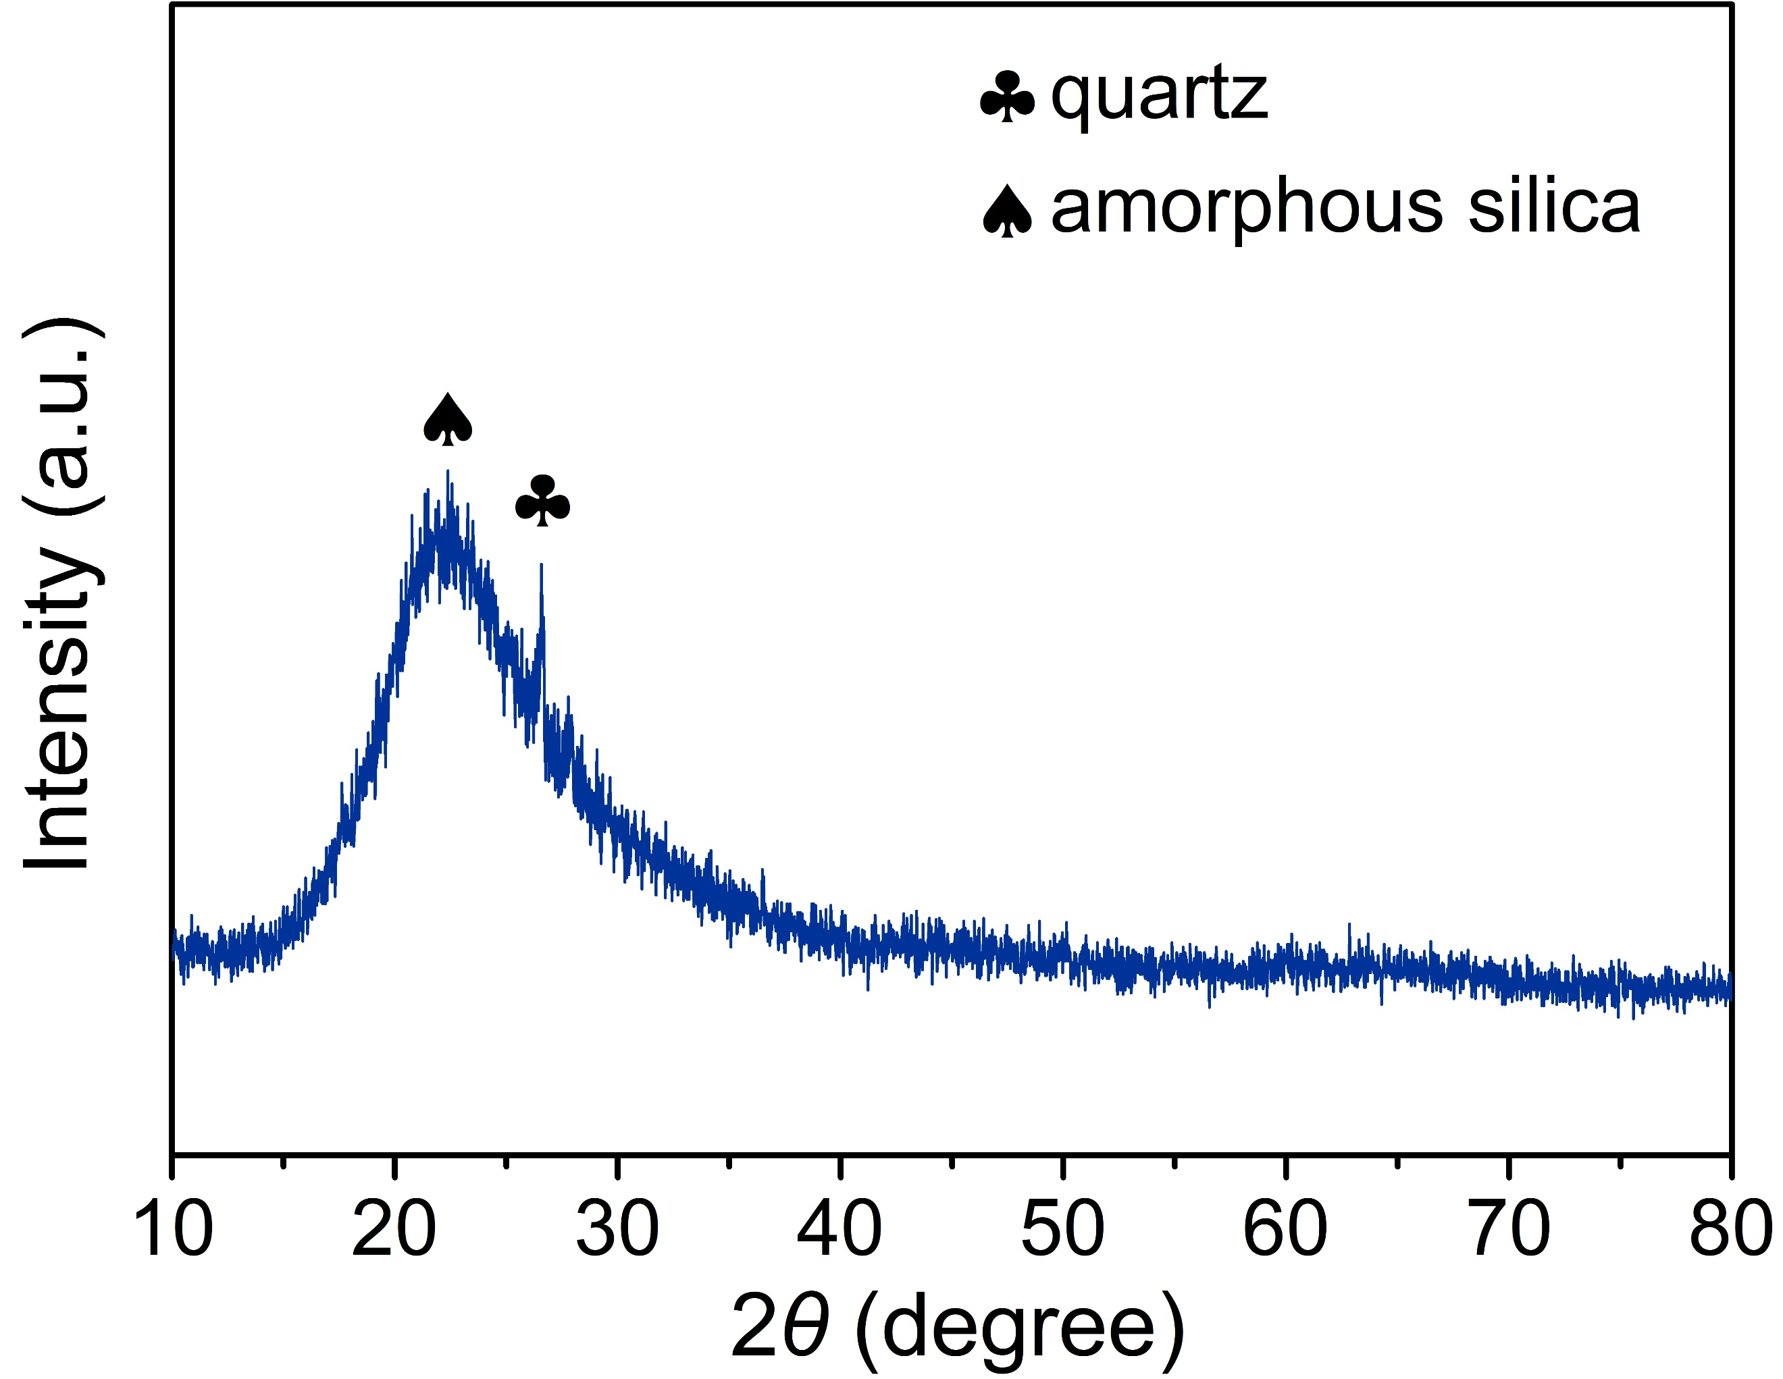
Supplementary Figure 1. XRD pattern of diatomite.
The broad diffraction peak appearing at 21º matches well with amorphous silica, and impurity peaks located at 20º and 26º correspond to (100) and (011) planes of quartz, respectively⁶.
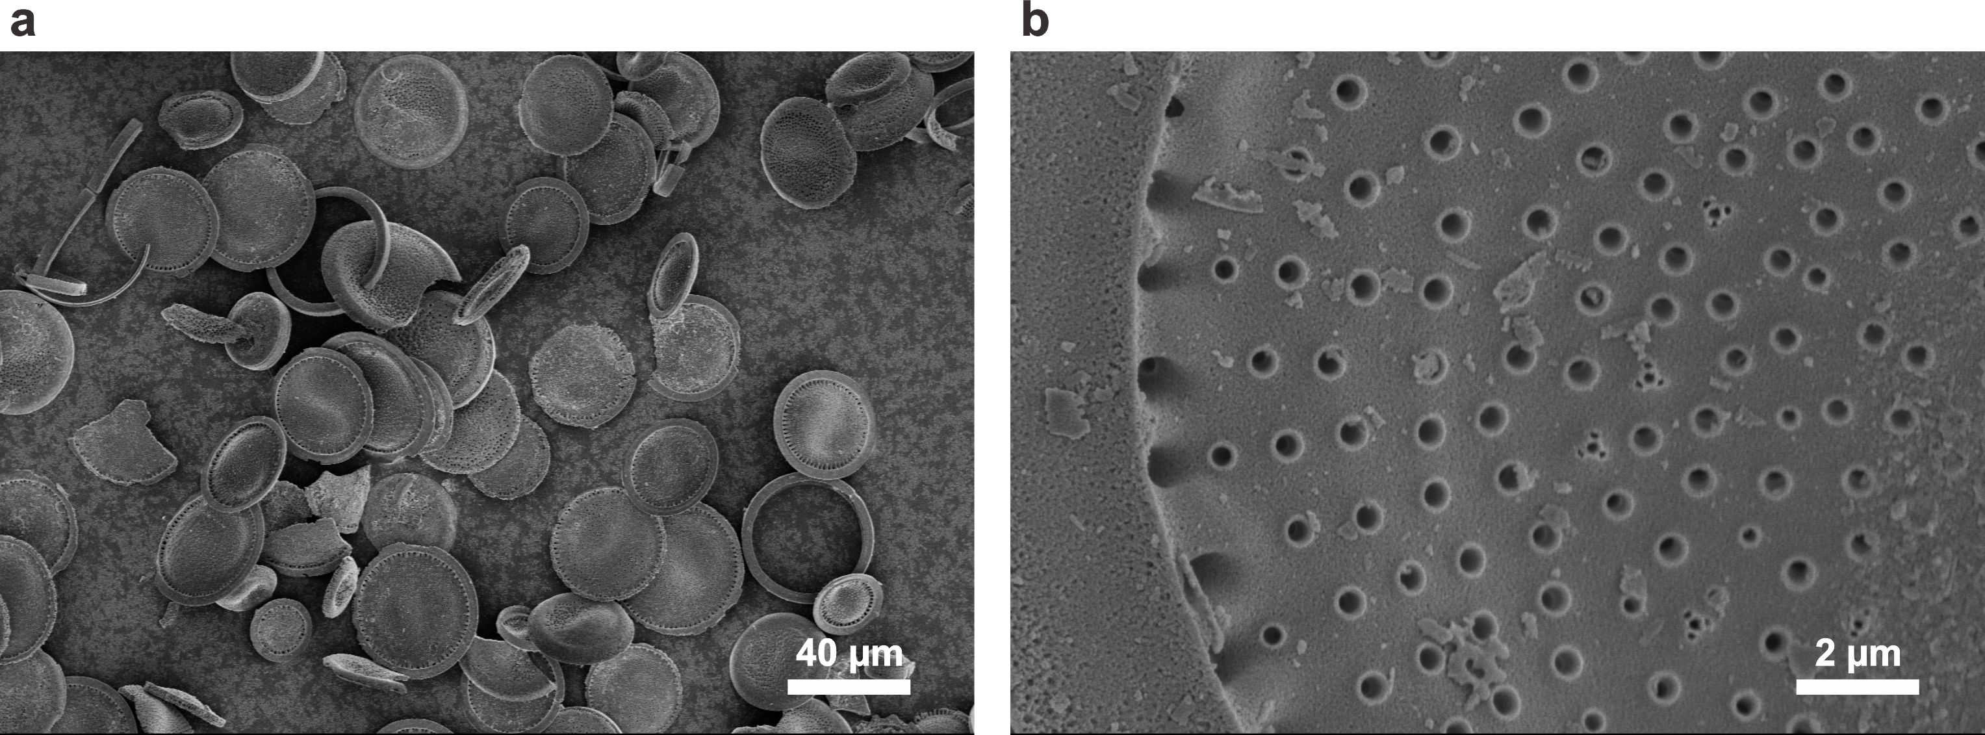
Supplementary Figure 2. SEM images of diatomite.

Supplementary Figure 3. SEM image and corresponding EDS mapping of metal-precursors@diatomite composite.
The homogeneous distribution of Co element manifests the well-defined spatial distribution of Co precursor on disc-shaped diatomite, which is beneficial for the uniform dispersion and exposure of single cobalt sites during polymerization and pyrolysis.
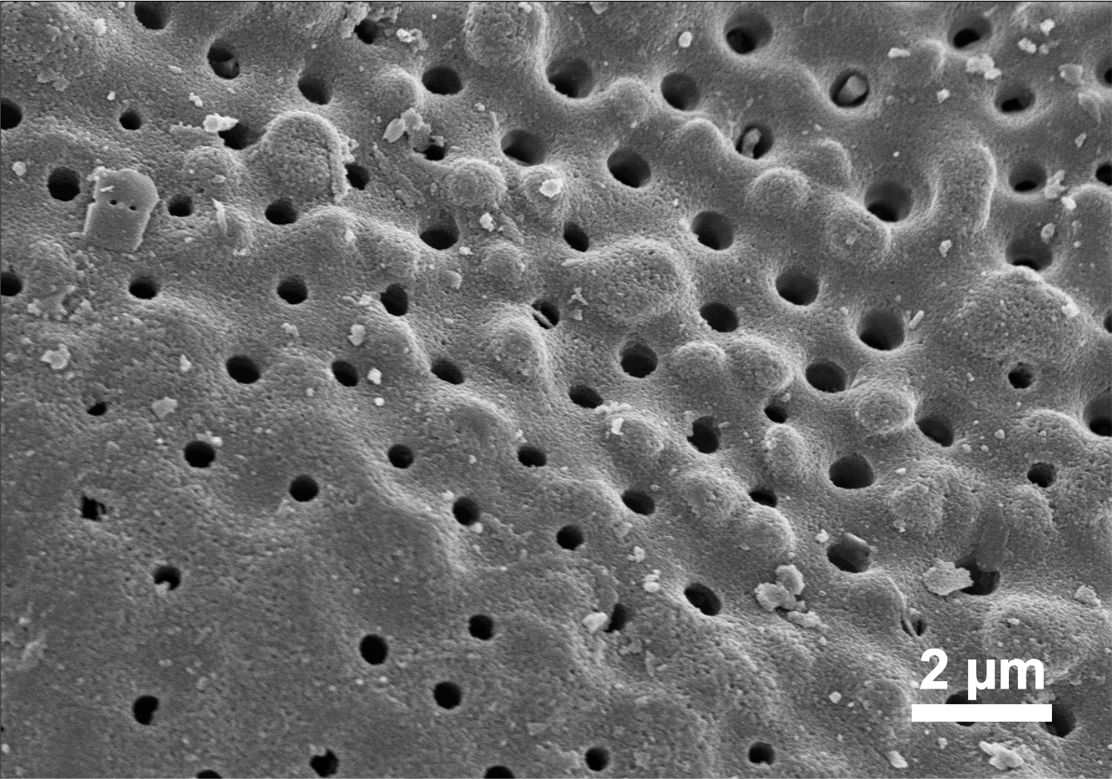
Supplementary Figure 4. SEM image of CoN₃Si₁@D.
It is shown that the CoN₃Si₁@D inherits the hierarchically porous structure of diatomite. Nearly no obvious metal nanoparticles could be detected on the surface of CoN₃Si₁@D.
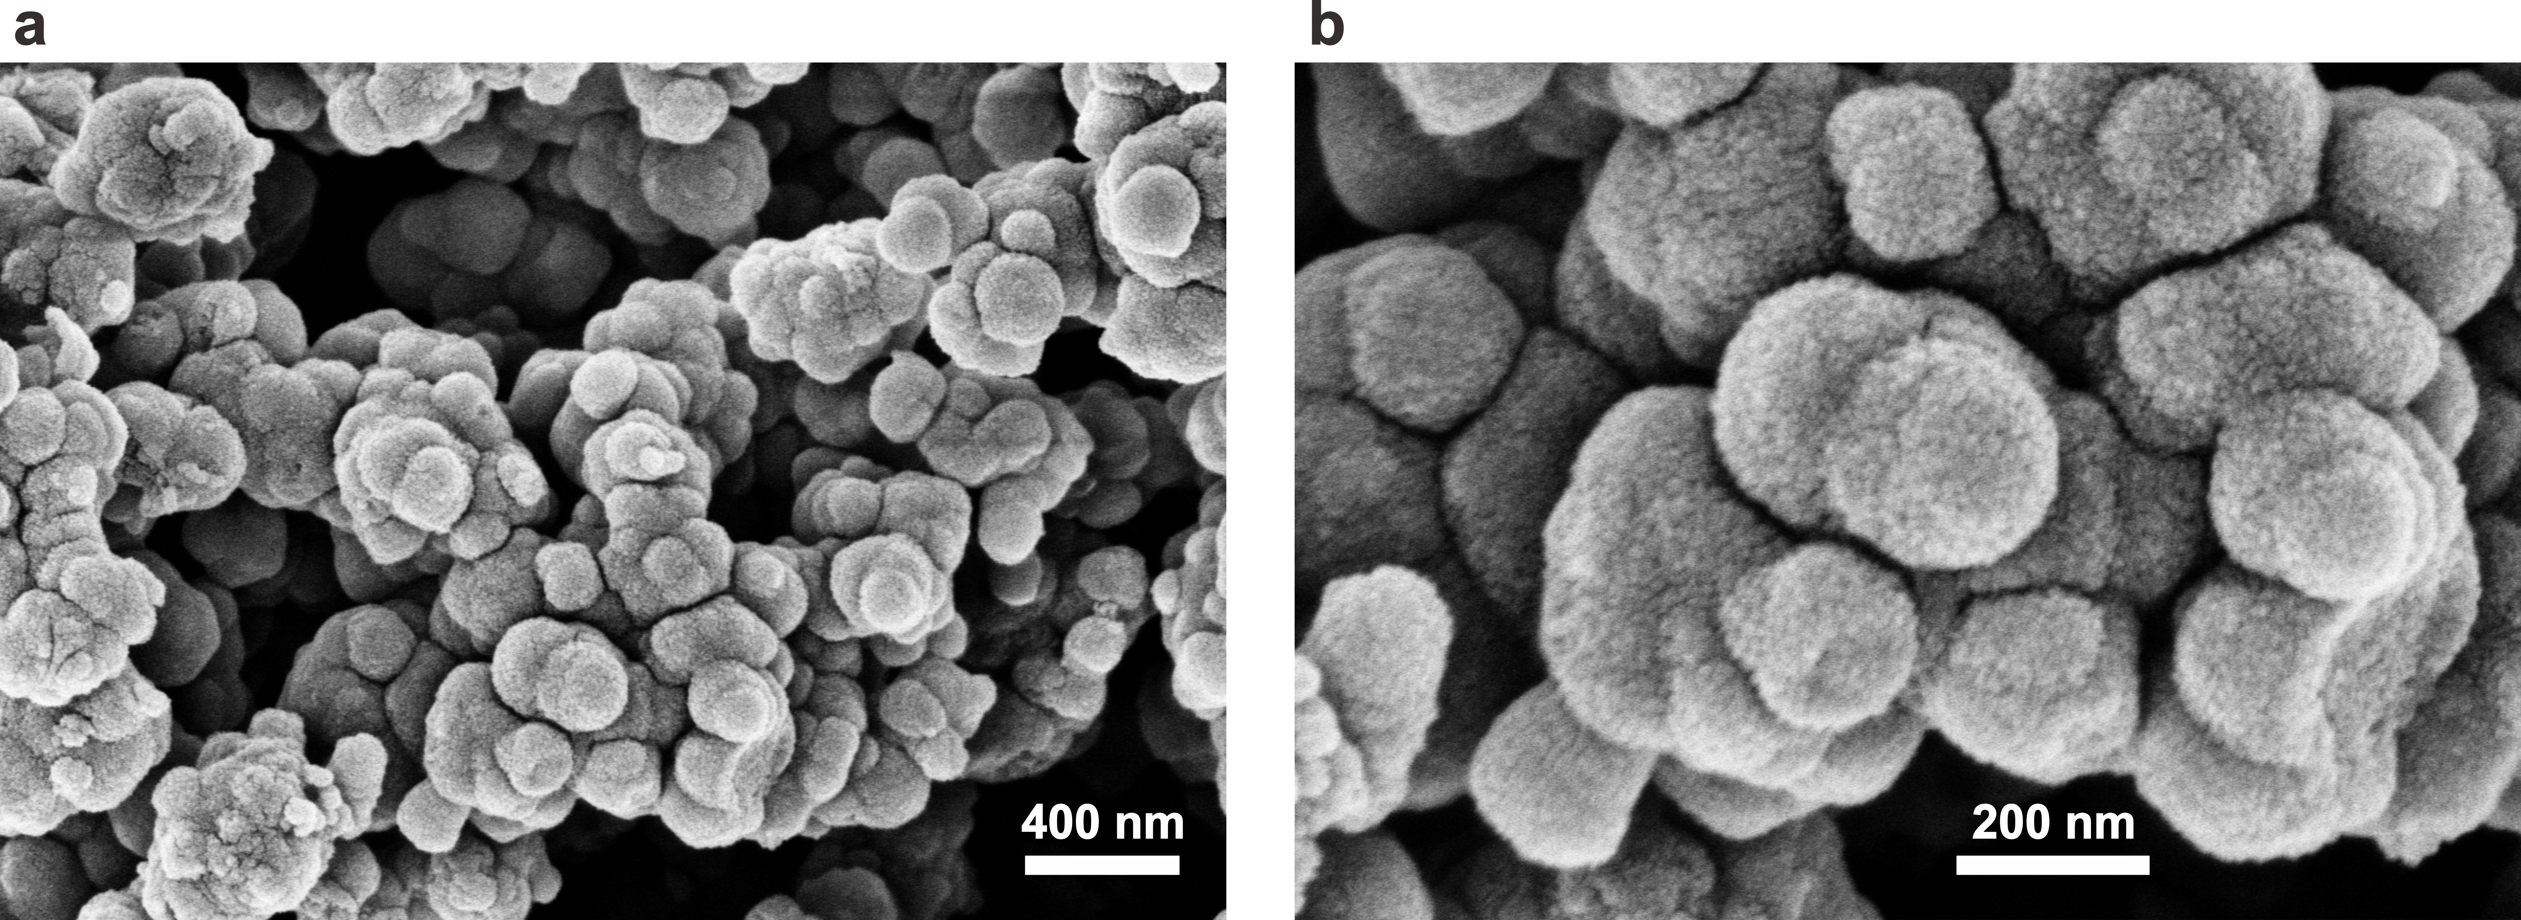
Supplementary Figure 5. SEM images of p-CoN₄.
Different from the p-CoN₃Si₁@D with porous and freestanding structure, the p-CoN₄ nanosphere clusters agglomerate severely. The PDA molecules tent to self-aggregate which results in the formation of nanosphere clusters.
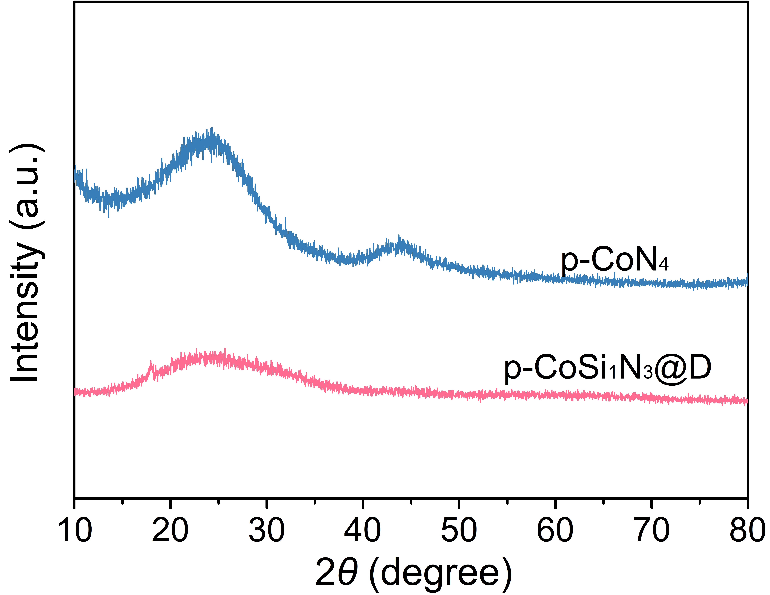
Supplementary Figure 6. XRD patterns of p-CoN₃Si₁@D and p-CoN₄.
No metal peak observed in p-CoN₄ and p-CoN₃Si₁@D demonstrates the possible formation of single Co atoms.
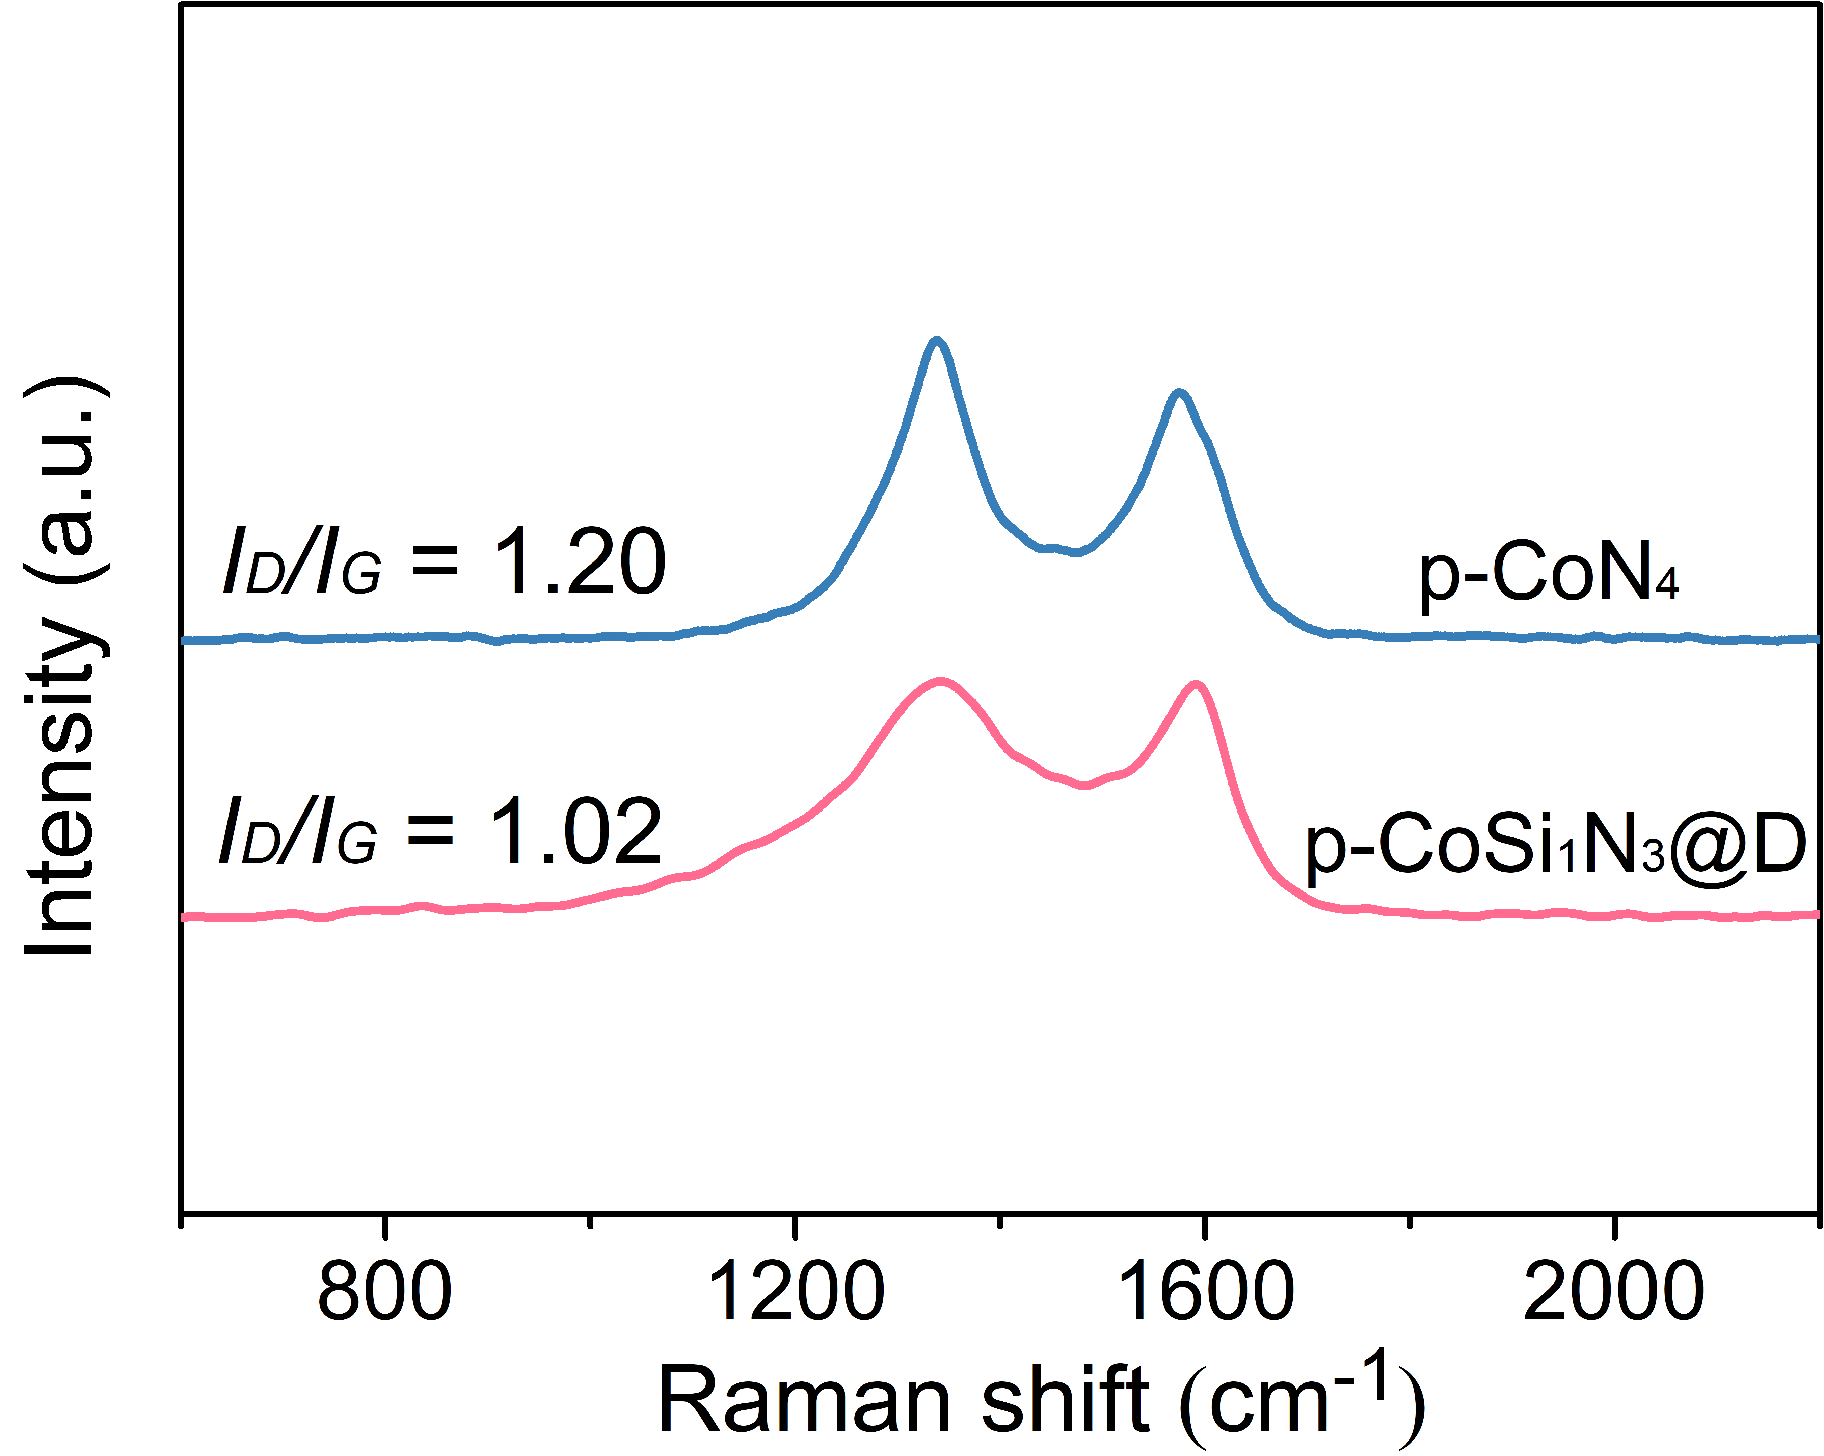
Supplementary Figure 7. Raman spectroscopy of p-CoN₃Si₁@D and p-CoN₄.
In comparison to p-CoN₄ (I_{D}/I_{G} = 1.20), the lower intensity ratio (I_{D}/I_{G} = 1.02) of D band (~1345 cm⁻¹) and G band (~1590 cm⁻¹) suggests the higher graphitization degree of p-CoN₃Si₁@D. The higher graphitization degree could increase the electrical conductivity of catalyst, which further accelerates the electron transport during its interaction with PMS molecules⁷.
Supplementary Figure 8. N₂ adsorption/desorption isotherms and pore size distributions for diatomite ((a) and (b)), p-CoN₄ ((c) and (d)), and p-CoN₃Si₁@D ((e) and (f)).
As seen in Supplementary Fig. 7a, the isotherm curve of diatomite presents a typical III adsorption branch with a H₃-type hysteresis loop, revealing the macroporous channels caused by the existence of vertical and smooth holes⁶. For p-CoN₄, the typical IV adsorption branch with a H₃-type of hysteresis loop could be detected, which confirms the existence of slit mesopores^{8,9}. Interestingly, p-CoN₃Si₁@D displays a similar curve isotherm compared with that of diatomite, demonstrating the preservation of macroporous channels. By contrast, p-CoN₃Si₁@D possesses the highest specific surface area (465.5 m²/g) and largest pore volume (1.158 cm³/g) (Supplementary Fig. 7b and Supplementary Table 3). Moreover, the average pore radius of the mesoporous p-CoSi₁N₃@D extends to 9.949 nm.
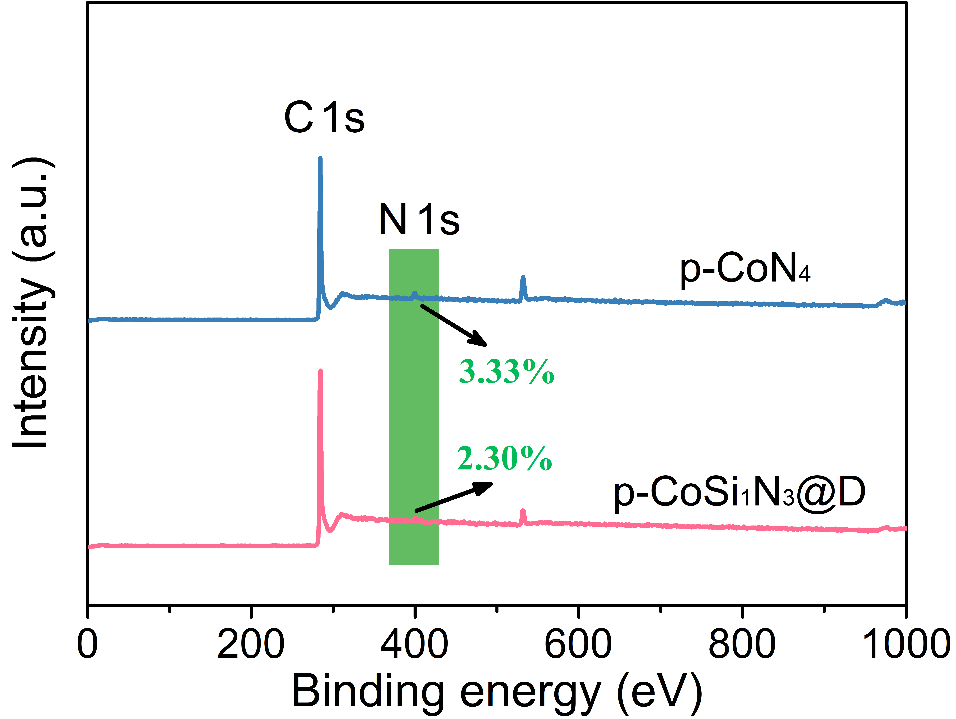
Supplementary Figure 9. X-ray photoelectron spectroscopy (XPS) spectrum survey of p-CoN₃Si₁@D and p-CoN₄.
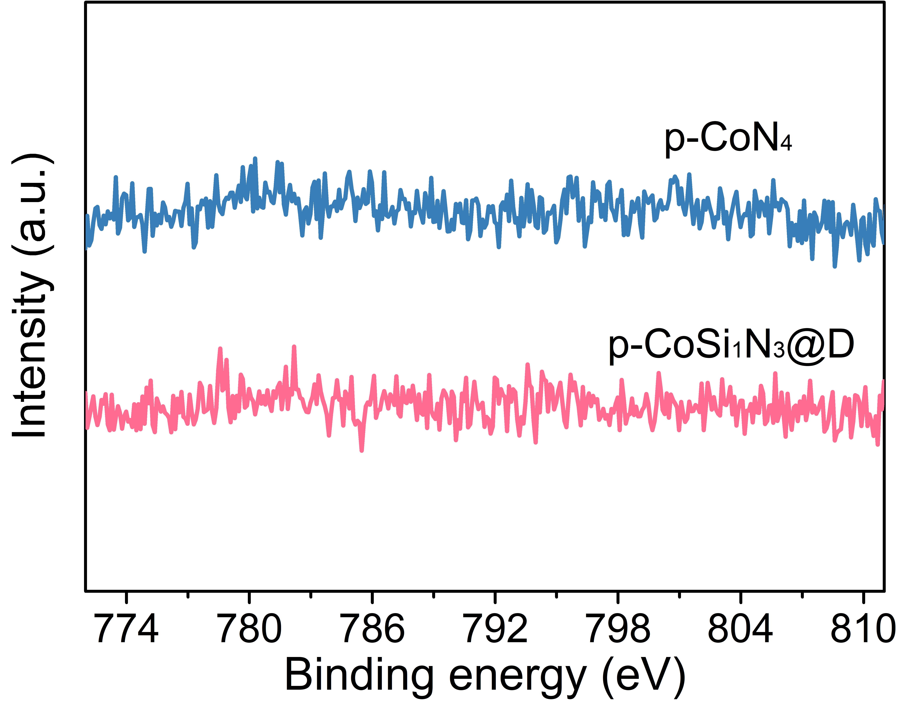
Supplementary Figure 10. Co 2p photoemission spectra of p-CoN₃Si₁@D and p-CoN₄.
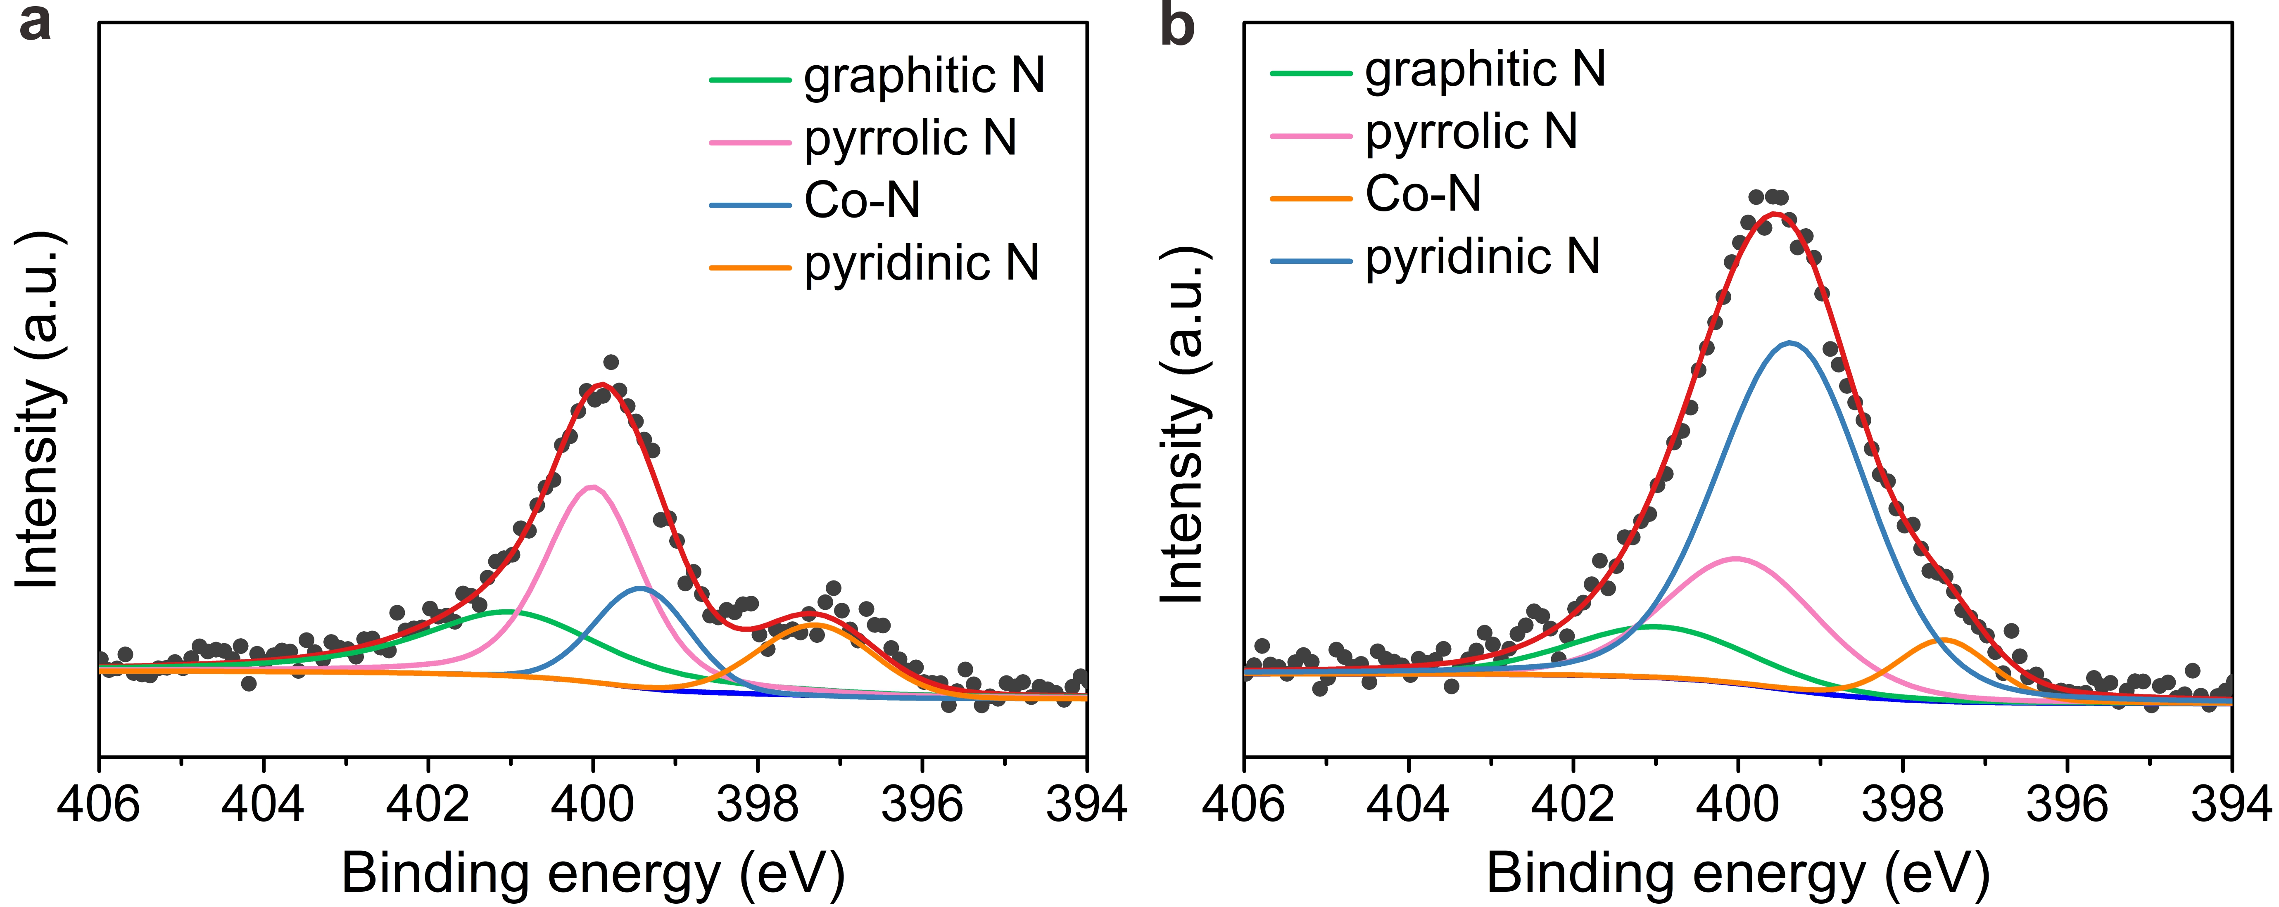
Supplementary Figure 11. N 1s photoemission spectra of (a) p-CoN₃Si₁@D and (b) p-CoN₄.
Similar to p-CoSi₁N₃@D, the N 1s core-level spectrum of p-CoN₄ exhibits four deconvoluted components at 397.5 eV (pyridinic N), 399.4 eV (Co‒N), 400.0 eV (pyrrolic N), and 401.0 eV (graphitic N), respectively ^{[10]}. Among these species, the pyrrolic N is the dominant chemical species in p-CoN₄. In addition, the Co‒N bond intensity of p-CoN₄ is much higher than that of p-CoN₃Si₁@D, which is in agreement to the higher Co loadings in p-CoN₄ (Supplementary Table 2).
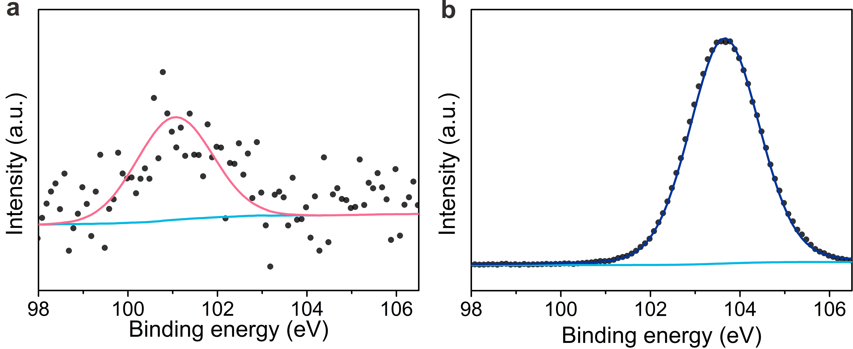
Supplementary Figure 12. Si 2p photoemission spectra of (a) p-CoN₃Si₁@D and (b) diatomite.
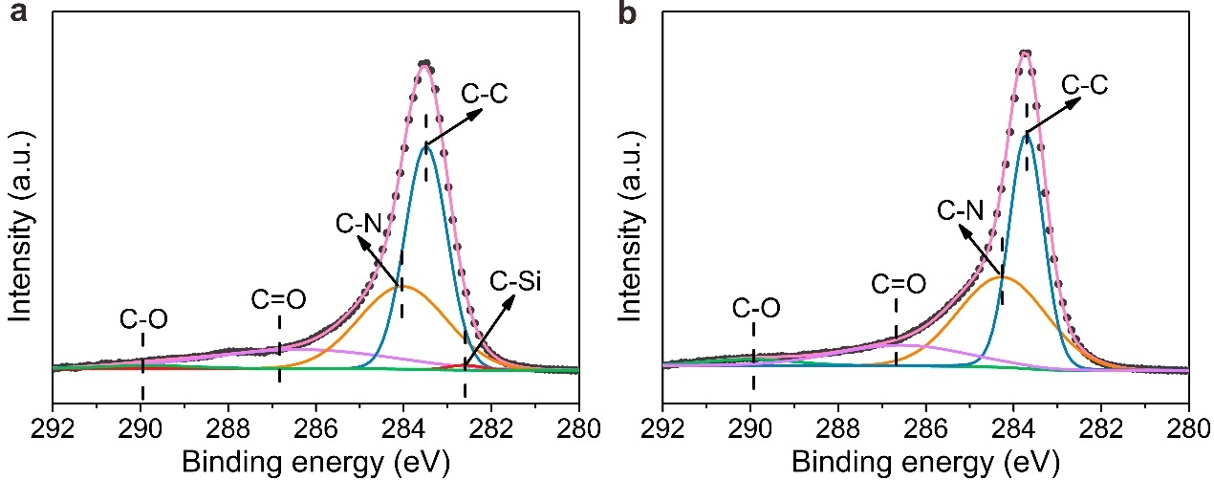
Supplementary Figure 13. C 1s photoemission spectra of (a) p-CoN₃Si₁@D and (b) p-CoN₄.
The C 1s XPS spectra of p-CoN₄ could be divided into four peaks at 290.0 eV (C‒O), 286.5 eV (C=O), 284.3 eV (C‒N), and 283.7 eV (C‒C), respectively ^{[11]}. In comparison to p-CoN₄, the presence of C‒Si bond (located at 282.6 eV) in the C 1s XPS spectrum of p-CoN₃Si₁@D confirms the successful introduction of Si into carbon basal.
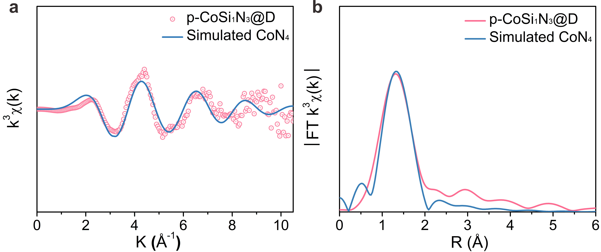
Supplementary Figure 14. The prediction of Fourier-transformed k³-weighted EXAFS curve (k and R space) for CoN₄.
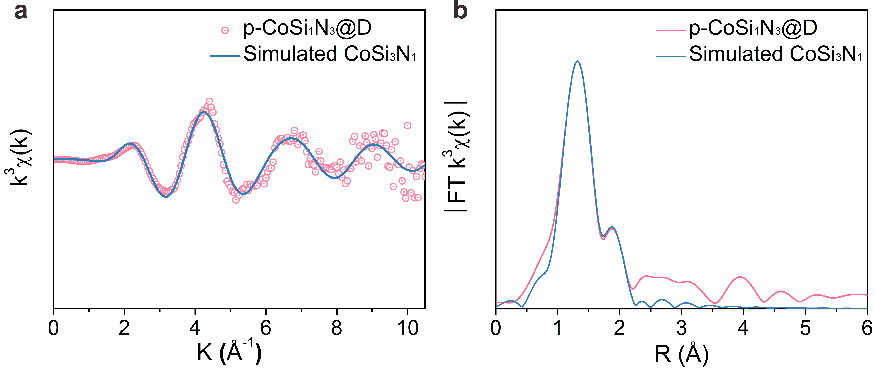
Supplementary Figure 15. The prediction of Fourier-transformed k³-weighted EXAFS curve (k and R space) for CoSi₃N₁.
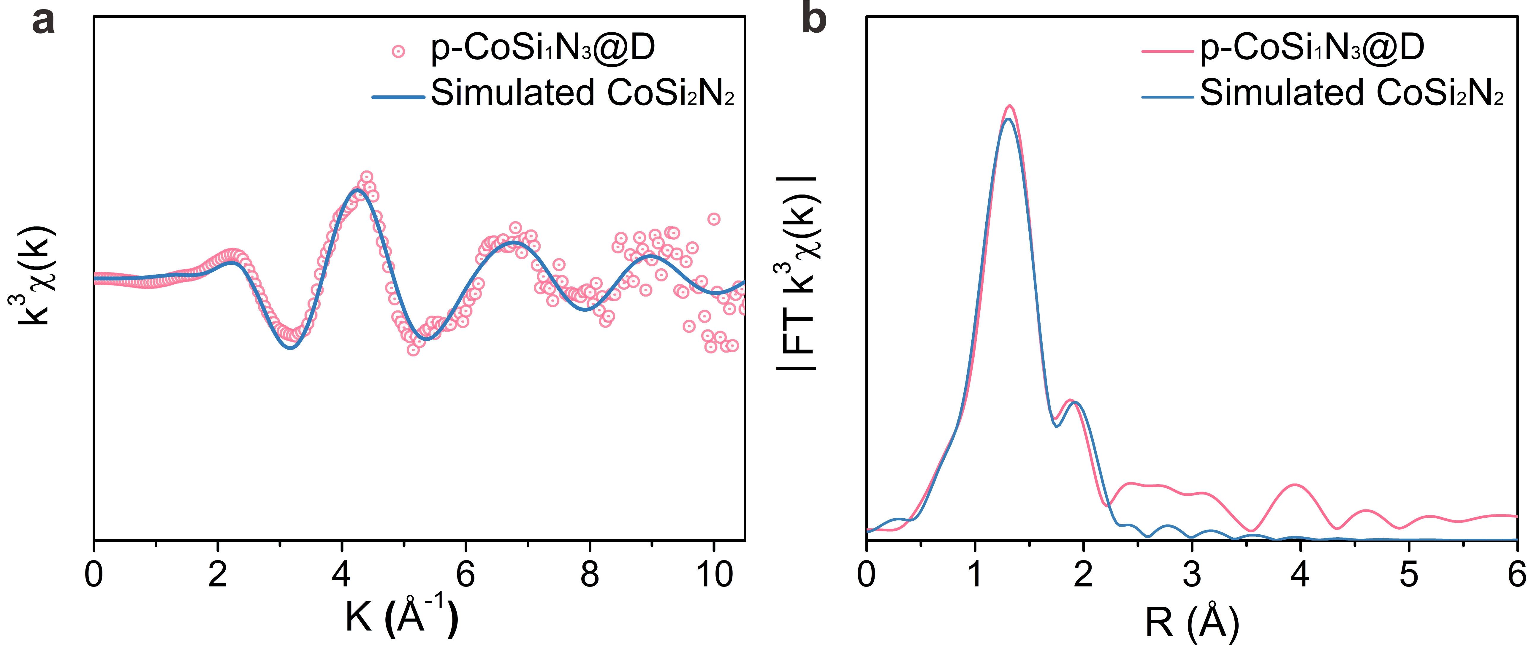
Supplementary Figure 16. The prediction of Fourier-transformed k³-weighted EXAFS curve (k and R space) for CoSi₂N₂.

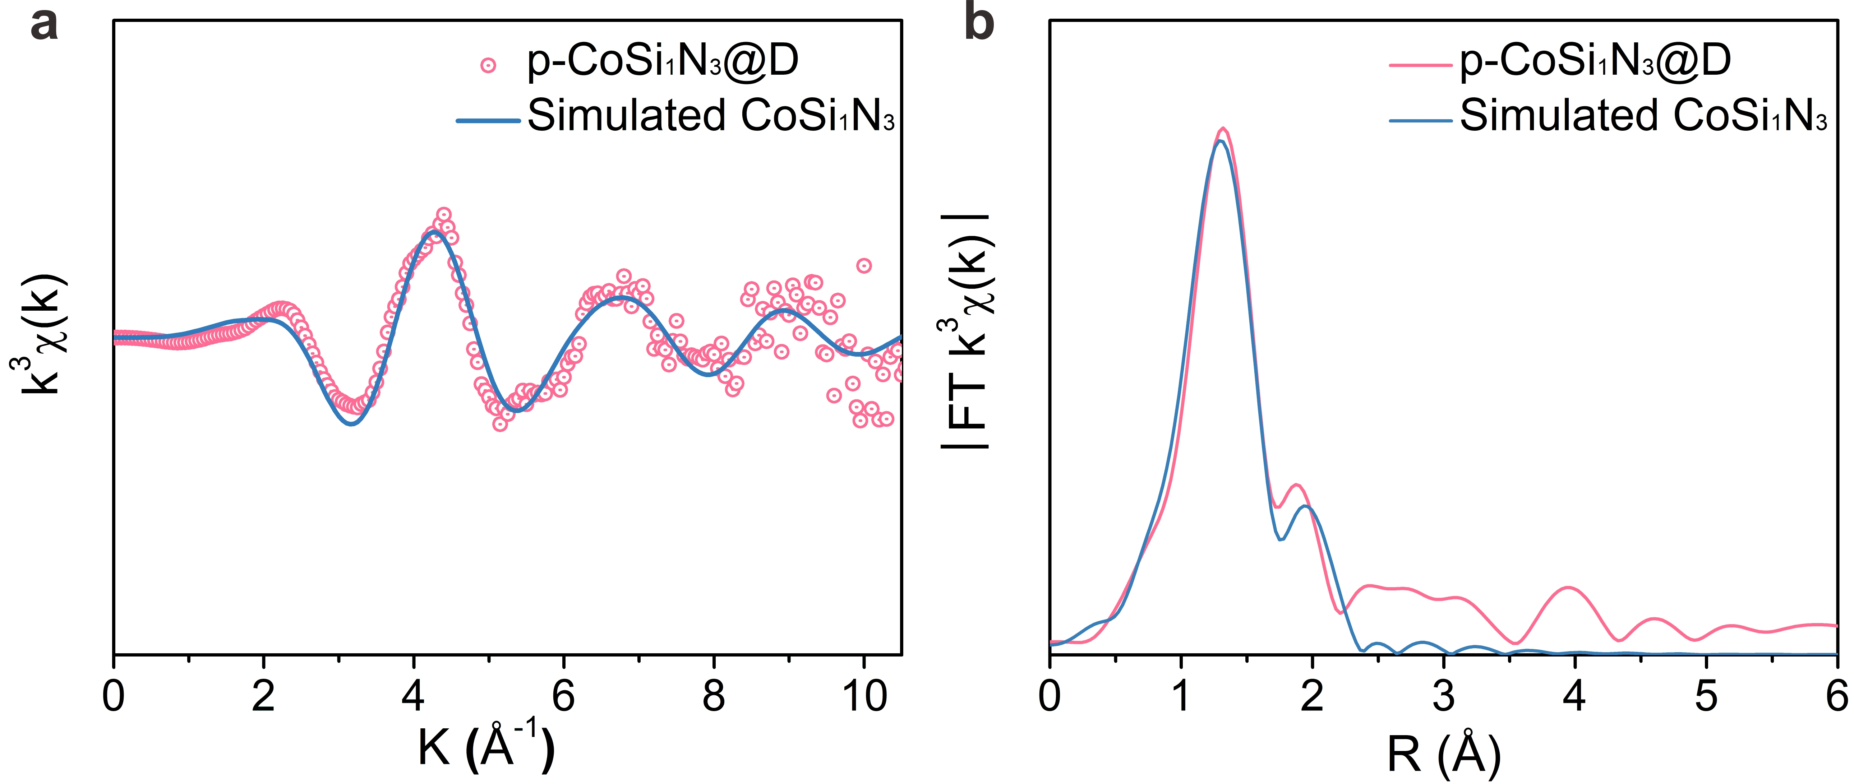
Supplementary Figure 17. The prediction of Fourier-transformed k³-weighted EXAFS curve (k and R space) for CoSi₁N₃.
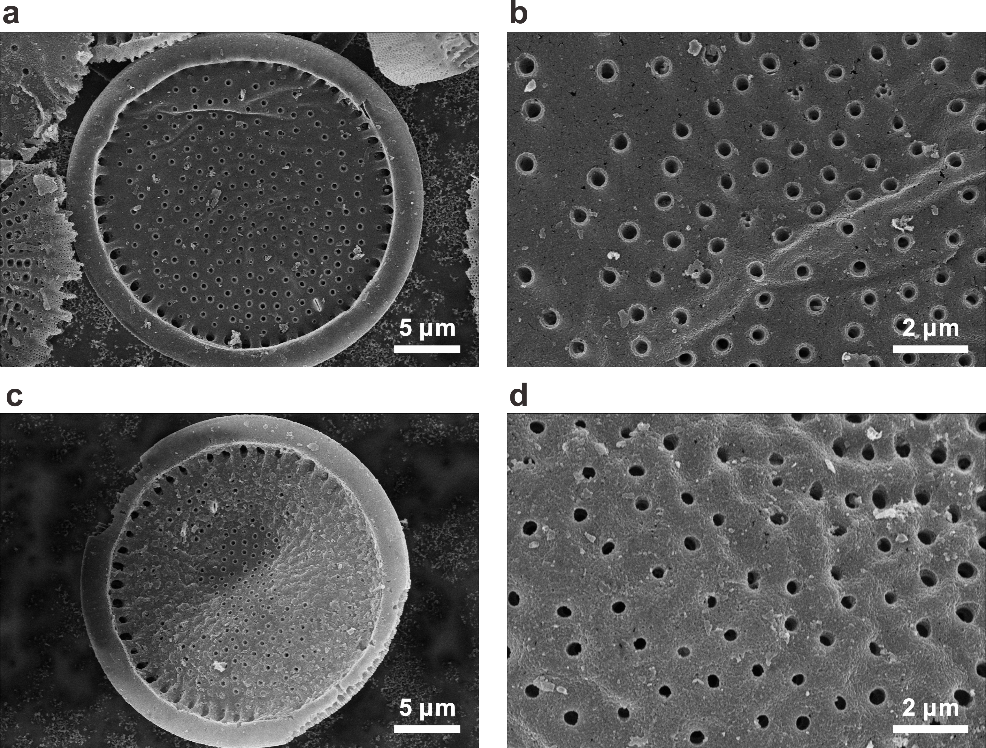
Supplementary Figure 18. SEM images of fresh ((a) and (b)) and used ((c) and (d)) p-CoN₃Si₁@D.
The p-CoN₃Si₁@D preserves the 3D freestanding and porous structure after 5 cycle runs.
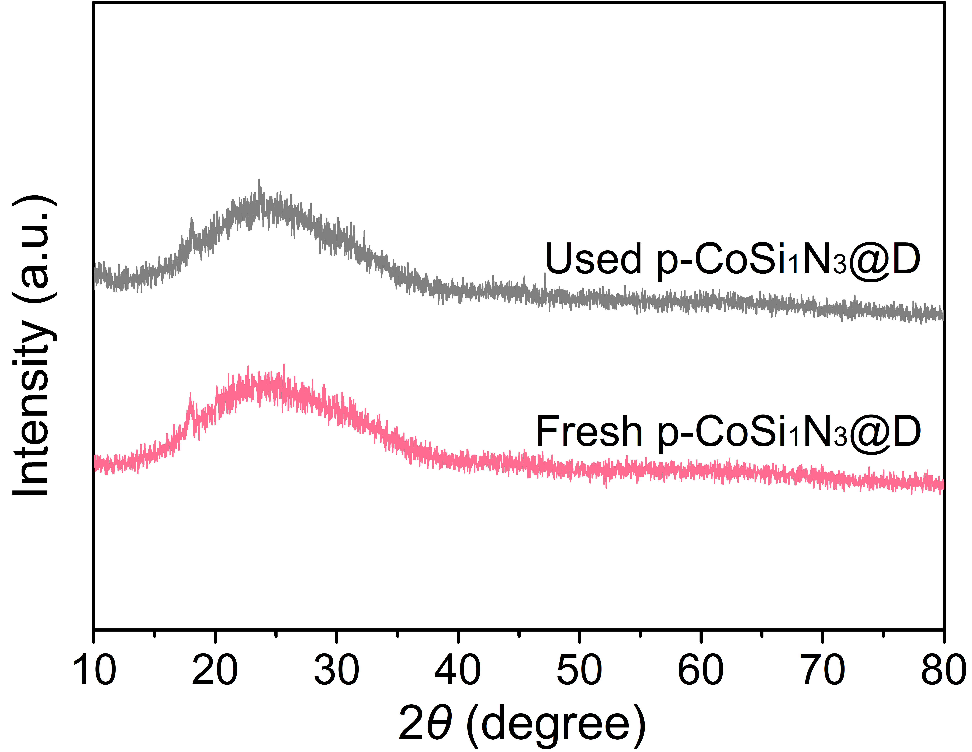
Supplementary Figure 19. XRD spectra of fresh and used p-CoN₃Si₁@D.
Nearly no difference could be detected in fresh and used p-CoN₃Si₁@D, suggesting the preservation of its crystallographic structure during the PMS activation process.
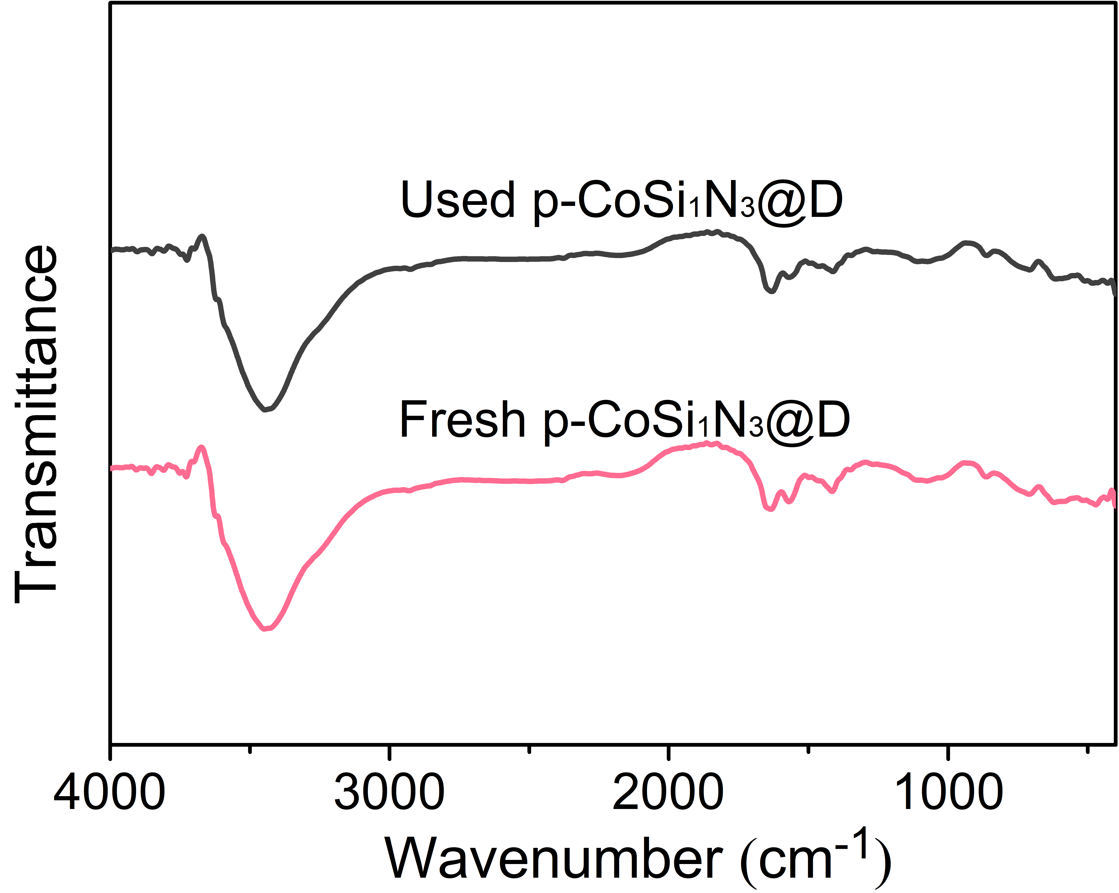
Supplementary Figure 20. FTIR spectra of fresh and used p-CoN₃Si₁@D.
Negligible changes could be detected between fresh and used p-CoN₃Si₁@D in FTIR, which matches well with the results derived from XRD analysis.
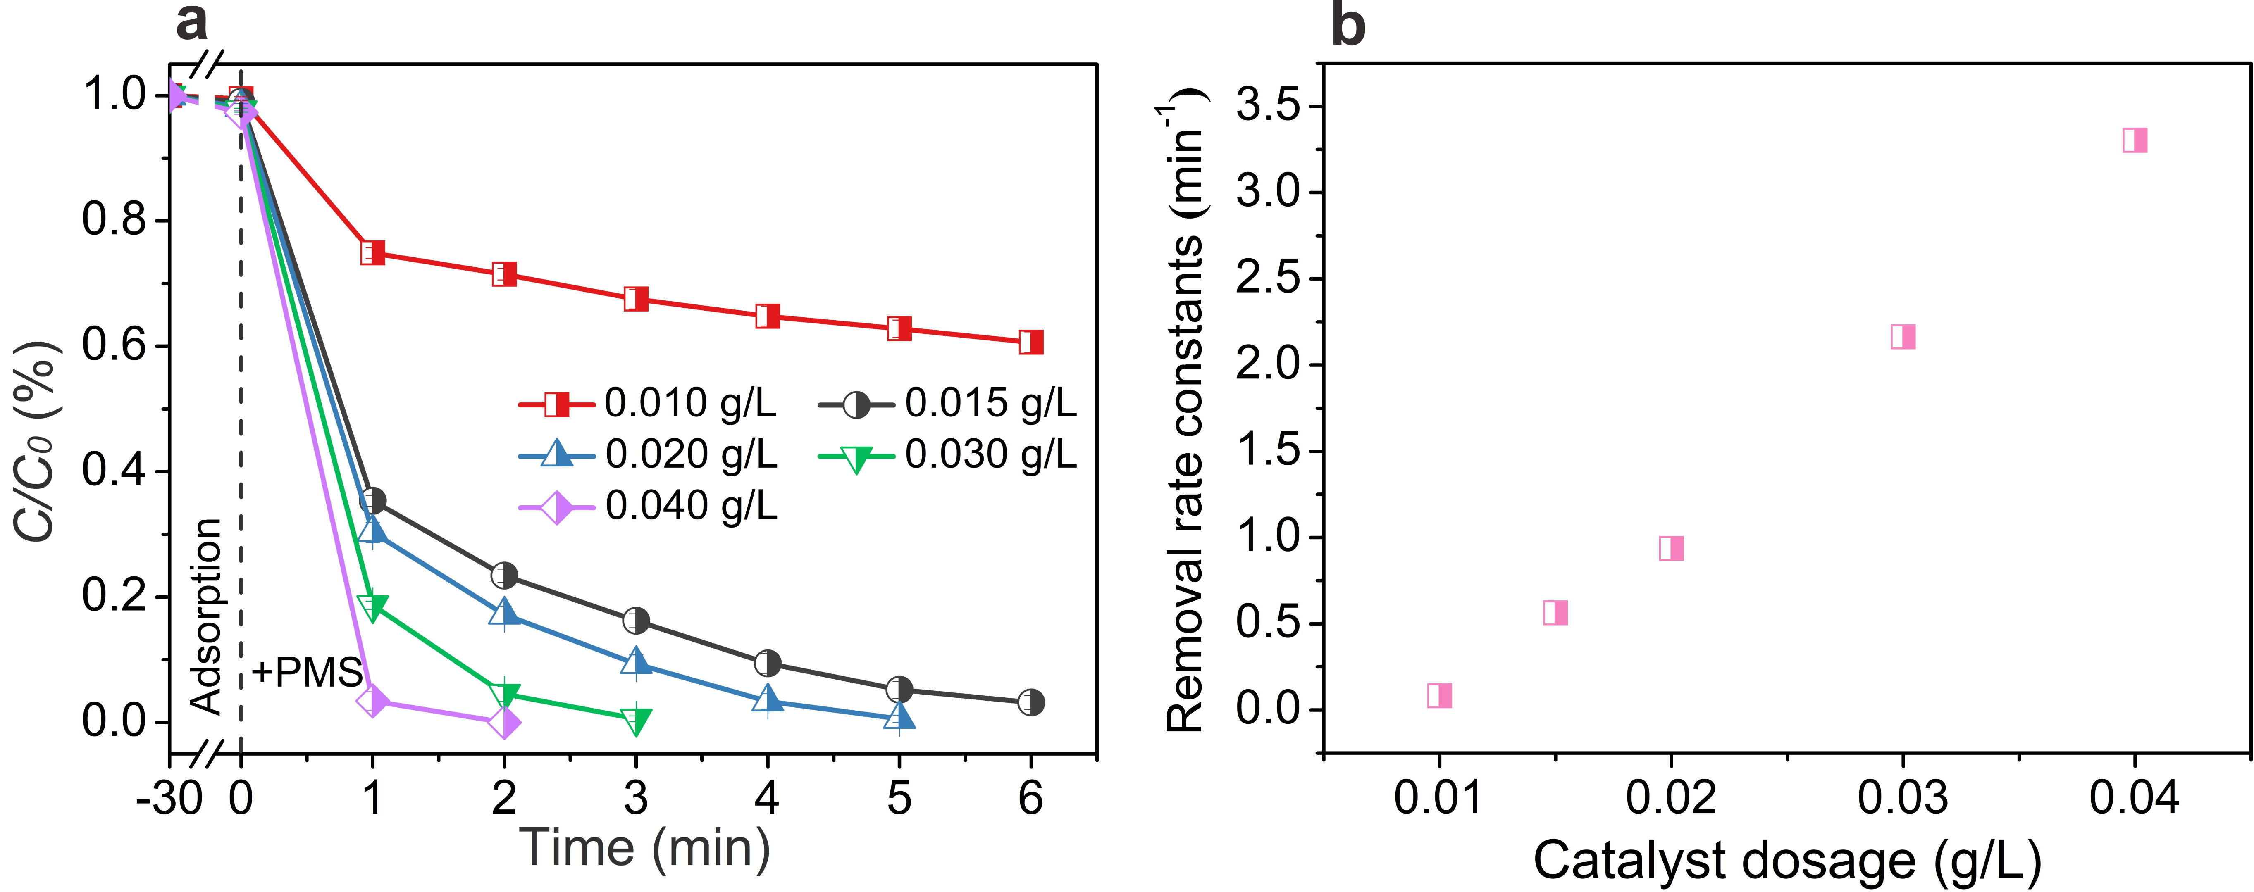
Supplementary Figure 21. (a) Effect of catalyst dosage on BPA degradation catalyzed by p-CoN₃Si₁@D/PMS system. (b) Effect of catalyst dosage on BPA degradation rate constants (k) catalyzed by p-CoN₃Si₁@D/PMS system. Experimental conditions: [BPA]₀ = 20 mg/L, [PMS]₀ = 0.5 mM, initial pH = 7.0.
It is observed that increasing p-CoN₃Si₁@D dosage can result in the increased efficiency for BPA degradation (Supplementary Fig. 21a). In addition, the BPA removal rate constants (k) gradually increase with the increase of p-CoN₃Si₁@D dosage (Supplementary Fig. 21b).
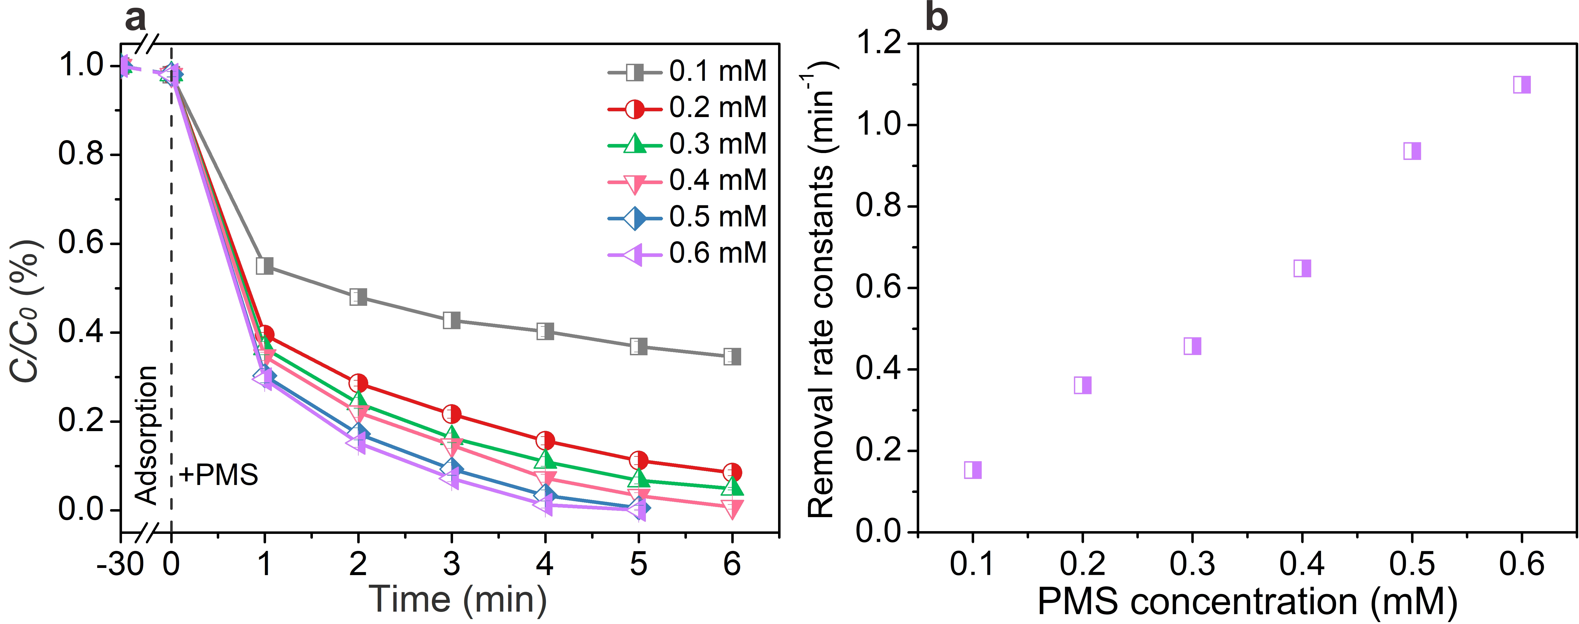
Supplementary Figure 22. (a) Effect of PMS concentration on BPA degradation catalyzed by p-CoN₃Si₁@D/PMS system. (b) Effect of PMS concentration on BPA degradation rate constants (k) catalyzed by p-CoN₃Si₁@D/PMS system. Experimental conditions: [BPA]₀ = 20 mg/L, [Catalyst]₀ = 0.02 g/L, initial pH = 7.0.
With the increase of PMS dosage, the BPA removal efficiency gradually increases (Supplementary Fig. 22a). In addition, the BPA removal rate constants (k) increase linearly with the PMS dosage from 0.1 mM to 0.6 mM (Supplementary Fig. 22b).
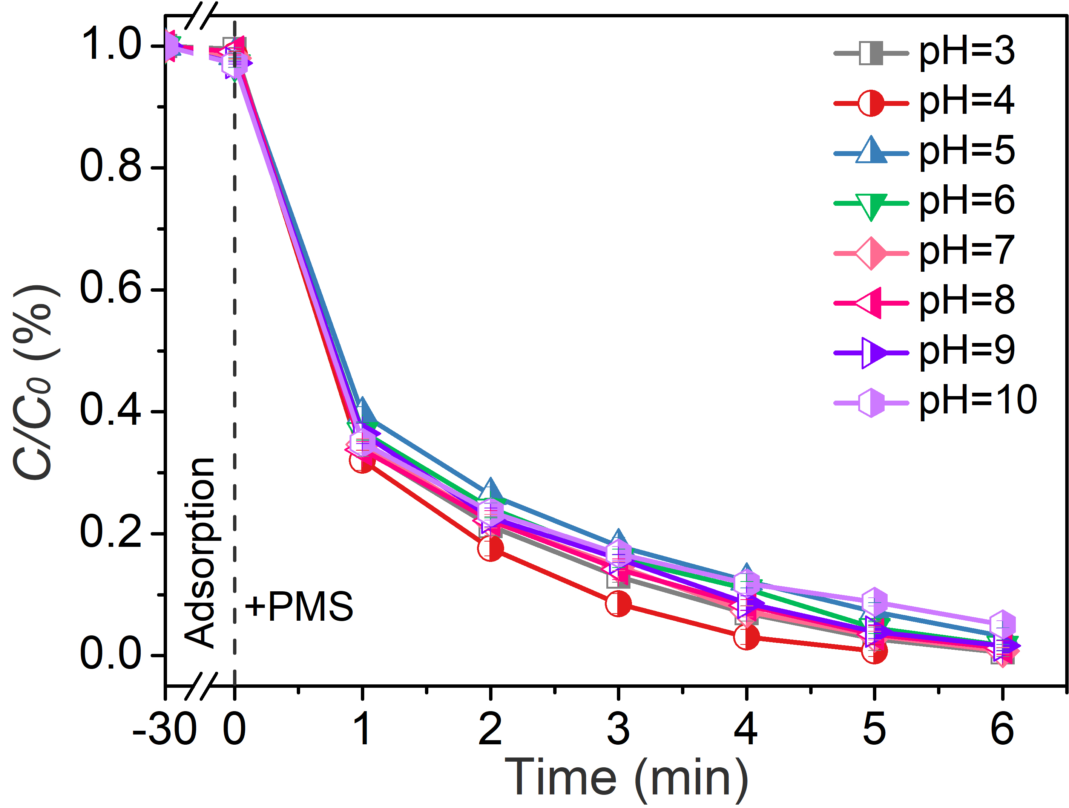
Supplementary Figure 23. Effect of initial pH value on BPA degradation catalyzed by p-CoN₃Si₁@D/PMS system. Experimental conditions: [BPA]₀ = 20 mg/L, [Catalyst]₀ = 0.02 g/L, [PMS]₀ = 0.4 mM.
Negligible effect could be observed for BPA degradation with the initial pH range from 3 to 10 (Supplementary Figure 23). In addition, the final pH values declined to around 3 in all p-CoN₃Si₁@D/PMS systems with the initial pH range from 3 to 10 (Supplementary Table 8).
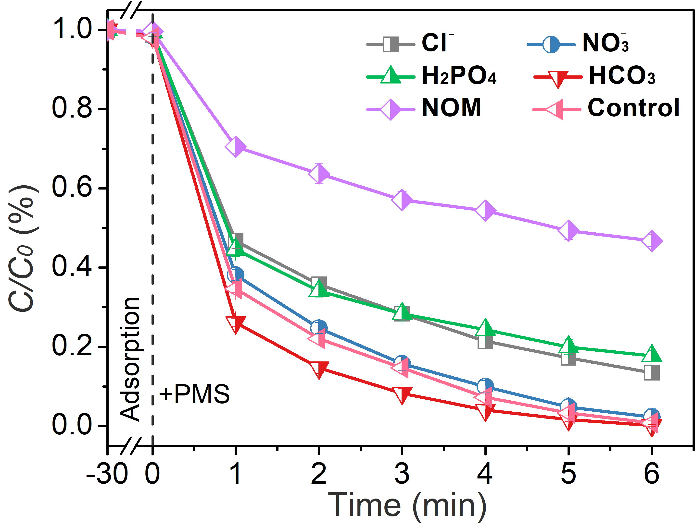
Supplementary Figure 24. Effects of inorganic anions and HA ([NO₃‒] = [SO₄^{2‒}] = [Cl‒] = [H₂PO₄‒] = [HCO₃‒] = 20 mM; [HA] = 20 mg/L) on BPA degradation catalyzed by p-CoN₃Si₁@D/PMS system. Experimental conditions: [BPA]₀ = 20 mg/L; [Catalyst]₀ = 0.02 g/L; [PMS]₀ = 0.4 mM; initial pH = 7.0.
Negligible change on BPA degradation is observed in the presence of 20 mM of NO₃ˉ or HCO₃ˉ. The presence of H₂PO₄ˉ, Clˉ or HA show the negative effect on BPA degradation, which might be attributed to the scavenging effect towards ¹O₂ and PMS^{6,12}.
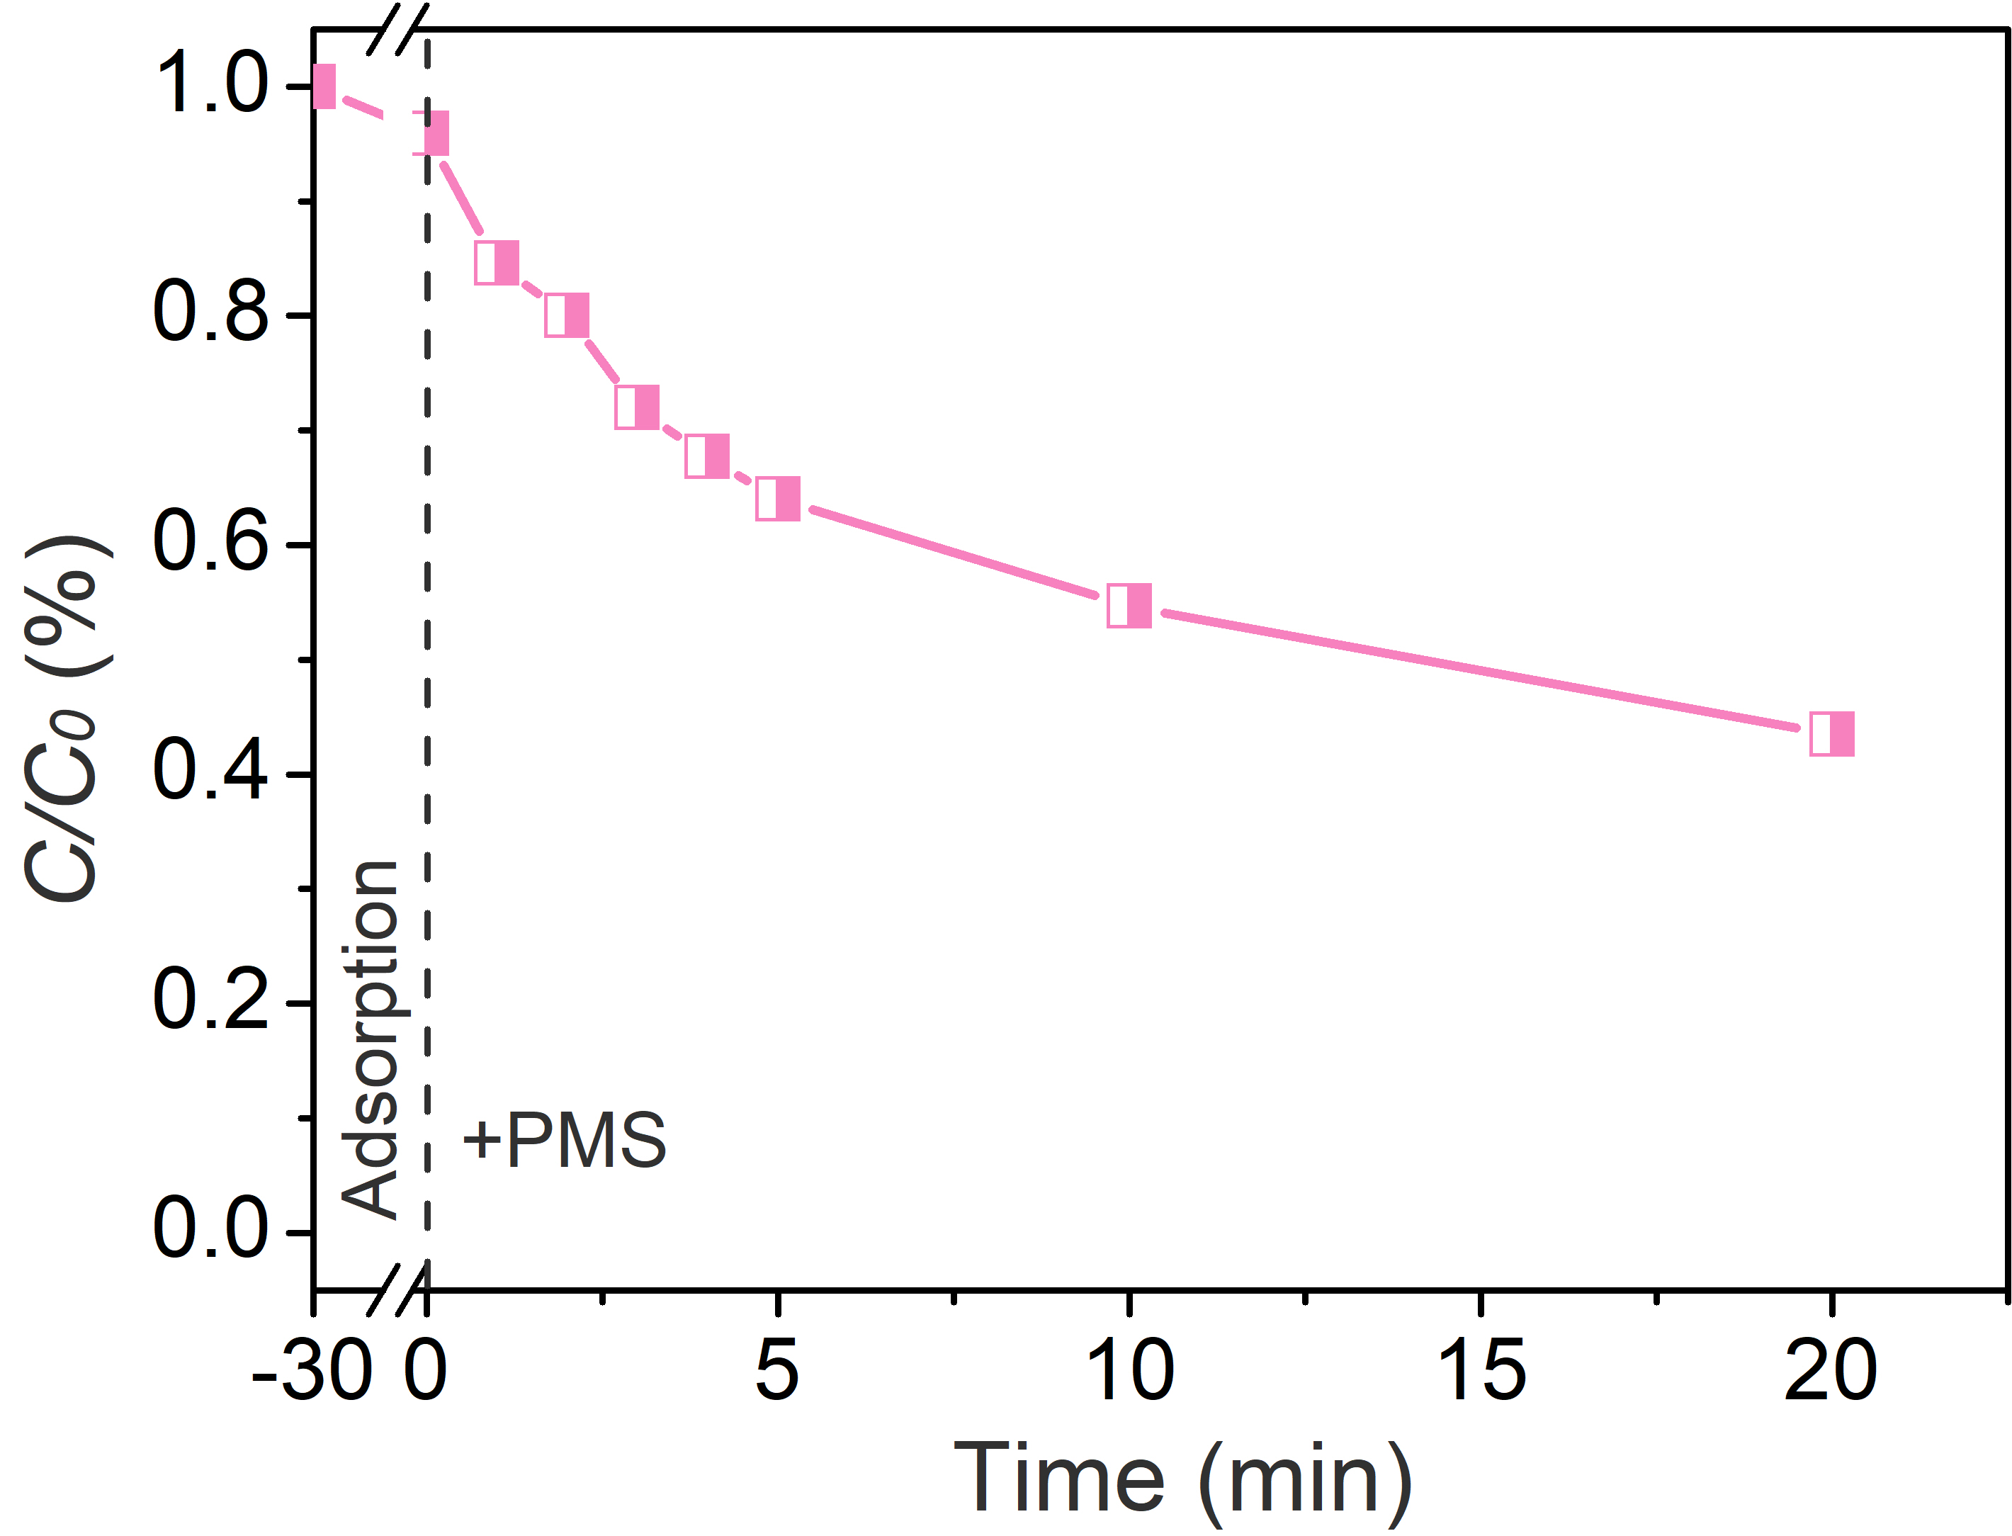
Supplementary Figure 25. The atrazine degradation efficiency by p-CoSi₁N₃@D/PMS system. Experimental conditions: [atrazine]₀ = 10 mg/L, [Catalyst]₀ = 0.05 g/L, [PMS]₀ = 0.5 mM, initial pH = 7.0.
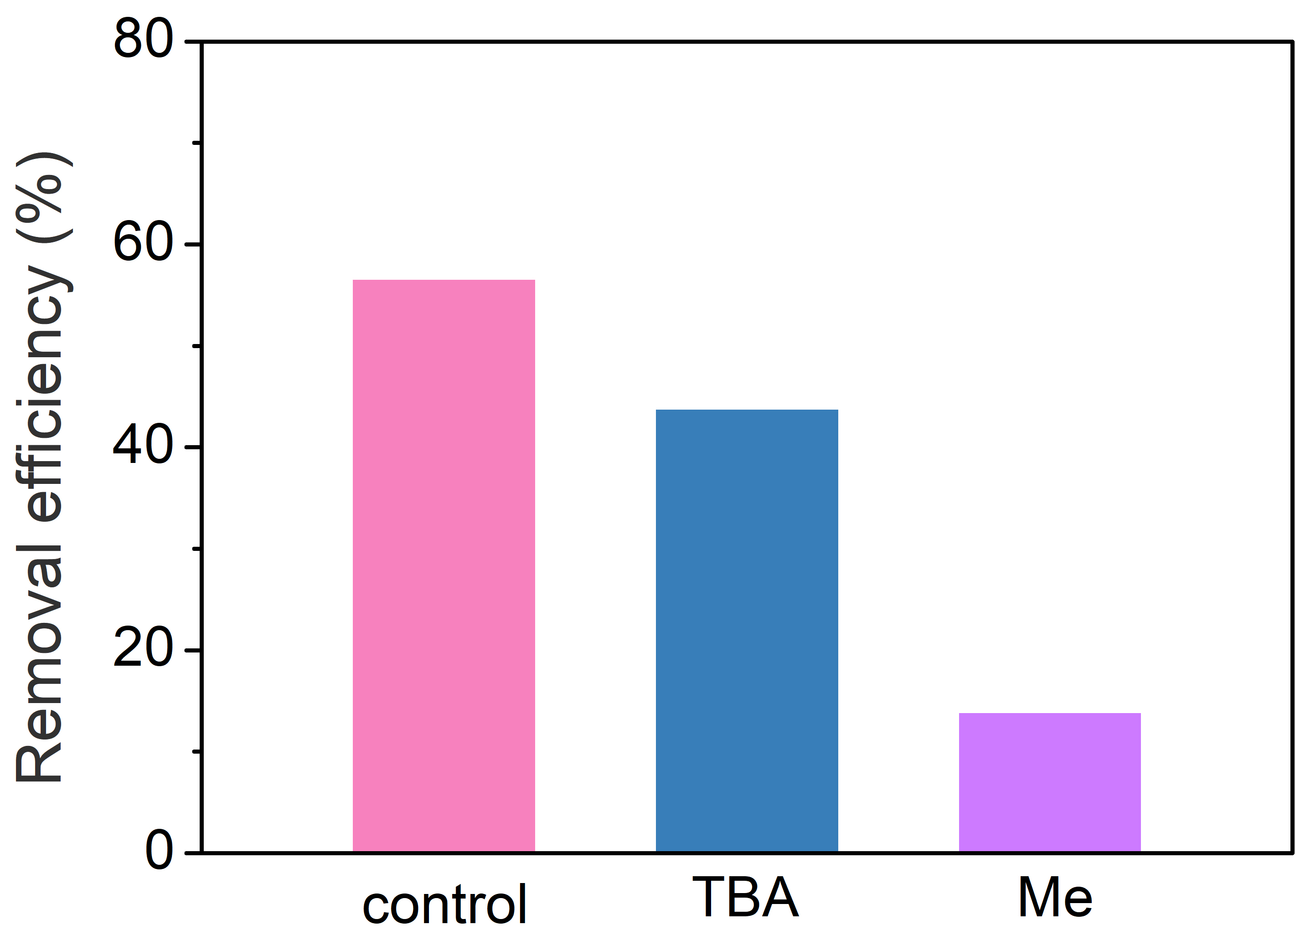
Supplementary Figure 26. Quenching effect on atrazine degradation during PMS activation by different scavengers (Experimental conditions: [Methanol]₀ = 200 mM, [TBA]₀ = 200 mM, [atrazine]₀ = 10 mg/L, [Catalyst]₀ = 0.05 g/L; [PMS]₀ = 0.5 mM; initial pH = 7.0).
When tert-butyl alcohol (TBA) and methanol (MeOH) were added in the reaction mixture respectively, the significant inhibitions observed further confirm the dominant roles of •OH and SO₄^{•−} in p-CoN₃Si₁@D/PMS oxidation system for ATZ degradation.
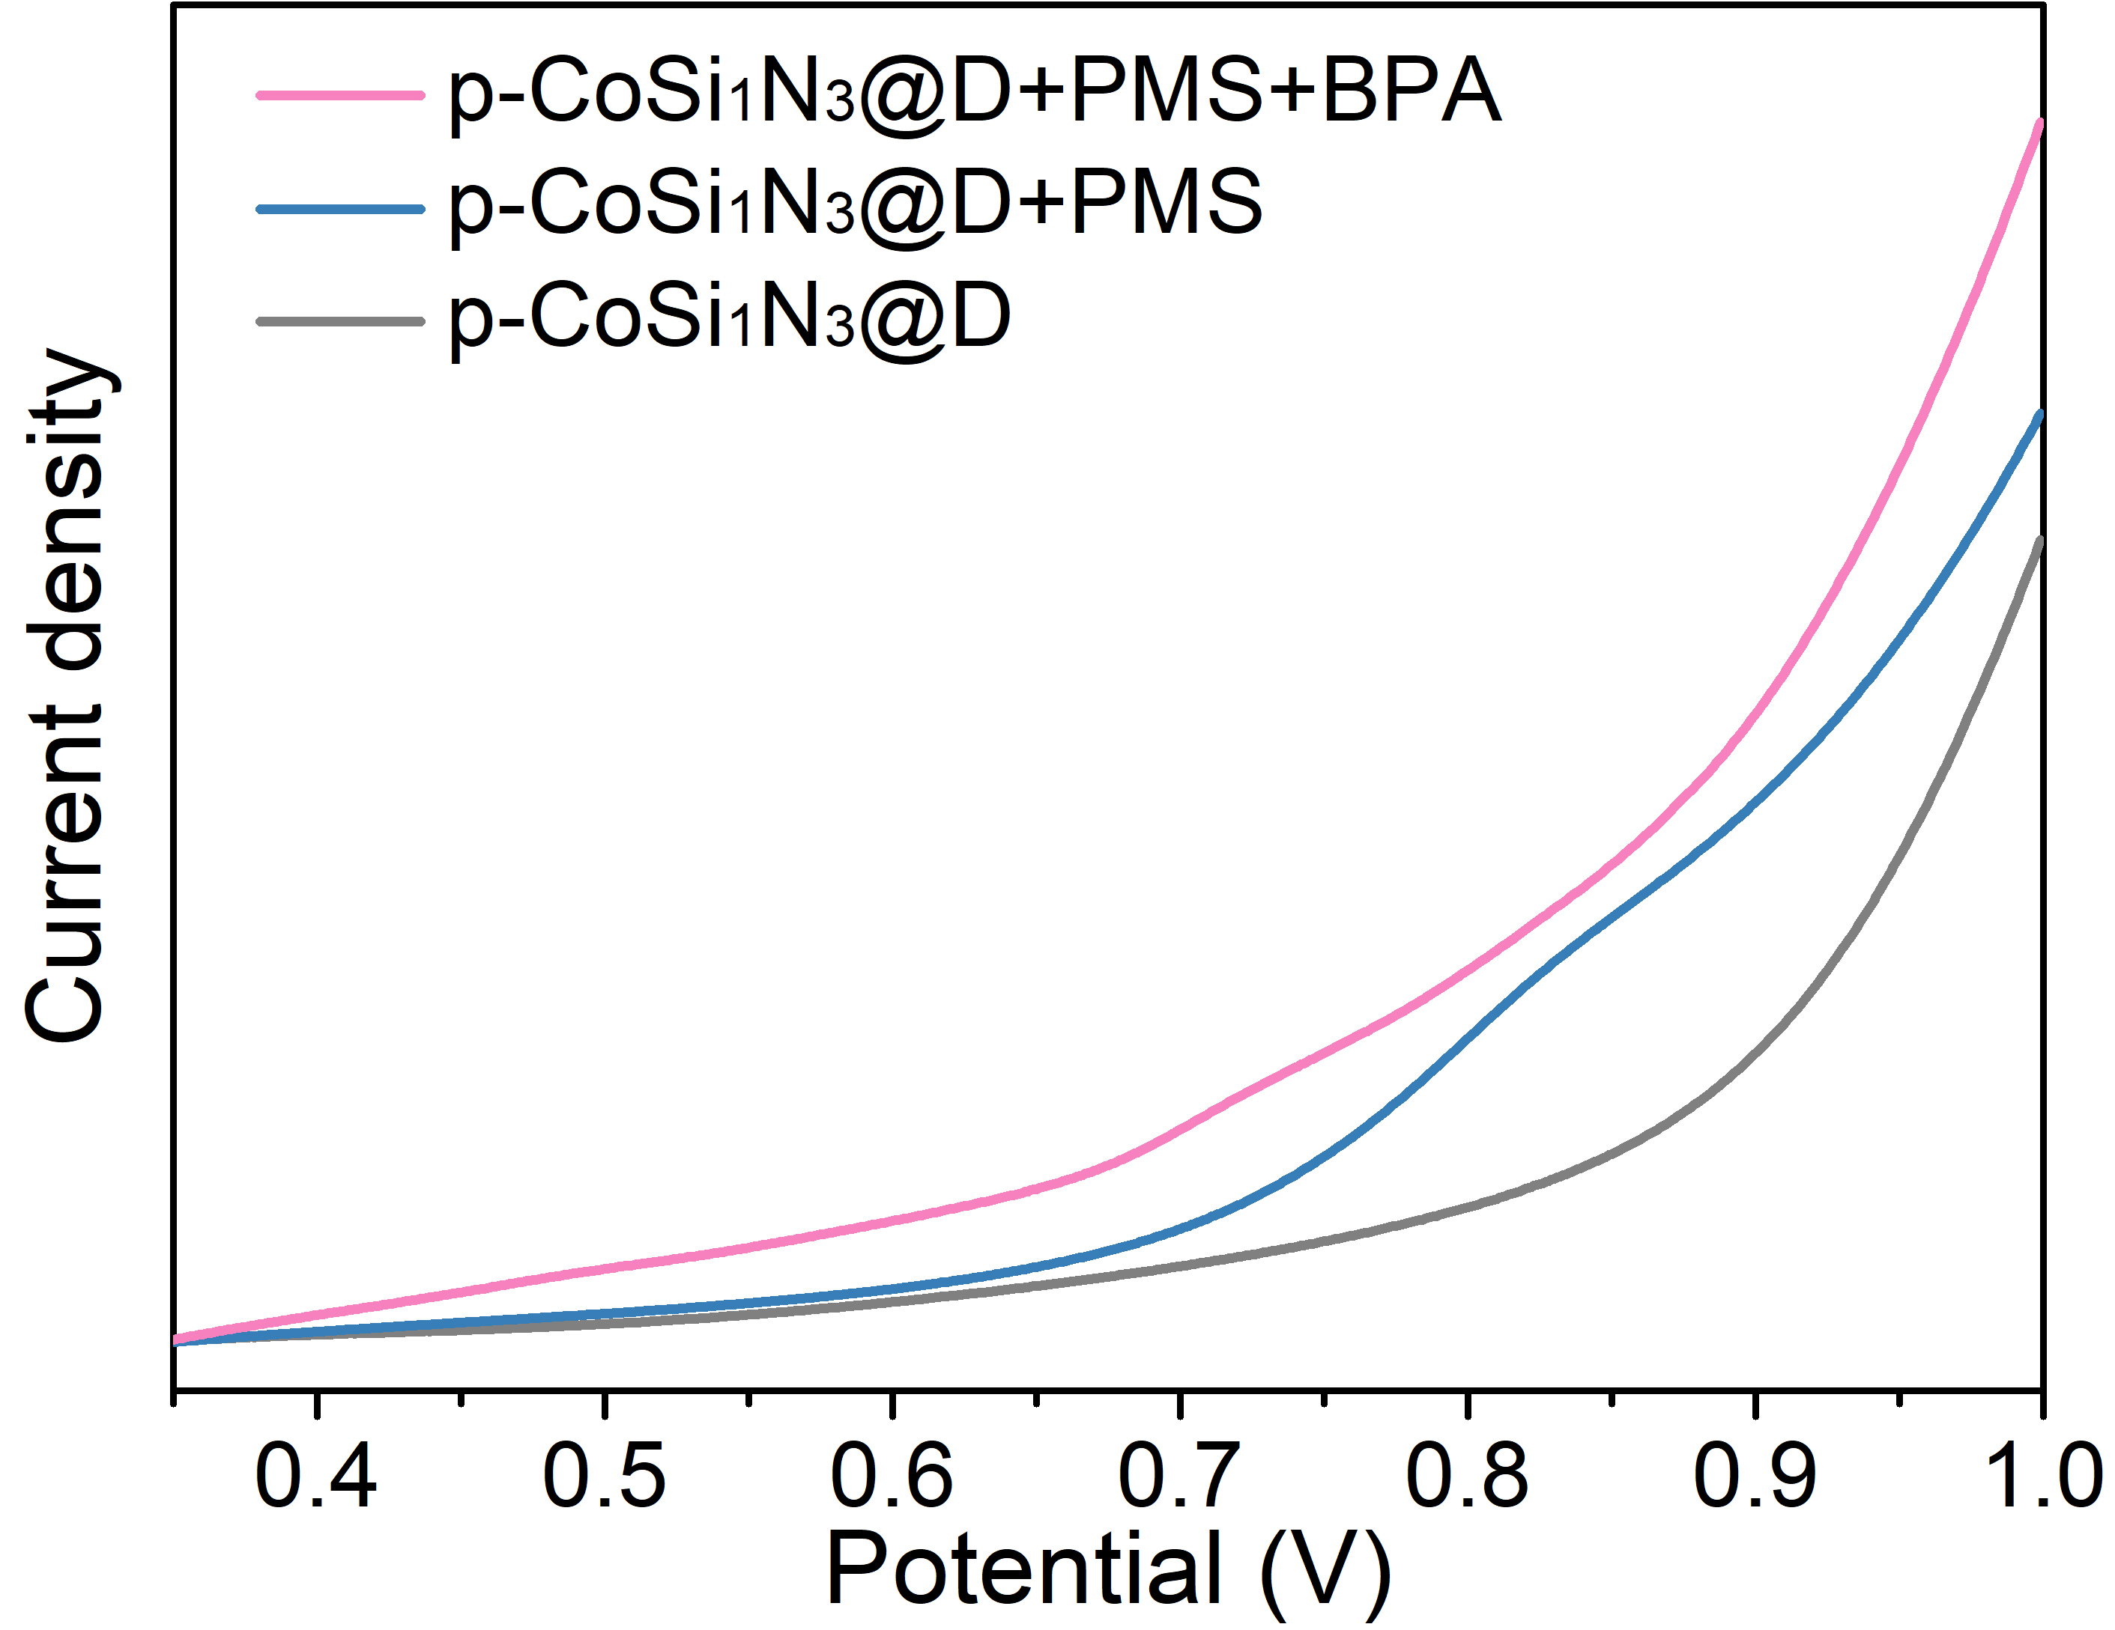
Supplementary Figure 27. Linear-sweep voltammograms of p-CoSi₁N₃@D under different conditions.
The process of electron transfer is regarded as the essence of nonradical pathway^{13,14}. The specific electron transfer process included two steps: (i) PMS activation caused by the electron transfer between PMS and catalysts results in the generation of metastable M^{n+}-(HO)OSO₃ˉ complex. (ii) Driven by the basal redox potential differences, the electron transfer from BPA molecule to metastable M^{n+}-(HO)OSO₃ˉ complex further contributes to its decomposition^{13,14}. To identify above electron transfer process in p-CoSi₁N₃@D/PMS system, the electrochemical measurements were carried out (Supplementary Fig. 24). Comparing the linear sweep voltammogram (LSV) recorded upon 0.25 M Na₂SO₄ electrolyte, obviously increased cathodic current densities were detected with the injection of 0.4 mM PMS. This fact confirms the PMS activation by p-CoSi₁N₃@D and the fast generation of metastable M^{n+}-(HO)OSO₃ˉ complex^{13,14}. Another increased cathodic current densities with the addition of 20 mg/L BPA further suggests the electron transfer from BPA to M^{n+}-(HO)OSO₃ˉ complex^{13,14}.
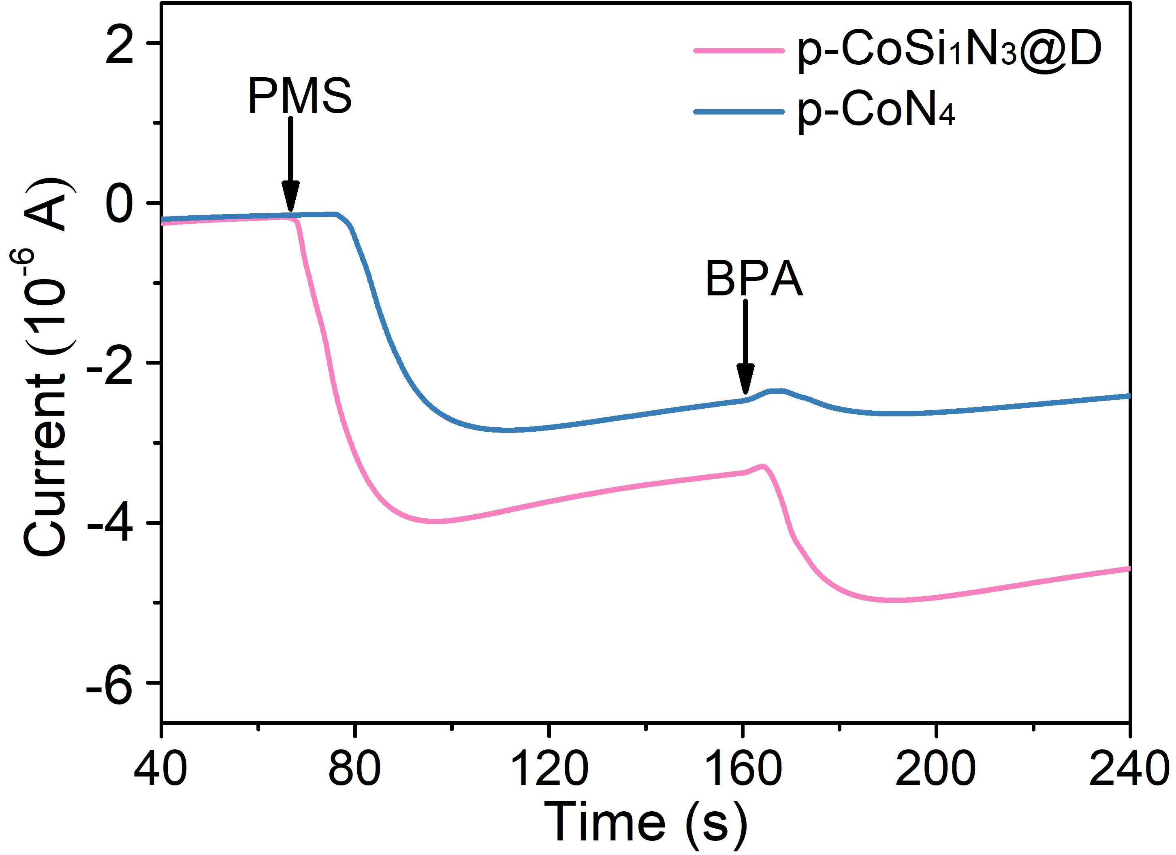
Supplementary Figure 28. Chronoamperometric curves of p-CoSi₁N₃@D and p-CoN₄ under different conditions.
For p-CoSi₁N₃@D or p-CoN₄, the abrupt changes of current density were observed with the addition of PMS or BPA. This phenomenon is ascribed to the electron transfer between catalysts, PMS, and BPA molecules. On the other hand, the much higher current density in the chronoamperometric curve of p-CoSi₁N₃@D (compared with p-CoN₄) reveals that the introduction of Si atom into CoN₄ moieties significantly enhances the electron transfer efficiency (Supplementary Fig. 26)¹³.
Supplementary Table 1. Comparison of PMS activation performance of p-CoN₃Si₁@D with previously reported metal SACs.
Catalyst | Metal loading | Contaminants |  | Catalyst dosage | PMS dosage | Removal (%) | Removal time | Ref
Catalyst | Metal loading | Type | Concentration
Co-TPML | 0.04 wt% | BPA | 11 mg/L | 0.20 g/L | 1.23 g/L | 100% | 5 min | [1]
SA Co-MXene | 1.30 at% | 2, 4-DCP | 0.8 mg/L | 0.05 g/L | 1.23 g/L | 99% | 40 s | [15]
SA Co-N/C | 2.45 wt% | BPA | 10 mg/L | 0.05 g/L | 0.31 g/L | 100% | 15 min | [16]
Co-SA | — | CIP | 20 mg/L | 0.20 g/L | 0.30 g/L | 100% | 40 min | [17]
CoCN | 16.87 wt% | BPA | 20 mg/L | 0.10 g/L | 0.20 g/L | 100% | 9 min | [18]
Co-N-C | 0.45 at% | 2, 4-DCP | 0.8 mg/L | 0.005 g /L | 0.12 g/L | 100% | 30 min | [19]
Co-SAs | 0.80 at% | BPA | 200 mg/L | 0.20 g/L | 0.40 g/L | 82% | 12 min | [20]
Co-N-PCs | 5.90 wt% | BPA | 20 mg/L | 0.05 g/L | 0.98 g/L | 100% | 20 min | [21]
SAFeCo@NC | 8.90 wt% | BPA | 20 mg/L | 0.10 g/L | 0.20 g/L | 100% | 4 min | [10]
FeSA-N/C | 0.88 wt% | BPA | 20 mg/L | 0.15 g/L | 0.40 g/L | 100% | 20 min | [22]
Fe_{SA}-N-CNT | 5.81 wt% | BPA | 11 mg/L | 0.02 g/L | 0.25 g/L | 100% | 60 min | [23]
Fe-N-C | 0.84 wt% | Paracetamol | 10 mg/L | 0.10 g/L | 0.31 g/L | 100% | 30 min | [24]
Fe_{SA}-N-C | 0.93 wt% | BPA | 20 mg/L | 0.15 g/L | 0.40 g/L | 100% | 15 min | [25]
Fe_{x}Mn_{y}-Fe@NCs | — | ABEE | 20 mg/L | 0.10 g/L | 0.62 g/L | 95% | 6 min | [26]
Fe@COF | 2.14 wt% | Orange II | 20 mg/L | 0.10 g/L | 0.40 g/L | 100% | 45 min | [27]
MnN₄ | — | BPA | 20 mg/L | 0.20 g/L | 0.20 g/L | 100% | 6 min | [28]
Ag/mpg-C₃N₄ | 10.00 wt% | BPA | 20 mg/L | 0.10 g/L | 0.62 g/L | 100% | 60 min | [29]
SA-Cu/rGO | — | SMX | 10 mg/L | 0.10 g/L | 0.40 g/L | 100% | 60 min | [30]
p-CoN₃Si₁@D | 0.05 wt% | BPA | 20 mg/L | 0.02 g/L | 0.31 g/L | 99% | 5 min | This work

Supplementary Table 2. The Co and Si loadings of p-CoN₃Si₁@D and p-CoN₄ determined by inductively coupled plasma mass spectroscopy.
Sample | Constituent (wt %)
Sample | Co | Si
p-CoN₃Si₁@D | 0.05 | 1.12
p-CoN₄ | 0.35 | —
Supplementary Table 3. Surface and structure characterization of p-CoN₄ and p-CoN₃Si₁@D.
Sample | BET surface area  (m²/g) | Pore volume  (cm³/g) | Average pore size  (nm)
Diatomite | 8.1 | 0.028 | 13.846
p-CoN₄ | 199.1 | 0.237 | 4.765
p-CoN₃Si₁@D | 465.5 | 1.158 | 9.949
Supplementary Table 4. Structural parameters extracted from the Co K-edge EXAFS fitting.
Sample | Scattering pair | CN | R (Å) | σ² | R factor
p-CoN₃Si₁@D | Co‒N | 2.8 | 1.86 | 2.8 | 0.007
p-CoN₃Si₁@D | Co‒Si | 1.3 | 2.25 | 25.8 | 0.007
Co foil | Co‒Co | 12 | 2.49 | 6.0 | 0.001
CN is the coordination number; R is interatomic distance (the bond length between Co central atoms and surrounding coordination atoms); σ² is Debye-Waller factor (a measure of thermal and static disorder in absorber-scatterer distances); R factor is used to value the goodness of the fitting.
Supplementary Table 5. The Co loadings of fresh and used p-CoN₃Si₁@D determined by inductively coupled plasma mass spectroscopy.
Sample | Constituent
Sample | Co
Fresh p-CoN₃Si₁@D | 0.05 wt%
Used p-CoN₃Si₁@D | 0.04 wt%
Supplementary Table 6. The relevant calculation results of PMS adsorption on p-CoN₄ and p-CoN₃Si₁@D surfaces. The adsorption energy E_{ads}, bond length l_{O‒O} between ‒OH group and ‒SO₄ group.
Models | E_{ads} (eV) | lo‒o (Å)
PMS | — | 1.394
PMS-p-CoN₄ | -3.21 | 1.473
PMS- p-CoN₃Si₁@D | -5.37 | 1.474
Supplementary Table 7. The chemical composition of purified diatomite.
Sample | Constituent (wt %)
Sample | SiO₂ | Al₂O₃ | Na₂O | ZnO | K₂O | CaO | MgO | Fe₂O₃
Purified diatomite | 97.91 | 0.80 | 0.47 | 0.22 | 0.13 | 0.09 | 0.07 | 0.03
Supplementary Table 8. The final pH values in p-CoN₃Si₁@D/PMS systems with the initial pH range from 3 to 10.
Initial pH value | 3 | 4 | 5 | 6 | 7 | 8 | 9 | 10
Final pH value | 2.78 | 3.08 | 3.15 | 3.23 | 3.30 | 3.31 | 3.31 | 3.45

References
1. Chu, C., Yang, J., Zhou, X., Huang, D., Qi, H., Weon, S., et al. Cobalt single atoms on tetrapyridomacrocyclic support for efficient peroxymonosulfate activation. Environmental Science & Technology 55, 1242-1250 (2021).
2. Segall, M., Lindan, P., Probert, M., Pickard, C., Hasnip, P., Clark, S., et al. First-principles simulation: ideas, illustrations and the CASTEP code. Journal of Physics: Condensed Matter 14, 2717 (2002).
3. Perdew, J., Burke, K., Ernzerhof, M. Generalized gradient approximation made simple. Physical Review Letters 77, 3865-3868 (1996).
4. Grimme, S. Semiempirical GGA-type density functional constructed with a long-range dispersion correction. Journal of Computational Chemistry 27, 1787-1799 (2006).
5. Hamann, D., Schlüter, M., Chiang, C. Norm-conserving pseudopotentials. Physical Review Letters 43, 1494-1497 (1979).
6. Dong, X., Ren, B., Zhang, X., Liu, X., Sun, Z., Li, C., et al. Diatomite supported hierarchical 2D CoNi₃O₄ nanoribbons as highly efficient peroxymonosulfate catalyst for atrazine degradation. Applied Catalysis B: Environmental 272, 118971 (2020).
7. Yang, S., Huang, Z., Wu, P., Li, Y., Dong, X., Li, C., et al. Rapid removal of tetrabromobisphenol A by α-Fe₂O_{3-x}@Graphene@Montmorillonite catalyst with oxygen vacancies through peroxymonosulfate activation: role of halogen and α-hydroxyalkyl radicals. Applied Catalysis B: Environmental 260, 118129 (2020).
8. Chen, W., Zhang, A., Gu, Z., Li, Q. Enhanced degradation of refractory organics in concentrated landfill leachate by Fe₀/H₂O₂ coupled with microwave irradiation. Chemical Engineering Journal 354, 680-691 (2018).
9. Deng, Y., Wei, J., Sun, Z., Zhao, D. Large-pore ordered mesoporous materials templated from non-pluronic amphiphilic block copolymers. Chemical Society Reviews 42, 4054-4070 (2013).
10. Li, X., Huang, X., Xi, S., Miao, S., Ding, J., Cai, W., et al. Single cobalt atoms anchored on porous N-doped graphene with dual reaction sites for efficient Fenton-like catalysis. Journal of the American Chemical Society 140, 12469-12475 (2018).
11. G, Zhai., D, Xu., S, Zhang., Z, Xue., H, Su., Q, Yu., H, Wang., X, Lin., Y, Lin., L, Sun., X, Li., J, Chen. Isoelectric Si heteroatoms as electron traps for N₂ fixation and activation. Advanced Functional Materials 30, 2005779 (2020).
12. Dong, X., Ren, B., Sun, Z., Li, C., Zhang, X., Kong, M., et al. Monodispersed CuFe₂O₄ nanoparticles anchored on natural kaolinite as highly efficient peroxymonosulfate catalyst for bisphenol A degradation. Applied Catalysis B: Environmental 253, 206-217 (2019).
13. Li, X., Wang, J., Duan, X., Li, Y., Fan, X., Zhang, G., et al. Fine-tuning radical/nonradical pathways on graphene by porous engineering and doping strategies. ACS Catalysis 11, 4848-4861 (2021).
14. Zhu, S., Huang, X., Ma, F., Wang, L., Duan, X., Wang, S.. Catalytic removal of aqueous contaminants on N-doped graphitic biochars: Inherent roles of adsorption and nonradical mechanisms. Environmental Science & Technology 52, 8649-8658 (2018).
15. Song, H., Du, R., Wang, Y., Zu, D., Zhou, R., Cai, Y., et al. Anchoring single atom cobalt on two-dimensional MXene for activation of peroxymonosulfate. Applied Catalysis B: Environmental 286, 119898 (2021).
16. Qi, Y., Li, J., Zhang, Y., Cao, Q., Si, Y., Wu, Z., et al. Novel lignin-based single atom catalysts as peroxymonosulfate activator for pollutants degradation: Role of single cobalt and electron transfer pathway. Applied Catalysis B: Environmental 286, 119910 (2021).
17. Mi, X., Wang, P., Xu, S., Su, L., Zhong, H., Wang, H., et al. Almost 100 % Peroxymonosulfate conversion to singlet oxygen on single-atom CoN₂₊₂ Sites. Angewandte Chemie International Edition 60, 4588-4593 (2021).
18. Liu, N., Lu, N., Yu, H., Chen, S., Quan, X. Degradation of aqueous bisphenol A in the CoCN/Vis/PMS system: Catalyst design, reaction kinetic and mechanism analysis. Chemical Engineering Journal 407, 127228 (2021).
19. Xu, H., Jiang, N., Wang, D., Wang, L., Song, Y., Chen, Z., et al. Improving PMS oxidation of organic pollutants by single cobalt atom catalyst through hybrid radical and non-radical pathways. Applied Catalysis B: Environmental 263, 118350 (2020).
20. Gao, Y., Yang, C., Zhou, M., He, C., Cao, S., Long, Y., et al. Transition metal and metal–N_{x} codoped MOF-derived Fenton-like catalysts: A comparative study on single atoms and nanoparticles. Small 16, 2005060 (2020).
21. Wang, G., Nie, X., Ji, X., Quan, X., Chen, S., Wang, H., et al. Enhanced heterogeneous activation of peroxymonosulfate by Co and N codoped porous carbon for degradation of organic pollutants: the synergism between Co and N. Environmental Science: Nano 6, 399-410 (2019).
22. Yang, T., Fan, S., Li, Y., Zhou, Q. Fe-N/C single-atom catalysts with high density of Fe-N_{x} sites toward peroxymonosulfate activation for high-efficient oxidation of bisphenol A: Electron-transfer mechanism. Chemical Engineering Journal 419, 2021: 129590.
23. Qian, K., Chen, H., Li, W., Ao, Z., Wu, Y., Guan, X. Single-atom Fe catalyst outperforms its homogeneous counterpart for activating peroxymonosulfate to achieve effective degradation of organic contaminants. Environmental Science & Technology, 2021. doi.org/10.1021/acs.est.0c08805
24. Peng, L., Duan, X., Shang, Y., Gao, B., Xu, X. Engineered carbon supported single iron atom sites and iron clusters from Fe-rich enteromorpha for Fenton-like reactions via nonradical pathways. Applied Catalysis B: Environmental 287, 119963 (2021).
25. Li, Y., Yang, T., Qiu, S., Lin, W., Yan, J., Fan, S., et al. Uniform N-coordinated single-atomic iron sites dispersed in porous carbon framework to activate PMS for efficient BPA degradation via high-valent iron-oxo species. Chemical Engineering Journal 389, 124382 (2020).
26. Huang, Z., Wu, P., Liu, C., Chen, M., Yang, S., Dang, Z., et al. Multiple catalytic reaction sites induced non-radical/radical pathway with graphene layers encapsulated Fe-NC toward highly efficient peroxymonosulfate (PMS) activation. Chemical Engineering Journal 413, 2020: 127507.
27. Yao, Y., Yin, H., Gao, M., Hu, Y., Hu, H., Yu, M., et al. Electronic structure modulation of covalent organic frameworks by single-atom Fe doping for enhanced oxidation of aqueous contaminants. Chemical Engineering Science 209, 115211 (2019).
28. Yang, J., Zeng, D., Zhang, Q., Cui, R., Hassan, M., Dong, L., et al. Single Mn atom anchored on N-doped porous carbon as highly efficient Fenton-like catalyst for the degradation of organic contaminants. Applied Catalysis B: Environmental 279, 119363 (2020).
29. Wang, Y., Zhao, X., Cao, D., Wang, Y., Zhu, Y. Peroxymonosulfate enhanced visible light photocatalytic degradation bisphenol A by single-atom dispersed Ag mesoporous g-C₃N₄ hybrid. Applied Catalysis B: Environmental 211, 79-88 (2017).
30. Chen, F., Wu, X., Yang, L., Chen, C., Lin, H., Chen, J. Efficient degradation and mineralization of antibiotics via heterogeneous activation of peroxymonosulfate by using graphene supported single-atom Cu catalyst. Chemical Engineering Journal 394, 124904 (2020).

