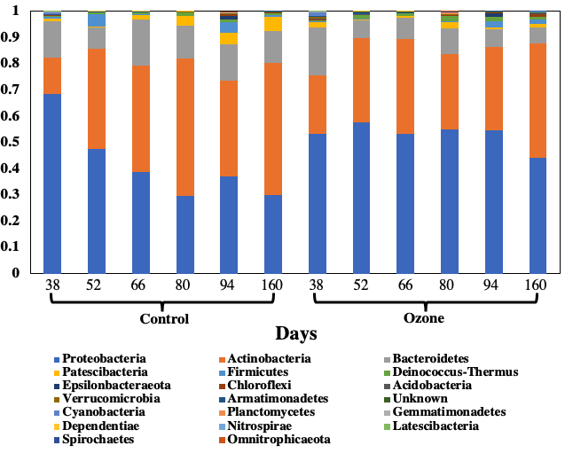

Supp. figure 5a. Microbial community structure at phylum level, phyla of top 20 relative abundance are shown.

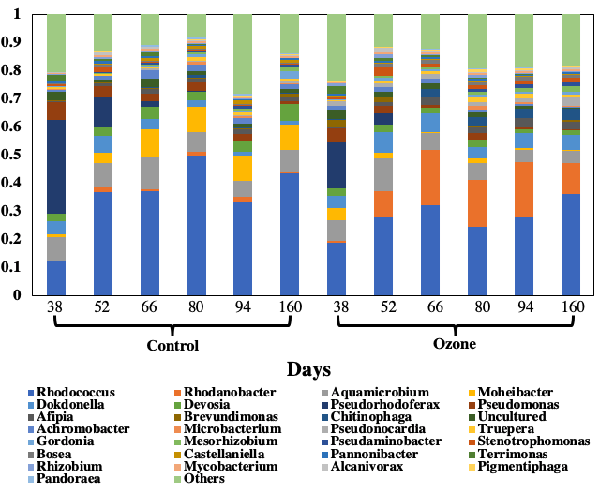

Supp. figure 5b. Microbial community structure at genus level, genera of top 30 relative abundance are shown, others are combined and shown as “others”.

