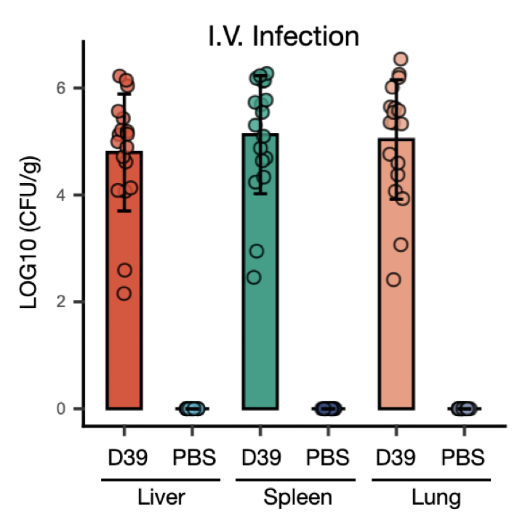
Fig. S1. S. pneumoniae distribution in mice following intravenous infection.
Detection of S. pneumoniae in liver, spleen and lung 24 hours post PBS- or S. pneumoniae D39-nasal administration. n=18.

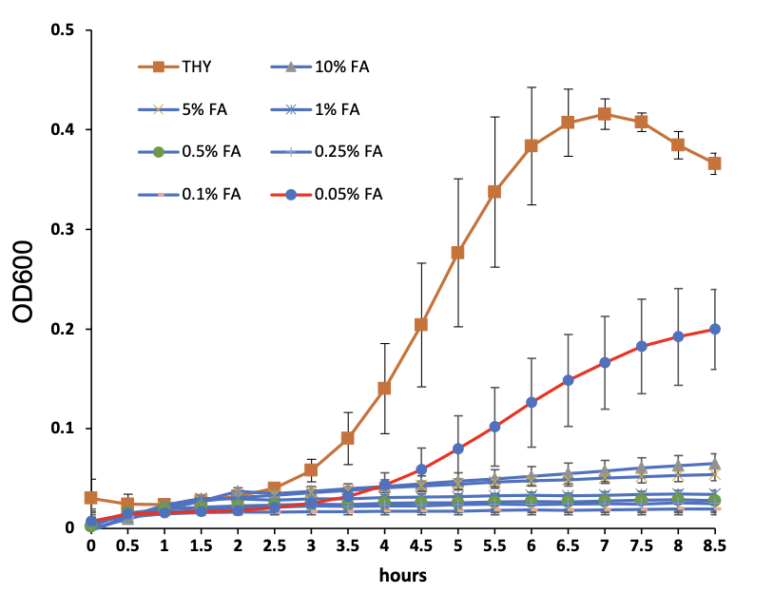
Fig. S2. Growth of S. pneumoniae TIGR4 strain in different concentration of formic acid.
S. pneumoniae TIGR4 strain keeps growing in THY broth containing formic acid (0.05%, v/v)

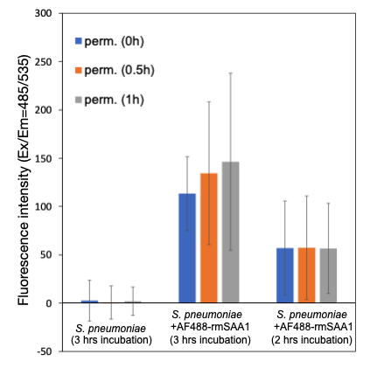
Fig. S3. Fluorescence intensity increased after permeabilization of AF488-rmSAA1 intake S. pneumoniae.
S. pneumoniae TIGR4 cocultured with AF488-rmSAA1 for 3 hours, and then bacterial bodies were permeabilized with 0.05% Triton X-100, fluorescence intensity increased with the elongtion of permeabilization time. However, the same result was not observed in S. pneumoniae TIGR4 cocultured with AF488-rmSAA1 for 2 hours. Blue bars, before permeabilization; orange bars, permeabilization for 30 minutes, grey bars, permeabilization for 1 hour.

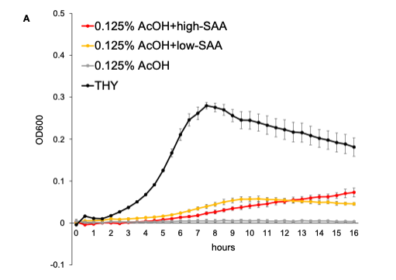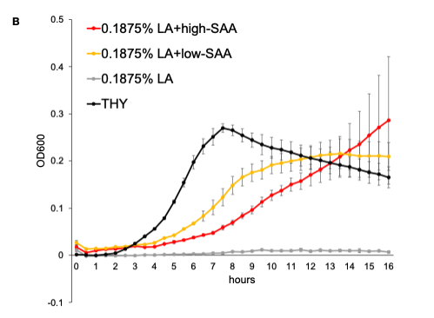
Fig. S4. Growth curve of S. pneumoniae in lethal concentration of acetic and lactic acid with no serum, serum ^{high-SAA1} or serum ^{low-SAA1}.
Minimal effects of SAA1 on S. pneumoniae resistance against acetic and lactic acid. AcOH, acetic acid; LA, lactic acid. Red lines, THY broth containing lethal concentration of acid and 10% serum ^{high-SAA} ; yellow lines, THY broth containing lethal concentration of acid and 10% serum ^{low-SAA}; grey lines, THY broth containing lethal concentration of acid without serum; black lines, THY broth.

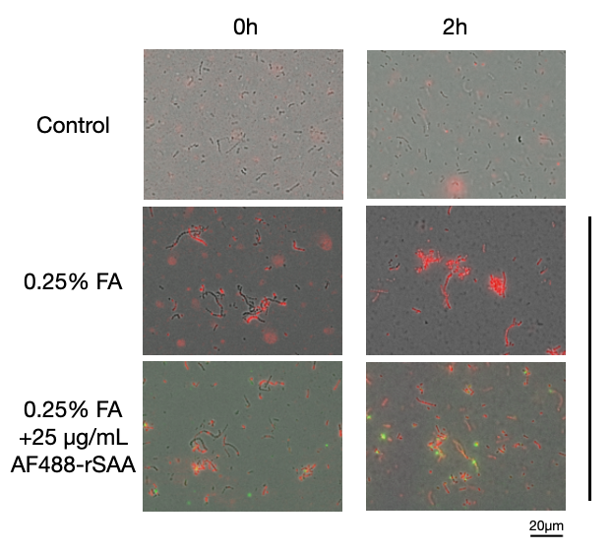
Fig. S5. Intake of SAA1 facilitate S. pneumoniae resistance to formic acid
Fluorescence microscope showed that intake of AF488-rmSAA1 keeps S. pneumoniae alive in lethal concentration of formic acid. Green, AF488-rmSAA1; red, dead bacteria.

Table. S1. Molarity and pH of different concenration (%, v/v) of acetic acid
Acetic acid
% (v/v) | 0.05% | 0.08% | 0.125% | 0.15%
Molarity (mM) | 8.3261 | 13.3218 | 20.8153 | 24.9784
pH | 6 | 5.875 | 5.5 | 4.875
Red, S. pneumoniae D39 remained growing; Black, S. pneumoniae D39 was inhibited.

Table. S2. Molarity and pH of different concenration (%, v/v) of lactic acid
Lactic acid
% (v/v) | 0.10% | 0.125% | 0.1875% | 0.20%
Molarity (mM) | 11.1012 | 13.8766 | 20.8148 | 22.2025
pH | 6.7436335 | 4.625 | 4.875 | 4.375
Red, S. pneumoniae D39 remained growing; Black, S. pneumoniae D39 was inhibited.

Table. S3. Molarity and pH of different concenration (%, v/v) of formic acid
Formic acid
% (v/v) | 0.0250% | 0.05% | 0.075% | 0.10%
Molarity (mM) | 5.4322 | 10.8652 | 16.2937 | 21.725
pH | 7.07674125 | 6.4872235 | 5.375 | 4.625
Red, S. pneumoniae D39 remained growing; Black, S. pneumoniae D39 was inhibited.

