Supplementary appendix

Supplement to: Transmission dynamics of Escherichia coli sequence type 131 amongst community dwelling households – a “One Health” prospective cohort study. Rebecca Lynn Perez, Hao Chung The, Kithalakshmi Vignesvaran et al.

Contents:

1. Sensitivity analysis of persistent carrier status definition 3
2. Hidden Markov Model with varied false negative rate 0 - 20% 5
3. Proportion of E. coli ST131 isolates from all sources (human and non-human) 6
4. Antimicrobial susceptibility for all E. coli ST 131 isolates 7
5. Clinical characteristics of persistent and intermittent carriers 8
6. Patterns of carriage in index patients 9
7. Regression analyses for risk factors associated with E. coli ST131 carriage and persistent carriage 10
8. Methods 11
8.1 Whole genome sequencing 11
8.2 Antibiotic susceptibility testing 11
8.3 Markov-chain Monte Carlo modelling 11
8.4 Phylogenetic analysis 12
8.5 Read mapping 13
8.6 References 14

S1: Sensitivity analysis of persistent carrier status definition, defined by two or three sequential positive stool samples
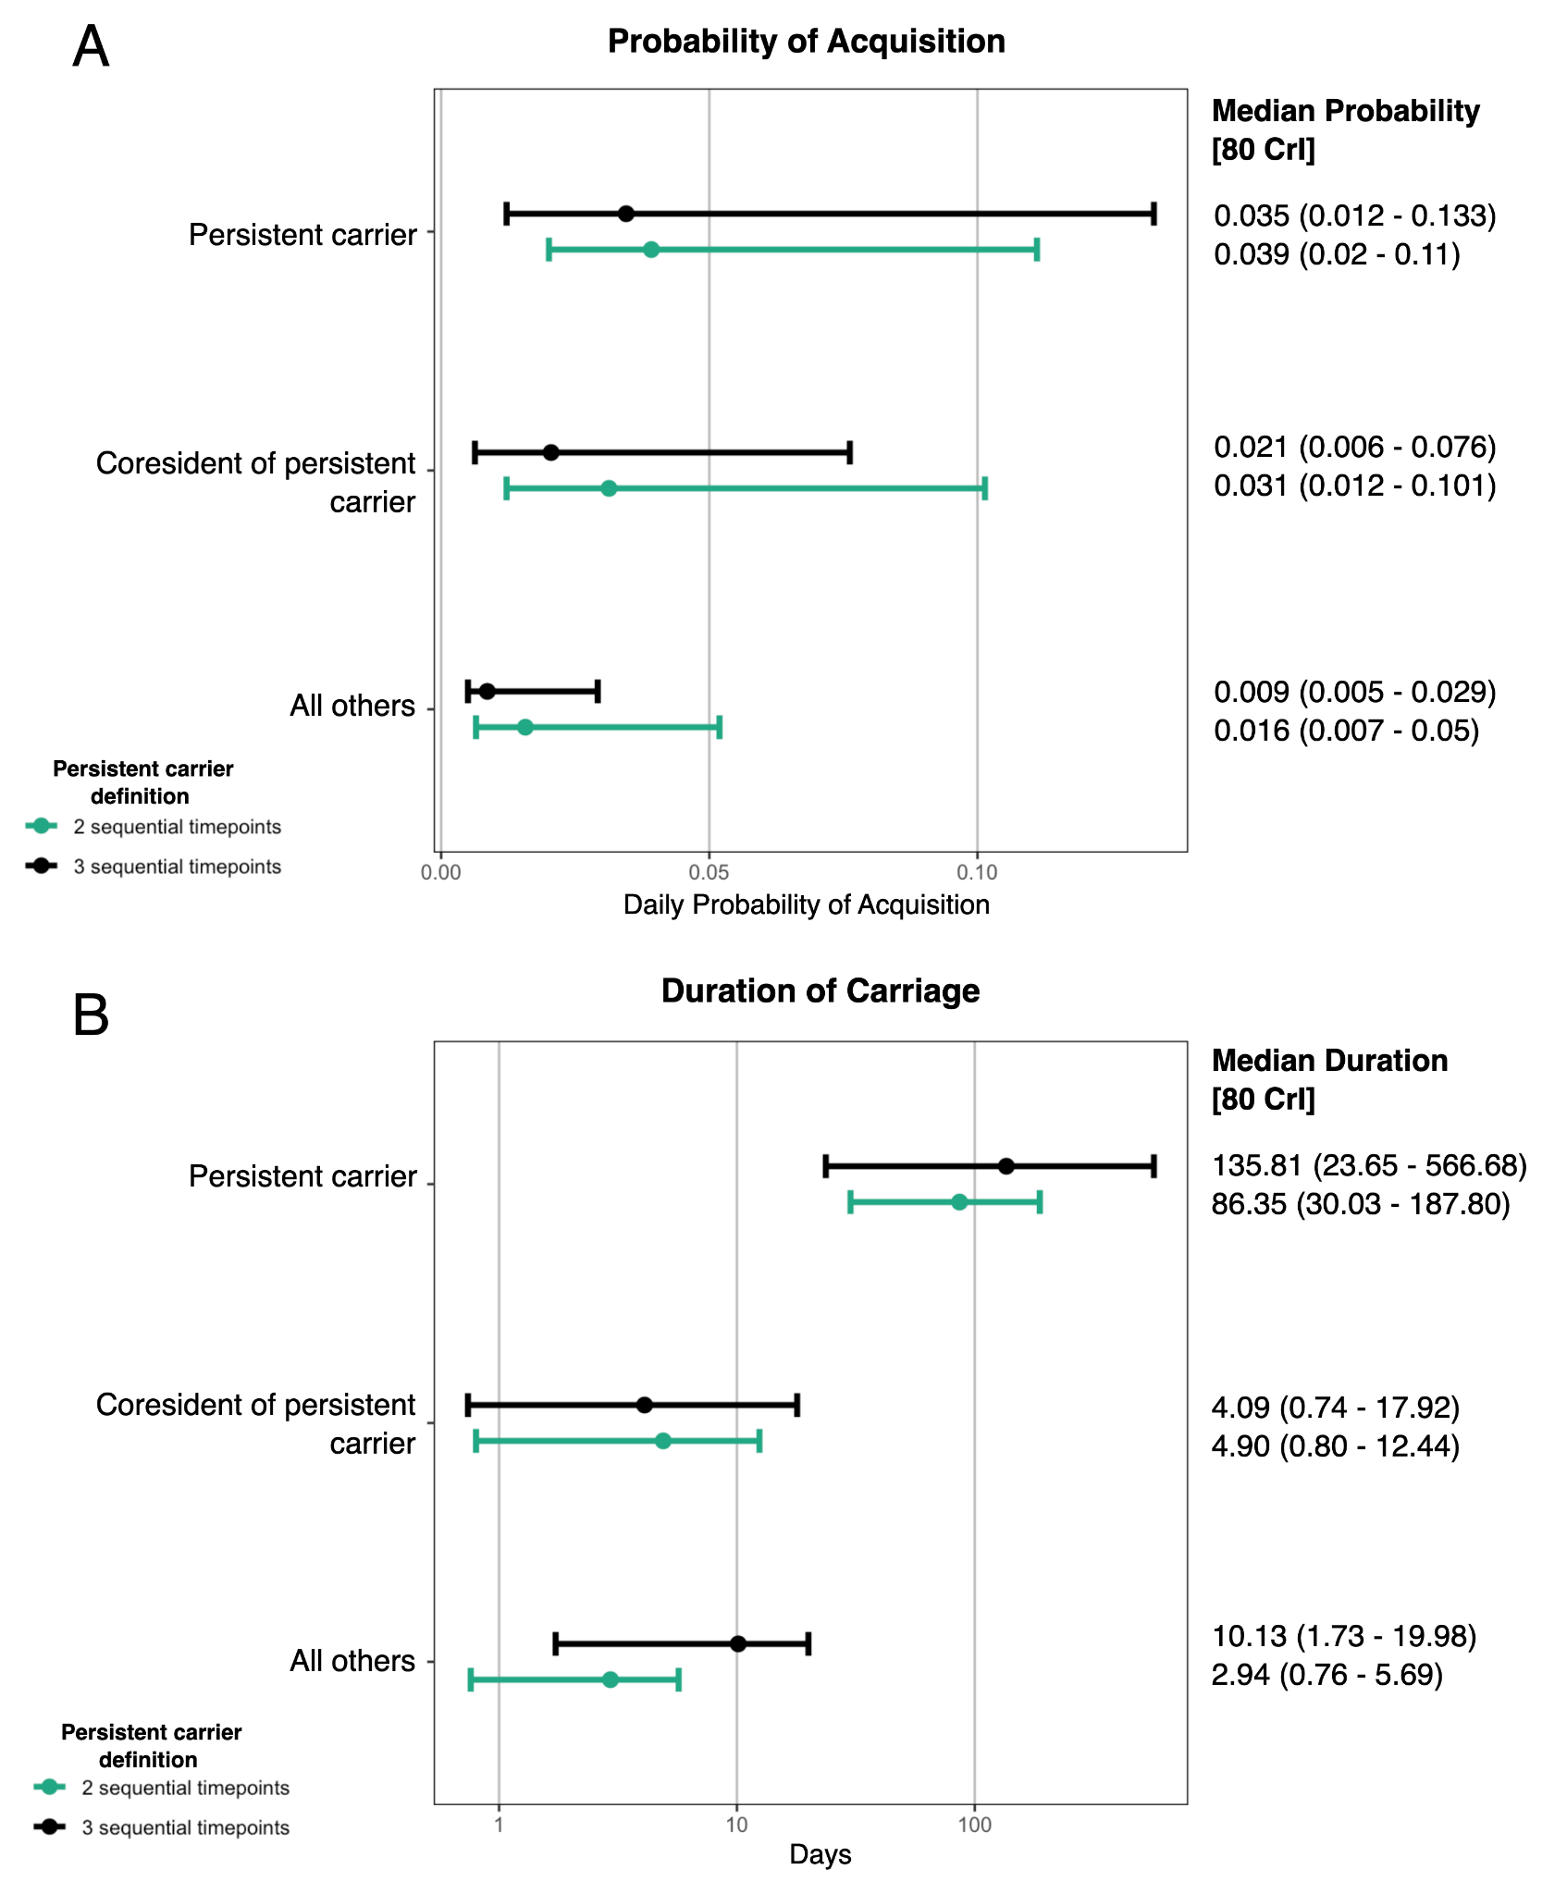
Fig S1 A: MCMC estimates of probability of acquisition of E. coli ST131, their coresidents, and all others
Fig S1 B: MCMC estimates of duration of carriage E. coli ST131 in persistent carriers, their coresidents, and others

To assess the impact of our definition of persistent carriage on our estimates, we compared carriage duration and probability of acquisition estimates for all subgroups under two definitions of persistent carriage, two sequential positives and three sequential positive stool samples. We found that estimates under both definitions were similar, with a high degree of CrI overlap, indicating that results are not significantly influenced by the cutoff point used.

S2: Hidden Markov model estimates of carriage duration with underlying assumption of false negative rates, the proportion of true positive samples that are falsely observed as negative samples, up to 20%
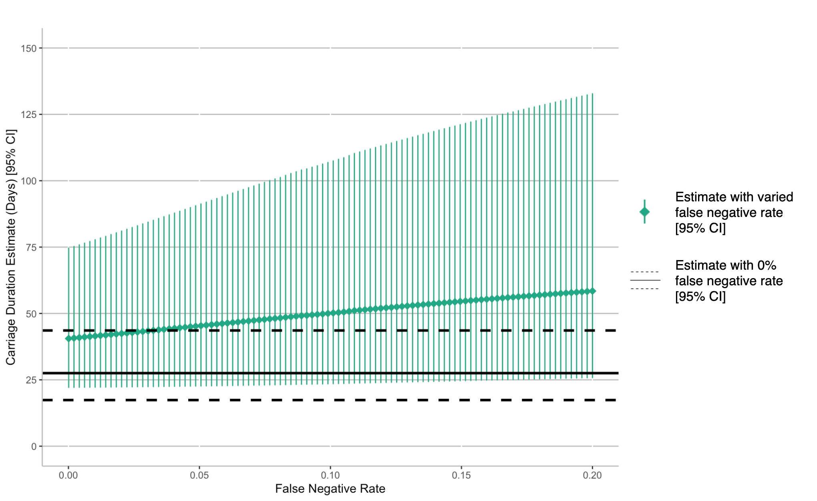

We conducted a sensitivity analysis of the impact of false negative rate, the proportion of true positive samples that are falsely observed as negative samples, on our MCMC estimates of mean E. coli ST131 carriage duration. While estimates of carriage duration do increase as the rate of false negatives increases, estimated carriage duration under the assumption of perfect observation of positives (false negative rate = 0%) continues to fall within the 95% confidence interval generated by estimates made under false negative rates up to 20%, indicating that despite the potential for positive isolates to be missed by qPCR screening, our estimates would still fall within the 95% CI.

S3: Proportion of E. coli ST131, by sample and by isolate, derived from each source (human, domestic animal, environmental, and food)
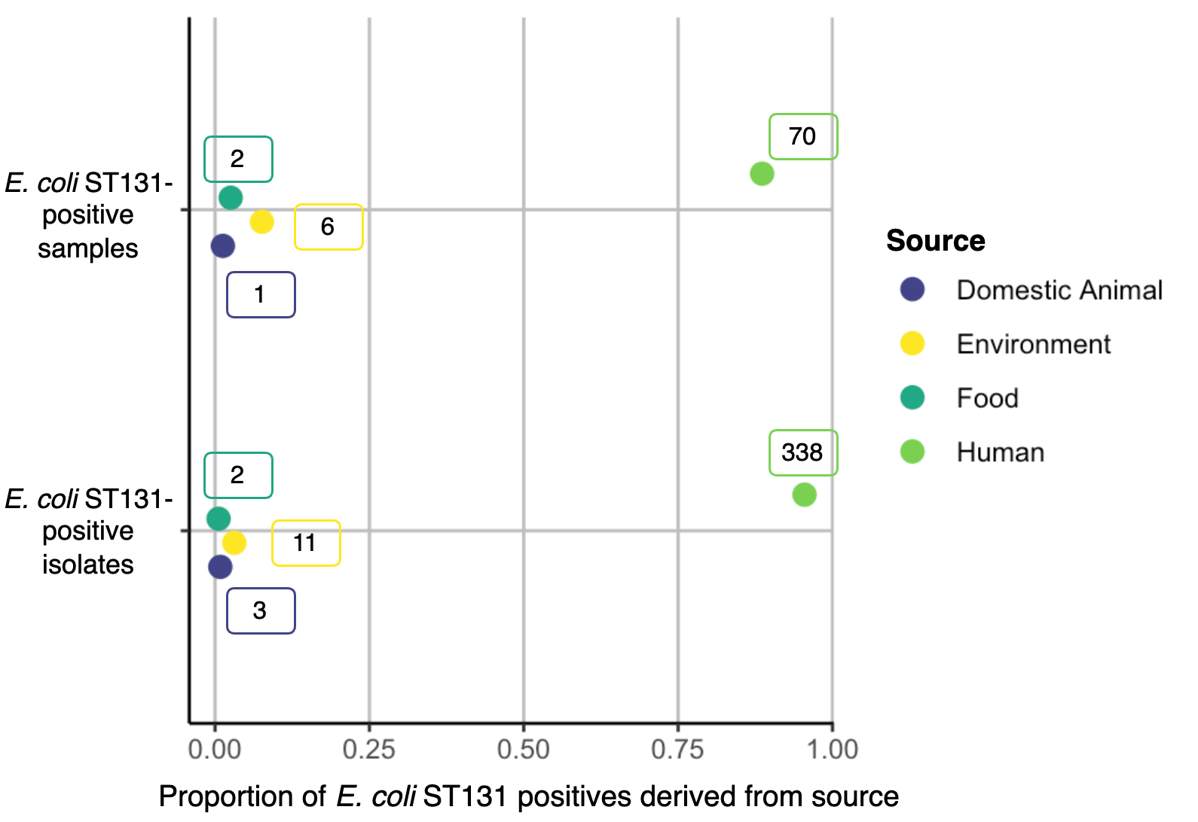

We found that the majority of E. coli ST131 isolates (88·61% of E. coli ST131 positive samples and 95·48% of E. coli ST131 isolates) were obtained from human samples. This indicated that humans, rather than domestic animals, food, or other environmental sources, were primary hosts of E. coli ST131.

S4: Antimicrobial susceptibility for all E. coli ST 131 isolates
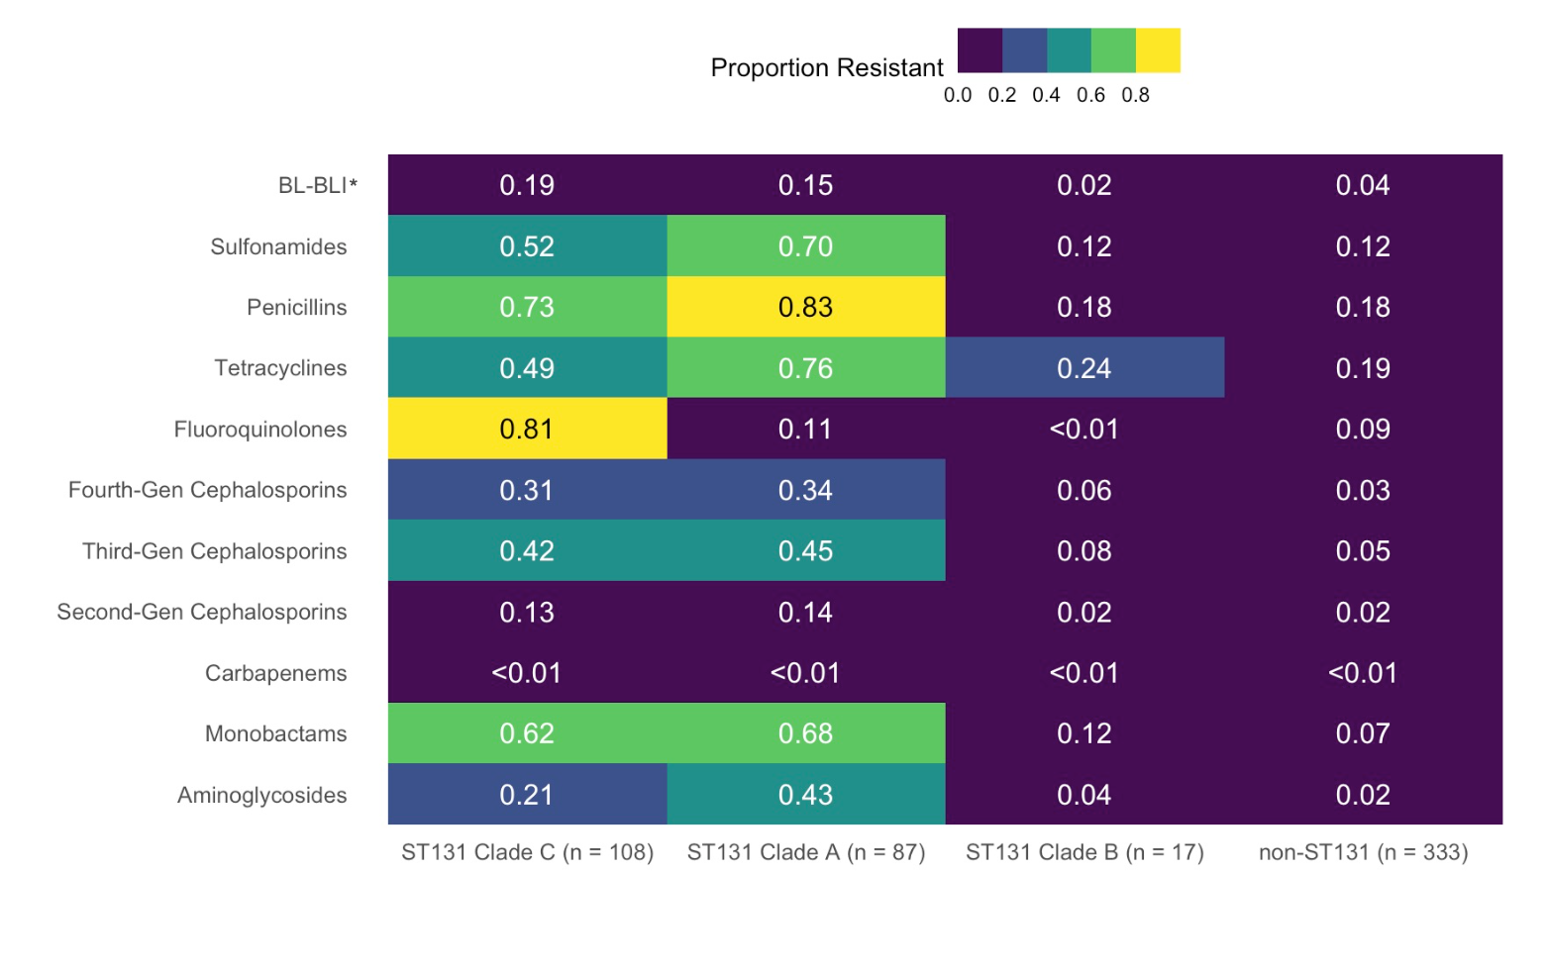
*BL-BLI: β-lactam, β-lactamase inhibitor combination

636 E. coli isolates were tested for susceptibility to 33 antimicrobials. For E. coli ST131, results are reported according to clade. Of 212 E. coli ST131 isolates subjected to antibiotic susceptibility testing, 97 (45.75%) and 86 (40.57%) were resistant to fluoroquinolones and third generation cephalosporins respectively. None were resistant to carbapenems. Clades C (108 isolates) and A (87 isolates) demonstrated higher rates of drug resistance to multiple classes of antibiotics in comparison to non-ST131 E. coli (333 isolates), including monobactams (Clade C: 62.37%, Clade A: 67.82%, non-ST131 E. coli: 7.21%), fourth-generation cephalosporins (Clade C: 31.48%, Clade A: 33.91%, non-ST131 E. coli: 3.45%), sulfonamides (Clade C: 51.85%, Clade A: 70.11%, non-ST131 E. coli: 12.31%), and aminoglycosides (Clade C: 20.68%, Clade A: 42.53%, non-ST131 E. coli: 19.02%). E. coli ST131 Clade C demonstrated significantly higher rates of resistance to fluoroquinolones in comparison to Clade A and non-ST131 E. coli (Clade C: 80.56%, Clade A: 11.49%, non-ST131 E. coli: 9.00%).

S5: Clinical characteristics of persistent carriers and intermittent carriers
 |  | Persistent carriers*  (n = 9) | Intermittent carriers (n = 32) | p-value
Demographics
Sex (%) | Female | 4 (44·44) |  | 0·445
 | Male | 5 (55·55) | 11 (34.38)
Mean age (SD) |  | 49.11 (31.01) | 40.25 (28.05) | 0·418
Children under two years old (%) |  | 2 (22·22) | 4 (12·50) | 0·478
Case index patient |  | 3 (33·33) | 3 (9·38) | 0·076
Chronic disease(s)#(%) |  | 5 (55·55) | 13 (40·63) | 0·677
Incontinent (%) |  | 3 (33·33) | 6 (18·75) | 0·363
Took antibiotics within six months prior to enrolment (%) |  | 3 (33·33) | 13 (40·63) | 0·701
# Chronic diseases included diabetes mellitus, hypertension, ischemic heart disease, cancer and other immunocompromising conditions.
* Persistent carriage status was defined by the presence of at least one E. coli ST131 isolate in at least two consecutive stool samples. Intermittent carriers were all carriers of E. coli ST131 who did not fall into this category
ST: sequence type; SD: standard deviation; IQR: interquartile range.

S6: E. coli sequence type (ST) 131 carriage characteristics for index patients infected with E. coli ST 131 and infected with other E. coli STs.
 | Index patients previously infected with E. coli ST131 (n = 16) | Index patients previously infected with other E. coli STs  (n = 17) | p-value
E. coli ST131 carriers (%) | 6 (37·50) | 6 (35·29) | 0·899
Mean E. coli ST131 density* in positive stool samples (SD) | 0·69 (0·36) | 0·27 (0·23) | 0.007
Median carriage duration# (days) (80% CrI) | 59·71 (33·92-111·83) | 16·968 (3·49-45·52) | ··
#Duration of carriage was estimated with a two-state Markov-chain Monte Carlo model.
*Density was calculated as the proportion of E. coli ST131 amongst all E. coli isolates recovered from each stool sample.
ST: sequence type; SD: standard deviation; CrI: credible interval.

S7. Multivariable and univariable regression analysis for risk factors associated with A) E. coli ST131 carriage and B) E. coli ST131 persistent carriage.
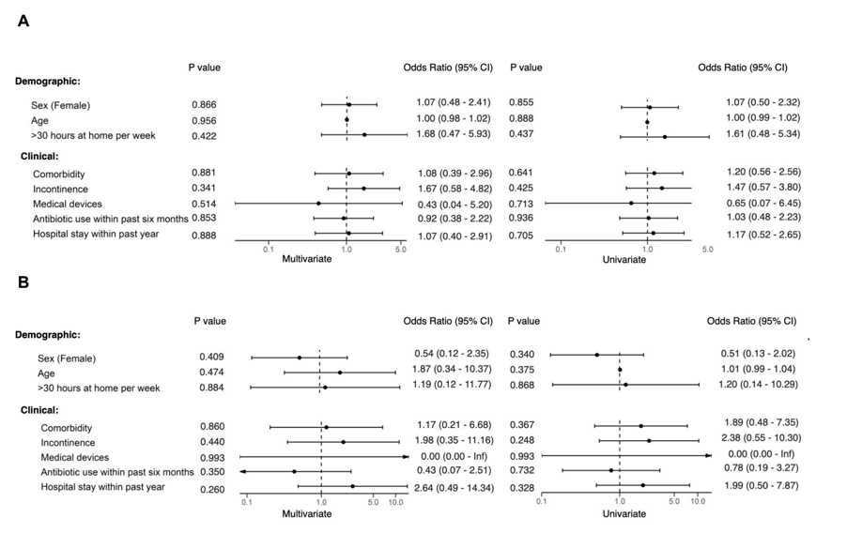

S8 Methods

S8.1 Whole genome sequencing

DNA was extracted using the Wizard Genomic DNA Purification kit (Promega, USA), following manufacturer’s instructions, and then subjected to library preparation using NEBNext Ultra II DNA Library Prep Kit (New England Biolab, USA). Illumina short-read sequencing was performed for all isolates using the NovaSeq 6000 platform, providing 2x150bp paired-end sequence reads. Low quality bases and adaptors in the sequencing reads were removed using Trimmomatic v0.32.¹ The trimmed reads were then assembled using SPAdes (v3.11.1),² and assemblies were subsequently subjected to species identification using Mash Screen (v2.3).³ MLST was determined by searching the assembled genomes using BLASTn against the PubMLST database^{4,5}, showing that 338 sequenced isolates belonged to ST131. E. coli ST131 assemblies were further subjected to ST131Typer to infer the O:H type, fimH allele and clade membership. The presence of antibiotic resistance genes and point mutations in the genomes were identified using AMRFinderPlus (v3.11.18) using its own database (version 2023-04-17.1).⁶

S8.2 Antibiotic susceptibility testing
Antibiotic susceptibility testing was performed on all E. coli ST131 isolates using the broth microdilution method. The minimum inhibitory concentrations (MICs) of 33 antimicrobials were determined by using MicroScan Neg MIC Panel Type 40 (Beckman Coulter, Inc., Brea, CA, USA), in accordance with the manufacturer's instructions. E. coli ATCC 25922 was included as a quality control. The isolates were then classified as susceptible, intermediate, and resistant, based on the interpretation of MIC results in accordance with EUCAST guideline (2015).⁷ As no EUCAST interpretation was available for tetracycline, trimethoprim and cefoxitin, classifications on these antimicrobials followed the CLSI guideline (2013).⁸ The isolates resistant to ceftriaxone were further subjected to double-disk synergy test to confirm ESBL-production using three cephalosporins including ceftriaxone (CRO; 30 μg), ceftazidime (CAZ; 30 μg), and cefotaxime (CTX; 30 μg) (Oxoid, UK), as well as of amoxicillin/clavulanic acid (AMC; 20/10 μg) (Thermo Fisher Scientific, USA).⁹

S8.3 Markov-chain Monte Carlo modelling
The transition from one state to another was governed by an intensity matrix Q (K $×$ K, where K is the number of states, i.e. two). For every individual i, the probability of transition between states was modelled by the equations:
$$log (q_{12}) = β_{0} + \sum_{i = 1}^{D}{}{ β}_{i }× X_{i}$$
$$log (q_{21}) = β_{0} + \sum_{i = 1}^{D}{}{ β}_{i }× X_{i}$$
in which $q_{12}$ and $q_{21}$ represented the probability of transitioning from non-carrier to carrier state and from carrier to non-carrier state, respectively. $β_{i}$ represented the sampling parameter for transition from non-carrier to carrier state, D represents the number of covariates, and $X_{i}$ represents covariate i in set of covariates $X_{1}$, $X_{2}$, ... $X_{D}$.

Models were constructed in Stan to sample for the posterior distribution of the parameters $β_{12}$ and $β_{21}$. From these values, median rate of acquisition of E. coli ST131 per day and median carriage duration (1 / mean rate of transition from carrier to non-carrier state per day) were derived using the above formulae. Model fits were assessed using the Hamiltonian Monte Carlo diagnostics function in RStan,¹⁰ Gelman-Rubin convergence diagnostics, and through the visualisation of trace plots and sample density plots.

S8.4 Phylogenetic analysis

Assembly quality was assessed using assembly-stats v1·0·1, which removed 16 genomes with potential contamination (assembly sizes > 6·4 Mbp and exceeding 5000 contigs) from downstream analyses. For the remaining E. coli ST131 genomes (n=328), Prokka v1·14·6 was used to annotate the assemblies and two ST131 chromosome references (NCTC13441, and EC958). Panaroo v1·5·0 was used for pan-genome analysis, with annotated assemblies serving as input.^{11,12} The inclusion of the two chromosome references was to ensure that the core genes (found in all 330 genomes) did not contain genes from plasmids. This generated a recombination-free core-genome alignment of 3,344,606 bp (3,448 genes). While comparing phylogenetic grouping and family information, we noticed that several genomes (n=8) were interspersed within specific family-restricted phylogenetic clusters. These were usually lone genomes (1 to 2 isolates situated outside their respective family-phylogenetic cluster) and shared 0-1 SNP difference to their nearest sister taxa on the phylogeny (of a different family). We reasoned that this observation most likely stems from mis-labelling of isolates during sample handling and processing, and did not represent true biological interpretation. Therefore, we removed these outlying genomes from downstream analyses to avoid misleading interpretation.

S8.5 Read mapping
For each isolate, read pairs were mapped to the ST131 reference NCTC13441 (accession number: NZ_LT632320.1) using BWA-mem v0.7.17, followed by removal of duplicate reads using PICARD and indel realignment using GATK v3.7.0. Non-optimal local alignment was removed using samclip to limit false positives during variant calling. Single nucleotide polymorphisms (SNPs) were identified using the haplotype-based caller Freebayes v1·3·7, and we used bcftools v1·12 to remove low quality SNPs, which satisfied any of these criteria: consensus quality < 30, mapping quality < 30, read depth < 4, ratio of SNPs to reads at a position (AO/DP) < 85%, coverage of the forward or reverse strand < 1. For each isolate, the bcftools ‘consensus’ command was used to generate a pseudogenome sequence, with length equal to that of the reference and incorporating filtered SNPs as well as invariant sites. Regions with low mapping (depth <4) and low-quality SNPs were masked as N. This procedure produced five alignments (each corresponding to a family). Regions annotated as transposases and prophages (by PHASTEST) were further masked, followed by the removal of sites with at least 80% indeterminate nucleotide and invariable, generating SNP-only alignments of variable lengths. For each alignment, a maximum parsimony phylogeny was constructed using the DNApars algorithm implemented in SEAVIEW v5·0·5, with 100 bootstrap supports.

S8.6 References

1. Bolger, A. M., Lohse, M. & Usadel, B. Trimmomatic: a flexible trimmer for Illumina sequence data. Bioinformatics 30, 2114–2120 (2014).
2. Prjibelski, A., Antipov, D., Meleshko, D., Lapidus, A. & Korobeynikov, A. Using SPAdes De Novo Assembler. CP in Bioinformatics 70, e102 (2020).
3. Ondov, B. D. et al. Mash Screen: high-throughput sequence containment estimation for genome discovery. Genome Biol 20, 232 (2019).
4. Camacho, C. et al. BLAST+: architecture and applications. BMC Bioinformatics 10, 421 (2009).
5. Jolley, K. A., Bray, J. E. & Maiden, M. C. J. Open-access bacterial population genomics: BIGSdb software, the PubMLST.org website and their applications. Wellcome Open Res 3, 124 (2018).
6. Feldgarden, M. et al. AMRFinderPlus and the Reference Gene Catalog facilitate examination of the genomic links among antimicrobial resistance, stress response, and virulence. Sci Rep 11, 12728 (2021).
7. EUCAST. Breakpoint tables for interpretation of MICs and zone diameters, version 5.0. (2015).
8. Cockerill, F. R. Performance Standards for Antimicrobial Susceptibility Testing: Twenty-Third Informational Supplement. (Clinical and Laboratory Standards Institute, Wayne, Pa, 2013).
9. Drieux, L., Brossier, F., Sougakoff, W. & Jarlier, V. Phenotypic detection of extended-spectrum β-lactamase production in Enterobacteriaceae: review and bench guide. Clinical Microbiology and Infection 14, 90–103 (2008).
10. R Interface to Stan • rstan. https://mc-stan.org/rstan/.
11. Page, A. J. et al. Roary: rapid large-scale prokaryote pan genome analysis. Bioinformatics 31, 3691–3693 (2015).
12. Seemann, T. Prokka: rapid prokaryotic genome annotation. Bioinformatics 30, 2068–2069 (2014).

