Regulation of remote sites to enhance Pt activity in the hydrogenation of sulfur-containing nitroarenes

Haitao Chen^{1,3}, Zongpeng Ling^{1,3}, Jie Yu¹, Tao Cheng¹, Jingru Yang¹, Xuefang Zhao¹, Yunuo Chen¹, Xin Liu², Zhenchao Zhao^{1, *}, Qihua Yang^{1,} *
¹ Key Laboratory of the Ministry of Education for Advanced Catalysis Materials, Zhejiang Key Laboratory for Reactive Chemistry on Solid Surfaces, Institute of Physical Chemistry, Zhejiang Normal University, Jinhua 321004, China
² State Key Laboratory of Catalysis, Dalian Institute of Chemical Physics, Chinese Academy of Sciences, 457 Zhongshan Road, Dalian 116023, China
³ These authors contributed equally: Haitao Chen, Zongpeng Ling.
*Corresponding authors. E-mail: zhaoenc@zjnu.edu.cn, qhyang@zjnu.cn

Experimental
Preparation of catalysts
Preparation of MoO₃ modified oxide supports. The xMo-TiO₂ supports were prepared by incipient wetness impregnation, and Mo contents were adjusted to 5 wt%, 10 wt%, 15 wt%, and 20 wt%. Typically, 1 g of TiO₂ (Rutile, 25 nm, from Aladdin Biochemical Technology) was dried in an oven at 100 °C for 8 h. Then, the aqueous solution of (NH₄)₆Mo₇O₂₄.4H₂O dissolved in 800 µL of deionized water was mixed thoroughly with the TiO₂. The mixture was dried at 60 °C for 24 h and then calcined at 550 °C for 4 h. The same procedure was applied to prepare Mo-ZrO₂, Mo-CeO₂, and Mo-SiO₂.

Preparation of nPt/xMo-TiO₂ catalysts. Pt/Mo-TiO₂ and Pt/TiO₂ catalysts were prepared by wet impregnation method with Pt loadings of 0.05 wt%, 0.1 wt%, 1.0 wt%. Typically, 300 mg of Mo-TiO₂ was introduced into 500 µL tetraaminoplatinum nitrate (Pt(II)(NH₃)₄(NO₃)₂) solution with a pH of 3.2, adjusted using acetic acid. Then the mixture was stirred at room temperature for 8 h, subsequently dried at 60 °C for 24 h, followed by calcination in air at 350 °C (2 °C/min) for 4 h. The catalyst was subjected to reduction in a flowing hydrogen atmosphere at 300 °C (5 ºC/min) for 2 h, prior to the activity test.
Pt(C)/Mo-TiO₂ catalysts were prepared by adsorbing pre-synthesized Pt nanoparticles (1-2 nm) based on the method outlined in prior studies.^{1, 2} Typically, 300 mg of Mo/TiO₂ or TiO₂ was dispersed in 10 mL of ethanol and stirred for 30 minutes. Afterward, a Pt nanoparticle solution with specific loadings of 0.05, 0.1, 0.5, 1, or 2 wt% was added and the mixture was stirred for 24 h. Subsequently, the resultant solid was obtained by repeated centrifugation and washing with ethanol before being dried at 70 °C for 12 h.

Characterizations
X-ray diffraction patterns were obtained using a BRUKER D8-Advance X-Ray powder diffractometer equipped with a Cu Kα source, spanning a 2θ range of 5 to 50° at a scan rate of 5°/min. Mo and Pt contents were analyzed with inductively coupled plasma–optical emission spectroscopy (ICP–OES) using a SHIMADZU ICPS‐8100 analyzer. Nitrogen adsorption analyses were carried out using a Micromeritics ASAP 2460 after degassing samples at 200 °C for 5 hours, and the Brunauer-Emmett-Teller (BET) method was applied to calculate the specific surface area. High angle angular dark field-scanning transmission electron microscopy (HAADF-STEM) images were obtained using a JEOL F200 instrument. Raman spectra were recorded using a confocal microscope Raman system (Renishaw InVia), utilizing a 632.8 nm excitation wavelength and a 50x objective with a numerical aperture of 0.55. In situ FTIR spectra of CO adsorption were acquired on a Nicolet iS50 spectrometer with a mercury cadmium telluride (MCT) detector within a transmission cell. Catalysts were pretreated at 150 °C in an H₂ atmosphere, diluted with N₂ (10% H₂, 40 mL/min) for 30 minutes, subsequently cooled to room temperature under N₂ flow (40 mL/min). After recording background spectra, CO flow (5% in N₂, 40 mL/min) was introduced, and excess CO was removed with N₂ flow. XPS spectra were collected using a Thermo Scientific ESCALAB 250Xi, utilizing Al Kα (1486.6 eV) radiation under ultrahigh vacuum (5×10⁻⁷ Pa), with internal calibration via carbon C(1s) (BE = 284.8 eV). H₂-TPR was carried out using BELCAT II catalyst analyzer equipped with a thermal conductivity detector (TCD). About 50 mg of catalyst was placed in a quartz tube and pretreated in a stream of 10% O₂ and 90% N₂ at 30 mL/min at 300 °C for 1 hour to eliminate any adsorbed water and surface carbonates. After cooling down to -40 °C using a CATCryo II unit, a 5% H₂ in Ar mixture (30 mL/min) was introduced, and the sample was then heated from -50 °C to 600 °C at a rate of 10 °C/min.

Catalytic hydrogenation test
For the hydrogenation of 5-nitrobenzothiazole (NBZ), typically, 6 mg NBZ, 6.5 mg catalyst (0.05 wt% Pt) and 3 mL ethanol were combined in a 5 mL ampoule (with a substrate to catalyst ratio S/C = 2000). This ampoule was then placed inside a 300 mL stainless steel autoclave equipped with a thermocouple detector, which had been preheated at 80 °C for 30 minutes. The autoclave was purged six times with hydrogen, and the pressure was adjusted to 2 MPa. The reaction began under vigorous stirring. Upon completion of the reaction, the catalyst was filtered out using organic syringe filters, while the filtrate was analyzed using an Agilent 8860 B gas chromatograph, fitted with an Agilent DB-1701 capillary column (30 m×250 μm×0.25 μm). Similar steps were applied to other sulfur-containing substrates, with the reaction results being analyzed by gas chromatography-mass spectrometry on a Shimadzu GCMS-OP2010 SE, utilizing a Shimadzu Rtx-5 capillary column (30 m×250 μm×0.25 μm).
The stability of the catalysts for NBZ hydrogenation was evaluated at a high-pressure fixed-bed reactor. Before the reaction, the catalyst powder was pelleted and crashed with 30-60 mesh, and then loaded into the reactor. The solution of NBZ in ethanol (5 mM) was then fed into the reactor as a mobile feed at a given flow rate of 12 mL ⋅ h⁻¹ using a high-pressure pump. Concurrently, high-purity H₂ was fed into the reactor at 4 bar and 80 °C. The effluent from the reactor was sampled for gas chromatography (GC) analysis.

Table S1. Pt and Mo contents measured with ICP-OES and BET surface areas of supported Pt catalysts.
Catalyst | Pt (wt%) | Mo (wt%) | BET (m²/g)
0.05Pt/20Mo-TiO₂ | 0.05 | 19.8 | 25
0.05Pt/15Mo-TiO₂ | 0.05 | 15.2 | 25
0.05Pt/10Mo-TiO₂ | 0.05 | 10.1 | 25
0.05Pt/5Mo-TiO₂ | 0.05 | 4.9 | 24
0.05Pt/TiO₂ | 0.04 | - | 33
0.05Pt/MoO₃ | 0.05 | - | 2
0.01Pt/15Mo-TiO₂ | 0.11 | 15.3 | -
0.5Pt/15Mo-TiO₂ | 0.45 | 15.3 | -
1Pt/15Mo-TiO₂ | 1.0 | 15.3 | -

Table S2. Conversion and selectivity of the NBZ hydrogenation reaction of Pt-Mo supported on both reducible and non-reducible oxides, and their BET surface areas.
Catalyst | Conversion (%) | Selectivity (%) | BET (m²/g)
0.1Pt/5Mo-CeO₂ | 3 | >99 | 22
0.1Pt/5Mo-ZrO₂ | 3 | >99 | 14
0.1Pt/5Mo-SiO₂ | 13 | >99 | 209
0.1Pt/5Mo-TiO₂ | >99 | >99 | 25
Reaction conditions: 3 mg catalyst, 0.17 mmol 5-nitrobenzothiazole, 2 mL ethanol, 80 ºC, 2 MPa H₂, 1 h, S/C = 500.

Table S3. The Mo 3d binding energies of Mo with various valences and their corresponding atom percentages.
Catalysts | Mo⁶⁺(eV)(at%) | Mo⁵⁺(eV)(at%) | Mo⁴⁺(eV)(at%) | Mo³⁺(eV)(at%)
1Pt/15Mo-TiO₂ |  | 232.1 (34) | 231.2 (40) | 223.0 (26)
0.05Pt/MoO₃ | 232.0 (34) | 230.8 (46) | 229.8 (20) | -
0.05Pt/20Mo-TiO₂ |  | 231.9 (32) | 230.8 (43) | 229.8 (25)
0.05Pt/15Mo-TiO₂ |  | 232.0 (51) | 231.0 (27) | 299.9 (22)
0.05Pt/10Mo-TiO₂ |  | 232.1 (47) | 231.1 (33) | 230.0 (20)
0.05Pt/5Mo-TiO₂ |  | 232.2 (51) | 231.2 (36) | 230.1 (13)

Table S4. The Pt 4f and O1s binding energies of supported Pt catalysts and atom percentages of hydroxyl groups in total O.
Catalyst | Pt⁰ (eV) | O_{OH} (eV)(at%) | O1s (eV)
0.05Pt/20Mo-TiO₂ | 71.5 | 531.5 (15) | 530.3
0.05Pt/15Mo-TiO₂ | 71.4 | 531.6 (16) | 530.4
0.05Pt/10Mo-TiO₂ | 71.3 | 531.7 (13) | 530.4
0.05Pt/5Mo-TiO₂ | 71.1 | 531.8 (12) | 530.5
0.05Pt/TiO₂ | 70.8 | 532.3 (15) | 530.4
0.05Pt/MoO₃ | 71.6 | 531.7 (57) | 530.9
1Pt/15Mo-TiO₂ | 71.3 | 531.6 (17) | 530.4

Table S5. H₂ consumption (mmol H₂/g) at low temperature (below 200 ºC) and high temperature (above 200 ºC) derived from H₂-TPR by integration of each peak.
Catalyst | Below 200 °C | Above 200 °C
1Pt/15Mo-TiO₂ | 3.7 | 0.2
0.05Pt/MoO₃ | 19.3 | 5.5
0.05Pt/20Mo-TiO₂ | 2.4 | 0.4
0.05Pt/15Mo-TiO₂ | 3.4 | 0.8
0.05Pt/10Mo-TiO₂ | 1.7 | 0.1
0.05Pt/5Mo-TiO₂ | 0.8 | 0
15Mo/TiO₂ | 0 | 1.8

Figure S1. XRD patterns (A) and Raman spectra (B) of 0.05Pt/Mo-TiO₂, 0.05Pt/TiO₂ and 0.05Pt/MoO₃

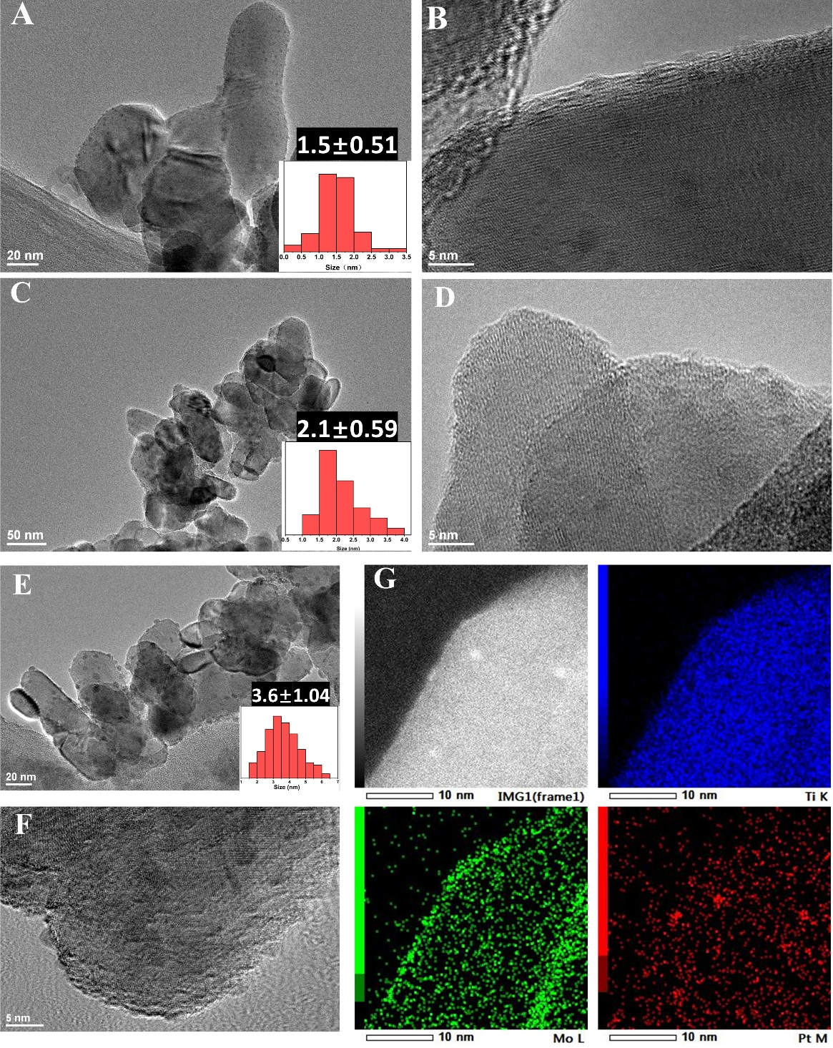

Figure S2. HRTEM images of 0.05Pt/5Mo-TiO₂ (A, B), 0.05Pt/TiO₂ (C, D) and 1Pt/15Mo-TiO₂ (E, F). EDS mapping of 1Pt/15Mo-TiO₂(G).

Figure S3. O1s and Pt 4f XPS spectra of 0.05Pt/xMo-TiO₂ and 0.05Pt/MoO₃.

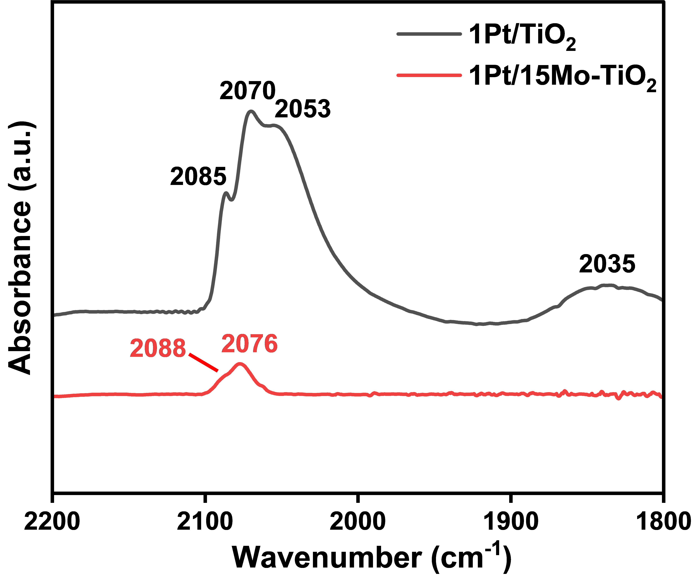
Figure S4. Fourier transform infrared (FTIR) spectra of CO adsorbed 1Pt/15Mo-TiO₂ and 1Pt/TiO₂ catalysts.

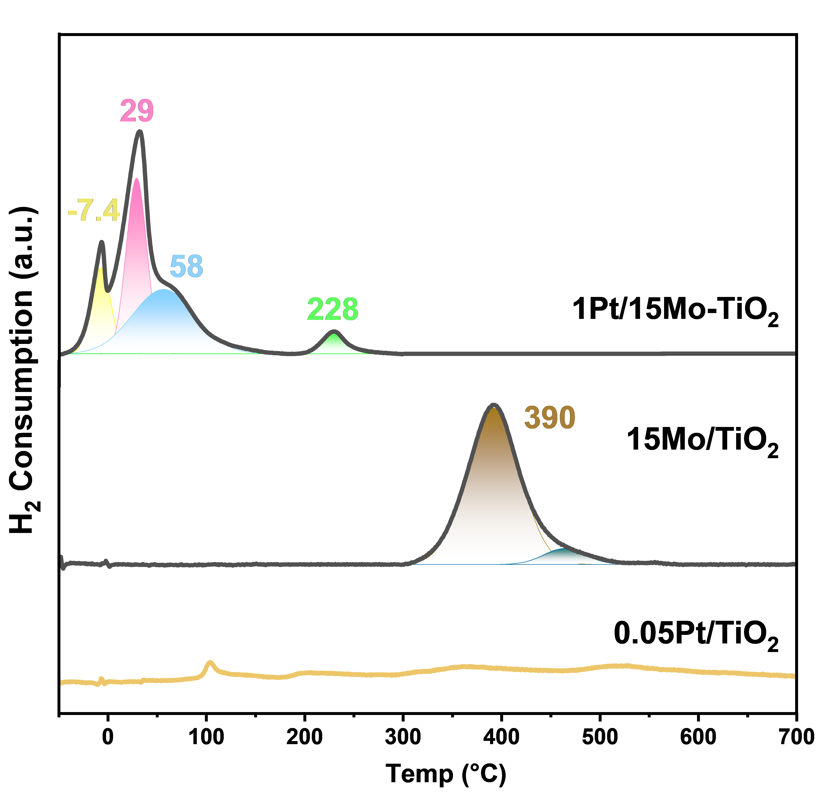
Figure S5. H₂-TPR profiles of 15Mo/TiO₂, 0.05Pt/TiO₂, 1Pt/15Mo-TiO₂ catalysts

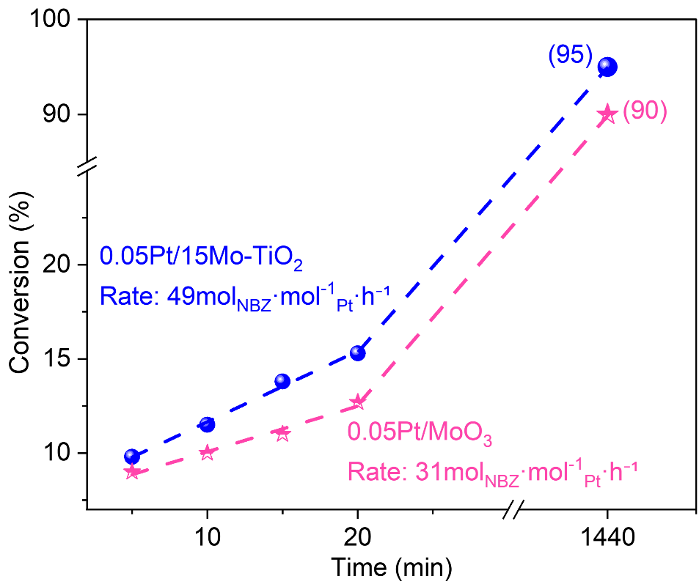
Figure S6. Reaction profiles of H₂ activated 0.05Pt/15Mo-TiO₂ and 0.05Pt/MoO₃ catalysts for NBZ hydrogenation under N₂ condition. Catalysts activated in 2 MPa H₂ at 80 ºC for 2 h, then flushed with N₂ for 5 times. Reaction conditions: 30 mg catalyst, 3 mg 5-Nitrobenzothiazole in 3 mL EtOH, 2 MPa N₂, 80 ºC.

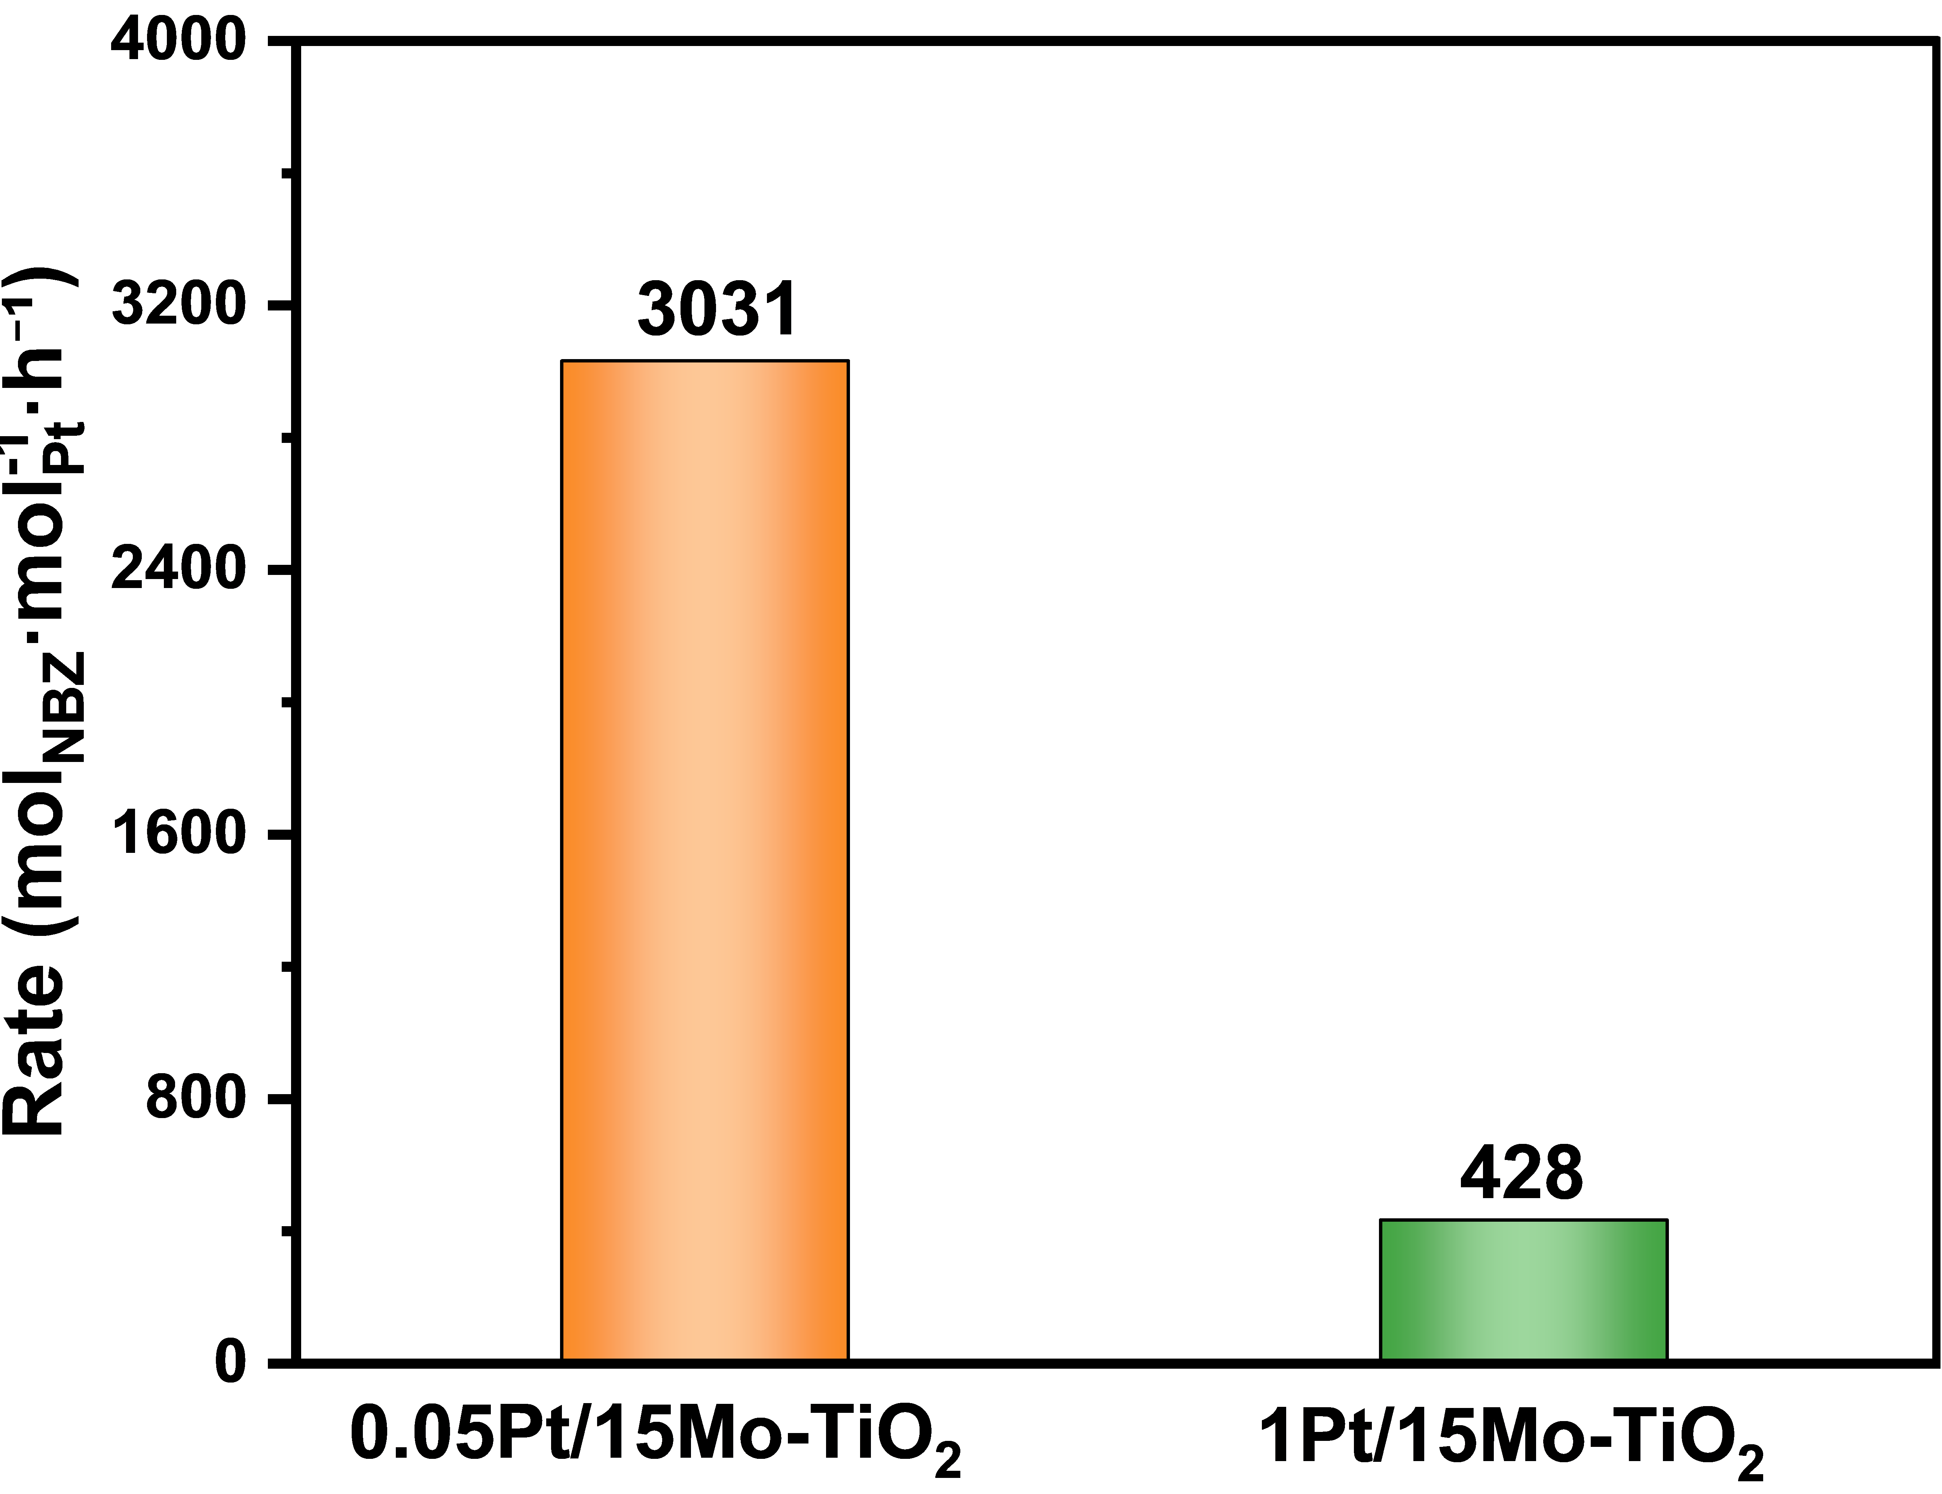
Figure S7. Conversion rate of 0.05Pt/15Mo-TiO₂ and 1Pt/15Mo-TiO₂ with the same catalyst weight. Reaction conditions: 3 mg catalyst, 10 mg 5-nitrobenzothiazole，80 ºC，3 mL ethanol, 2 MPa H₂.

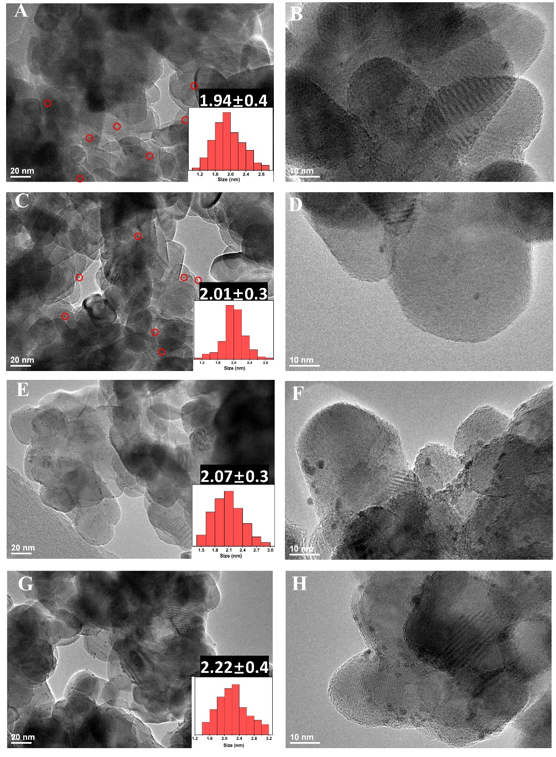
Figure S8. TEM images of xPt(C)/Mo-TiO₂: 0.05Pt(A-B), 0.5Pt(C-D), 1Pt(E-F) and 2Pt(G-H).

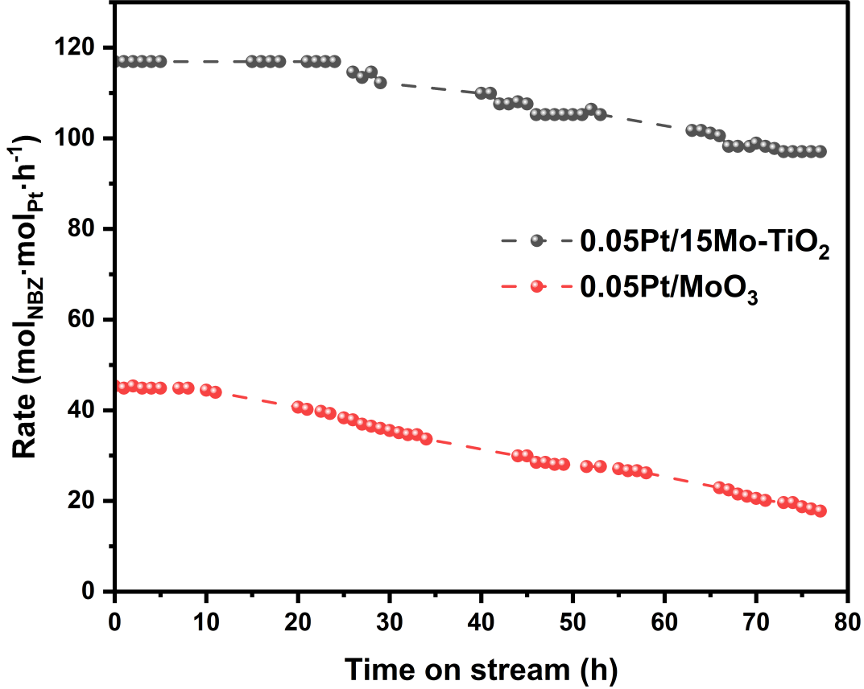

Figure S10. Continuous flow reaction profiles of 0.05Pt/15Mo-TiO₂ and 0.05Pt/MoO₃.
Reaction conditions：200 mg catalysts, 80 ℃, 4 bar H₂, 5 mM 5-nitrobenzothiazole in ethanol with 12 mL⋅h⁻¹ and 6 mL⋅h⁻¹ flow rates for 0.05Pt/15Mo/TiO₂ and 0.05Pt/MoO₃, respectively.

References
(1) Wang, Y.; Ren, J.; Deng, K.; Gui, L.; Tang, Y. Preparation of Tractable Platinum, Rhodium, and Ruthenium Nanoclusters with Small Particle Size in Organic Media. Chem. Mater. 2000, 12 (6), 1622-1627. DOI: 10.1021/cm0000853.
(2) Zhao, Z.; Li, X.; Liu, X.; Gao, H.; Jia, A.; Xie, S.; Song, X.; Liu, X.; Yang, F.; Yang, Q. Pt/Fe-TiO2-Catalyzed Selective Carbonyl Hydrogenation: Fe-Promoted Hydrogen Spillover. ACS Catal. 2024, 14 (7), 4478-4488. DOI: 10.1021/acscatal.3c05478.

