Supplementary Information

Molecule-Probed Raman Spectroscopy for Femtogram-per-Liter Level Per- and Polyfluoroalkyl Substances Detection
Liang Zhao¹, Jiayue Hu², Chenchi Gong¹, Alexis Dyke¹, Han Cao³, Jianlei Wu⁴, Laura G. Bracaglia⁴, Ling Liu²*, Wenqing Xu³*, Bo Li¹*
¹Hybrid Nano-Architectures and Advanced Manufacturing Laboratory, Department of Mechanical Engineering, Villanova University, Villanova, PA 19085, USA.
²Department of Mechanical Engineering, Temple University, Philadelphia, PA 19122, USA.
³Department of Civil and Environmental Engineering, Villanova University, Villanova, PA 19085, USA.
⁴Department of Chemical and Biological Engineering, Villanova University, Villanova, PA 19085, USA.
L.Z. and J.Y.H. contribute equally to this work
*Corresponding author. Email: ling.liu@temple.edu; wenqing.xu@villanova.edu; bo.li@villanova.edu

This file includes:
Materials and methods
Figs. S1-S17
Tables S1-S8
References S1-S77.

Materials and Methods
Materials
Per- and poly-fluoroalkyl substances (PFAS) were directly purchased from vendors and used without further purification. Perfluorooctanoic acid (PFOA, 95%) powder, perfluorooctanesulfonic acid (PFOS, 100 μg/mL in methanol) solution, perfluorobutanoic acid (PFBA, 98%) solution, and perfluorobutanesulfonic acid (PFBS, 97%) solution were purchased from Sigma-Aldrich. Hexafluoropropylene oxide dimer acid (GenX, 90%) solution was purchased from LGC Group. The Polydimethylsiloxane (PDMS) (SYLGARDTM 184) was obtained from Dow Corning Corporation. Sodium chloride (NaCl) (≥99.0%, ACS) and potassium chloride (KCl) (99.0-100.5%, ACS) were purchased from VWR Chemicals BDH. Calcium chloride (CaCl₂) (≥99.0%, dihydrate) was obtained from Fisher BioReagents. Magnesium chloride (MgCl₂) (98%, anhydrous) was purchased from VWR Life Science. Sodium sulfate (Na₂SO₄) (≥99.0%, ACS) and sodium bicarbonate (NaHCO₃) (≥99.7%, ACS) were purchased from Sigma-Aldrich. Deionized (DI) water was obtained from a Mili-Q-plus purification system (Millipore Sigma, USA) (≥18.2 MΩ·cm at 25 °C).
PDMS substrate preparation
The PDMS substrate for PFAS capturing was prepared using the spin-coating method on a SiO₂/Si wafer. The dimethylsiloxane (DMS) monomer and cross-linking agent were mixed in a fixed volume ratio of 10:1. After thorough stirring, the mixture underwent five cycles of degassing in a vacuum chamber. Subsequently, the solution was dropped onto the SiO₂/Si wafer for spin coating. The spin-coating process began with an acceleration speed of 500 rpm/s and reached a spinning speed of 4000 rpm. The overall spin-coating time is 1 minute. Finally, the sample was cured on a hot plate at 100 °C for 5 minutes.
PFAS-spiked solution preparation
0.28 g of PFAS (powder or liquid format) was dissolved in 1000 mL DI water using a polypropylene volumetric flask, yielding a PFAS-spiked solution with a concentration of 2.8 × 10⁻¹ g/L. The solution was agitated in a vortex mixer for 15 minutes and in a sonication bath (40 kHz, 60 W) for 15 minutes to dissolve PFAS. To prepare a diluted PFAS-spiked solution of 2.8 × 10⁻² g/L, 100 mL of the 2.8 × 10⁻¹ g/L PFAS-spiked solution was transferred into another 1000 mL volumetric flask followed by adding 900 mL DI water. Afterward, the diluted solution was agitated in a sonication bath for 15 minutes. This dilution process was repeated to obtain progressively lower concentrations of PFAS-spiked solution down to 2.8 × 10⁻²¹ g/L.
PFAS-adsorbed PDMS substrate preparation
PFAS-spiked DI water solution with a designated concentration was placed in a 50 mL polypropylene tube. The tube was placed in a sonication bath (40 kHz, 60 W) and underwent a 15-minute sonication followed by vortex mixing to ensure homogeneous dispersion of PFAS in the solution. Then the PDMS (on a SiO₂/Si wafer) substrate was submerged in the solution. To ensure a uniform PFAS adsorption on the PDMS surface, the substrate was dipped vertically at approximately 1.5 m/min and the sonication was turned on throughout the PFAS adsorption process. Two adsorption times (t_{adsorption}) were adopted: 10 min and 2 min. In this process, the PDMS substrate was in the solution throughout the entire adsorption time. It is different from a traditional dip coating, where the substrate is withdrawn completely from the solution leading to evaporation-driven deposition ¹. Afterward, the PFAS-adsorbed PDMS (PFAS@PDMS) substrate was removed from the solution and thoroughly rinsed with DI water to eliminate any non-adhered PFAS molecules. The sample was then dried using nitrogen gas.
Roughness determination of PDMS substrates
The roughness (Rq) of spin-coated PDMS on a SiO₂/Si wafer is obtained by atomic force microscopy (AFM) (Park Systems NX10) in a non-contact mode. The Rq is calculated using Gwyddion 2.58 software.
Confocal Raman measurement
The Raman characterizations of both PDMS and PFAS@PDMS substrates were conducted using a Confocal Raman Microscope (CRM, WITec 540alpha300). To ensure the reliability of the measurement and compare the result of the same point, the motorized stage of CRM was used to identify the same point on a PDMS substrate before and after the PFAS adsorption. Three distinct regions (Area: 20 μm × 20 μm) were selected with five points within each region for the measurements. Therefore, for each concentration, at least 15 data points were measured. In a routine measurement, the laser wavelength is fixed to 532 nm (laser power: 3 mW) with an integration time of 10 seconds and an accumulation time of 1. We have also studied the influence of laser power, where the laser power is changed from 0.1 mW to 5 mW as shown in fig. S7, while other parameters remain the same. The enhancement in Raman intensity (R_{E}) was quantitatively assessed using the formula: $R_{E}=(I-I_{0})/I_{0}$, where I and I₀ are the Raman signal intensity of symmetric (or asymmetric) stretching mode of methyl groups on PFAS@PDMS and PDMS.
Limit of detection (LOD) determination
The limit of detection (LOD) of MPRS was calculated according to the concentration corresponding to three-fold water background (R_{E} = 0.6%) in the linear fitting curve. In detail, a linear fitting curve can be obtained with $R_{E}=aLog (C_{PFAS})+b$. The LOD is the concentration corresponding to three-fold water background (blank) in the linear fitting curve of Fig. 2a. When t_{adsorption} = 2 min, a and b are 0.29147 and 4.23837. When t_{adsorption} = 10 min, a and b are 0.66184 and 11.35512.
Liquid chromatography/tandem mass spectrometry (LC-MS/MS)
The analytical method of PFOA was adopted from Gravesen et al. ². All sample cleanup and analysis protocols were conducted in alignment with EPA draft Method 1633.³. Water samples were passed through mixed-mode weak-anion exchange and solid-phase extraction (SPE) cartridges, followed by elution by acetonitrile with 5% ammonium hydroxide. Interfering substances in the extracts were removed by SPE and further cleaned up with powdered activated carbon. The extracts were evaporated under nitrogen gas and reconstituted for PFAS analysis by a Nexera XR liquid chromatography system coupled to aLCMS-8040 mass spectrometer (Shimadzu, MD, USA). The electrospray ionization (ESI) was operated in negative ionization mode under multiple reaction monitoring (MRM). The mobile phases were (A) H₂O 20 mM ammonium acetate buffer and (B) methanol. The sample injection volume was 20 µL, and the flow rate was 0.4 µL/min with oven temperature at 40 °C. Quantitative analysis was performed with LabSoultions software, and MS Information of the compounds analyzed can be found in table S1. Analytical sequences included instrument blanks, instrument sensitivity checks, calibration verification standards, qualitative identification standards, method blanks, ongoing precision and recovery standards, and experimental samples.
Time-of-flight secondary ion mass spectrometry (ToF-SIMS) analysis
ToF-SIMS analyses were performed on an ION-TOF TOF.SIMS 5-100 (ION-TOF USA INC., Chestnut Ridge, NY, USA) instrument at the Surface Analysis Facility, University of Delaware. 30 kV Bi³⁺ was used for analyzing a 200 × 200 μm area at a 512 × 512 pixel density. An electron flood gun was used to neutralize charges build-up following sputter and analysis cycles. Negative secondary ions were collected.
Models and computational methods
The molecular dynamics (MD) model for simulating PFOA adsorption consisted of a PDMS substrate and a liquid environment containing PFOA substances. The simulation box dimensions were 65.99 Å (length) × 65.99 Å (width) × 108.50 Å (height), with periodic boundary conditions applied in all three spatial directions. The amorphous PDMS model contains 20 chains, each with 50 repeating units. The PDMS model underwent energy minimization and relaxation to achieve the desired density with atomistic surface roughness, resulting in a relaxed PDMS substrate approximately 30 Å thick. The PFOA molecule was obtained from the National Center for Biotechnology Information ⁴ and generated using Moltemplate ⁵. The system was filled with 10207 water molecules and 50 PFOA molecules, yielding a PFOA concentration of 0.271 mol/L. For comparative analysis, a control system without PFOA was also constructed. The equilibrium molecular dynamics (EMD) simulations revealed the adsorption configuration of the PFOA molecules on the PDMS substrate, which subsequently served as the initial structure for density functional theory (DFT) calculations. The DFT model contains one PFOA molecule and one adjacent PDMS chain, which are from the EMD results of PFOA adsorption. The model comprised a 20 Å × 20 Å × 40 Å supercell, incorporating a vacuum layer of at least 20 Å to prevent interactions with periodic images. Periodic boundary conditions were consistently applied in the DFT calculations.
Classical MD simulations were performed using the large-scale atomic/molecular massively parallel simulator (LAMMPS) ⁶ to study PFOA adsorption on PDMS substrate. PFOA was modeled using the optimized potentials for liquid simulations all-atom (OPLS-AA) force field ⁷, renowned for accurately describing interactions between adsorbents and PFAS ⁸⁻¹¹. Water molecules were represented using the SPC/E model ¹², known for its effective combination with the OPLS-AA force field to predict solution and transport properties such as diffusion coefficients ¹³. The SHAKE algorithm ^{14,15} was employed to maintain the O-H bond lengths and H-O-H bond angles in water molecules. PDMS was modeled with the explicit-atom Buckingham force field developed by Smith et al., which has shown high accuracy for PDMS interfacial calculations ¹⁶⁻¹⁸. These force fields describe atomic non-bonded interactions considering the Lennard-Jones (LJ) potential and the electrostatic interactions with partial charges, detailed in table S3. The LJ interactions between different atom types were determined using the Lorentz-Berthelot combining rules. A cut-off distance of 10 Å was employed for both the LJ and Coulombic terms. Long-range interactions were handled by the particle-particle particle-mesh (PPPM) algorithm with a precision of 10⁻⁵ ¹⁹. The simulation was carried out under the NPT ensemble at a temperature of 293.15 K, maintained by the Nosé-Hoover thermostat with a damping parameter of 100 fs. The pressure of 1 atm was controlled by the Nosé-Hoover barostat with a damping parameter of 1000 fs. The time step for the simulation was set as 1 fs. Initially, the PDMS-water system was equilibrated over 20 ns to achieve stable configurations. Following equilibration, PFOA molecules were introduced and positioned 20 Å away from the PDMS surface. Subsequently, MD simulations were performed for 30 ns to investigate the adsorption process.
Density functional theory (DFT) calculations (Quantum Ab Initio (AI) Calculations) were conducted to explore the PFOA adsorption mechanisms ^{20,21}, using the plane-wave-based Vienna Ab initio Simulation Package (VASP) ^{22,23}. The generalized gradient approximation (GGA) in the scheme of Perdew-Burke-Ernzerhof (PBE) exchange-correlation functional ²⁴⁻²⁶ was employed to describe the exchange-correlation potential. The projected augmented wave (PAW) method ^{23,27} was used to describe the ionic core-valence interactions. Integration over the Brillouin zone was performed using a 3 × 1 × 1 Monkhorst-Pack (MP) k-mesh ^{28,29}, which was refined to 6 × 2 × 2 k-points for density of states (DOS) calculations. The valence wave functions near the atomic cores were expanded as a linear combination of plane waves, with an energy cutoff of 400 eV. Partial occupancies of the Kohn-Sham orbitals were treated using the Gaussian smearing method with a smearing width of 0.1 eV. For geometry optimization, the conjugate gradient algorithm was used to relax atomic positions until the Hellmann-Feynman forces on each atom were below 0.02 eV/Å. Electronic energy was considered self-consistent when the change in energy between consecutive steps was less than 10⁻⁶ eV. The electronic density of states (DOS) was analyzed using the linear tetrahedron method with Blöchl corrections to determine the partial occupancies for each orbital. Charge density difference was calculated by comparing charge densities before and after PFOA adsorption, i.e., $Δρ=ρ_{PDMS\&PFOA}-ρ_{PDMS}-ρ_{PFOA}$, where $ρ_{PDMS}$ and $ρ_{PFOA}$ are charge densities of the PDMS and PFOA molecules when isolated, while $ρ_{PDMS\&PFOA}$ is charge densities after adsorption.
Surface water collection and analysis
Surface water (SW) was collected using a polypropylene tube from a pool in West Windsor township, New Jersey, USA (40.310326°, -74.644474°). After collection, the SW was stored in refrigerator without further purification before use. A small portion of SW was removed from the PP bottle and passed through nylon syringe filters with a pore size of 0.45 µm (VWR, Radnor, PA) for the analysis of ionic content (i.e., cation and anion), non-purgeable organic carbon (NPOC), and inorganic carbon.
The cation analysis of SW was conducted using High Performance Liquid Chromatography (HPLC, Shidmadzu) coupled with conductivity detector (CDD-10AVP) using a Shodex YS-50 cationic column with 4 mM methanesulfonic acid as a mobile phase. The flow rate and oven temperature were set at 1 mL/min and 40 °C, respectively. After calibrating the SW species using the standard calibration curve (r²>0.995), we reported the cation species listed in Table S5.
The anion analysis of SW was conducted using Shidmadzu HPLC coupled with conductivity detector (CDD-10AVP) using a Shodex SI52 4E anionic column with 3.6 mM sodium carbonate as a mobile phase. The flow rate and oven temperature were set at 0.9 mL/min and 45 °C, respectively. All analyzed anions showed distinctive peaks during analysis, except for HCO₃⁻, which the present concentration is not sensitive enough to be quantified through IC. Although NO₂⁻, Br⁻, NO₃⁻, PO₄³⁻ were also detected in the surface water sample, only Cl⁻ and SO₄²⁻ are quantified shown in Table S6.
The NPOC analysis was performed on a Shimadzu TOC-L machine with combustion temperature of 680 °C using catalytic oxidation method. The generated CO₂ was detected by non-dispersive infrared detection (NDIR) method. The SW was analyzed without dilution, which peak areas were calibrated with a standard curve from 0-50 ppm using a standard TOC solution (potassium hydrogen phthalate). The results are shown in Table S7. The analysis of NPOC standard is for validation of our values, which showed minimum systematic error (<3%). The surface water has 7.3 ± 0.4 ppm of NPOC, which is slightly higher than typical surface water TOC range (3-5 ppm) but still in a rational range ³⁰.
The analysis of inorganic carbon was also performed on a Shimadzu TOC-L machine. The injected samples were firstly undergoing acidification to pH below 3 using 3% of 2N HCl solution. Subsequently, the samples were sufficiently sparged to isolate the CO₂, which was cooled and humidified for NDIR detection. The results are shown in Table S8.
The result of inorganic carbon represents the total carbonate concentration in the surface water system. The pH of the surface water is 7.42, while the HCO₃– concentration is calculated by the following equation:
$$HCO_{3}^{–}=\frac{Ct}{1+\frac{{[H]}^{+}}{Ka1}+\frac{Ka2}{{[H]}^{+}}}$$
which the Ct represents the total concentration of inorganic carbon (325.8 ± 2.1 µM), the [H]⁺ represents the proton concentration (10^{–7.42} M), Ka1 and Ka2 represent the two equilibrium constants for HCO₃– and CO₃^{2–} in carbonate buffer system, which are 6.3 and 10.3, respectively. The activity of ions is assumed to be 1 (ideal solution) for our samples.
The concentration of HCO₃– is calculated to be [HCO₃–] = 306.2 ± 2.3 µM, which accounts for 94% of the total inorganic carbon in the surface water sample. The alkalinity is calculated to be [Alk]₀ = 15.3 ppm as CaCO₃.
Human blood collection and PFOA-spiked blood preparation
Human blood was collected from de-identified umbilical cords and placenta tissue, which were obtained from healthy, consenting donors. The tissue collection process was meticulously carried out according to the approval from both the Villanova Institutional Biosafety Committee (IBC) and Lankenau Institute for Medical Research (Wynewood, PA). Blood samples were taken from donated tissue within 3 hours of cesarean section procedures to ensure the highest quality and integrity of the specimens. The whole blood was collected using sterile tools to prevent any contamination, and then promptly stored at -20 °C to preserve the biological and chemical properties of the blood until it was time for experimentation. When the experiment was ready to be conducted, the stored blood samples were carefully thawed to maintain their integrity.
The PFOA-spiked blood was prepared with known PFOA concentrations of 2.8 × 10⁻⁹ and 2.8 × 10⁻¹ g/L. In detail, 2.8 mg PFOA powder was added into 10 mL stored blood (in a polypropylene tube), followed by agitation in a vortex mixer for 15 minutes and in a sonication bath (40 kHz, 60 W) for 15 minutes, to obtain the 2.8 × 10⁻¹ g/L PFOA-spiked blood sample. For a concentration of 2.8 × 10⁻⁹ g/L PFOA in blood, the stored blood was added to 0.1 ml PFOA solution with a concentration of 2.8 × 10⁻⁷ g/L to obtain a mixed blood sample with a 10 mL volume. The agitation in a vortex mixer for 15 minutes and in a sonication bath (40 kHz, 60 W) for 15 minutes were employed.

Portable Raman measurement
PDMS and PFOA@PDMS samples were conducted using a Portable Raman Microscope (PRM, Anton Paar, Cora 5001). Five random points for each sample were selected for testing. The laser wavelength was set to 532 nm with a laser power of 50 mW, an integration time of 10 seconds, and an accumulation time of 1. The enhancement in Raman intensity (R_{E}) was quantitatively assessed using the formula: $R_{E}=(I-I_{0})/I_{0}$, where I and I₀ are the Raman signal intensity of the symmetric stretching mode of methyl groups on PFOA@PDMS and PDMS.

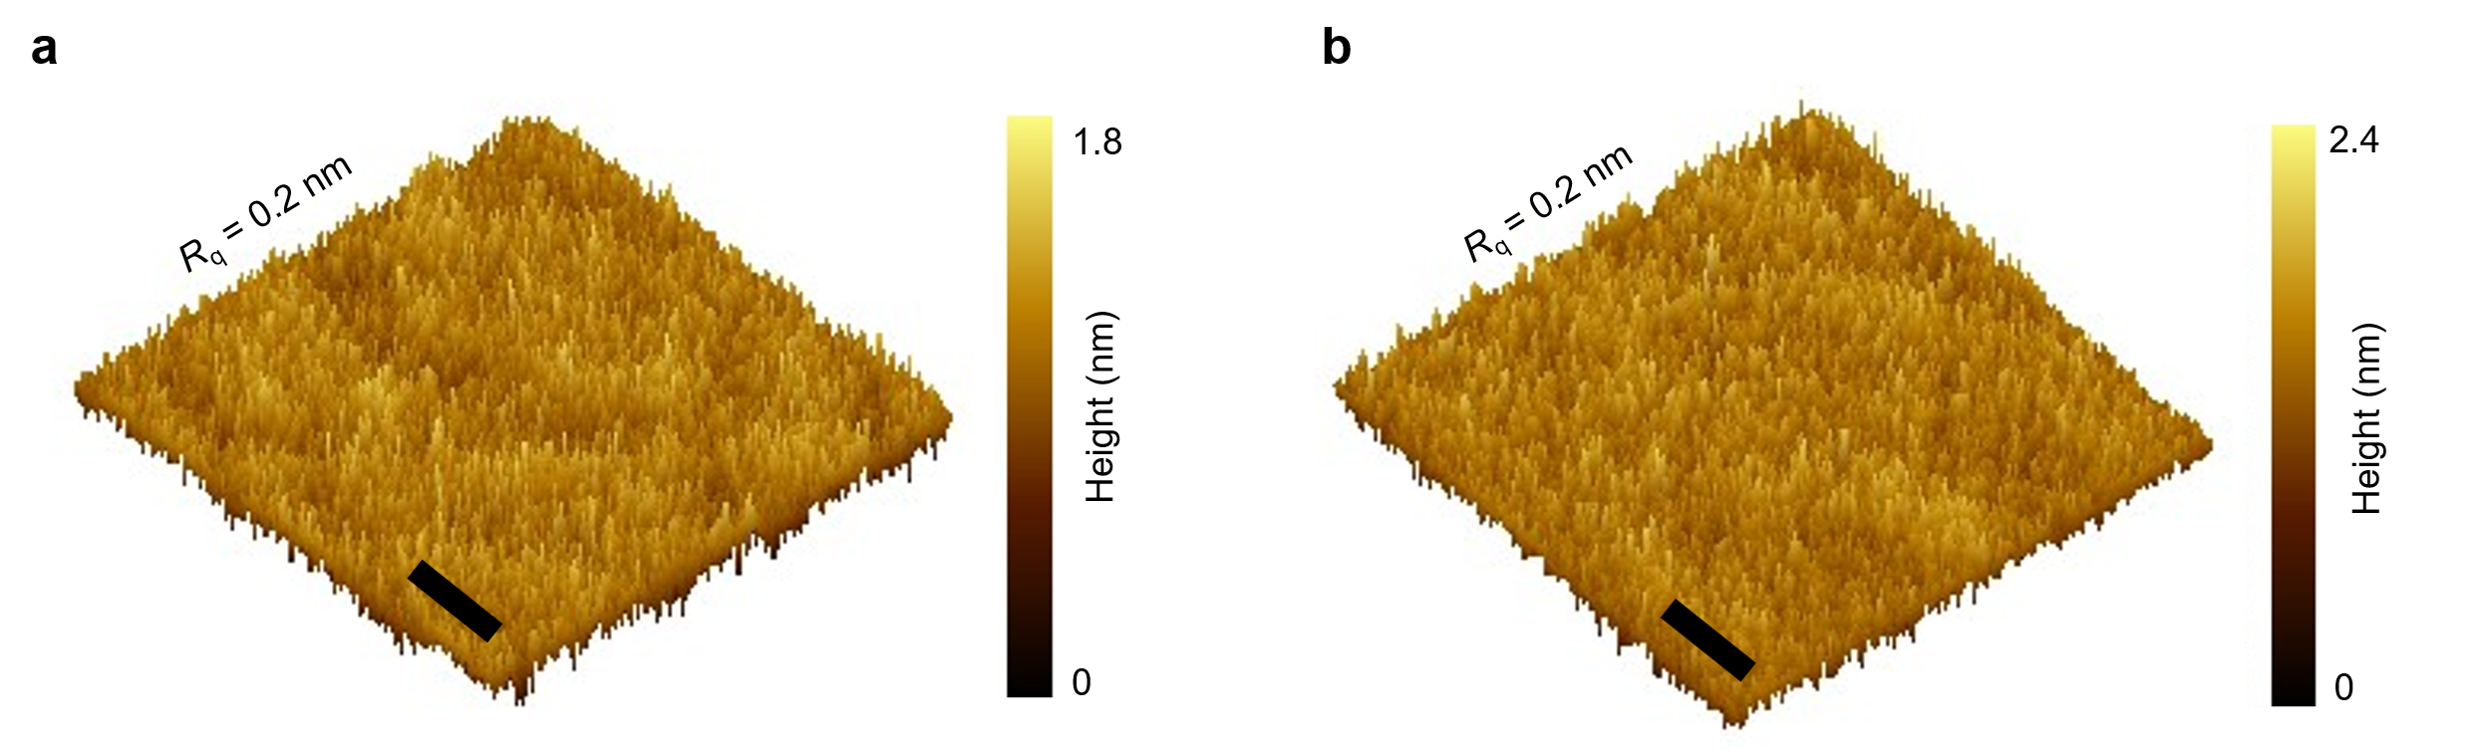
Fig. S1 | Atomic force microscopy (AFM) images of spin-coated PDMS film on a SiO₂/Si wafer. a, PDMS. b, PFOA@PDMS (t_{adsorption} = 10 min, C_{PFOA} = 2.8 × 10⁻⁹ g/L). Scale bars, 100 nm. The images and R_{q} roughness based on 500 nm × 500 nm areas are processed using Gwyddion 2.58 software. The R_{q} roughness of 0.2 nm remains unchanged before and after PFOA adsorption on PDMS substrates. The small roughness before PFOA adsorption indicates molecularly flat surfaces of PDMS. The unchanged roughness after PFOA adsorption suggests uniform PFOA distribution on PDMS.
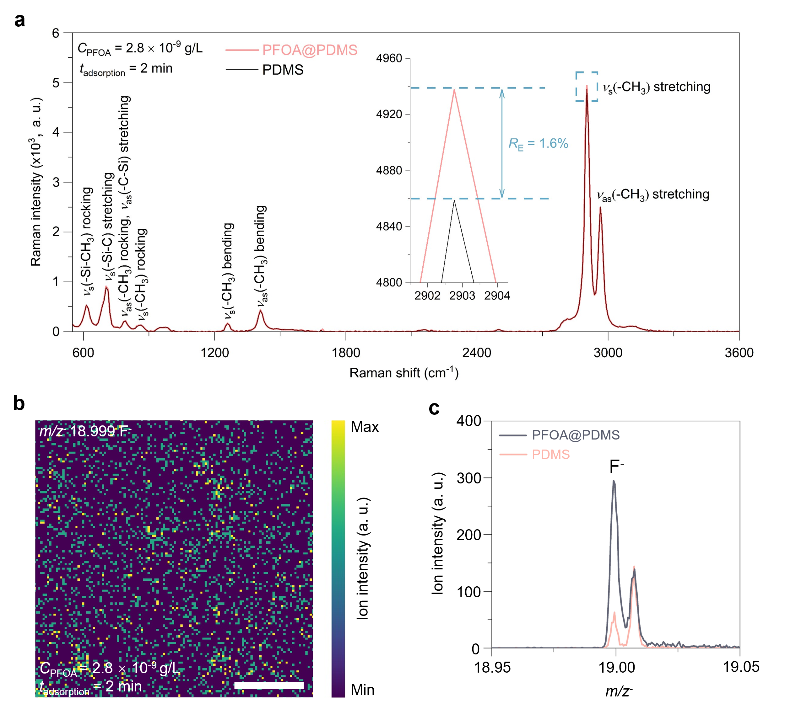
Fig. S2 | PFOA adsorption on PDMS from PFOA-spiked DI water with shorting adsorption time (t_{adsorption} = 2 min, C_{PFOA} = 2.8 × 10⁻⁹ g/L). a, Raman spectra of PDMS and PFOA@PDMS. With shorting adsorption time, R_{E} reduces to 1.6% at 2902.8 cm⁻¹. b, ToF-SIMS mapping of PFOA@PDMS for F⁻ (m/z⁻ = 18.999). Scale bar, 50 μm. c, Integrated ToF-SIMS spectra of F⁻ for PDMS and PFOA@PDMS.

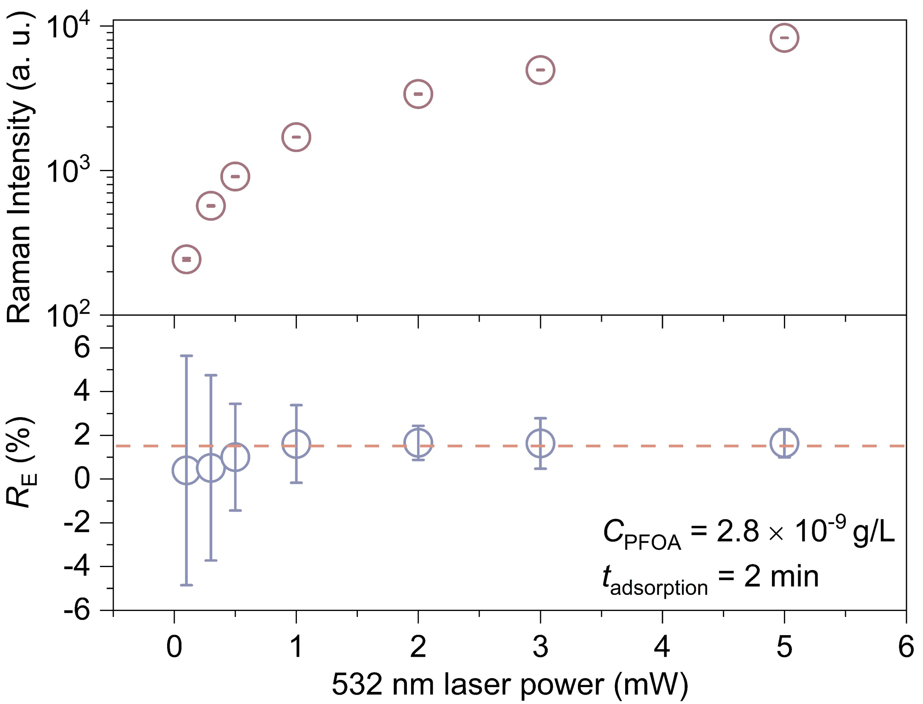
Fig. S3 | Effect of laser power on the R_{E} and I₀ at 2902.8 cm⁻¹. For all laser powers, the PFOA processing parameters are fixed, i.e., C_{PFOA} = 2.8 × 10⁻⁹ g/L and t_{adsorption} = 2 min. R_{E} values experience a nonlinear increase at first and then reach a plateau when the laser power increases to 1 mW and beyond. With low laser power (e.g., 0.1 to 0.5 mW), R_{E} values are lower than 1% with large variations. Once reaching the plateau, R_{E} values are independent of laser power, i.e., 1.61% for 1 mW, 1.66% for 2 mW, 1.63% for 3 mW, and 1.64 for 5 mW, despite the different initial I₀ values caused by different laser powers. This phenomenon indicates R_{E} is a reliable evaluation criterion for PFAS adsorption and can tolerate laser power variation in a certain range (e.g., 1 mW to 5 mW in the current work).

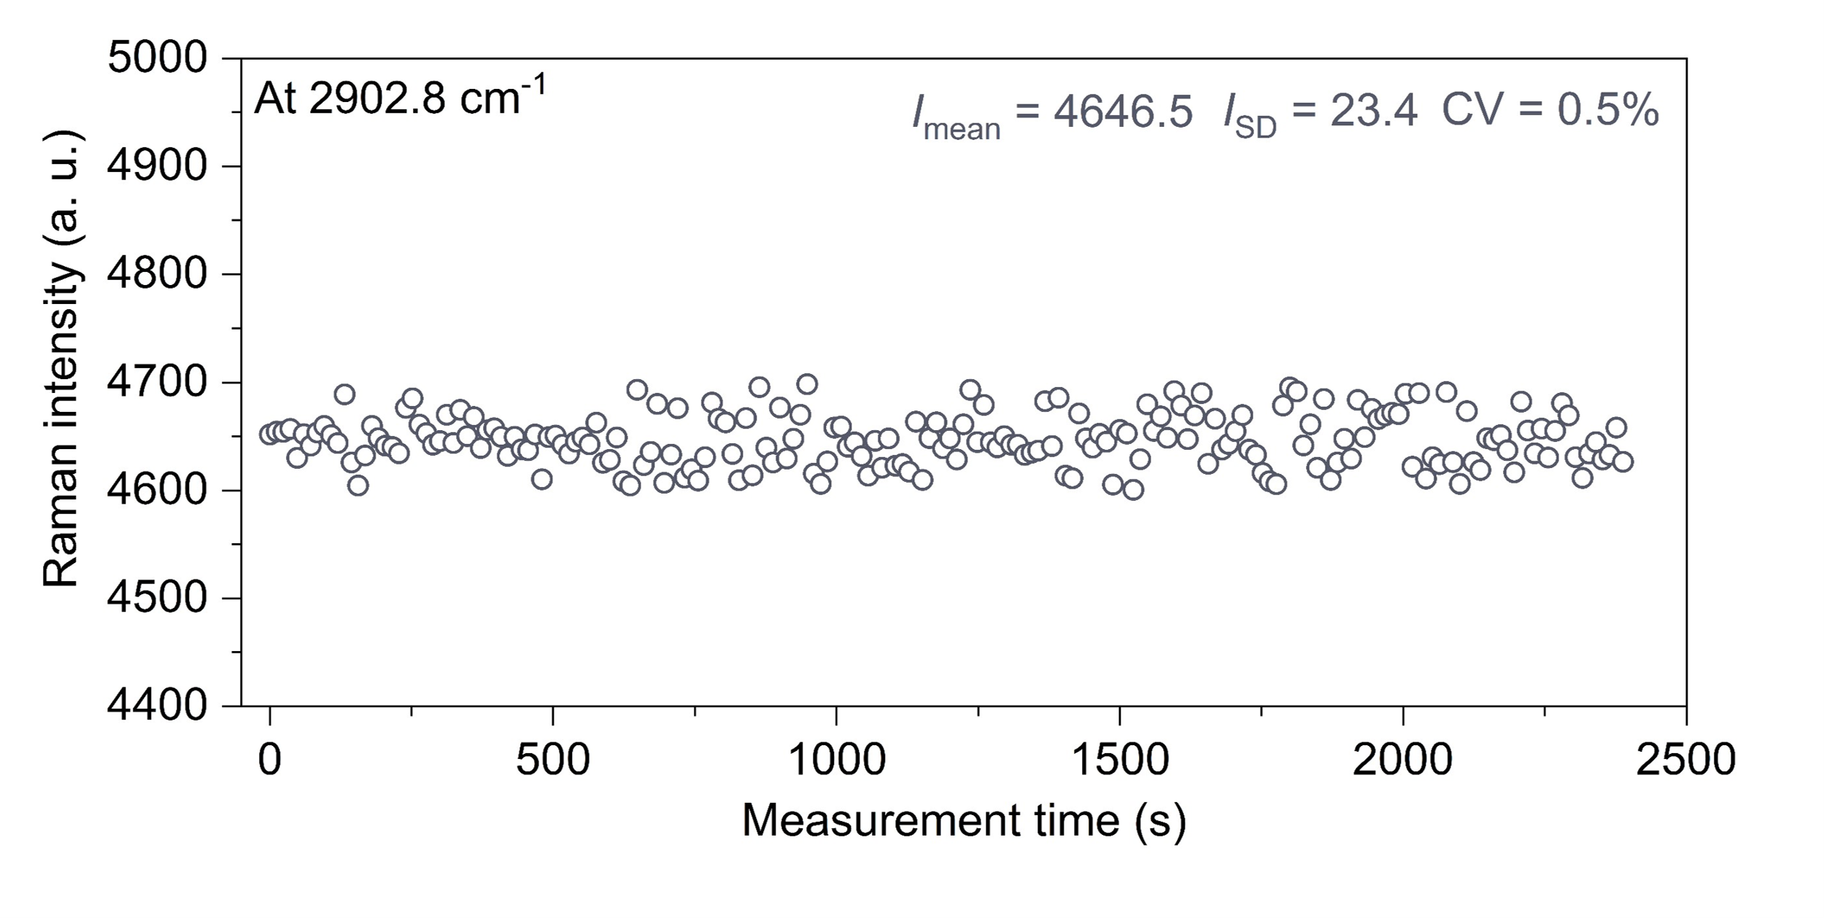
Fig. S4 | Evaluation of instrument noise. 200 cyclic measurements were conducted at a fixed location on a pristine PDMS substrate. The integration time is 10 s and an accumulation time of 1 for each cycle. There is a 2 s interval between cycles. Raman intensity of 2902.8 cm⁻¹ peak of each cycle was recorded. The calculated mean Raman intensity (I_{mean}) is 4646.5, with a standard deviation (I_{SD}) of 23.4. The coefficient of variation (CV), calculated as $CV=\frac{I_{SD}}{I_{mean}}$, is 0.5%. This CV value primarily reflects instrument perturbations.
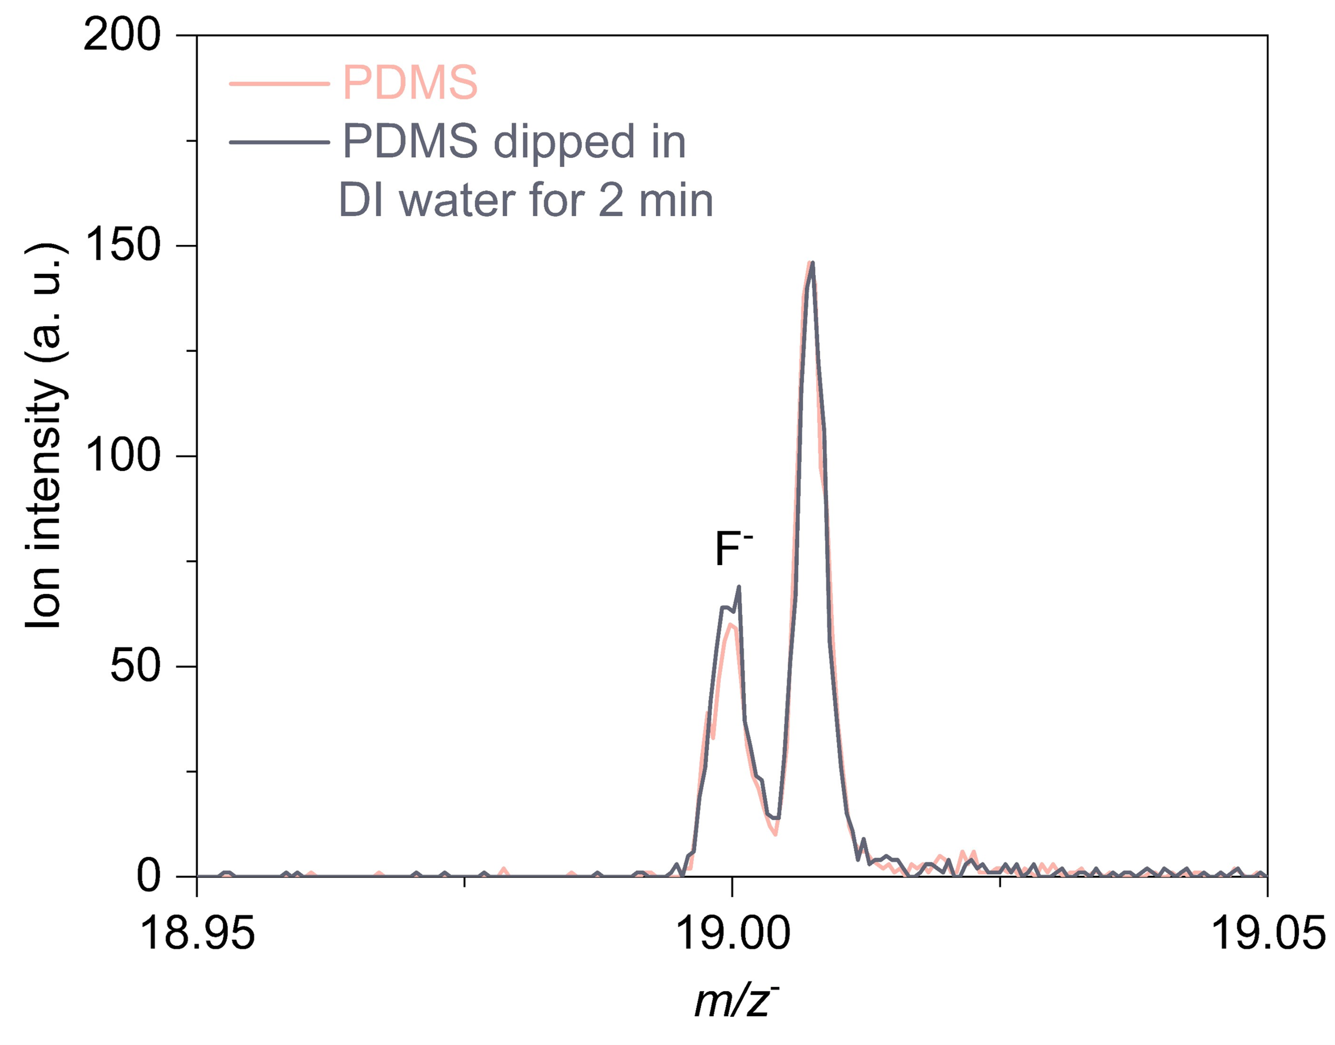
Fig. S5 | Integrated ToF-SIMS spectra of F⁻ of pristine PDMS and PDMS dipped in DI water for 2 min. The overlapping F⁻ signals suggest no detectable F⁻ exists in DI water. More importantly, it proves that the increased signal of F⁻ on PDMS substrate dipped in PFOA-spiked solution truly comes from adsorbed PFOA molecules.

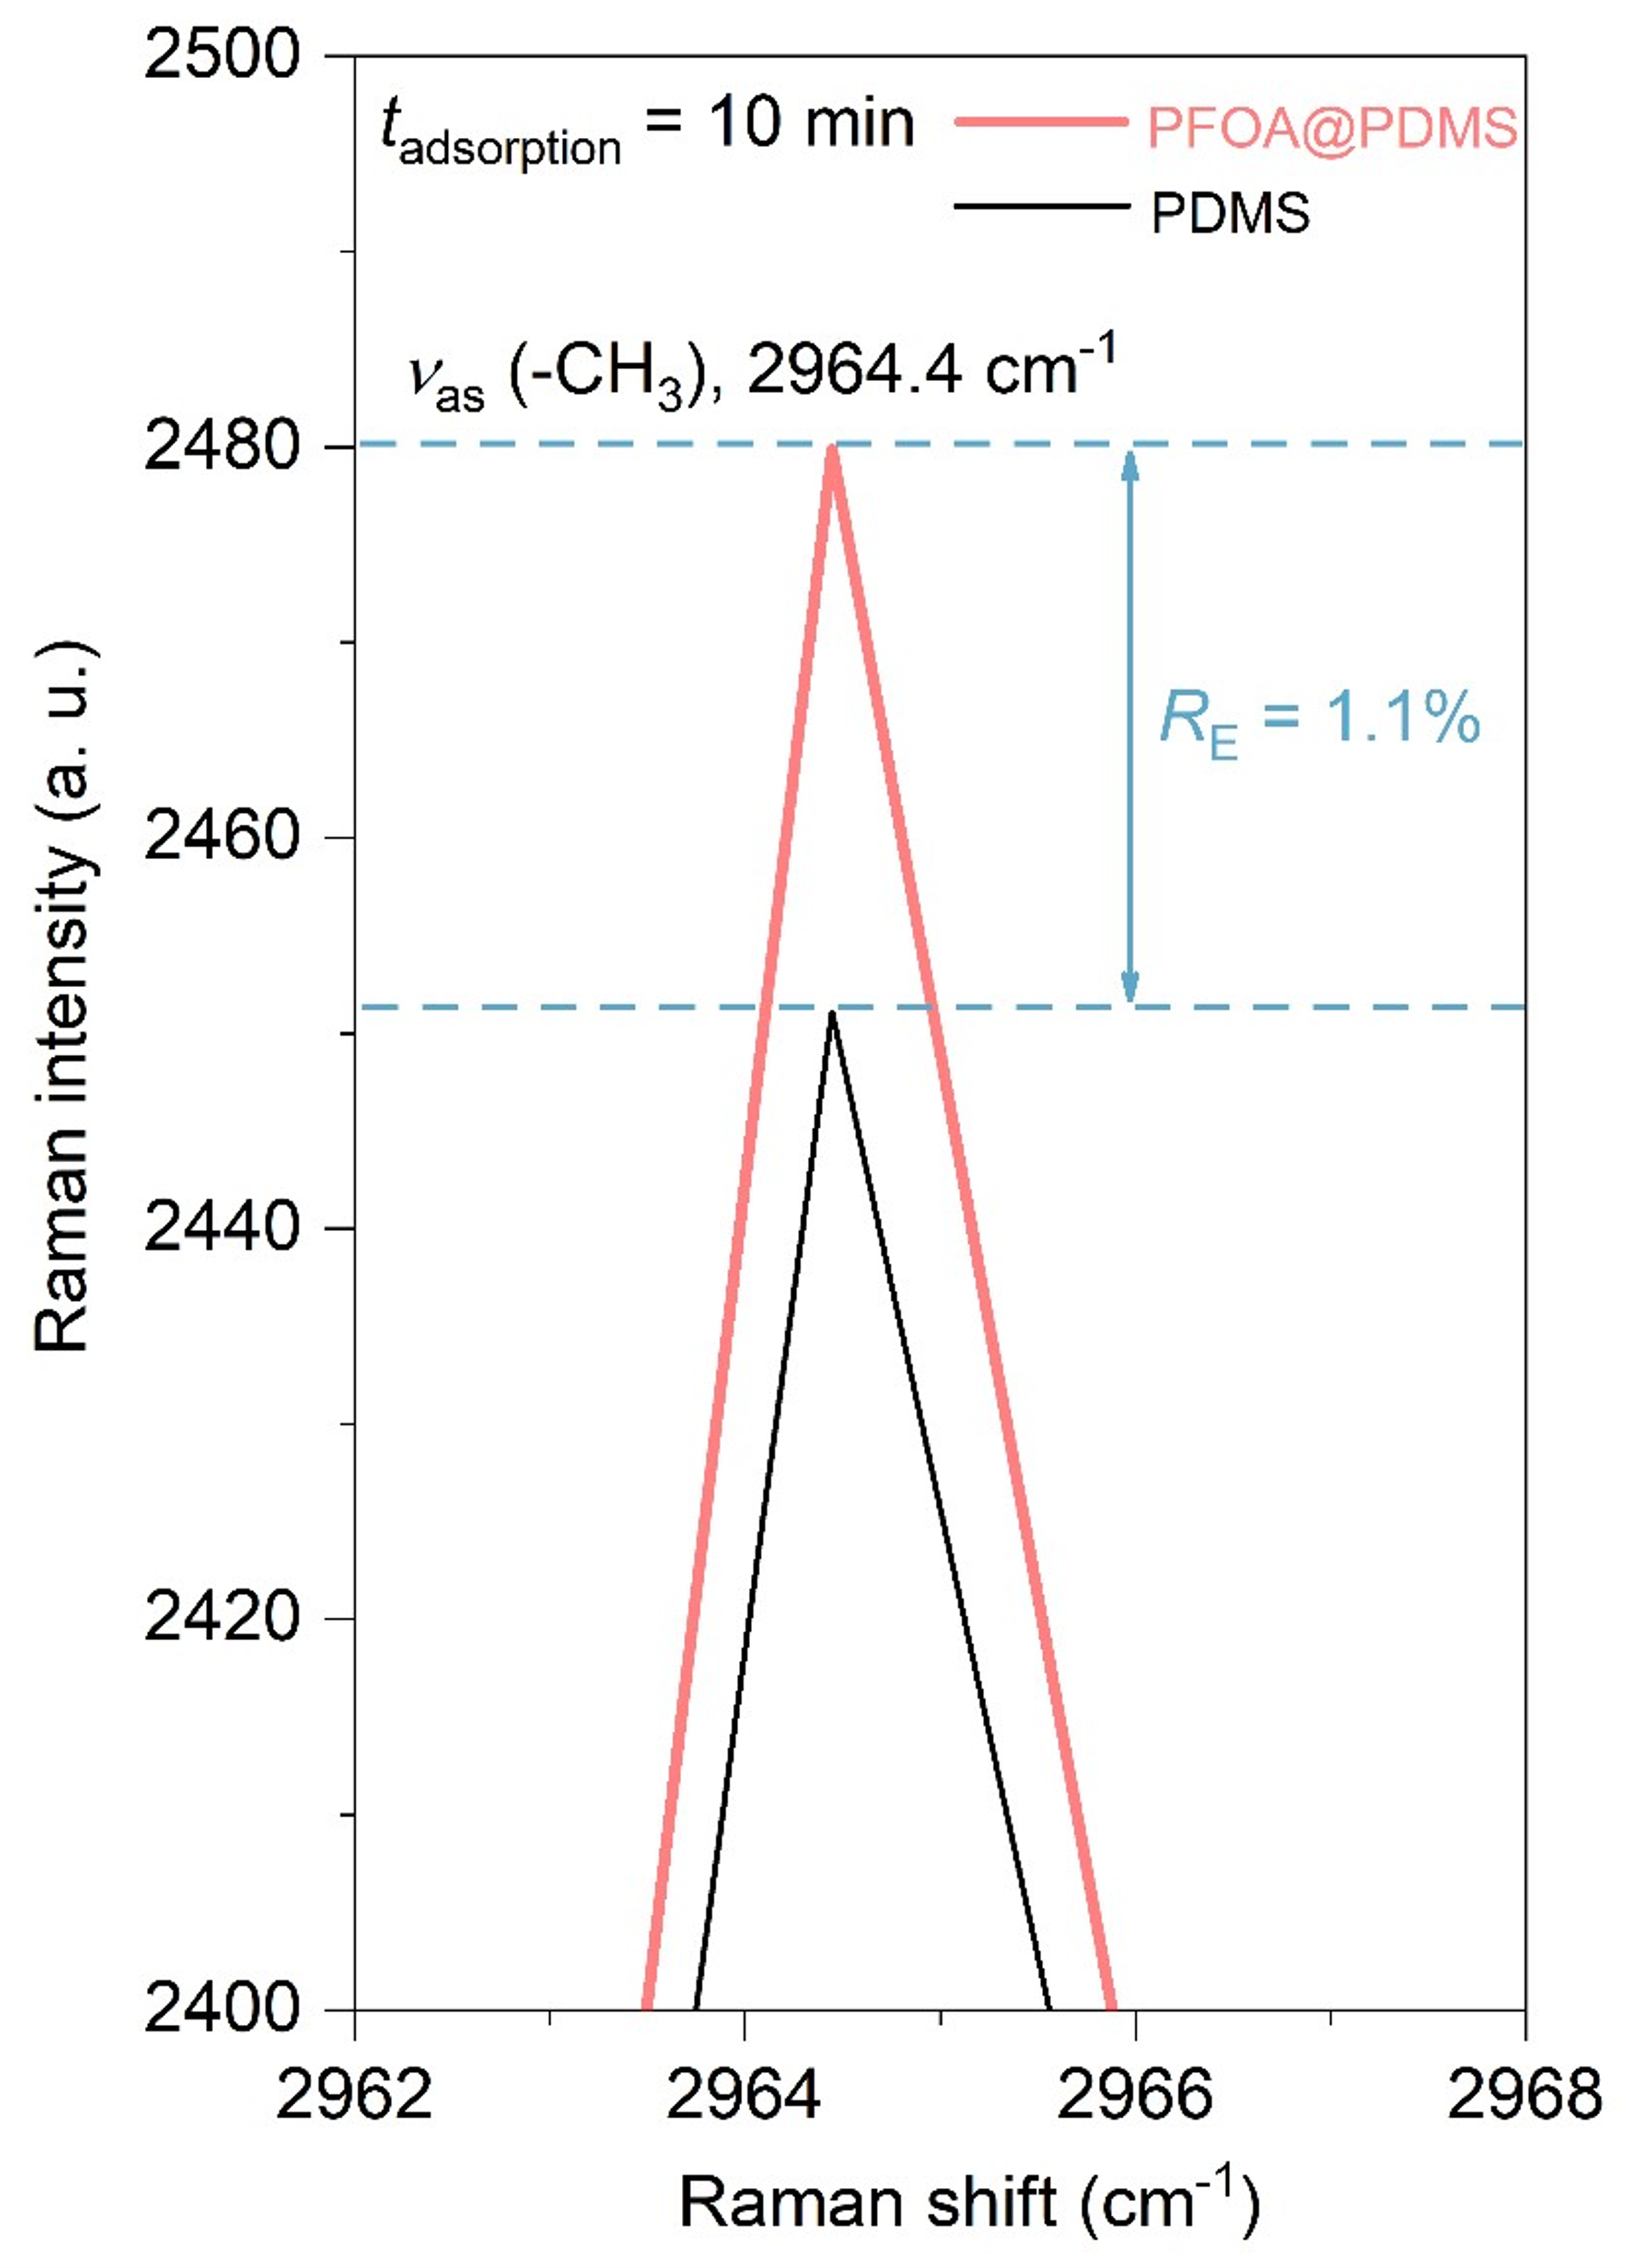
Fig. S6 | Zoom-in Raman spectra of PDMS and PFOA@PDMS at 2964.4 cm⁻¹ from Fig. 1b (t_{adsorption} = 10 min, C_{PFOA} = 2.8 × 10⁻⁹ g/L).

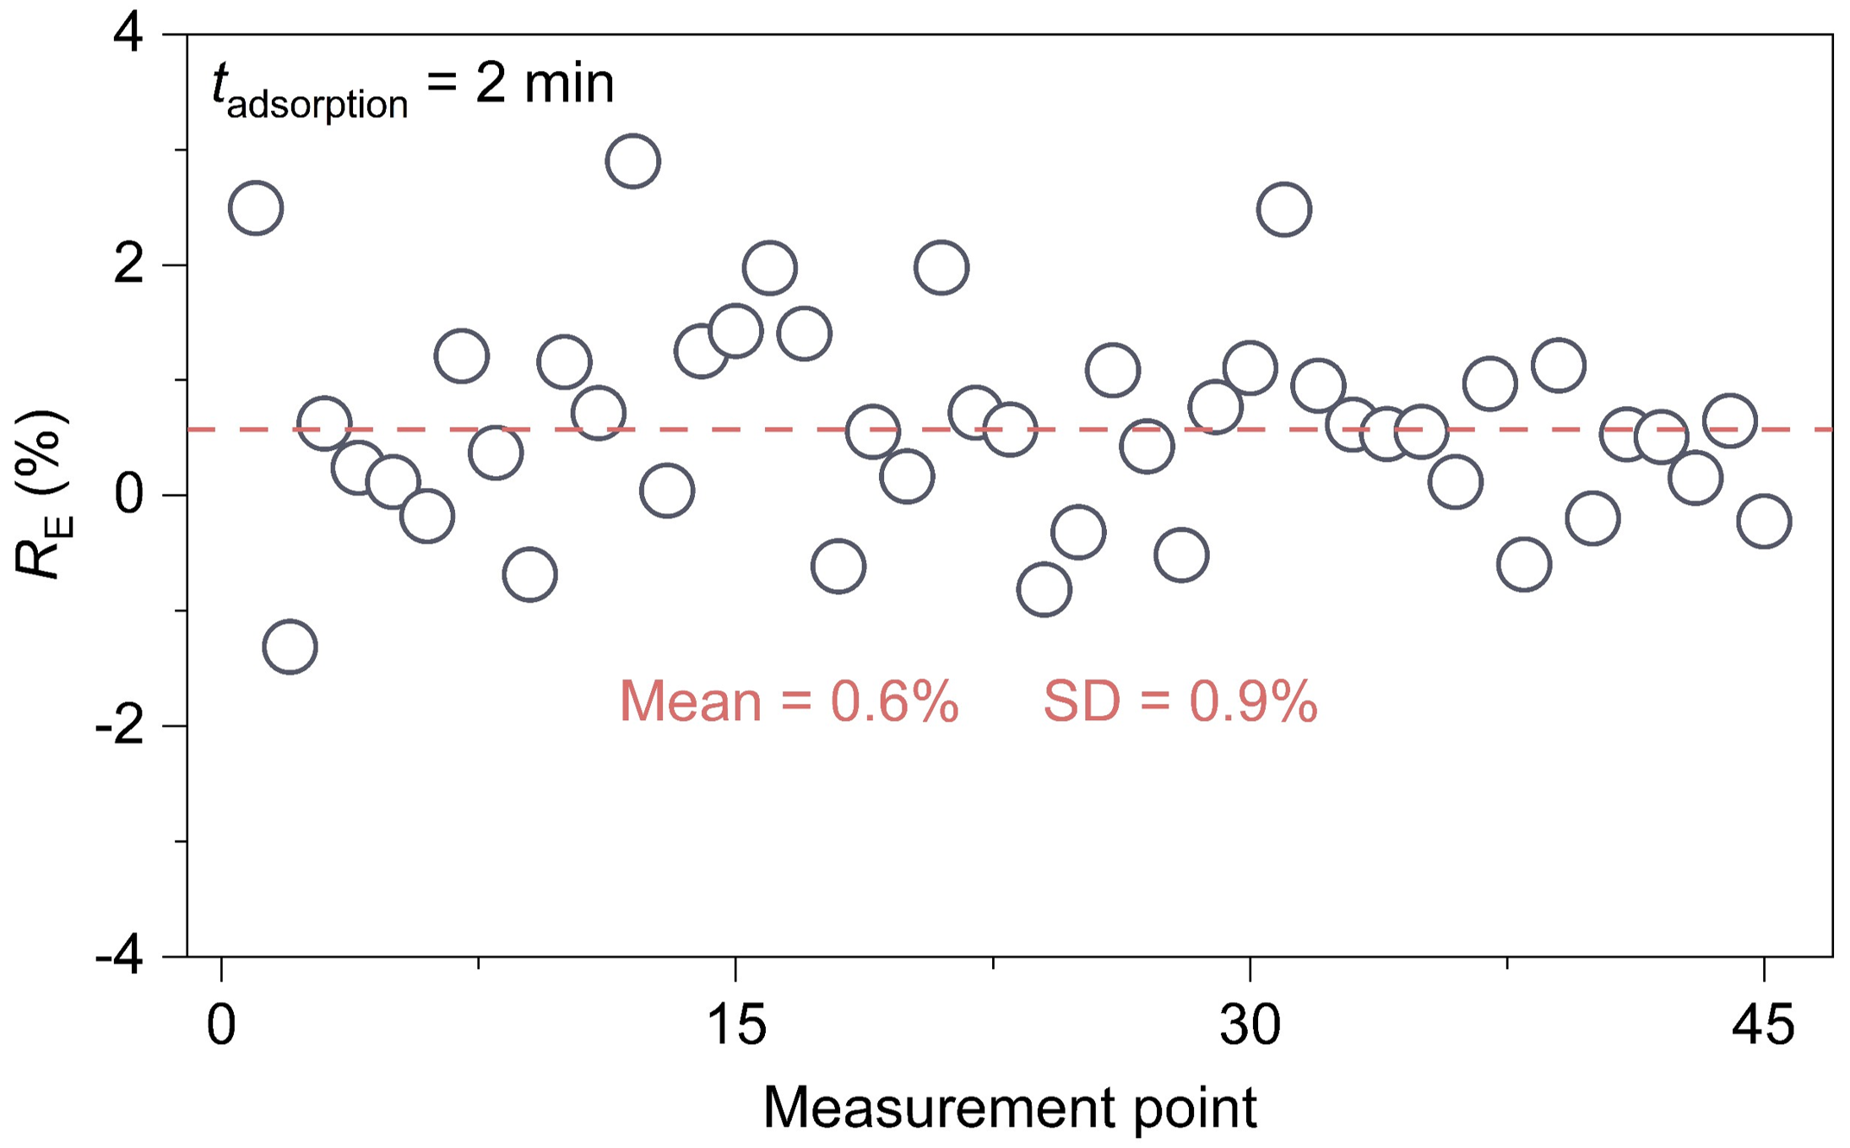
Fig. S7 | Water background generated by DI water. R_{E} = 0.6% ± 0.9% for PDMS dipped in DI water for 2 min.

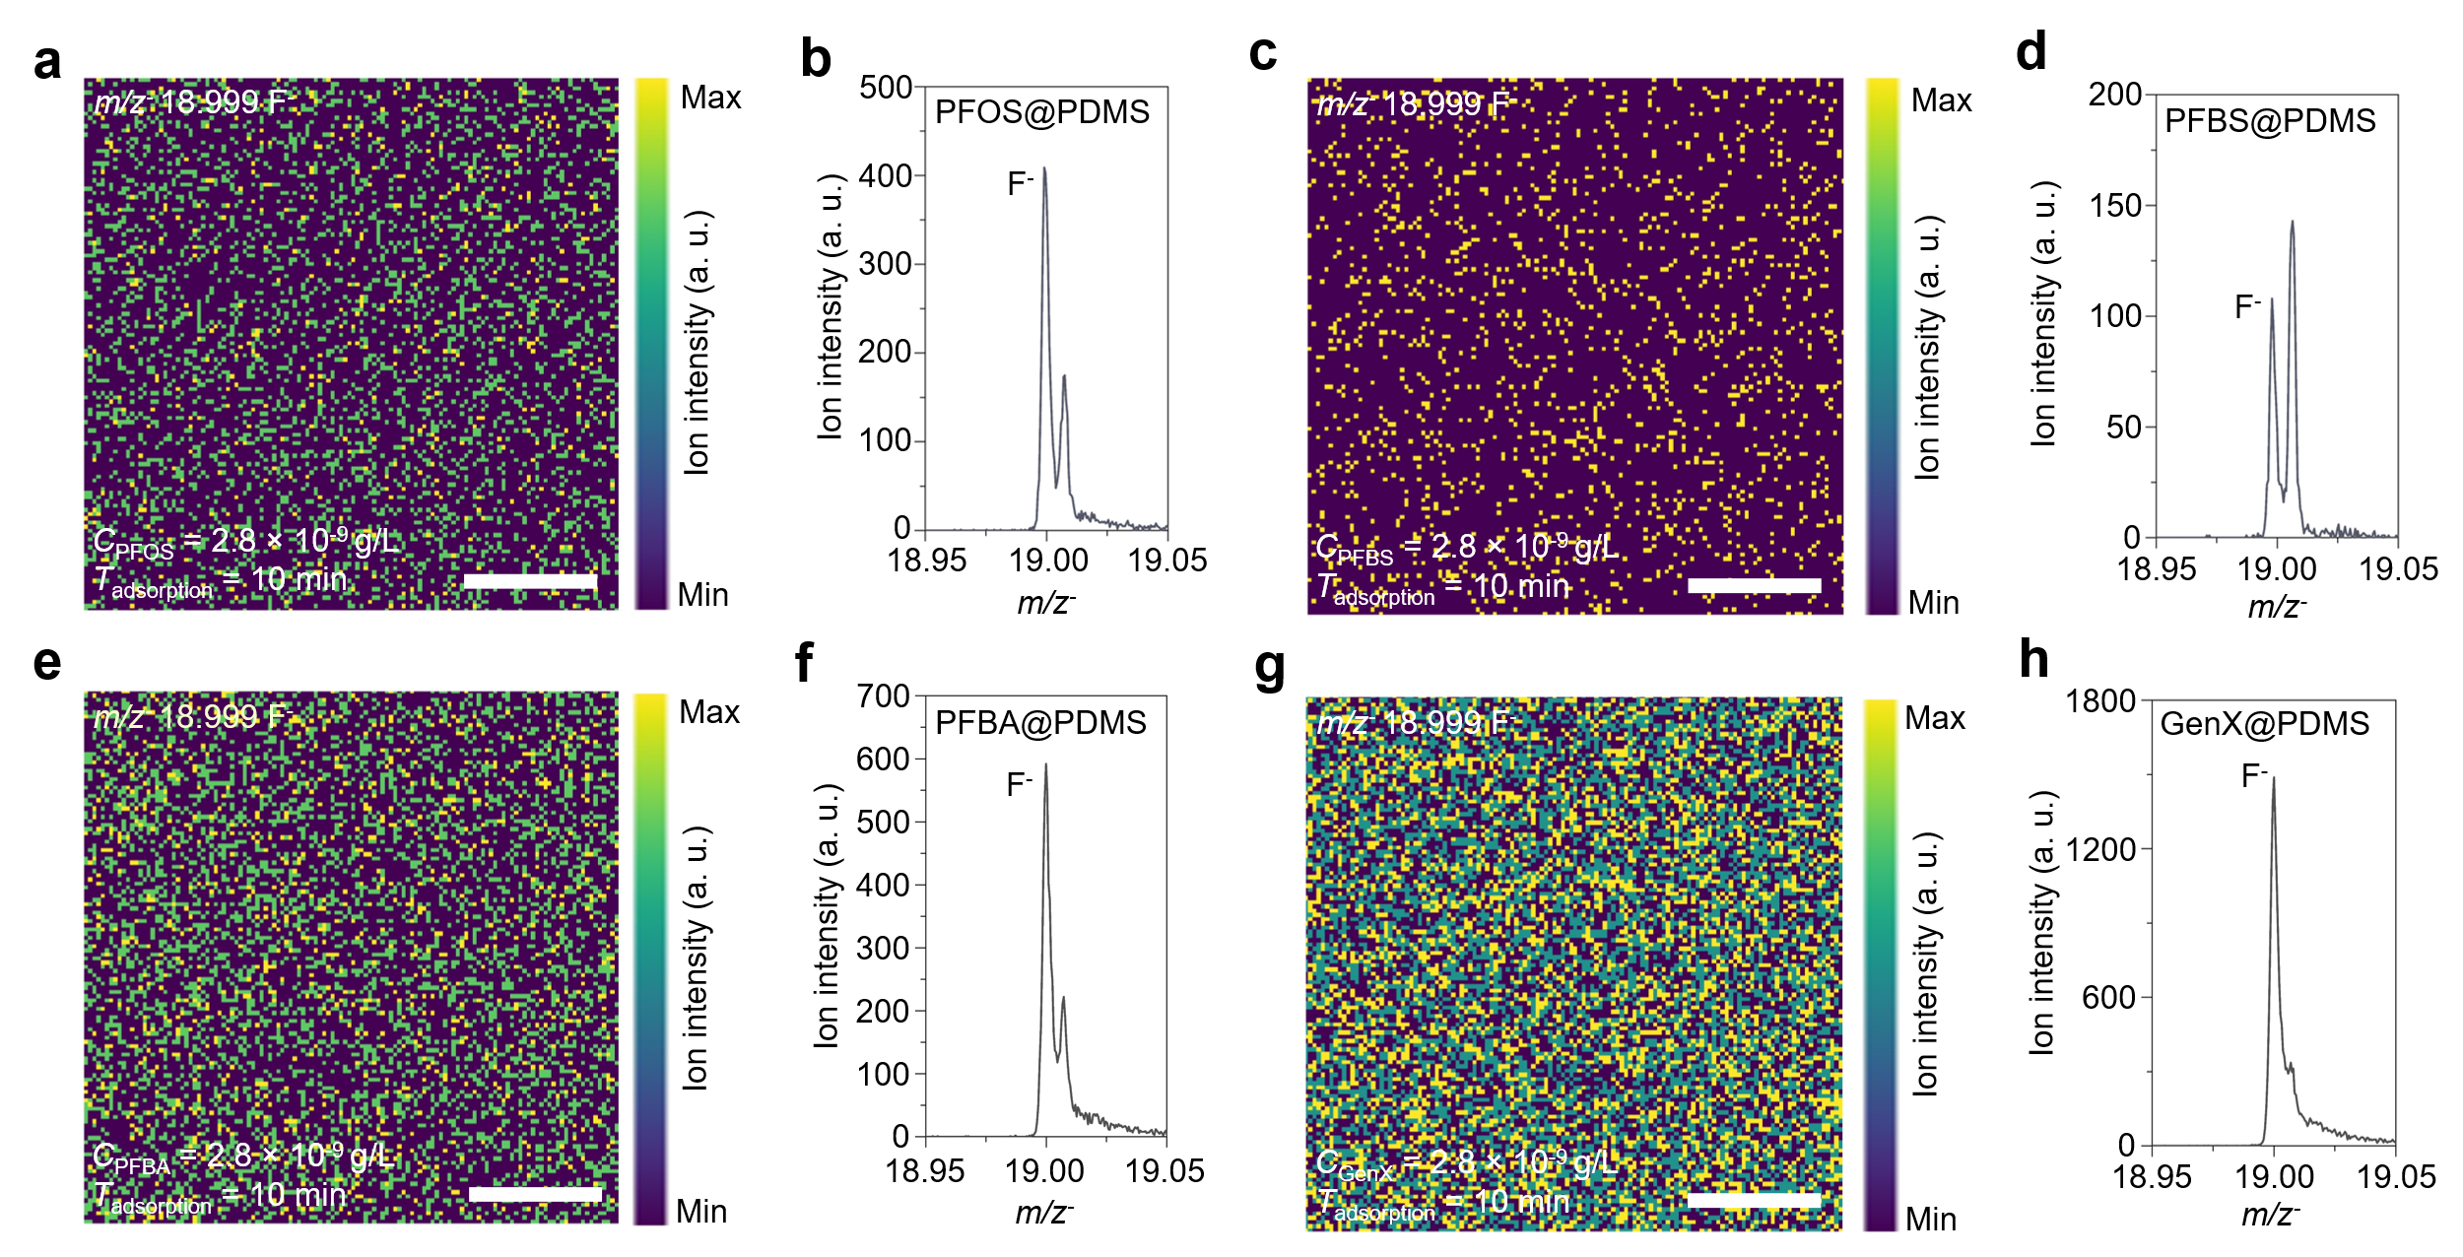
Fig. S8 | ToF-SIMS mapping and integrated spectra of F⁻ ions for different PFAS species adsorbed on PDMS. a, b, PFOS@PDMS. c, d, PFBS@PDMS. e, f, PFBA@PDMS. g, h, GenX@PDMS. For all samples, the tested C_{PFAS} is 2.8 × 10⁻⁹ g/L and t_{adsorption} is 10 min. Scale bars, 50 μm. It should be noted that different PFAS molecular structures can lead to variations in fragmentation behavior during ToF-SIMS analysis. Subtle changes in molecular structure, such as chain length and functional groups, can affect their ionization efficiency ³¹. Thus, the detected F⁻ ion intensities here for different PFAS species show evidence of PFAS adsorption but not a quantitative representation of the amount of adsorbed PFAS.

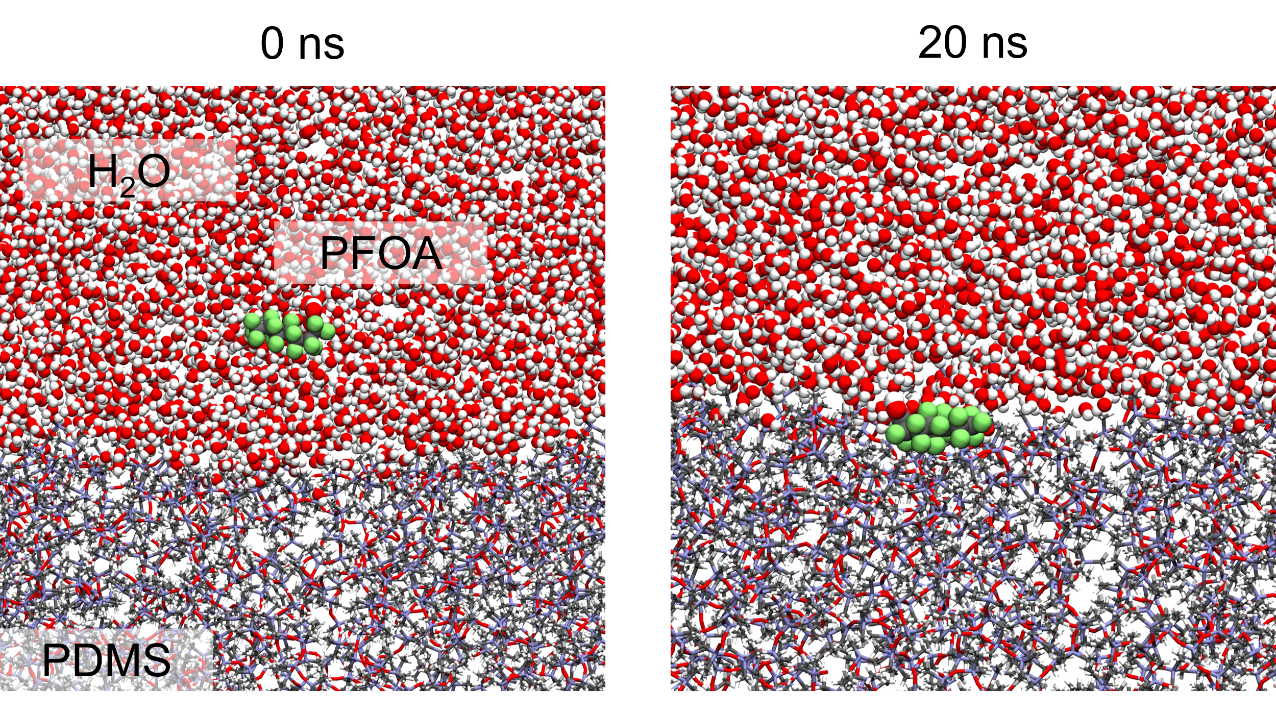

Fig. S9 | Molecular trajectory of the PFOA molecule adsorption on PDMS substrate in an aqueous environment. Grey, C; green, F; red, O; white, H; blue, Si. The equilibrium result shows an adsorption configuration that the PFOA molecule adopts a parallel orientation to the PDMS surface, while the -COOH head group of PFOA orients away from the hydrophobic substrate.

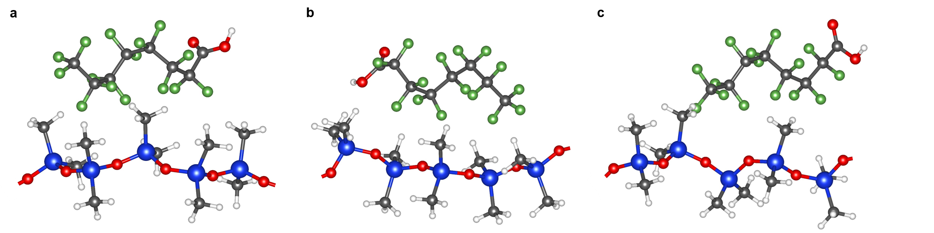

Fig. S10 | Three representations of the optimized adsorption configuration of PFOA and PDMS molecules. a, Configuration 1. b, Configuration 2. c, Configuration 3.

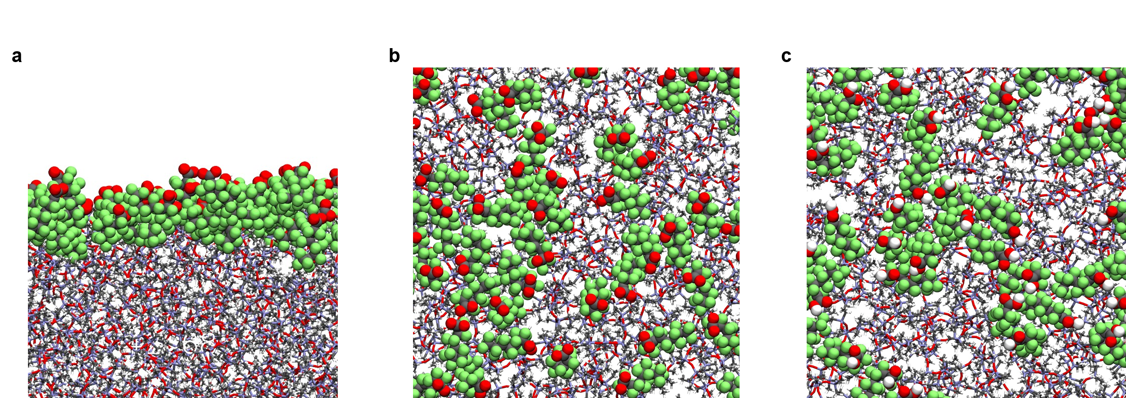

Fig. S11 | a, Side view and b, top view of ionic PFOA adsorption on PDMS substrate. c, Top view of molecular PFOA adsorption on PDMS substrate.

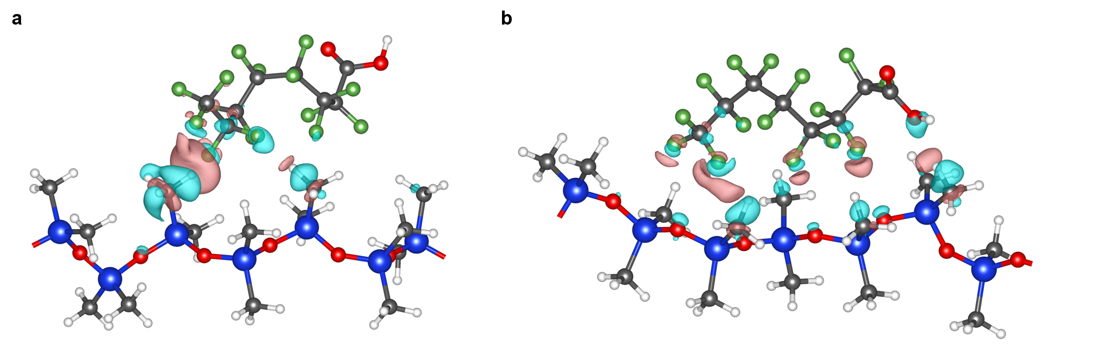
Fig. S12 | Charge density difference profiles between -CH₃ of PDMS and -CF₃ of PFOA. a, Adsorption configuration 1; and b, Adsorption configuration 2. Cyan and red represent charge accumulation and charge depletion, respectively. Iso-surfaces refers to a level of 0.0005 Bohr⁻³.

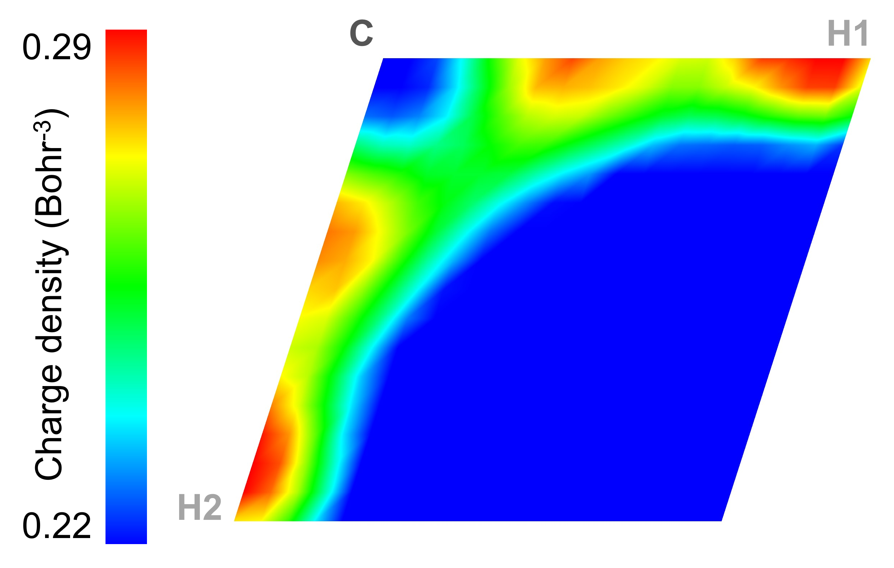

Fig. S13 | Charge density distribution on C-H bonds of PDMS -CH₃ group before PFOA adsorption.

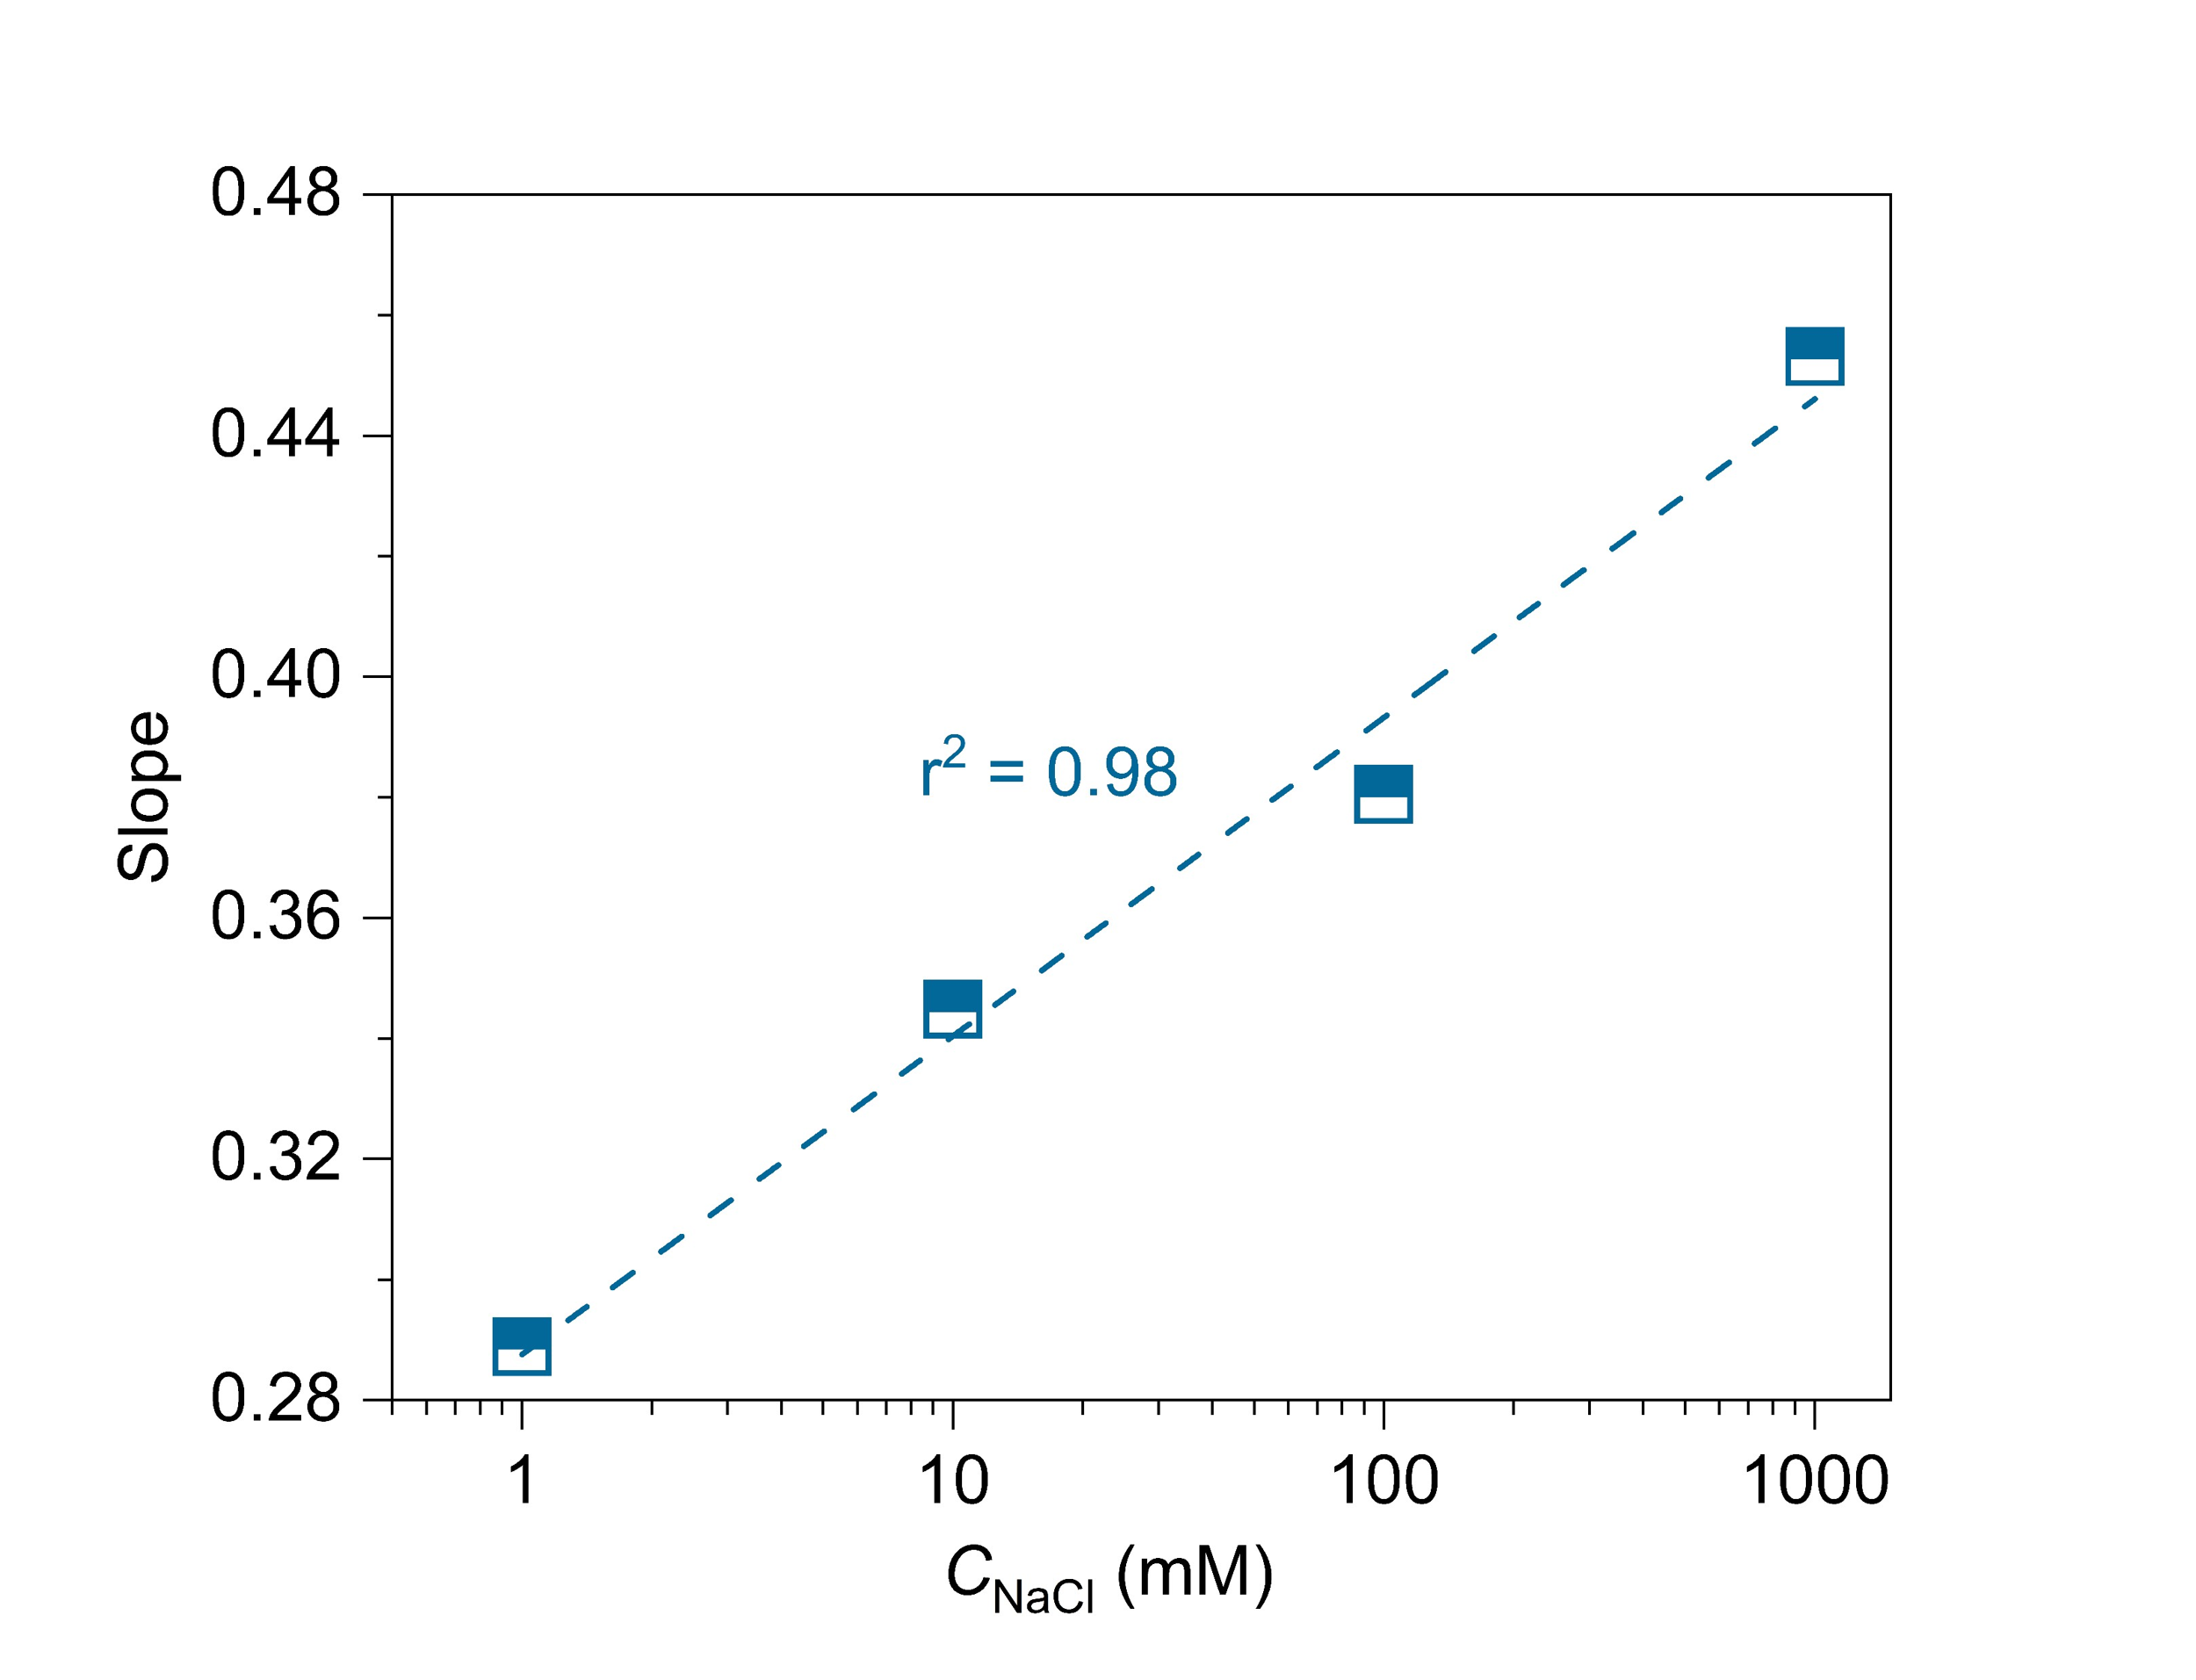

Fig. S14 | Slope evolution of salt/PFOA system with different C_{NaCl}. The results show a linear relationship between C_{NaCl} (logarithm scale) and the fitting slopes in Fig. 4b suggesting a strong correlation between C_{NaCl} and the adsorption kinetics of PFOA molecules.

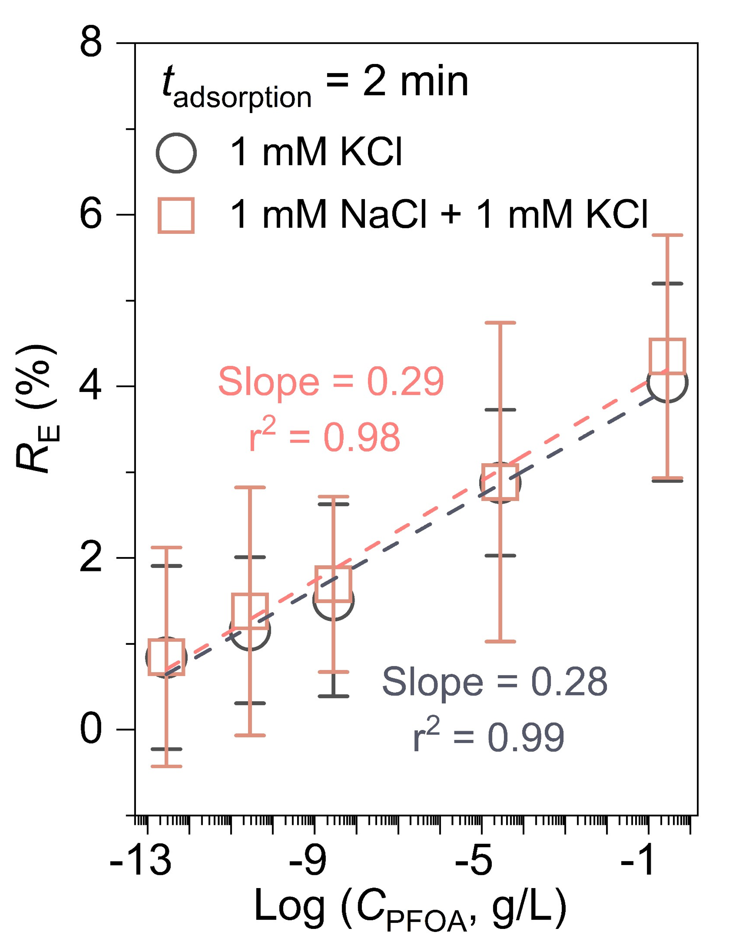
Fig. S15 | PFOA detection in PFOA-spiked aqueous solution with 1 mM KCl, and 1 mM NaCl + 1 mM KCl (2 mM salt in total).
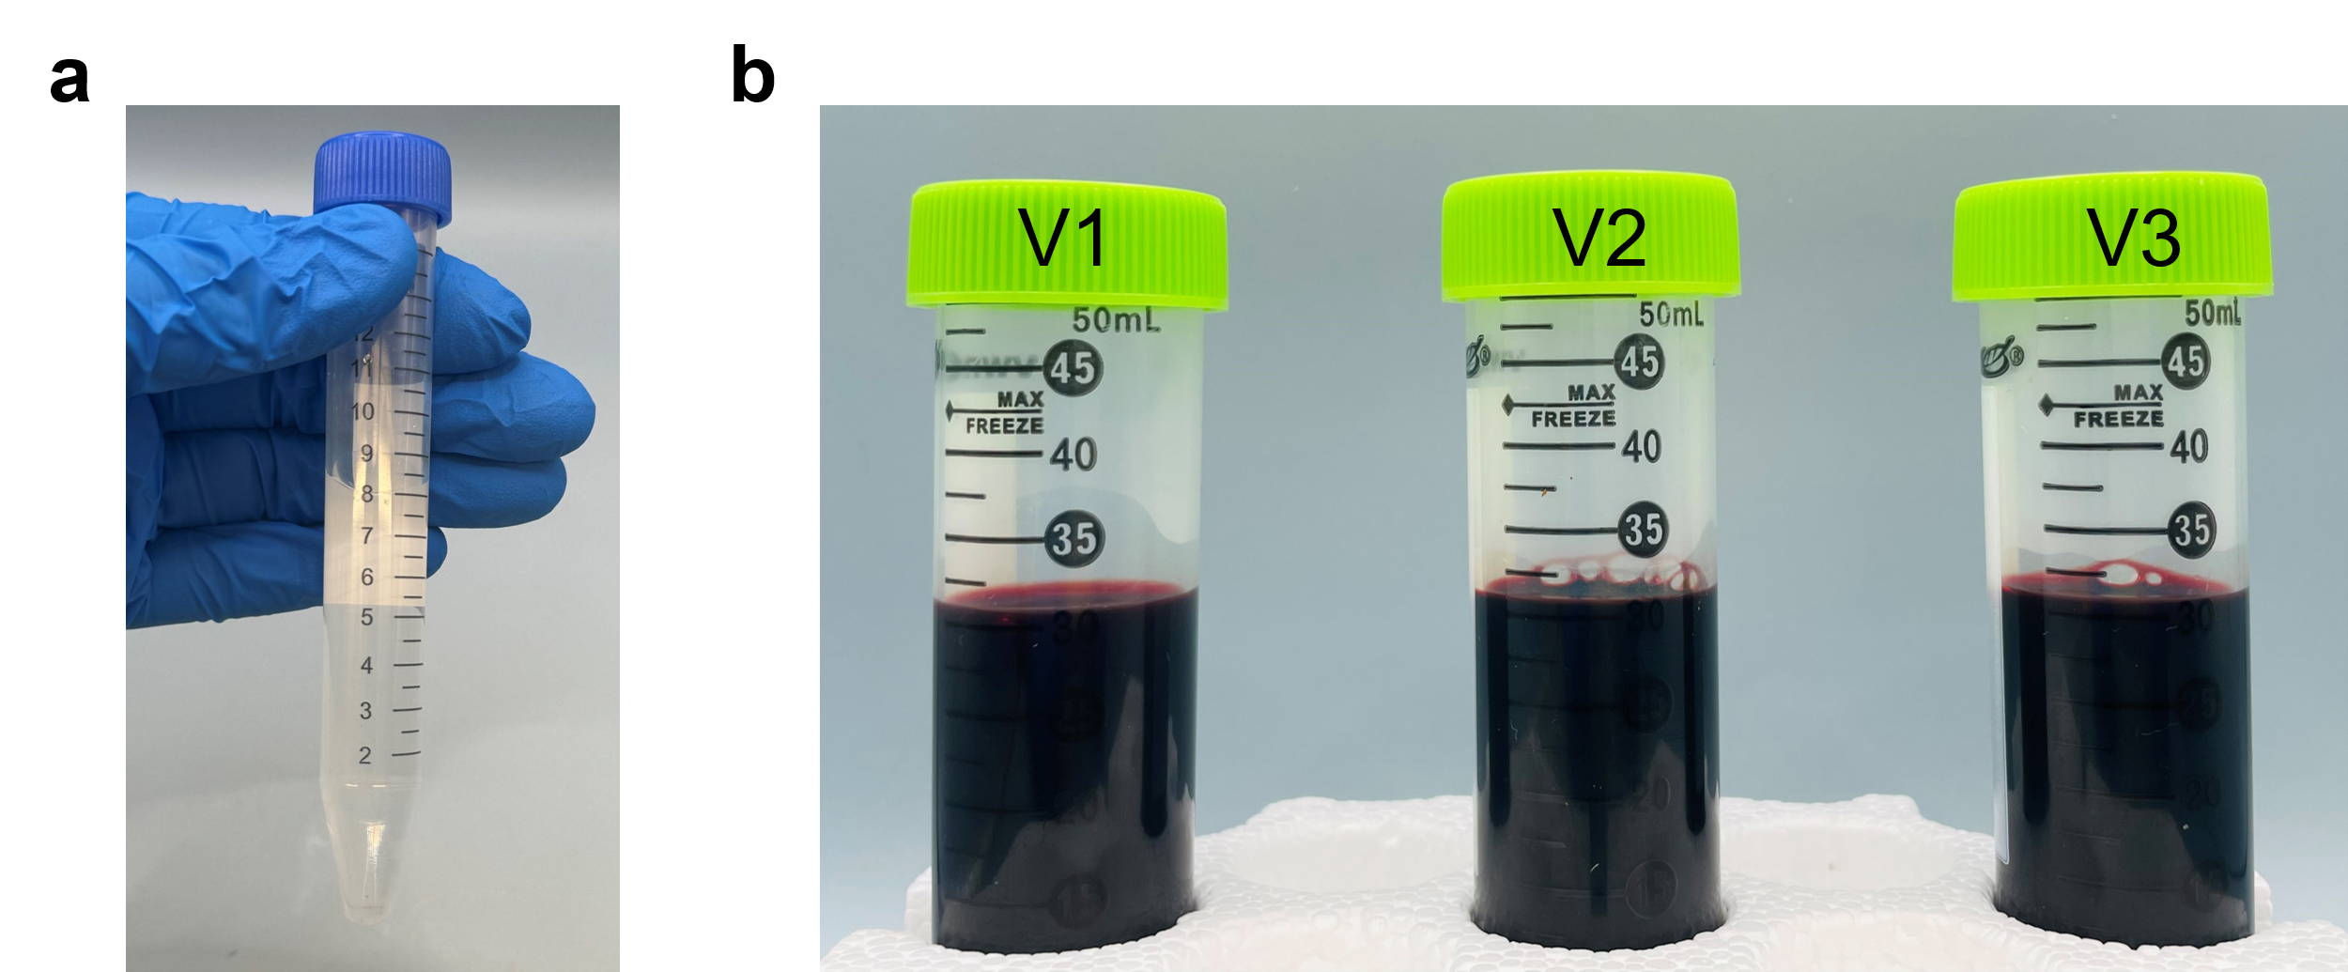
Fig. S16 | Real water sample images without PFOA spiking. a, Surface water. b, human blood.

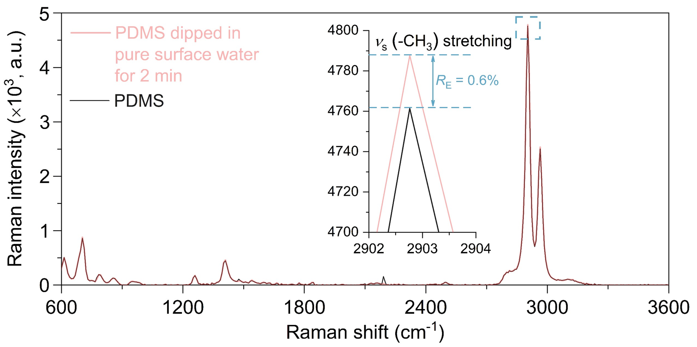
Fig. S17 | Raman spectra of PDMS and PDMS dipped in pure surface water for 2 min.
Table S1 | LC-MS/MS results of DI water and PFOA-spiked DI water.
 | C_{PFOA} (g/L) added | C_{PFOA} (g/L) determined by LC-MS/MS
DI water | 0 | 0
PFOA-spiked DI water. | 2.8 × 10⁻⁷ | 2.71 × 10⁻⁷

Table S2 | Summary of reported sensors in PFOA-spiked aqueous solution. The testing PFOA concentration range is defined as the one that is used for the calculation of LOD. Note, LOD calculation can be varied according to different cases. Methods a-e have been labelled in the table. Superscripts: a, 3σ/S method, where σ is the y-intercept standard deviation of the linear regression line and S is calibration equation’s slope. b, 3σ/S method, where σ is the standard deviation of the blank solution and S is calibration equation’s slope. c, method detection limit (MDL) method. d, 3σ/sensitivity at low concentration of PFAS, where σ is the standard deviation of the blank solution. e, lowest detectable concentration in linear curve. f, the concentration corresponding to three-fold water background (blank) in the linear fitting curve. N/A means not available.
Substrate (Absorber/Adsorber) | Testing PFOA concentration range (g/L) | LOD  (g/L) | Substrate preparation time (min) | Adsorption/absorption time  (min) | Testing time  (min) | Sensor type | Ref
MPA-CdS QD | 2.1 × 10⁻⁴-1.7 × 10⁻² | ^{N/A}1.2 × 10⁻⁴ | >150 | 10 | N/A | Fluorescence | ³²
EB-CTAB | 2.1 × 10⁻⁵-4.1 × 10⁻³ | ^{N/A}4.9 × 10⁻⁶ | N/A | 10 | N/A | Fluorescence | ³³
PPE:F-Sq CPNP | 5 × 10⁻⁵-1 × 10⁻³ | ª5.9x10⁻⁵ | >4330 | 60 | N/A | Fluorescence | ³⁴
AIEgen | 4.1 × 10⁻⁵-4.1 × 10⁻² | N/A | N/A | N/A | N/A | Fluorescence | ³⁵
Zr-MOF | 1 × 10⁻⁴-2 × 10⁻³ | ^{b}4.6 × 10⁻⁵ | >5790 | 1 | N/A | Fluorescence | ³⁶
PPE-Py* | 5 × 10⁻⁸-1.5 × 10⁻⁶ | ª8 × 10⁻⁸ | >4380 | 60 | N/A | Fluorescence | ³⁷
cpGFP-hLFABP | 6.63 × 10⁻⁴-6.63 × 10⁻³ | ^{c}2.36 × 10⁻⁴ | >1080 | 5 | N/A | Fluorescence | ³⁸
ssDNA aptamer | 2.07 × 10⁻³-2.07 × 10⁻¹ | ^{b}7.04 × 10⁻⁵ | N/A | 40 | N/A | Fluorescence | ³⁹
Se, N doped C QD | 4.1 × 10⁻⁴-2.9 × 10⁻² | ^{b}7.452 × 10⁻⁴ | >4320 | 5 | N/A | Fluorescence | ⁴⁰
In (2,3,5,6-tetrakis(4-carboxyphenyl) pyrazine) | 1.3 × 10⁻⁶-8.28 × 10⁻² | ^{b}1.9 × 10⁻⁵ | >3605 | 5 | N/A | Fluorescence | ⁴¹
Human liver fatty acid binding protein | 4.14 × 10⁻⁶-4.14 × 10⁻¹ | ^{N/A}1.12 × 10⁻⁴ | N/A | 5 | N/A | Fluorescence | ⁴²
Guanidinocalix[5]arene | 1 × 10⁻⁴-1 × 10⁻³ | ^{b}1.09 × 10⁻⁵ | >960 | N/A | N/A | Fluorescence | ⁴³
PF-DBT-Im | N/A | ^{N/A}2.5 × 10⁻⁶ | >1470 | N/A | N/A | Fluorescence | ⁴⁴
L1-Zn(II) complexes | N/A | ^{b}9.1x10⁻⁵ | N/A | N/A | N/A | Fluorescence | ⁴⁵
Ce-Gly cluster | 5 × 10⁻⁷-7 × 10⁻⁶ | ^{b}2.4 × 10⁻⁷ | >10080 | 10 | N/A | Fluorescence | ⁴⁶
PDI-MOF@cellulose paper | 4.14 × 10⁻⁶-2.07 × 10⁻⁵ | ^{b}1.28 × 10⁻⁶ | >4360 | N/A | N/A | Fluorescence | ⁴⁷
IrC₁₂-FSA@Au | 1 × 10⁻⁵-1 | ^{N/A}6.2 × 10⁻⁶ | >2175 | 30 | N/A | Fluorescence | ⁴⁸
CNF-Cu/C | 4.14 × 10⁻⁴-2.07 × 10⁻² | ^{N/A}5.51 × 10⁻⁵ | >1440 | 10 | N/A | Color | ⁴⁹
SMIP@N-CF | 2.9 × 10⁻⁵-3.73 × 10⁻² | ^{N/A}4.02 × 10⁻⁴ | >520 | 10 | N/A | Color | ⁵⁰
SAp-PD | 4.14 × 10⁻⁹⁻4.14 × 10⁻¹ | ^{N/A}5.3 × 10⁻¹⁰ | >91 | 720 | N/A | SERS | ⁵¹
Graphene and Ag Nano-particles | 4.14 × 10⁻¹⁰⁻4.14 × 10⁻⁴ | ^{N/A}4.14 × 10⁻⁷ | N/A | 30 | N/A | SERS | ⁵²
Dye-AgNP-graphene oxide | N/A | ^{N/A}5 × 10⁻⁵ | N/A | N/A | N/A | SERS | ⁵³
Ag nanoclusters | 1.1 × 10⁻⁸⁻1 × 10⁻³ | ª1.1 × 10⁻⁵ | N/A | 1 | N/A | SERS | ⁵⁴
β-CD/Ag/Optical fiber | 4 × 10⁻⁸-4 × 10⁰ | ^{N/A}7.14 × 10⁻⁸ | N/A | N/A | N/A | SERS | ⁵⁵
Ag nanocolloidal | 1 × 10⁻⁶-5 × 10⁻⁹ | ^{N/A}5 × 10⁻⁹ | N/A | N/A | N/A | SERS | ⁵⁶
MIP/optical fiber | 1 × 10⁻⁷-4 × 10⁻⁶ | ^{d}1.3 × 10⁻⁷ | N/A | 10 | N/A | Surface plasmon resonance | ⁵⁷
MIP/optical fiber | 1 × 10⁻⁹-7.5 × 10⁻⁷ | ^{d}8.1 × 10⁻¹⁰ | N/A | 10 | N/A | Surface plasmon resonance | ⁵⁸
Ag-Au@nanocarbon floret | N/A | ^{N/A}4.14 × 10⁻¹⁰ | N/A | 10 | N/A | Surface plasmon resonance | ⁵⁹
PFOA antibody/Au@plastic optical fiber | 2.5 × 10⁻⁷-1 × 10⁻⁴ | ^{N/A}2.1 × 10⁻⁷ | N/A | 10 | N/A | Surface plasmon resonance | ⁶⁰
Alg/GO/optical fiber | 2 × 10⁻⁷-2 × 10⁻⁶ | ^{e}4 × 10⁻⁷ | ＞30 | 0.28 | 0.28 | Surface plasmon resonance | ⁶¹
MIP | 4.1 × 10⁻⁶-4.1 × 10⁻² | ª9.1×10⁻⁹ | N/A | 17 | N/A | Thermal | ⁶²
MIP/g-C₃N₄ | 2 × 10⁻⁸-4 × 10⁻⁴ | ^{N/A}1 × 10⁻⁵ | ＞865 | 20 | N/A | Electrochemiluminescence | ⁶³
MIP@AgI-BiOINF | 2 × 10⁻⁸-1 × 10⁻³ | ^{b}1 × 10⁻⁸ | ＞640 | 20 | N/A | Electrochemical | ⁶⁴
PFAEI/SPE | 6.2 × 10⁻⁶-3.1 × 10⁻⁵ | ^{N/A}6.51 × 10⁻⁶ | ＞13 | 1 | 1 | Electrochemical | ⁶⁵
PANI-CHT/SPCE | 5 × 10⁻⁶-1.5 × 10⁻⁴ | ^{N/A}1.08 × 10⁻⁶ | ＞7260 | 0.33 | 0.33 | Electrochemical | ⁶⁶
WS₂-MWCNT | 4.14 × 10⁻⁹-4.97 × 10⁻⁸ | ^{b}9.95 × 10⁻¹⁰ | ＞1080 | 1.3 | N/A | Electrochemical | ⁶⁷
Graphene | 2.07 × 10⁻⁵-2.07 × 10⁻¹ | ^{N/A}4.31 × 10⁻⁶ | ＞340 | 0.5 | N/A | Electrochemical | ⁶⁸
Micropipette | 4.14 × 10⁻⁵-4.97 × 10⁻⁴ | ª2.07 × 10⁻⁵ | ＞220 | 0.83 | 0.83 | Electrochemical | ⁶⁹
Ce-UiO-66-F/GCE | 1.66 × 10⁻⁷-1.86 × 10⁻⁴ | ^{b}1.99 × 10⁻⁸ | ＞3070 | 0.33 | 0.33 | Electrochemical | ⁷⁰
Hf.WO₃/CP | 2.9 × 10⁻⁵-1.24 × 10⁻¹ | ^{b}7.58 × 10⁻⁶ | ＞490 | 0.6 | 0.6 | Electrochemical | ⁷¹
PFDT/AuNPs/GCE | 1 × 10⁻⁷-5 × 10⁻⁶ | ^{b}2.4 × 10⁻⁸ | ＞727 | 0.26 | 0.26 | Electrochemical | ⁷²
MIP-Co/Fe@CNF | 4.14 × 10⁻⁶-3.73 × 10⁻² | ^{b}4.44 × 10⁻⁷ | ＞3010 | 0.3 | 0.3 | Electrochemical | ⁷³
Cu-HHTP MOF | N/A | ^{e}2 × 10⁻¹² | ＞60 | N/A | N/A | Electrochemical | ⁷⁴
Au/NiOScZ/SPCE | 4.14 × 10⁻¹⁰-4.14 × 10⁻⁵ | ^{N/A}1.24 × 10⁻¹⁰ | ＞60 | 0.8 | 0.8 | Electrochemical | ⁷⁵
PEDOT-TEMPO-MIP | 4.14 × 10⁻⁹-4.14 × 10⁻⁴ | ^{c}2.8 × 10⁻¹⁰ | ＞4335 | 240 | 240 | Electrochemical | ⁷⁶
Fluorous-PANI | 4.14 × 10⁻⁸-4.14 × 10⁰ | ª4 × 10⁻⁷ | ＞930 | 30 | N/A | Electrical | ⁷⁷
PDMS | 2.8 × 10⁻¹⁷-2.8 × 10⁻¹  2.8 × 10⁻¹³-2.8 × 10⁻¹ | ^{f}3.7 × 10⁻¹⁵  ^{f}4.3 × 10⁻⁹ | ＞6 | 10  2 | ~5 | MPRS | This work

Table S3 | Lennard-Jones potential parameters ($σ$ and $ε$) and partial charges ($q$) of water, PDMS, and PFOA.
 | Water |  | PDMS
 | O_{water} | H_{water} | Si | O | C | H
$σ$ (kcal/mol) | 0.1553 | 0.0000 | 0.2443 | 0.2004 | 0.0847 | 0.0098
$ε$ (Å) | 3.1660 | 0.0000 | 3.8140 | 2.8200 | 3.4180 | 2.9720
$q$ (e) | -0.8476 | +0.4238 | +0.7608 | -0.4620 | -0.5604 | +0.1370
 | PFOA
 | C_{-COOH} | O_{C=O} | O_{-OH} | H_{-COOH} | C_{-CF3} | C_{-CF2-} | F_{C-F}
$σ$ (kcal/mol) | 0.1050 | 0.2100 | 0.1700 | 0.0000 | 0.0660 | 0.0660 | 0.0530
$ε$ (Å) | 3.7500 | 2.9600 | 3.0000 | 0.0000 | 3.5000 | 3.5000 | 2.9500
$q$ (e) | +0.52 | -0.44 | -0.53 | +0.45 | +0.36 | +0.24 | -0.12

Table S4 | Effects of salt interference in aqueous solution on R_{E} at 2902.8 cm⁻¹ of PDMS. Note, the t_{adsorption} is 10 min and the C_{salt} is 1 mM.
Salt species | R_{E} (%)
NaCl | 0.7 ± 1.0
KCl | 0.7 ± 1.3
CaCl₂ | 0.6 ± 1.1
MgCl₂ | 0.7 ± 1.6
NaHCO₃ | 0.7 ± 1.4
Na₂SO₄ | 0.8 ± 1.7

Table S5 | Cation concentrations in surface water.
Samples | Na⁺ | K⁺ | Mg⁺ | Ca⁺
Surface water (mg/L) | 8.42 ± 0.08 | 1.58 ± 0.01 | 0.95 ± 0.01 | 2.76 ± 0.03

Table S6 | Anion concentrations in surface water.
Samples | Cl– | SO₄^{2–}
Surface water (mg/L) | 7.83 ± 0.13 | 0.73 ± 0.10

Table S7 | NPOC result of surface water analyzed using TOC-L machine. *For validation.
Sample | Concentration (mg_{C}/L)
Surface water | 7.3 ± 0.4
TOC 50 ppm standard* | 51.7 ± 0.4

Table S8 | Total inorganic carbon result of surface water analyzed using TOC-L machine.
Sample | Concentration (mg/L)
Surface water | 3.9 ± 0.0

References
1 Faustini, M. et al. Engineering functionality gradients by dip coating process in acceleration mode. ACS Appl. Mater. Interfaces 6, 17102-17110 (2014).
2 Gravesen, C. R., Lee, L. S., Choi, Y. J., Silveira, M. L. & Judy, J. D. PFAS release from wastewater residuals as a function of composition and production practices. Environ. Pollut. 322, 121167 (2023).
3 EPA. Draft Method 1633: Analysis of Per- and Polyfluoroalkyl Substances (PFAS) in Aqueous, Solid, Biosolids, and Tissue Samples by LC-MS/MS, EPA Office of Water, EPA 821-D-21-001, August 2021).
4 Reyes, V., Martínez, O. & Hernández, G. National center for biotechnology information. Plant Breeding. Universidad Autónoma Agraria Antonio Narro, Calzada Antonio Narro (1923).
5 Jewett, A. I. et al. Moltemplate: A tool for coarse-grained modeling of complex biological matter and soft condensed matter physics. J. Mol. Biol. 433, 166841 (2021).
6 Plimpton, S. Fast parallel algorithms for short-range molecular dynamics. J. Comput. Phys. 117, 1-19 (1995).
7 Jorgensen, W. L., Maxwell, D. S. & Tirado-Rives, J. Development and testing of the OPLS all-atom force field on conformational energetics and properties of organic liquids. J. Am. Chem. Soc. 118, 11225-11236 (1996).
8 Watkins, E. K. & Jorgensen, W. L. Perfluoroalkanes: Conformational analysis and liquid-state properties from ab initio and Monte Carlo calculations. J. Phys. Chem. A 105, 4118-4125 (2001).
9 Barbosa, G. D. & Turner, C. H. Investigating the molecular-level thermodynamics and adsorption properties of per-and poly-fluoroalkyl substances. J. Mol. Liq. 389, 122826 (2023).
10 Wang, X., Zhang, H., Ham, S. & Qiao, R. Graphene Oxide and Its Derivatives as Adsorbents for PFOA Molecules. J. Phys. Chem. B 127, 9620-9629 (2023).
11 Ke, Z.-W., Wei, S.-J., Shen, P., Chen, Y.-M. & Li, Y.-C. Mechanism for the adsorption of per-and polyfluoroalkyl substances on kaolinite: Molecular dynamics modeling. Appl. Clay Sci. 232, 106804 (2023).
12 Berendsen, H. J., Grigera, J.-R. & Straatsma, T. P. The missing term in effective pair potentials. J. Phys. Chem. 91, 6269-6271 (1987).
13 Obeidat, A. & Abu-Ghazleh, H. The validity of the potential model in predicting the structural, dynamical, thermodynamic properties of the unary and binary mixture of water-alcohol: Methanol-water case. AIP Adv. 8, 065203 (2018).
14 Kräutler, V., Van Gunsteren, W. F. & Hünenberger, P. H. A fast SHAKE algorithm to solve distance constraint equations for small molecules in molecular dynamics simulations. J. Comput. Chem. 22, 501-508 (2001).
15 Ryckaert, J.-P., Ciccotti, G. & Berendsen, H. J. Numerical integration of the cartesian equations of motion of a system with constraints: molecular dynamics of n-alkanes. J. Comput. Phys. 23, 327-341 (1977).
16 Smith, J. S., Borodin, O. & Smith, G. D. A quantum chemistry based force field for poly (dimethylsiloxane). J. Phys. Chem. B 108, 20340-20350 (2004).
17 Chen, S. et al. Multiscale modeling to predict the hydrophobicity of an experimentally designed coating. J. Phys. Chem. C 124, 9866-9875 (2020).
18 Ismail, A. E., Grest, G. S., Heine, D. R., Stevens, M. J. & Tsige, M. Interfacial structure and dynamics of siloxane systems: PDMS-vapor and PDMS-water. Macromolecules 42, 3186-3194 (2009).
19 Shi, B., Sinha, S. & Dhir, V. K. Molecular dynamics simulation of the density and surface tension of water by particle-particle particle-mesh method. J. Chem. Phys. 124, 204715 (2006).
20 Hohenberg, P. & Kohn, W. Density functional theory (DFT). Phys. Rev. 136, B864 (1964).
21 Hohenberg, P. & Kohn, W. Inhomogeneous electron gas. Phys. Rev. 136, B864 (1964).
22 Kresse, G. & Furthmüller, J. Efficient iterative schemes for ab initio total-energy calculations using a plane-wave basis set. Phys. Rev. B 54, 11169 (1996).
23 Kresse, G. & Joubert, D. From ultrasoft pseudopotentials to the projector augmented-wave method. Phys. Rev. B 59, 1758 (1999).
24 Perdew, J. P., Burke, K. & Ernzerhof, M. Generalized gradient approximation made simple. Phys. Rev. Lett. 77, 3865 (1996).
25 Grimme, S. Semiempirical GGA‐type density functional constructed with a long‐range dispersion correction. J. Comput. Chem. 27, 1787-1799 (2006).
26 Perdew, J. P. & Wang, Y. Accurate and simple analytic representation of the electron-gas correlation energy. Phys. Rev. B 45, 13244 (1992).
27 Blochl, P. E. Projector augmented-wave method. Phys. Rev. B Condens. Matter 50, 17953-17979 (1994).
28 Monkhorst, H. J. & Pack, J. D. Special points for Brillouin-zone integrations. Phy. Rev. B 13, 5188 (1976).
29 Pack, J. D. & Monkhorst, H. J. " Special points for Brillouin-zone integrations"-a reply. Phys. Rev. B 16, 1748 (1977).
30 Sobczak, P. & Rosińska, A. in Proceedings. 35 (MDPI).
31 Yu, X.-Y. et al. Molecular detection of per-and polyfluoroalkyl substances in water using time-of-flight secondary ion mass spectrometry. Front. Chem. 11, 1253685 (2023).
32 Liu, Q., Huang, A., Wang, N., Zheng, G. & Zhu, L. Rapid fluorometric determination of perfluorooctanoic acid by its quenching effect on the fluorescence of quantum dots. J. Lumin. 161, 374-381 (2015).
33 Cheng, Z., Du, L., Zhu, P., Chen, Q. & Tan, K. An erythrosin B-based “turn on” fluorescent sensor for detecting perfluorooctane sulfonate and perfluorooctanoic acid in environmental water samples. Spectrochim. Acta A 201, 281-287 (2018).
34 Concellón, A. & Swager, T. M. Detection of per‐and polyfluoroalkyl substances (PFAS) by interrupted energy transfer. Angew. Chem. Int. Ed. 62, e202309928 (2023).
35 Fang, C., Wu, J., Sobhani, Z., Al Amin, M. & Tang, Y. Aggregated-fluorescent detection of PFAS with a simple chip. Anal. Method. 11, 163-170 (2019).
36 Chen, B. et al. Screening and discrimination of perfluoroalkyl substances in aqueous solution using a luminescent metal–organic framework sensor array. ACS Appl. Mater. Interfaces 13, 47706-47716 (2021).
37 Concellón, A., Castro-Esteban, J. & Swager, T. M. Ultratrace PFAS detection using amplifying fluorescent polymers. J. Am. Chem. Soc. 145, 11420-11430 (2023).
38 Mann, M. M. & Berger, B. W. A genetically-encoded biosensor for direct detection of perfluorooctanoic acid. Sci. Rep. 13, 15186 (2023).
39 Park, J., Yang, K.-A., Choi, Y. & Choe, J. K. Novel ssDNA aptamer-based fluorescence sensor for perfluorooctanoic acid detection in water. Environ. Int. 158, 107000 (2022).
40 Walekar, L. S., Zheng, M., Zheng, L. & Long, M. Selenium and nitrogen co-doped carbon quantum dots as a fluorescent probe for perfluorooctanoic acid. Microchim. Acta 186, 278 (2019).
41 Yin, H.-Q. et al. A switchable sensor and scavenger: detection and removal of fluorinated chemical species by a luminescent metal-organic framework. Chem. Sci. 12, 14189-14197 (2021).
42 Mann, M. M., Tang, J. D. & Berger, B. W. Engineering human liver fatty acid binding protein for detection of poly‐and perfluoroalkyl substances. Biotechnol. Bioeng. 119, 513-522 (2022).
43 Zheng, Z. et al. Guanidinocalix [5] arene for sensitive fluorescence detection and magnetic removal of perfluorinated pollutants. Nat. Commun. 10, 5762 (2019).
44 Chen, X. et al. Two-in-one platform based on conjugated polymer for ultrasensitive ratiometric detection and efficient removal of perfluoroalkyl substances from environmental water. Sci. Total Environ. 860, 160467 (2023).
45 Simonini Steiner, Y. T. et al. Pyrene-containing polyamines as fluorescent receptors for recognition of PFOA in aqueous media. Molecules 28, 4552 (2023).
46 Hassan, M. H. et al. Atomically precise hexanuclear Ce (IV) clusters as functional fluorescent nanosensors for rapid one‐step detection of PFAS. Adv. Funct. Mater., 2403364 (2024).
47 Dalapati, R., Hunter, M., Sk, M., Yang, X. & Zang, L. Fluorescence turn-on detection of perfluorooctanoic acid (PFOA) by perylene diimide-based metal-organic framework. ACS Appl. Mater. Interfaces 16, 32344−32356 (2024).
48 Zhang, K. et al. Luminescence lifetime-based sensing platform based on cyclometalated iridium (III) complexes for the detection of perfluorooctanoic acid in aqueous samples. Analy. Chem. 96, 1565-1575 (2024).
49 Hou, C. et al. MOFs-derived Cu/carbon membrane as bi-functional catalyst: Improving catalytic activity in detection and degradation of PFOA via regulation of reactive Cu species. Chem. Eng. J. 481, 148467 (2024).
50 Wang, Y. et al. Supramolecular imprinted cellulose-based N-doped biomass carbon fiber for visual detection and specific degradation of perfluorooctanoic acid. Sep. Purif. Technol. 332, 125824 (2024).
51 Park, H., Park, J., Kim, W., Kim, W. & Park, J. Ultra-sensitive SERS detection of perfluorooctanoic acid based on self-assembled p-phenylenediamine nanoparticle complex. J. Hazard. Mater. 453, 131384 (2023).
52 McDonnell, C. et al. Aerosol jet printed surface-enhanced Raman substrates: application for high-sensitivity detection of perfluoroalkyl substances. ACS Omega 8, 1597-1605 (2022).
53 Fang, C., Megharaj, M. & Naidu, R. Surface-enhanced Raman scattering (SERS) detection of fluorosurfactants in firefighting foams. RSC Adv. 6, 11140-11145 (2016).
54 Bai, S. et al. Plasmonic superstructure arrays fabricated by laser near-field reduction for wide-range SERS analysis of fluorescent materials. Nanomaterials 12, 970 (2022).
55 Li, C., Fang, X., Li, H. & Zhang, X. Direct and rapid sensing of per- and polyfluoroalkyl substances using SERS-active optical fibers. ACS Appl.Opt. Mater. 2, 610-616 (2024).
56 Lada, Z. G., Mathioudakis, G. N., Beobide, A. S., Andrikopoulos, K. S. & Voyiatzis, G. A. Generic method for the detection of short & long chain PFAS extended to the lowest concentration levels of SERS capability. Chemosphere 363, 142916 (2024).
57 Cennamo, N. et al. A molecularly imprinted polymer on a plasmonic plastic optical fiber to detect perfluorinated compounds in water. Sensors 18, 1836 (2018).
58 Pitruzzella, R. et al. Ultra-low detection of perfluorooctanoic acid using a novel plasmonic sensing approach combined with molecularly imprinted polymers. Chemosensors 11, 211 (2023).
59 Thacharakkal, D. et al. Plasmonic synergism in tailored metal-carbon interfaces for real-time single molecular level sniffing of PFOS and PFOA. Chem. Eng. J. 480, 148166 (2023).
60 Cennamo, N. et al. A high sensitivity biosensor to detect the presence of perfluorinated compounds in environment. Talanta 178, 955-961 (2018).
61 Faiz, F., Cran, M. J., Zhang, J., Muthukumaran, S. & Sidiroglou, F. Graphene oxide doped alginate coated optical fiber sensor for the detection of perfluorooctanoic acid in water. IEEE Sens. J. 23, 12861-12867 (2023).
62 Tabar, F. A. et al. Thermal determination of perfluoroalkyl substances in environmental samples employing a molecularly imprinted polyacrylamide as a receptor layer. Environ. Technol. Innov. 29, 103021 (2023).
63 Chen, S., Li, A., Zhang, L. & Gong, J. Molecularly imprinted ultrathin graphitic carbon nitride nanosheets-Based electrochemiluminescence sensing probe for sensitive detection of perfluorooctanoic acid. Anal. Chim. Acta 896, 68-77 (2015).
64 Gong, J., Fang, T., Peng, D., Li, A. & Zhang, L. A highly sensitive photoelectrochemical detection of perfluorooctanic acid with molecularly imprined polymer-functionalized nanoarchitectured hybrid of AgI–BiOI composite. Biosens. Bioelectron. 73, 256-263 (2015).
65 Sahu, S. P., Kole, S., Arges, C. G. & Gartia, M. R. Rapid and direct perfluorooctanoic acid sensing with selective ionomer coatings on screen-printed electrodes under environmentally relevant concentrations. ACS Omega 7, 5001-5007 (2022).
66 Suhaimi, N. F., Baharin, S. N. A., Jamion, N. A., Zain, Z. M. & Sambasevam, K. P. Polyaniline-chitosan modified on screen-printed carbon electrode for the electrochemical detection of perfluorooctanoic acid. Microchem. J. 188, 108502 (2023).
67 Mashkoor, F. et al. Freestanding WS₂-MWCNT nanocomposite for electrochemical detection of contaminants of emerging concern-perfluorooctanoic acid “A Forever Chemical” and supercapacitor applications. ACS Sustain. Chem. Eng. 11, 13306-13319 (2023).
68 Shanbhag, M. M. et al. Detection of perfluorooctanoic and perfluorodecanoic acids on a graphene-based electrochemical sensor aided by computational simulations. Langmuir 40, 3831-3847 (2024).
69 Islam, G. J. & Arrigan, D. W. Voltammetric selectivity in detection of ionized perfluoroalkyl substances at micro-interfaces between immiscible electrolyte solutions. ACS Sens. 7, 2960-2967 (2022).
70 Tian, Q. et al. Fluorine-functionalized MOF modified GCE for highly sensitive electrochemical detection of persistent pollutant perfluorooctanoic acid. Sensor. Actuat. B-Chem. 404, 135309 (2024).
71 Shanbhag, M. M. et al. Hafnium doped tungsten oxide intercalated carbon matrix for electrochemical detection of perfluorooctanoic acid. Chem. Eng. J. 434, 134700 (2022).
72 Solís, J. J. C. et al. " Forever Chemicals” detection: a selective nano-enabled electrochemical sensing approach for perfluorooctanoic acid (PFOA). Chem. Eng. J. 491, 151821 (2024).
73 Wang, Y. et al. Molecularly imprinted MOFs-driven carbon nanofiber for sensitive electrochemical detection and targeted electro-Fenton degradation of perfluorooctanoic acid. Sep. Purif. Technol. 310, 123257 (2023).
74 Gumyusenge, A. et al. Copper-based 2D conductive metal organic framework thin films for ultrasensitive detection of perfluoroalkyls in drinking water. Chemrxiv. 10.26434/chemrxiv-2022-tlkgq (2022).
75 Comnea-Stancu, I. R. & van Staden, J. K. F. Ultrasensitive detection of water pollutant PFOA based on AuNPs decorated NiOScZ screen-printed electrode. J. Environ. Chem. Eng. 12, 113850 (2024).
76 Hafeez, S., Khanam, A., Cao, H., Chaplin, B. P. & Xu, W. Novel conductive and redox-active molecularly imprinted polymer for direct quantification of perfluorooctanoic acid. Environ. Sci. Technol. Lett. 11, 871−877 (2024).
77 Park, S., Gordon, C. T. & Swager, T. M. Resistivity detection of perfluoroalkyl substances with fluorous polyaniline in an electrical lateral flow sensor. Proc. Nat. Acad. Sci. USA 121, e2317300121 (2024).

