Supplementary information for
2D PbS Quantum Dot Superlattices with Unprecedented Area Coverage and Homogeneity via Langmuir-Schaefer Deposition Jacopo Pinna¹, Alexandru Mednicov¹, Razieh Mehrabi Koushki¹, Majid Ahmadi¹, José Ruiz-Franco¹, Andrea Giuntoli¹, Bart J. Kooi¹, Giuseppe Portale¹, Maria Antonietta Loi^{1*}
1 – Zernike Institute for Advanced Materials, University of Groningen; Nijenborgh 4,
9747 AG Groningen, The Netherlands.
Corresponding author email: m.a.loi@rug.nl

This file includes:
Figures S1 to S9
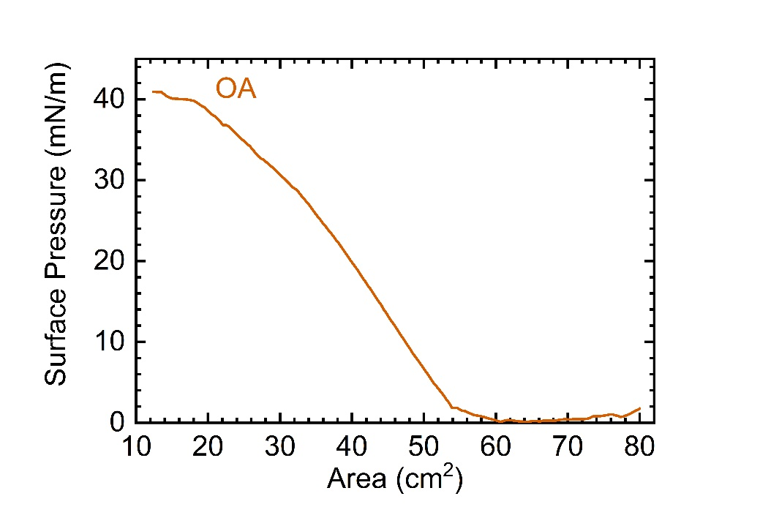
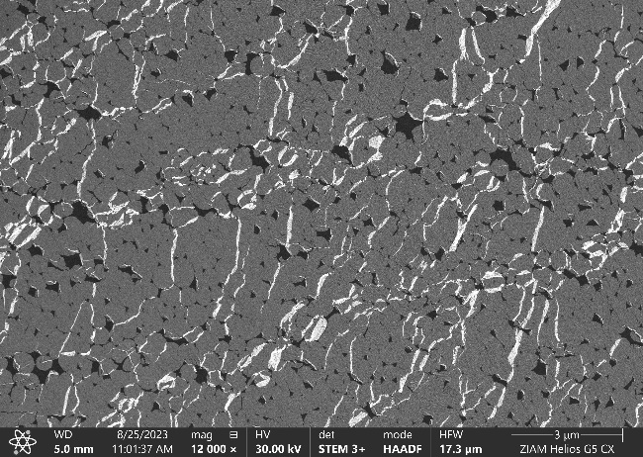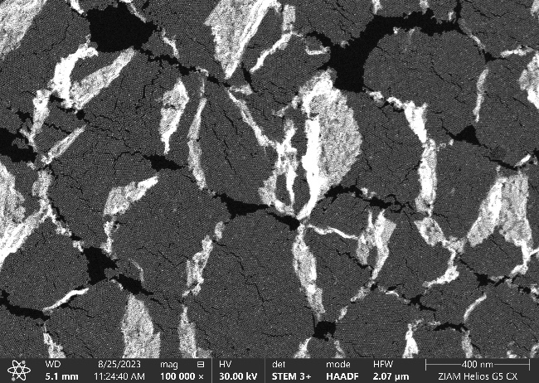
Figure S1. Isotherm (Top) and STEM-HAADF micrographs (bottom) at different magnifications of a highly compressed (40 mN/m) OA sample as in Figure 1f from the main text.

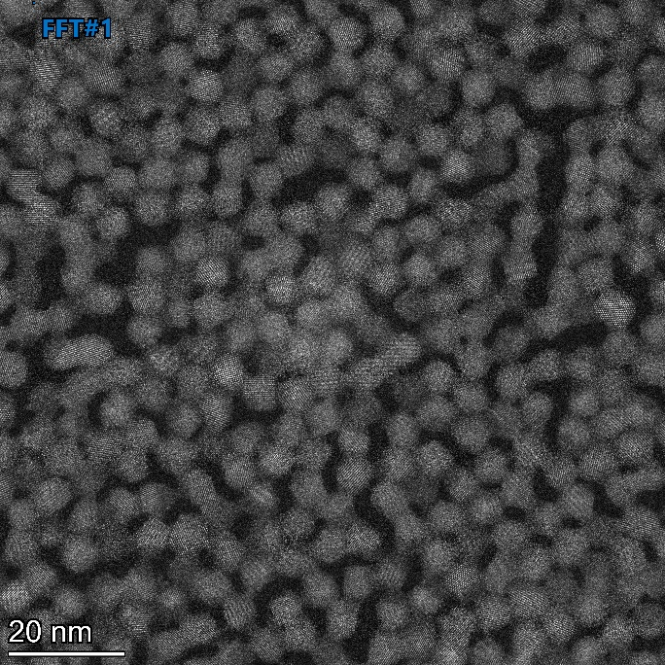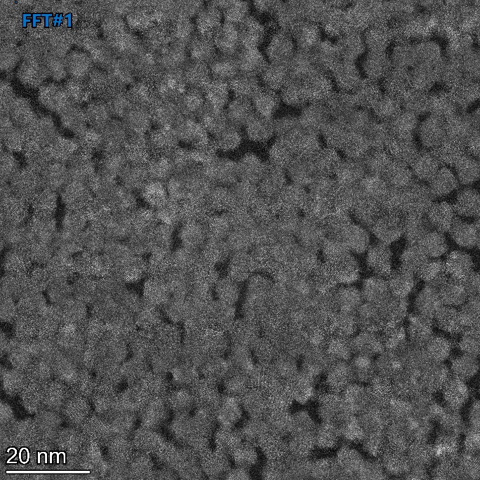
Figure S2. Atomic resolution STEM-HAADF micrographs of the LC SL (Left) and HC SL (Right) respectively.

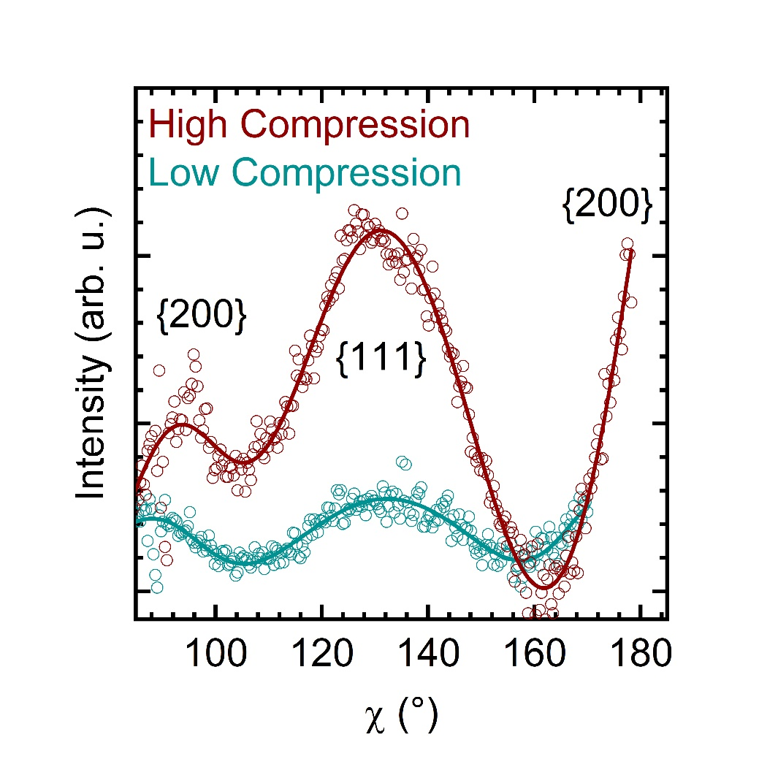
Figure S3. GIWAXS azimuthal profiles (χ-cuts) of the {111}_{AL} and {200}_{AL} peaks for the low and high compression superlattices. The circles represent the raw data while the continuous line is a superposition of Gaussian peaks after background subtraction.

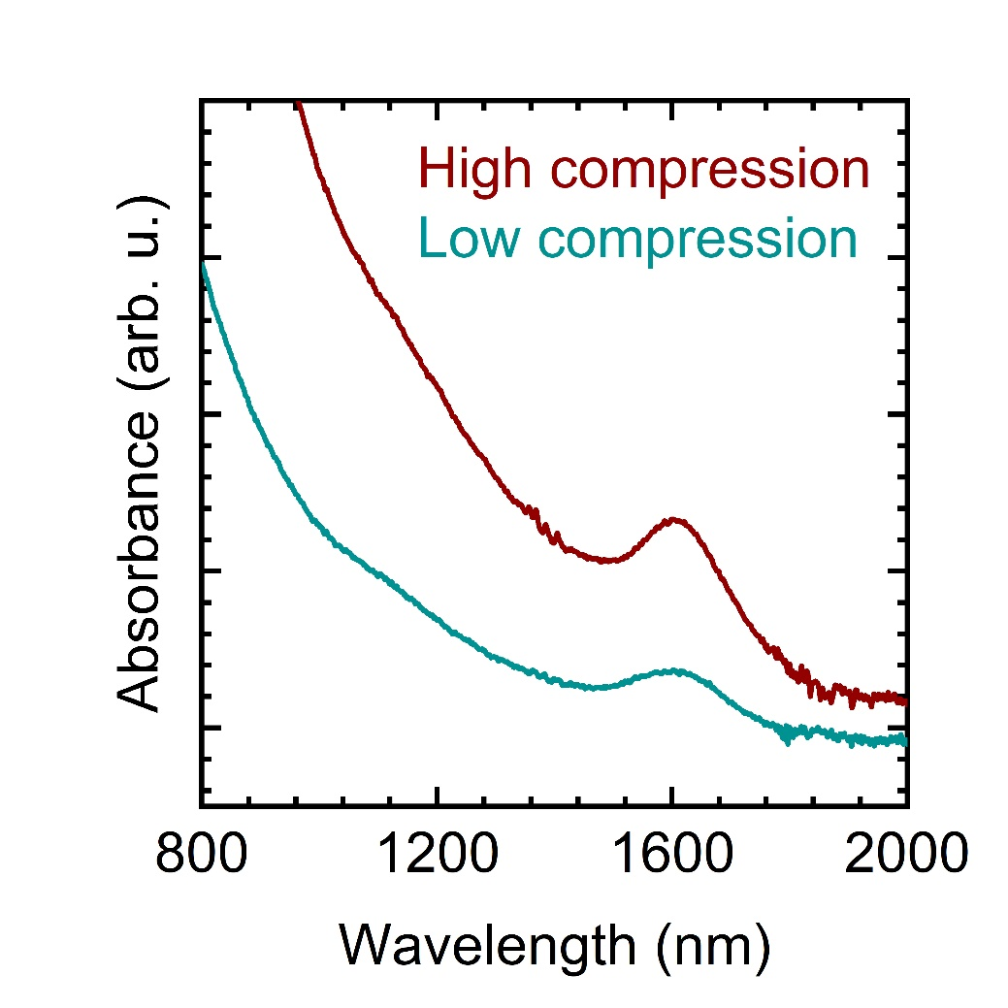
Figure S4. Absorption spectra of the low and high compression superlattices displaying the retained quantum confinement.

Figure S5. AFM micrograph of the HC superlattice showing little fraction of buckling and mostly mono-layered coverage.

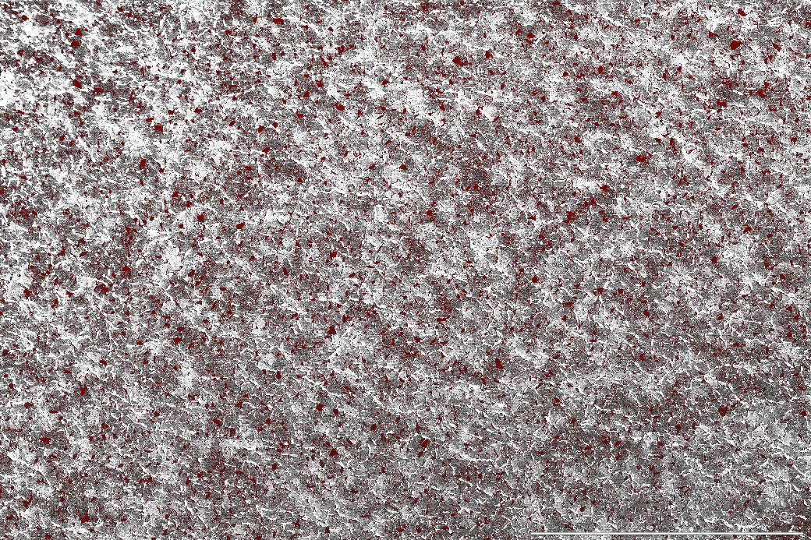
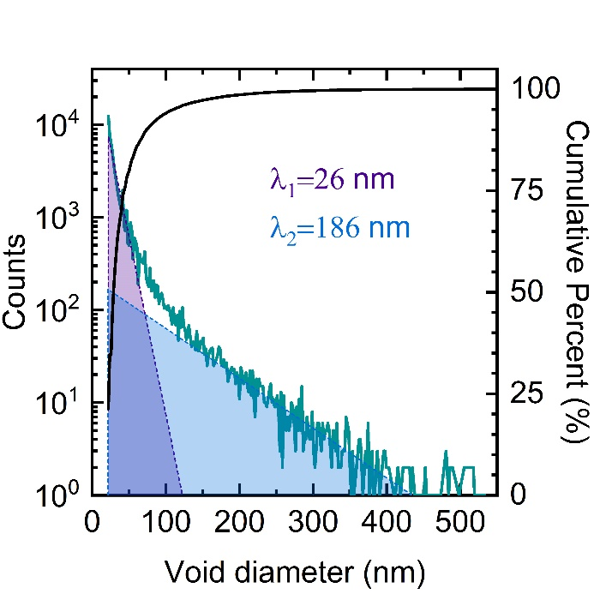
Figure S6. Quantitative analysis of the void distribution in low magnification SEM micrographs (Top, scale bar 20 µm). The raw images are first levelled, corrected for strikes and artefacts and the contrast is enhanced in the software Gwyddion. The voids are then selected and masked by arbitrarily choosing the threshold level which is different for every image depending on the acquisition conditions. The projected areas are extracted and converted into void diameters supposing a circular shape for simplicity. All the points with a radius equal to or smaller than a single pixel are excluded from the analysis as they are an artefact of the threshold selection. (Bottom) The obtained distribution is then plotted and fitted with two exponential distribution functions (Equation 2 from the main text). The analysis was repeated for 5 images of each condition for the statistical significance of all the extracted parameters.
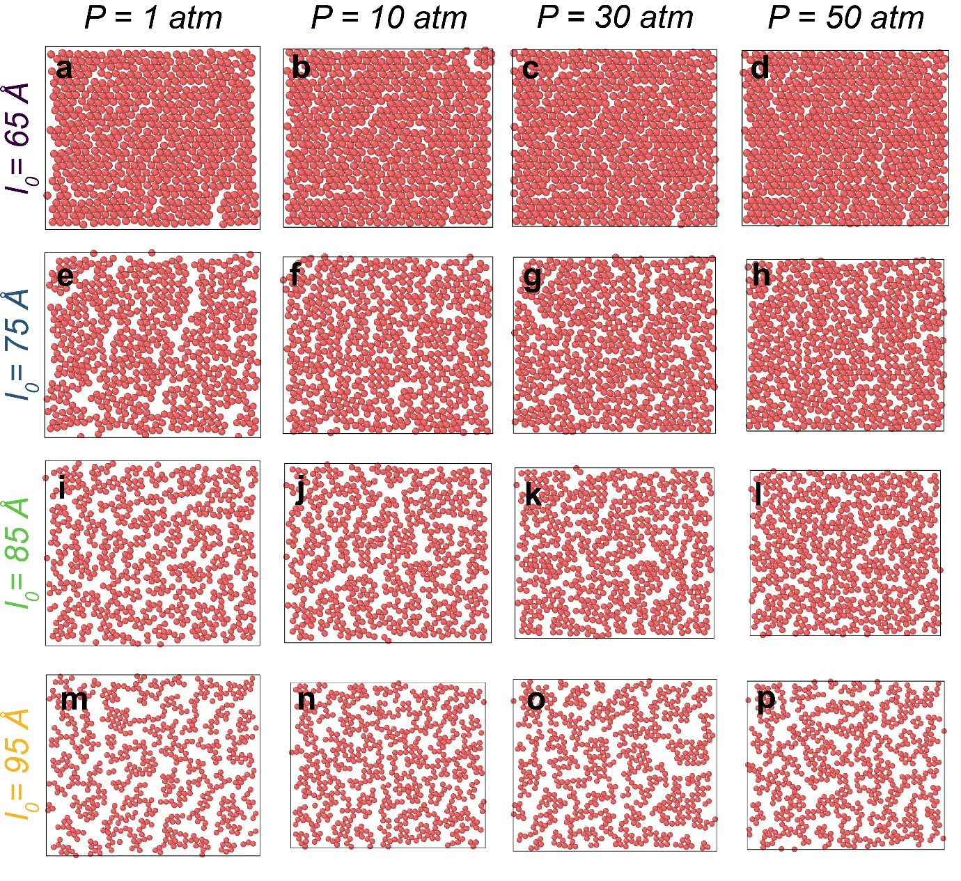
Figure S7. Snapshots of the MD simulations in the colloidal representation as a function of the starting distance l₀ and of the external pressure P.
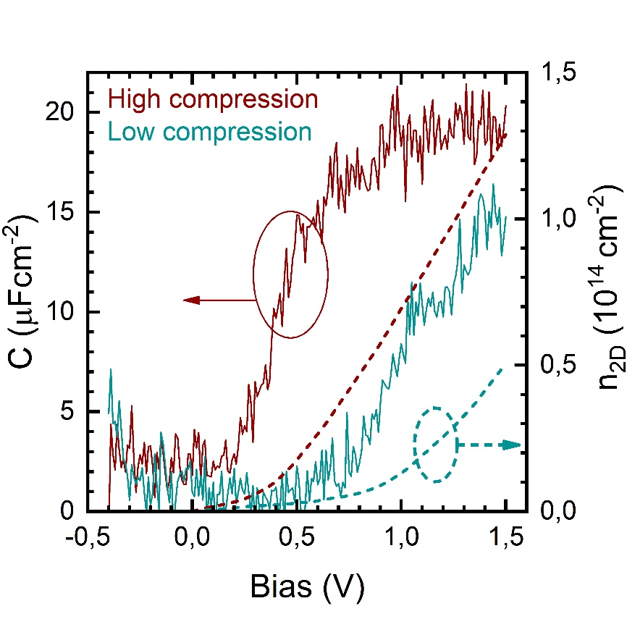
Figure S8. Exemplary bias-dependent capacitance measurements and charge accumulation estimation for the low and high compression superlattices. The impedance data was acquired directly on the ion-gel gated FETs by connecting the Pt foil gate and the drain-source electrodes (shorted together). The continuous lines indicate the specific capacitance curves (left axis) while the dashed lines indicate the accumulated carrier density (right axis) in the stack as a function of voltage applied to the gate.

Table S1. Summary of the measured specific capacitances for all the devices in Figure 5d of the main text. Each device contains 5 different pairs of electrodes with different channel lengths that are measured independently.
Device | Capacitance (µFcm⁻²)
Device | Low compression | High compression
1 | 16.9±0.9 | 16.4±0.5
2 | 4.0±0.1 | 16.9±0.4
3 | 15.0±0.6 | 8.0±0.2
4 | - | 15.1±0.3

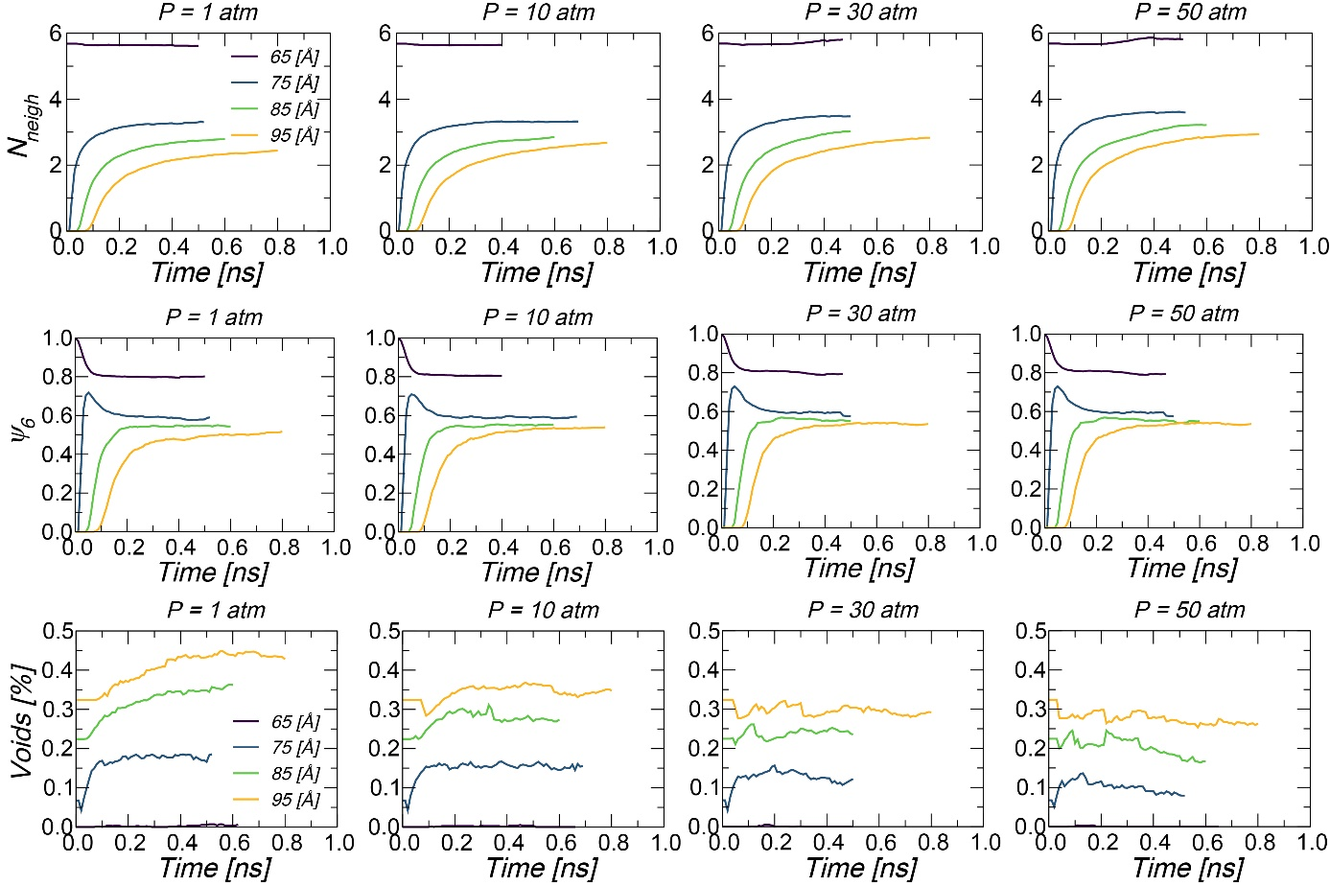
Figure S9. Exemplary equilibration curves for the three measured parameters in Figure 4 as a function of starting QD distance and external pressure.

