Supplementary materials for:
Prospects for pastoralist-farmer conflict in Africa
Mostafa Khorsandi^{1,2,3} *, Erwann Fillol⁴, Andrew Smerald⁵, Klaus Butterbach-Bahl^{3,5,6}, Jaber Rahimi^{3,5*}
1- Centre Eau Terre Environnement, Institut national de la recherche scientifique, 490 rue de la Couronne Street, Québec, Québec, Canada, G1K 9A9.
2- Canadian Rivers Institute, University of New Brunswick, Fredericton, NB E3B 5A3, Canada.
3- Land-CRAFT Center, Department of Agroecology, Aarhus University, Aarhus, Denmark.
4- Action Against Hunger (AAH), Regional Office for Western and Central Africa, Dakar, Senegal
5- Karlsruhe Institute of Technology (KIT), Institute of Meteorology and Climate Research, Atmospheric Environmental Research (IMK-IFU), Garmisch-Partenkirchen, Germany
6- International Livestock Research Institute (ILRI), Mazingira Centre, Nairobi, Kenya.

This section shows the supplementary supporting materials derived or used in the current study.

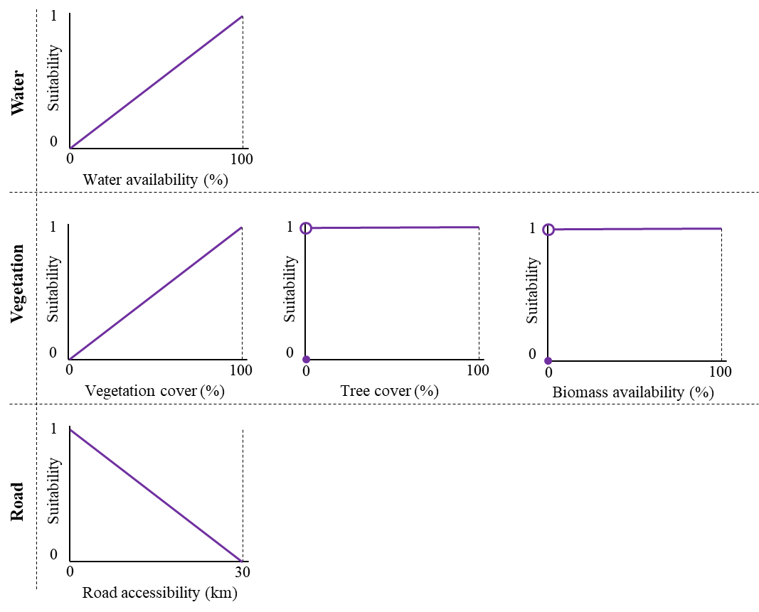
Figure S1: Fuzzy membership functions for transhumance suitability based on water availability, vegetation cover, tree cover, biomass availability, and road accessibility conditions ¹.

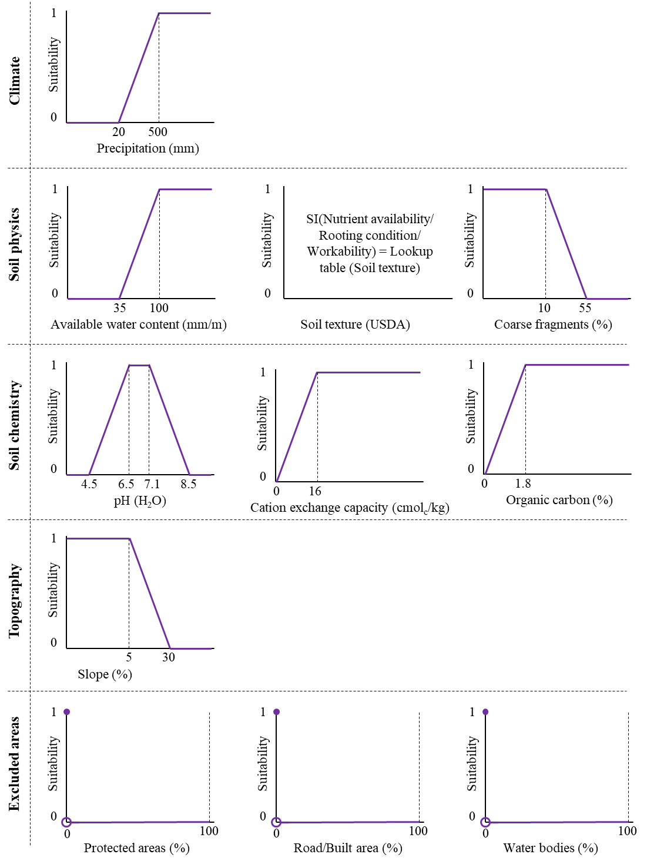
Figure S2: Fuzzy membership functions for agriculture suitability based on climatic, soil, topography conditions, and excluded areas^{2,3}.

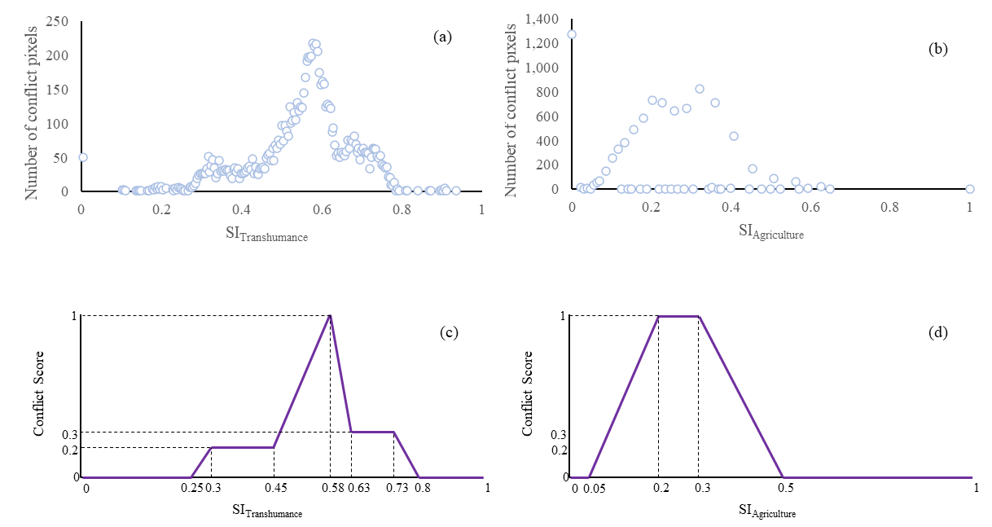
Figure S3: Distribution of the pastoralist-related conflicts into (a) transhumance suitability and (b) agriculture suitability classes. The SaSu can be partitioned and scored in three zones using fuzzy inference. Panels (c) and (d) show the derived fuzzy functions based on the distribution of conflict pixels into SI_{Transhumance} and SI_{Agriculture} maps and their suitability index.
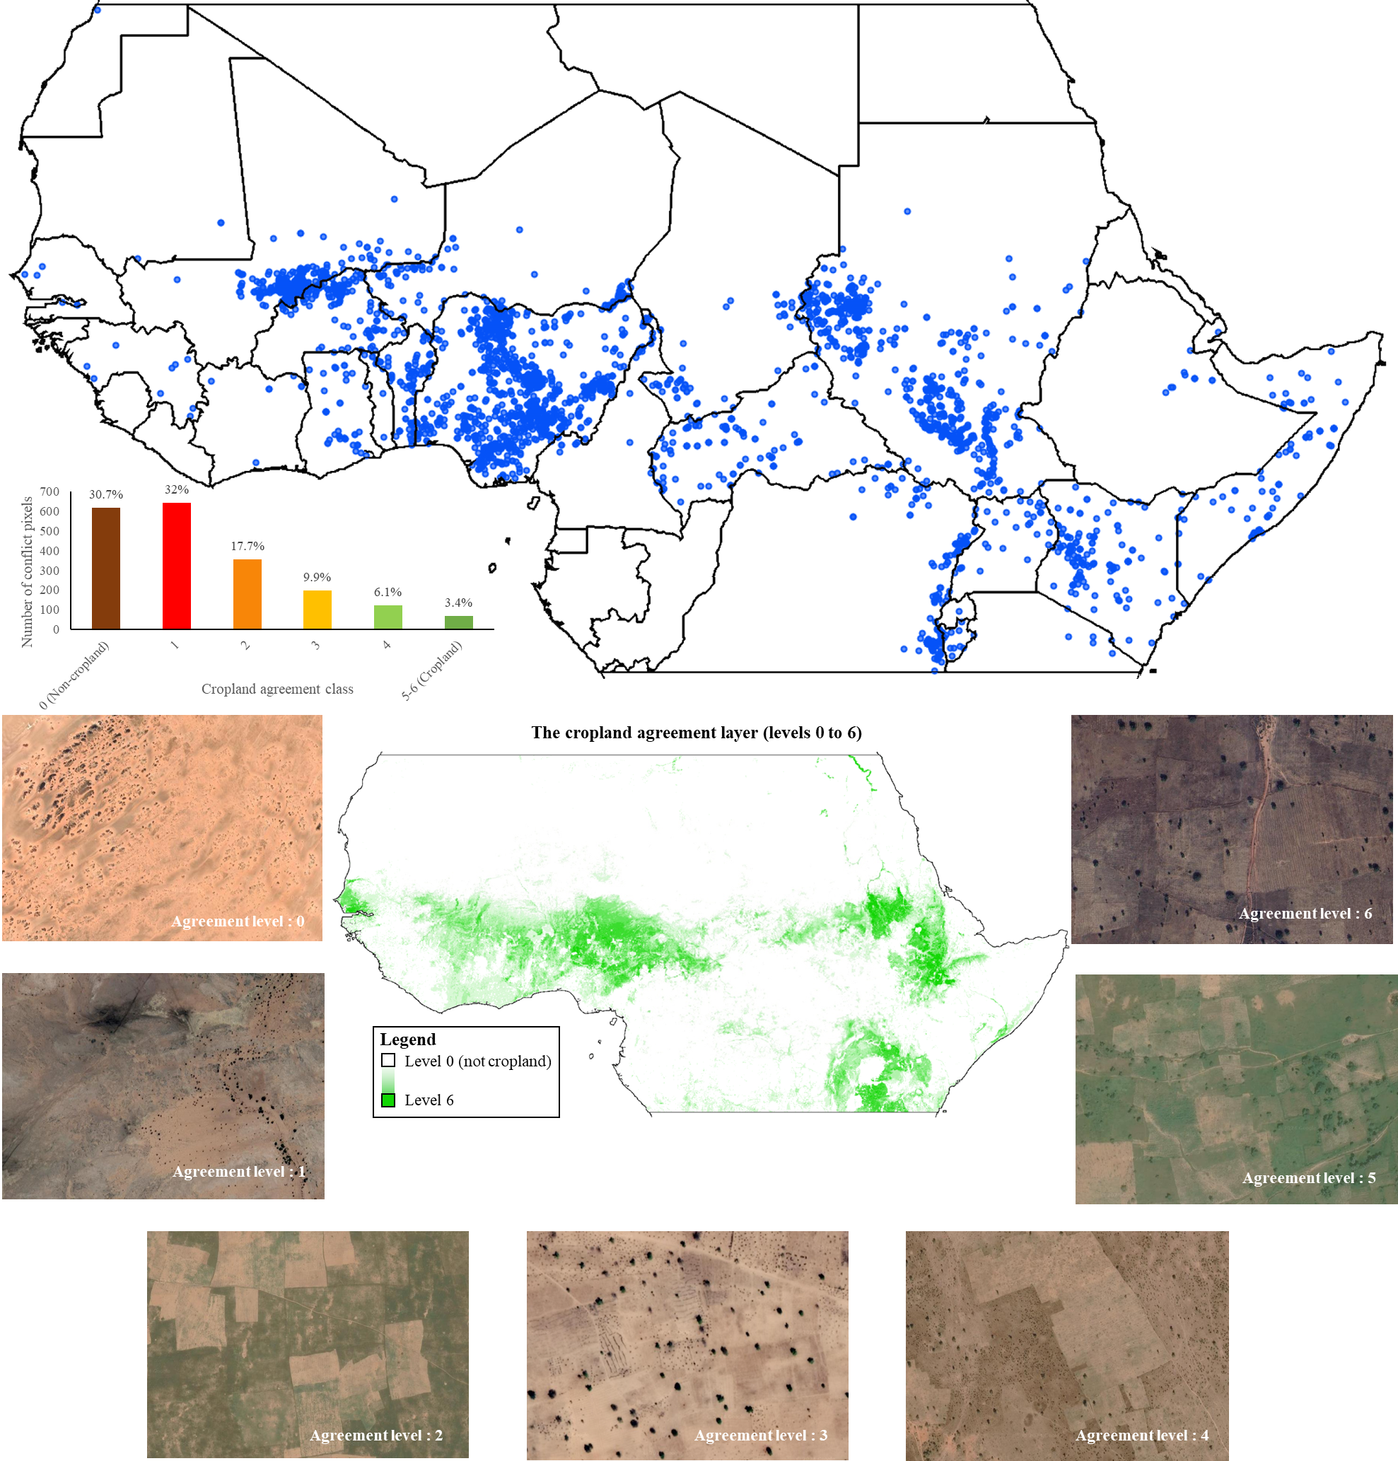
Figure S4: The spread of pastoralist-related conflict in Sub-Saharan Africa. The figure shows the country borders and distribution of pastoralist-related conflict locations in SaSu (2001-2020) classified by cropland agreement classes. The snapshots showcase random conflict locations, aligning cropland agreement classes with the quality of the land for agriculture and providing insights into the actors involved. Images are derived from GEE base maps.

Table S1: List of maps used for qualitative validation of transhumance suitability map.
Name | Reference title
Map 1 | Système d’information sur le pastoralisme au Sahel: Atlas des évolutions des systèmes pastoraux au Sahel 1970-2012 | ⁴⁻⁶
Map 2 | West and cental africa regional migration health roadmap | ⁷
Map 3 | The social uses of livestock among pastoralists in Sudan: Food systems, stores of value, wealth, power, and authority | ⁸
Map 4 | The security challenges of pastoralism in central Africa | ⁹
Map 5 | The Nuer pastoralists: between large scale agriculture and villagization: a case study of the Lare District in the Gambella Region of Ethiopia | ¹⁰
Map 6 | Évolution des transhumances | ⁴⁻⁶
Map 7 | Toward climate-smart agriculture in West Africa: a review of climate change impacts, adaptation strategies and policy developments for the livestock, fishery and crop production sectors | ¹¹
Map 8 | La terre est finie! Quel avenir pour le pastoralisme en Afrique de l’Ouest? | ¹²
Map 9 | Climate change and farmer–herder conflicts in west Africa | ¹³
Map 10 | Cartographie des transhumants bloques – impacts et risques | https://dtm.iom.int/
Map 11 | Livestock systems in Mali | ⁴
Map 12 | Cattle's Routes of Transhumance in Burkina Faso | ¹⁴
Map 13 | Transhumance corridors, grazing areas and entry points of Burkina Faso transhumant herds through Benin | ¹⁵
Map 14 | The Dynamics and Impacts of Transhumance  and Neo-Pastoralism on Biodiversity,  Local Communities and Security: Congo Basin | ¹⁶
Map 15 | Bulletin de la situation pastorale Benin mars 2019 | Action contre la faim
Map 16 | Monitoring changes in pastoral resources in eastern Sudan: A synthesis of remote sensing and local knowledge | ¹⁷
Map 17 | Mobility mapping in Chad | ¹⁸
Map 18 | Open Access, Open Systems: Pastoral Management of Common-Pool Resources in the Chad Basin | ¹⁹
Map 19 | Situation pastorale dans la region de l'est, Burkina Faso | Action contre la faim
Map 20 | Challenges of transhumance in Northwest Cameroon | ²⁰
Map 21 | Transhumance hotspots in the CAR | World Food Program 2022
Map 22 | Cattle transhumance and agropastoral nomadic herding practices in Central Cameroon | ²¹
Map 23 | Pastoralism and Security in West Africa and the Sahel: Towards Peaceful Coexistence | ²²
Map 24 | Transhumance corridors in the Central African Republic | ¹⁶
Map 25 | Cross-border transhumance, conservation and security in Central Africa | ¹⁶
Map 26 | Transhumance Routes & Grazing Resource | ICPALD, GIS and RS Unit, 2019
Map 27 | Bulletin de la situation pastorale Mauritanie mars - 2018 | Action contre la faim
Map 28 | Des indicateurs spatialisés des transhumances pastorales au Ferlo | ²³
Map 29 | Map of Benin (and Africa) indicating the cotton growing zones, main transhumance routes and location of the three study areas. | ²⁴
Map 30 | Carte des axes de transhumance dans le Sahel burkinabé / Map of transhumance  routes in the Sahel of Burkina Faso | ²⁵
Map 31 | Strengthening the Livelihoods Resilience of Pastoral and AgroPastoral Communities in South Sudan’s cross-border areas with  Sudan, Ethiopia, Kenya and Uganda | ²⁶
Map 32 | Strengthening Community Managed Drought Risk Reduction in Northern Kenya and Southern Ethiopia (SCMDRR)-Mapping of grazing corridors for the Garre and Degodia clans in Wajir and Mandera Counties in Northern Kenya and MoyaleDolo Ado | ²⁷
Map 33 | The projected LAPSSET corridor and current mobility patterns of pastoral communities | ²⁸
Map 34 | Promising resilience practices: Demarcation of livestock routes | IGAD
Map 35 | Importance of Livestock Routes for Local, National and Regional Development: Their Mapping, Serving & Protection | ²⁹
Map 36 | Mapping Potential Amplification and Transmission Hotspots for MERS-CoV, Kenya | ³⁰
Map 37 | Food security master plan for Turkana County | ³¹

References
1 Schwarz, M. et al. Assessing the Environmental Suitability for Transhumance in Support of Conflict Prevention in the Sahel. Remote Sensing 14, 1109 (2022).
2 Fischer, G. et al. Global Agro-ecological Zones (GAEZ v4)-Model Documentation. (2021).
3 Mesgaran, M. B., Madani, K., Hashemi, H. & Azadi, P. Iran’s land suitability for agriculture. Scientific reports 7, 7670 (2017).
4 Touré, I., Ickowicz, A., Wane, A., Garba, I. & Gerber, P. Systeme d'information sur le pastoralisme au Sahel. Atlas des evolutions des systemes pastoraux au Sahel 1970-2012. (2012).
5 Opitz-Stapleton, S. Transboundary climate risks to african dryland livestock economies. (2023).
6 Simonet, C. & Carabine, E. (SPARC Policy Brief, 2021).
7 (IOM), I. O. f. M. West and cental africa regional migration health roadmap. (2020).
8 Ahmed, A. G. M. The social uses of livestock among pastoralists in Sudan: Food systems, stores of value, wealth, power, and authority. CMI Sudan Working Paper (2014).
9 Group, I. C. The security challenges of pastoralism in central Africa. (2014).
10 Seide, W. M. The Nuer pastoralists: between large scale agriculture and villagization: a case study of the Lare District in the Gambella Region of Ethiopia. (Nordiska Afrikainstitutet, 2017).
11 Zougmoré, R. et al. Toward climate-smart agriculture in West Africa: a review of climate change impacts, adaptation strategies and policy developments for the livestock, fishery and crop production sectors. Agriculture & Food Security 5, 26 (2016). https://doi.org/10.1186/s40066-016-0075-3
12 Gonin, A. La terre est finie! Quel avenir pour le pastoralisme en Afrique de l’Ouest? Métropolitique. eu, 5-6 (2017).
13 Cabot, C. & Cabot, C. Climate change and farmer–herder conflicts in west Africa. Climate Change, Security Risks and Conflict Reduction in Africa: A Case Study of Farmer-Herder Conflicts over Natural Resources in Côte d’Ivoire, Ghana and Burkina Faso 1960–2000, 11-44 (2017).
14 Diagbouga, S. et al. Mycobacterium bovis prevalence in humans does not differ between regions in Burkina Faso. Arch. Clin. Microbiol 8 (2017).
15 Ouedraogo, A. S. et al. Cross border transhumance involvement in ticks and tick-borne pathogens dissemination and first evidence of Anaplasma centrale in Burkina Faso. Ticks and Tick-borne Diseases 12, 101781 (2021). https://doi.org/https://doi.org/10.1016/j.ttbdis.2021.101781
16 Léonard, U. B., MOUSSA. The Dynamics and Impacts of Transhumance and Neo-Pastoralism on Biodiversity, Local Communities and Security: Congo Basin. (2021).
17 Sulieman, H. M. & Ahmed, A. G. M. Monitoring changes in pastoral resources in eastern Sudan: A synthesis of remote sensing and local knowledge. Pastoralism: Research, Policy and Practice 3, 22 (2013). https://doi.org/10.1186/2041-7136-3-22
18 Migration, I. O. f. Mobility mapping in Chad. (2022).
19 Moritz, M., Scholte, P., Hamilton, I. M. & Kari, S. Open Access, Open Systems: Pastoral Management of Common-Pool Resources in the Chad Basin. Human Ecology 41, 351-365 (2013). https://doi.org/10.1007/s10745-012-9550-z
20 Mbih, R. A., Ndzeidze, S. K., Wanyama, D. & Mbuh, M. J. Challenges of transhumance in Northwest Cameroon. SN Social Sciences 2, 208 (2022). https://doi.org/10.1007/s43545-022-00515-4
21 Motta, P. et al. Cattle transhumance and agropastoral nomadic herding practices in Central Cameroon. BMC Veterinary Research 14, 214 (2018). https://doi.org/10.1186/s12917-018-1515-z
22 Higazi, A. & Abubakar Ali, S. Pastoralism and Security in West Africa and the Sahel: Towards Peaceful Coexistence. (2018).
23 Leclerc, G. & Sy, O. Des indicateurs spatialisés des transhumances pastorales au Ferlo. Cybergeo: European Journal of Geography (2011).
24 Dossouhoui, G. I. A., Yemadje, P. L., Diogo, R. V. C., Balarabe, O. & Tittonell, P. “Sedentarisation” of transhumant pastoralists results in privatization of resources and soil fertility decline in West Africa's cotton belt. Frontiers in Sustainable Food Systems 7 (2023). https://doi.org/10.3389/fsufs.2023.1120315
25 Kiema, A., Tontibomma, G. B. & Zampaligré, N. Transhumance et gestion des ressources naturelles au Sahel: contraintes et perspectives face aux mutations des systèmes de productions pastorales. VertigO 14 (2014).
26 IGAD, G. Strengthening the Livelihoods Resilience of Pastoral and AgroPastoral Communities in South Sudan’s cross-border areas with Sudan, Ethiopia, Kenya and Uganda. (2014).
27 Wamugi, I. & Muchemi, J. Strengthening Community Managed Drought Risk Reduction in Northern Kenya and Southern Ethiopia (SCMDRR)-Mapping of grazing corridors for the Garre and Degodia clans in Wajir and Mandera Counties in Northern Kenya and MoyaleDolo Ado. Filtu and Hudet Woredas in Southern Ethiopia (2011).
28 Flintan, F., Behnke, R. & Neely, C.
29 Flintan, F. Importance of Livestock Routes for Local, National and Regional Development: Their Mapping, Serving & Protection. (2015).
30 Gikonyo, S. et al. Mapping Potential Amplification and Transmission Hotspots for MERS-CoV, Kenya. EcoHealth 15, 372-387 (2018). https://doi.org/10.1007/s10393-018-1317-6
31 Oduor, A. et al. Food security master plan for Turkana County. Diocese of Lodwar, Lodwar (2012).

