Supplementary material
Supplementary Table 1. Additional information on the baseline characteristics of the identified studies
Study | Follow up time | Age (mean) | Female  (%) | NT-pro BNP (pg/mL) | HF/  LVEF (%) | eGFR  mL/min/1.73m2 | DM (%) /HbA1c | SBP (mmHg) | MI  (%) | ACEI/  ARB  (%) | ARNI  (%) | MRA  (%)
CANVAS PROGRAM  (Canagliflozin) | 188.2 weeks | C:63.2±8.3  P:63.4±8.2 | C:35.1  P:36.7 | NA | C:13.9/NA  P:15.1/NA | C:76.7±20.3  P:76.2±20.8 | C:100/8.2±0.9  P:100/8.2±0.9 | C:136.4±15.8  P: 136.9±15.8 | C:55.8  P:57.2 | RAAS medication *  C:80.2  P:79.8
DECLARE-TIMI 58  (Dapagliflozin) | 4.2 years | D:63.9±6.8  P:64.0±6.8 | D:36.9  P:27.9 | NA | D:9.9/NA  P:10.2/NA | D:85.4±15.8  P:85.1±16.0 | D:100/8.3±1.2  P:100/8.3±1.2 | D: 135.1±15.3  P: 134.8±15.5 | D:32.9  P:33 | D:81.3  P:81.3 | NA | NA
DEFINE-HF  (Dapagliflozin) | 13 weeks | D:62.2±11  P:60.4±12 | D:27.5  P:25.8 | D:1136  P:1136 | D:100/27.2±8.0  P:100/25.7±8.2 | D:66.9±21.1  P:71.2±23.1 | D:61.8/7.0±1.8  P:64.4/7.3±2.0 | NA | NA | D:58  P:60.6 | D:35.9  P:28.8 | D:58  P:63.3
DAPA-HF  (Dapagliflozin) | 18.2 months | D:66.2±11.0  P:66.5±10.8 | D:23.8  P:23.0 | D:1428  P:1446 | D: 100/31.2±6.7  P: 100/30.9±6.9 | D: 66.0±19.6  P: 65.5±19.3 | D:41.8/NA  P:41.8/NA | D: 122.0±16.3  P: 121.6±16.3 | NA | D:84.5  P:82.8 | D:10.5  P:10.9 | D:71.5  P:70.6
EMPA-REG OUTCOME  (Empagliflozin) | 3.1 years | E: 63.1 ± 8.6  P: 63.2 ± 8.8 | E:28.8  P:28 | NA | E:9.9/NA  P:10.5/NA | E: 74.2 ± 21.6  P: 73.8 ± 21.1 | E: 100/8.07 ± 0.85  P: 100/8.08 ± 0.84 | E: 135.3 ± 16.9  P: 135.8 ± 17.2 | E:46.7  P:46.4 | E:81  P:80.1 | NA | E:6.5  P:5.8
EMPA-RESPONSE-AHF  (Empagliflozin) | 12 weeks | E:79  P:73 | E:40  P:16 | E:4406  P:6168 | E:100/36±17  P:100/37±14 | E:55±18  P:55±18 | E:38/NA  P:28/NA | E: 127±22  P: 121±25 | E:30  P:38 | E:45  P:50 | E:5  P:3 | E:48  P:45
EMPEROR-Reduced  (Empagliflozin) | 16 months | E:67.2±10.8  P:66.5±11.2 | E:23.5  P:24.4 | E:1887  P:1926 | E:100/27.7±6.0  P:100/27.2±6.1 | E:61.8±21.7  P:62.2±21.5 | E:49.8/NA  P:49.8/NA | E: 122.6±15.9  P: 121.4±15.4 | NA | E:70.5  P:68.9 | E:18.3  P:20.7 | E:70.1  P:72.6
VERTIS-CV  (Ertugliflozin) | 3.5 years | Er: 64.4±8.1  P: 64.4±8.0 | Er:29.7  P:30.7 | NA | Er:23.4/NA  P:24.5/NA | Er: 76.1±20.9  P: 75.7±20.8 | Er: 100/8.2±1.0  P: 100/8.2±0.9 | Er: 133.5±13.7  P: 133.1±13.9 | Er:47.7  P:48.4 | Er:80.9  P:81.5 | NA | Er:8.2  P:8.2
SOLOIST-WHF  (Sotagliflozin) | 9 months | S:69  P:70 | S:32.6  P:34.9 | S:1816.8  P:1741 | S:100/35  P:100/35 | S:49.2  P:50.5 | S:100/7.1  P:100/7.2 | S:122  P:122 | NA | S:82.1  P:83.3 | S:15.3  P:18.2 | S:66.3  P:62.7
SCORED  (Sotagliflozin) | 16 months | S:69  P:69 | S:44.3  P:45.5 | S:196  P:198.1 | S:19.9/NA  P:19.9/NA | S:44.4  P:44.7 | S:NA/8.3  P:NA/8.3 | S:138  P:139 | S:19.9  P:20 | S:87.5  P:86.9 | S:1.2  P:1.2 | S:15.3  P:14.7
*Any RAAS inhibitor including ACEI/ARB, ARNI and MRA. NT-pro BNP , N- terminal pro-brain natriuretic peptide; HF, heart failure; LVEF, left ventricular ejection fraction; eGFR, estimated Glomerular filtration rate; DM, diabetes mellitus; SBP, systolic blood pressure; MI, myocardial infarction; ACEI, angiotensin Converting Enzyme Inhibitors; ARB, angiotensin receptor blocker; ARNI, angiotensin receptor-neprilysin inhibitor; MRA, mineralocorticoid receptor antagonist; NA, not applicable (a lack of outcomes reported in the original studies), C, canagliflozin; P, placebo; D, dapagliflozin; E, empagliflozin; Er, ertugliflozin; S, sotagliflozin.

Supplementary Figures

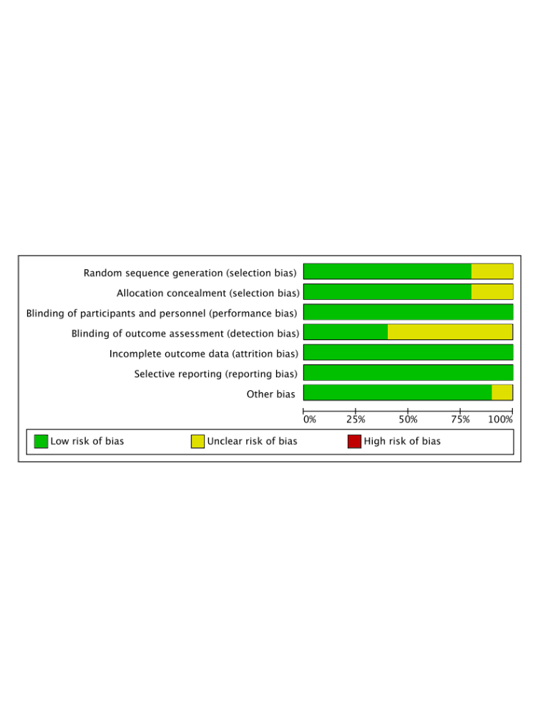

Figure 1. Risk of bias assessment

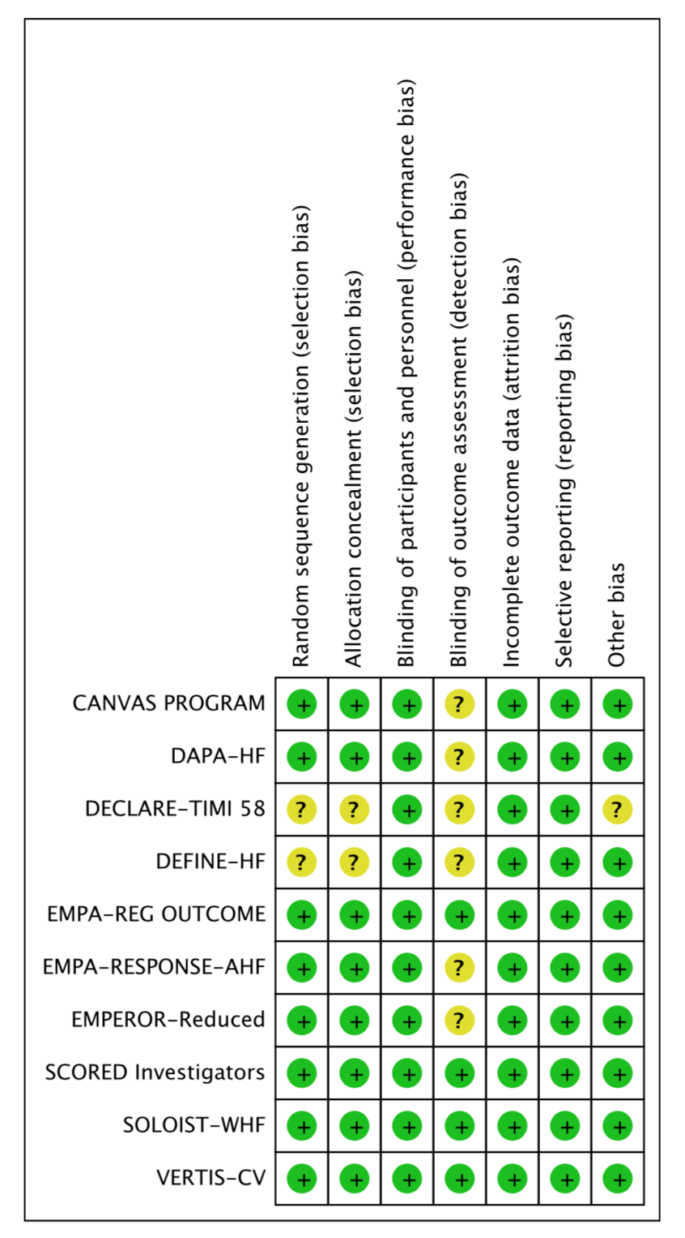
Figure 2. Risk of bias assessment of included trials

