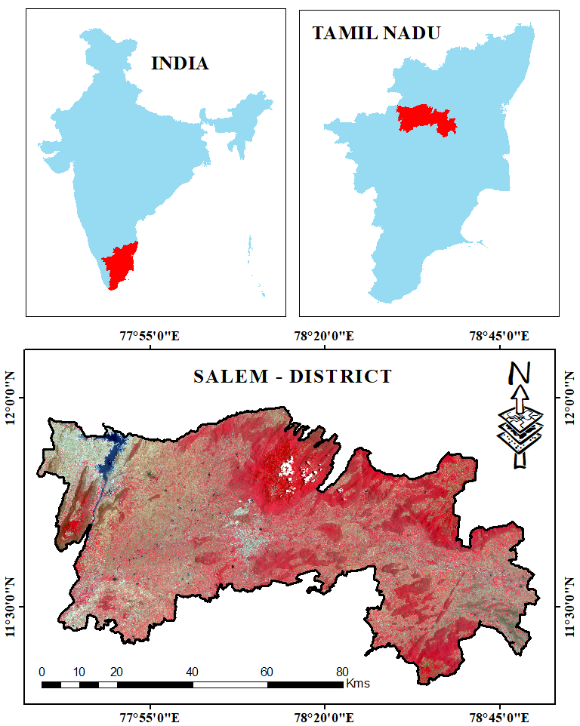

Map. 1 Study Area Map - Salem District

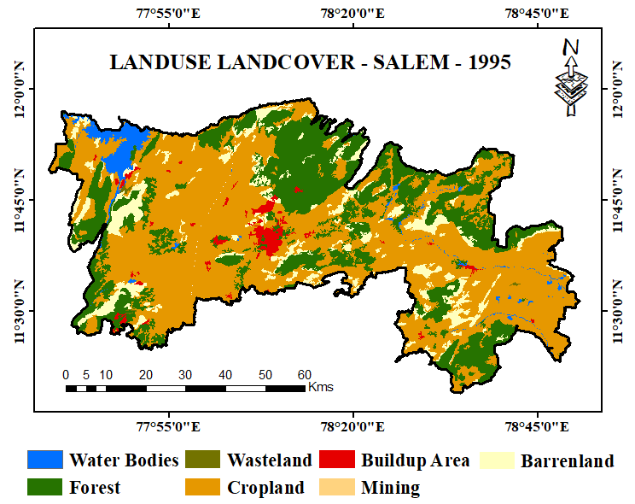  Map. 2 Landuse Landcover of Salem - 1995 | 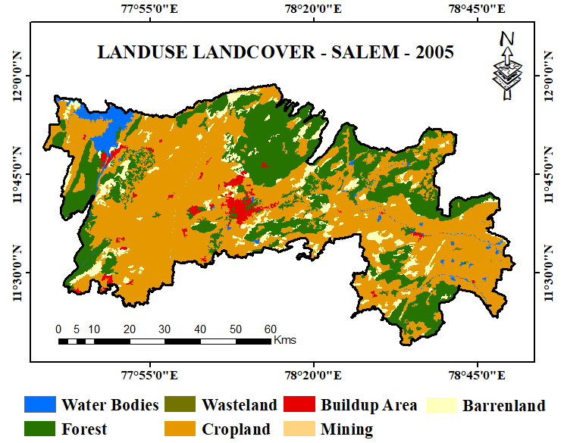  Map. 3 Landuse Landcover of Salem - 2005
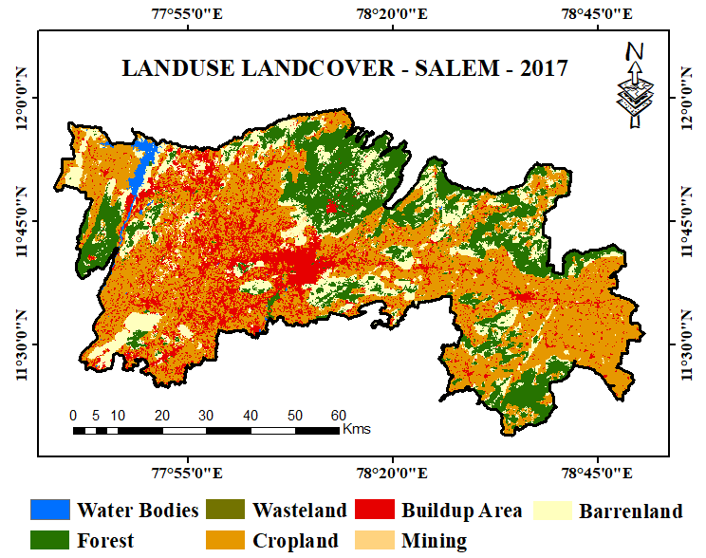  Map. 4 Landuse Landcover of Salem - 2017 | 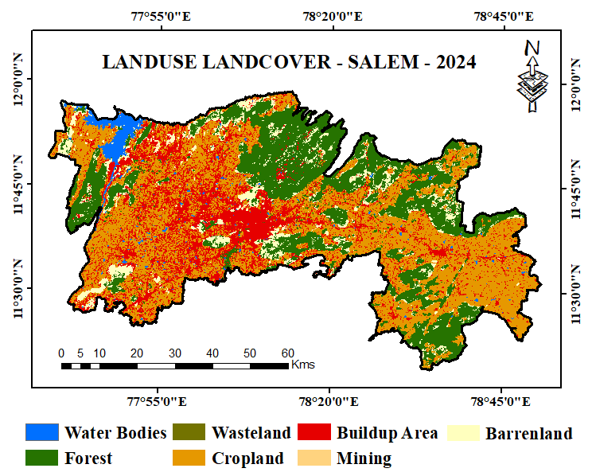  Map. 5 Landuse Landcover of Salem - 2024
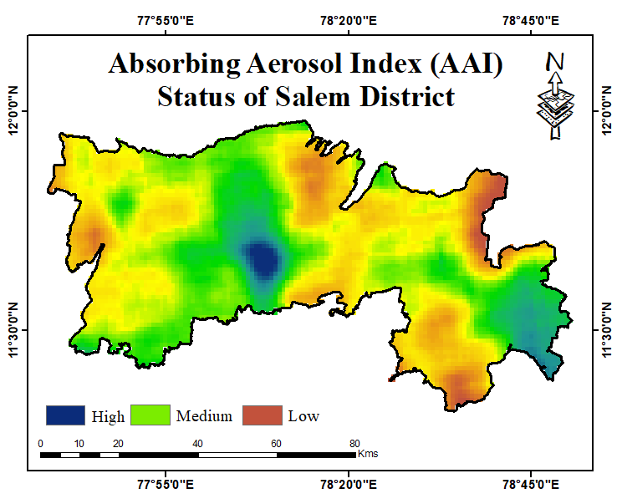
Map - 6. AAI Status of Salem district
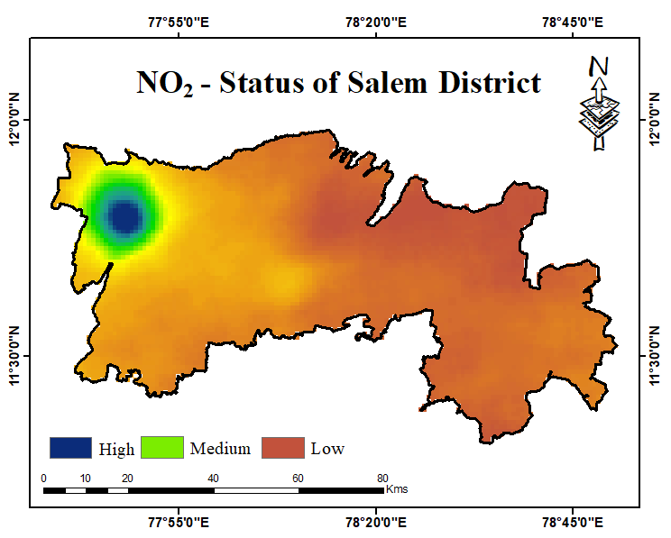  Map - 7. NO2 Status of Salem district | 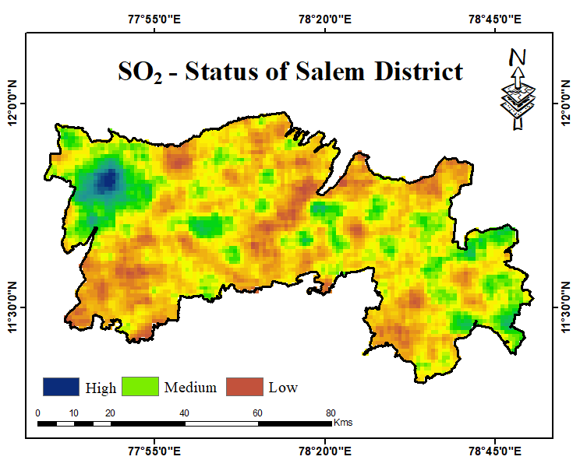  Map - 8. SO2 Status of Salem district
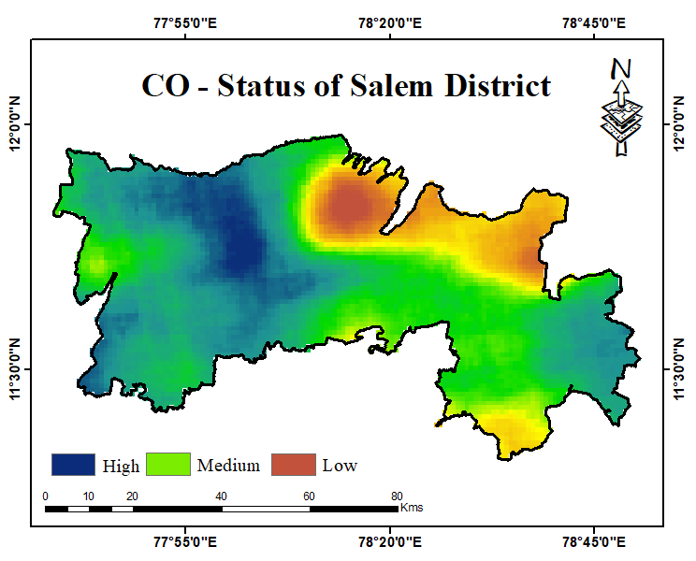  Map - 9. CO Status of Salem district | 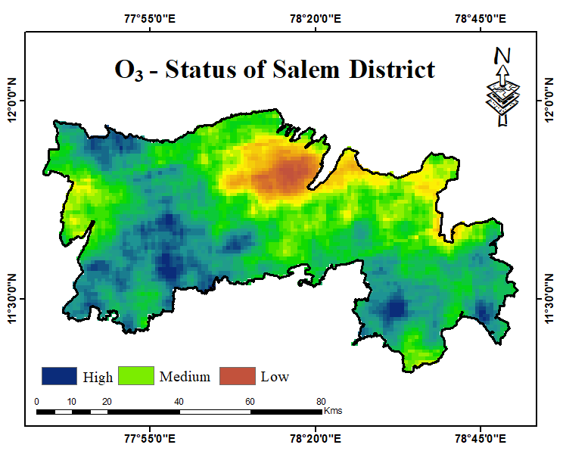  Map - 10. O3 Status of Salem district

