Network Pharmacology, Molecular Docking, Molecular Dynamics Simulation and Experiment Verification Analysis to Reveal the Action Mechanism of RenShen Guipi Wan in treating Anaemia

Tingli Qu ^{1,2,3}, Nan Zhang ³, Chen Li ³, Xuyuan Liu ^{4*}, Keming Yun ^{2*}, and Quan An ^{1*}
¹ China Institute for Radiation Protection, Taiyuan, China; ² School of Forensic Medicine, Shanxi Medical University, Taiyuan, China; ³ School of Pharmaceutical Science, Shanxi Medical University, Taiyuan, China; ⁴ Department of pharmaceutical, Shanxi Bethune Hospital, Shanxi Academy of Medical Sciences, Third Hospital of Shanxi Medical University, Tongji Shanxi Hospital, Taiyuan, China

*Corresponding author: Keming Yun, E-mail: yunkeming5142@163.com.

Table S1 Identification of chemical components in RGW by UPLC-Q Exactive Orbitrap-HRMS
No. | t_{R}/min | Formular | [M-H]⁻/[M+H]⁺ | Error/×10⁻⁶ | MS/MS | compound | Class | Source
1 | 1.95 | C₁₁H₁₂N₂O₂ | 203.0829 | -6.89 | 186.0563, 159.0928, 142.0663,116.0506 | Tryptophan | Amino acids | 4,5
2 | 1.97 | C₁₁H₉NO₂ | 188.0703 | 1.60 | 170.0597, 146.0598, 118.0651 | Indole-3-acrylic acid | Volatile oils | 4,5
3 | 2.16 | C₁₆H₁₈O₉ | 353.0881 | -3.97 | 191.0564,179.0357, 135.0452 | Neochlorogenic acid | Organic acids | 10
4 | 2.34 | C₉H₁₀O₃ | 165.0557 | -6.66 | 147.0448, 121.0659, 93.0346 | Dihydrocaffeic acid | Organic acids | 10
5 | 2.37 | C₂₂H₃₀O₁₄ | 517.1567, | -2.90 | 337.0924, 193.0509, 175.0402 | Sibiricose A5 | Oligosaccharide esters | 8
6 | 2.51 | C₂₃H₃₂O₁₅ | 547.1675 | -3.29 | 367.1039, 223.0612, 205.0508, 190.0273 | Sibiricose A6 | Oligosaccharide esters | 8
7 | 3.03 | C₁₈H₂₄O₁₂ | 433.1338 | 0.69 | 145.0493,127.0389, 103.0391 | Liquiritin B | Glycosides | 10
8 | 3.13 | C₁₇H₁₉NO₃ | 286.1436 | 0.70 | 237.0906, 209.0957, 191.0850, 175.0751, 143.0490, 107.0493 | Coclaurine | Alkaloids | 7
9 | 3.25 | C₈H₆O₄ | 165.0194 | -7.27 | 148.0170, 121.0296, 96.9695 | Phthalic acid | Organic acids | 5
10 | 3.44 | C₈H₈O₄ | 167.0351 | -7.18 | 123.0453 | Vanillic acid | Organic acids | 5
12 | 4.51 | C₂₄H₂₆O₁₄ | 537.1254 | -2.79 | 417.0819, 387.0721, 315.0513, 285.0406, 267.0300 | Sibiricaxanthone A | Flavonoids | 8
13 | 4.51 | C₂₀H₂₀O₁₁ | 435.0936 | -3.22 | 345.0616, 315.0512, 272.0326 | 7-O-Methylmangiferin | Leafy ketones | 8
15 | 5.17 | C₂₅H₂₈O₁₅ | 567.1362 | -3.17 | 435.0943, 345.0614, 315.0510, 272.0326 | PolygalaxanthoneⅢ | Leafy ketones | 8
16 | 5.19 | C₂₇H₃₀O₁₅ | 595.1652 | 0.84 | 379.0806, 337.0697, 295.0602 | Vicenin Ⅱ | Flavonoids | 7
18 | 5.51 | C₁₀H₈O₃ | 177.0546 | 0.00 | 162.0306, 149.0595, 145.0282, 134.0361, 117.0335 | 7-methoxycoumarin | Coumarins | 5
19 | 5.53 | C₁₀H₁₀O₄ | 193.0508 | -6.73 | 178.0272, 149.0609, 134.0375, 103.9499 | Ferulic acid or isomer | Organic acids | 5
20 | 5.80 | C₂₇H₃₂O₁₄ | 581.1860 | 0.86 | 419.1363,257.0802, 137.0231 | Isoliquiritigenin-4,4' -diglucoside | Flavonoids | 10
22 | 5.80 | C₂₁H₂₀O₁₀ | 433.1125 | 0.92 | 397.0910, 337.0698, 313.0699, 295.0602, 283.0594 | Vitexin | Flavonoids | 7
23 | 5.92 | C₂₇H₃₀O₁₄ | 577.1567 | -2.60 | 383.0773,255.0657,117.0346 | Violanthin | Flavonoids | 10
24 | 6.05 | C₂₈H₃₂O₁₅ | 609.1812 | 0.33 | 447.1276, 429.1172, 351.0856, 327.0855, 297.0751, 285.0750 | Spinosin | Flavonoids | 7
25 | 6.07 | C₂₇H₃₀O₁₄ | 577.1566 | -2.43 | 383.0772,255.0663,117.0347 | Isoviolanthin | Flavonoids | 10
26 | 6.10 | C₂₁H₂₂O₉ | 417.1191 | -2.64 | 255.0664,135.0089,119.0503 | Liquiritin | Flavonoids | 10
27 | 6.11 | C₂₁H₂₂O₉ | 417.1191 | -2.64 | 255.0664,135.0089, 119.0503 | Isoliquiritoside | Flavonoids | 10
28 | 6.21 | C₂₆H₃₀O₁₃ | 549.1620 | -3.10 | 255.0663,153.0193,135.0089,119.0502 | Naringenin 7-O-（2-β-D -apiofuranosyl）-β-D-glucopyranoside | Flavonoids | 10
29 | 6.50 | C₃₀H₃₆O₁₇ | 667.1888 | -2.85 | 461.1304, 281.0668, 239.0560, 205.0507 | Tenuifoliside B | Oligosaccharide esters | 8
30 | 6.57 | C₂₂H₂₂O₁₀ | 445.1142 | -2.92 | 325.0719, 297.0406, 282.0533 | Apigenin 6-glucosyl-7-O-methyl ether | Flavonoids | 7
31 | 7.26 | C₂₆H₃₀O₁₂ | 533.1667 | -2.44 | 353.1031, 338.0800, 279.0664 | 7-methoxycoumarin | Coumarins | 5
32 | 7.37 | C₃₀H₃₄O₁₆ | 649.1776 | -2.00 | 445.1155, 427.1029 | 6‴-AC-spinosin | Flavonoids | 7
33 | 7.58 | C₃₆H₃₈O₁₈ | 757.1987 | -1.72 | 427.1045, 307.0615, 269.0673 | 6‴- scy-vanillin | Flavonoids | 7
34 | 7.59 | C₂₅H₂₄O₁₂ | 515.1197 | -2.52 | 353.0877,191.0562,179.0350,161.0244 | Isochlorogenic acid A | Organic acids | 2
35 | 7.69 | C₂₅H₂₄O₁₂ | 515.1198 | -2.72 | 353.0877,335.0773,191.0562, 135.0452 | 3,5-Di-O-caffeoylquinic acid | Phenolic acids | 2
36 | 7.84 | C₁₅H₁₀O₅ | 269.0457 | -4.83 | 241.0502,213.0551, 135.0089 | 3', 4', 7-Trihydroxyflavone | Flavonoids | 4,10
37 | 7.84 | C₃₇H₃₈O₁₈ | 769.1987 | -1.69 | 593.1531, 413.0880, 353.0672, 293.0458 | Isovitexin-2" -O- β - (6-O-E-feruloyl) glucopyranoside | Flavonoids | 7
38 | 8.09 | C₁₆H₁₂O₆ | 299.0562 | -4.01 | 284.0321,255.0665,199.0402,147.0089 | Pratensein | Flavonoids | 4,10
39 | 8.27 | C₁₆H₁₄O₆ | 301.0719 | -3.99 | 286.0486,269.0467,191.0351,150.0323 | 3,3‘,4,4‘-Tetrahydroxy 2-methoxychalcone | Flavonoids | 10
40 | 8.38 | C₂₁H₂₂O₁₀ | 433.1143 | -3.23 | 271.0613,177.0193,151.0037, 119.0502 | Chalcone naringenin-4-O-glucoside | Flavonoids | 10
42 | 8.63 | C₃₄H₄₂O₁₉ | 753.2253 | -2.12 | 547.1682, 529.1567, 367.1040, 223.0614 | 3，6'-Disinapoyl sucrose（3，6'-二芥子酰基蔗糖） | Sugars | 8
43 | 9.02 | C₃₃H₄₀O₁₈ | 723.2149 | -2.49 | 547.1688, 529.1547, 499.1447, 265.0717, 223.0612 | Arillanin A | Oligosaccharide esters | 8
44 | 9.07 | C₃₈H₄₀O₁₈ | 785.2275 | 1.53 | 327.0856, 297.0752, 177.0543, 145.0282 | 6'''-Feruloylspinosin | Flavonoids | 7
45 | 9.82 | C₂₇H₃₀O₁₃ | 563.1753 | 1.07 | 269.0904,254.0567, 137.0232 | Glycyroside | Flavonoids | 10
46 | 10.06 | C₂₆H₃₀O₁₃ | 549.1619 | -2.91 | 255.0663,153.0194,135.0089,119.0502 | Isoliquiritin apioside | Flavonoids | 10
47 | 10.13 | C₂₂H₂₂O₉ | 475.1248 | 2.10 | 267.0663, 252.0428 | Ononin | Flavonoids | 4,10
48 | 10.14 | C₄₄H₄₉NO₂₂ | 944.2802 | 1.80 | 764.2178, 489.1364, 393.0959, 327.0856, 297.0750 | epi-6'''-（N-β-D-glucopyranosyl）-2''''，3''''-dihydro-2''''-oxo-3''''-yl-acetate spinosin | Flavonoids | 7
49 | 10.37 | C₂₁H₂₂O₉ | 417.1194 | -3.36 | 255.0663,153.0194,135.0089, 119.0502 | Neoliquiritin | Flavonoids | 10
50 | 10.56 | C₁₅H₁₀O₄ | 255.0646 | 2.35 | 181.0643 | 7, 4'-Dihydroxyflavone | Flavonoids | 4,10
51 | 10.65 | C₂₃H₂₄O₁₀ | 459.1299 | -2.83 | 255.0664,153.0194,135.0089,119.0502 | 6'-acetylglycyrrhizin | Flavonoids | 10
52 | 10.65 | C₂₈H₃₂O₁₄ | 591.1722 | -2.37 | 549.1612,255.0664,135.0089, 119.0503 | Liquiritigenin-4'-O-β-D-3-O-acetyl group-pyranose-Pyranoglucoside | Flavonoids | 10
53 | 10.69 | C₂₆H₃₀O₁₃ | 549.1617 | -2.55 | 255.0664, 153.0194, 135.0089, 119.0503 | Liquiritin apioside | Flavonoids | 10
54 | 10.70 | C₂₄H₂₄O₁₁ | 489.1387 | 0.82 | 285.0753, 270.0516, 225.0541, 137.0231 | Mullein isoflavones -7-O-D- (6 "-acetyl) -glucoside | Flavonoids | 4,10
55 | 10.72 | C₁₆H₁₄O₅ | 285.0769 | -4.21 | 150.0323 | HoMobutein | Flavonoids | 10
56 | 10.75 | C₃₁H₃₈O₁₇ | 681.2042 | -2.50 | 443.1199, 281.0666, 239.0563, 223.0613 | Tenuifoliside A | Oligosaccharide esters | 8
57 | 10.79 | C₁₆H₁₄O₅ | 285.0767 | -3.51 | 270.0534, 177.0194, 150.0323 | Licochalcone | Flavonoids | 10
58 | 10.85 | C₁₅H₁₂O₄ | 255.0664 | -4.70 | 153.0089，119.0503 | Liquiritigenin | Flavonoids | 10
59 | 10.89 | C₁₅H₁₂O₄ | 255.0665 | -5.10 | 153.0194,119.0503 | Isoliquiritigenin | Flavonoids | 10
60 | 11.00 | C₄₃H₅₀O₁₉ | 869.2878 | -1.73 | 607.1687, 589.1554, 445.1148, 427.1039, 307.0608 | 6‴-(–)-phaseolspinosin | Flavonoids | 7
61 | 11.03 | C₂₁H₂₂O₉ | 417.1192 | -2.88 | 255.0664,153.0195,135.0089, 119.0502 | Neoisoliquiritin | Flavonoids | 10
62 | 11.32 | C₃₅H₃₆O₁₅ | 695.1983 | -1.87 | 531.1511, 255.0664, 135.0089 | Liquiritin B/D1 | Flavonoids | 10
63 | 11.39 | C₃₅H₃₆O₁₅ | 695.1987 | -2.45 | 531.1511, 255.0664, 119.0503 | Liquiritin D2 | Flavonoids | 10
64 | 11.42 | C₃₆H₃₈O₁₆ | 725.2094 | -2.48 | 549.1621, 531.1510, 399.1075, 255.0664 | Liquiritin A/C1 | Flavonoids | 10
65 | 11.42 | C₃₆H₃₈O₁₆ | 725.2094 | -2.48 | 531.1510, 255.0664, 193.0508 | Liquiritin C2 | Flavonoids | 10
66 | 11.47 | C₁₆H₁₂O₆ | 299.0563 | -4.35 | 284.0328,256.0379 | Rhamnocitrin | Flavonoids | 10
67 | 11.53 | C₁₆H₁₂O₆ | 299.0563 | -4.35 | 284.0328, 255.0297, 227.0350 | 7, 2', 4' -trihydroxy-5-methoxy-3-arylcoumarin | Flavonoids | 10
68 | 11.65 | C₁₆H₁₂O₅ | 285.0753 | 1.75 | 270.0516, 253.0490, 225.0542, 137.0232 | Clycosin | Flavonoids | 4,10
69 | 11.70 | C₄₂H₇₂O₁₄ | 845.4914 | 9.58 | 799.4854,637.4322,475.3787,179.0562,161.0457 | Ginsenoside Rg1 | Saponins | 1
70 | 11.72 | C₃₆H₆₀O₈ | 621.4351 | 1.61 | 187.1478 | Ginsenoside Rg4 | Saponins | 1
71 | 11.75 | C₄₈H₈₂O₁₈ | 991.5487 | 8.77 | 945.5432,799.4851,783.4888,637.4328,475.3793,179.0561, 161.0455 | Ginsenoside Re | Saponins | 1
72 | 11.87 | C₃₅H₄₄O₁₉ | 767.2409 | -2.09 | 529.1567, 367.1033 | Tenuifoliside C | Oligosaccharide esters | 8
73 | 11.99 | C₁₇H₁₄O₆ | 315.0859 | 1.27 | 300.0621, 255.0642, 167.0337 | 8, 3' -dimethyl-7, 4' -dimethoxy-isoflavones | Flavonoids | 4
74 | 11.99 | C₂₁H₃₀O₈ | 433.1828 | 1.15 | 389.1913, 271.1287, 221.0804, 207.0649, 175.0382 | Picriside B | Saponins | 9
75 | 12.12 | C₄₅H₇₄O₁₇ | 885.4858 | -1.81 | 841.4935,799.4833,781.4746,637.4323,619.4215, 475.3805 | Malonyl ginsenoside Rg1 | Saponins | 1
76 | 12.12 | C₅₆H₇₀O₃₂ | 1253.3774 | -0.64 | 1131.3438,1077.3234,985.3105,823.2527, 661.1992 | Tenuifoliose T | Oligosaccharide esters | 8
77 | 12.22 | C₅₈H₇₂O₃₃ | 1295.3892 | -1.54 | 1173.3501,1119.3411,1101.3306,997.3011 | Tenuifoliose C | Oligosaccharide esters | 8
78 | 12.39 | C₅₁H₈₄O₂₁ | 1031.5433 | -1.16 | 987.5533,945.5429,927.5323, 799.4860, 781.4769, 783.4897,765.4742,637.4329, 475.3798 | Malonyl ginsenoside Re | Saponins | 1
79 | 12.42 | C₅₉H₇₂O₃₃ | 1307.3888 | -1.22 | 1265.3771,1247.3699,1161.3517,1143.3417,1119.3403,1101.3291,1039.3147,997.3049 | Tenuifoliose I | Oligosaccharide esters | 8
80 | 12.44 | C₂₀H₂₉NO₄ | 348.2162 | 2.01 | 302.2110, 133.1009 | Saussureamine A | Terpenoids | 9
81 | 12.56 | C₆₀H₇₄O₃₄ | 1337.3997 | -1.42 | 1337.3997,1295.3868,1161.3516,1119.3405, 997.3041 | Tenuifoliose B | Oligosaccharide esters | 8
82 | 12.65 | C₁₂H₁₂O₂ | 189.0909 | 0.53 | 171.0801, 161.0958, 143.0853, 128.0619, 115.0543 | E-butylidenephthalide | Volatile oils | 5
83 | 12.67 | C₁₅H₁₂O₅ | 271.0614 | -4.80 | 177.0195, 151.0040, 135.0452, 119.0500, 107.0141 | Naringenin | Flavonoids | 4,10
84 | 12.67 | C₆₁H₇₆O₃₅ | 1367.4098 | -1.10 | 1325.3987,1245.3739,1191.3623,1173.3512,1149.3522,997.3057 | Tenuifoliose O | Oligosaccharide esters | 8
85 | 12.68 | C₁₂H₁₂O₂ | 189.0909 | 0.53 | 171.0801, 159.0805, 131.0852 | (Z)-3-butylidenephthalide | Volatile oils | 5
86 | 12.75 | C₂₀H₂₇NO₄ | 346.2005 | 2.31 | 300.1951, 131.0855 | Saussureamine B | Terpenoids | 9
87 | 12.77 | C₅₇H₇₀O₃₂ | 1265.3781 | -1.19 | 1119.3407, 997.3036 | Tenuifoliose K | Oligosaccharide esters | 8
88 | 12.80 | C₅₉H₇₂O₃₃ | 1307.3882 | -0.76 | 1265.3748,1161.3518,1143.3416,1119.3381,1101.3367,1039.3147, 997.3167 | Tenuifoliose J | Oligosaccharide esters | 8
89 | 13.04 | C₆₁H₇₄O₃₄ | 1349.3990 | -0.89 | 1203.3635,1161.3523,1143.3439,1081.3237,1039.3141 | Tenuifoliose H | Oligosaccharide esters | 8
90 | 13.06 | C₂₄H₂₄O₁₀ | 473.1436 | 1.27 | 269.0804, 254.0563, 133.0650 | 6 "-O-acetyl-ononin | Flavonoids | 10
91 | 13.08 | C₅₃H₈₄O₂₄ | 1103.5284 | -1.36 | 1073.5162,455.3168, 425.3063 | Polygalasaponin XXVIII | Saponins | 8
92 | 13.08 | C₆₄H₁₀₀O₃₂ | 1379.6124 | -0.72 | 1235.5702,455.3166 | Onjisaponin TG | Saponins | 8
93 | 13.15 | C₅₉H₉₄O₂₈ | 1249.5858 | -0.80 | 1219.5806,1025.5283,455.3170, 425.3065 | Onjisaponin TF | Saponins | 8
94 | 13.22 | C₆₂H₇₆O₃₅ | 1379.4103 | -1.45 | 1203.3630,1161.3518,1143.3418, 1039.3170 | Tenuifoliose A | Oligosaccharide esters | 8
95 | 13.28 | C₂₀H₂₀O₆ | 355.1187 | -3.10 | 311.1290, 174.0638, 145.0297, 116.4392 | (Z)-3-butylidenephthalide | Volatile oils | 5
96 | 13.28 | C₆₃H₇₈O₃₆ | 1409.4210 | -1.49 | 1233.3735,191.3622,1111.3357, 1069.3243 | Tenuifoliose N | Oligosaccharide esters | 8
97 | 13.32 | C₄₈H₇₂O₂₁ | 983.4492 | -1.02 | 821.3961,627.3559,469.3339 | Licoricesaponin A3 | Saponins | 10
98 | 13.50 | C₄₂H₇₂O₁₄ | 799.4844 | -0.75 | 637.4325,475.3788,161.0458 | Ginsenoside Rf | Saponins | 1
99 | 13.54 | C₄₂H₇₂O₁₄ | 845.4911 | 0.59 | 799.4852,637.4331,475.3794, 179.0562, 161.0456 | Ginsenoside Rg1 isomer | Saponins | 1
100 | 13.75 | C₄₂H₆₂O₁₇ | 837.3916 | -1.55 | 351.0571,193.0354 | Licoricesaponin P2 | Saponins | 10
101 | 13.78 | C₁₅H₁₂O₄ | 255.0664 | -4.70 | 135.0089 | 4, 2', 4' -trihydroxychalcone | Flavonoids | 10
102 | 13.87 | C₄₂H₇₀O₁₂ | 767.4929 | 1.43 | 605.4393,569.4152,443.3871,425.3776,407.3666,163.0598, 145.0494 | Ginsenoside Rg4 | Saponins | 1
103 | 13.88 | C₅₄H₉₂O₂₃ | 1153.6031 | 6.15 | 1107.5959,945.5413,621.4355, 179.0562 | Ginsenoside Rb1 | Saponins | 1
104 | 13.92 | C₁₅H₂₂O₅ | 281.1396 | -4.27 | 219.1392,193.1234,87.0088 | 6,9⁃Dihydroxy-3,3α⁃Dihydroalpinum lactone III | Lactones | 2
105 | 13.92 | C₁₆H₁₂O₄ | 267.0663 | -4.12 | 252.0428, 223.0401, 195.0453, 132.0219 | Formononetin | Flavonoids | 4,10
106 | 13.98 | C₅₇H₉₄O₂₆ | 1193.5967 | -1.42 | 1149.6067,1107.5957,1089.5847,945.5431,783.4899, 621.4366 | malonyl ginsenoside Rb1 | Saponins | 1
107 | 14.02 | C₃₆H₆₂O₉ | 683.4375 | 13.46 | 637.4294,523.5629,161.0461, 113.0244 | Ginsenoside Rh1 | Saponins | 1
108 | 14.02 | C₄₂H₇₂O₁₃ | 829.4958 | 10.61 | 783.4904,637.4321,619.4219, 475.3793, 161.0457 | Ginsenoside Rg2 | Saponins | 1
109 | 14.02 | C₃₆H₆₂O₉ | 683.4376 | 13.31 | 637.4294, 113.0244 | Ginsenoside F1 | Saponins | 1
110 | 14.02 | C₃₆H₅₆O₁₂ | 679.3699 | -1.62 | 455.3167,425.3060 | Tenuifolin | Saponins | 8
111 | 14.05 | C₄₈H₇₆O₁₉ | 955.4907 | -1.05 | 793.4387,631.3900,569.3851, 455.3529 | Ginsenoside Ro | Saponins | 1
112 | 14.10 | C₄₂H₇₀O₁₂ | 767.4928 | 1.56 | 605.4371,443.3878,425.3759,407.3667, 163.0598, 145.0492 | Ginsenoside Rg5 | Saponins | 1
113 | 14.12 | C₅₃H₉₀O₂₂ | 1123.5908 | 7.92 | 1077.5853,945.5394,783.4937,621.4386, 149.0456 | Ginsenoside Rc | Saponins | 1
114 | 14.15 | C₅₆H₉₂O₂₅ | 1163.5864 | -1.72 |  | Malonyl ginsenoside Rc | Saponins | 1
115 | 14.17 | C₁₂H₁₂O₂ | 189.0907 | 1.59 | 171.0800, 161.0958, 143.0852, 133.0282 117.0698 | Z-butylidenephthalide | Volatile oils | 5
116 | 14.22 | C₄₂H₆₂O₁₇ | 837.3916 | -1.55 | 351.0572, 193.0355, 113.0245 | K2 cloud glycoside | Saponins | 10
117 | 14.29 | C₅₃H₉₀O₂₂ | 1123.5907 | 8.01 | 1077.5852,945.5420,783.4999,621.4432, 149.0456 | Ginsenoside Rb2 or Rb3 | Saponins | 1
118 | 14.30 | C₁₇H₁₆O₅ | 301.1066 | 1.66 | 269.0805, 191.0700, 167.0701 | (6αR,11αR)-3, 9-dimethoxy-10-hydroxysantalane | Flavonoids | 4
119 | 14.35 | C₅₆H₉₂O₂₅ | 1163.5859 | -1.29 | 1119.5966,1077.5856,1059.5748,945.5440,783.4904 | Malonyl ginsenoside Rb2 | Saponins | 1
120 | 14.52 | C₄₁H₆₈O₁₄ | 829.4589 | 11.21 | 783.4551 | Astragaloside III | Saponins | 4
121 | 14.63 | C₅₆H₉₂O₂₅ | 1163.5859 | -1.29 | 1119.5959,1077.5852,1059.5748,945.5521,783.4932, 621.4367 | Malonyl ginsenoside Rb3 | Saponins | 1
122 | 14.69 | C₄₂H₆₂O₁₆ | 821.3975 | -2.56 | 351.0568, 193.0355, 113.0245 | Compound Glycyrrhizin | Flavonoids | 10
123 | 14.71 | C₃₀H₄₆O₄ | 471.3466 | 0.64 | 453.3356, 317.2103, 235.1687, 135.1165 | Glycyrrhetinic acid | Flavonoids | 10
124 | 14.76 | C₄₈H₈₂O₁₈ | 991.5486 | 8.87 | 945.5430,783.4921,621.4370, 459.3833 | Ginsenoside Rd | Saponins | 1
125 | 14.78 | C₄₂H₇₀O₁₂ | 767.4927 | 1.69 | 605.4397,569.4183,443.3858,425.3768,407.3665, 163.0598, 145.0492 | Ginsenoside Rg6 | Saponins | 1
126 | 14.83 | C₅₁H₈₄O₂₁ | 1031.5441 | -1.94 | 987.5532,945.5430,927.5319,783.4888,765.4816,621.4379, 459.3843 | Malonyl ginsenoside Rd | Saponins | 1
127 | 14.90 | C₄₈H₇₈O₁₈ | 941.5114 | -1.06 | 923.4958, 615.3984, 457.3701 | Soyasaponin Bb | Saponins | 4,10
128 | 15.05 | C₂₁H₂₀O₆ | 369.1329 | 1.08 | 313.0699, 285.0754, 271.0593 | Glycycoumarin | Flavonoids | 10
129 | 15.10 | C₄₃H₇₀O₁₅ | 871.4703 | 9.64 | 825.4631 | Astragaloside II | Saponins | 4
130 | 15.27 | C₄₂H₆₂O₁₆ | 821.3969 | -1.83 | 583.3627, 351.0572, 193.0354, 113.0245 | Licoricesaponin K2 | Flavonoids | 10
131 | 15.51 | C₄₃H₇₀O₁₅ | 871.4699 | 10.10 | 825.4626 | Isoastragaloside II | Saponins | 4
132 | 15.63 | C₂₀H₁₈O₆ | 355.1166 | 2.82 | 229.0851, 201.0905, 179.0336, 151.0387 | Licoisoflavone A | Flavonoids | 10
133 | 15.65 | C₇₁H₁₀₆O₃₃ | 1485.6558 | -1.68 | 1455.6460,675.3880,455.3179, 425.3064 | Onjisaponin E | Saponins | 8
134 | 15.72 | C₇₀H₁₀₄O₃₂ | 1455.6445 | -1.24 | 1425.6332, 455.3170, 425.3064 | Onjisaponin G | Saponins | 8
135 | 15.84 | C₂₁H₂₀O₆ | 369.1326 | 1.90 | 313.0701, 285.0751, 271.0583, 243.0644 | 6-Prenylluteolin | Flavonoids | 10
136 | 15.99 | C₆₅H₉₆O₂₈ | 1323.6018 | -1.06 | 1293.5897, 455.3172, 425.3064 | Onjisaponin TH | Saponins | 8
137 | 16.00 | C₁₅H₂₀O₃ | 249.1482 | 1.20 | 232.1408,204.1463,189.0906,162.0626,161.0594,147.0807,133.1009,119.0855,105.0700,91.0545, 79.0545, 67.0547 | Atractylenolide III | Lactones | 2
138 | 16.00 | C₁₅H₁₈O₂ | 231.1377 | 1.30 | 185.1322, 117.0698, 103.0544, 91.0545, 79.0546, 67.0547 | Dehydrocostus lactone | Terpenoids | 9
139 | 16.07 | C₂₀H₁₈O₆ | 355.1173 | 0.84 | 229.0548, 189.0896, 151.0181 | Glycyrrhisoflavone | Flavonoids | 10
140 | 16.26 | C₄₅H₇₂O₁₆ | 913.4817 | 8.32 | 867.4839 | Isoastragaloside I | Saponins | 4
141 | 16.28 | C₁₅H₁₉NO | 230.1538 | 0.43 | 200.1056,160.0751,110.0600, 91.0545 | Whitecatlactam | Terpenoids | 2
142 | 16.34 | C₂₀H₁₈O₆ | 355.1172 | 1.13 | 299.0547, 229.0855, 165.0180 | Licoisoflavanone | Flavonoids | 10
143 | 16.48 | C₂₁H₂₂O₄ | 339.1588 | 0.88 | 283.0595, 259.0594 | Licochalcone A | Flavonoids | 4
144 | 16.51 | C₂₁H₁₈O₆ | 367.1172 | 1.09 | 311.0543, 296.0311, 253.0489 | Glycyrol | Flavonoids | 10
145 | 16.65 | C₁₂H₁₄O₂ | 191.1065 | 1.05 | 173.0957, 163.1113, 149.0593, 135.0437 | Isomer of ligustilide | Volatile oils | 5
146 | 16.70 | C₄₅H₇₂O₁₆ | 913.4808 | 9.30 | 867.4762, 161.0463 | Astragaloside I | Saponins | 4
147 | 16.76 | C₂₀H₁₈O₅ | 337.1085 | -4.15 | 293.0460, 268.0367, 161.0246 | Eurycarpin | Flavonoids | 10
148 | 16.91 | C₂₀H₁₈O₆ | 355.1172 | 1.13 | 299.0545 | Licoflavonol | Flavonoids | 10
149 | 17.08 | C₁₅H₂₀O₂ | 233.1535 | 0.43 | 215.1426,187.1478,159.1166,145.1009,131.0854,91.0545,79.0546, 77.0391 | Isoatractylodes A | Lactones | 2
150 | 17.11 | C₁₅H₁₈O | 215.1428 | 0.93 | 168.0929,167.0857,159.1166,141.0697,115.0542,91.0545,79.0546 | Lindestrene | Terpenoids | 2
151 | 17.11 | C₁₅H₂₀O₂ | 233.1534 | 0.86 | 187.1478, 119.0855, 105.0700, 91.0545, 81.0702, 67.0547 | Costunolide | Terpenoids | 9
152 | 17.15 | C₂₀H₁₆O₆ | 353.1012 | 2.27 | 335.0900, 311.0545, 299.0538, 109.0648 | Licoisoflavone B | Flavonoids | 10
153 | 17.31 | C₁₅H₂₀O₂ | 233.1534 | 0.86 | 215.1425,187.1478,159.0801,145.1010,131.0853,117.0700,105.0700,91.0544, 79.0546, 67.0547 | 2-Atractylenolide | Lactones | 2
154 | 17.31 | C₁₅H₂₀O₂ | 233.1534 | 0.86 | 187.1478, 119.0855, 105.0700, 91.0544, 81.0702, 67.0547 | Isocarbenolactone | Terpenoids | 9
155 | 17.48 | C₂₀H₁₆O₅ | 337.1067 | 1.19 | 319.0964, 295.0597, 153.0180 | Glabrone | Flavonoids | 10
156 | 17.66 | C₃₀H₄₆O₅ | 485.3275 | -2.68 | 423.3275 | Epitheic acid | Terpenoids | 7
157 | 17.80 | C₁₈H₃₀O₃ | 293.2132 | -7.16 | 275.2018,171.1028, 96.9601 | 9(S)-hydroxy-10(E),12(Z),15(Z)-octadecatrienoicacid | Organic acids | 2
158 | 17.97 | C₁₈H₃₀O₃ | 293.2117 | -2.05 | 96.9601 | 9-OXO-10(E),12(Z) -octadecan-10,12 ⁃ dienoic acid | Organic acids | 2
159 | 18.18 | C₁₆H₂₂O₃ | 263.1638 | 1.52 | 231.1376,203.1429,189.0906,175.0752,163.0751,161.0595,119.0856,105.0701,91.0545,79.0546,77.0393, 69.0703 | Methoxyatractylenolide I | Lactones | 2
160 | 18.18 | C₁₅H₁₈O₂ | 231.1378 | 0.87 | 185.1321,157.1011,155.0854,129.0700,128.0621,105.0700,91.0545,67.0547 | Atractylenolide I | Lactones | 2
161 | 18.23 | C₁₈H₃₂O₃ | 295.2280 | -4.06 | 277.2174 | Coriolic acid | Organic acids | 2
162 | 18.56 | C₁₈H₃₂O₃ | 295.2281 | -4.40 | 277.2173, 171.1027 | 9-hydroxy-10, 12-octadecadienoic acid | Organic acids | 2
163 | 18.74 | C₁₅H₂₂O | 219.1739 | 1.83 | 159.1166,145.1009,105.0700,95.0857,77.0391, 67.0546 | Selina-4(14),7(11)-dien-8-one | Volatile oils | 2
164 | 18.74 | C₁₂H₁₄O₂ | 191.1064 | 1.57 | 173.0957, 163.1118, 145.1009, 117.0699 | 3-butylphthalide | Volatile oils | 5
165 | 19.02 | C₃₀H₄₆O₅ | 485.3275 | -2.68 | 423.3288 | Ceanothic acid | Terpenoids | 7
166 | 19.16 | C₁₂H₁₄O₂ | 191.1064 | 1.57 | 173.0959, 163.1115, 145.1009, 117.0699 | E-ligustilide | Volatile oils | 5
167 | 19.39 | C₁₂H₁₄O₂ | 191.1065 | 1.05 | 173.0959, 163.1112, 145.1011, 117.0700 | Z-ligustilide | Volatile oils | 5
168 | 19.65 | C₃₁H₄₈O₄ | 483.3484 | -3.10 | 437.3398, 295.2098 | 3-Epidehydrotumulosic acid | Terpenoids | 3
169 | 20.05 | C₁₈H₃₂O₃ | 295.2281 | -4.40 | 277.2178,141.1286 | 12-keto-octadecan-9-enoic acid | Organic acids | 2
170 | 20.21 | C₁₅H₂₀ | 201.1636 | 0.99 | 173.1322,145.1010,131.0854,91.0545 | 2-methyl-6 - (4-methylphenyl) -1, 6⁃ heptadiene | Terpenoids | 2
171 | 20.65 | C₁₅H₂₂ | 203.1792 | 0.98 | 161.1323,147.1166,133.1011,119.0855,105.0701,91.0545,79.0546, 67.0547 | (-)-Eudesma-3, 5, 11-triene | Terpenoids | 2
注：1. Ginseng Radix Et Rhizoma; 2. Atractylodis macrocephalae rhizoma; 3. Poria; 4. Astragali radix praeparata cum melle; 5. Angelicae sinensis radix; 6. Longan arillus; 7. Ziziphi spinosae semen; 8. Polygalae radix; 9. Aucklandiae radi; 10. Glycyrrhizae radix et rhizoma praeparata cum melle

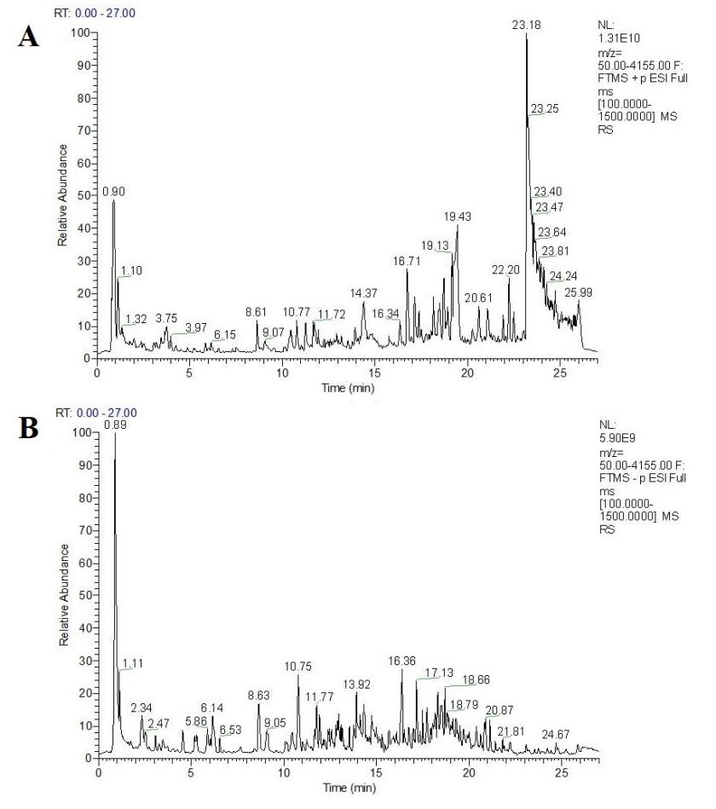
Figure S1 Total ion diagrams of Renshen Guipi Wan (A. positive ion; B. Negative ion)

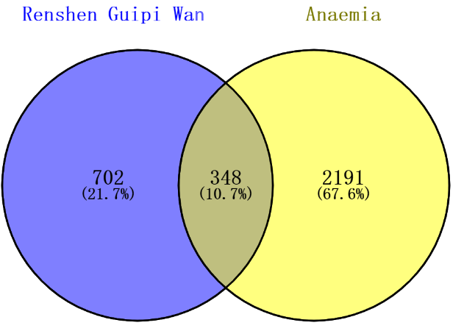
Figure S2 Venn diagram of active components of Rensen Guipi Wan targets and anaemia target
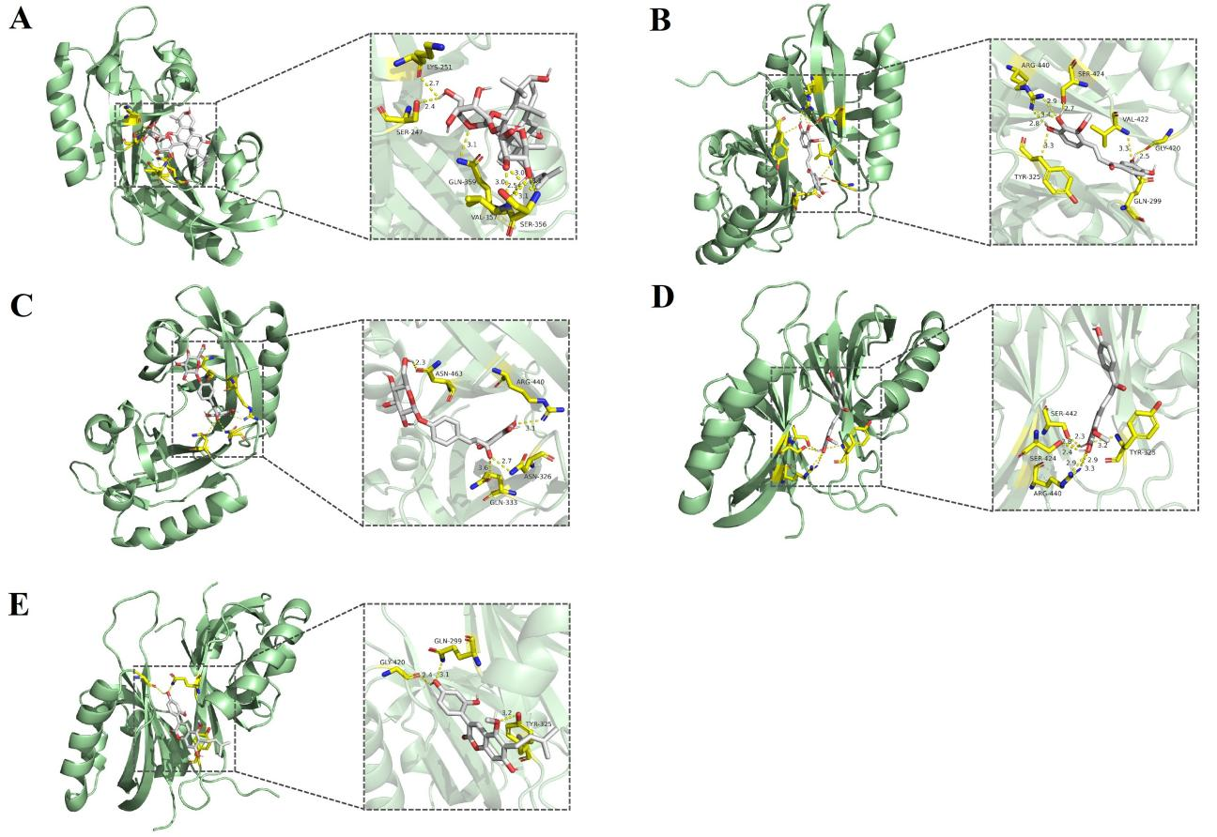

Figure S3 Molecular docking results of active components and HIF-1α target (A: HIF-1α (PDBID：4H6J) -Ginsenoside Rg4; B: HIF-1α (PDBID：4H6J)-3,3’,4,4’-Tetrahydroxy 2-methoxychalcone; C: HIF-1α (PDBID：4H6J) - Chalconaringenin 4’-glucoside; D: HIF-1α (PDBID：4H6J)-Licochalcone B; E: HIF-1α (PDBID：4H6J)-Glycycoumarin)

