Supplemental Materials

- Supplemental Tables
Supplemental Table 1. Causes of Death in the Total Cohort

2. Supplemental Figures
Supplemental Figure 1. Schematic Diagram of the LASSO Regression Variable Selection Process
Supplemental Figure 2. Association between IR Indices and All-cause Mortality in the Total Cohort
Supplemental Figure 3. Association between IR Indices and All-cause Mortality in the Male Cohort
Supplemental Figure 4. Association between IR Indices and All-cause Mortality in the Female Cohort
Supplemental Figure 5. Sensitivity Analysis of the Associations between IR Indices and All-cause Mortality

Supplemental Table 1. Causes of Death in the Total Cohort
Cause of death | ICD-10 codes | Number of events
All cause |  | 805
Cardiovascular disease | I00-I09, I11, I13, and I20-I51 | 250
Cancer | C00-C97 | 144
Diabetes mellitus | E10-E14 | 80
Alzheimer’s disease | G30 | 28
Chronic lower respiratory diseases | J40-J47 | 25
Nephritis, nephrotic syndrome, and nephrosis | N00-N07, N17-N19, and N25-N27 | 23
Influenza and pneumonia | J09-J18 | 20
Accidents (unintentional injuries) | V01-X59, Y85-Y86 | 16
Other causes |  | 219

ICD, International Statistical Classification of Disease.

Supplemental Table 2. The VIF values of the excluded variables
Variable | TG | HDL-C | TC | LDL-C | WC
VIF value | 3228.779182 | 2032.960150 | 26443.141576 | 20375.962016 | 7.993481
Abbreviations: TG, fasting triglyceride; HDL-C, high-density lipoprotein cholesterol; TC, total cholesterol; LDL-C, low-density lipoprotein cholesterol; WC, waist circumference;

Supplemental Figure 1. Schematic Diagram of the LASSO Regression Variable Selection Process

Supplemental Figure 2. Association between IR Indices and All-cause Mortality in the Total Cohort
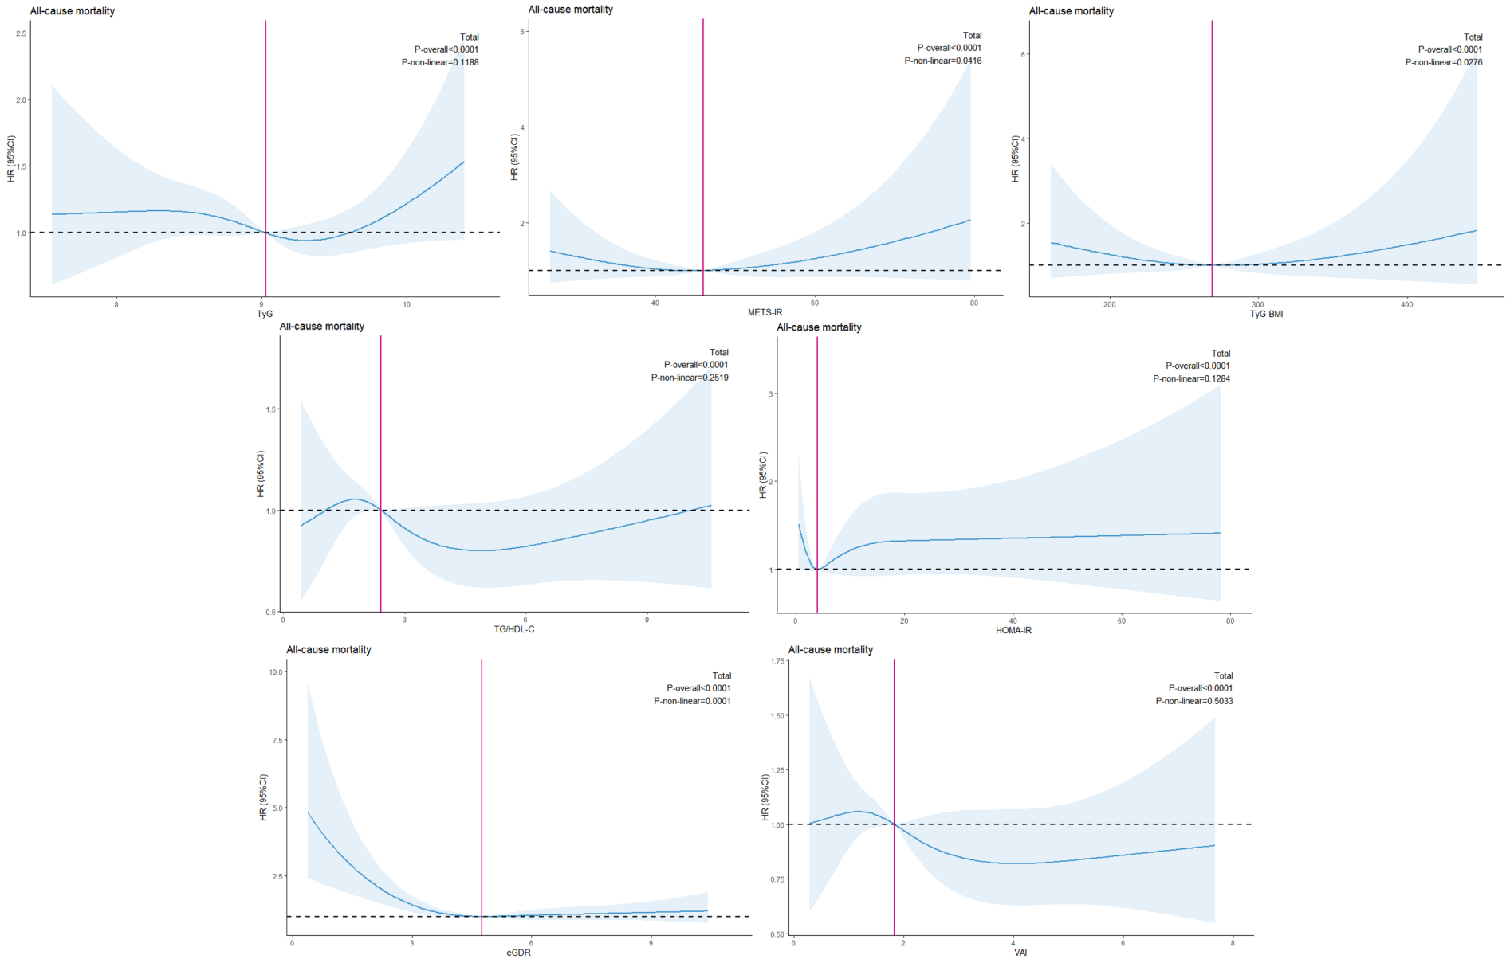

Models for all-cause mortality were adjusted for age, ethnicity, educational level, BMI, albumin, UACR, UA, creatinine, smoking, Insulin treatment, hypoglycemic drugs, antihypertensive drugs, lipid-lowering drugs, hypertension, hyperlipidemia, stroke, CAD, fasting-glucose, fasting-Insulin, HbA1c, eGFR.

Supplemental Figure 3. Association between IR Indices and All-cause Mortality in the Male Cohort
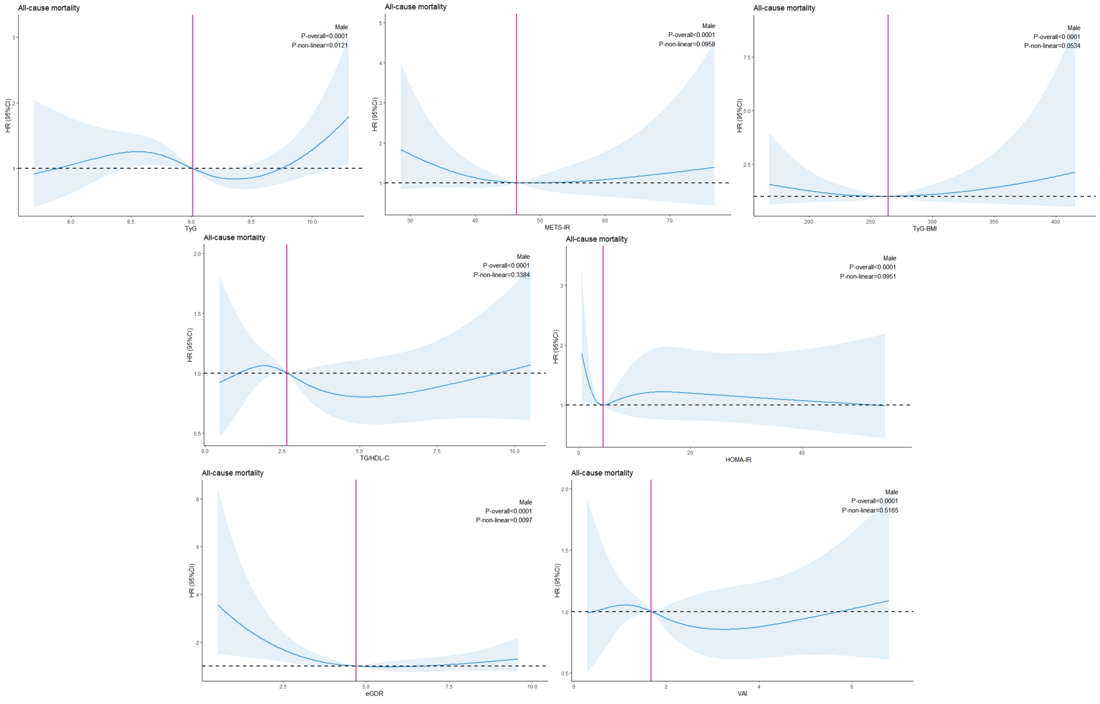
Models for all-cause mortality were adjusted for age, ethnicity, educational level, BMI, albumin, UACR, UA, creatinine, smoking, Insulin treatment, hypoglycemic drugs, antihypertensive drugs, lipid-lowering drugs, hypertension, hyperlipidemia, stroke, CAD, fasting-glucose , fasting-Insulin, HbA1c, eGFR.

Supplemental Figure 4. Association between IR Indices and All-cause Mortality in the Female Cohort
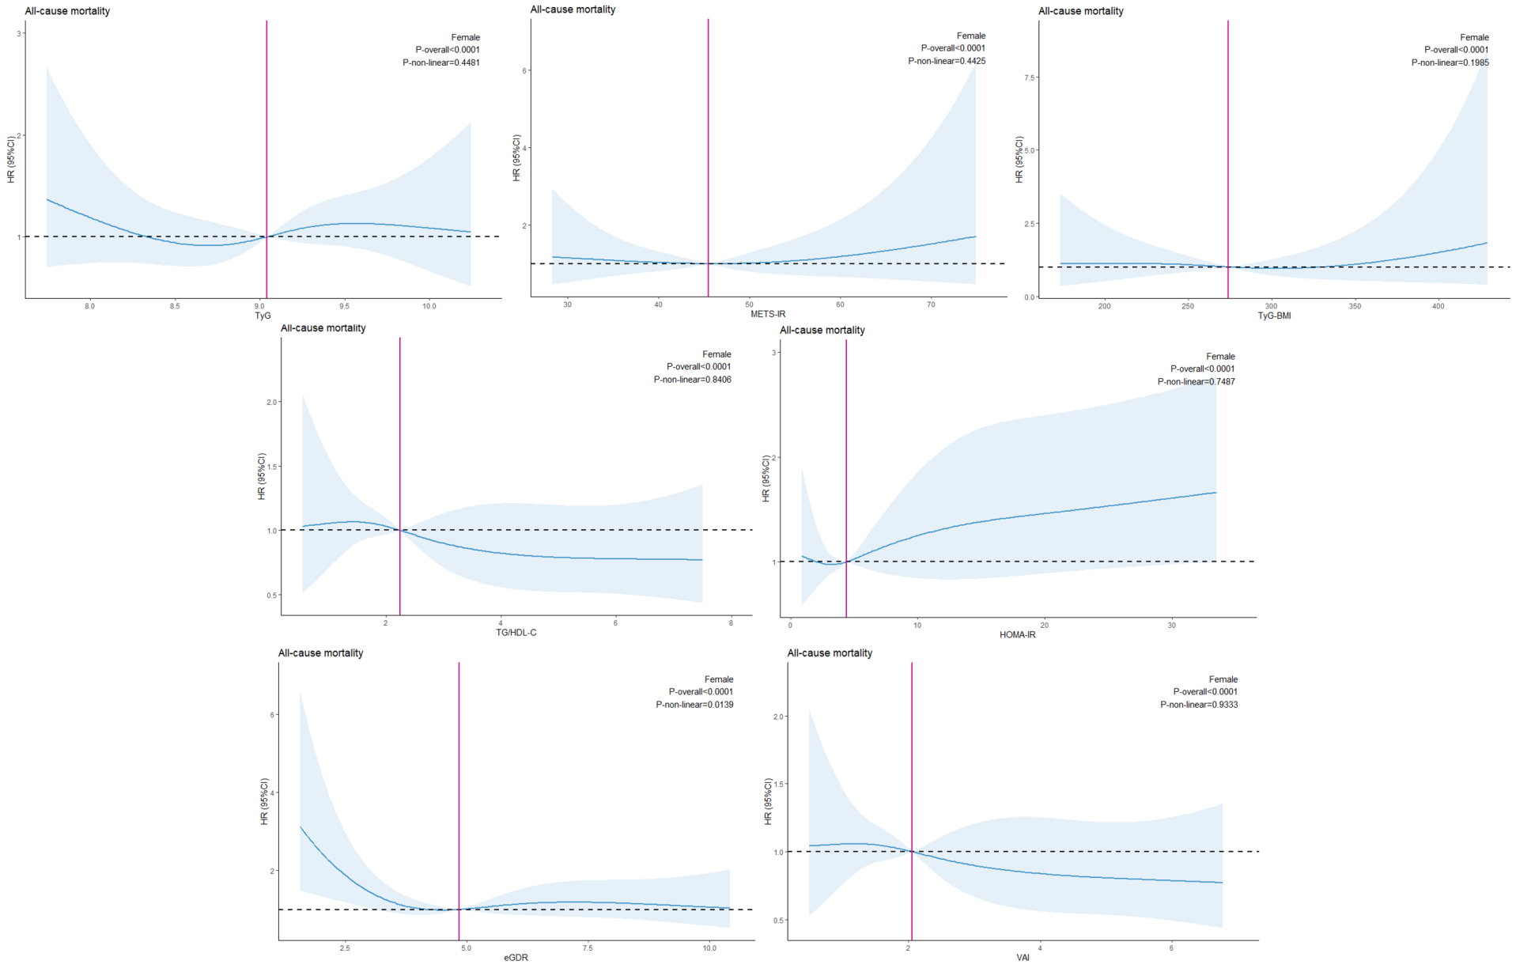
Models for all-cause mortality were adjusted for age, ethnicity, educational level, BMI, albumin, UACR, UA, creatinine, smoking, Insulin treatment, hypoglycemic drugs, antihypertensive drugs, lipid-lowering drugs, hypertension, hyperlipidemia, stroke, CAD, fasting-glucose, fasting-Insulin, HbA1c, eGFR.

Supplemental Figure 5. Sensitivity Analysis of the Associations between IR Indices and All-cause Mortality

