Supplementary Figure 1. Kaplan-Meier survival curves for OS with nonsignificant factors evidenced by multivariate analysis.
A
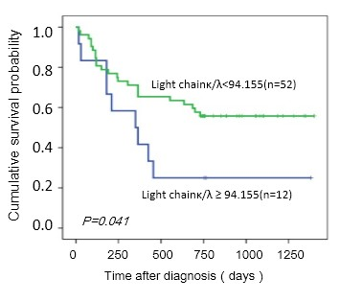
B
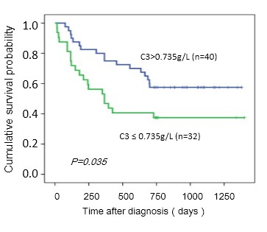
C
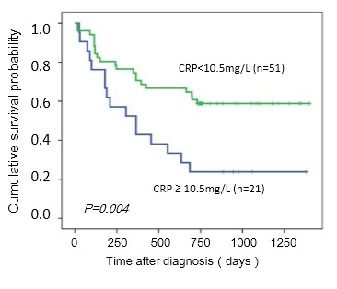
D
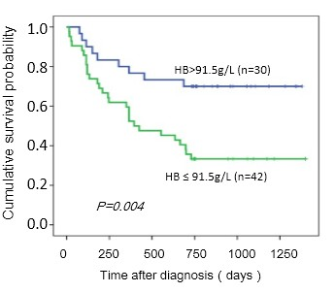
E
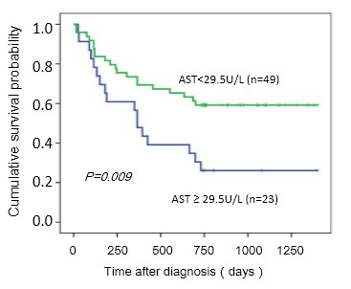
F
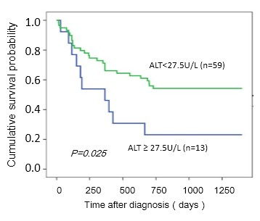
G
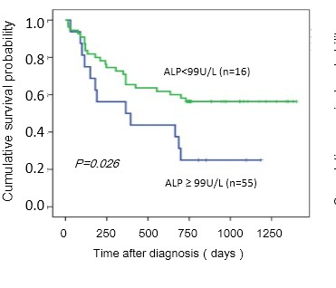
H
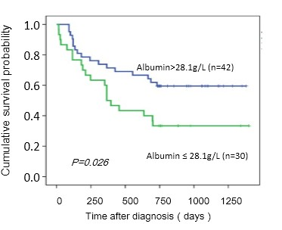
I
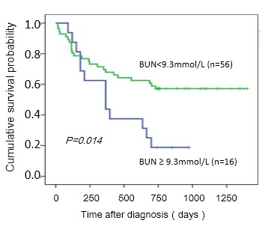
J
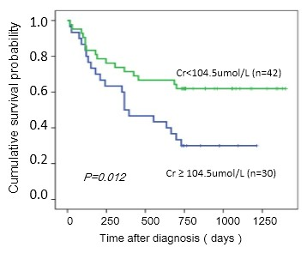
K
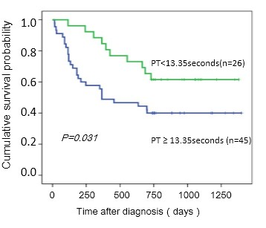
L
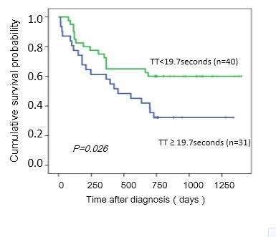
Supplementary Figure 1.Kaplan-Meier curve of patients Overall survival (OS) in patients with（A）Light chain κ/λ≥94.155 or Light chain κ/λ<94.155 ,（B）complement 3≤0.735 g/L or complement 3>0.735 g/L, (C) CRP ≥10.5 mg/L or CRP <10.5 mg/L, (D)hemoglobin≤91.5 g/L or hemoglobin>91.5 g/L, (E) aspartate aminotransferase≥29.5 U/L or aspartate aminotransferase<29.5 U/L, (F)alanine aminotransferase≥27.5 U/L or alanine aminotransferase<27.5 U/L, (G) alkaline phosphatase≥99 U/L or alkaline phosphatase<99 U/L, (H)albumin≤28.1 g/L or albumin>28.1 g/L , (I) blood urea nitrogen≥9.3 mmol/L or blood urea nitrogen<9.3 mmol/L , (J) creatinine≥104.5 umol/L or creatinine<104.5 umol/L, (K)prothrombin time≥13.35 s or prothrombin time<13.35 s , (L)thrombin time≥13.35 s or thrombin time<13.35 s.

