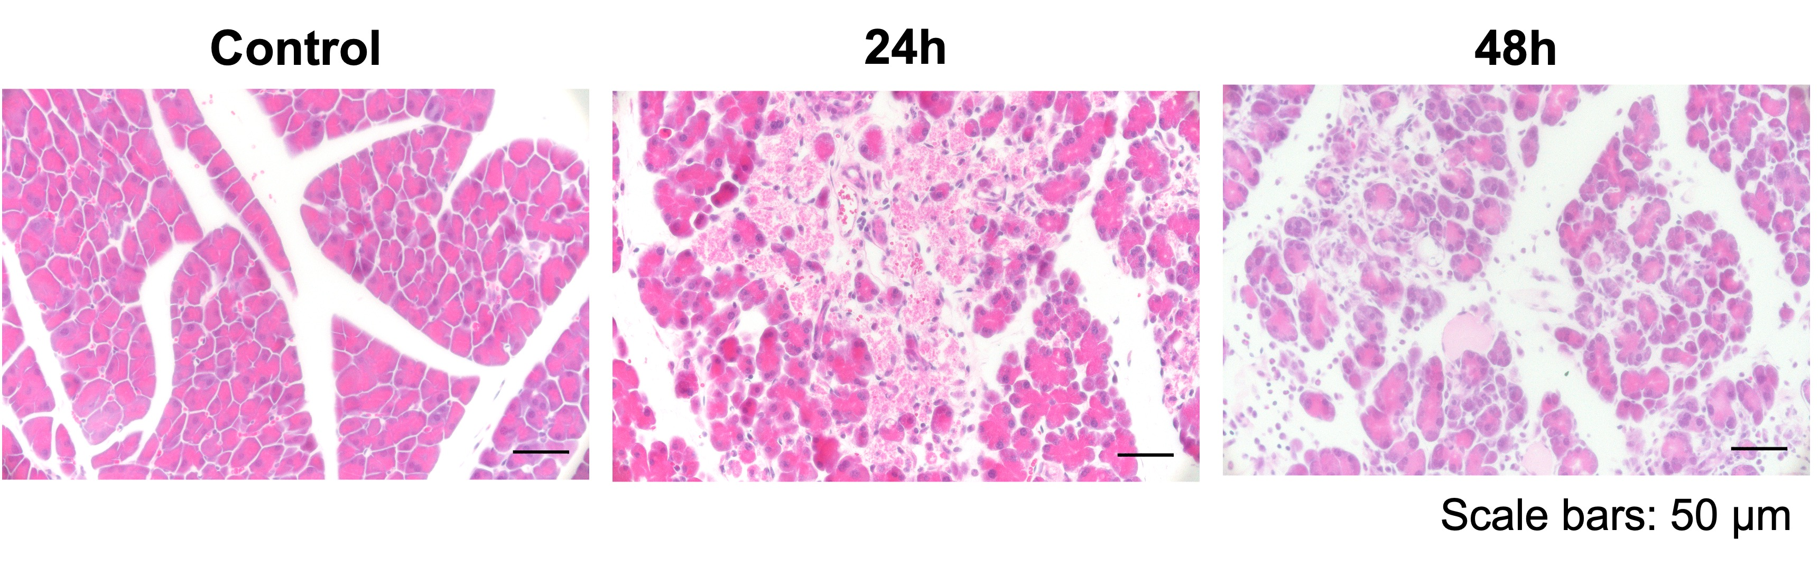
Supplementary Fig. 1 | Inflammation caused by injecting 0.5 mL of saline solution into the pancreatic duct. Inflammation was induced in the same manner as the contrast medium.

