Global incidence, prevalence, deaths, and disability-adjusted life-years (DALYs) for idiopathic epilepsy, 1990-2021: a systematic analysis for the Global Burden of Disease Study 2021

Figure legend
Figure S1. Numbers and age-standardized rates of idiopathic epilepsy-related incidence, prevalence, deaths, and DALYs for both sexes in 2021. Abbreviations: DALYs, disability-adjusted life years.
Figure S2. Numbers and age-standardized rates of idiopathic epilepsy-related incidence, prevalence, deaths, and DALYs for different age groups in 2021. Abbreviations: DALYs, disability-adjusted life years.
Figure S3. Numbers and age-standardized rates of idiopathic epilepsy-related incidence, prevalence, deaths, and DALYs for different SDI regions in 2021. Abbreviations: DALYs, disability-adjusted life years.
Figure S4. Numbers and age-standardized rates of idiopathic epilepsy-related incidence, prevalence, deaths, and DALYs for different GBD regions in 2021. Abbreviations: DALYs, disability-adjusted life years.
Figure S5. Trends in the numbers and age-standardized rates of idiopathic epilepsy-related incidence, prevalence, deaths, and DALYs globally from 1990 to 2021. Abbreviations: DALYs, disability-adjusted-life-years.
Figure S6. Trends in the numbers and age-standardized rates of idiopathic epilepsy-related incidence, prevalence, deaths, and DALYs globally by sexes from 1990 to 2021. Abbreviations: DALYs, disability-adjusted-life-years.
Figure S7. Trends in the numbers and age-standardized rates of idiopathic epilepsy-related incidence, prevalence, deaths, and DALYs globally by age groups from 1990 to 2021. Abbreviations: DALYs, disability-adjusted-life-years.
Figure S8. Trends in the numbers and age-standardized rates of idiopathic epilepsy-related incidence, prevalence, deaths, and DALYs globally by SDI regions from 1990 to 2021. Abbreviations: DALYs, disability-adjusted-life-years.
Figure S9. The EAPC of the idiopathic epilepsy-related ASR of incidence, prevalence, deaths, and DALYs between 1990 and 2021. Abbreviations: EAPC, estimated annual percentage change; ASR, age-standardized rate; DALYs, disability-adjusted-life-years.
Figure S10. The relative change in the numbers of incidence, prevalence, deaths, and DALYs between 1990 and 2021. Abbreviations: DALYs, disability-adjusted-life-years.

Figure S1. Numbers and age-standardized rates of idiopathic epilepsy-related incidence, prevalence, deaths, and DALYs for both sexes in 2021. Abbreviations: DALYs, disability-adjusted life years.
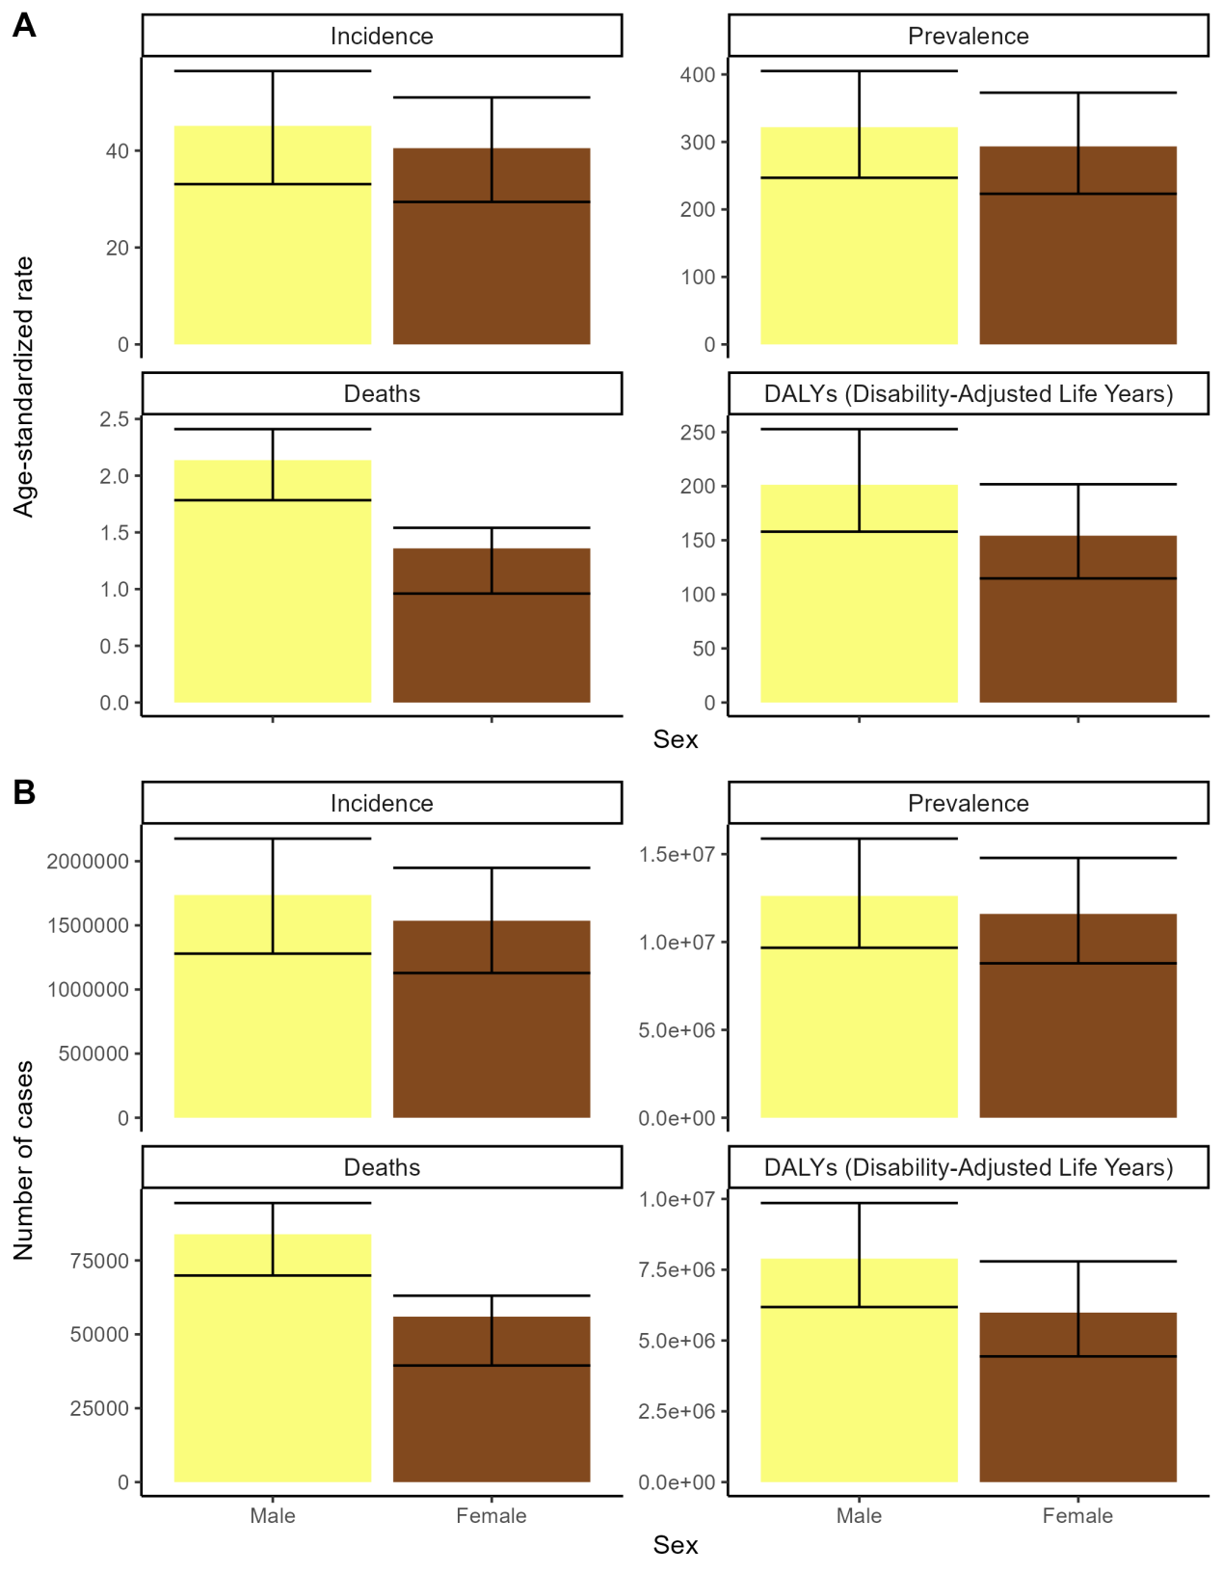
Figure S2. Numbers and age-standardized rates of idiopathic epilepsy-related incidence, prevalence, deaths, and DALYs for different age groups in 2021. Abbreviations: DALYs, disability-adjusted life years.
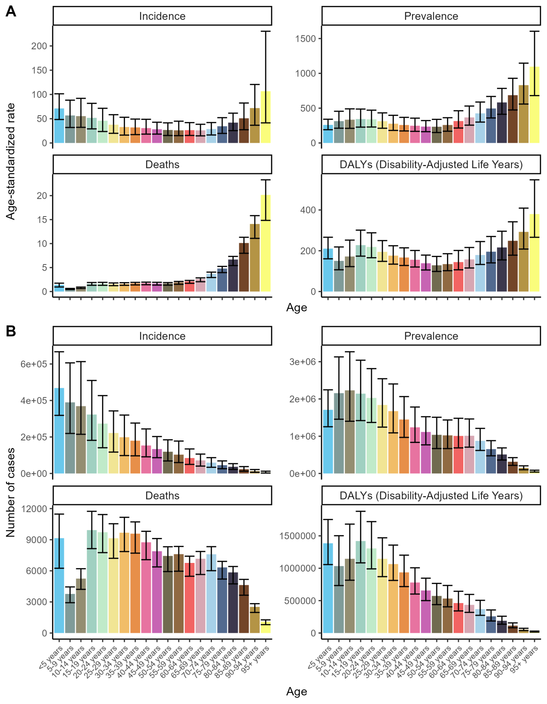

Figure S3. Numbers and age-standardized rates of idiopathic epilepsy-related incidence, prevalence, deaths, and DALYs for different SDI regions in 2021. Abbreviations: DALYs, disability-adjusted life years.
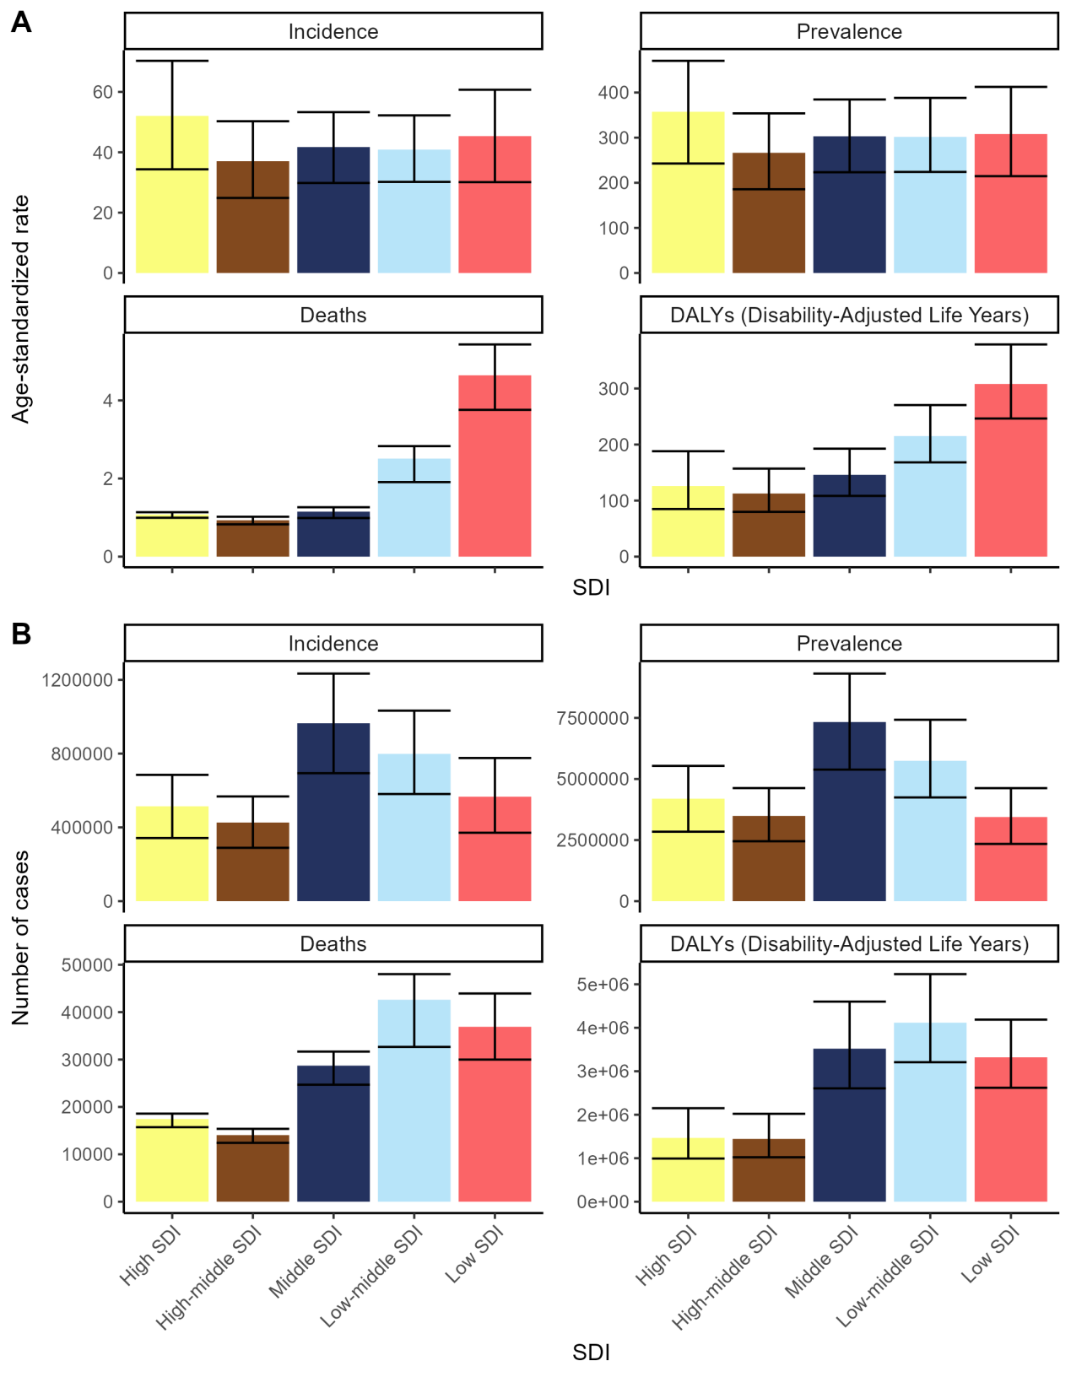

Figure S4. Numbers and age-standardized rates of idiopathic epilepsy-related incidence, prevalence, deaths, and DALYs for different GBD regions in 2021. Abbreviations: DALYs, disability-adjusted life years.
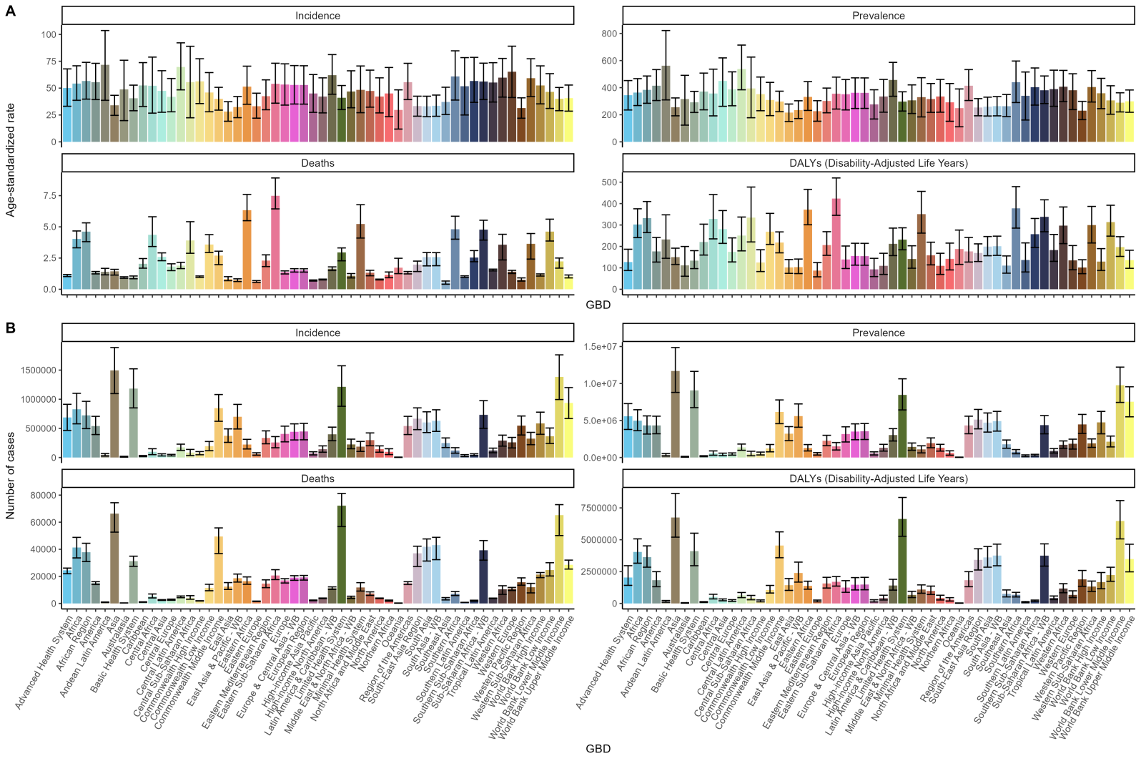

Figure S5. Trends in the numbers and age-standardized rates of idiopathic epilepsy-related incidence, prevalence, deaths, and DALYs globally from 1990 to 2021. Abbreviations: DALYs, disability-adjusted-life-years.
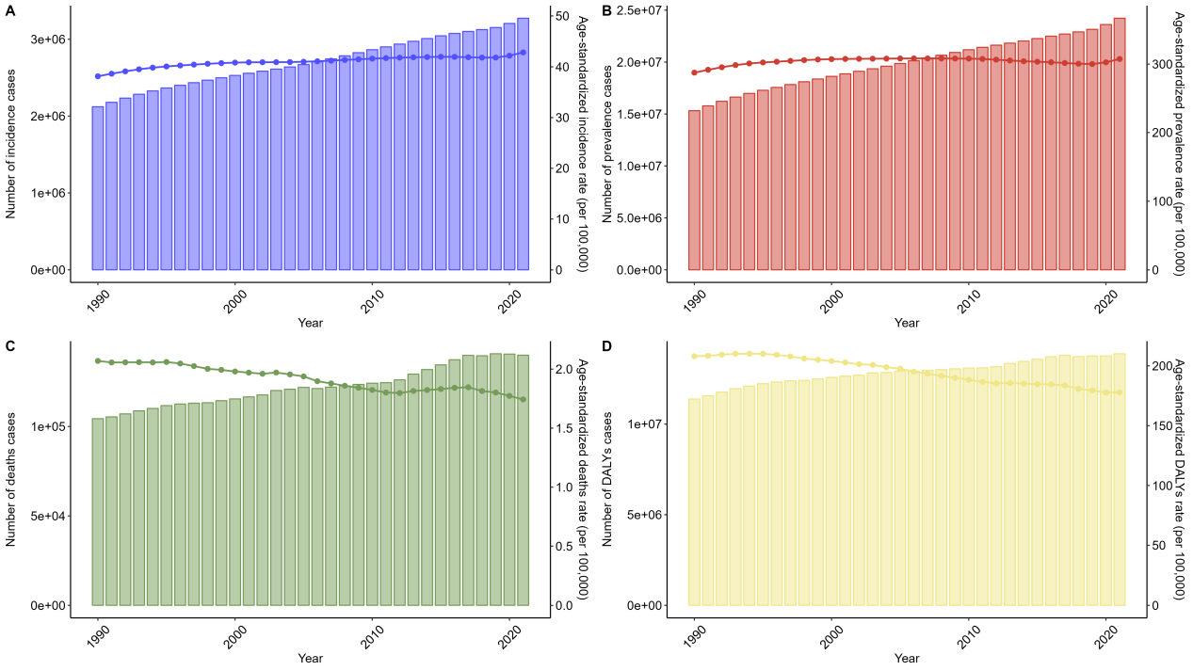

Figure S6. Trends in the numbers and age-standardized rates of idiopathic epilepsy-related incidence, prevalence, deaths, and DALYs globally by sexes from 1990 to 2021. Abbreviations: DALYs, disability-adjusted-life-years.
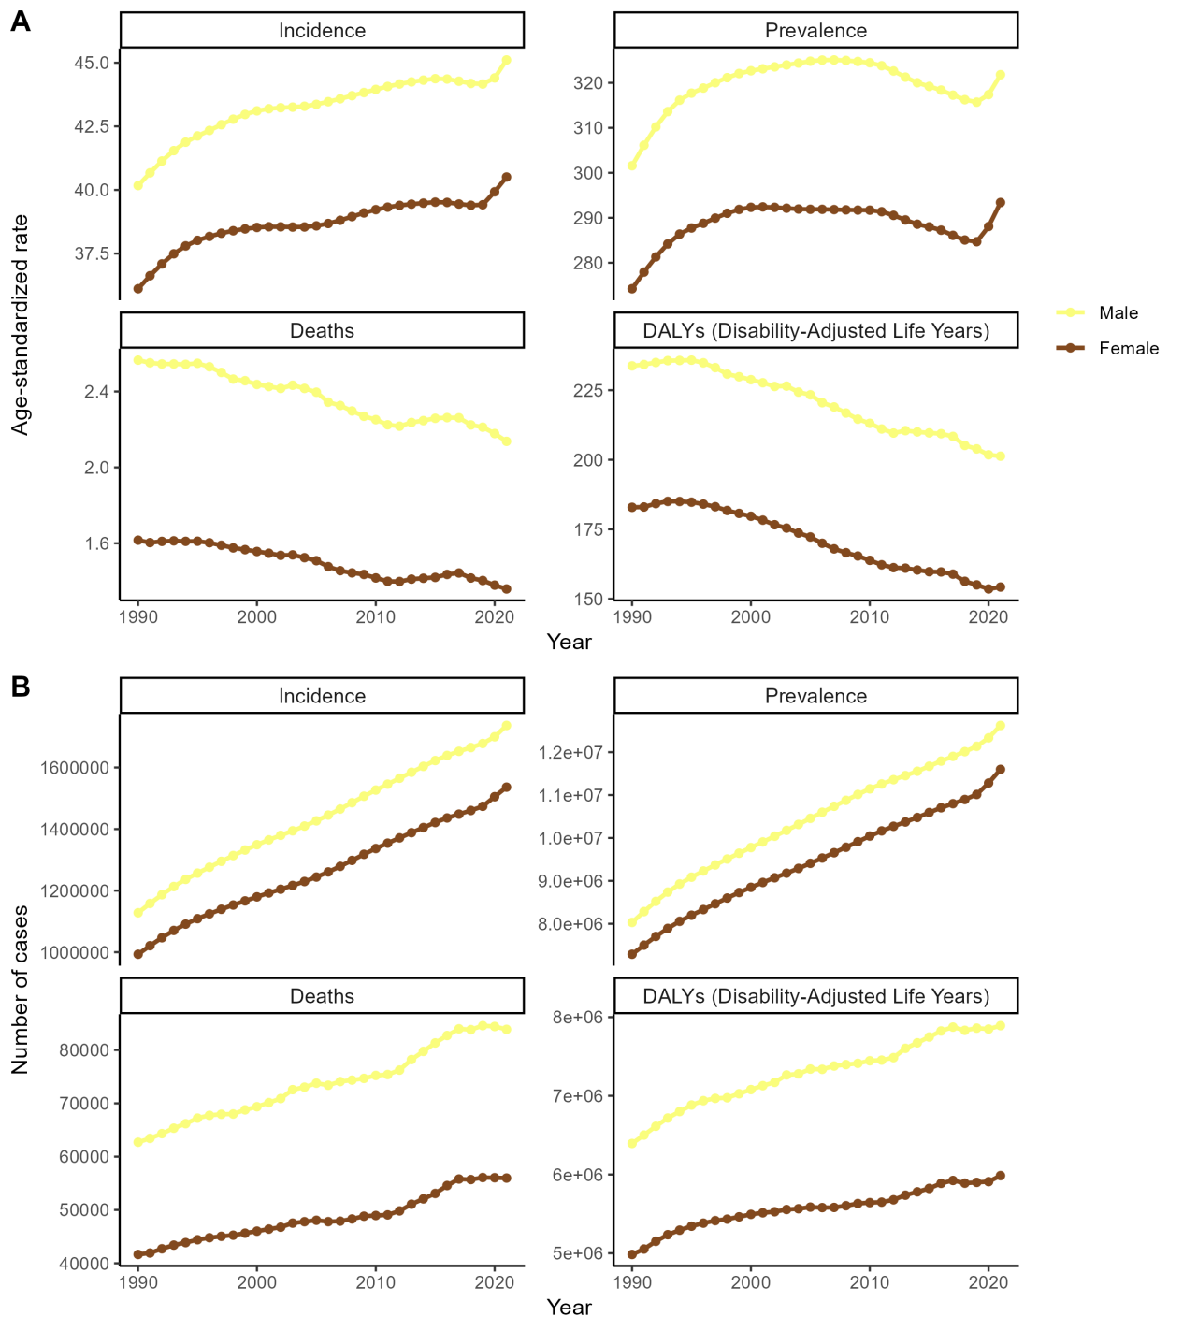

Figure S7. Trends in the numbers and age-standardized rates of idiopathic epilepsy-related incidence, prevalence, deaths, and DALYs globally by age groups from 1990 to 2021. Abbreviations: DALYs, disability-adjusted-life-years.
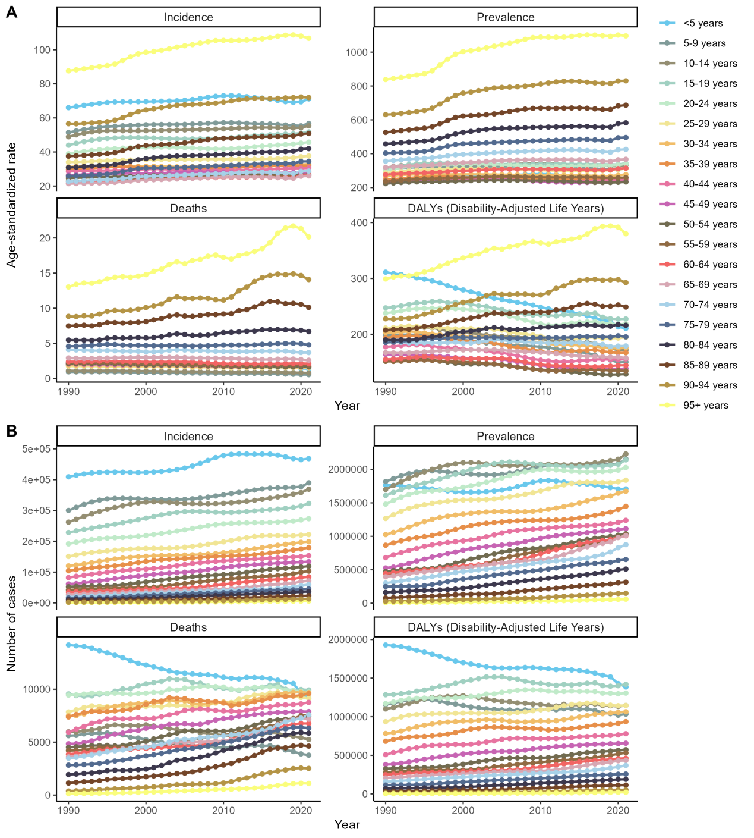

Figure S8. Trends in the numbers and age-standardized rates of idiopathic epilepsy-related incidence, prevalence, deaths, and DALYs globally by SDI regions from 1990 to 2021. Abbreviations: DALYs, disability-adjusted-life-years.
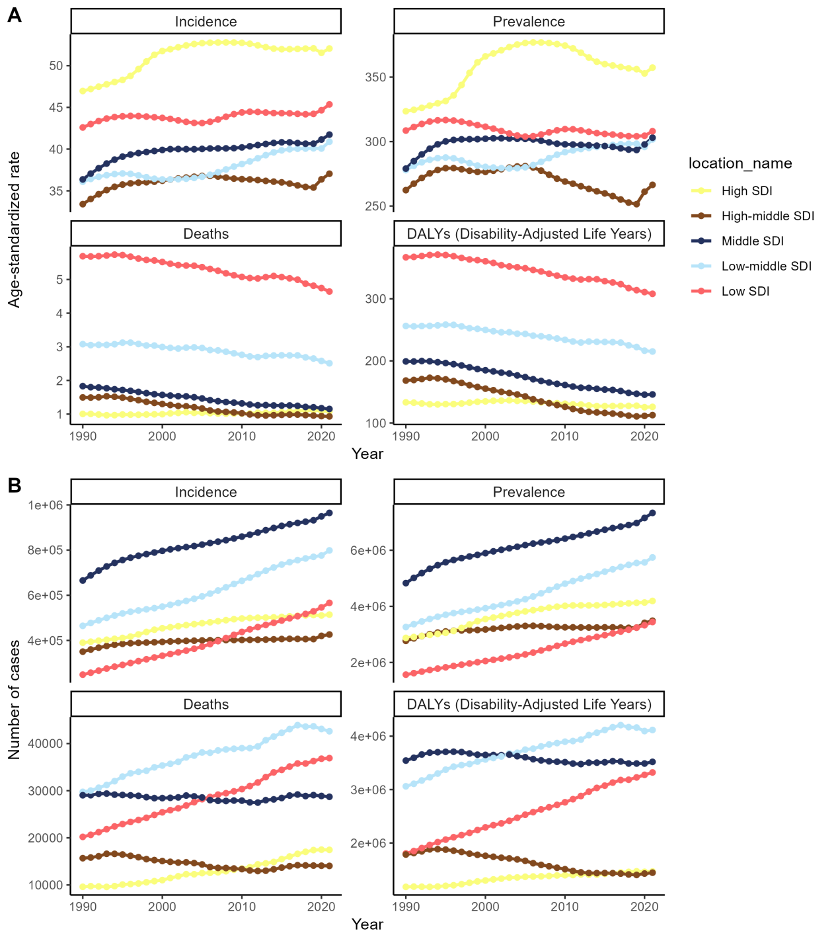

Figure S9. The EAPC of the idiopathic epilepsy-related ASR of incidence, prevalence, deaths, and DALYs between 1990 and 2021. Abbreviations: EAPC, estimated annual percentage change; ASR, age-standardized rate; DALYs, disability-adjusted-life-years.
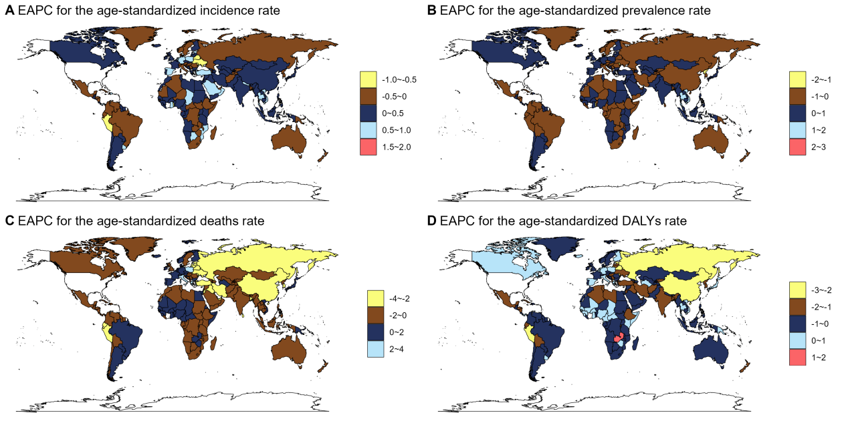

Figure S10. The relative change in the numbers of incidence, prevalence, deaths, and DALYs between 1990 and 2021. Abbreviations: DALYs, disability-adjusted-life-years.
