Supplementary materials
Table S1: Variation in environmental variables across three coffee systems in the Tshopo province, DRC (n = 76).
Environmental variables | Monoculture  (n=27) |  |  | Agroforestry  (n=24) |  | Forest Coffee  (n=25)
 |  | µ | ± se | µ | ± se | µ | ± se | p-value
Canopy closure [%] |  | 1.09 ^{c} | (± 0.48) | 45.0 ^{b} | (± 3.23) | 90.9 ª | (± 0.79) | <0.0001
Olsen-P [mg/kg] |  | 13.1 ^{b} | (± 3.30) | 33.5 ª | (± 3.63) | 11.7 ^{b} | (± 0.86) | < 0.0001
pH (CaCl₂) |  | 4.40 ^{b} | (± 0.18) | 4.95 ª | (± 0.13) | 3.40 ^{c} | (± 0.02) | < 0.0001
Soil Bulk Density [kg/m³] |  | 1.34 ª | (± 0.03) | 1.34 ª | (± 0.03) | 1.18 ^{b} | (± 0.02) | <0.0001
CN-ratio |  | 13.2 ª | (± 0.27) | 14.0 ª | (± 0.31) | 13.5 ª | (± 0.27) | 0.127
Organic carbon [%] |  | 1.75 ª | (± 0.10) | 1.68 ª | (± 0.10) | 1.52 ª | (± 0.11) | 0.279
Total N [%] |  | 0.132 ª | (± 0.007) | 0.125 ª | (± 0.007) | 0.117 ª | (± 0.009) | 0.420
Different letters indicate significant differences between the coffee systems based on ANOVA and Tukey’s HSD tests. Soil organic carbon concentration (C%) is expressed as a percentage. Soil bulk density is expressed in kilograms per cubic meter [kg/m³]. Different letters indicate significant differences between the coffee systems based on ANOVA and Tukey’s HSD tests using mean values, except for SMC, which was analysed using the Kruskal-Wallis test for non-normal distributions.

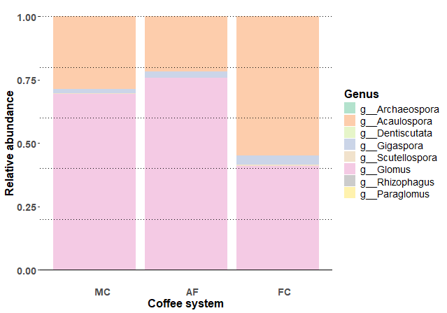
Fig. S1 Relative read abundances (%) of AMF genera in the roots of robusta coffee across the three robusta coffee systems of the Tshopo province, DRC (n = 284)
Table S2: Summary of AMF diversity indices for Monoculture (MC), Agroforestry (AF), and Forest Coffee (FC) systems (mean ± SE) based on 284 AMF Robusta coffee root samples.
Coffee system | Monoculture  (n= 87) |  | Agroforestry  (n= 98) |  | Forest Coffee  (n= 99)
 | µ | ± se | µ | ± se | µ | ± se | Test-statistic (χ²) | p-value
S_{obs} | 15.31 ª | (± 1.23) | 13.45 ª | (± 1.07) | 15.30 ª | (± 1.21) | 0.2891 | 0.8654
S_{exp} | 15.69 ª | (± 3.18) | 13.92 ª | (± 2.81) | 16.12 ª | (± 3.25) | 0.1225 | 0.9406
N₁ | 3.28 ª | (± 0.691) | 2.89 ª | (± 0.604) | 2.91 ª | (± 0.607) | 0.3732 | 0.8208
N₂ | 2.54 ª | (± 0.542) | 2.25 ª | (± 0.476) | 2.23 ª | (± 0.472) | 0.1390 | 0.9329
E₁ | 0.231 ª | (± 0.0697) | 0.230 ª | (± 0.0669) | 0.212 ª | (± 0.0629) | 1.9741 | 0.3727
E₂ | 0.795 ª | (± 0.187) | 0.803 ª | (± 0.185) | 0.788 ª | (± 0.181) | 0.1156 | 0.9438
Different letters indicate significant differences between the coffee systems based on the Kruskal-Wallis rank sum test and pairwise Wilcoxon rank sum tests with Benjamini-Hochberg correction for multiple testing for comparing non-normal distributions.

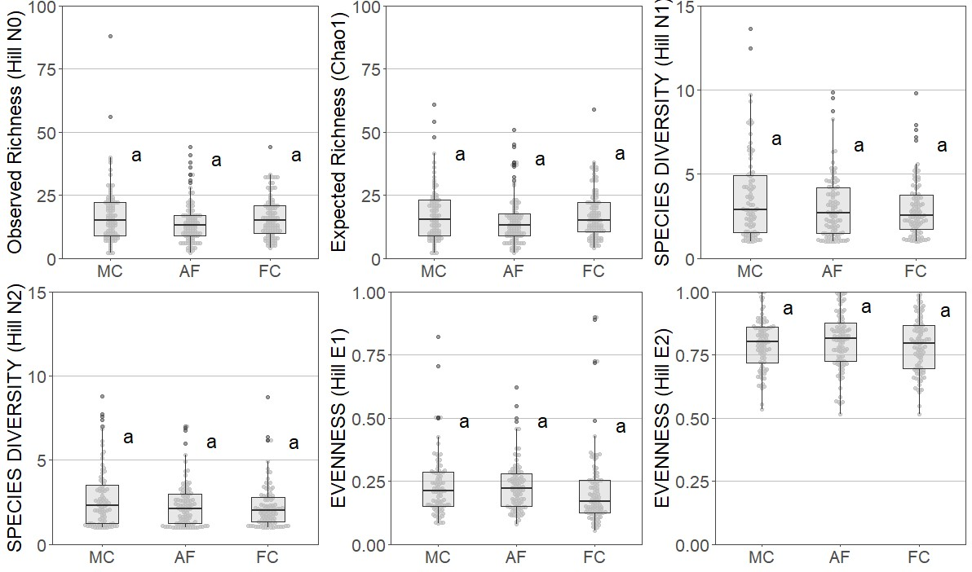
Fig. S2 Similarities in alpha-diversity indices for AMF in the roots of robusta coffee in coffee systems of the Tshopo province, DRC (n = 284). Monocultures (MC), Agroforestry (AF) and Forest Coffee (FC) systems were compared. Different letters indicate significant differences between the different coffee systems based on the Kruskal-Wallis rank sum test and pairwise Wilcoxon rank sum tests with Benjamini-Hochberg correction for multiple testing for comparing non-normal distributions, based on GLMM models with the plot as a random factor. The horizontal lines within the boxes represent the estimated marginal mean values, while the box boundaries indicate the 25th and 75th percentiles. Whiskers extend to the minimum and maximum values within 1.5 times the interquartile range (IQR) from the first and third quartiles

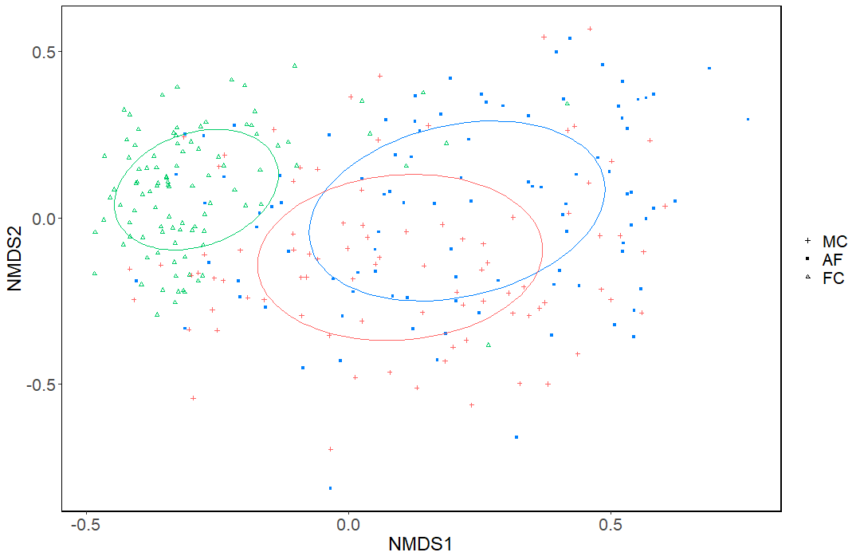
Fig. S3 Nonmetric multidimensional scaling (NMDS) ordination of AMF of 284 Robusta coffee plants in the Tshopo province, DRC, comparing Coffee Monocultures (MC), Agroforestry (AF) and Forest Coffee (FC) systems. The AMF community compositions differed significantly between all three coffee systems. The forest coffee and agroforestry systems. Ellipses: blue (MC), red (AF) and green (FC). The ordination is based on the Bray-Curtis distance calculated using OTU abundances. The ellipses presented are the dispersion ellipses using the standard deviation of the mean
Table S3: Unique AMF OTUs per coffee system according to genera (n = 284)
 | Monoculture |  |  | Agroforestry |  | Forest Coffee |  | Total Unique OTUs
 |  | # | % | # | % | # | % | # | %
Archeospora |  | 2 | 9 % | 1 | 3 % | 1 | 2 % | 4 | 4 %
Glomus |  | 10 | 43 % | 28 | 88 % | 33 | 65 % | 71 | 67 %
Acaulospora |  | 4 | 17 % | 1 | 3 % | 11 | 22 % | 16 | 15 %
Scutellospora |  | 3 | 13 % | 1 | 3 % | 1 | 2 % | 5 | 5 %
Rhizophagus |  | 3 | 13 % | 1 | 3 % | 0 | 0 % | 4 | 4 %
Gigaspora |  | 1 | 4 % | 0 | 0 % | 1 | 2 % | 2 | 2 %
Paraglomus |  | 0 | 0 % | 0 | 0 % | 4 | 8 % | 4 | 4 %
Total |  | 23 | 100 % | 32 | 100 % | 51 | 100 % | 106 | 100 %

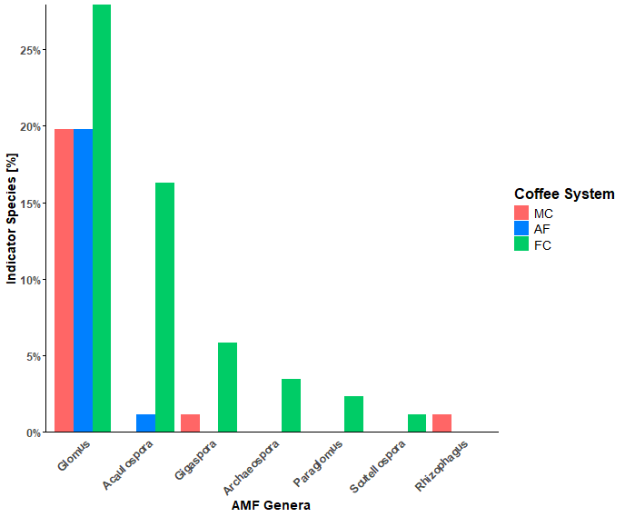
Fig. S4 106 AMF Indicator species (OTUs) shown per genera and per coffee system based on 284 Robusta coffee root samples across 3 coffee systems in the Tshopo, DRC: Monocultures (MC), Agroforestry (AF) and Forest Coffee (FC)
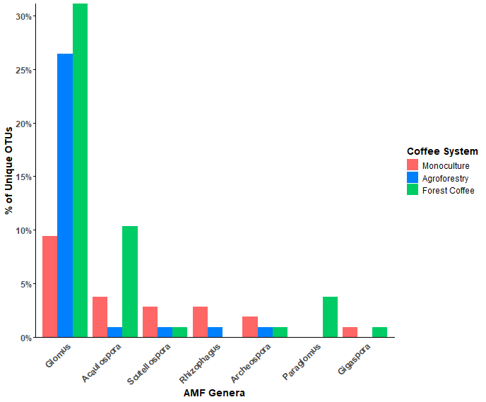
Fig. S5 86 Unique AMF species (OTUs) shown per genera and per coffee system based on 284 Robusta coffee root samples across 3 coffee systems in the Tshopo, DRC: Monocultures (MC), Agroforestry (AF) and Forest Coffee (FC)
Table S4: Effect of soil physio-chemical properties and canopy closure on Hill N₀ and Hill N₁, alpha-diversity indices, analysed using a Generalised Linear Model with a Negative Binomial distribution (n = 258).
 | Reduced GLM – Hill N₀
 |  | Estimate | ± se | z-value | p-value
(Intercept) |  | 2.85 | 0.08 | 37.93 | < 0.0001 ***
Bulk density |  | - 0.13 | 0.49 | - 2.82 | 0.0048 **
Olsen-P [mg/kg] |  | - 0.01 | 0.06 | - 2.51 | 0.012 *
Forest Coffee |  | 1.22 | 0.54 | 2.24 | 0.025 *
Agroforestry |  | -0.11 | 0.15 | -0.70 | 0.49
pH |  | - 0.12 | 0.07 | - 1.70 | 0.090
pH x FC |  | 1.78 | 0.62 | 2.87 | 0.0041 **
pH x AF |  | 0.26 | 0.16 | 1.67 | 0.095
 | Reduced GLM – Hill N₁
 |  | Estimate | ± se | z-value | p-value
(Intercept) |  | 1.14 | 0.068 | 16.7 | < 0.0001 ***
Bulk density |  | - 0.17 | 0.076 | - 2.20 | 0.062

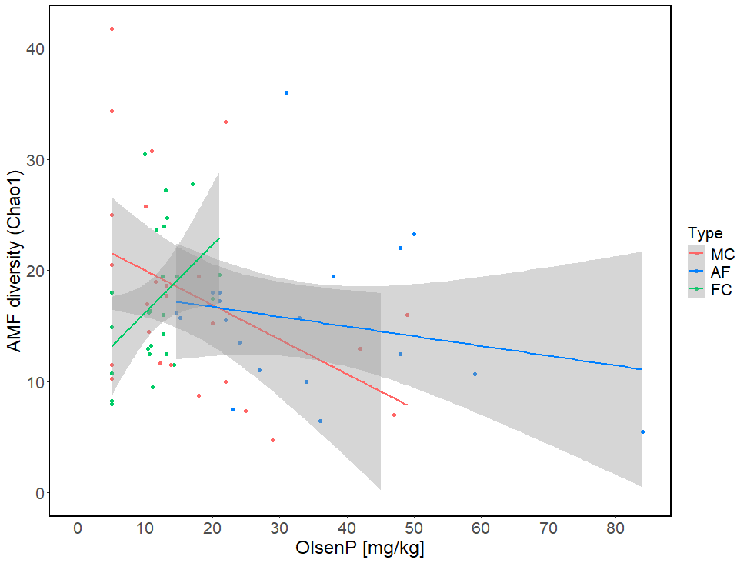
Fig. S6 The effect of OlsenP (mg/kg) on AMF diversity (Chao1), with linear effects plotted per type of coffee system: MC = Monoculture (red), AF = Agroforestry (blue), FC = Forest Coffee (green) based on 69 plots in the Thsopo province, DRC
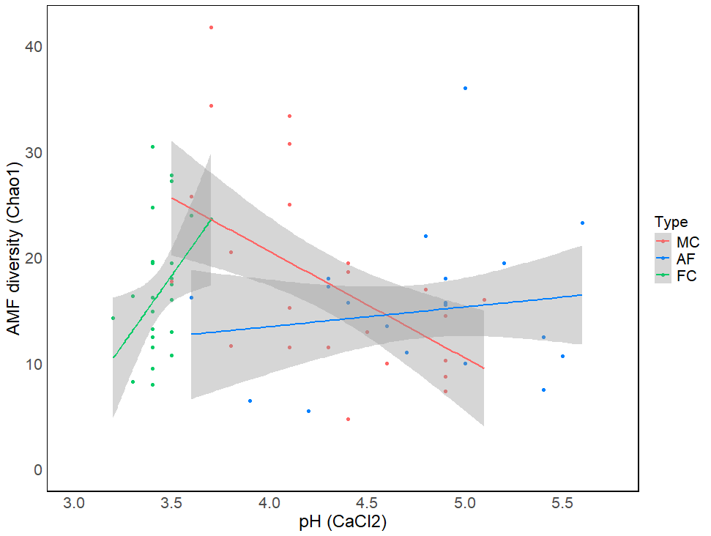
Fig. S7 The effect of soil pH (CaCl₂) on AMF diversity (Chao1), with linear effects plotted per type of coffee system: MC = Monoculture (red), AF = Agroforestry (blue), FC = Forest Coffee (green) based on 69 plots in the Thsopo province, DRC

