SUPPLEMENTARY INFORMATION
Fenton-like modification of Bauhinia tomentosa seedpod for improved sequestration of methylene blue from water
Michael Tope Agbadaola^{1,2,*}; Damilola Adeola Akinyemi¹; Dorcas Abiodun Olatunji¹; Jonathan Oyebamiji Babalola^{3,4}
- Department of Chemical Sciences, Dominion University, Ibadan, Nigeria.
- Biophysics, Institute of Molecular Biosciences (IMB), University of Graz, NAWI Graz, Graz, Austria
- Bowen University, Iwo, Osun State, Nigeria.
- Department of Chemistry, University of Ibadan, Ibadan, Nigeria.
* Correspondence should be addressed to: m.agbadaola@dominionuniversity.edu.ng; mt.agbadaola@gmail.com. ORCID: https://orcid.org/0000-0001-9481-1645
- Supplementary Methods
  - Fourier-transformed Infrared Spectroscopy (FTIR)
The functional groups present in BTSP and Fenton-BTSP were analyzed using Fourier-transformed Infrared (FTIR). After a preliminary background measurement, the calcinated adsorbent was attached to the crystal sample holder of the equipment and the spectra was recorded at 400-4000cm⁻¹ using a Perkin Elmer FT-IR spectrophotometer (Spectrum 2).
  - pH point of zero charge (pH-PZC)
The pH at which the overall charge on the surface of the adsorbents is zero was investigated according to established protocol (Kosmulski, 2002). 25 mL of 0.01 M NaCl solution was prepared in six different 100 mL plastic bottles. The pH was adjusted to different pH values (2, 4, 6, 8, 10, & 12) using 0.1 M HCl or NaOH. 75 mg of the adsorbent was added to the NaCl solution and shaken for 24 hours at room temperature. The mixture was filtered by centrifugation and the final pH (pH_{f}) of the supernatant was measured. The change in pH (ΔpH) was plotted against the initial pH (pH_{i}). The point of intersection of the graph at which ΔpH equals zero is the pH-PZC.
  - Dynamic light scattering (DLS)
The DLS analysis was carried out on a Zetasizer Nano S90 (Malvern Instruments) equipped with a 633-nm He–Ne laser and a right-angle photodetector. Measurements were carried out by introducing 60 µL of a suspension of the adsorbents prepared in ddH₂O into a 3 mm × 3 mm high precision quartz cuvette (Hellma Analytics, Germany). Automatic attenuation was used to determine particle size distribution. The average intensity of scattered light was obtained by setting the instrument to maximum photon count detection. The solvent composition was pre-recorded in the system to account for solvent influence on viscosity and refractive index of the sample during analysis. Experimentally determined autocorrelation functions were automatically fitted with a non-negatively constrained least-squares function by the instrument in order to obtain the intensity-weighted particle size distributions of the analyzed sample (Hassan et al., 2015).
  - UV-Vis spectroscopy
Before adsorption, the absorbance of different concentrations of MB solutions (25, 50, 75, 100, 150, 200, 500 mg/ml) was recorded on a JENWAY 6305 UV-Vis spectrophotometer (JENWAY, U.K) in a 3 mm x 3 mm high precision quartz cuvette (Hellma Analytics, Germany) at wavelength of maximum absorption of MB (662 nm). The absorbance values was plotted against the corresponding dye concentrations and fitted to a linear equation to determine the slope and the intercept, which was used to convert dye absorbances to concentration post adsorption. After adsorption, the absorbance of resultant MB after separation from the adsorbent by centrifugation was analyzed after a blank measurement with the solvent only and converted to concentrations using the slope and intercept obtained from the calibration curve.
  - Scanning electron microscopy coupled with energy dispersive X-ray spectroscopy
The surface morphology and elemental composition of the adsorbents before and after adsorption was analyzed using a scanning electron microscope coupled to an energy dispersive X-ray detector (SEM-EDX, Hitachi SU 3500, Japan). The EDX detector was equipped with an ultra-thin element light window that detect elements with atomic numbers > 4. The adsorbent was coated with a thin layer (~20 nm) of gold under vacuum, tethered to the sample chamber, and imaged at different magnifications (Shrestha, 2016).
- Supplementary Figures
SF 1 Methylene blue calibration curve.

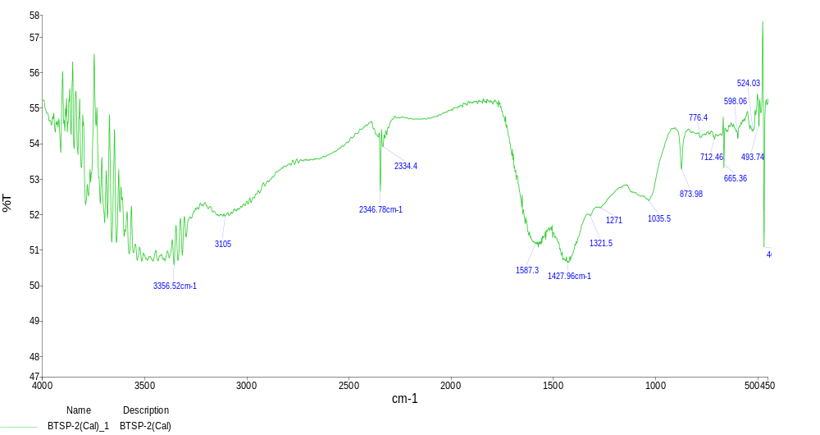
SF 2 FTIR spectrum of BTSP after adsorption of MB dye.

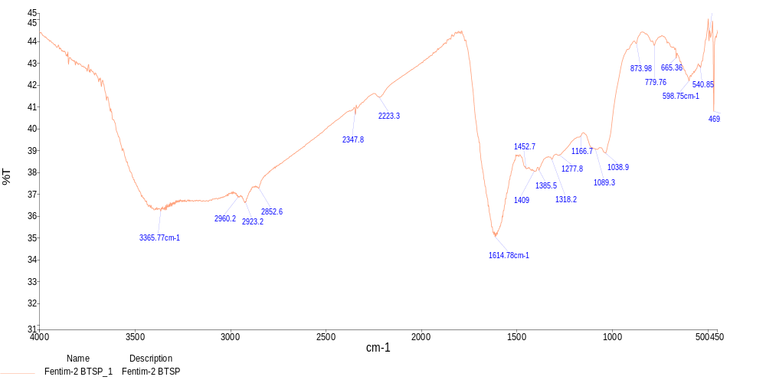
SF 3 FTIR spectrum of Fenton-BTSP after adsorption of MB dye.

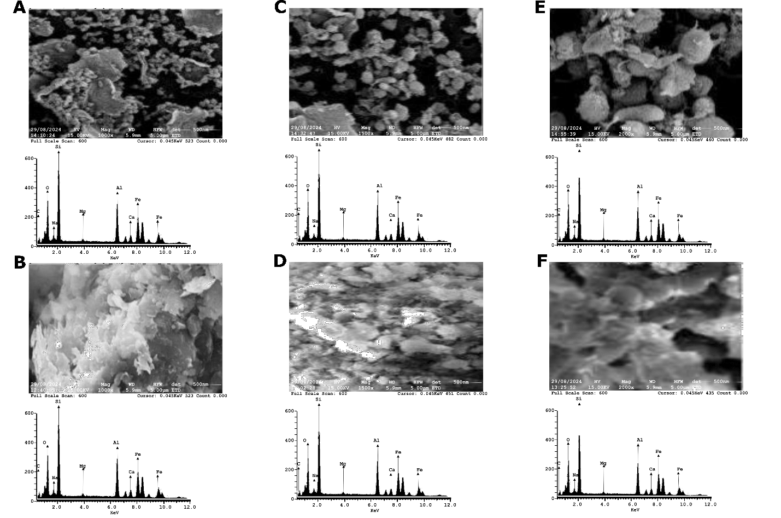
SF 4 Surface morphology of BTSP in the absence (upper) and presence (lower) of MB. SEM-EDX micrograph at 1000x, 1500x, and 2000x in the absence (A, C, D) and presence (B, D, F) of loaded MB respectively.
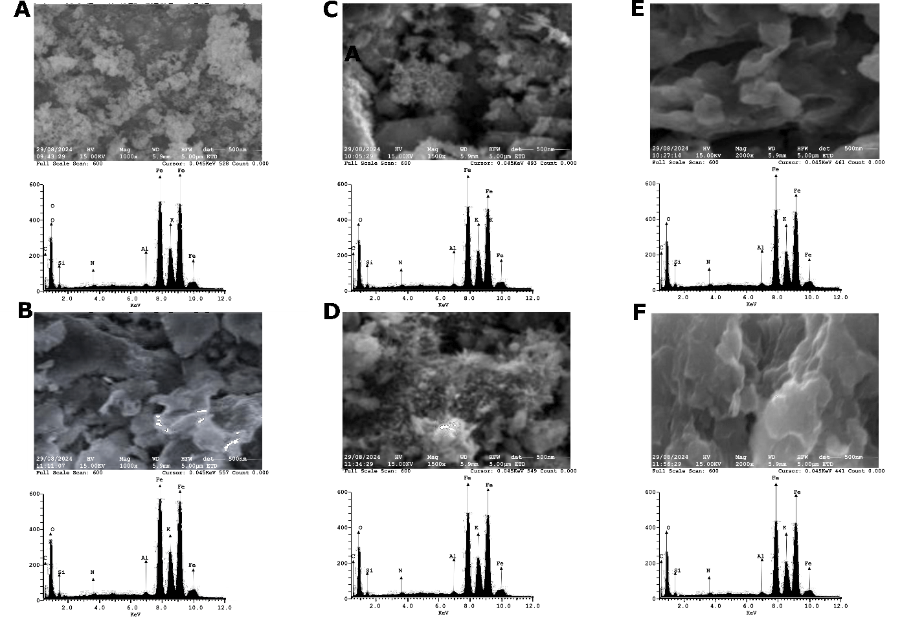
SF 5 Surface morphology of Fenton-BTSP in the absence (upper) and presence (lower) of MB. SEM-EDX micrograph at 1000x, 1500x, and 2000x in the absence (A, C, D) and presence (B, D, F) of loaded MB respectively.

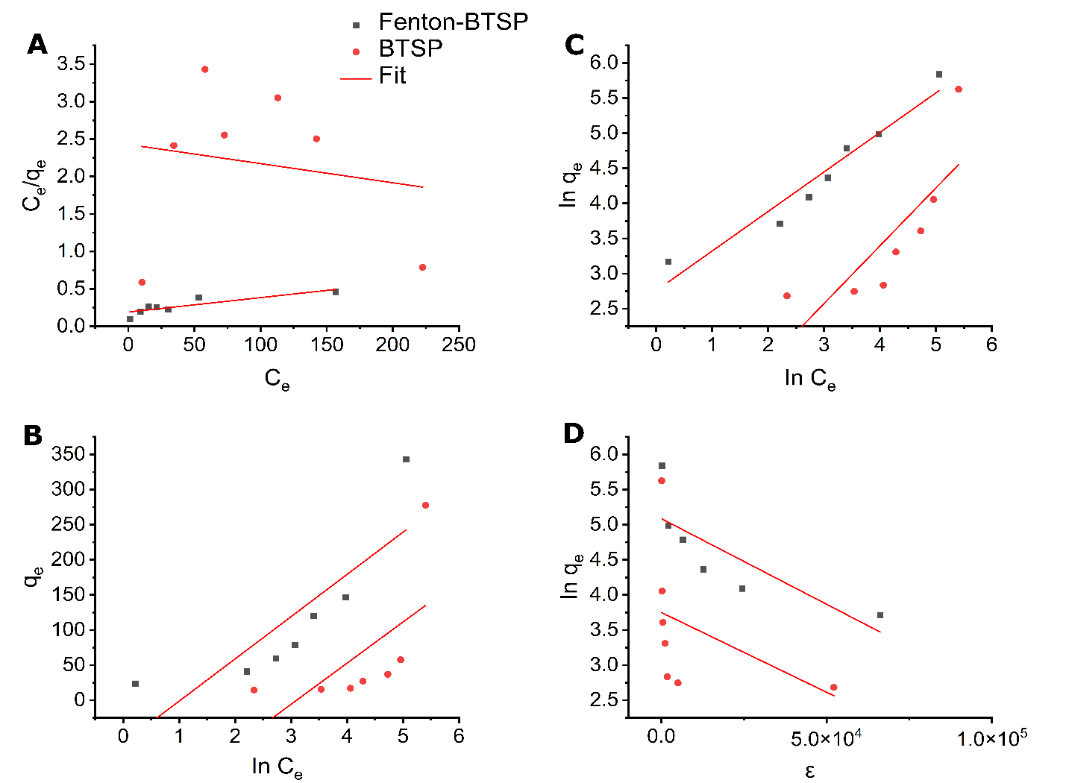
SF 6 Isotherm modelling. (A) Langmuir (B) Freundlich (C) Dubinin-Radushkevich and (D) Temkin equilibrium models for the adsorption of MB onto BTSP and Fenton-BTSP.

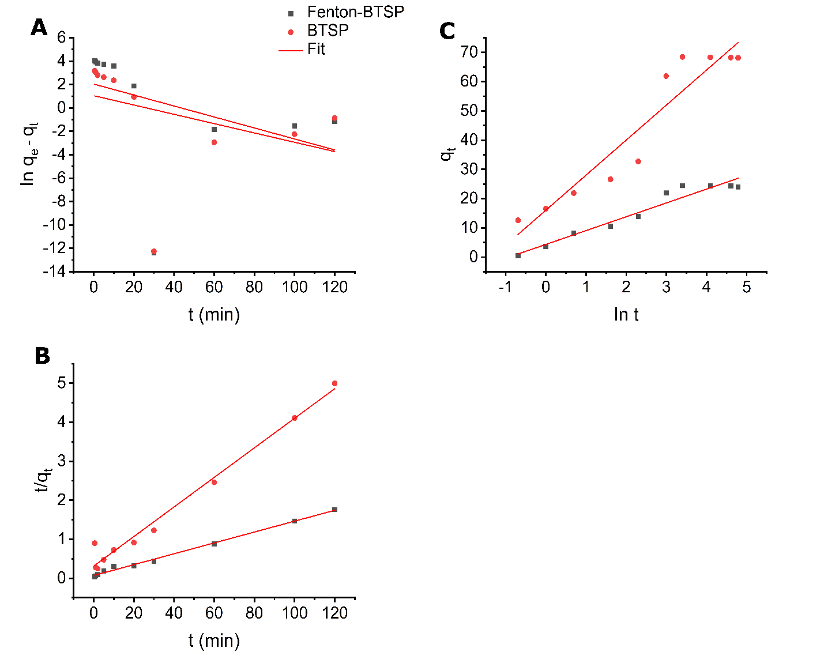
SF 7 Kinetics modelling. (A) Pseudo-first order (B) Pseudo-second order and (C) Temkin models for the adsorption of MB onto BTSP and Fenton-BTSP.
References
Hassan, P., Rana, S., Verma, G. (2015). Making sense of Brownian motion: colloid characterization by dynamic light scattering. Langmuir. 31:3–11. https://doi.org/10.1021/la501789z
Kosmulski, M. (2002). The pH-dependent surface charging and the points of zero charge. J Colloid Interface Sci. 253(1):77–87. https://doi.org/10.1006/jcis.2002.8490.
Shrestha, S. (2016). Chemical, Structural and Elemental Characterization of Biosorbents Using FE-SEM, SEM-EDX, XRD/XRPD and ATR-FTIR Techniques. Journal of Chemical Engineering & Process Technology. 7(3):295–306. https://doi.org/10.4172/2157-7048.1000295

