Supporting Information for
Bending Behavior and Directed Self-assembly of Rod-Coil Block Copolymers
Ling-Ying Shi,^{1,2} Sangho Lee,² Qingyang Du,² Rong Ran,¹ Runze Liu,² Caroline A. Ross*^{,2}
¹College of Polymer Science and Engineering, Sichuan University, Chengdu 610065, China
²Department of Materials Science and Engineering, Massachusetts Institute of Technology, 77 Massachusetts Avenue, Cambridge, Massachusetts 02139, United States
* To whom correspondence should be addressed. E-mail: caross@mit.edu

Contents
Bending energy in a coil-coil block copolymer | S2-3
Fig. S1. SEM images of oxidized PDMS nanopatterns formed in D_{4K}M_{17K} films on PS-brush and PDMS-brush functionalized silicon substrates, and the oxidized PDMS patterns of D_{4K}M_{12K}, D_{4K}M_{21K}, D_{4K}M_{34K} and D_{4K}S_{7K}M_{40K} films on PDMS brush functionalized silicon substrates | S4
Fig. S2. SEM images of oxidized PDMS nanopatterns formed in D_{4K}M_{12K} (a), D_{4K}M_{17K} (b), D_{4K}M_{21K} (c) and D_{4K}M_{34K} (d) block copolymers thin films with indication of the bending angle. | S5
Fig. S3. SEM images of oxidized PDMS nanopatterns formed in D_{4K}S_{7K}M_{40K} terpolymer thin films with indication of the bending angle. | S6
Fig. S4. Phase diagrams of bending morphologies of D_{4K}M_{12K} (a), D_{4K}M_{17K} (b), D_{4K}M_{21K} (c) and D_{4K}S_{7K}M_{40K} (d) in the plots of L_{cp}/L₀ and L_{cv}/L₀ as function of θ. (e,f) The length of segments (L_{b}) in the Y-junctions as a function of θ, and the curves of normalized L_{b}/L₀ as function of θ. | S7
Fig. S5. Low magnification SEM images of transverse cylinders of D_{4K}M_{12K} (a), D_{4K}M_{21K} (b), D_{4K}M_{34K} (c) and D_{4K}S_{7K}M_{40K} (d) block copolymers in 100 nm deep topographic trenches with trench width 120 nm. | S8
Fig. S6. Low magnification SEM images of transverse cylinders of D_{4K}M_{12K} (a), D_{4K}M_{21K} (b), D_{4K}M_{34K} (c) and D_{4K}S_{7K}M_{40K} (d) block copolymers in 100 nm deep topographic trenches with trench width 120 nm. | S9
Fig. S7. SEM images of transverse cylindrical patterns in 780 nm wide topographic trenches (a), in trenches with different bending angles (b), and in other geometrical patterned trenches (c-d). | S10
Fig. S8. Low magnification SEM images of parallel cylinders of D_{4K}M_{34K} block copolymers in PDMS brush functionalized topographic trenches with width 120 nm. | S11
Fig. S9. SEM images of thick films of D_{4K}M_{21K} templated by PS brush and PDMS brush functionalized topographic trenches. | S11
Fig. S10. SEM images of D_{4K}M_{21K} vertical lamellae after two-step anneal in PS brush and PDMS brush functionalized topographic trenches. | S12
Fig. S11. The preferred parallel orientation of cylinders of D_{4K}M_{34K} block copolymers in PDMS brush functionalized templates. | S12

Bending energy in a coil-coil block copolymer
To characterize the bends, we describe a bent cylinder as shown in Fig. S4a where L₀ is the equilibrium cylinder-cylinder spacing, d is the diameter of the cylinder and θ is the bending angle. The bent region forms an arc with width W and radius R_{c} = W/2cos(θ/2). The distance between neighboring bending center points L_{cp} and the gap between neighboring bends L_{cv} are given by L_{cp}=L₀/sin(θ/2), and L_{cp}=(L₀−d)/sin(θ/2). L_{cp} values with bending angle 150, 120, 90, 60 and 30º are calculated to be 1.04L₀, 1.15L₀, 1.41L₀, 2L₀ and 3.86L₀, respectively. This is illustrated in Fig. S4b-f, where the L_{cp} and L_{cv} are plotted vs. bend angle θ, using the line-space ratios and L₀ values from Table 1. For the Y-junction, Fig. S4a, L_{b} represents the length of the segment protruding into the bend.
The bending energy for cylinders is given by:^{45,46}
$${∆G}^{bend}(L,R_{c})=\frac{π^{2}}{128}∙\frac{kT}{Na^{2}}∙({L/2)}^{4}∙\frac{1}{{R_{c}}^{2}}$$
where k, T, a, and N, denote the Boltzmann constant, the temperature, the Kuhn step size, and the total number of Kuhn segments. The length L is the cylinder-cylinder distance at the center of bending region, i.e. L_{cp}, and R_{c} is the curvature of the bending region, both of which are functions of θ : L=L₀/sin(θ/2) and R_{c}=W/2cos(θ/2), where L₀ is the equilibrium cylinder-cylinder distance and W is the bending boundary width as shown in Fig. 2b.⁴² The domain spacing for the relaxed chain, L₀^{relaxed}, is twice the end-to-end distance of a Gaussian chain, and following the Alexander-de Gennes formalism, that is L₀^{relaxed} = 2aN^{1/2}.⁴⁷ Thus, Na² = (L₀^{ralaxed}/2)². Considering that the chains are 10-40% stretched by microphase separation compared with the relaxed state, L₀^{relaxed} should be smaller than the microphase separated periodicity L₀. In the case of 30% stretching, L₀^{relaxed} ≈0.7L₀ and Na² =(0.35L₀)². This yields a bending energy vs. bending angleθ:
$${∆G}^{bend}\left(\right)=\frac{π^{2}}{62.7}∙kT∙\frac{{L_{0}}^{2}}{W^{2}}∙\frac{{1-\sin\left(\frac{θ}{2}\right)}^{2}}{{\sin\left(\frac{θ}{2}\right)}^{4}}$$
To show the dependence of ΔG^{bend} on the angle of the bend, Fig. S5 plots ΔG^{bend}/ξkT per chain as a function of θ, where ξ = (L₀/W)². ΔG^{bend} increased as the bending angle decreased, with dramatic increases below ~60˚, e.g. for θ = 120º, 90º and 60º, ΔG^{bend} = (0.07, 0.30 and 1.89)ξkT respectively. The width W of the bent region of cylinders also affects the energy, with ΔG^{bend} ~ W⁻².

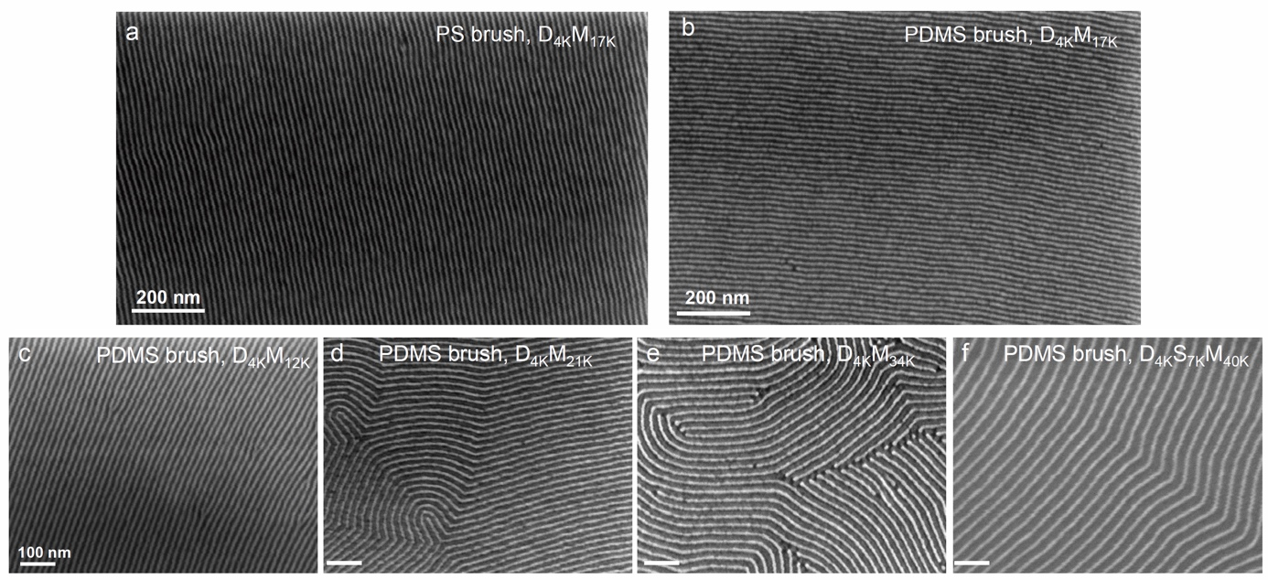
Fig. S1. SEM images of oxidized PDMS nanopatterns formed in D_{4K}M_{17K} films on PS-brush and PDMS-brush functionalized silicon substrates (a-b), and the oxidized PDMS patterns of D_{4K}M_{12K}, D_{4K}M_{21K}, D_{4K}M_{34K} and D_{4K}S_{7K}M_{40K} films on PDMS brush functionalized silicon substrates (c-f).

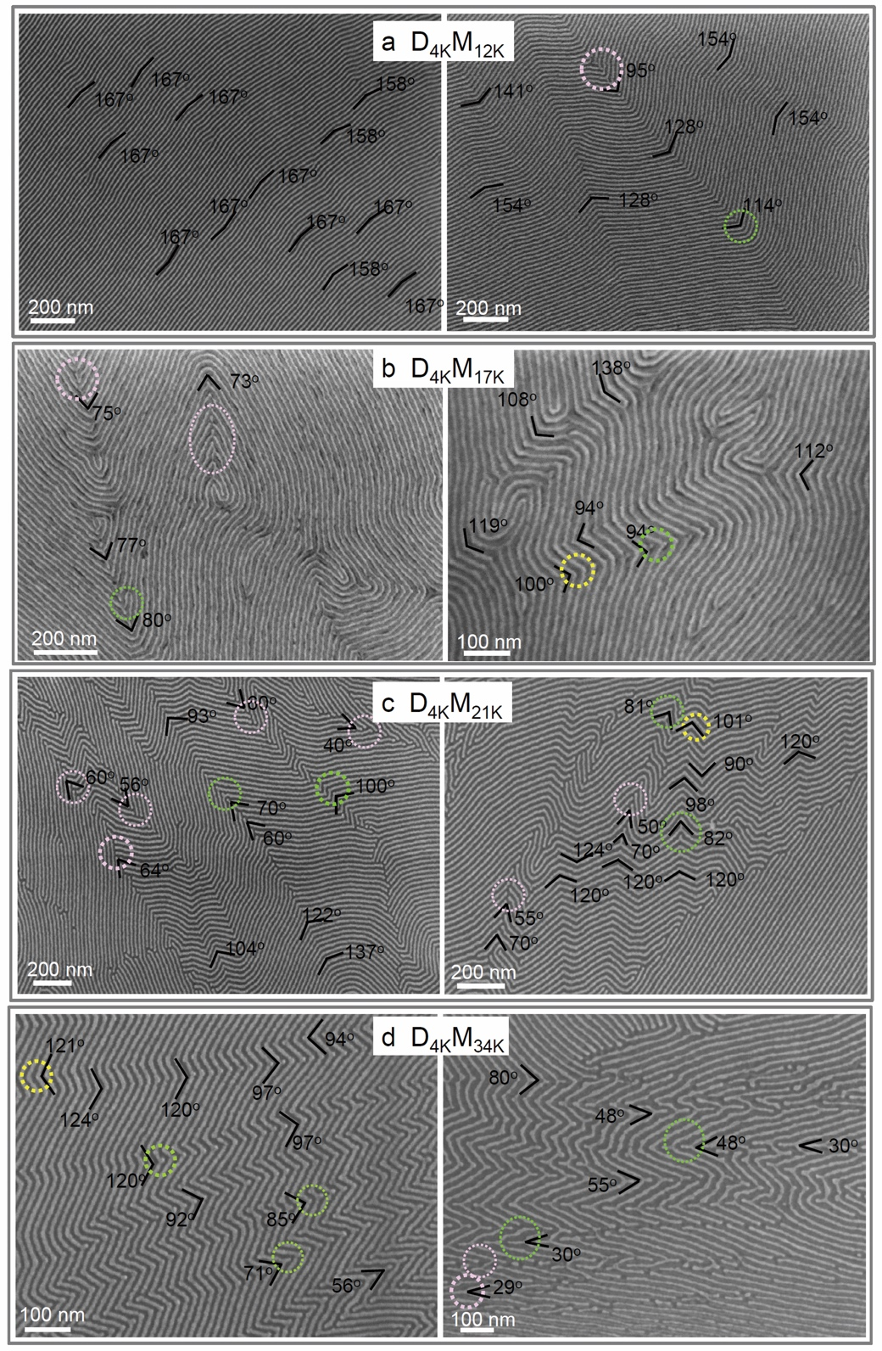
Fig. S2. SEM images of oxidized PDMS nanopatterns formed in D_{4K}M_{12K} (a), D_{4K}M_{17K} (b), D_{4K}M_{21K} (c) and D_{4K}M_{34K} (d) block copolymers thin films with the bending angle indicated. The yellow circles indicate the chevrons, the green circles indicate the Y-junctions and the light pink circles indicate the line segments, and the circles with bolder lines indicate the examples with critical bending angle around the bending morphology transition.

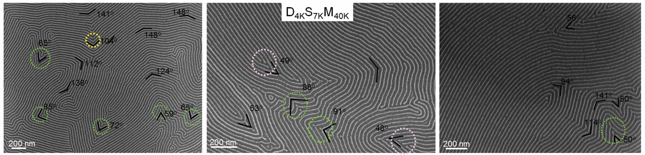
Fig. S3. SEM images of oxidized PDMS nanopatterns formed in D_{4K}S_{7K}M_{40K} terpolymer thin films with the bending angle indicated.

Fig. S4. (a) Schematic illustrations of a model of bending morphology (i) and a comparison of straight cylinders, chevrons and Y-junctions (ii-iv). Phase diagrams of bending morphologies of D_{4K}M_{12K} (b), D_{4K}M_{17K} (c), D_{4K}M_{21K} (d), D_{4K}M_{34K} (e) and D_{4K}S_{7K}M_{40K} (f) in the plots of L_{cp}/L₀ and L_{cv}/L₀ as function of θ. The length of segments (L_{b}) in the Y-junctions as a function of θ (g).

Fig. S5. The plot of bending free energy per chain as function of θ, in which the constant ξ is (L₀/W)² and W is the bending boundary width.

Fig. S6. Low magnification SEM images of transverse cylinders of D_{4K}M_{12K} (a), D_{4K}M_{21K} (b), D_{4K}M_{34K} (c) and D_{4K}S_{7K}M_{40K} (d) block copolymers in 100 nm deep, 120 nm wide topographic trenches.
Fig. S7. SEM images of transverse cylindrical patterns in 780 nm wide topographic trenches (a), in trenches with different bending angles (b), and in other geometrical patterned trenches (c-d). (Some breaks in the cylinders are attributed to overetching)
Fig. S8. Low magnification SEM images of parallel cylinders of D_{4K}M_{34K} block copolymers in PDMS brush functionalized topographic trenches with width 120 nm.

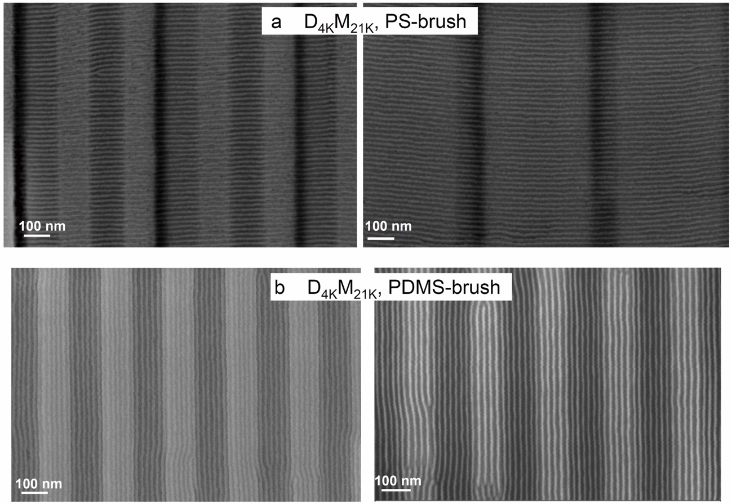
Fig. S9. SEM images of thick films of D_{4K}M_{21K} templated by PS brush and PDMS brush functionalized topographic trenches.

Fig. S10. SEM images of D_{4K}M_{21K} vertical lamellae after two-step anneal in PS brush (a) and PDMS (b) brush functionalized topographic trenches. Some regions of in-plane lamellae are visible in (b).

Fig. S11. The parallel orientation of cylinders of D_{4K}M_{34K} block copolymers in PDMS brush functionalized templates.

