Supplementary Information
Supplemental Table 1. List of primers used in this study.
Primer sets | Sequence (5′ To 3′) | Use of PCR products | Annealing (℃)
SBE3-F1 | GGATGCCGGTTTCAGCAGGTTC | Detect sequence of SBEIIb, target 1 and target 2 | 60
SBE3-R1 | CATCTTGTGAAAGACTGAACAGATGGAG | Detect sequence of SBEIIb, target 1 and target 2 | 60
SBE3-F2 | TTAGTCCATACTAGTTGTCTGCGTG | Detect mutations of SBEIIb, target 1 | 56
SBE3-R2 | TCAGCAGCTAATTCTTCAACCACTC | Detect mutations of SBEIIb, target 1 | 56
pCas9-F | GACTCCATCGACAACAAGG | Flank the sequence of Cas9 in plasmid | 55
pCas9-R | GATCAACAACTACCACCACG | Flank the sequence of Cas9 in plasmid | 55
psgRNA-F | CTCTCAGCACTTCGATTCG | Flank the sequence of sgRNA in plasmid | 55
psgRNA-R | GCATCTATGTCGGGTGC | Flank the sequence of sgRNA in plasmid | 55
phptII-F | TAGCGCGTCTGCTGCTCCAT | Flank the sequence of hptII in plasmid | 55
phptII-R | ACTTTGCATCGGCCGCG | Flank the sequence of hptII in plasmid | 55
OFTA1-1F | ACTGCTGGTCAGTCAACCAT | Detect mutations on putative off-target site of SBEIIb gRNA target 1 | 56
OFTA1-1R | CGCACTACAGAGCAACGAGA |  | 56
OFTA1-2F | CTCCAATGTTCCAGCACCGA | Detect mutations on putative off-target site of SBEIIb gRNA target 1 | 59
OFTA1-2R | CCGGGAACACATCTGGGTAG |  | 59
OFTA1-3F | TTGACATCAGCAACTGGAGTTGG | Detect mutations on putative off-target site of SBEIIb gRNA target 1 | 56
OFTA1-3R | GAAGTTCTTGCTGGTGGCCA |  | 56
OFTA2-1F | CCATGTATAGGGAAGCAGTTTCCA | Detect mutations on putative off-target site of SBEIIb gRNA target 2 | 58
OFTA2-1R | GGTGAGCGTGCACGTTGTGAG |  | 58
OFTA2-2F | CCATGTGTTGACTGCTGCCAC | Detect mutations on putative off-target site of SBEIIb gRNA target 2 | 58
OFTA2-2R | CCATAGAAGGCATCATGGGCG |  | 58
OFTA2-3F | TCGCGGTGGCTACCCG | Detect mutations on putative off-target site of SBEIIb gRNA target 2 | 56
OFTA2-3R | GTGCTTCAGAAACTGGAGGGGT |  | 56
qcSBE3-F2 | CTCCCGGGGCACATTCTGCAGCA | Detect expression level of SBEIIb gene | 65
qcSBE3-R2 | CTCCTGCGGCCTGCACAGAGTAC | Detect expression level of SBEIIb gene | 65
qcSBE1-F1 | CGGGCATGCCAGTGCTTTGTCG | Detect expression level of SBEI gene | 65
qcSBE1-R1 | CCATCACCTCCAAGGGCCATCG | Detect expression level of SBEI gene | 65
17S rRNA_F | GATAACTCGACGGATCGCACGG | Detect expression level of 17S rRNA | 65
17S rRNA_R | GCCTGCTGCCTTCCTTGGATGTG | Detect expression level of 17S rRNA | 65

Supplemental Table 2. Analysis of potential off-target editing effects. The PAM motif (NGG) is boxed; mismatching bases are shown in red.

Target | Name of putative off-target site | Putative off-target locus | Sequence of the putative off-target site | Number of  Plants with  mutations
SBEIIb  Target 1 | OFF1(Intergenic) | chr09:16385288-16385309 | CCTGCCTTAGATTATGAATTTAT | 0
SBEIIb  Target 1 | OFF2(Intergenic) | chr03:13608316-13608337 | CCAGCTTTAGATGTT_AATTAAG | 0
SBEIIb  Target 1 | OFF3(exon) | chr02:1635325 - 1635347 | CTAGCCTTTGATGATGAATTAGG | 0
SBEIIb  Target 2 | OFF1(Intergenic) | chr06: 15877177-15877199 | CCCCTCTTTTTTATAGATGACAC | 0
SBEIIb  Target 2 | OFF2(Intergenic) | chr08: 23981336-23981358 | CCAACCTTCTTTTTAAATCACAA | 0
 | OFF3(Intergenic) | chr05: 19897375-19897397 | CCTCCTTTTTTTATATATGACAT | 0

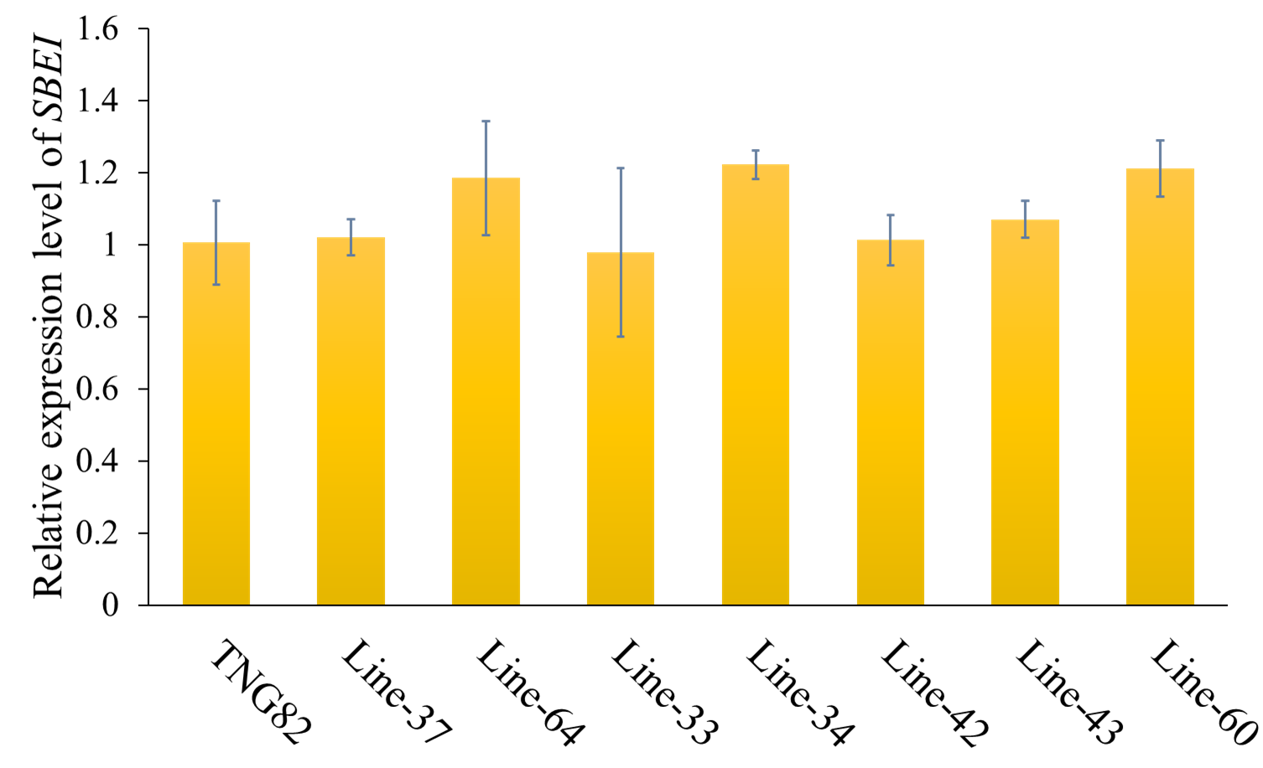

Supplemental Figure 1. Expression levels of SBEI in the endosperms of TNG82 (WT) and representative heterozygous and homozygous mutant rice lines, as analyzed by qRT-PCR. Total RNA was isolated from young endosperms 25 days after flowering. The expression level of ribosomal RNA was used as an internal control for normalization.

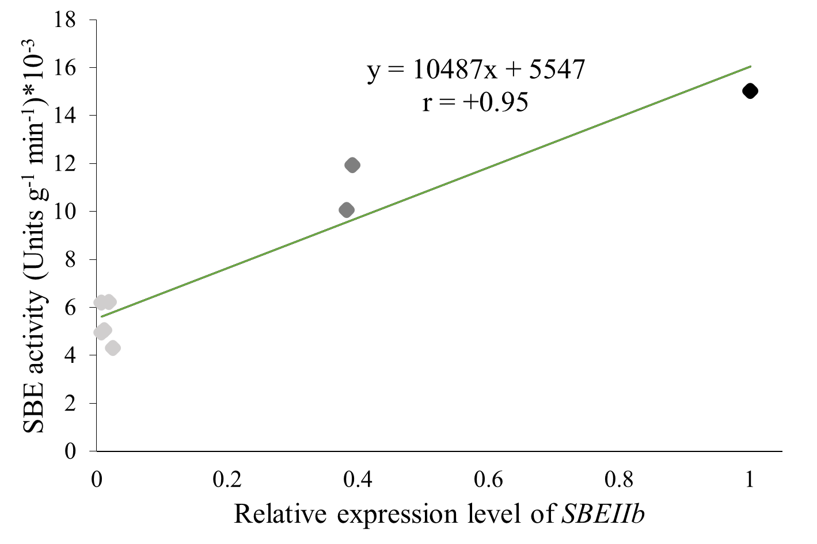
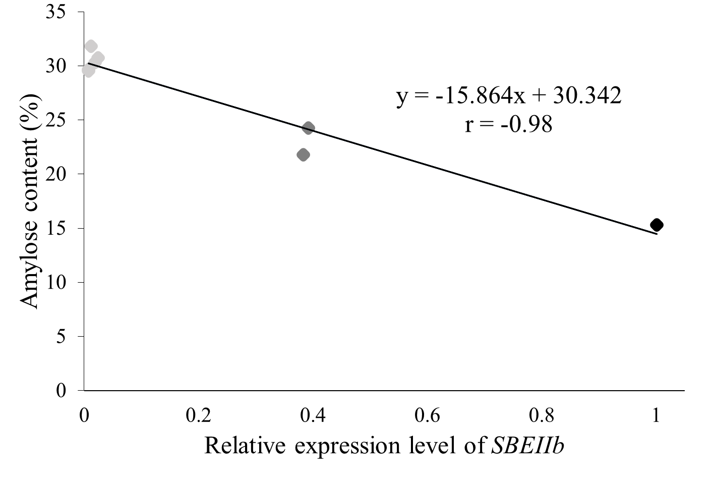
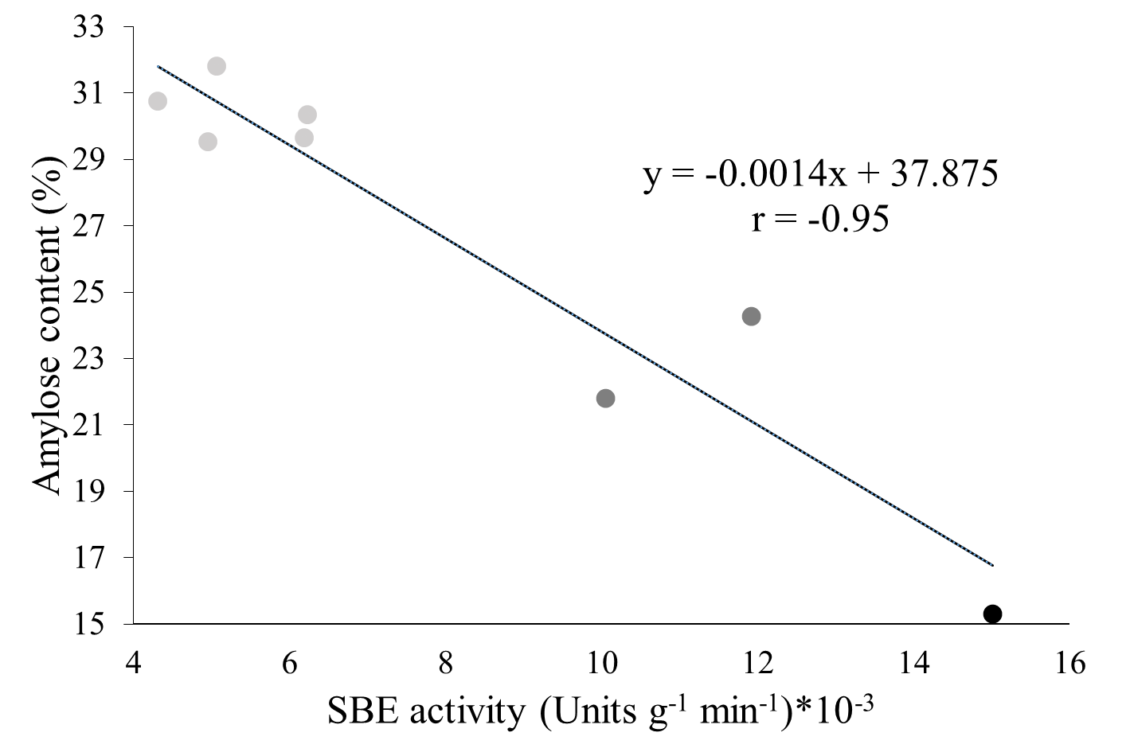
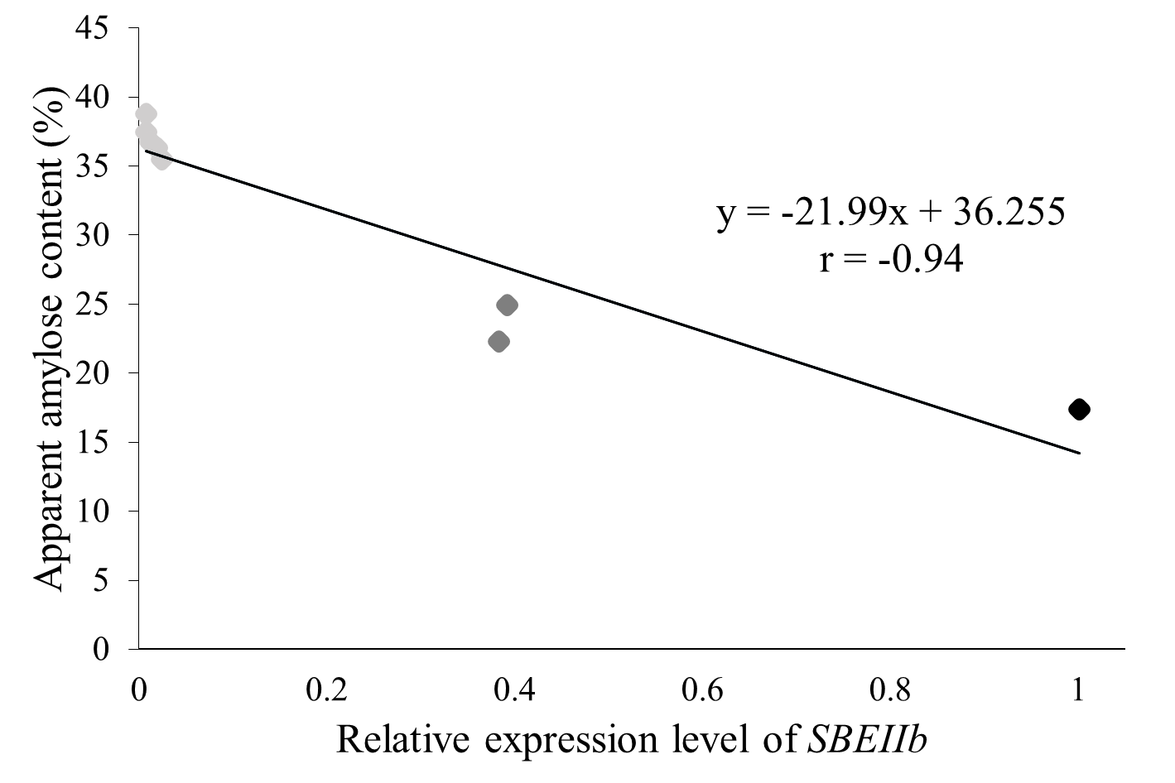
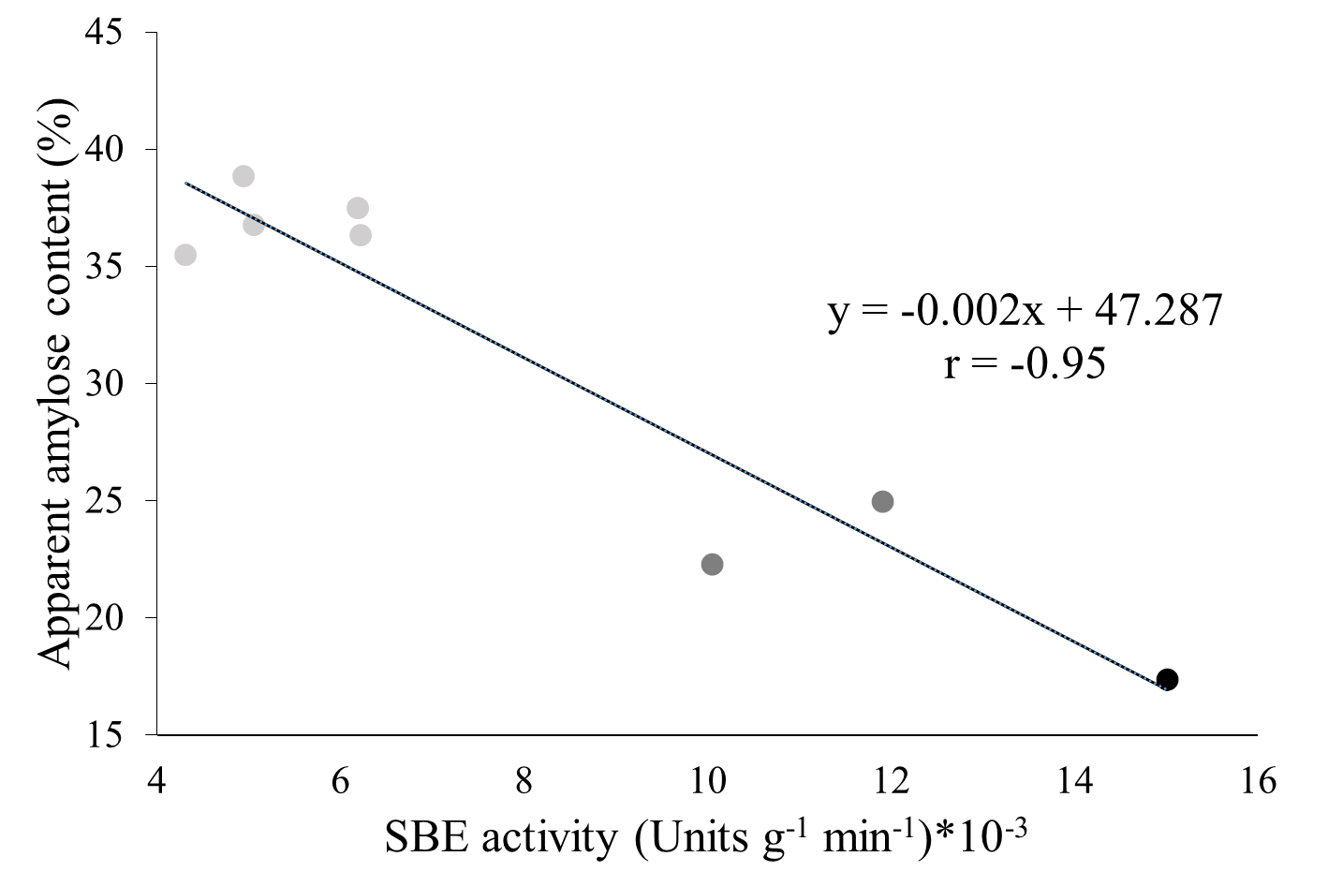
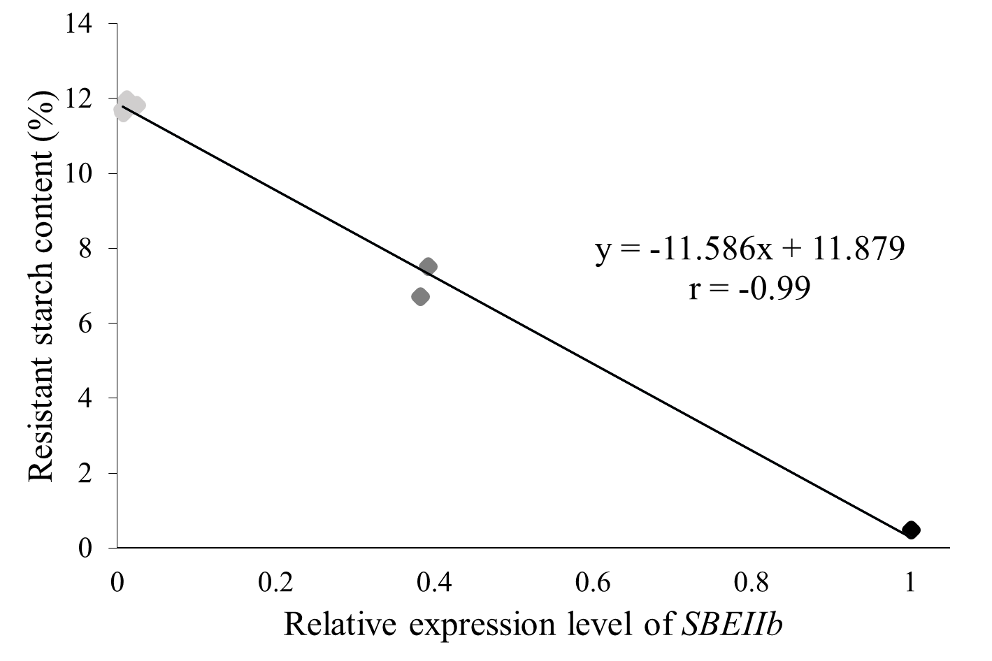
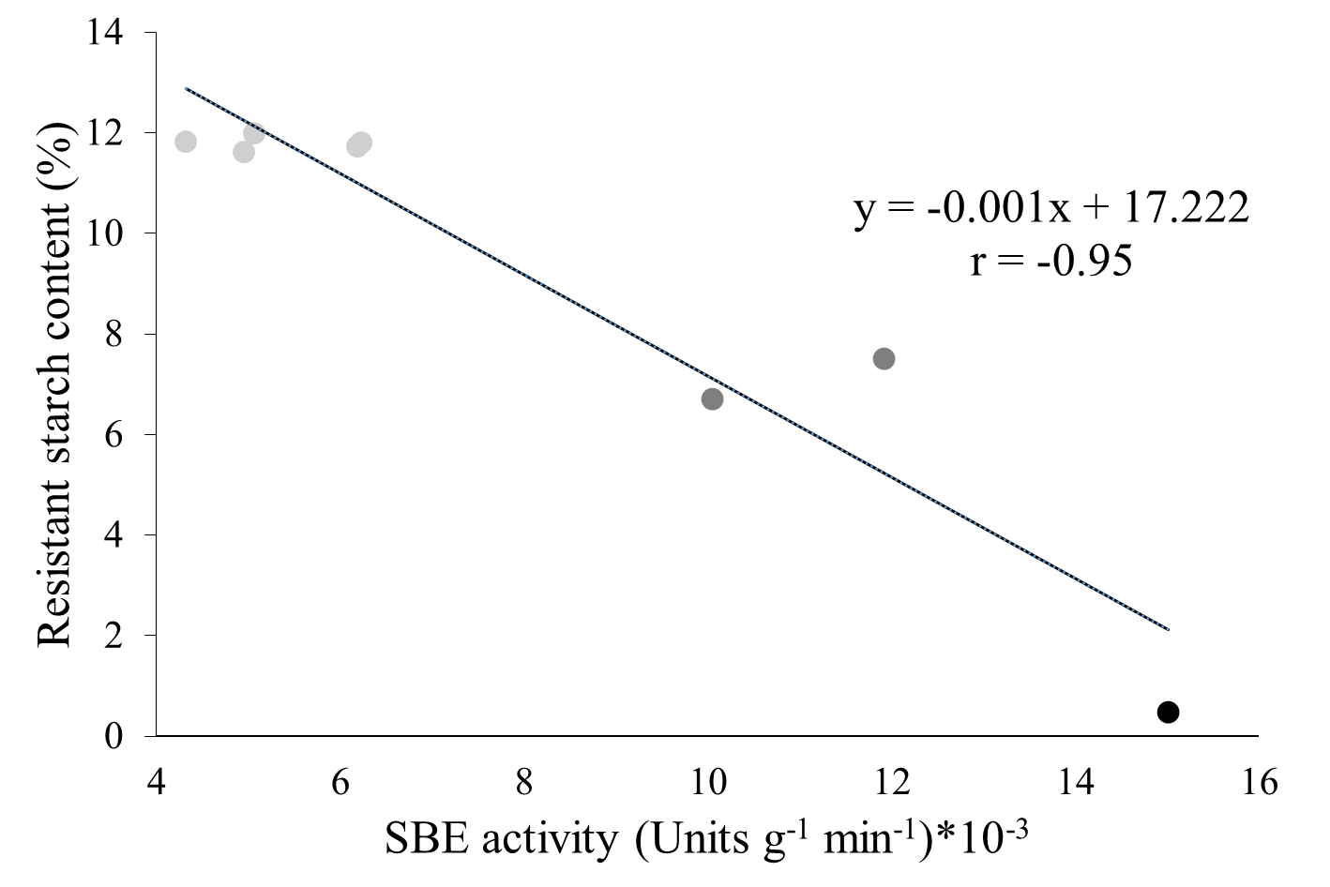
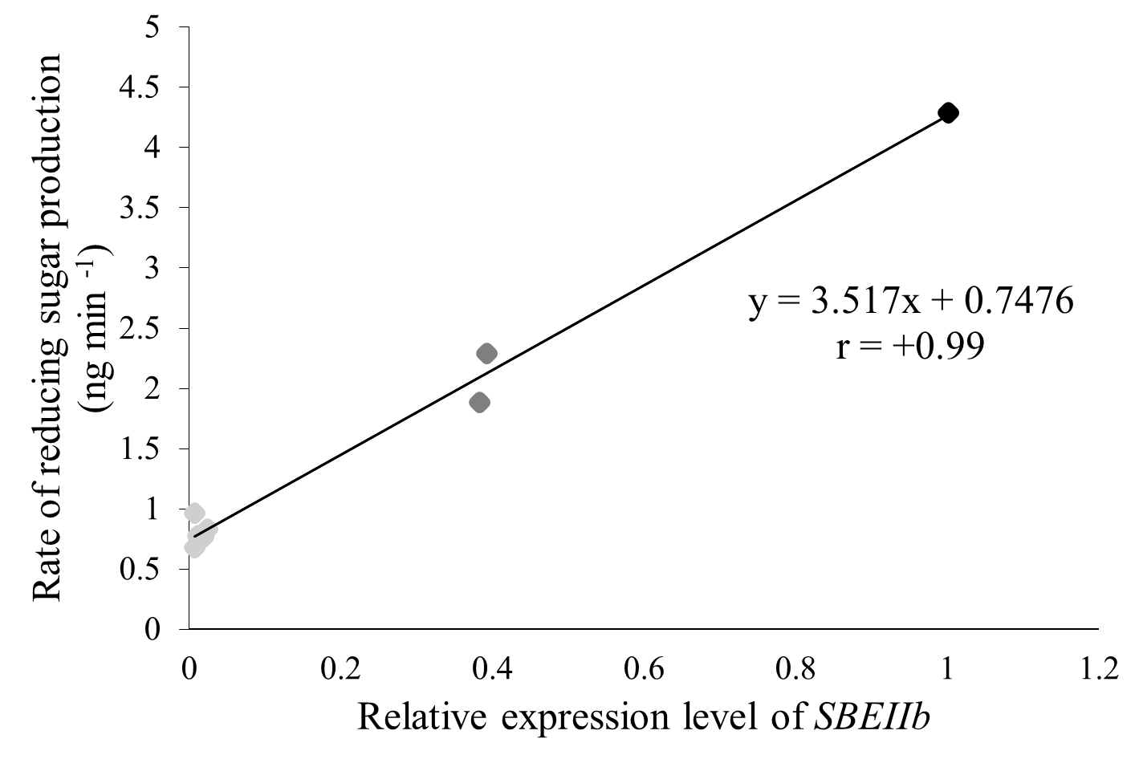
(A)
(B)
(C)
(D)
(E)
(F)
(G)
(H)
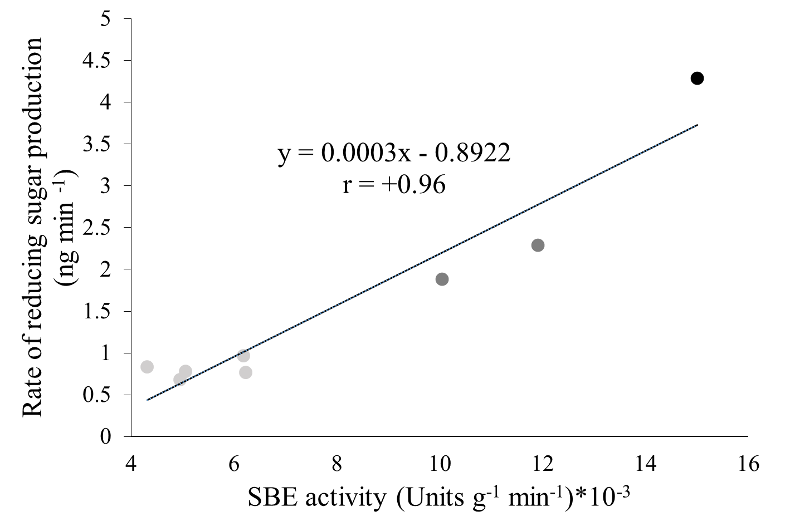
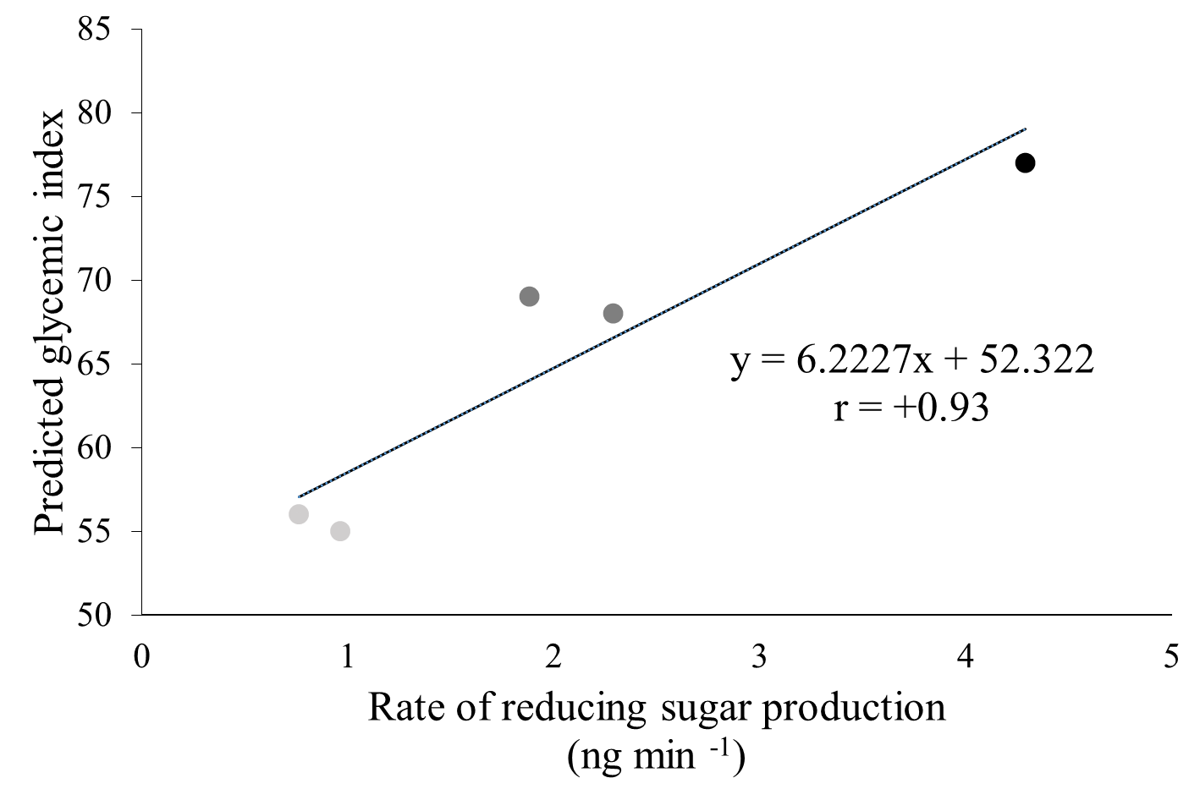
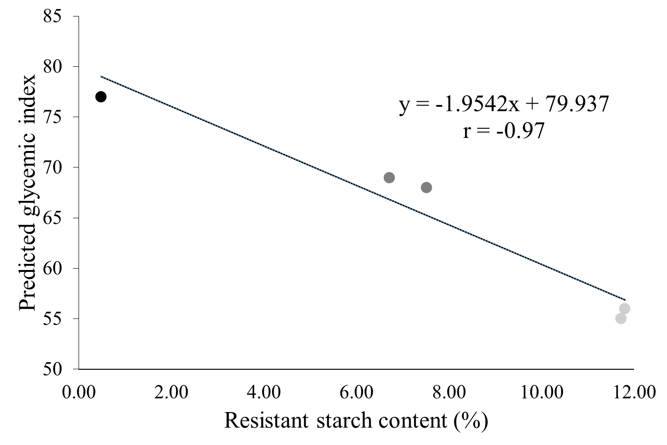
(I)
(J)
(K)

Supplemental Figure 2. Correlation analyses between starch molecular and physicochemical properties of TNG82 (WT) and OsSBEIIb mutant lines. TNG82 is shown in black; heterozygous mutant line are shown in dark grey; homozygous mutant lines are shown in light grey. (A) Correlation between SBE activity and relative expression level of OsSBEIIb. (B) Correlation between amylose content and relative expression level of OsSBEIIb. (C) Correlation between amylose content and SBE activity. (D) Correlation between apparent amylose content and relative expression level of OsSBEIIb. (E) Correlation between apparent amylose content and SBE activity. (F) Correlation between resistant starch content and relative expression level of OsSBEIIb. (G) Correlation between resistant starch content and SBE activity. (H) Correlation between rate of reducing sugar production and relative expression level of OsSBEIIb. (I) Correlation between rate of reducing sugar production and SBE activity. (J) Correlation between predicted glycemic index and rate of reducing sugar production. (K) Correlation between rate of reducing sugar production and resistant starch content.

