Supplemental Figure 1. 47 year old female with a history of widely-metastatic melanoma with metastases to liver, lungs, adrenal glands, bone, on systemic treatment with ipilimumab/nivolumab, who presented to the hospital with worsening right sided visual field deficit, found to have 15 brain metastases with a dominant left temporal lesion, 27 mm in diameter. She underwent GKS to all 15 lesions with a total of 18Gy at 50% isodose line delivered to the dominant lesion via 18 shots. At 8 week follow up, the dominant lesion had decreased to 7 mm.

Pre GKS MRI Post GKS MRI at 8 weeks
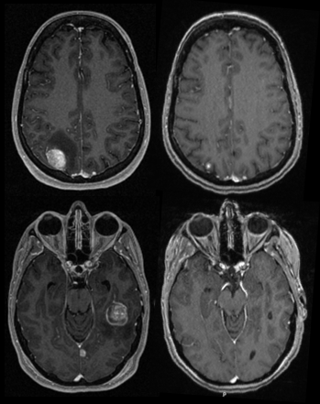

Supplemental Figure 2. 80 year old male with a history of atrial fibrillation on Coumadin, coronary artery disease (CAD) status post coronary artery bypass grafting (CABG) and permanent pacemaker placement, and multifocal papillary thyroid cancer metastatic to lung and bone status post thyroidectomy and bilateral neck dissection and radiation, who presented to the hospital with worsening headaches, found to have a 5 cm acute intraparenchymal hemorrhage with surrounding vasogenic edema concerning for metastatic lesion. He underwent right craniotomy for tumor resection and was discharged home on post-operative day 2. On post-operative day 14, he began to have worsening headaches, fevers, chills and altered mental status with erythema along the surgical wound. Workup was significant for worsening sepsis secondary to cerebritis, Staph. epidermidis bacteremia and pneumonia. Hospital course was further complicated by end-organ dysfunction including new heart failure and disseminated intravascular coagulopathy. Due to progressive multi-organ failure, the patient’s family decided to withdraw further life-sustaining treatment.

Pre-operative MRI Post-operative MRI Readmission MRI
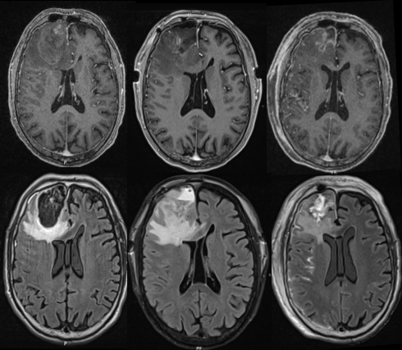

Supplemental Figure 3. 72 year old female with history of stage III adeno-squamous carcinoma of the right upper lobe, diagnosed in September 2015, who completed radiation with weekly Taxol and carboplatin, subsequently found to have metastatic progression to the brain in January 2018, for which she underwent GKS to all 3 lesions, with a total of 18Gy at 50% isodose line delivered to the dominant right occipital lesion via 15 shots. In August 2018, she developed flashing in the left visual field, initially thought to be seizures secondary to the known right occipital metastasis; however, neuro-ophthalmology felt patient’s symptoms were instead attributable to Charles Bonnet syndrome. MRI in October 2018 revealed increase in the size and surrounding vasogenic edema of the known and previously treated right occipital lobe. She underwent right occipital craniotomy for tumor in November 2018, followed by Cyberknife to the resection bed in December, with treatment to 3000 cGy in 600 cGy fractions prescribed to the 70% isodose line.

Pre GKS MRI Pre-operative MRI Post-operative MRI
