Supplementary Information for “Resilience and Stability of Wastewater Treatment Plant under Stochastic Influent: A Novel Pollutant-Carbon Synergy Framework”

Table of Contents

Supplementary Notes 1 to 3
Supplementary Note 1. Calculation method of CEI
Supplementary Note 2. Normalization methods of GWFRE and CEI
Supplementary Note 3. Construction of fully connected neural network

Supplementary Figures 1 to 6
Figure S1 Flow chart of case OD process WWTP
Figure S2 Flow chart of case A²/O process WWTP
Figure S3 Flow chart of A²/O-MBR process WWTP
Figure S4 Flow chart of CASS process WWTP
Figure S5 Architecture of multi-task learning fully connected neural network
Figure S6 Training and validation loss curves of the multi-task learning fully connected neural network. (Eval_1 to Eval_4 correspond to the OD, A²/O, A²/O-MBR and CASS

Supplementary Tables 1 to 8
Table S1 Average daily capacity and pollutant loading rates of influent in case WWTPs from 2019 to 2022
Table S2 Historical SCC matrix of influent loading rates in the OD process
Table S3 Historical SCC matrix of influent loading rates in the A²/O process
Table S4 Historical SCC matrix of influent loading rates in the A²/O-MBR process
Table S5 Historical SCC matrix of influent loading rates in the CASS process
Table S6 Fitting parameters for the CV of CCD under different SCC matrices.
Table S7 Design parameters of influent for the case WWTPs
Table S8 The emission factors for CEI calculation

Supplementary Notes

Supplementary Note 1. Calculation method of CEI
CEI of WWTP is categorized into three scopes:
- Scope 1 (CEI₁): Direct CH₄ and N₂O emissions from the treatment process.
- Scope 2 (CEI₂): Indirect CO₂ emissions from electricity consumption.
- Scope 3 (CEI₃): Indirect CH₄ and N₂O emissions from effluent and CO₂ emissions from chemical usage.
The emission factors are summarized in Table S8. The calculation of CEI is based on equations (S1) to (S4)：
$CEI=C{EI}_{1}+{CEI}_{2}+{CEI}_{3}$ (S1)
${CEI}_{1}={BOD}_{in}×{EF}_{{CH}_{4}}×{10}^{-3}×{GWP}_{{CH}_{4}}+{TN}_{in}×{EF}_{N_{2}O}{×44}/{28}×{10}^{-3}{×GWP}_{N_{2}O}$ (S2)
${CEI}_{2}=E_{Energy}/Q×{EF}_{Energy}×{GWP}_{{CO}_{2}}$ (S3)
${CEI}_{3}=\frac{\left(\sum{{EF}_{C_{i}}}×C_{i}\right)}{Q}×{GWP}_{{CO}_{2}}+{BOD}_{out}×{EF}_{{CH}_{4}}'×{10}^{-3}×{GWP}_{{CH}_{4}}+{TN}_{out}{×EF}_{N_{2}O}'×{44}/{28}×{GWP}_{N_{2}O}$ (S4)
Where Q is capacity of WWTPs, m³/d; ${BOD}_{in}$ is the BOD₅ concentration of influent, mg BOD₅/L; ${EF}_{{CH}_{4}}$ is CH₄ emission factor of influent, CH₄/kg BOD₅,；${GWP}_{{CH}_{4}}$ is global warming potential of CH₄, 28；${TN}_{in}$ is TN concentration of influent, mg N/L; ${EF}_{N_{2}O}$ is N₂O emission factor of influent, N₂O-N/kg N; ${GWP}_{N_{2}O}$ is global warming potential of CH₄, 265；$E_{energy}$ is energy consumption during the operational phase, kW·h；${EF}_{energy}$ is emission factor of energy consumption, kg CO₂-eq/kW·h；${GWP}_{{CO}_{2}}$ is global warming potential of CO₂, 1；${EF}_{C_{i}}$ is the emission factor for chemical i, kg CO₂-eq /kg; $C_{i}$ is consumption of chemical i; kg; ${BOD}_{out}$ is BOD₅ concentration of effluent, mg/L; ${EF}_{{CH}_{4}}'$ is CH₄ emission factor of effluent, kg CH₄/kg BOD₅；${TN}_{out}$ is TN concentration of effluent, mg/L; ${EF}_{N_{2}O}'$ is N₂O emission factor of effluent, kg N₂O-N/kg N.

Supplementary Note 2. Normalization methods of GWFRE and CEI
The dimensionless value 𝑊, which represents the normalized daily GWFRE using Min-Max Normalization, is calculated using Equation (S5) as follows：
$W=\frac{GWFRE-{GWFRE}_{min}}{{GWFRE}_{max}-{GWFRE}_{min}}$ (S5)
Where ${GWFRE}_{max}$ is the maximum value of daily GWFRE within historical data of 4 years; ${GWFRE}_{min}$ is the minimum value of daily GWFRE within historical data of 4 years.
The dimensionless value C, which represents the normalized daily CEI using Man-Min Normalization, is calculated using Equation (S6) as follows：
$C=\frac{{CEI}_{max}-CEI}{{CEI}_{max}-C{EI}_{min}}$ (S6)
Where ${CEI}_{max}$ is the maximum value of daily GWFRE within historical data of 4 years; $C{EI}_{min}$ is the minimum value of daily GWFRE within historical data of 4 years.

Supplementary Note 3. Construction of fully connected neural network
The study developed a multi-task learning-based fully connected neural network (FCNN), featuring two shared layers and four task-specific output layers. The shared layers utilized the ReLU activation function to handle non-linear information, while the output layers produce prediction results for each task. The model can be expressed as y_{i} = f_{shared}(x) + f_{specific_i}(x), where 𝑖 represents different tasks (e.g., different WWTPs). The shared function, f_{shared}, captures common features across all plants, while the specific function, f_{specific_i}, focuses on the unique features of each plant.
In contrast to traditional single-task fully connected networks (where each task trains a separate model, expressed as y_{i} = f_{i}(x)), the multi-task network’s shared base features enable simultaneous processing of data from multiple plants. This reduces training time and costs while enhancing output comparability and prediction accuracy. Therefore, the multi-task learning-based FCNN is a more suitable deep learning architecture for handling data from multiple WWTPs. The model architecture and training process are as follows:
- Model Architecture
The architecture is implemented using PyTorch, comprising two shared hidden layers and four task-specific output layers (Figure S5). The details are as follows:
- Input Layer: The input feature vector has 7 dimensions.
- Shared Layers:
  - First Layer: A fully connected layer with an input dimension of 7 and an output dimension of 64. The ReLU activation function introduces non-linearity into the data processing.
  - Second Layer: Another fully connected layer with both input and output dimensions of 64, also using the ReLU activation function.
- Task-specific Output Layers: The model includes four tasks, each corresponding to a separate fully connected layer. Each layer has an input dimension of 64 and an output dimension of 2, designed for regression predictions.
- Forward Propagation: The model’s forward propagation process sequentially traverses the shared layers and the task-specific output layers to generate predictions for all four tasks.
- Data Processing
The dataset used in this study was derived from actual operational data from four case-study WWTPs spanning 2019 to 2022. The input features consist of a seven-dimensional vector comprising the loading rates of COD, BOD₅, TN, TP, SS, NH₃-N, and treated capacity. The output features are represented by a two-dimensional vector, including the normalized GWFRE and CEI (Outputs 1–4). Each dataset was split into training and testing sets with an 80:20 ratio to ensure the model's generalization ability.
- Model Training Process
The model training process uses Mean Squared Error (MSE) as the loss function. The Adam optimizer is employed with a learning rate of 0.001. During training, the model is trained for 100 epochs on each dataset with a batch size of 128. The detailed process is as follows:
- Training Set Iteration: During each epoch, the model is trained on each dataset. The input data undergoes forward propagation, generating predictions through the corresponding task-specific output layers.
- Loss Calculation and Backpropagation: For each task, the MSE loss is computed and accumulated to form the total loss. After calculating the loss for each batch of training samples, backpropagation is performed to optimize the model parameters, minimizing the loss for each task.
- Model Evaluation: At the end of each epoch, the model's performance is evaluated using the test set. The MSE loss for each task is calculated, and both training and evaluation loss values are recorded to plot the loss curves (Figure S6).

Supplementary Figures
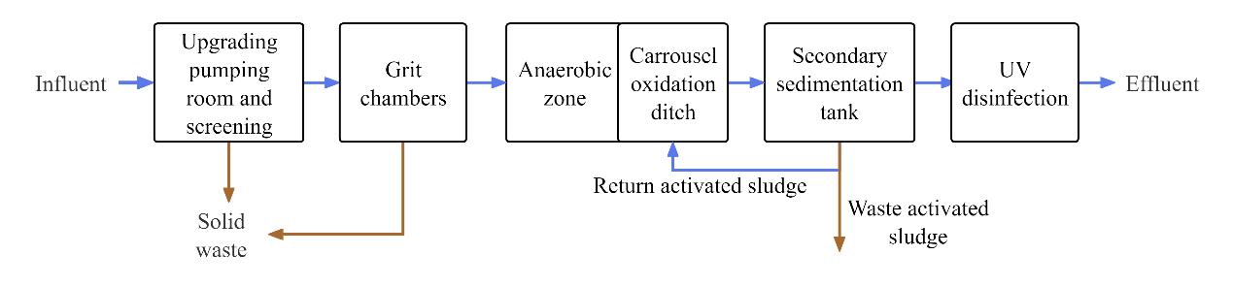

Figure S1 Flow chart of case OD process WWTP

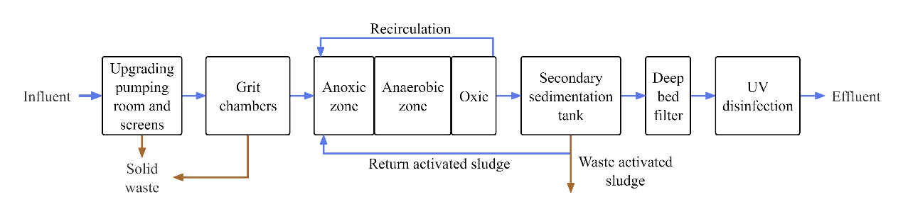

Figure S2 Flow chart of case A²/O process WWTP

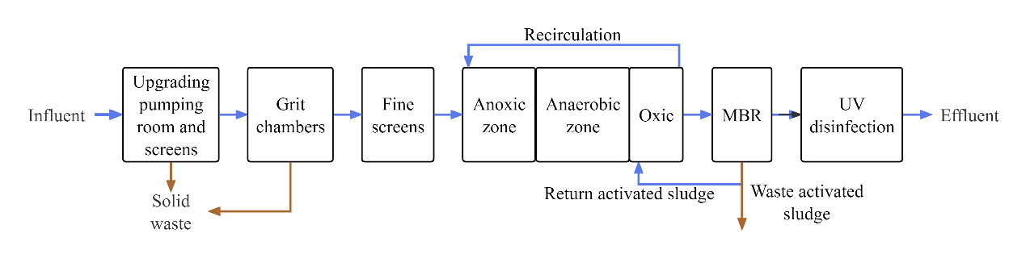

Figure S3 Flow chart of A²/O-MBR process WWTP
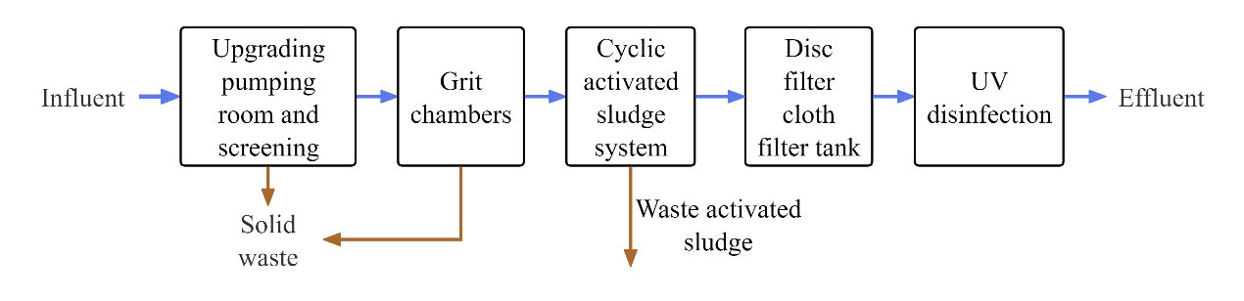

Figure S4 Flow chart of CASS process WWTP

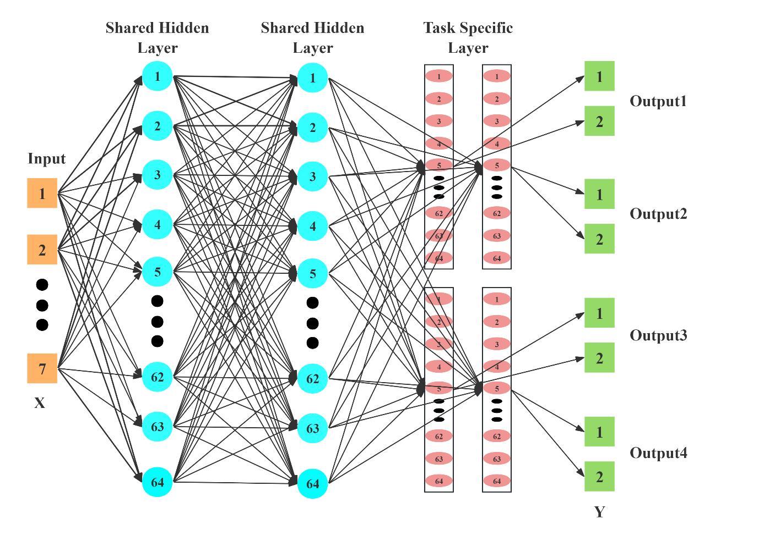

Figure S5 Architecture of multi-task learning fully connected neural network

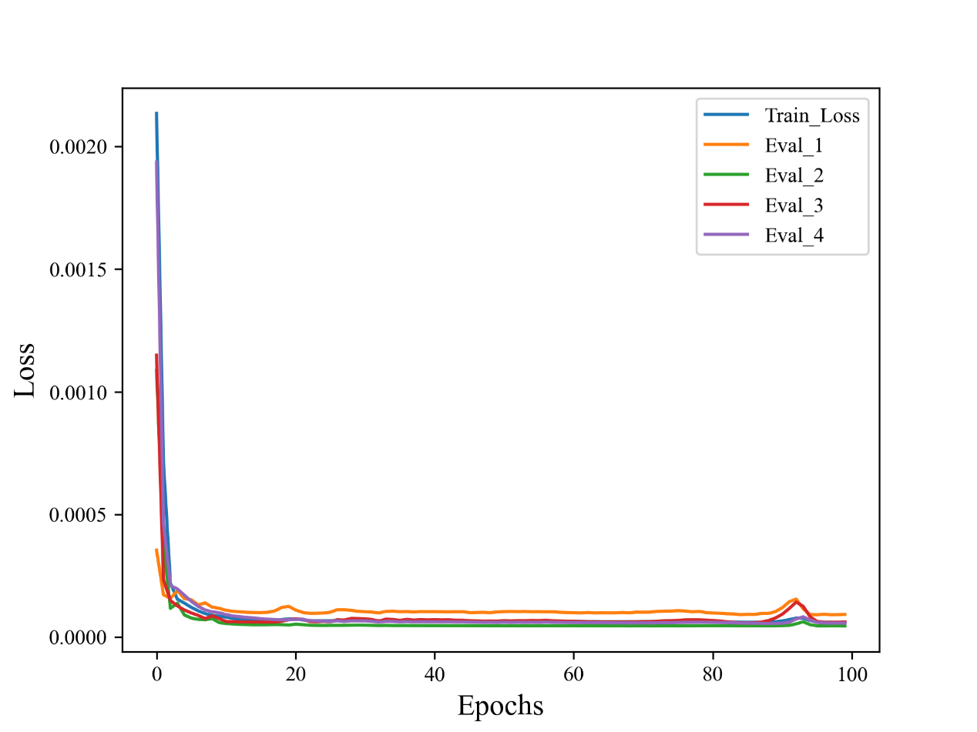

Figure S6 Training and validation loss curves of the multi-task learning fully connected neural network. (Eval_1 to Eval_4 correspond to the OD, A²/O, A²/O-MBR and CASS processes)

Supplementary Tables

Table S1 Average daily capacity and pollutant loading rates of influent in case WWTPs from 2019 to 2022
Process | COD | BOD₅ | TN | TP | SS | NH₃-N | Capacity
OD | 0.48 ± 0.14 | 0.46 ± 0.14 | 0.50 ± 0.08 | 0.71 ± 0.19 | 0.58 ± 0.20 | 0.64 ± 0.12 | 1.21 ± 0.20
A²/O | 0.54 ± 0.16 | 0.52 ± 0.15 | 0.57 ± 0.10 | 0.82 ± 0.27 | 0.69 ± 0.26 | 0.64 ± 0.13 | 1.01 ± 0.12
A²/O-MBR | 0.54 ± 0.16 | 0.52 ± 0.15 | 0.57 ± 0.10 | 0.82 ± 0.27 | 0.69 ± 0.26 | 0.64 ± 0.13 | 0.73 ± 0.17
CASS | 0.59 ± 0.14 | 0.55 ± 0.17 | 0.71 ± 0.14 | 0.83 ± 0.19 | 0.69 ± 0.21 | 0.95 ± 0.21 | 0.70 ± 0.15

Table S2 Historical SCC matrix of influent loading rates in the OD process
 | Capacity | COD | BOD₅ | TN | TP | SS | NH₃-N
Capacity | 1 | 0.560 | 0.543 | 0.346 | 0.422 | 0.356 | 0.289
COD | 0.560 | 1 | 0.932 | 0.543 | 0.695 | 0.661 | 0.438
BOD₅ | 0.543 | 0.932 | 1 | 0.545 | 0.652 | 0.633 | 0.438
TN | 0.346 | 0.543 | 0.545 | 1 | 0.514 | 0.411 | 0.651
TP | 0.422 | 0.695 | 0.652 | 0.514 | 1 | 0.592 | 0.351
SS | 0.356 | 0.661 | 0.633 | 0.411 | 0.592 | 1 | 0.298
NH₃-N | 0.289 | 0.438 | 0.438 | 0.651 | 0.351 | 0.298 | 1

Table S3 Historical SCC matrix of influent loading rates in the A²/O process
 | Capacity | COD | BOD₅ | TN | TP | SS | NH₃-N
Capacity | 1 | 0.326 | 0.330 | 0.016 | 0.115 | 0.128 | 0.044
COD | 0.326 | 1 | 0.916 | 0.503 | 0.721 | 0.642 | 0.296
BOD₅ | 0.330 | 0.916 | 1 | 0.491 | 0.653 | 0.588 | 0.316
TN | 0.016 | 0.503 | 0.491 | 1 | 0.505 | 0.350 | 0.599
TP | 0.115 | 0.721 | 0.653 | 0.505 | 1 | 0.649 | 0.233
SS | 0.128 | 0.642 | 0.588 | 0.350 | 0.649 | 1 | 0.157
NH₃-N | 0.044 | 0.296 | 0.316 | 0.599 | 0.233 | 0.157 | 1

Table S4 Historical SCC matrix of influent loading rates in the A²/O-MBR process
 | Capacity | COD | BOD₅ | TN | TP | SS | NH₃-N
Capacity | 1 | 0.196 | 0.169 | -0.086 | 0.182 | 0.184 | -0.081
COD | 0.196 | 1 | 0.916 | 0.502 | 0.720 | 0.642 | 0.294
BOD₅ | 0.169 | 0.916 | 1 | 0.490 | 0.652 | 0.587 | 0.315
TN | -0.086 | 0.502 | 0.490 | 1 | 0.503 | 0.349 | 0.597
TP | 0.182 | 0.720 | 0.652 | 0.503 | 1 | 0.648 | 0.232
SS | 0.184 | 0.642 | 0.587 | 0.349 | 0.648 | 1 | 0.157
NH₃-N | -0.081 | 0.294 | 0.315 | 0.597 | 0.232 | 0.157 | 1

Table S5 Historical SCC matrix of influent loading rates in the CASS process
 | Capacity | COD | BOD₅ | TN | TP | SS | NH₃-N
Capacity | 1 | -0.337 | -0.185 | -0.390 | -0.480 | -0.051 | -0.371
COD | -0.337 | 1 | 0.864 | 0.648 | 0.615 | 0.221 | 0.639
BOD₅ | -0.185 | 0.864 | 1 | 0.579 | 0.513 | 0.161 | 0.578
TN | -0.390 | 0.648 | 0.579 | 1 | 0.661 | 0.139 | 0.930
TP | -0.480 | 0.615 | 0.513 | 0.661 | 1 | 0.184 | 0.629
SS | -0.051 | 0.221 | 0.161 | 0.139 | 0.184 | 1 | 0.138
NH₃-N | -0.371 | 0.639 | 0.578 | 0.930 | 0.629 | 0.138 | 1

Table S6 Fitting parameters for the CV of CCD under different SCC matrices.
 | Original SCC Matrix |  | Matrix decreased to 0.8 times |  | Matrix decreased to 0.5 times |  | Matrix decreased to 0.2 times
 | Absolute value of the slope | R² | Absolute value of the slope | R² | Absolute value of the slope | R² | Absolute value of the slope | R²
OD | 0.032 (0.0324)* | 0.866 (0.836) | 0.0322 (0.0348) | 0.805 (0.801) | 0.0318 (0.0361) | 0.861 (0.815) | 0.0342 (0.0466) | 0.863 (0.829)
A²/O | 0.0127 (0.0136) | 0.91 (0.803) | 0.0157 (0.012) | 0.871 (0.839) | 0.016 (0.0107) | 0.835 (0.854) | 0.0143(0.0126) | 0.871 (0.791)
A²/O-MBR | 0.0429 (0.0418) | 0.812 (0.805) | 0.0366 (0.0381) | 0.799 (0.879) | 0.0395 (0.037) | 0.856 (0.874) | 0.0367 (0.0318) | 0.875 (0.891)
CASS | 0.0288 (0.0269) | 0.856 (0.802) | 0.0258 (0.0261) | 0.712 (0.835) | 0.0263 (0.0266) | 0.885 (0.848) | 0.0275 (0.0238) | 0.827 (0.832)
*Data format: Positive correlation curve values (negative correlation curve values). The positive correlation curve values represent the fitting parameters when the ACC is greater than zero, while the negative correlation curve values represent the fitting parameters when the ACC is less than zero. “Matrix decreased to X times” indicates that the SCC matrix has been scaled to X times of the historical matrix.

Table S7 Design parameters of influent for the case WWTPs
Process | COD | BOD₅ | NH₃-N | TN | TP | SS | Capacity
Process | mg/L | mg/L | mg/L | mg/L | mg/L | mg/L | 10⁴ m³/d
OD | 300 | 150 | 25 | 45 | 4 | 200 | 15
A²/O | 300 | 150 | 25 | 40 | 4 | 200 | 10
A²/O-MBR | 300 | 150 | 25 | 40 | 4 | 200 | 20
CASS | 300 | 150 | 25 | 40 | 4 | 200 | 5

Table S8 The emission factors for CEI calculation.
Index | Value | Unit | Application
$${EF}_{{CH}_{4}}$$ | 0.0142 | kg CH₄/kg BOD | Influent of A²/O and A²/O-MBR process
$${EF}_{{CH}_{4}}$$ | 0.0096 | kg CH₄/kg BOD | Influent of OD process
$${EF}_{{CH}_{4}}$$ | 0.0100 | kg CH₄/kg BOD | Influent of CASS process
$${EF}_{N_{2}O}$$ | 0.00466 | kg N₂O-N/kg N | Influent of A²/O and A²/O-MBR process
$${EF}_{N_{2}O}$$ | 0.00641 | kg N₂O-N/kg N | Influent of OD process
$${EF}_{N_{2}O}$$ | 0.02020 | kg N₂O-N/kg N | Influent of CASS process
$${EF}_{energy}$$ | 0.5810 | kg CO₂-eq/kW·h | Electricity consumption
$${EF}_{C_{i}}$$ | 0.1623 | kg CO₂-eq /kg | Polymeric aluminum chloride (10%)
$${EF}_{C_{i}}$$ | 0.61 | kg CO₂-eq /kg | NaClO (10%)
$${EF}_{C_{i}}$$ | 0.125 | kg CO₂-eq /kg | CH₃COONa (20%)
$${EF}_{C_{i}}$$ | 1.48 | kg CO₂-eq /kg | Polyacrylamide
$${EF}_{C_{i}}$$ | 1.6 | kg CO₂-eq /kg | Citrate, Glucose
$${EF}_{C_{i}}$$ | 2.24 | kg CO₂-eq /kg | NaOH
$${EF}_{C_{i}}$$ | 0.68 | kg CO₂-eq /kg | CaO
$${EF}_{C_{i}}$$ | 0.26 | kg CO₂-eq /kg | FeCl₃
$${EF}_{{CH}_{4}}'$$ | 0.068 | kg CH₄/kg BOD | Effluent
$${EF}_{N_{2}O}'$$ | 0.005 | kg N₂O-N/kg N | Effluent

