Supplementary Information
Toxicological Impacts and Environmental Risk of Atrazine in the Presence of Graphene Family Nanomaterials (GFNs) on Chlorella sp.

Abhrajit Debroyª, Mrudula Pulimiª, Amitava Mukherjeeª*

ªCentre for Nanobiotechnology, Vellore Institute of Technology, Vellore, Tamil Nadu, India

*Corresponding author
Dr. Amitava Mukherjee
Senior Professor & Director
Centre for Nanobiotechnology
Vellore Institute of Technology, Vellore – 632014, India.
Email: amit.mookerjea@gmail.com, amitav@vit.ac.in
Phone: 91 416 2204211
Fax: 91-416-224
Materials and Methods
M1S1: Chemicals used
Sulphuric acid (H₂SO₄), phosphoric acid (H₃PO₄), and hydrochloric acid (HCl) were purchased from Molychem Pvt. Ltd., India. Acetone, Potassium persulfate (K₂S₂O₈), potassium permanganate (KMnO₄), and sodium carbonate (Na₂CO₃) were purchased from Sisco Research Laboratories Pvt. Ltd., India. Phosphorous pentoxide (P₂O₅), 2′ ,7′ -dichlorofluorescein diacetate (DCFH-DA) were purchased from Sigma Aldrich. hydrogen peroxide (H₂O₂) were purchased from SDFCL (Mumbai). Trichloroacetic acid (TCA) and thiobarbituric acid (TBA) were purchased from Hi Media Pvt. Ltd (Mumbai, India).
Collected NSW (natural sea water) was filtered through blotting paper first for removing the larger particles followed by filtration with Whatman no. 1 (pore size - 11 μm) filter paper to discard any other colloidal particles. The filtered water was then subjected to sterilisation using autoclaving at 121˚ C for 15 min.

M2S2: Synthesis of GFNs
Synthesis of GO
The modified Hummer’s method was followed using graphite powder (>99.95% purity). The sulphuric acid and phosphoric acid were measured in the volume of 27 mL and 3 mL (9:1 ratio) and stirred continuously for 15 min. 0.225 g of graphite powder was added to the acid mix and followed by the slow addition of KMnO₄ (1.32 g). The solution changed to dark green after 6 h of continuous stirring. The removal of excess KMnO₄ was done by adding 0.675 mL of H₂O₂ in a dropwise manner, under continuous stirring for 10 min. The solution was allowed to cool down after completion of the exothermic reaction. At the end of the reaction, the material was washed with HCl (10 mL) and deionized water (30 mL) using centrifugation at 5000 rpm for 20 min. The obtained pellet was dried in a hot air oven (for 24 h at 80 ᵒC) to achieve the powder form of GO for further studies [1].
Synthesis of rGO
The prepared GO was diluted with milliQ water to form a suspension of 0.5 mg/mL. NaBH₄ (2.28 g) was added to 200 mL of GO suspension. The mixture was kept under stirring at room temperature for 12 h to obtain rGO. Next, the rGO was filtered and washed with milliQ water until neutralization [2].
Synthesis of graphene
A single-step process was followed for the synthesis of stable graphene sheets. The raw graphite flakes were dispersed in a solution of ethanol and deionized water (1:9 volume ratio). The suspension was subjected to bath sonication with a working frequency of 40/50 Hz at room temperature for 180 min. The dispersion was centrifuged for 30 min at 1200 rpm to filter out unexfoliated graphite flakes. The supernatant was then dried at 80 ᵒC for 24 h for complete drying [3].
M3S3: Characterization
Raman spectroscopy (acquisition at 532 nm) (Anton Paar Cora 5001, Austria) was used for confirmation of defects in the GFNs. The shape of the GFNs were precisely analyzed by Transmission Electron Microscopy (TEM) [1].
M4S4: Surface charge, hydrophobicity, and adsorption
The surface charge of pristine materials and their mixtures were analyzed by zeta potential analysis (90 Plus Particle Size Analyzer, Brookhaven Instruments Corp., USA). The hydrophobicity/hydrophilicity of the samples were measured using a goniometer (Model: DMs-401, Kyowa Interface Science Co., Ltd.; software- FAMAS).
Surface charge of the liquid sample was measured by zeta potential. To check the hydrophobicity, a minute drop of liquid sample was taken and kept over the glass slide for air drying. When the sample was properly air dried, contact angle was measured. The contact angles were measured with the sessile drop technique using water [4].
Ultra-performance liquid chromatography (UPLC system, Waters Inc., Bedford, MA, US) technique was used to measure the concentration of atrazine in pristine form as well as for the mixture treatment groups of atrazine with GFNs at 0 and 72 h (abiotic conditions, without algal cells). It was carried in abiotic condition, without algal cells in replicates. For UPLC, the protocol was followed from [5].
M5S5: Effects on growth inhibition
The growth inhibition was assessed after the incubation time, by counting the healthy cells on a haemocytometer and examined under an optical microscope. Healthy algal cells can be differentiated from dead algal cells as they exist as distinct, relatively big cells, whereas, dead cells form clusters. Highly damaged cells were also counted as dead cells. The cell counts for the treatment groups were compared with the control group [6].
$$Growth Inhibition (\%)=100-\left(\frac{Test}{Control}*100\right)$$
EC₅₀ was calculated with a range of concentration of 0.025 mg/L to 25.6 mg/L for atrazine pristine, by following the log concentration and probit values. For EC₅₀ calculation, at first, the percentage of growth inhibition (rounded off) of the various concentrations of atrazine tested on algal cells were recorded in comparison to the control cells, this was followed by the probit analysis of the growth inhibition percentages. Then a graph was plotted in MS Excel by plotting the values of probit against the log value of the atrazine concentrations used. From this graph, r² value was determined along with the equation. Using this equation, the value of the EC₅₀ concentration was determined, after considering the anti-log at the end.
On the basis of the growth inhibition data, Abbott’s model predicts the toxicity by examining the interaction between the contaminants in the combination of atrazine and GFNs. The ratio between the expected value (C_{exp}) and the observed value (C_{obs}) was presented by R_{I} (ratio of inhibition). For Abbott’s model, if the computed RI value is equal to 1, then the nature of interaction is stated to be additive. If the calculated RI value is less than 1, then the interaction is antagonistic. Similarly, the interaction is said to be synergistic, if the RI value obtained is greater than 1. Statistical significance between C_{obs} and C_{exp} values were performed using Two-way ANOVA (Bonferroni post-test) to validate the computed RI value. Despite the RI values obtained, the interaction between GFNs and atrazine were considered as additive when the toxicity difference between C_{obs} and C_{exp} were statistically insignificant at p< 0.05.

M6S6: Oxidative stress- Total ROS
DCFH-DA is a non-fluorescent cell permeable dye. In reaction with ROS, this dye is oxidized to a highly fluorescent 2’,7’-dichlorofluorescein, which is detected. After 72 h, 10 ml of algal cell suspension was incubated with 100 µl of DCFH-DA (100 mM) under the dark condition for 30 min. The fluorescence intensity of the samples loaded in 96 well plate (white) was measured at an excitation and emission wavelength of 485 nm and 530 nm respectively, using a spectrofluorometer. The generated ROS was calculated with reference to the algal cells without treatment [7].
M7S7: Oxidative stress- MDA content
After 72 h of interaction, treated samples were centrifuged at 4 °C for 10 min at 7000 rpm. The cell pellets were further treated with 0.25% TBA (prepared in a 10% TCA solution) and kept in a water bath at 95 °C for 30 min. The heated sample mixtures were quickly placed on ice to stop the reaction and centrifuged at 7000 rpm for 10 min. The supernatant’s absorbance containing the released MDA enzyme was measured by subtracting the absorbance at from 532 nm to 600 nm [8].
M8S8: Photosynthetic parameters assessment
In this study, a photosynthesis yield analyzer (Mini PAM, Heinz Walz, Germany) was used to measure the light response curve of photochemical quantum yield of the PS II (Y II) system, and electron transport rate (ETR) in the treated and control algal cells. After 72 h of interaction, the control and the treated cells were placed in dark incubation for 15 min, followed by, addition of 400 µl of sample into the instrument chamber and passing on the high-intensity Actinic light to record the effective quantum yield of PS II (Y II) and ETR of the samples [9].
M9S9: Antioxidant enzyme estimation
For SOD, after 72 h interaction, the algal cells were collected by centrifugation at 7000 rpm for 10 min at 4 °C followed by washing with 0.5 M phosphate buffer saline (PBS). Samples were further homogenized in PBS followed by centrifugation at 13,000 rpm for 20 min at 4 °C. After that, supernatant had been collected, it was then mixed with other chemicals (hydroxylamine hydrochlorides at a concentration of 20 mM, nitro blue tetrazolium chloride at a concentration of 96 mM, Na₂CO₃ buffer at a concentration of 50 mM with a pH of 10, and Triton X-100 at a concentration of 0.6%) and kept under visible light for 20 min. The reaction mixture was analyzed using a UV–Vis microplate-reader (xMARK microplate absorbance spectrophotometer, BIO-RAD) at a wavelength of 560 nm.
For catalase activity, 72 h treated algal cells were centrifuged at a temperature of 4 °C for 10 min at 7000 rpm. The collected cell pellet was treated in the similar fashion as mentioned prior for the SOD activity. Using a spectrophotometer (Thermofisher evolution 220), the absorbance decrease was recorded at 240 nm for 3 min after adding 800 µl of freshly made H₂O₂ solution (0.3% v/v) to 200 µl of supernatant. The reaction solution lacking H₂O₂ was treated as a blank [10].

Figures
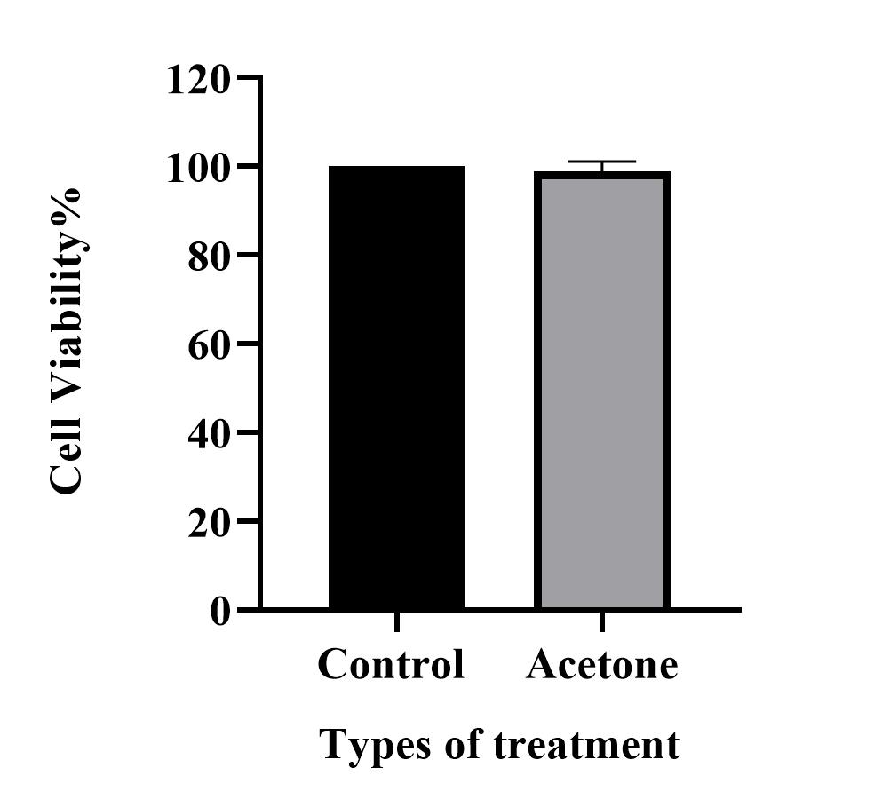
Fig S1: Cell viability in the presence of acetone

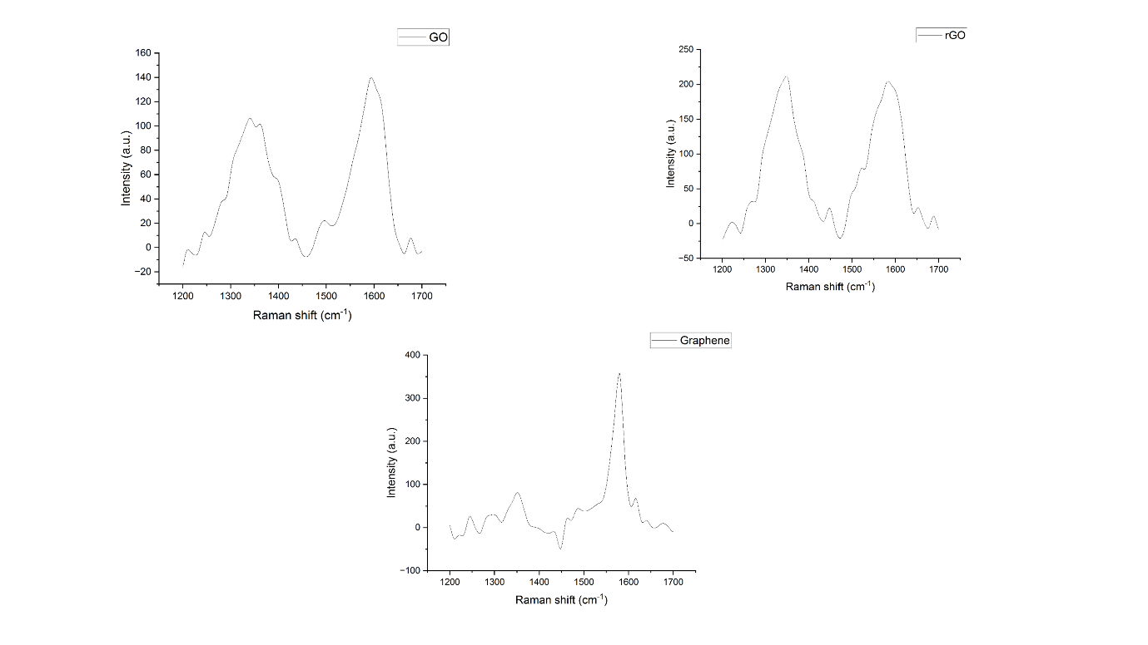
Fig S2: Raman spectra of GO, rGO, Graphene.

Fig S3: Photosynthetic parameters in algal cells exposed to the pristine atrazine, GFNs and atrazine -GFNs were assessed. The comparison of effective quantum yield of PS II (Y II) of (A-i): pristine GO and the mixture of GO and atrazine. (A-ii): pristine rGO and the mixture of rGO and atrazine; (A-iii): pristine graphene and the mixture of graphene and atrazine. The comparison of electron transport rate of (B-i): pristine GO and the mixture of GO and atrazine. (B-ii): pristine rGO and the mixture of rGO and atrazine; (B-iii): pristine graphene and the mixture of graphene and atrazine. ‘α, β, χ, δ’ indicates a significant difference between pristine and mixture treatment groups (α = p < 0.001, β = p < 0.01, χ = p < 0.05, and δ = no significance).

Tables:
Table S1. Composition of Artificial Sea Water per 1000 ml

Chemicals | Grams
Sodium Chloride | 26.29
Potassium chloride | 0.74
Calcium chloride | 0.99
Magnesium chloride | 6.09
Magnesium sulphate heptahydrate | 3.94

Table S2. Preparation of stock 1 per 100 ml
Chemicals | Grams
Zinc chloride | 2.1
Cobalt chloride | 2.0
Ammomium molybdate | 0.9
Copper sulphate | 2.0

Table S3 Preparation of stock 2 per 100 ml
Chemicals | Milligrams
Vitamin B12 | 10
Vitamin B6 | 10

Table S4. Preparation of stock 3 per L
Chemicals | Grams
Iron chloride hexahydrate | 1.3
Manganese chloride | 0.36
Boric chloride | 33.6
Ethylenediaminetetraacetic acid | 45.0
Sodium dihydrogen phosphate dehydrate | 20.0
Sodium nitrate | 100

Table S5: Zeta potential of the pristine GFNs, ATRAZINE and their mixture in the ASW medium
Material | Concentration of Atz (µg/L) | Concentration of GFNs (µg/L) | Zeta value (mV) | SD
Atz | 25 | _ | -5.4 | 0.7
Atz | 50 | _ | -11.4 | 4.3
Atz | 75 | _ | -14.8 | 1.9
Atz | 100 | _ | -16.0 | 1.5
GO | _ | 250 | -15.5 | 4.1
rGO | _ | 250 | -25.2 | 1.6
Graphene | _ | 250 | -7.3 | 3.6
GO + Atz | 25 | 250 | -14.6 | 3.4
GO + Atz | 50 | 250 | -11.7 | 0.5
GO + Atz | 75 | 250 | -8.3 | 1.9
GO + Atz | 100 | 250 | -5.8 | 2.3
rGO + Atz | 25 | 250 | -15.3 | 5.4
rGO + Atz | 50 | 250 | -12.7 | 4.4
rGO + Atz | 75 | 250 | -9.1 | 4.4
rGO + Atz | 100 | 250 | -6.7 | 2.0
Graphene + Atz | 25 | 250 | -10.2 | 1.0
Graphene + Atz | 50 | 250 | -8.7 | 2.3
Graphene + Atz | 75 | 250 | -6.1 | 0.9
Graphene + Atz | 100 | 250 | -4.8 | 1.7

Table S6: Contact angle of the pristine GFNs and the mixture of the GFNs and atrazine

Material | Concentration of Atz (µg/L) | Concentration of GFNs (µg/L) | Contact angle (°) | SD
GO | _ | 250 | 36.37 | 2.87
rGO | _ | 250 | 45.90 | 1.77
Graphene | _ | 250 | 21.00 | 3.02
GO + Atz | 25 | 250 | 30.30 | 1.85
GO + Atz | 50 | 250 | 24.03 | 2.54
GO + Atz | 75 | 250 | 20.20 | 1.85
GO + Atz | 100 | 250 | 18.07 | 1.53
rGO + Atz | 25 | 250 | 33.17 | 2.01
rGO + Atz | 50 | 250 | 28.23 | 1.96
rGO + Atz | 75 | 250 | 20.43 | 0.75
rGO + Atz | 100 | 250 | 14.00 | 1.44
Graphene + Atz | 25 | 250 | 20.20 | 2.69
Graphene + Atz | 50 | 250 | 19.20 | 1.60
Graphene + Atz | 75 | 250 | 14.03 | 1.60
Graphene + Atz | 100 | 250 | 8.77 | 1.48

Table S7: Quantification of atrazine concentration and adsorption of atrazine over GFNs by UPLC
Concentration of Atz (μg/L) | Concentration of GFNs (μg/L) | 0 h (μg/L) |  | 72 h (μg/L) |  | Adsorbed (μg/L)
Concentration of Atz (μg/L) | Concentration of GFNs (μg/L) | Avg | SD | Avg | SD | Avg | SD
25 | _ | 27.72 | 1.66 | 22.86 | 1.67 | 4.86 | 3.32
50 | _ | 77.15 | 15.91 | 73.57 | 15.18 | 3.57 | 0.73
75 | _ | 146.21 | 2.34 | 144.82 | 2.10 | 1.39 | 0.24
100 | _ | 142.65 | 2.72 | 136.88 | 0.04 | 5.77 | 2.76
25 | 250 (GO) | 42.43 | 1.34 | 23.57 | 3.46 | 18.86 | 4.80
50 | 250 (GO) | 90.39 | 4.40 | 70.67 | 8.54 | 19.72 | 4.14
75 | 250 (GO) | 129.17 | 9.32 | 103.19 | 0.07 | 25.98 | 9.25
100 | 250 (GO) | 162.60 | 0.56 | 116.02 | 5.08 | 46.58 | 4.52
25 | 250 (rGO) | 58.29 | 4.22 | 28.34 | 2.15 | 29.95 | 2.07
50 | 250 (rGO) | 89.69 | 4.35 | 64.13 | 0.83 | 25.57 | 3.53
75 | 250 (rGO) | 156.81 | 4.87 | 117.38 | 7.26 | 39.43 | 2.39
100 | 250 (rGO) | 169.04 | 3.28 | 118.02 | 1.47 | 51.03 | 1.81
25 | 250 (Graphene) | 42.70 | 0.80 | 33.33 | 0.02 | 9.37 | 0.78
50 | 250 (Graphene) | 92.01 | 5.36 | 77.09 | 5.81 | 14.92 | 0.45
75 | 250 (Graphene) | 143.86 | 1.74 | 125.15 | 2.20 | 18.70 | 3.94
100 | 250 (Graphene) | 165.90 | 0.11 | 133.55 | 9.67 | 32.34 | 9.57

Table S8: EC₅₀ of ATRAZINE pristine and in the presence of GFNs on marine microalgae Chlorella sp.
Contaminants | EC50 values (mg/L)
Atz | 0.69
GO+Atz | 17.44
rGO+Atz | 28.76
Graphene+Atz | 41.17
GO | 2.25
rGO | 1.52
Graphene | 4.92

Table S9: Independent action model for the binary mixture of GFNs, and atrazine
Types of GFNs | Concentration of Atz (μg/L) | Observed Toxicity |  | Expected Toxicity |  | Ratio of Inhibition (RI) |  | Nature of Action
Types of GFNs | Concentration of Atz (μg/L) | Average | SD | Average | SD | Average | SD | Nature of Action
GO (250 μg/L) | 25 | 22.98 | 2.44 | 23.89 | 6.50 | 1.00 | 0.21 | Additive
GO (250 μg/L) | 50 | 19.90 | 5.72 | 26.65 | 3.88 | 0.74 | 0.12 | Additive
GO (250 μg/L) | 75 | 13.92 | 4.61 | 32.05 | 4.80 | 0.44 | 0.15 | Antagonistic
GO (250 μg/L) | 100 | 10.52 | 3.16 | 38.24 | 1.44 | 0.28 | 0.09 | Antagonistic
rGO (250 μg/L) | 25 | 19.42 | 4.15 | 27.65 | 2.88 | 0.72 | 0.22 | Additive
rGO (250 μg/L) | 50 | 16.50 | 1.94 | 30.13 | 4.14 | 0.56 | 0.12 | Antagonistic
rGO (250 μg/L) | 75 | 10.03 | 3.92 | 35.33 | 3.44 | 0.28 | 0.09 | Antagonistic
rGO (250 μg/L) | 100 | 6.15 | 4.86 | 41.09 | 4.29 | 0.15 | 0.12 | Antagonistic
Graphene (250 μg/L) | 25 | 12.94 | 4.19 | 14.15 | 4.50 | 1.07 | 0.76 | Additive
Graphene (250 μg/L) | 50 | 10.36 | 3.16 | 17.12 | 4.72 | 0.60 | 0.04 | Additive
Graphene (250 μg/L) | 75 | 7.61 | 4.59 | 23.32 | 2.75 | 0.32 | 0.18 | Antagonistic
Graphene (250 μg/L) | 100 | 2.43 | 1.94 | 29.87 | 8.69 | 0.08 | 0.05 | Antagonistic

References
1. Roy N, Kannabiran K, Mukherjee A (2023) Chemosphere Integrated adsorption and photocatalytic degradation based removal of ciprofloxacin and sulfamethoxazole antibiotics using Fc @ rGO-ZnO nanocomposite in aqueous systems. 333:
2. Yang ZZ, Zheng Q Bin, Qiu HX, et al (2015) A simple method for the reduction of graphene oxide by sodium borohydride with CaCl2 as a catalyst. Xinxing Tan Cailiao/New Carbon Mater 30:41–47. https://doi.org/10.1016/S1872-5805(15)60174-3
3. Chia JSY, Tan MTT, Khiew PS, et al (2014) A novel one step synthesis of graphene via sonochemical-assisted solvent exfoliation approach for electrochemical sensing application. Chem Eng J 249:270–278. https://doi.org/10.1016/j.cej.2014.03.081
4. Drelich J (2013) Guidelines to measurements of reproducible contact angles using a sessile-drop technique. Surf Innov 1:248–254. https://doi.org/10.1680/si.13.00010
5. Jacomini AE, Bonato PS, Avelar WEP (2003) HPLC method for the analysis of atrazine in freshwater bivalves. J Liq Chromatogr Relat Technol 26:1885–1894. https://doi.org/10.1081/JLC-120021757
6. Natarajan L, Annie Jenifer M, Peijnenburg WJGM, Mukherjee A (2023) Algal extracellular polymeric substances (algal-EPS) for mitigating the combined toxic effects of polystyrene nanoplastics and nano-TiO2 in Chlorella sp. Nanotoxicology 0:1–14. https://doi.org/10.1080/17435390.2023.2179438
7. Thiagarajan V, M. P, S. A, et al (2019) Diminishing bioavailability and toxicity of P25 TiO2 NPs during continuous exposure to marine algae Chlorella sp. Chemosphere 233:363–372. https://doi.org/10.1016/j.chemosphere.2019.05.270
8. Das S, Giri S, Wadhwa G, et al (2023) Comparative ecotoxicity of graphene, functionalized multi-walled CNTs, and their mixture in freshwater microalgae, Scenedesmus obliquus: analyzing the role of oxidative stress. Environ Sci Pollut Res 70246–70259. https://doi.org/10.1007/s11356-023-27367-6
9. Giri S, Mukherjee A (2021) Ageing with algal EPS reduces the toxic effects of polystyrene nanoplastics in freshwater microalgae Scenedesmus obliquus. J Environ Chem Eng 9:105978. https://doi.org/10.1016/j.jece.2021.105978
10. Giri S, Christudoss AC, Chandrasekaran N, et al (2023) The role of algal EPS in reducing the combined toxicity of BPA and polystyrene nanoparticles to the freshwater algae Scenedesmus obliquus. Plant Physiol Biochem 197:107664

