Supplementary Material
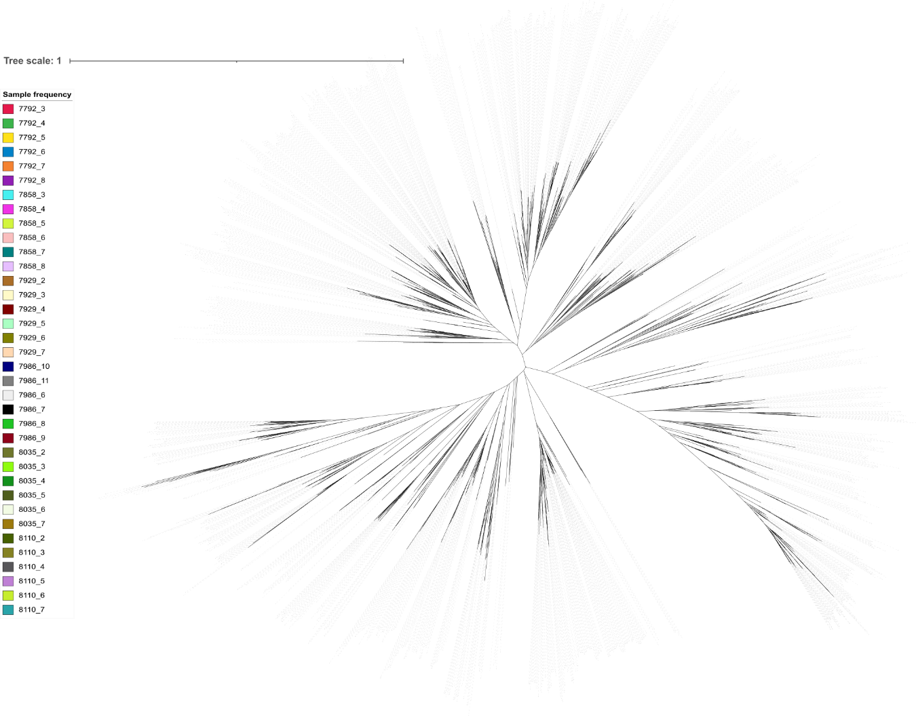
Supplementary Fig. S1 Construction of a phylogenetic tree for analyzing beta diversity (See Tree_biofilter.nwk in the supplementary documents)

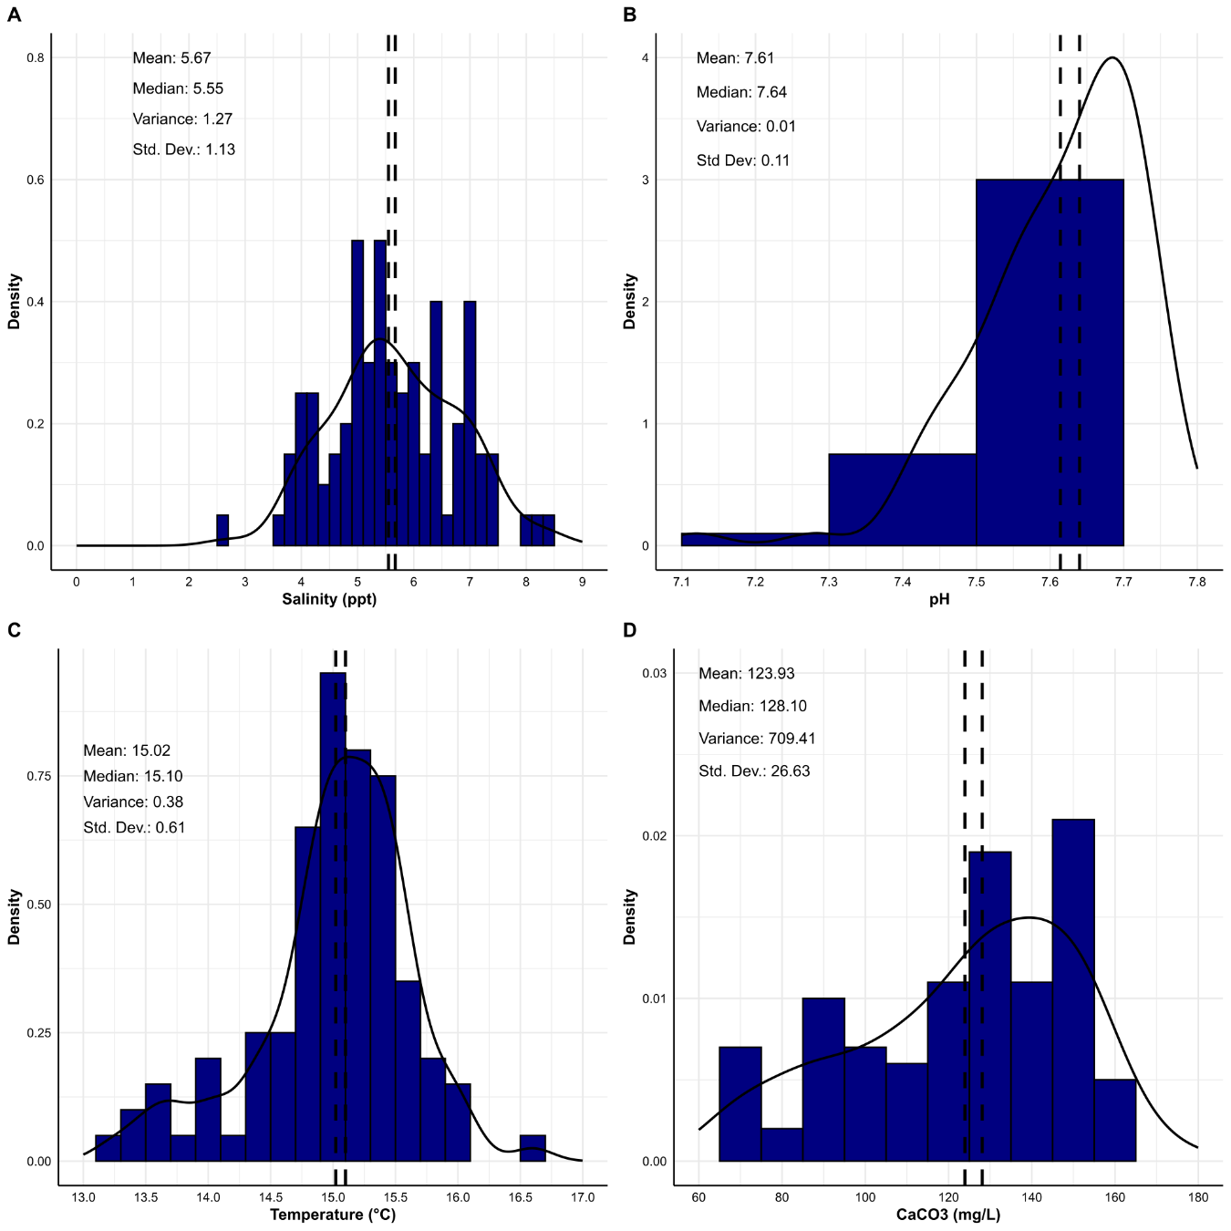
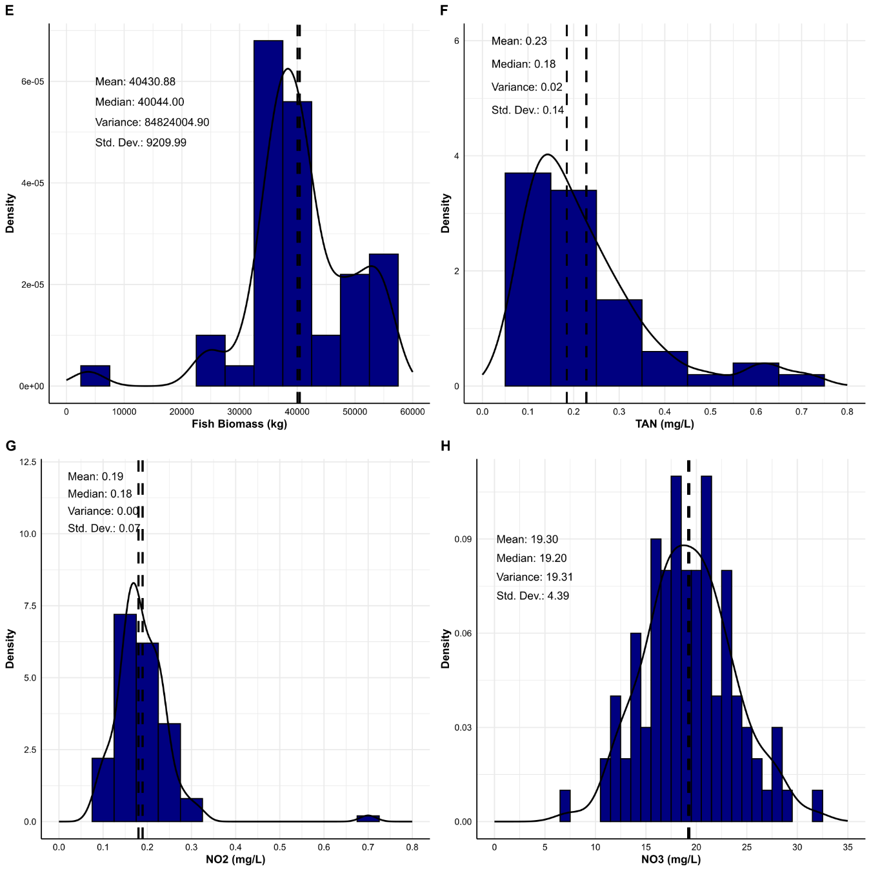
Supplementary Fig. S2 Statistical parameters of the moving bed biofilter documented throughout the production cycle

Supplementary Table S1. List of nitrifying and denitrifying bacterial genera categorized by their role in ammonia, nitrite, and nitrate oxidation processes
Reaction | Phase name | Genus | Source
$${{NH}_{4}}^{+}→{{NO}_{2}}^{-}$$ | Ammonia oxidation | Nitrosomonas spp | Kuhn et al. (2010), Bassin et al. (2011), Ramirez-Vargas et al. (2015)
$${{NH}_{4}}^{+}→{{NO}_{2}}^{-}$$ | Ammonia oxidation | Nitrosospira | Navada et al. (2019)
$${{NH}_{4}}^{+}→{{NO}_{2}}^{-}$$ | Ammonia oxidation | Nitrosococcus | Patil et al. (2021)
$${{NH}_{4}}^{+}→{{NO}_{2}}^{-}$$ | Ammonia oxidation | Nitrosolobus | Ida et al. (2005)
$${{NH}_{4}}^{+}→{{NO}_{2}}^{-}$$ | Ammonia oxidation | Nitrosovibrio | Ida et al. (2005)
$${{NO}_{2}}^{-}→{{NO}_{3}}^{-}$$ | Nitrite oxidation | Nitrobacter | Kuhn et al. (2010), Woese et al. (1985)
$${{NO}_{2}}^{-}→{{NO}_{3}}^{-}$$ | Nitrite oxidation | Nitrococcus | Watson et al. (1986), Woese et al. (1985)
$${{NO}_{2}}^{-}→{{NO}_{3}}^{-}$$ | Nitrite oxidation | Nitrospina | Lücker et al. (2015), Spieck et al. (2014)
$${{NO}_{2}}^{-}→{{NO}_{3}}^{-}$$ | Nitrite oxidation | Nitrospira | Bartelme et al. (2017), Daims et al. (2015), Bassin et al. (2011)
$${{NO}_{2}}^{-}→{{NO}_{3}}^{-}$$ | Nitrite oxidation | Candidatus Nitrotoga | Alawi et al. (2007), (Spieck et al. 2006), (Nowka et al. 2015)
$${{NO}_{2}}^{-}→{{NO}_{3}}^{-}$$ | Nitrite oxidation | Nitrolancea | Sorokin et al. (2012)
$${{NO}_{2}}^{-}→{{NO}_{3}}^{-}$$ | Nitrite oxidation | Candidatus Nitromaritima | Ngugi et al. (2016)
$${{NH}_{4}}^{+}→{{NO}_{3}}^{-}$$ | Complete ammonia oxidation | Nitrospira | Van Kessel et al. (2015)
$${{NO}_{3}}^{-}→{{NO}_{2}}^{-}→NO→N_{2}O→N_{2}$$ | Denitrification | Hydrogenophaga | Deng et al. (2020), Lai et al. (2020)
$${{NO}_{3}}^{-}→{{NO}_{2}}^{-}→NO→N_{2}O→N_{2}$$ | Denitrification | Flavobacterium | Deng et al. (2020), Lai et al. (2020)
$${{NO}_{3}}^{-}→{{NO}_{2}}^{-}→NO→N_{2}O→N_{2}$$ | Denitrification | Rhodobacter | Deng et al. (2020), Hüpeden et al. (2020)
$${{NO}_{3}}^{-}→{{NO}_{2}}^{-}→NO→N_{2}O→N_{2}$$ | Denitrification | Pseudomonas | Deng et al. (2020), Lai et al. (2020), Liu et al. (2019)
$${{NO}_{3}}^{-}→{{NO}_{2}}^{-}→NO→N_{2}O→N_{2}$$ | Denitrification | Thermomonas | Deng et al. (2020), Lai et al. (2020)
$${{NO}_{3}}^{-}→{{NO}_{2}}^{-}→NO→N_{2}O→N_{2}$$ | Denitrification | Dechloromonas | Deng et al. (2020), Lai et al. (2020)
$${{NO}_{3}}^{-}→{{NO}_{2}}^{-}→NO→N_{2}O→N_{2}$$ | Denitrification | Planctomyces | Hüpeden et al. (2020)
$${{NO}_{3}}^{-}→{{NO}_{2}}^{-}→NO→N_{2}O→N_{2}$$ | Denitrification | Azospira | Hüpeden et al. (2020), Lai et al. (2020)
$${{NO}_{3}}^{-}→{{NO}_{2}}^{-}→NO→N_{2}O→N_{2}$$ | Denitrification | Blastopirellula | Hüpeden et al. (2020)
$${{NO}_{3}}^{-}→{{NO}_{2}}^{-}→NO→N_{2}O→N_{2}$$ | Denitrification | Marinobacter | Hüpeden et al. (2020)
$${{NO}_{3}}^{-}→{{NO}_{2}}^{-}→NO→N_{2}O→N_{2}$$ | Denitrification | Parasegetibacter | Lai et al. (2020)
$${{NO}_{3}}^{-}→{{NO}_{2}}^{-}→NO→N_{2}O→N_{2}$$ | Denitrification | Thauera | Lai et al. (2020)
$${{NO}_{3}}^{-}→{{NO}_{2}}^{-}→NO→N_{2}O→N_{2}$$ | Denitrification | Comamonas | Lai et al. (2020), Liu et al. (2019)
$${{NO}_{3}}^{-}→{{NO}_{2}}^{-}→NO→N_{2}O→N_{2}$$ | Denitrification | Bacillus | Liu et al. (2019)
$${{NO}_{3}}^{-}→{{NO}_{2}}^{-}→NO→N_{2}O→N_{2}$$ | Denitrification | Citrobacter | Liu et al. (2019)
$${{NO}_{3}}^{-}→{{NO}_{2}}^{-}→NO→N_{2}O→N_{2}$$ | Denitrification | Ammoniphilus | Liu et al. (2019)
$${{NO}_{3}}^{-}→{{NO}_{2}}^{-}→NO→N_{2}O→N_{2}$$ | Denitrification | Clostridium | Liu et al. (2019)
$${{NO}_{3}}^{-}→{{NO}_{2}}^{-}→NO→N_{2}O→N_{2}$$ | Denitrification | Caldilinea | Liu et al. (2019)

Supplementary Table S2. Custom PCR1 primers used for the generation of V3–V4 16S rRNA gene sequencing libraries. Blue highlighted primer sequences are Fluidigm consensus sequence pads, red regions are custom linker-spacer nucleotides added to increase read diversity, and the black sequences are the target specific V3-V4 primers from Klindworth et al. (2013)
Primer Set | Name | Primer Sequence
Forward Primer  Pool | CS1-341F  CS1-341F_LS1  CS1-341F_LS2  CS1-341F_LS3  CS1-341F_LS4  CS1-341F_LS5 | ACACTGACGACATGGTTCTACACCTACGGGNGGCWGCAG  ACACTGACGACATGGTTCTACAAGCCTACGGGNGGCWGCAG  ACACTGACGACATGGTTCTACATAGCCTACGGGNGGCWGCAG  ACACTGACGACATGGTTCTACAGTAGCCTACGGGNGGCWGCAG  ACACTGACGACATGGTTCTACACGTAGCCTACGGGNGGCWGCAG  ACACTGACGACATGGTTCTACAACGTAGCCTACGGGNGGCWGCAG
Reverse Primer  Pool | CS2-785R  CS2-785R_LS1  CS2-785R_LS2  CS2-785R_LS3  CS2-785R_LS4  CS2-785R_LS5 | TACGGTAGCAGAGACTTGGTCTGACTACHVGGGTATCTAATCC  TACGGTAGCAGAGACTTGGTCTATGACTACHVGGGTATCTAATCC  TACGGTAGCAGAGACTTGGTCTCATGACTACHVGGGTATCTAATCC  TACGGTAGCAGAGACTTGGTCTTCATGACTACHVGGGTATCTAATCC  TACGGTAGCAGAGACTTGGTCTGTCATGACTACHVGGGTATCTAATCC  TACGGTAGCAGAGACTTGGTCTAGTCATGACTACHVGGGTATCTAATCC

Reference
Alawi M, Lipski A, Sanders T, Eva-Maria-Pfeiffer, Spieck E (2007) Cultivation of a novel cold-adapted nitrite oxidizing betaproteobacterium from the Siberian Arctic. The ISME Journal 1(3):256–264. https://doi.org/10.1038/ismej.2007.34
Bartelme RP, McLellan SL, Newton RJ (2017) Freshwater Recirculating Aquaculture System Operations Drive Biofilter Bacterial Community Shifts around a Stable Nitrifying Consortium of Ammonia-Oxidizing Archaea and Comammox Nitrospira. Frontiers in Microbiology 8. https://doi.org/10.3389/fmicb.2017.00101
Bassin JP, Pronk M, Muyzer G, Kleerebezem R, Dezotti M, Van Loosdrecht MCM (2011) Effect of Elevated Salt Concentrations on the Aerobic Granular Sludge Process: Linking Microbial Activity with Microbial Community Structure. Applied and Environmental Microbiology 77(22):7942–7953. https://doi.org/10.1128/AEM.05016-11
Daims H, Lebedeva EV, Pjevac P, Han P, Herbold C, Albertsen M, Jehmlich N, Palatinszky M, Vierheilig J, Bulaev A, Kirkegaard RH, Von Bergen M, Rattei T, Bendinger B, Nielsen PH, Wagner M (2015) Complete nitrification by Nitrospira bacteria. Nature 528(7583):504–509. https://doi.org/10.1038/nature16461
Deng Q, Wan L, Li X, Cao X, Zhou Y, Song C (2020) Metagenomic evidence reveals denitrifying community diversity rather than abundance drives nitrate removal in stormwater biofilters amended with different organic and inorganic electron donors. Chemosphere 257:127269. https://doi.org/10.1016/j.chemosphere.2020.127269
Hüpeden J, Wemheuer B, Indenbirken D, Schulz C, Spieck E (2020) Taxonomic and functional profiling of nitrifying biofilms in freshwater, brackish and marine RAS biofilters. Aquacultural Engineering 90:102094. https://doi.org/10.1016/j.aquaeng.2020.102094
Ida T, Kugimiya M, Kogure M, Takahashi R, Tokuyama T (2005) Phylogenetic relationships among ammonia-oxidizing bacteria as revealed by gene sequences of glyceraldehyde 3-phosphate dehydrogenase and phosphoglycerate kinase. Journal of Bioscience and Bioengineering 99(6):569–576. https://doi.org/10.1263/jbb.99.569
Klindworth A, Pruesse E, Schweer T, Peplies J, Quast C, Horn M, Glöckner FO (2013) Evaluation of general 16S ribosomal RNA gene PCR primers for classical and next-generation sequencing-based diversity studies. Nucleic Acids Research 41(1):e1. https://doi.org/10.1093/nar/gks808
Kuhn DD, Drahos DD, Marsh L, Flick GJ (2010) Evaluation of nitrifying bacteria product to improve nitrification efficacy in recirculating aquaculture systems. Aquacultural Engineering 43(2):78–82. https://doi.org/10.1016/j.aquaeng.2010.07.001
Lai C, Guo Y, Cai Q, Yang P (2020) Enhanced nitrogen removal by simultaneous nitrification-denitrification and further denitrification (SND-DN) in a moving bed and constructed wetland (MBCW) integrated bioreactor. Chemosphere 261:127744. https://doi.org/10.1016/j.chemosphere.2020.127744
Liu G, Deng Y, Verdegem M, Ye Z, Zhu S (2019) Using poly(β-hydroxybutyrate-β-hydroxyvalerate) as carbon source in biofloc-systems: Nitrogen dynamics and shift of Oreochromis niloticus gut microbiota. Science of The Total Environment, 694, 133664. https://doi.org/10.1016/j.scitotenv.2019.133664
Lücker S, Schwarz J, Gruber-Dorninger C, Spieck E, Wagner M, Daims H (2015) Nitrotoga -like bacteria are previously unrecognized key nitrite oxidizers in full-scale wastewater treatment plants. The ISME Journal 9(3):708–720. https://doi.org/10.1038/ismej.2014.158
Navada S, Vadstein O, Tveten A-K, Verstege GC, Terjesen BF, Mota VC, Venkataraman V, Gaumet F, Mikkelsen Ø, Kamstra A (2019) Influence of rate of salinity increase on nitrifying biofilms. Journal of Cleaner Production 238:117835. https://doi.org/10.1016/j.jclepro.2019.117835
Ngugi DK, Blom J, Stepanauskas R, Stingl U (2016) Diversification and niche adaptations of Nitrospina -like bacteria in the polyextreme interfaces of Red Sea brines. The ISME Journal 10(6):1383–1399. https://doi.org/10.1038/ismej.2015.214
Nowka B, Daims H, Spieck E (2015) Comparison of Oxidation Kinetics of Nitrite-Oxidizing Bacteria: Nitrite Availability as a Key Factor in Niche Differentiation. Applied and Environmental Microbiology 81(2):745–753. https://doi.org/10.1128/AEM.02734-14
Patil PK, Antony L, Avunje S, Viswanathan B, Lalitha N, Jangam AK, Kumar D, Solanki HG, Reddy MA, Alavandi SV, Vijayan KK (2021) Bioaugmentation with nitrifying and denitrifying microbial consortia for mitigation of nitrogenous metabolites in shrimp ponds. Aquaculture 541:736819. https://doi.org/10.1016/j.aquaculture.2021.736819
Ramirez-Vargas R, Serrano-Silva N, Navarro-Noya YE, Alcántara-Hernández RJ, Luna-Guido M, Thalasso F, Dendooven L (2015) 454 pyrosequencing-based characterization of the bacterial consortia in a well established nitrifying reactor. Water Science and Technology 72(6):990–997. https://doi.org/10.2166/wst.2015.295
Sorokin DY, Lücker S, Vejmelkova D, Kostrikina NA, Kleerebezem R, Rijpstra WIC, Damsté JSS, Le Paslier D, Muyzer G, Wagner M, Van Loosdrecht MCM, Daims H (2012) Nitrification expanded: Discovery, physiology and genomics of a nitrite-oxidizing bacterium from the phylum Chloroflexi. The ISME Journal 6(12):2245–2256. https://doi.org/10.1038/ismej.2012.70
Spieck E, Hartwig C, McCormack I, Maixner F, Wagner M, Lipski A, Daims H (2006) Selective enrichment and molecular characterization of a previously uncultured Nitrospira ‐like bacterium from activated sludge. Environmental Microbiology 8(3):405–415. https://doi.org/10.1111/j.1462-2920.2005.00905.x
Spieck E, Keuter S, Wenzel T, Bock E, Ludwig W (2014) Characterization of a new marine nitrite oxidizing bacterium, Nitrospina watsonii sp. Nov., a member of the newly proposed phylum “Nitrospinae”. Systematic and Applied Microbiology 37(3):170–176. https://doi.org/10.1016/j.syapm.2013.12.005
Van Kessel MAHJ, Speth DR, Albertsen M, Nielsen PH, Op Den Camp HJM, Kartal B, Jetten MSM, Lücker S (2015) Complete nitrification by a single microorganism. Nature 528(7583):555–559. https://doi.org/10.1038/nature16459
Watson SW, Bock E, Valois FW, Waterbury JB, Schlosser U (1986) Nitrospira marina gen. nov. sp. nov.: A chemolithotrophic nitrite-oxidizing bacterium. Archives of Microbiology 144(1):1–7. https://doi.org/10.1007/BF00454947
Woese CR, Weisburg WG, Hahn CM, Paster BJ, Zablen LB, Lewis BJ, Macke TJ, Ludwig W, Stackebrandt E (1985) The Phylogeny of Purple Bacteria: The Gamma Subdivision. Systematic and Applied Microbiology 6(1):25–33. https://doi.org/10.1016/S0723-2020(85)80007-2

