Stable Links for Experiments:
Exp 1a: https://yalesurvey.ca1.qualtrics.com/jfe/form/SV_9tvm8VougG0Yr0G
Exp 1b: https://yalesurvey.ca1.qualtrics.com/jfe/form/SV_b8aOGW3rqbJt2N8
Exp 1c: https://yalesurvey.ca1.qualtrics.com/jfe/form/SV_d4mtDuI8kuull2K

Exp 2: https://yalesurvey.ca1.qualtrics.com/jfe/form/SV_bj6CI2bQFXdq0eO
Exp 3: https://yalesurvey.ca1.qualtrics.com/jfe/form/SV_9takmv9t7AZi5uu
Exp 4: https://yalesurvey.ca1.qualtrics.com/jfe/form/SV_3jU08YAkculAdjU

Exp 5: https://yalesurvey.ca1.qualtrics.com/jfe/form/SV_9RJrTpSGYGCnGe2
Exp 6: https://yalesurvey.ca1.qualtrics.com/jfe/form/SV_8xewURBQAncx12u
Exp 7: https://yalesurvey.ca1.qualtrics.com/jfe/form/SV_elL9omOmxoYs5Ku

Experiments 1a-c
BLUE = ONLY Industry Study
RED = ONLY Surgery Study
YELLOW = ONLY AV Study

Protocol
ROBOT IMG1 ROBOT IMG2
Name1 Name2

{Name1} and {Name2} were developed by two different companies.
Both are at an early stage of their development.
<screen>
ROBOT IMG1 ROBOT IMG2
Name1 Name2
These robots were designed to [work in factories / help surgeons / transport passengers].
In [an industrial setting / a surgical environment / a self-driving setting], one marker of a robot’s capabilities is its ability to [move with precision / detect and react to obstacles].
<screen>
TARGET ROBOT IMG
You were randomly selected to learn about {target name}.

Your job is to review the recordings of {name}’s performance in several [navigation tasks, and to determine {name}’s value to a factory / navigation tasks, and to determine whether {name} is ready to advance to the next stage of development / tests].

Please pay attention to how reliable and competent {name} seems throughout the series of tests.
<screen>
Industry Task:
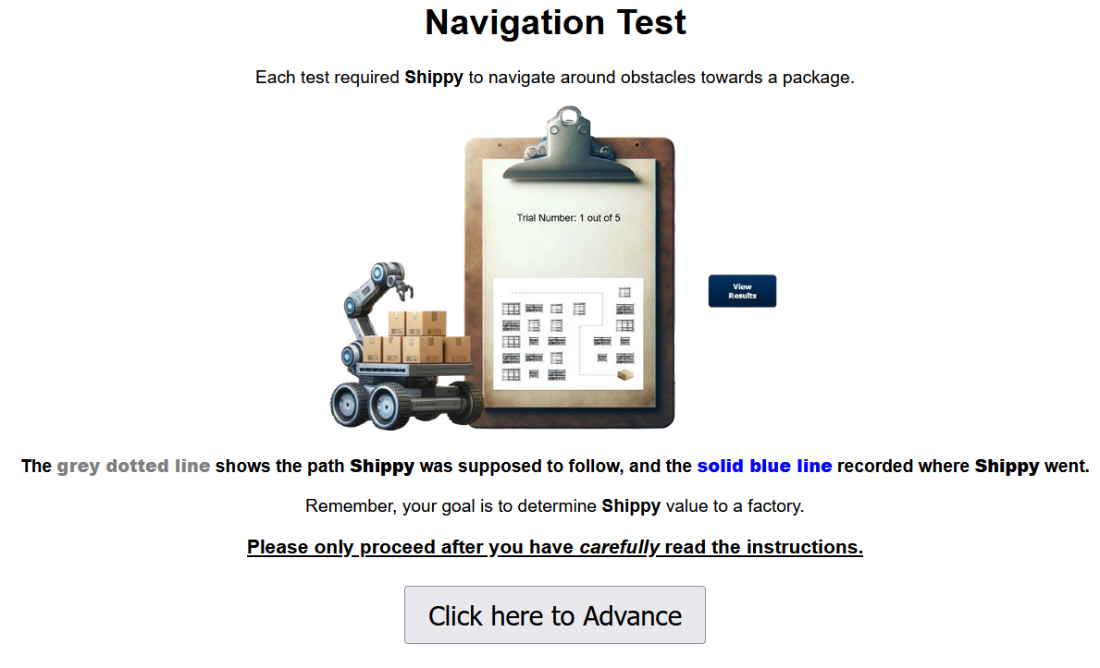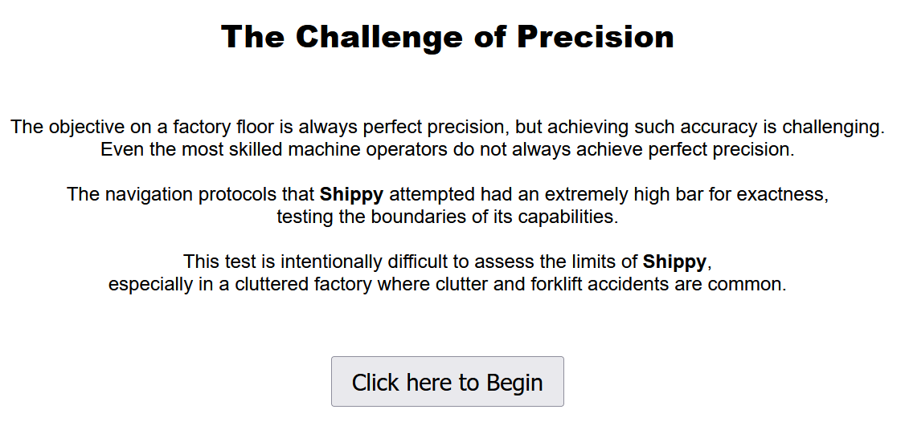



Surgery Task: (*Note: The navigation protocol was counterbalanced between subjects.)
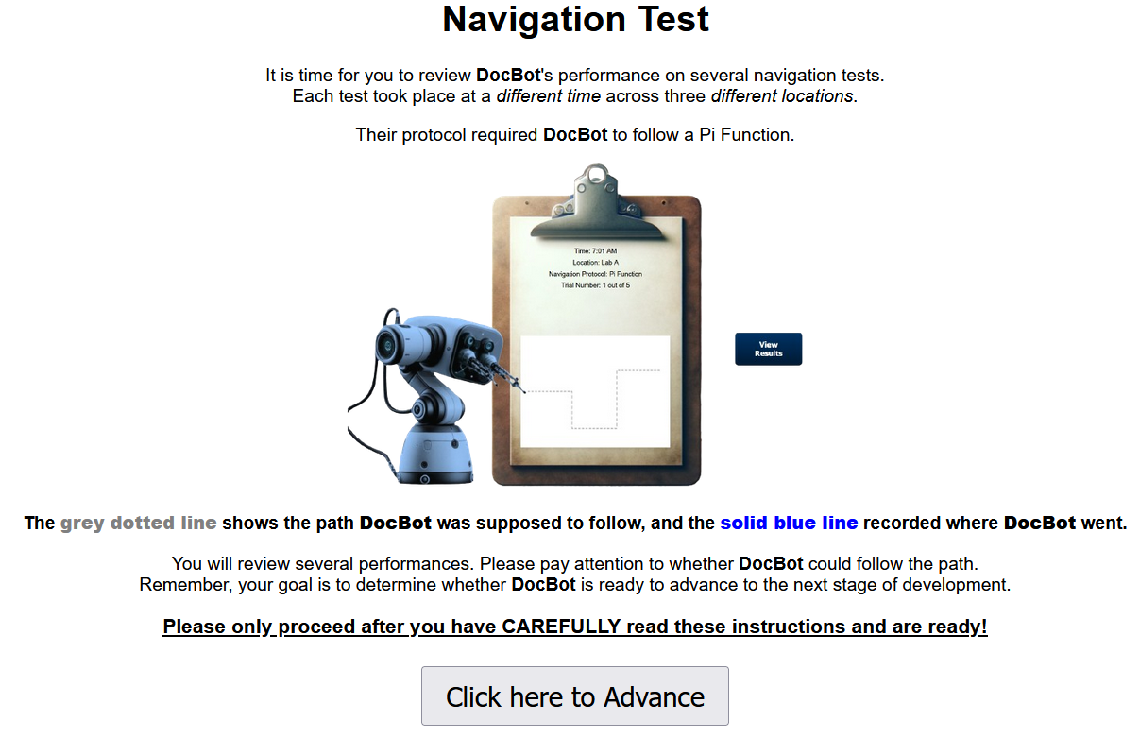
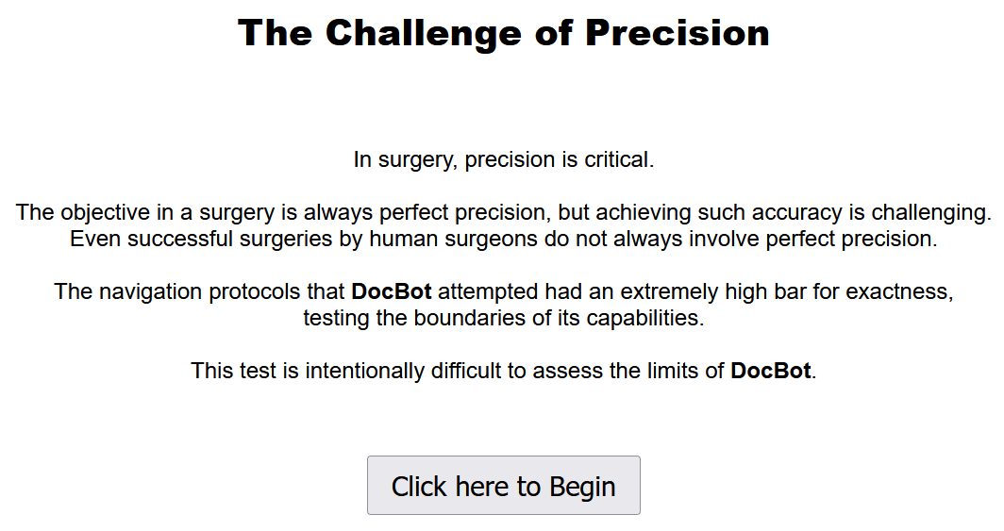
<screen>

AV Task:
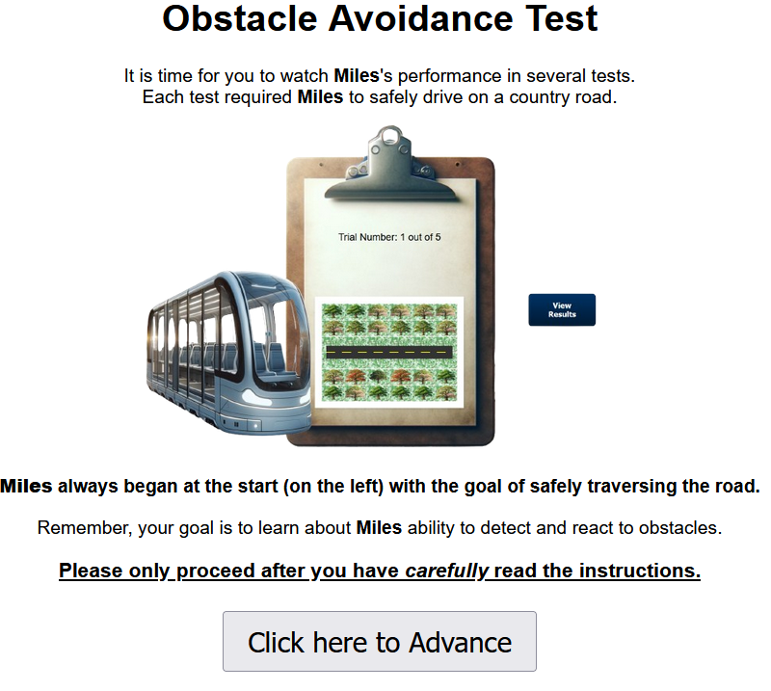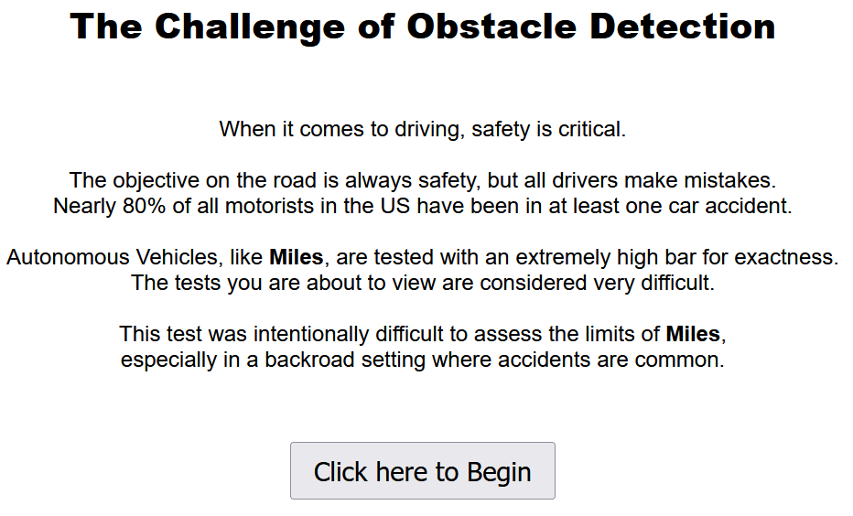

Redirect to AMP
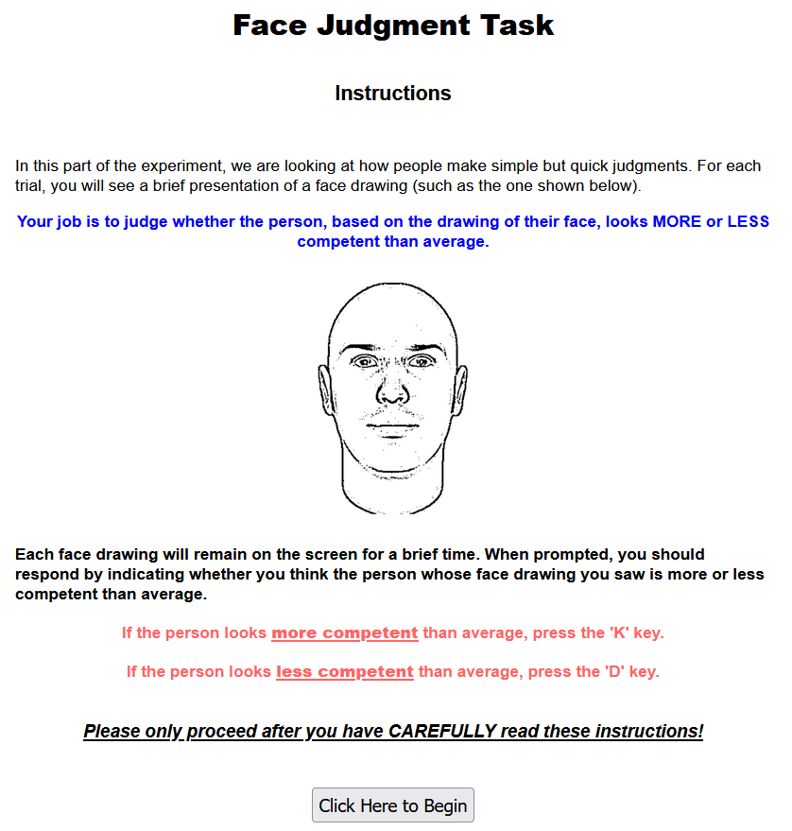
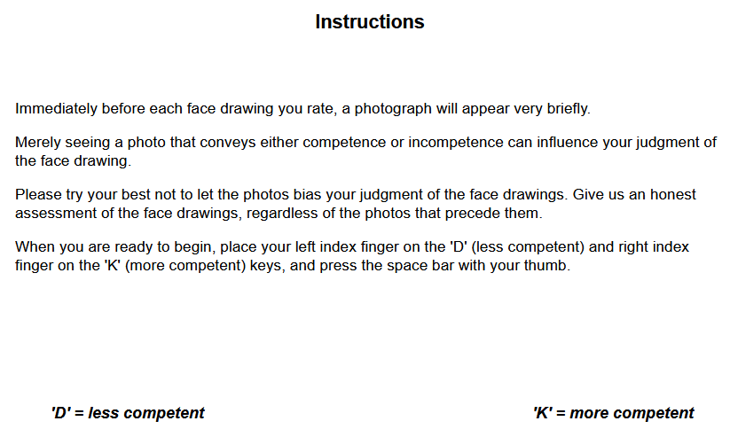
AMP Stimuli:

Primes.
Target Robot, Control Robot, WAM Arm (image available online) for 15-trials each.
Targets.
45 unique face drawings pre-tested to be competence neutral.

Redirect to Survey

TARGET ROBOT IMG
Please rate {name}:
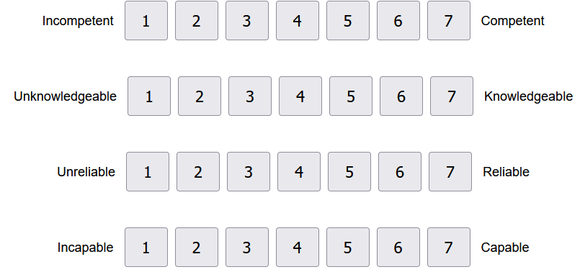
<screen>
TARGET ROBOT IMG
How much would you estimate {name}’s value to a factory? $_____
Is {name} ready to advance to the next stage of development? Yes / No
<screen>
CONTROL ROBOT IMG (*Control & Target presentation order were counterbalanced)
*Asked competence items for control robot
*Next, Industry and Surgery studies asked value and advancement questions for control robot
<screen>
TARGET ROBOT IMG
Suppose you were invited to ride on {name}. Rate how willing you would be to accept the ride: 0 = not at all; 100 = definitely accept
If you were ordering an Uber and had the choice, would you prefer to be driven by the average human driver or {name}? Average Human Driver / {Name}
Estimate how much State Farm would charge per month to insure {name}: $120 - $500
<screen>
How informative are trials with errors in the navigation task?
<screen>
How informative are trials without errors in the navigation task? (*order counterbalanced)
<screen>
Demographics.

Experiment 2
We will now introduce you to two different robots. Afterwards, you will play a series of competitive games against one of these robots.
<screen - robot order was counterbalanced>
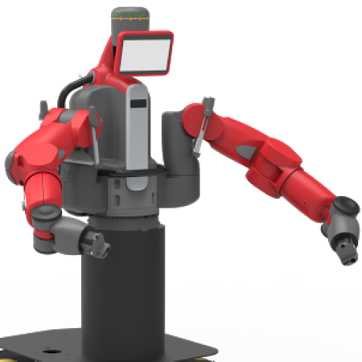
This is Jessie. Although researchers and the developers that created Jessie have worked on this project for a while, Jessie is still in the early testing phase.
<screen>
<same image>
Jessie is designed to play interactive and competitive games with people like you. Jessie is new to all testers.
<screen>
<same image>
Since Jessie is still in early development, it is not clear how well Jessie plays different types of games.
<screen>
Now that you have met Jessie, please proceed to meet Taylor, the other robot.
<screen – other robot introduction is semantically identical with minor variations>
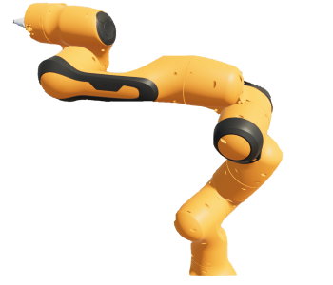
You have been selected to play with Taylor!
Today, you play Tic-Tac-Toe with Taylor.
<screen>
<screen>
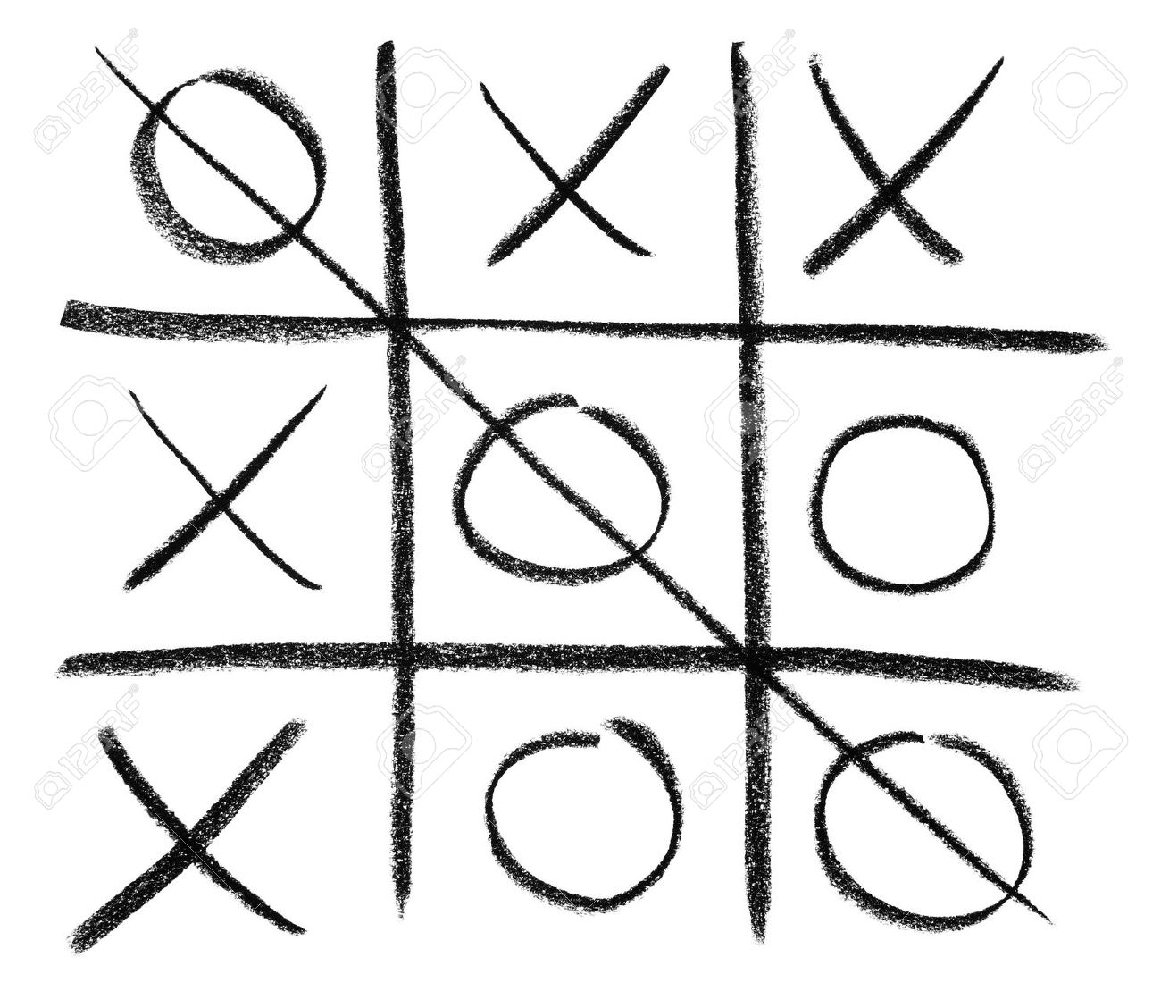
Remember, Tic-Tac-Toe has a 3x3 grid (as seen above). Your goal is to get three X's or O's in a row. If you get three in a row, as in the photo, you win!

By continuing you are confirming that you understand how to play…

I understand
o Yes (1)

<screen>

Redirect to Tic-Tac-Toe webpage
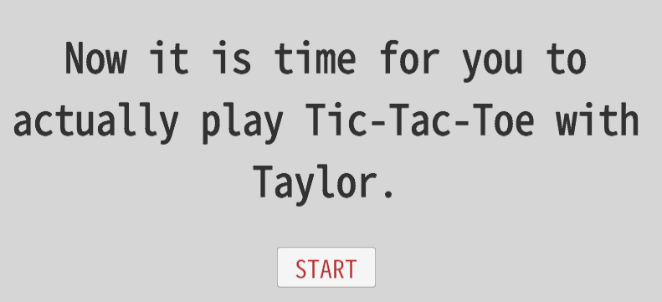
<start button>
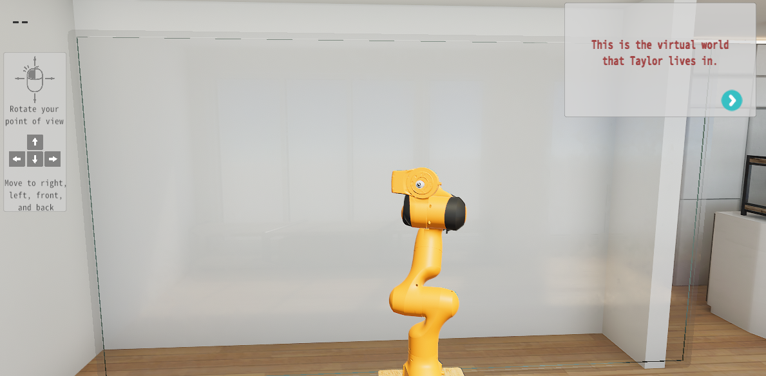
For a full video, click here.

<arrow>
Use your mouse and keyboard to move around the room and find Taylor.
<arrow>
Once you find Taylor, try walking closer using the ‘W’ or up-arrow key.
<arrow>
After you finish reading the rules, Taylor will draw a board to play on.
<arrow>
The board will have green icons that you click on to make your move.
<arrow>
The first player to get three X’s or O’s in a row, vertically, horizontally, or diagonally wins.
<arrow>
Your goal is to play your best to try to win.
<arrow>
Good luck!
*The game board is drawn, rounds are played. End-of-game feedback appears after each round*
*after 4-rounds, redirect message appears*

Redirect to direct AMP
YELLOW = Binary Condition
BLUE = Ordinal Condition
Judgment Task
Instructions
In this part of the experiment, we are looking at how people make simple but quick judgments. For each trial, you will see a brief presentation of a robot followed by a face drawing.
For example, you might see this robot on the left followed by this face drawing on the right.
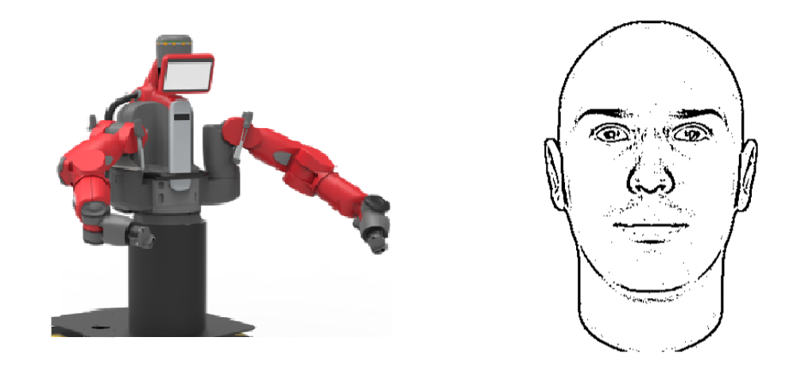
For this round of judgments, you should rate the robot you saw. Please note that sometimes the faces flashed after to the robots can influence people's ratings of the robots. Please try your best not to be influenced by the photographs. Instead, please give us an honest judgment of how competent or incompetent you believe each robot is. Of course, there are no right or wrong answers. Just report your "gut reaction."
Each robot drawing will remain on the screen for a brief time. When prompted, you will be asked how competent the robot is compared to the average robot.
If the robot looks more competent than average, press the 'K' key.
If the robot looks less competent than average, press the 'D' key.

If the robot looks much more competent than average, press the 'L' key.
If the robot looks slightly more competent than average, press the 'K' key.
If the robot looks slightly less competent than average, press the 'D' key.
If the robot looks much less competent than average, press the 'S' key.

Please only proceed after you have CAREFULLY read these instructions and are definitely sure that you are ready!

Redirect to Survey
<same explicit competence items>
<screen>
Demographics

Experiment 3
The only difference worth noting was the presentation of the indirect and direct AMPs.
Indirect AMP:
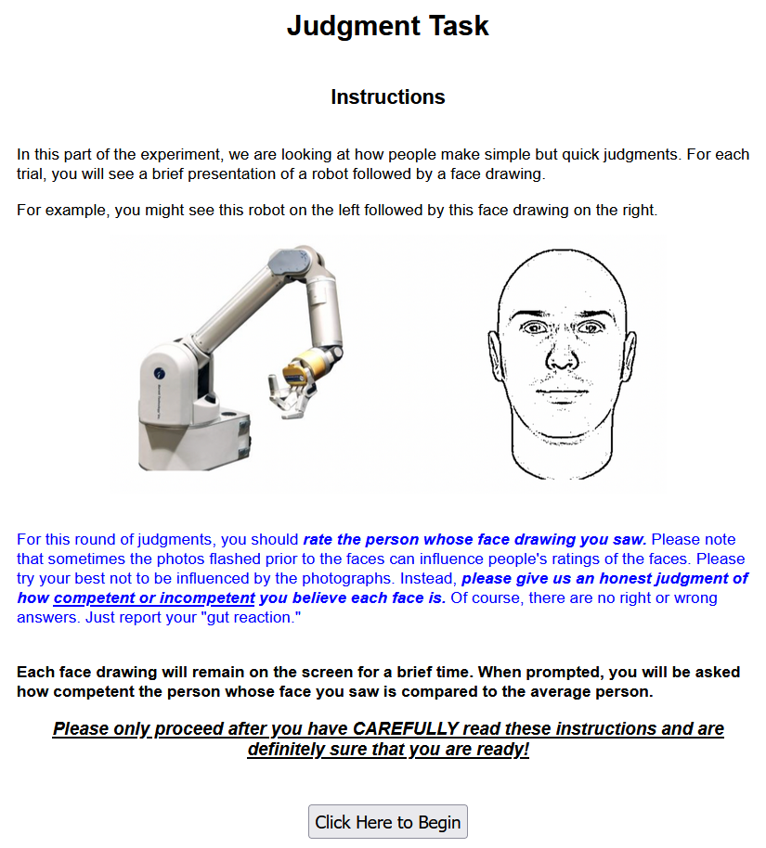
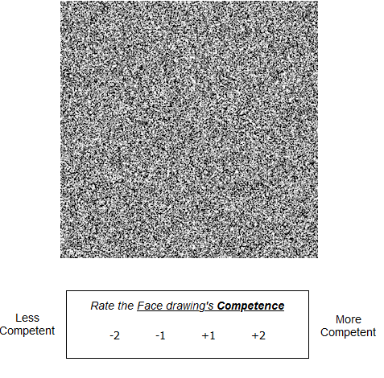
Direct AMP:
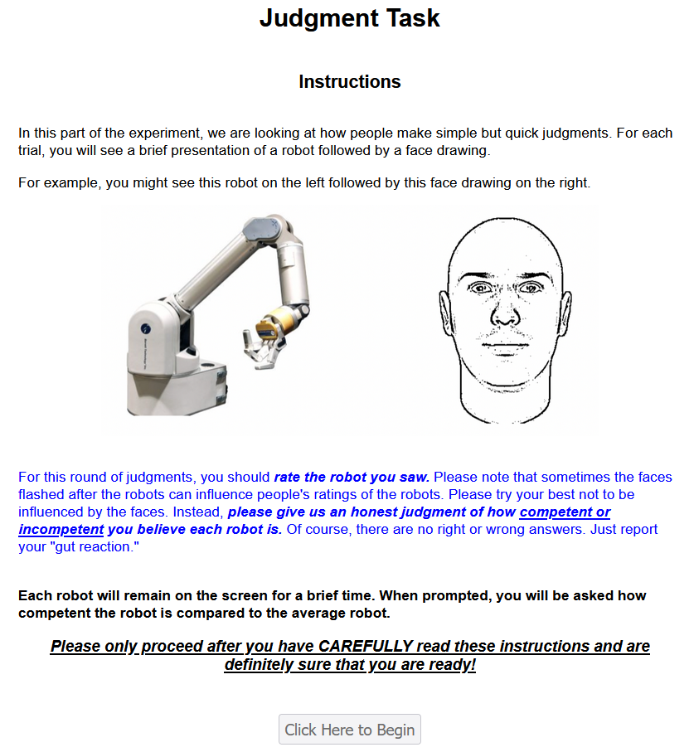
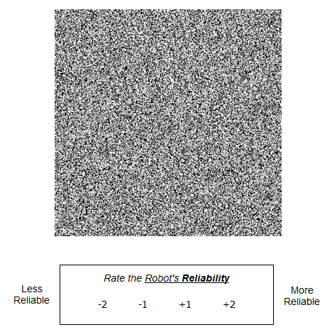

Experiment 4
Similarly, the only difference worth noting was the presentation of the indirect and direct AMPs. Both AMPs at the point of response looked like this:
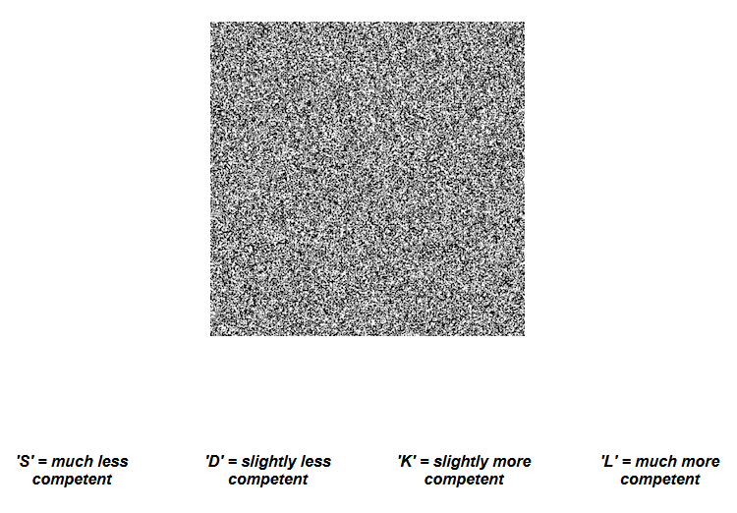

Experiment 5-7
The experimental protocols were nearly identical to Experiment 1a. The best way to fully understand these studies is to attempt them. The stable links are:
Exp 5: https://yalesurvey.ca1.qualtrics.com/jfe/form/SV_9RJrTpSGYGCnGe2
Exp 6: https://yalesurvey.ca1.qualtrics.com/jfe/form/SV_8xewURBQAncx12u
Exp 7: https://yalesurvey.ca1.qualtrics.com/jfe/form/SV_elL9omOmxoYs5Ku

