Appendix
Search formula
#1：polyfluoroalkyl substances OR Fluorocarbon OR PFC Perfluorinated Chemicals
Chemicals, PFC Perfluorinated OR Perfluorinated Chemicals, PFC OR Polyfluorocarbons OR Per- and Polyfluoroalkyl Substances OR Per and Polyfluoroalkyl Substances OR PFAS Per- and Polyfluoroalkyl Substances OR PFAS Per and Polyfluoroalkyl Substances OR Perfluorocarbon OR Perfluorocarbons OR Fluorocarbon Emulsions OR Emulsions, Fluorocarbon OR Fluorocarbon Emulsion
Emulsion, Fluorocarbon OR Telomer Fluorocarbons OR Fluorocarbons, Telomer
Perfluoroalkyl Carboxylates OR Carboxylates, Perfluoroalkyl OR Perfluoropolyether Carboxylic Acids OR Acids, Perfluoropolyether Carboxylic OR Carboxylic Acids, Perfluoropolyether OR PFECAs Perfluoropolyether Carboxylic Acids OR N-Alkyl Perfluoroalkyl Sulfonamido Carboxylates OR N Alkyl Perfluoroalkyl Sulfonamido Carboxylates OR Perfluoroalkyl Ether Carboxylates OR Carboxylates, Perfluoroalkyl Ether OR Ether Carboxylates, Perfluoroalkyl OR Fluorotelomer Phosphate Esters
Esters, Fluorotelomer Phosphate OR Phosphate Esters, Fluorotelomer OR Perfluoroalkyl Polyether Carboxylates OR Carboxylates, Perfluoroalkyl Polyether
Polyether Carboxylates, Perfluoroalkyl OR Fluorinated Telomer Alcohols OR Alcohols, Fluorinated Telomer OR Telomer Alcohols, Fluorinated OR Polyfluorinated Telomer Alcohols OR Alcohols, Polyfluorinated Telomer OR Telomer Alcohols, Polyfluorinated
Fluoro-Telomer Alcohols OR Alcohols, Fluoro-Telomer OR Fluoro Telomer Alcohols
Perfluoroalkane Sulfonamides OR Sulfonamides, Perfluoroalkane
#2: gestational diabetes mellitus OR Diabetes, Pregnancy-Induced OR Diabetes, Pregnancy Induced OR Pregnancy-Induced Diabetes OR Gestational Diabetes OR Diabetes Mellitus, Gestational OR Gestational Diabetes Mellitus
#3: #1 AND #2
Forest plot of continuity data
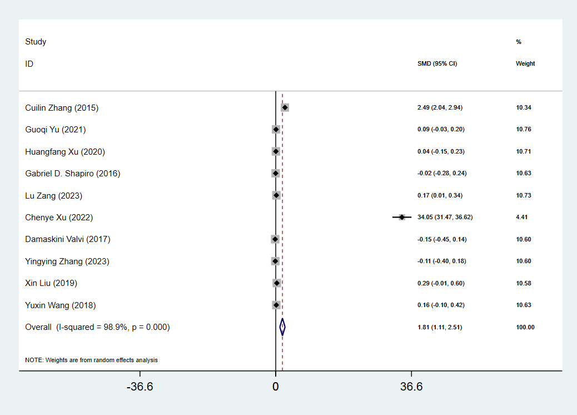
PFOA

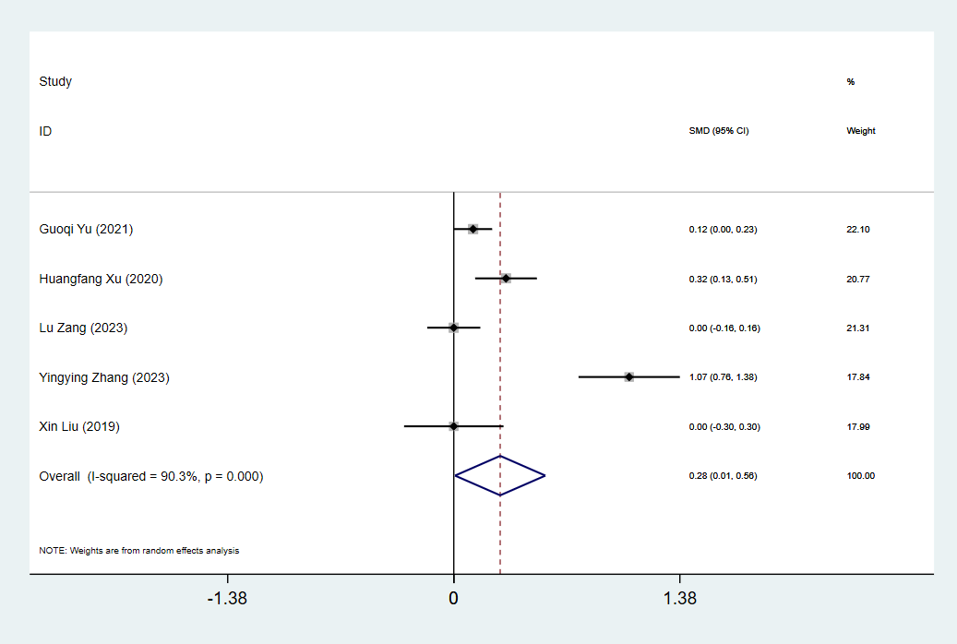
PFBS

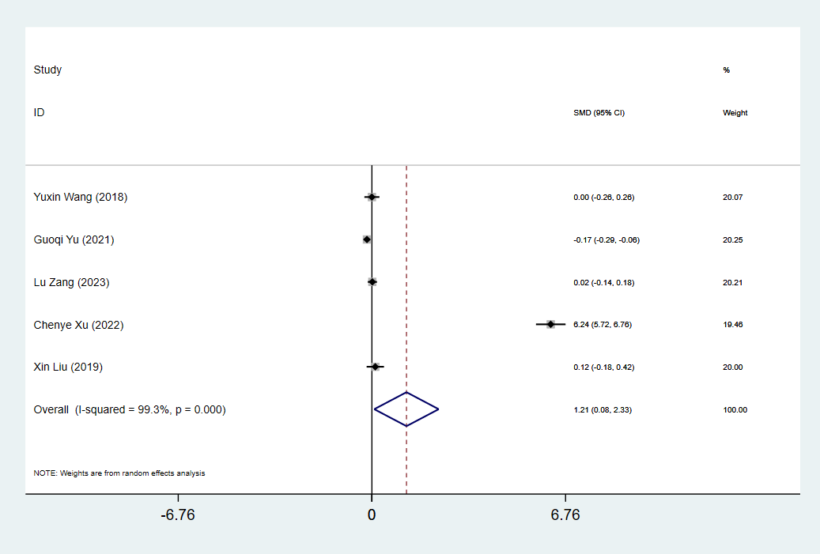
PFUnDA

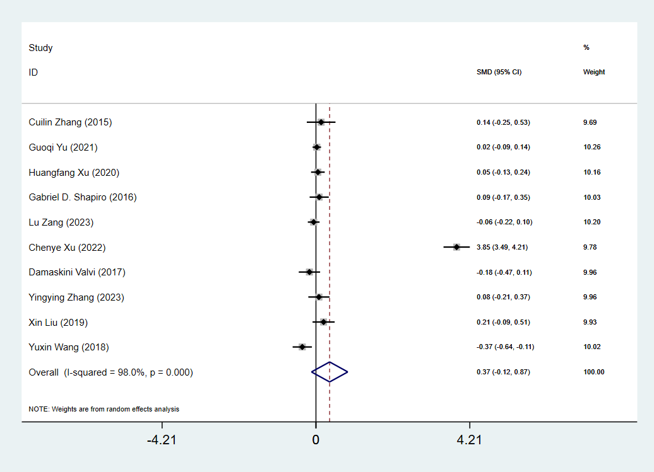
PFOS

