Supplementary Materials for
Spontaneous Droplet Uranium Extraction from Salt Lake Water Natural Falling

Xianchun Jin^{1,2†}, Lin Lei^{2†}, Jinyan Du¹, Fuqiang Wang³, Zhihe Long¹, Yongping He³, Lili Xing^{1*}, Xiaochong Zhao^{2*}, Xinyu Xue^{1*}

¹School of Physics, University of Electronic Science and Technology of China, Chengdu 611731, China.
²Institute of Materials, Chinese Academy of Engineering Physics, Jiangyou 621908, China.
³QingHai Salt Lake Industry Co., Ltd, Golmud 816000, China.

†These authors contributed equally to this work.
*Corresponding authors. Email: xinglili@uestc.edu.cn, Lili Xing; zhaoxiaochong_2013@tsinghua.org.cn, Xiaochong Zhao; xuexinyu@uestc.edu.cn, Xinyu Xue.

The PDF file includes:

Supplementary Note 1.
Supplementary Table 1.
Fig. S1. Droplet charge analysis.
Fig. S2. SEM image of the FEP membrane after ICP etching.
Fig. S3. EDS mapping of CTS@CF.
Fig. S4. XPS analysis of CTS@CF and CF.
Fig. S5. Zeta potential measurements of CTS@CF.
Fig. S6. Electrical output of the DUE film under 100 Hz droplet impact.
Fig. S7. Voltage output changes of the DUE film under varying water droplets release heights.
Fig. S8. Fluorescence images of the CTS@CF after adsorption.
Fig. S9. WT analysis of uranium compounds.
Fig. S10. MD simulation models to study the DUE process.
Fig. S11. Time-dependent uranium extraction mass at different initial concentrations.
Fig. S12. In-situ EIS during DUE.
Fig. S13. ESP distributions.
Fig. S14. ESP distributions of CTS adsorbing UO₂²⁺ and HVO₄²⁻.
Fig. S15. Antibacterial effects of CTS@CF.
Fig. S16. SEM images of bacteria on CF without CTS modification.
Fig. S17. SEM images of CTS@CF (no FEP membrane) for the adsorption method.
Fig. S18. XPS spectra before and after uranium extraction.
Fig. S19. α-particle decay spectra of uranium extraction sample.
Supplementary Note 1.
Uranium Extraction Energy Efficiency Calculation:
To standardize the calculation of energy efficiency across different uranium extraction methods (electrocatalysis, photocatalysis, and iron oxidation self-driven reactions), we could establish a detailed computational framework. For electrocatalytic and photocatalytic uranium extraction, the energy efficiency calculation formula was:
$η=\frac{m_{U}}{p×t}$ （S1）
In this context, $m_{U}$(mg) represented the mass of uranium extracted from the solution, $p$(w) denotes the total power used in the process, and $t$(s) indicated the duration of the reaction.
For uranium extraction via iron oxidation-driven electrochemical methods, the energy efficiency calculation formula was:
$η=\frac{m_{U}}{n_{Fe}×F×E_{0}}$ （S2）
In this calculation, $m_{U}$(mg) represented the mass of uranium extracted from the solution, $n_{Fe}$denoted the amount of iron consumed in the reaction (in moles), $F$(C/mol) stood for Faraday's constant, and $E_{0}$indicated the standard electromotive force of the reaction.
For the DUE method, the formula for calculating energy efficiency was:
$η=\frac{{3600×m}_{U}}{W_{G}}$ （S3）
In this formula, $m_{U}$(mg) represented the mass of uranium extracted from the solution, while $W_{G}$was calculated by multiplying the mass, height, and gravitational acceleration of the droplet, converting joules (J) to watt-hours (Wh).
Supplementary Table 1. Structural parameters of different samples extracted from the EXAFS fitting. (S0² =1)
Sample | Shell | CN | R (Å) | σ² (10⁻³Å²) | ΔE₀ (eV) | R factor
Sample | U-O | 2.9±0.8 | 1.77±0.01 | 5.2±2.8 | 7.4±1.4 | 0.01
 | U-O | 3.6±0.2 | 2.34±0.01 | 2.1±1.8 | 2.3±3.7
ªData ranges: 3.0 ≤ k ≤ 12.0 Å⁻¹, 1.0 ≤ R ≤ 3.0 Å. R: bond distance; σ²: Debye-Waller factors; R factor: goodness of fit.
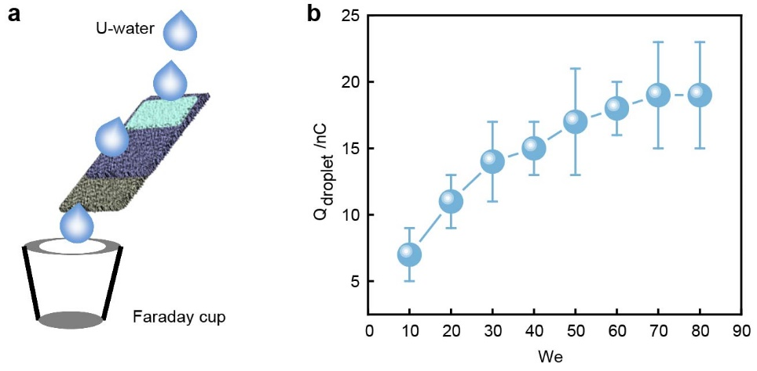
Fig. S1. Droplet charge analysis. (a) A schematic diagram illustrates the charge measurement process of 10 μL water droplets bouncing off from a 16 cm² DUE film positioned at a 45° incline, released from a height of 20 cm at 2.5 Hz. (b) The amount of positive charged carried by droplets across different We. We = ρDv²/γ. Error bars represent standard deviation (n = 3).
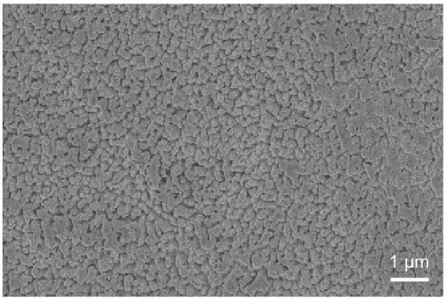
Fig. S2. SEM image of the FEP membrane after ICP etching.
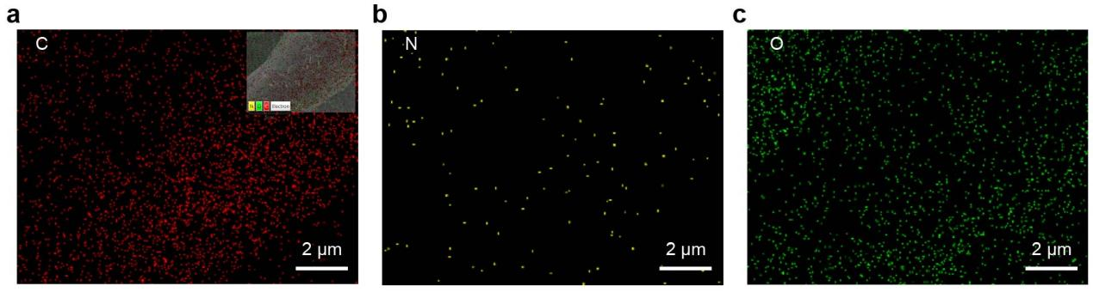
Fig. S3. EDS mapping of CTS@CF. (a) element C, (b) N, and (c) O.
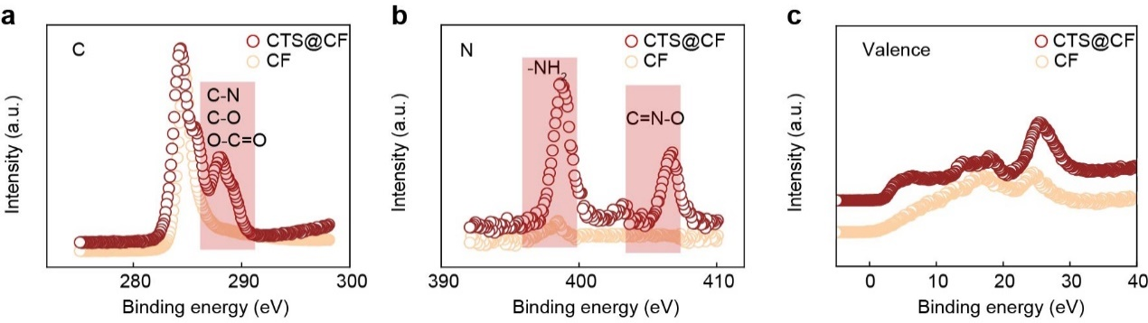
Fig. S4. XPS analysis of CTS@CF and CF. (a) element C spectra, (b) N spectra and, (c) the valence band.
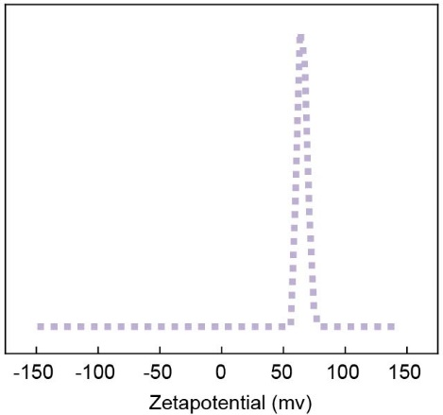
Fig. S5. Zeta potential measurements of CTS@CF. CTS@CF was immersed at 100 mg/L initial uranium concentrations.
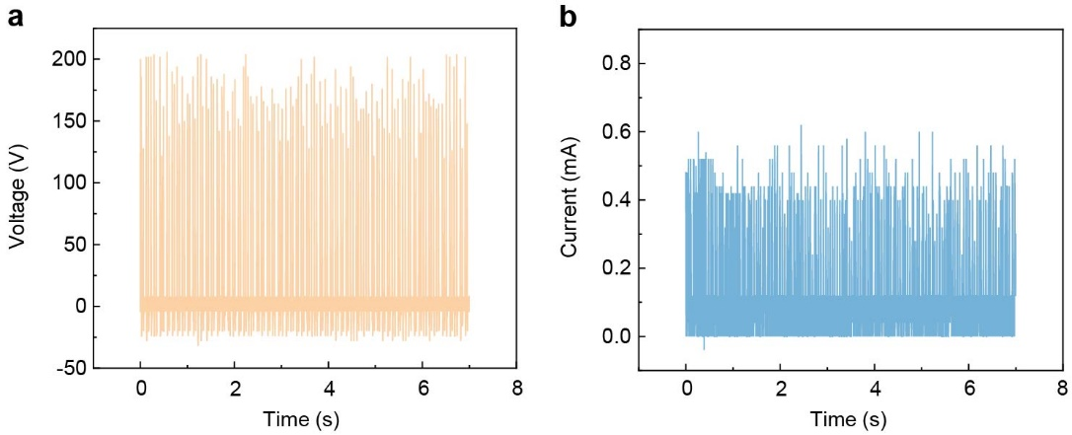
Fig. S6. Electrical output of the DUE film under 100 Hz droplet impact. (a) voltage output and, (b) current output ((Area:16 cm², positioned at a 45° incline) under water droplets (10 μL) released from a height of 20 cm and impacting at a frequency of 100 Hz.
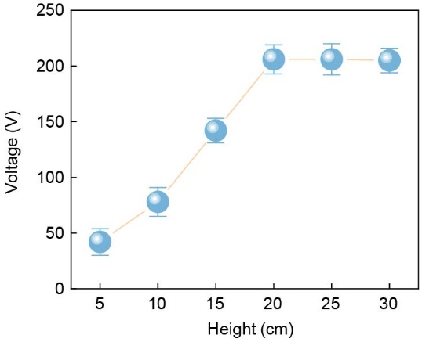
Fig. S7. Voltage output changes of the DUE film under varying water droplets release heights (Height: 15-30 cm, Area:16 cm², positioned at a 45° incline, volume: 10 μL) at 100 Hz. Error bars represent standard deviation (n = 3).
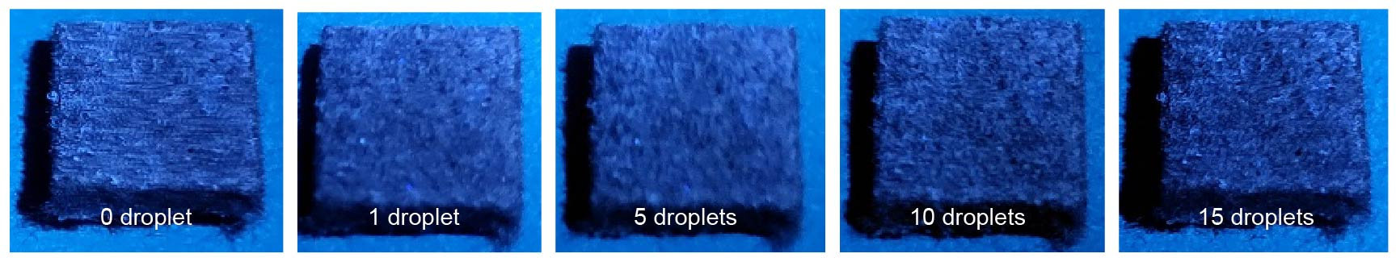
Fig. S8. Fluorescence images of the CTS@CF after adsorption. Fluorescence images of CTS@CF (no FEP membrane) under UV light after adsorption with different numbers of uranium contained droplets (1000 mg/L).
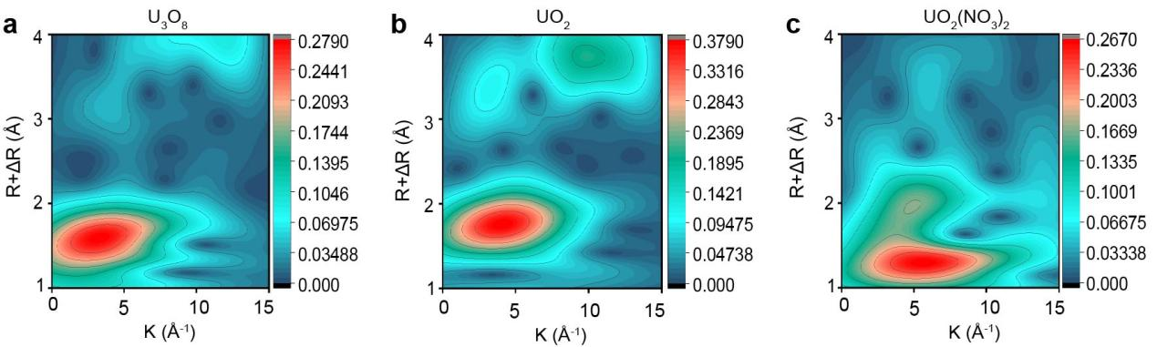
Fig. S9. WT analysis of uranium compounds. (a) U₃O₈, (b)UO₂, and (c) UO₂(NO₃)₂.
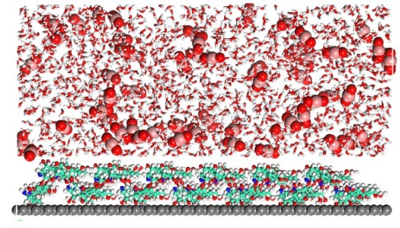
Fig. S10. MD simulation models to study the DUE process.
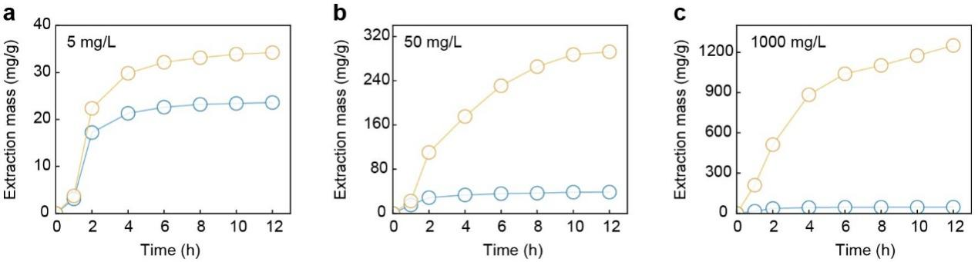
Fig. S11. Time-dependent uranium extraction mass at different initial concentrations. (a) 5, (b) 50, and (c) 1000 mg/L.
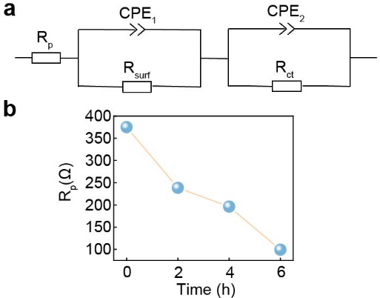
Fig. S12. In-situ EIS during DUE. (a) depicting circuit fitting, and (b) changes in polarization resistance Rp from 0-6 h.
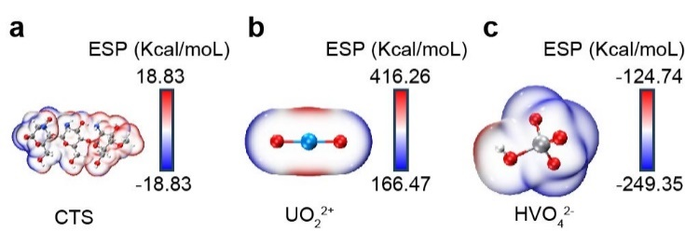
Fig. S13. ESP distributions. (a) CTS, (b) UO₂²⁺, and (c) HVO₄²⁻.
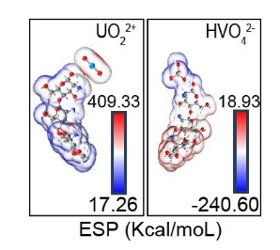
Fig. S14. ESP distributions of CTS adsorbing UO₂²⁺ and HVO₄²⁻.
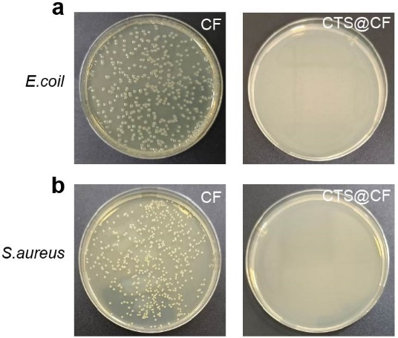
Fig. S15. Antibacterial effects of CTS@CF. (a) against E.coli, and (b) S.aureus.
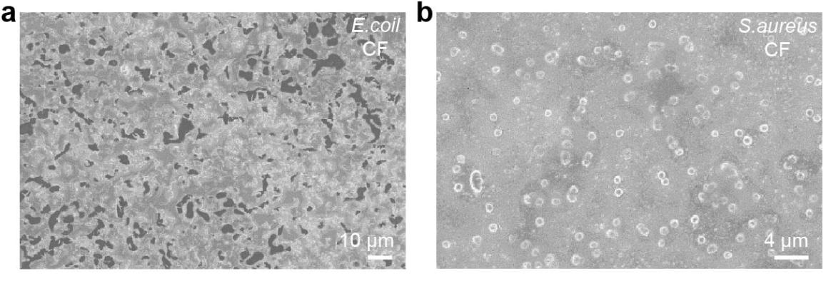
Fig. S16. SEM images of bacteria on CF without CTS modification. (a) E.coli, and (b) S.aureus.
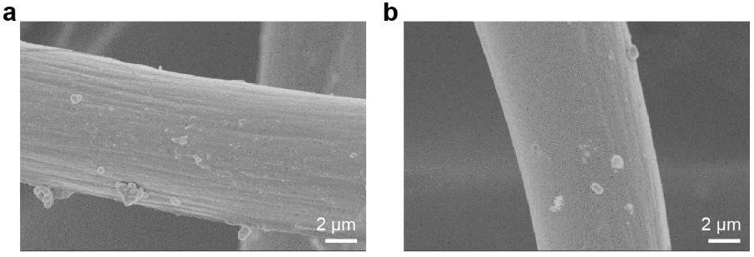
Fig. S17. SEM images of CTS@CF (no FEP membrane) for the adsorption method.
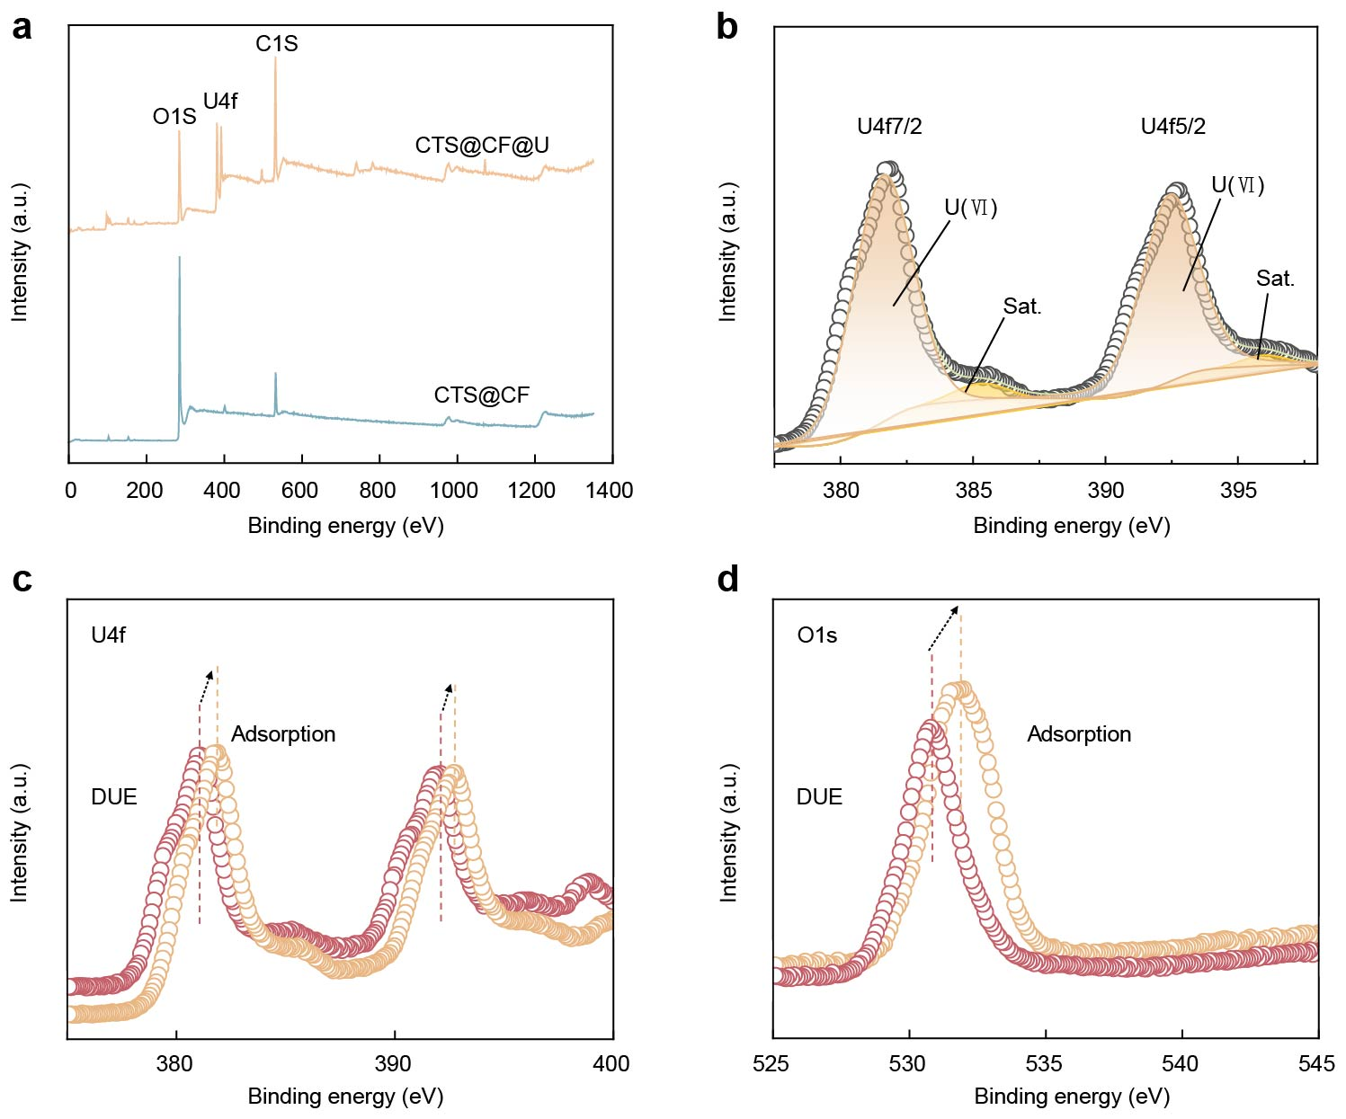
Fig. S18. XPS spectra before and after uranium extraction. (a) Overall XPS spectra of electrodes before and after uranium extraction using DUE and adsorption (no FEP membrane) methods. (b) XPS fitting of the U4f orbital during the adsorption process. A detailed comparison of the U4f (c) and O1s (d) by XPS spectra.

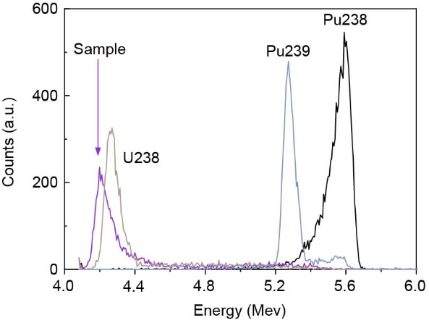
Fig. S19. α-particle decay spectra of uranium extraction sample. The spectra of pure U238, Pu239, and Pu238 are included for comparison.

