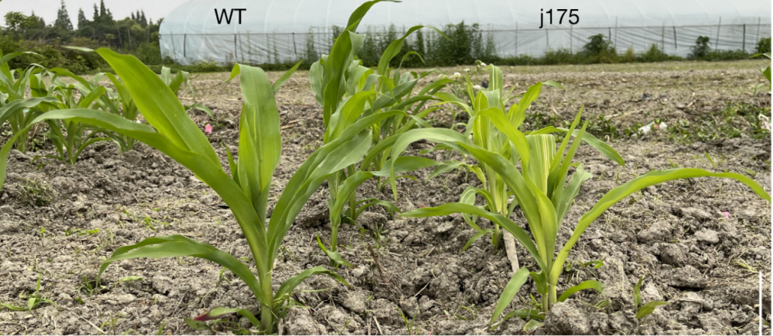
Supplementary 1 . Comparison of seedling plants. bar, 5cm.

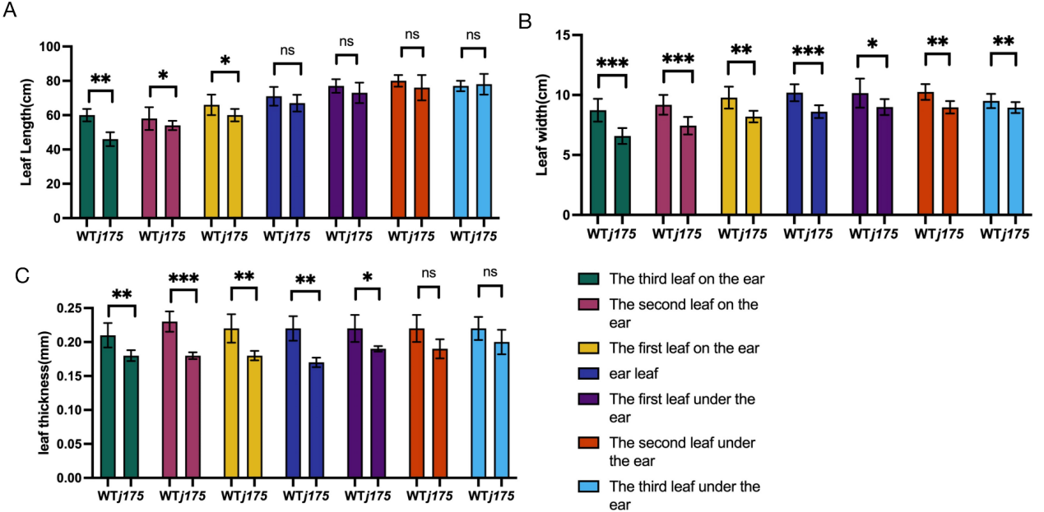
Supplementary 2. Comparison of leaf types between j175 and WT. A, laef length. B, leaf width. C, leaf, thickness.
Supplementary 3. Observation of chloroplasts in mesophyll cells by projection electron microscopy. A, WT leaf mesophyll cells during seedling stage. B-C, j175 leaf mesophyll cells during seedling stage.D, Mature WT mesophyll cells. E-F,Mature
Supplementary 4. the chi-square test of the F2 population
population | Normal plant | White striped plant | Theoretical proportion | Χ2 | Χ20.005
j175×B73 | 393 | 107 | 3:01 | 3.27 | <3.841

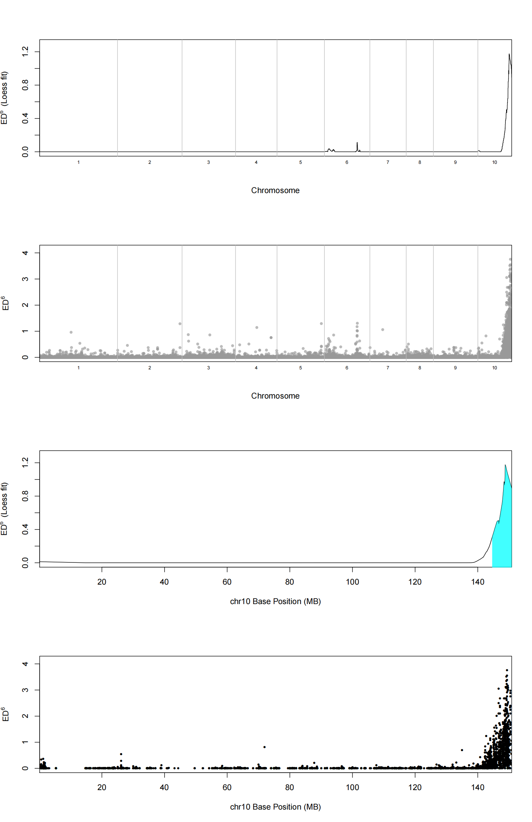

Supplementary 5. BSA-seq analysis
Supplementary 6. Molecular markers used for final-mapped of j175.
molecular markers | F primer | R primer
unc1084 | GATAAAAAGGCAAGTGCAACAAGG | ATATCAACCAGAGGCTGGAACTTG
indel1 | CTGGTAACACCATCGACGAG | ACGACCTAAACAATAGCCAAC
indel2 | TGTAGCGTTGGTGTCAATACT | TCACTGGAAAGGCAAGCTAC
indel3 | ACAGAGTAGATAGACCGGCG | ATAGCTAGCTCTCCTGCCG
indel4 | TCCGTCACTTGACTAGAGGT | ATAACACAGCTGCCTCACAG
indel5 | TGGGCCTATTAGCTCAACATTT | GGTAAGTCCAAGTCCACCAA
indel6 | GTCACAGCACATCCGTTACT | CGCGTGGCCAGAAATTTTA
indel7 | AGCGGGTTTTAACCCAAGAC | CCAGTGAAGTTCCAACTCTGT
Supplementary 7. Observation of chloroplast morphology in mesophyll cells of j175-1 and j175-2 by projection electron microscopy and starch granule morphology in mature endosperm cells by scanning electron microscopy
(A) WT mesophyll cell chloroplasts; (B) J175-1 leaf mesophyll cell chloroplasts; (C) J175-2 leaf mesophyll cell chloroplasts; (D) WT endosperm cell starch granules; (E) J175-1 endosperm cell starch granules; (F) J175-2 endosperm cell starch granules.
Supplementary 8. Evolutionary tree analysis
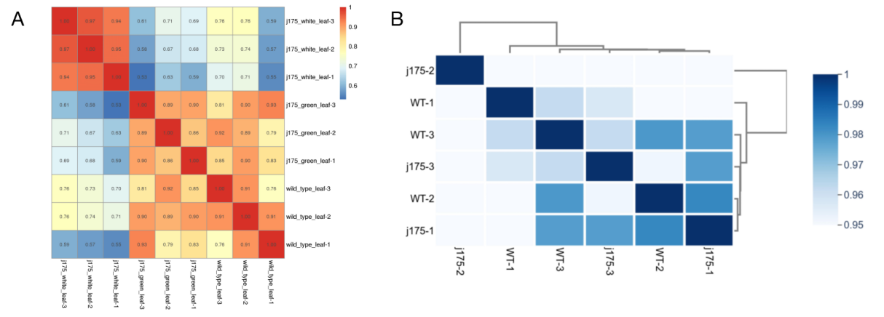
Supplementary 9. The clustering heatmap analysis of differential genes. A, leaf. B, kernel.

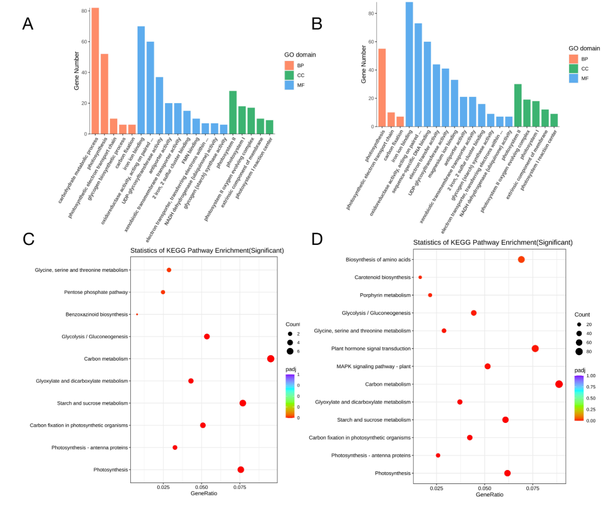
Supplementary 10. Gene Ontology Categories and Pathway Enrichment of Differentially Expressed Genes. A and C, GO and KEGG enrichment analysis of WT-Leaf and j175-white-leaf; B and D, GO and KEGG enrichment analysis of j175-green-leaf and j175-white-leaf;

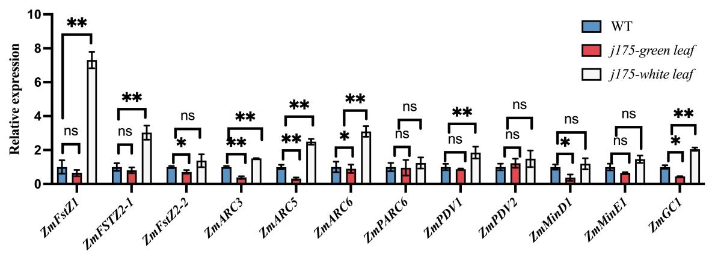
Supplementary 11. qPCR of plastid division related genes

