Supplementary materials
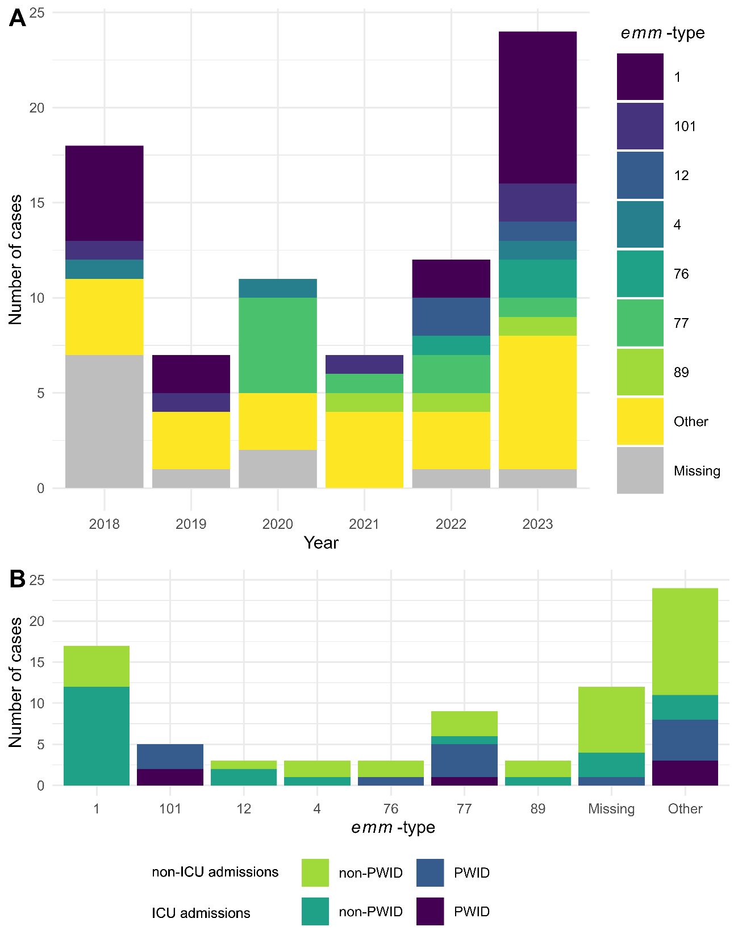
Figure S1: Adult (≥18 years) iGAS cases treated at the RMH between 2018 and 2023 (A) by year and emm-type and (B) by emm-type, admissions status and people who inject drugs (PWID).

Table S1: iGAS cases by emm-type and admissions status admitted to the RMH between 2018 and 2023
emm-type | emm-cluster | STSS cases | Injecting drug use | Non-ICU admissions | ICU admissions | Total
1 | A-C3 | 5 | 0 | 5 | 12 | 17
77 | E4 | 0 | 5 | 7 | 2 | 9
101 | D4 | 1 | 5 | 3 | 2 | 5
12 | A-C4 | 1 | 0 | 1 | 2 | 3
4 | E1 | 0 | 0 | 2 | 1 | 3
76 | E2 | 0 | 1 | 3 | 0 | 3
89 | E4 | 0 | 0 | 2 | 1 | 3
114 | E4 | 1 | 1 | 1 | 1 | 2
27 | E2 | 0 | 1 | 2 | 0 | 2
41 | D4 | 0 | 0 | 2 | 0 | 2
81 | E6 | 0 | 0 | 2 | 0 | 2
Other |  | 1 | 6 | 11 | 5 | 16
Missing |  | 1 | 1 | 9 | 3 | 12

Table S2: National extrapolation of iGAS disease incidence and healthcare costs by age and gender for adults (≥18 years) in Australia in 2023
 | 18-39 years⁴ | 40-59 years | 60-79 years | ≥80 years | Combined ≥18 years
Population (2022) | 7,577,114 | 6,513,292 | 4,811,953 | 1,115,058 | 20,017,417
Incidence rate (per 100,000) | 6.5 | 9.7 | 15.3 | 29.1 | 10.9
Impacted population | 489 | 630 | 738 | 325 | 2182
ED utilisation prior to index admission | $739,645 | $720,816 | $794,566 | $650,883 | $2,920,498
Index admission | $21,978,794 | $32,699,475 | $28,402,990 | $8,193,140 | $97,546,133
Re-admissions to the index hospital¹ | $2,457,116 | $4,582,622 | $5,622,645 | $3,760,386 | $15,682,631
Outpatient services² | $269,150 | $646,693 | $328,767 | $167,231 | $1,614,870
Total healthcare costs³ | $25,411,084 | $38,564,804 | $35,148,967 | $12,699,319 | $117,536,560
Sex⁵: Females | 18-39 years⁴ | 40-59 years | 60-79 years | ≥80 years | Combined ≥18 years
Population (2022) | 3,763,021 | 3,301,197 | 2,489,581 | 636,869 | 10,190,668
Incidence rate (per 100,000) | 7.2 | 8.2 | 12.7 | 22.5 | 9.8
Impacted population | 272 | 270 | 316 | 143 | 1001⁶
ED utilisation prior to index admission | $502,191 | $300,453 | $394,369 | $364,058 | $1,339,789
Index admission | $9,599,411 | $11,045,608 | $10,656,135 | $3,349,992 | $44,749,624
Re-admissions to the index hospital¹ | $166,897 | $397,125 | $464,783⁷ | $3,579,038 | $7,194,461
Outpatient services² | $134,202 | $184,201 | $56,547 | $12,270 | $740,827
Total healthcare costs³ | $10,369,222 | $11,827,236 | $11,107,051 | $7,305,358 | $53,920,301
Sex: Males | 18-39 years⁴ | 40-59 years | 60-79 years | ≥80 years | Combined ≥18 years
Population (2022) | 3,814,090 | 3,212,095 | 2,322,372 | 478,189 | 9,826,746
Incidence rate (per 100,000) | 5.7 | 11.2 | 18.2 | 38.1 | 12.0
Impacted population | 217 | 359 | 422 | 182 | 1180⁶
ED utilisation prior to index admission | $183,390 | $413,566 | $430,241 | $305,183 | $1,579,371
Index admission | $14,242,693 | $20,054,410 | $16,911,481 | $4,750,424 | $52,751,804
Re-admissions to the index hospital¹ | $3,141,577 | $3,361,369 | $4,286,822 | $881,155 | $8,480,983
Outpatient services² | $145,953 | $413,006 | $225,487 | $132,666 | $873,303
Total healthcare costs³ | $17,713,613 | $24,225,807 | $21,854,031 | $6,018,564 | $63,562,393
¹ Re-admissions to index hospital, including emergency department presentations.
² Outpatient services provided thorough the by index hospital
³ Total healthcare costs include: ED utilisation prior to index admission, index admission, re-admissions to index hospital and outpatient services.
⁴ Nationwide data presented from 15-19 years. For the purposes of this extrapolation, incident rate has been modelled based on cases who are over 18 years
⁵ Case’s reported sex at the time of admission to index hospital
⁶ n=1 person was not adequately described in 40-59 to category of the national database, therefore, this person was excluded from sex sub-group extrapolation
⁷ In the 60-79 year old age group of females, there were no re-admissions during the 6 month period. Therefore the average costs for the 40-59 year old female subgroup was used as a proxy.
Costs presented in AUD (2023)

Table S3: National extrapolation of iGAS disease incidence and healthcare costs by jurisdiction for adults (≥18 years) in Australia in 2023
 | ACT | NSW | NT | QLD | SA | TAS | VIC | WA | Combined
Population (2022) | 352,744 | 6,287,506 | 185,228 | 4,056,956 | 1,426,548 | 450,508 | 5,128,592 | 2,125,411 | 20,013,493
Incidence rate (per 100,000) | 6.2 | 11.2 | 61.0 | 12.0 | 9.0 | 8.7 | 9.0 | 10.5 | 10.9
Impacted population | 22 | 707 | 113 | 486 | 128 | 39 | 464 | 223 | 2182
ED utilisation prior to index admission | $29,446 | $946,284 | $151,245 | $650,487 | $171,322 | $52,200 | $621,041 | $298,474 | $2,920,498
Index admission | $983,508 | $31,606,378 | $5,051,656 | $21,726,590 | $5,722,230 | $1,743,492 | $20,743,082 | $9,969,197 | $97,546,133
Re-admissions to the index hospital¹ | $158,120 | $5,081,402 | $812,162 | $3,493,015 | $919,971 | $280,304 | $3,334,895 | $1,602,762 | $15,682,631
Outpatient services² | $16,282 | $523,242 | $83,630 | $359,682 | $94,731 | $28,863 | $343,400 | $165,039 | $1,614,870
Total healthcare costs³ | $1,185,062 | $38,083,569 | $6,086,907 | $26,179,087 | $6,894,904 | $2,100,791 | $24,994,026 | $12,012,215 | $117,536,560
¹ Re-admissions to index hospital, including emergency department presentations.
² Outpatient services provided thorough the by index hospital
³ Total healthcare costs include: ED utilisation prior to index admission, index admission, re-admissions to index hospital and outpatient services.
Costs presented in AUD (2023)

Table S4: Exploratory extrapolation of iGAS disease healthcare costs in Western Australia in 2023 that adjusts for remote-living people
 | Western Australia Regions¹
 | Goldfields | Great Southern | Kimberley | Metro Perth | Midwest | Pilbara | Southwest | Wheatbelt | Entire state
Incident rate (per 100,000) ² | 28.3 | 6.5 | 91.2 | 7.7 | 27.4 | 32.5 | 7.6 | 9.5 | 10.5
Impacted population (n) | 11 | 3 | 24 | 129 | 12 | 15 | 11 | 5 | 223
Rurality weighting applied³ | Yes (MM7) | No | Yes (MM7) | No | Yes (MM6) | Yes (MM7) | No | No
ED utilisation prior to index admission | $21,924 | $4,176 | $48,546 | $173,303 | $23,385 | $29,754 | $14,616 | $7,308 | $323,011
Index admission | $732,267 | $139,479 | $1,621,447 | $5,788,393 | $781,084 | $993,790 | $488,178 | $244,089 | $10,788,278
Re-admissions to hospital⁴ | $117,728 | $22,424 | $260,682 | $930,608 | $125,576 | $159,773 | $78,485 | $39,243 | $1,734,519
Outpatient services⁵ | $12,123 | $2,309 | $26,843 | $95,826 | $12,931 | $16,452 | $8,082 | $4,041 | $178,607
Total healthcare costs⁶ | $882,332 | $168,063 | $1,953,736 | $6,974,626 | $941,154 | $1,197,451 | $588,221 | $294,111 | $12,999,694
¹ Regions described as per https://www.health.wa.gov.au/articles/n_r/notifiable-infectious-disease-dashboard
² incidence rate reported by https://www.health.wa.gov.au/articles/n_r/notifiable-infectious-disease-dashboard. This incidence rate includes children. It is estimated that 22% of the impacted iGAS population <18 years of age (n=48 approximately), therefore adult impacted population was estimated to be 78% of the total number for those that were in each region.
³ Rurality weighting applied for areas classified as MM6 (remote) or MM7 (very remote)
⁴ Re-admissions to index hospital, including emergency department presentations.
⁵ Outpatient services provided thorough the by index hospital
⁶ Total healthcare costs include: ED utilisation prior to index admission, index admission, re-admissions to index hospital and outpatient services.
Costs presented in AUD (2023)

Table S5: Exploratory extrapolation of iGAS disease healthcare costs in Western Australia in 2023 that adjusts for First Nations status
 | Aboriginal¹ | Non-Aboriginal | Unknown | Entire state
Incident rate (per 100,000) ² in Western Australia | 63.9 | 7.6 | 0.0 | 10.5
Impacted population (n) in Western Australia | 55 | 152 | 4 | 223
Aboriginal weighting applied | Yes | No | No
ED utilisation prior to index admission | $270,166 | $203,444 | $5,354 | $478,964
Index admission | $9,023,688 | $6,795,148 | $178,820 | $15,997,655
Re-admissions to hospital³ | $1,450,751 | $1,092,466 | $28,749 | $2,571,966
Outpatient services⁴ | $149,387 | $112,493 | $2,960 | $264,840
Total healthcare costs⁵ | $10,872,940 | $8,187,698 | $215,466 | $19,276,104
¹Aboriginal status described as per https://www.health.wa.gov.au/articles/n_r/notifiable-infectious-disease-dashboard
² incidence rate reported by https://www.health.wa.gov.au/articles/n_r/notifiable-infectious-disease-dashboard. This incidence rate includes children. It is estimated that 22% of the impacted iGAS population <18 years of age (n=48 approximately), therefore adult impacted population was estimated to be 78% of the total number for those who were Aboriginal, Non-Aboriginal, Unknown.
³ Re-admissions to index hospital, including emergency department presentations.
⁴ Outpatient services provided thorough the by index hospital
⁵ Total healthcare costs include: ED utilisation prior to index admission, index admission, re-admissions to index hospital and outpatient services.
Costs presented in AUD (2023)

Table S6: Economic assumptions
 | Assumption
PHASE 1 initial analysis assumptions
Cost year | 2023 calendar year base/reference year due to seasonal impact of disease
Currency | AUD
Inflation of costs | All costs were inflated to 2023 calendar year.
Rurality of cases | Modified Monash Model was used to determine geographical remoteness based on cases residing postcode. The "Health Workforce Locator' was used to determine rurality of cases (https://www.health.gov.au/resources/apps-and-tools/health-workforce-locator/app?language=en).  Modified Monash Model Classifications are as follows (https://www.health.gov.au/topics/rural-health-workforce/classifications/mmm):  MM 1 - Metropolitan areas: Major cities accounting for 70% of Australia’s population.  All areas categorised ASGS-RA1.  MM 2 - Regional centres: Areas categorised ASGS-RA 2 and ASGS-RA 3 that are in, or within 20km road distance, of a town with a population greater than 50,000.  MM 3 - Large rural towns: Areas categorised ASGS-RA 2 and ASGS-RA 3 that are not in MM 2 and are in, or within 15km road distance, of a town with a population between 15,000 and 50,000.  MM 4 - Medium rural towns: Areas categorised ASGS-RA 2 and ASGS-RA 3 that are not in MM 2 or MM 3 and are in, or within 10km road distance, of a town with a population between 5,000 and 15,000.  MM 5 - Small rural towns: All other areas in ASGS-RA 2 and 3.  MM 6 - Remote communities: All areas categorised ASGS-RA 4 and islands that are separated from the mainland in the ABS geography and are less than 5km offshore.  Islands that have an MM 5 classification with a population of less than 1,000 without bridges to the mainland (2019 Modified Monash Model classification only).  MM 7 - Very remote communities: All other areas that are categorised ASGS-RA 5 and populated islands separated from the mainland in the ABS geography that are more than 5km offshore
Calculating missing 2023/2024 cost data for cases using modelling (ED admission preceding index admission; Index admission; and 6 Month follow up (ED admissions, acute admissions, sub-acute admissions, OP services during 6 month follow up period) | Formulae used = average total cost inflated 2023/average LOS
ED Admission total cost per day | $1,850.76
Index Admission total cost per day | $3,344.62
ED admissions costs during 6 month follow up per day | $913.87
IP admissions costs during 6 month follow up per day | $1,758.76
Subacute admissions cost during 6 month follow up per day modelled from recent clinical trial | $1,040
OP costs during 6 month follow up per day | $367.35
Average LOS in days for ED prior to index admission for modelling in days | 0.8
Average LOS in days for index admission for modelling in days | 13.18
Average LOS in days for ED admissions during 6 month follow up for modelling (this average only includes cases that recorded this type of episode of care) | 1.95
Average LOS in days for acute IP admissions during follow up for modelling (this average only includes cases that recorded this type of episode of care) | 16.06
Average LOS in days for subacute admissions during follow up for modelling (this average only includes cases that recorded this type of episode of care), n = 3 | 2.67 days * this LOS is not being used due to small numbers
Average LOS in days for OP services during follow up for modelling (this average only includes cases that recorded this type of episode of care) | 4.57
Average cost for ED prior to index admission for modelling | $1,480.61
Average cost for index admission for modelling | $44,082.07
Average cost for ED admissions during 6 month follow up for modelling | $1,782.04
Average cost for acute IP admissions during follow up for modelling | $28,245.71
Average cost for subacute admissions during follow up for modellings | Only a small number of cases received subacute services during the 6 month follow up period. Therefore, market rate to deliver subacute services per day was modelled from a recent clinical trial, which determined the subacute cost per day as $AUD981 (2021/2022). Inflated to 2023 cost year, subacute cost per day is $1040.
Average cost for OP services during follow up for modelling (this average only includes cases that recorded this type of episode of care) | $1,678.81
Follow up within 6 months | If any cases, have 0 day length-of-stay within the 6 month follow up period, it was assumed that they didn’t have any follow up or healthcare costs associated within 6 months
Base case analysis | All cases were included in the base case analysis.
Sensitivity analysis of data | Sensitivity analysis to exclude cases who had a length-of-stay that exceeded LOS>120days
Sub-group analysis | Sub-group analysis for age, gender, disease severity and surgery related to illness only included cases that survived.
Severity of disease | It was assumed that all cases were managed in hospital due to the severity of the disease and that it was therefore very unlikely for cases to be managed in the community.
ED total bucket costs moved across to the main ED total costs | Within the costing data provided by the index hospital, two ED costs buckets were presented. These two costs buckets have been merged to capture the total ED costs prior to index admission.
Deceased outcome recorded for cases | The outcome for 'deceased' recorded for cases assumes that the cases died during index admission.
Cases with medsurg and nonmedsurg costings | One case had costings in med surg and nonmed surgery cost buckets. These were assumed to be medical costs and re-allocated to the total medical costs
ED presentations prior to admission within 6 months | n=2 cases did not have an ED admission recorded prior to a re-admission to the index hospital. It was assumed that these cases were direct admissions onto the acute wards (i.e. bypassed ED).
PHASE 2 - cost extrapolation
2023 prevalence of iGAS | iGAS prevalence in Australia was gathered from a public data depository (https://www.health.gov.au/resources/apps-and-tools/national-notifiable-diseases- surveillance-system-nndss-data-visualisation-tool)
2022 population data | For population data by jurisdication (i.e. state), age and sex, 2022 data was used as this was the latest release for age and sex at the time of data analysis (Accessed via this link: https://www.abs.gov.au/statistics/people/population/regional-population-age-and-sex/2022#data-downloads).  For the 15-19 year old age bracket, this was modelled by including only 2/5 people (i.e. capturing 20% of the population, which is the 18 and 19 year old group).
Incidence rate per 100,000 | Formula: (Number of new cases/total population)*100,000.
Cost burden | Multiply the costs from phase 1 * prevalence number.  Extrapolation for sub-groups to include: age, gender, jurisdiction. Due to the prevalence data presenting age in bracket from 15-19 years, we only modelled data by including 2/5 people in the cost extrapolation (i.e. capturing 20% of the population, which is the 18 and 19 year old prevalence)
Weighting for rurality | For the extrapolation modelling, weighting for rurality (MM6 (remote) and MM7 (very remote) was applied.  Weighting applied for remote locations was 140% and weighting for very remote was 150% (Source: https://www.ndis.gov.au/providers/pricing-arrangements#ndis-pricing-arrangements-and-price-limits)
Weighting for Aboriginal and Torres Strait Islander peoples | For the extrapolation modelling, weighting for indigenous peoples was be applied. Weighting for indigenous peoples is 367% (Source: Ong, K. S., Kelaher, M., Anderson, I., & Carter, R. (2009)). A cost-based equity weight for use in the economic evaluation of primary health care interventions: case study of the Australian Indigenous population. International journal for equity in health, 8, 1-14.)
Cost of iGAS across lifetime | Previous study data to model cost of iGAS across the lifetime, by inflating to 2023 cost year (Source: Brusco, N. K., Oliver, J., McMinn, A., Steer, A., & Crawford, N. (2021). The cost of care for children hospitalised with Invasive Group A Streptococcal Disease in Australia. BMC Health Services Research, 21(1), 1340. https://doi.org/10.1186/s12913-021-07265-8 ).
Sunset clause | Sunset clause of 120 days post admission date for the index admissions and admissions during 6 months was applied (i.e. cases with LOS exceeding 120 days were excluded for the cost extrapolation)
Cost year | 2023 calendar year base/reference year due to seasonal impact of disease
Currency | AUD
Cost proxy | In the 60-79 year old age group of females, there were no re-admissions during the 6 month period. Therefore the average costs for the 40-59 year old female subgroup was used as a proxy.

Table S7: CHEERS 2022 Checklist

Topic | No. | Item | Location where item is reported
Title
Title | 1 | Identify the study as an economic evaluation and specify the interventions being compared. | Title
Abstract
Abstract | 2 | Provide a structured summary that highlights context, key methods, results, and alternative analyses. | Abstract
Introduction
Background and objectives | 3 | Give the context for the study, the study question, and its practical relevance for decision making in policy or practice. | Introduction
Methods
Health economic analysis plan | 4 | Indicate whether a health economic analysis plan was developed and where available. | Methods
Study population | 5 | Describe characteristics of the study population (such as age range, demographics, socioeconomic, or clinical characteristics). | Methods
Setting and location | 6 | Provide relevant contextual information that may influence findings. | Methods
Comparators | 7 | Describe the interventions or strategies being compared and why chosen. | Methods
Perspective | 8 | State the perspective(s) adopted by the study and why chosen. | Methods
Time horizon | 9 | State the time horizon for the study and why appropriate. | Methods
Discount rate | 10 | Report the discount rate(s) and reason chosen. | Methods
Selection of outcomes | 11 | Describe what outcomes were used as the measure(s) of benefit(s) and harm(s). | Methods
Measurement of outcomes | 12 | Describe how outcomes used to capture benefit(s) and harm(s) were measured. | Methods
Valuation of outcomes | 13 | Describe the population and methods used to measure and value outcomes. | Methods
Measurement and valuation of resources and costs | 14 | Describe how costs were valued. | Methods
Currency, price date, and conversion | 15 | Report the dates of the estimated resource quantities and unit costs, plus the currency and year of conversion. | Methods
Rationale and description of model | 16 | If modelling is used, describe in detail and why used. Report if the model is publicly available and where it can be accessed. | Methods
Analytics and assumptions | 17 | Describe any methods for analysing or statistically transforming data, any extrapolation methods, and approaches for validating any model used. | Methods and Table S6
Characterising heterogeneity | 18 | Describe any methods used for estimating how the results of the study vary for subgroups. | Methods
Characterising distributional effects | 19 | Describe how impacts are distributed across different individuals or adjustments made to reflect priority populations. | Methods
Characterising uncertainty | 20 | Describe methods to characterise any sources of uncertainty in the analysis. | Methods
Approach to engagement with patients and others affected by the study | 21 | Describe any approaches to engage patients or service recipients, the general public, communities, or stakeholders (such as clinicians or payers) in the design of the study. | Not reported
Results
Study parameters | 22 | Report all analytic inputs (such as values, ranges, references) including uncertainty or distributional assumptions. | Results
Summary of main results | 23 | Report the mean values for the main categories of costs and outcomes of interest and summarise them in the most appropriate overall measure. | Results
Effect of uncertainty | 24 | Describe how uncertainty about analytic judgments, inputs, or projections affect findings. Report the effect of choice of discount rate and time horizon, if applicable. | Results
Effect of engagement with patients and others affected by the study | 25 | Report on any difference patient/service recipient, general public, community, or stakeholder involvement made to the approach or findings of the study | Not reported
Discussion
Study findings, limitations, generalisability, and current knowledge | 26 | Report key findings, limitations, ethical or equity considerations not captured, and how these could affect patients, policy, or practice. | Discussion
Other relevant information
Source of funding | 27 | Describe how the study was funded and any role of the funder in the identification, design, conduct, and reporting of the analysis | Title Page
Conflicts of interest | 28 | Report authors conflicts of interest according to journal or International Committee of Medical Journal Editors requirements. | Title Page
From: Husereau D, Drummond M, Augustovski F, et al. Consolidated Health Economic Evaluation Reporting Standards 2022 (CHEERS 2022) Explanation and Elaboration: A Report of the ISPOR CHEERS II Good Practices Task Force. Value Health 2022;25. doi:10.1016/j.jval.2021.10.008

