Supplementary Information

Low-Dimensional Templates and Delayed Crystallization for High-Quality Tin-Based Perovskite Films

Methods
Materials. N, N-dimethylformamide (DMF, anhydrous, 99.8%), dimethyl sulfoxide (DMSO, anhydrous, 99.9%), chlorobenzene (CB, anhydrous, 99.8%), tin fluoride (SnF₂, 99%) were obtained from Aladdin and used as received with no further purification. 2-phenylethylamine thiocyanate (PEASCN, 99.9%) was purchased from Greatcell.
Preparation of the SnI₂ solution
To prepare a 0.2 M SnI₂ solution, 2.5 mmol I₂ was dissolved in 2.5 ml DMSO and 10 ml DMF successively, and then sufficient Sn powder was added to the I₂ solution after stirring at room temperature overnight.
Preparation of the perovskite precursor solution
For the PEAI precursor, a 0.2 M perovskite precursor comprised of PEAI, FAI, SnI₂ solution, and SnF₂ in the molar ratio of 0.34:0.83:1:0.1 was mixed and stirred at room temperature overnight. For PEASCN-FAHCOO precursor, a 0.2 M perovskite precursor comprised of PEASCN, FAHCOO, NH₄I, SnI₂ solution, and SnF₂ in the molar ratio of 0.34:0.83:0.83:1:0.1 were mixed and stirred at room temperature overnight.
Device Fabrication:
Highly doped P-type silicon with 100 nm SiO₂ was used as the substrate. The Si/SiO₂ substrate was treated under argon plasma for 20 seconds to improve the surface wettability. The perovskite precursor was spin-coated onto the substrate at 1000 and 5000 rpm for 5 s and 60 s, respectively. 100 ml of anti-solvent chlorobenzene was dropped onto the surface in the second step, then thermal annealing at 100 °C for 10 min. 50 nm gold was thermally evaporated as the source and drain electrodes. The channel length/width of the FETs was 150/1200 μm. All preparation processes were completed in a nitrogen-filled glove box.
Perovskite Film Characterization:
GIWAXS measurement was performed by employing a beam energy of 10 keV and a PILATUS detector at the BL02U1 beamline of Shanghai Synchrotron Radiation Facility (SDRS), Shanghai, China. The SEM images were taken by JSM-7800, JEOL. X-ray diffraction pattern data for 2θ values were collected with a Bruker AX D8 Advance diffractometer with nickel-filtered Cu Kα radiation (λ=1.5406 Å). AFM measurements were taken using Bruker's Dimension Edge03040155. Time-resolved photoluminescence (TRPL) spectra were obtained using a streak camera (Hamamatsu, C6860). PL is recorded using HORIBA Fluorolog-3 with a CCD detector.
Device Electrical Characterization:
The forward transmission characteristic curve in the perovskite transistor is used to calculate the device's mobility.
The calculation formula of mobility in the linear region is as follows:
$$μ_{Linear}=\frac{L}{WC_{i}V_{GS}}·\frac{dI_{DS}}{dV_{GS}}$$
The calculation formula of mobility in the saturated region is as follows:
$$μ_{sat}=\frac{2L}{WC_{i}}\frac{I_{DS}}{{{(V}_{GS}-V_{th})}^{2}}$$
where L is the channel length, W is the channel width, C_{i} is the dielectric capacitance, and I_{DS} and V_{GS} are the source-drain current and gate-source voltage, respectively.

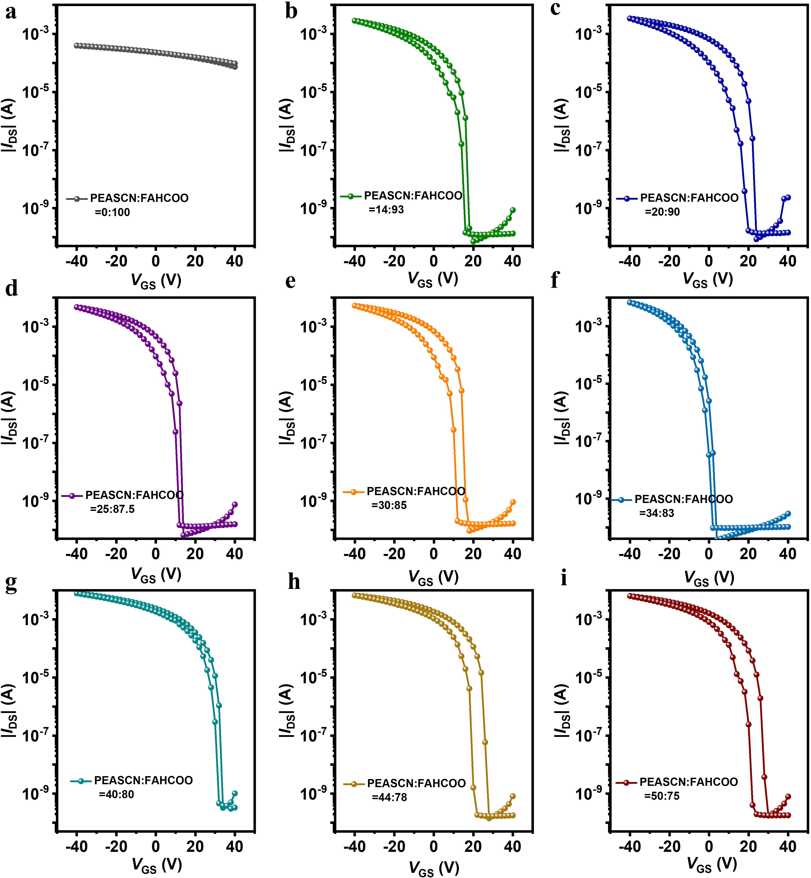
Figure S1. Transfer characteristic curves of perovskite FETs for different PEASCN and FAHCOO molar ratios.

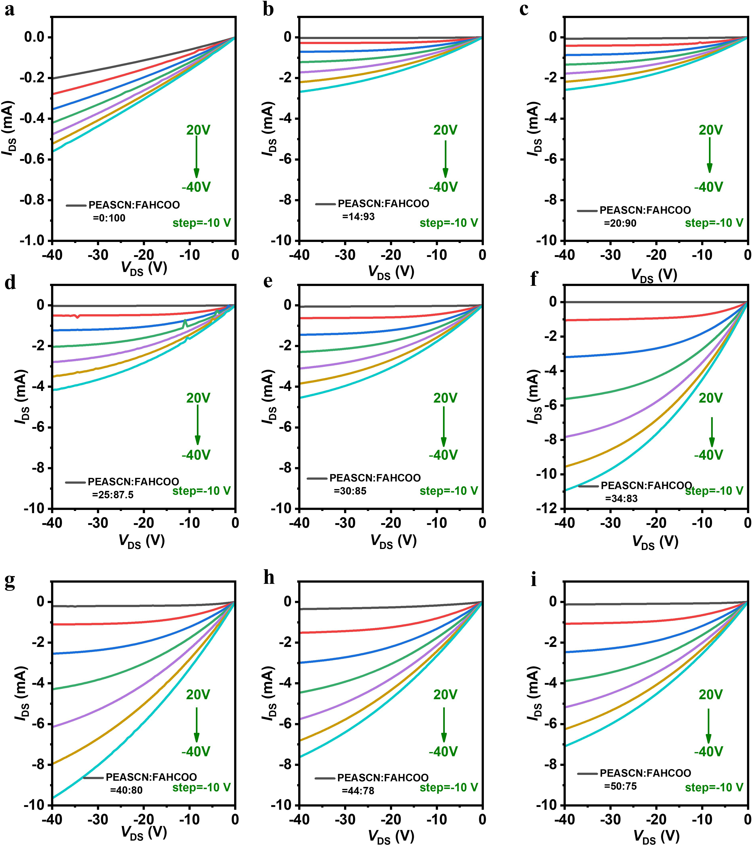

Figure S2. Output characteristic curves of perovskite FETs for different PEASCN and FAHCOO molar ratios.
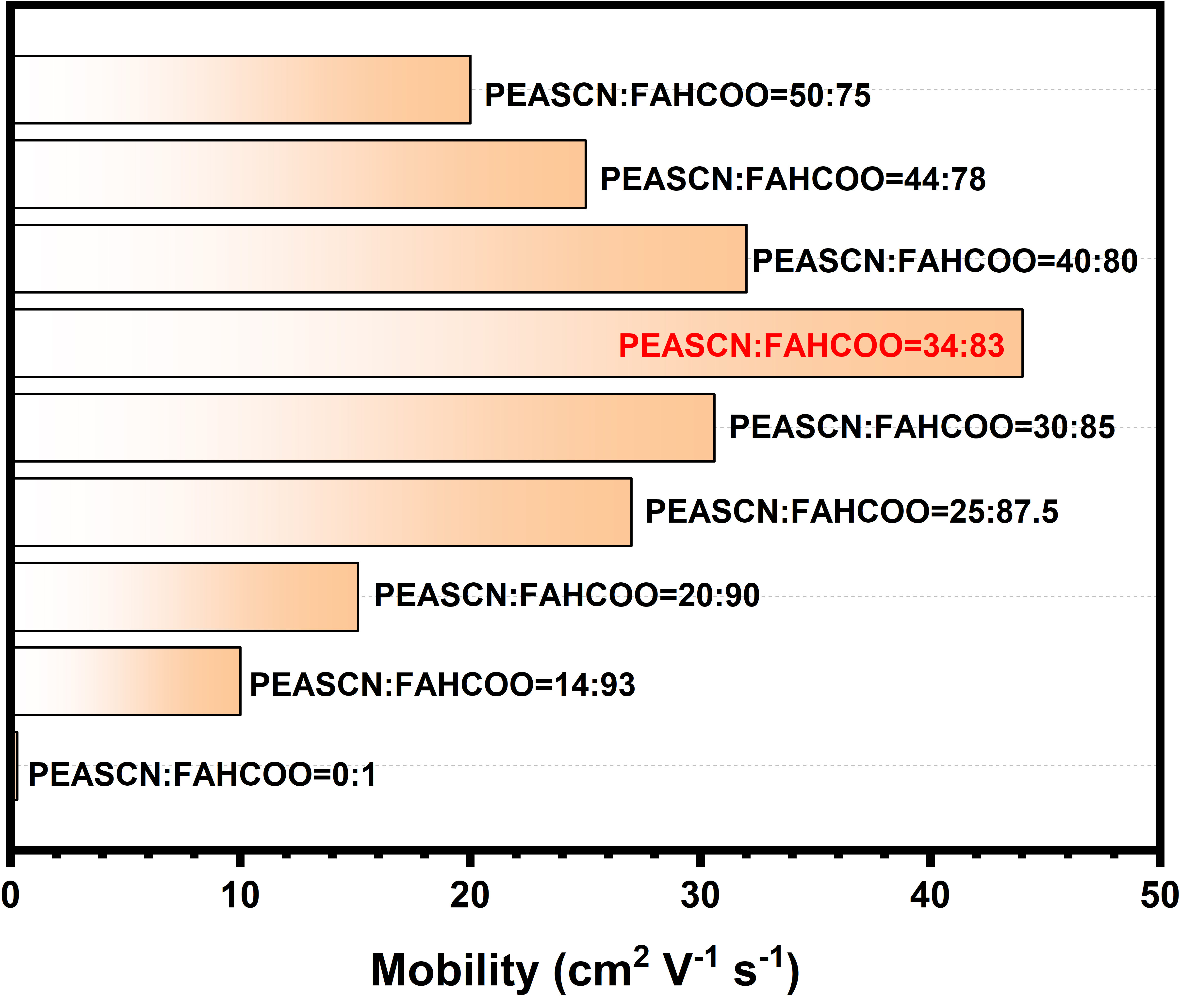
Figure S3. Mobility statistics of perovskite FETs for different PEASCN and FAHCOO molar ratios.

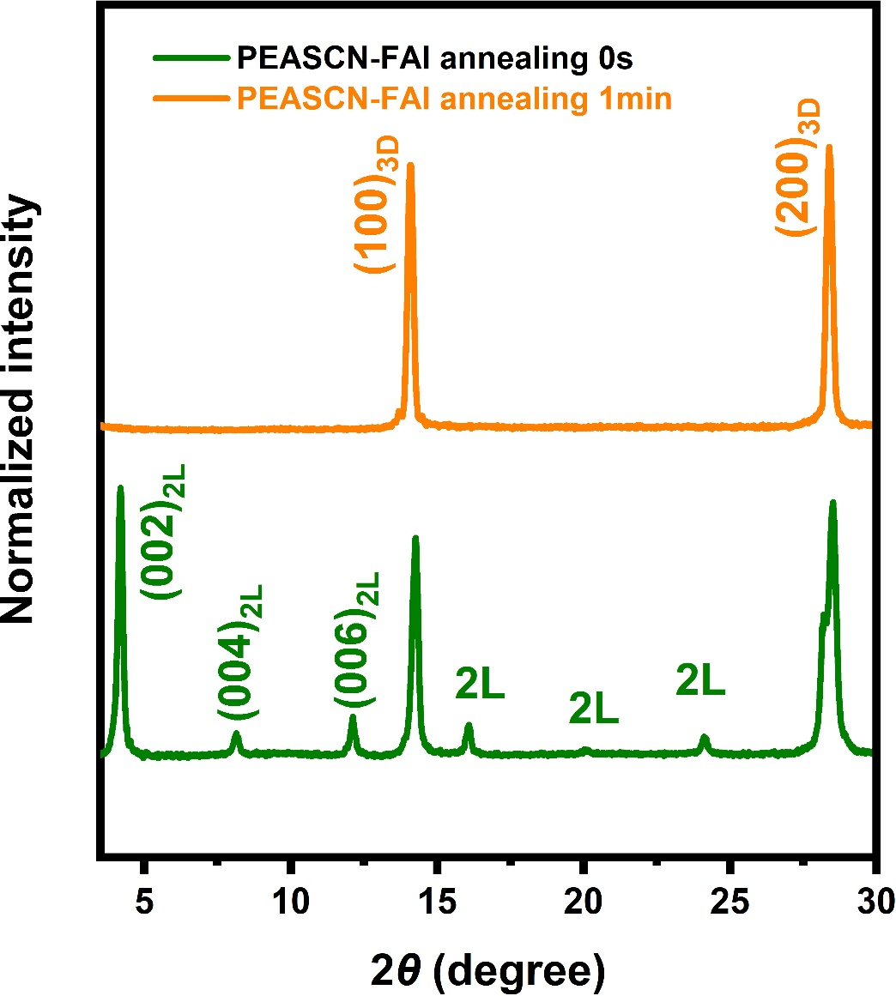

Figure S4. XRD spectra of perovskite thin films prepared exclusively with PEASCN, without utilizing FAHCOO and NH₄I as replacements for FAI, before and after annealing.

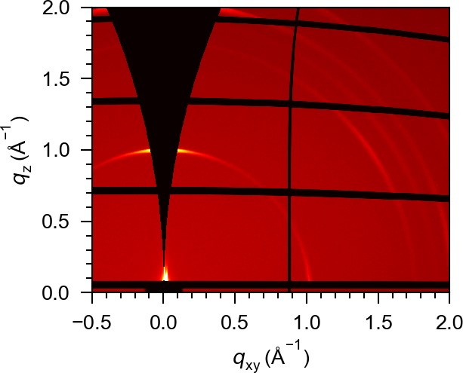

Figure S5. GIWAXS patterns of the PEAI-based perovskite films.

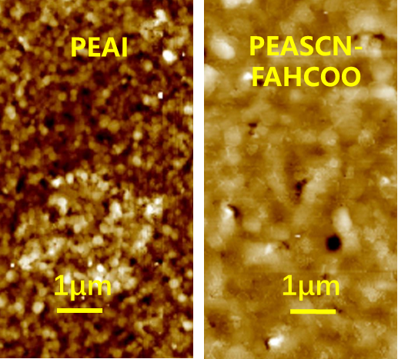
Figure S6. Typical AFM images of the PEAI and PEASCN-FAHCOO Sn-based perovskite films.

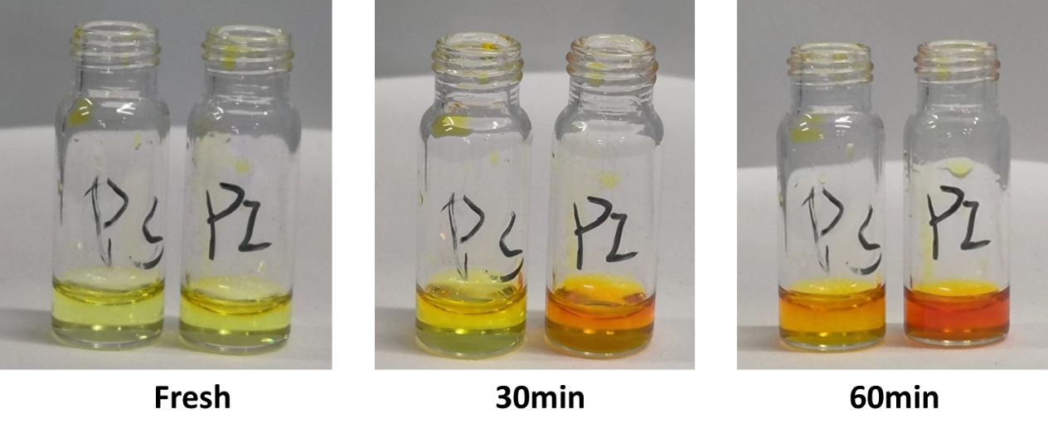
Figure S7. Photographs of the PEAI-based and PEASCN-FAHCOO-based solution stored in the air with a 40% relative humidity at room temperature for 0, 30, and 60 min.

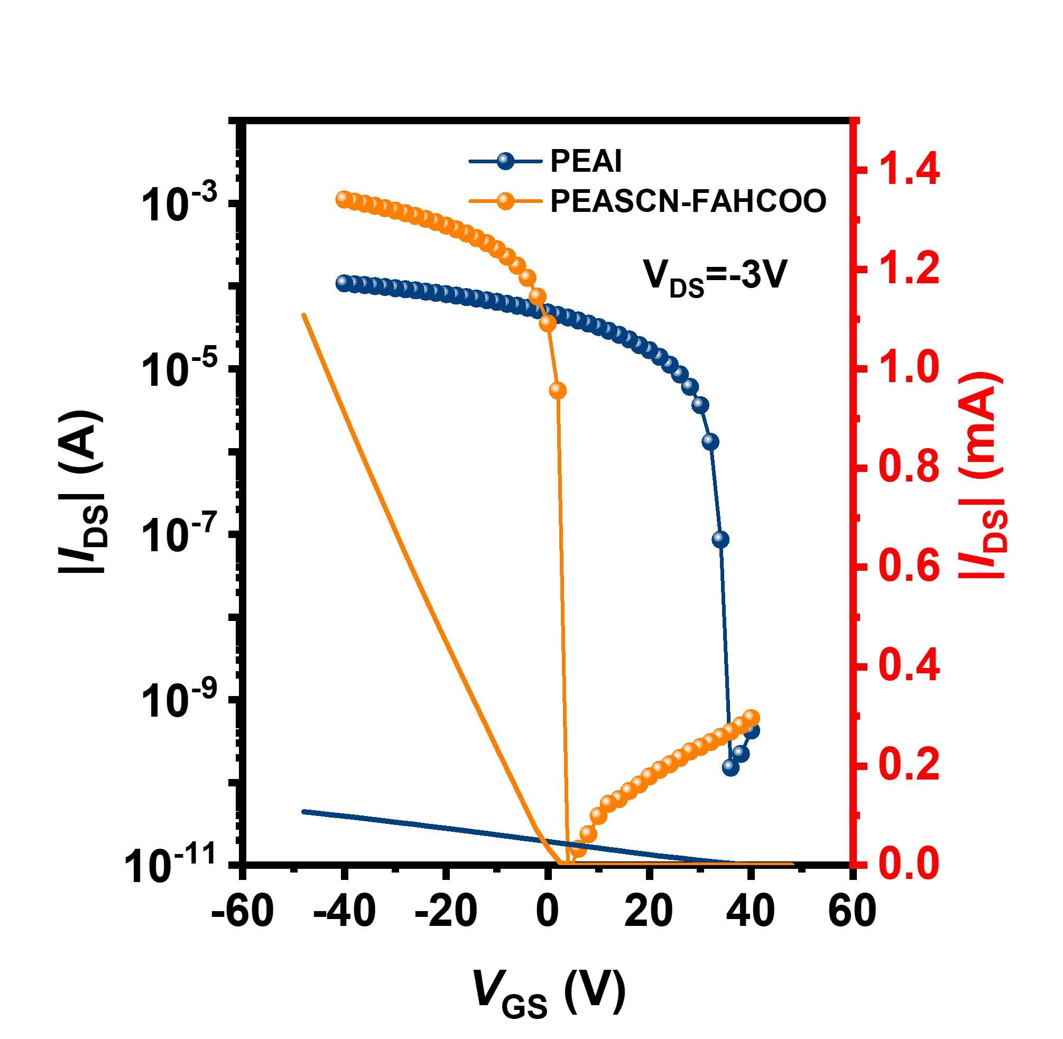
Figure S8. The transfer characteristic curve of the PEAI-based and PEASCN-FAHCOO-based FETs measured with V_{DS}=-3 V.

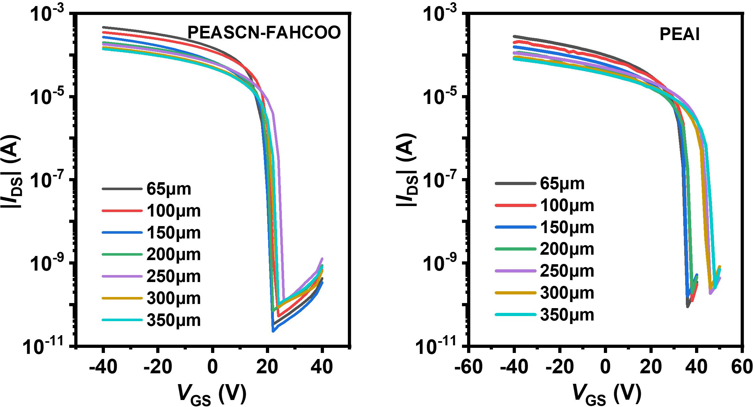

Figure S9. Transfer characteristic curves of the PEASCN-FAHCOO-based and PEAI-based FETs with different channel lengths at the linear region.

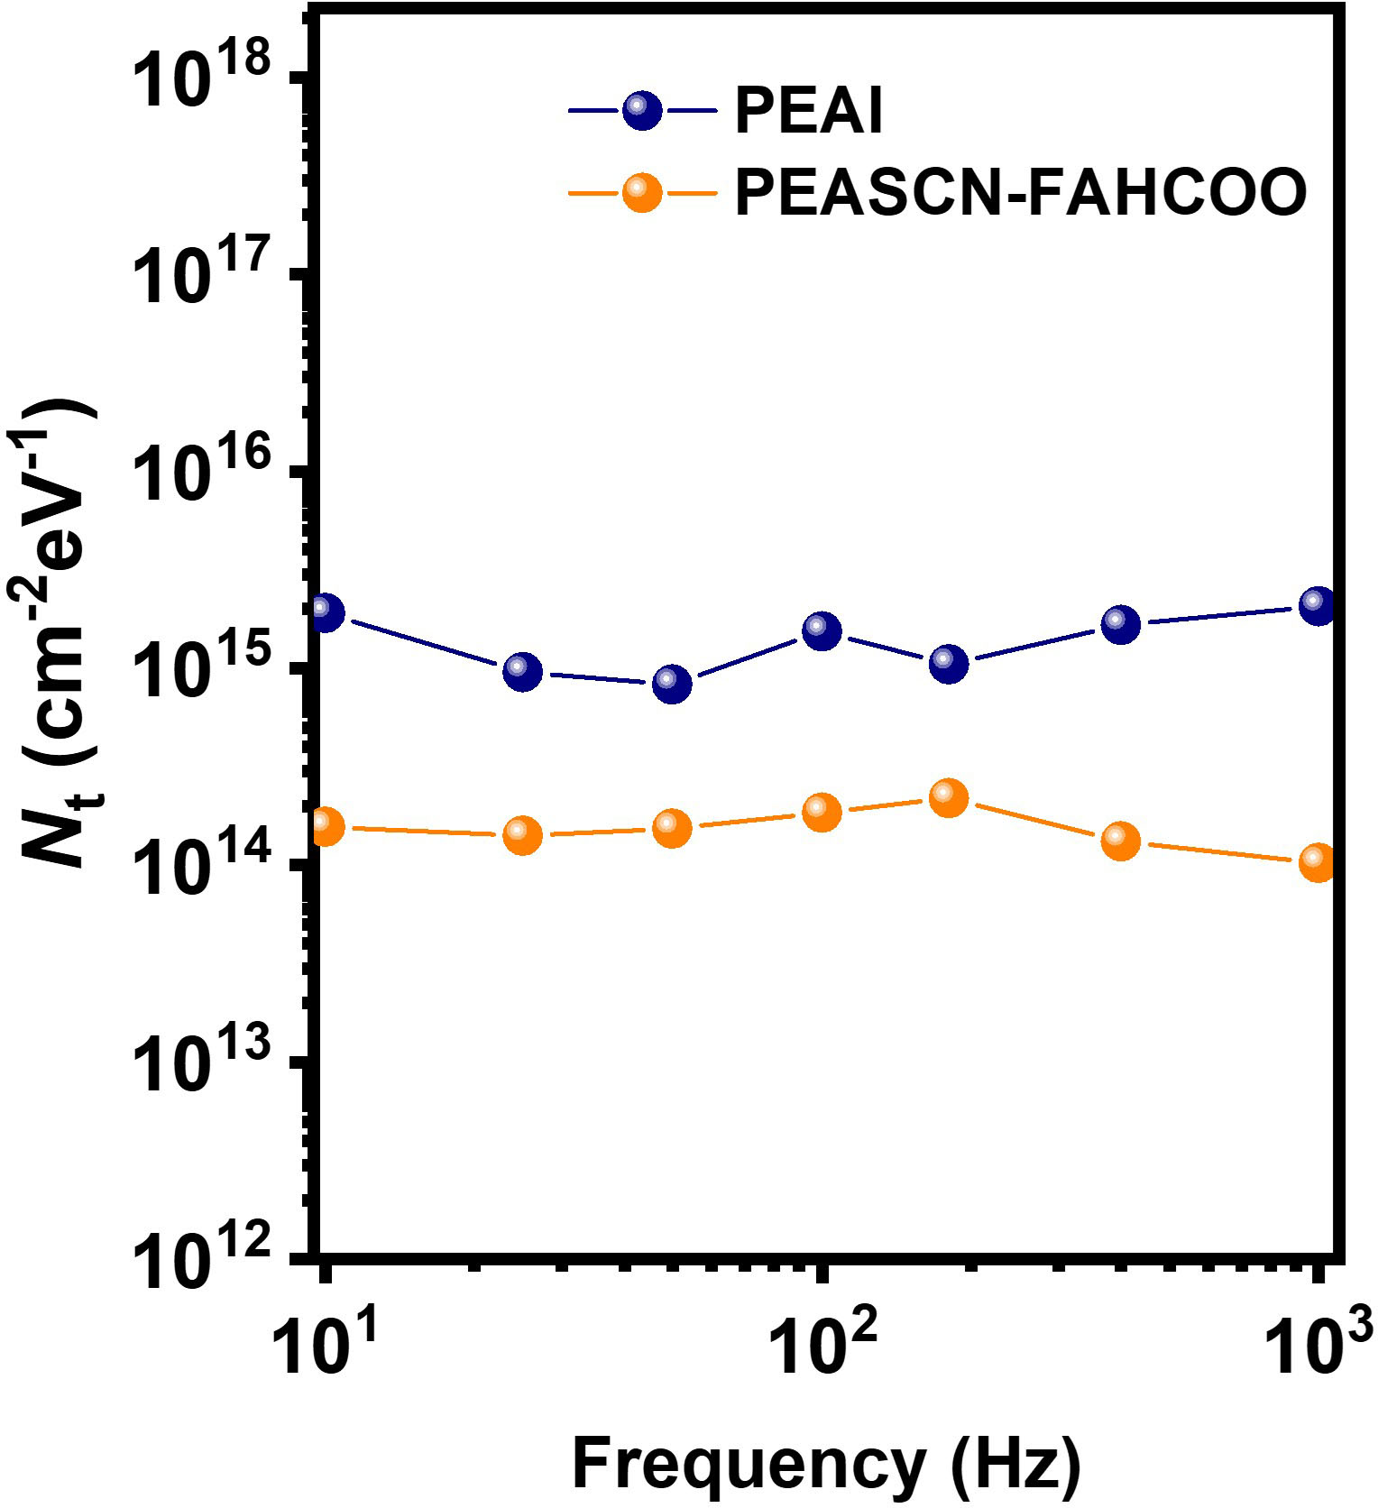
Figure S10. Defect state density of the PEAI-based and the PEASCN-FAHCOO-based FETs at different frequencies.

The surface trap density（N_{t}） can be extracted by the following formula：
$$\frac{S_{Id}}{{I_{DS}}^{2}}=\frac{q^{2}kTN_{t}}{WL{C_{i}}^{2}f}∙{（\frac{g_{m}}{I_{DS}}）}^{2}$$
where q is the electron charge, k is the Boltzmann constant, T is the Kelvin temperature, L is the channel length, W is the channel width, C_{i} is the capacitance per unit area of the gate dielectric, and g_{m} is the transconductance.

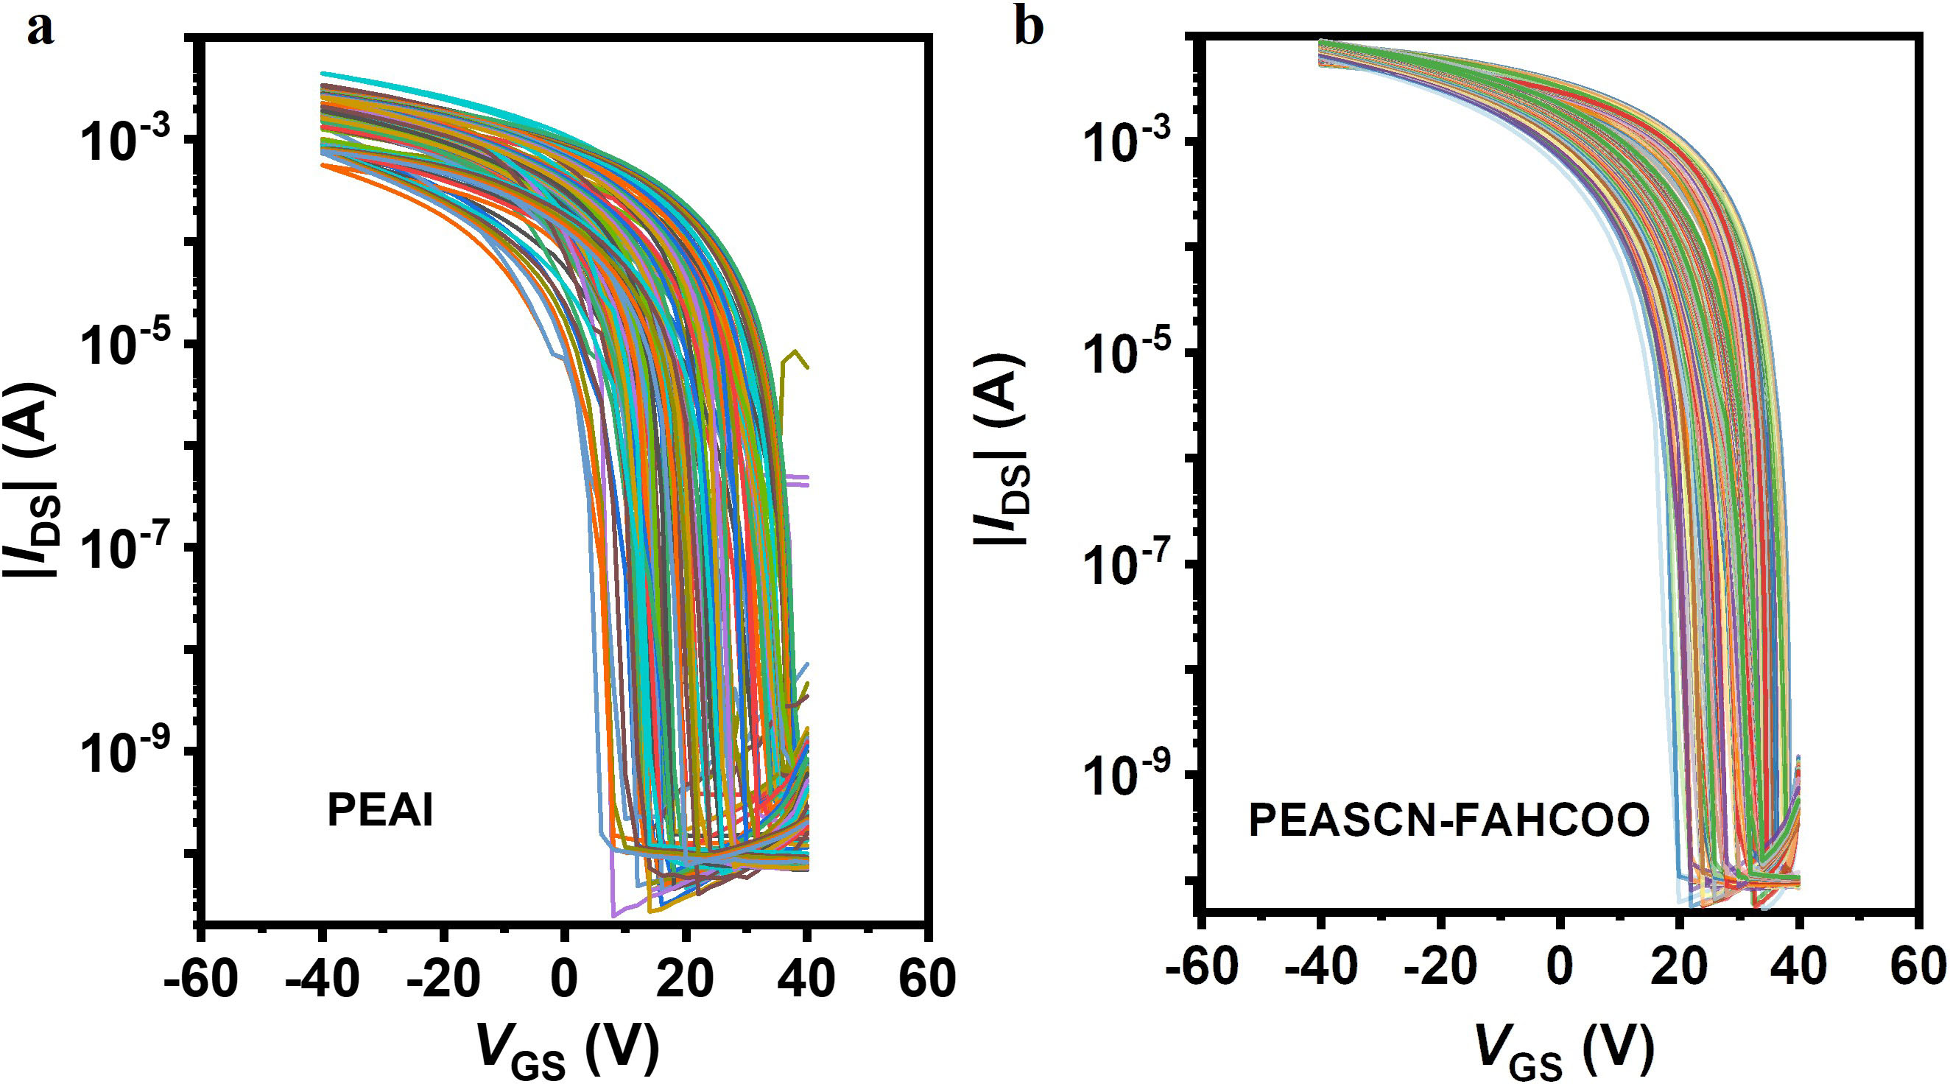

Figure S11. Transfer characteristics of 200 individual PEASCN-FAHCOO-based and PEAI-based FETs.

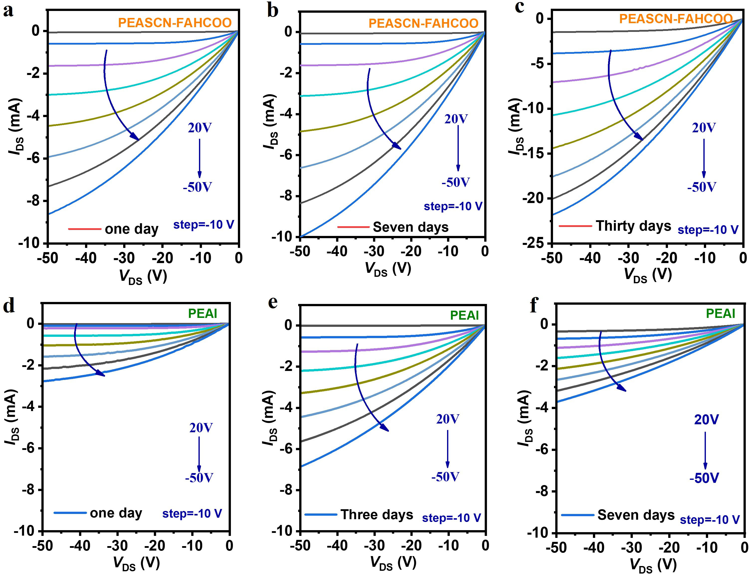
Figure S12. The output curve of the PEASCN-FAHCOO-based and PEAI-based FETs at different storage times.

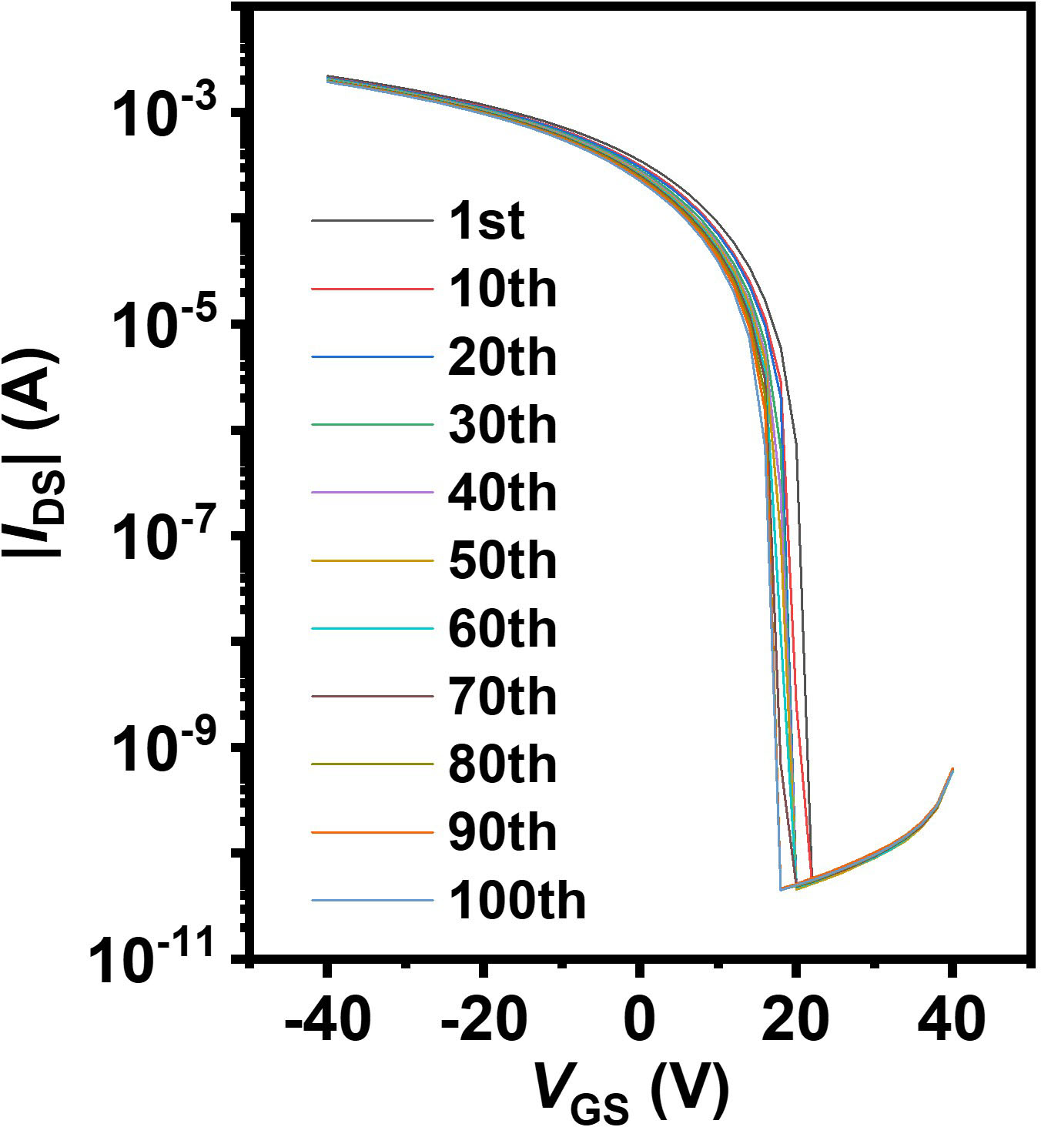
Figure S13. Consecutive transfer curve measurement results for 100 cycles (V_{DS} = -30 V) of the PEAI-based FETs.

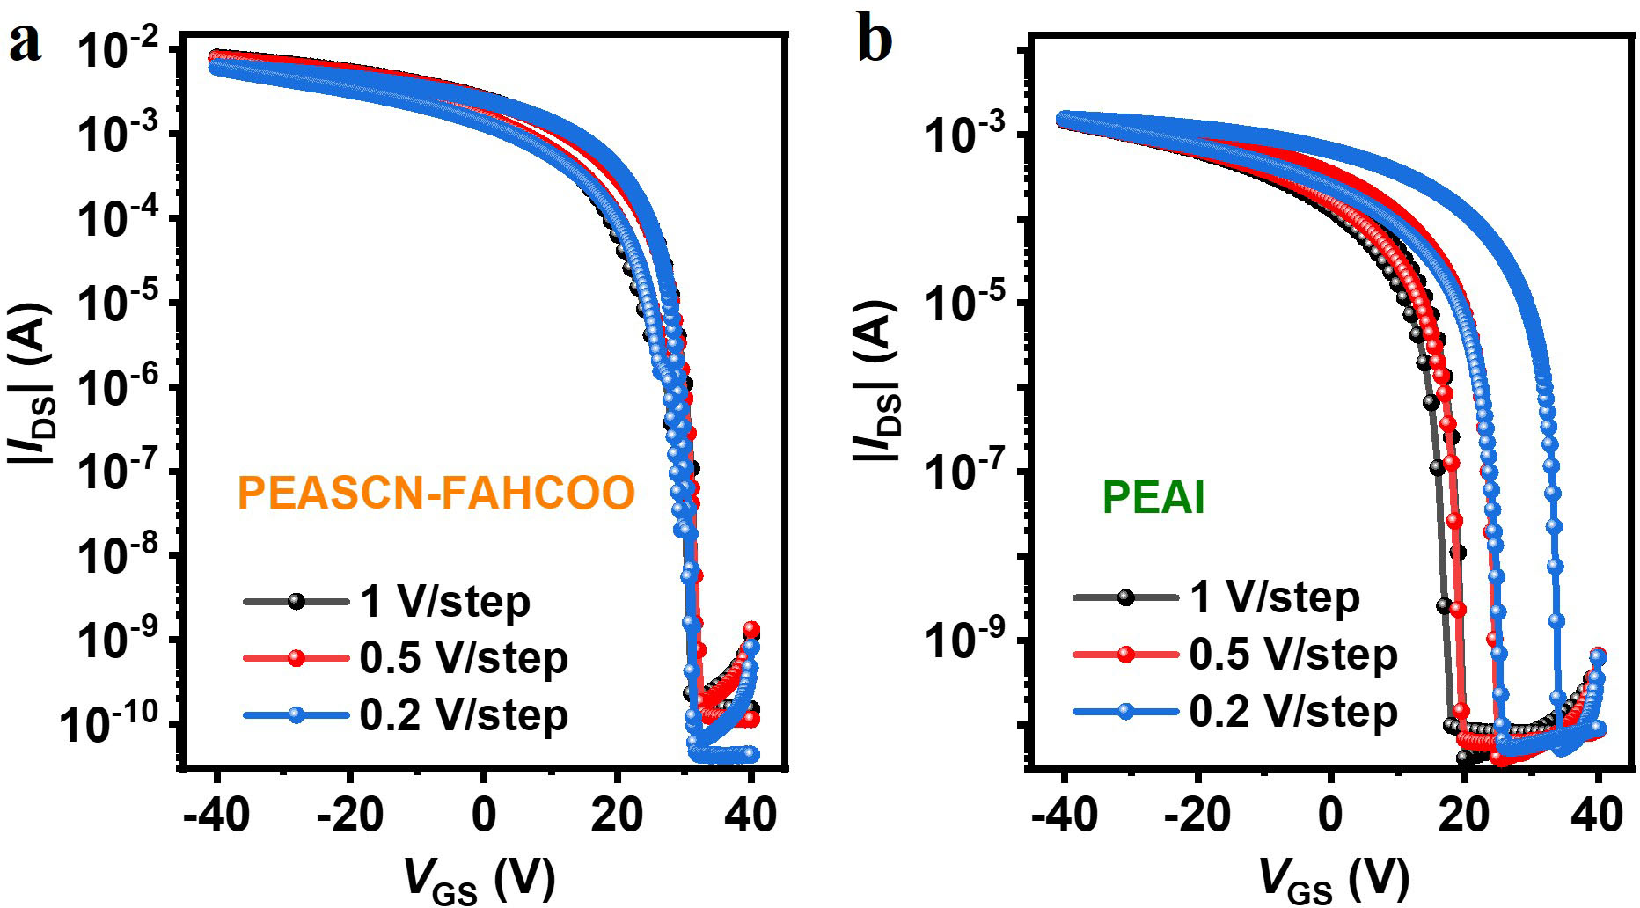
Figure S14. Transfer curves of the PEASCN-FAHCOO-based and PEAI-based FETs were measured at different scan steps.

Supplementary Table 1. Performance parameters of 2D and FA-based quasi-2D perovskite transistors.
 | Perovskite Channel | Operation Temp. | Mobility  (cm²V⁻¹ s⁻¹) | On/off ratio | Year | Ref.
2D Sn-based perovskites | (PEA)₂SnI₄ | RT | 0.6 | 10⁴ | 1999 | 1
2D Sn-based perovskites | (PEA)₂SnI₄ | RT | 2.6 | ~10⁶ | 2002 | 2
2D Sn-based perovskites | (PEA)₂SnI₄ | RT | 12 | ~10⁶ | 2016 | 3
2D Sn-based perovskites | (PEA)₂SnI₄ | RT | 1.5 | ~10⁵ | 2019 | 4
2D Sn-based perovskites | (PEA)₂SnI₄ | RT | 3.5 | ~10⁶ | 2020 | 5
2D Sn-based perovskites | (PEA)₂SnI₄ | RT | 3.8 | ~10⁶ | 2020 | 6
2D Sn-based perovskites | (PEA)₂SnI₄ | RT | 4.2 | ~10⁵ | 2021 | 7
2D Sn-based perovskites | (m-FPEA)₂SnI₄ | RT | 0.2~0.6 | ~10⁵ | 2001 | 8
2D Sn-based perovskites | (4Tm)₂SnI₄ | RT | 2.32 | ~10⁶ | 2019 | 9
2D Sn-based perovskites | (TT)₂SnI₄ | RT | 9.35 | ~10⁶ | 2021 | 10
2D Sn-based perovskites | (TEA)₂SnI₄ | RT | 0.34 | ~10⁵ | 2022 | 11
2D Sn-based perovskites | (PEA)₂SnI₄ | RT | 2.13 | ~10⁷ | 2022 | 12
2D Sn-based perovskites | BDASnI₄ | RT | 1.6 | ~10⁶ | 2023 | 13
2D Sn-based perovskites | (PEA)₂SnI₄ | RT | 2.96 | ~10⁴ | 2023 | 14
FA-based quasi-2D perovskites | (FA/PEA)SnI_{x} | RT | 0.21 | ~10⁴ | 2021 | 15
FA-based quasi-2D perovskites | (FA/PEA)SnI_{x} | RT | 25 | ~10⁶ | 2022 | 16
FA-based quasi-2D perovskites | (FA/4-PEA)SnI_{x} | RT | 12 | 10⁸ | 2023 | 17
FA-based quasi-2D perovskites | PEAFASnI₃ | RT | 7.45 | ~10⁷ | 2023 | 18
FA-based quasi-2D perovskites | PEAFASnI₃ | RT | 15.1 | ~10⁸ | 2023 | 19
FA-based quasi-2D perovskites | PEAFASnI3 | RT | 11.3 | ~10⁶ | 2023 | 20
 | PEASCN-FAHCOO | RT | 43 | 10⁸ | 2024 | This work
References
1 Kagan, C. R., Mitzi, D. B. & Dimitrakopoulos, C. D. Organic-inorganic hybrid materials as semiconducting channels in thin-film field-effect transistors. Science 286, 945-947 (1999). https://doi.org:10.1126/science.286.5441.945
2 Mitzi, D. B. et al. Hybrid field-effect transistor based on a low-temperature melt-processed channel layer. Adv. Mater. 14, 1772-1776 (2002). https://doi.org/10.1002/1521-4095(20021203)14:23<1772::AID-ADMA1772>3.0.CO;2-Y
3 Matsushima, T. et al. Solution-Processed Organic-Inorganic Perovskite Field-Effect Transistors with High Hole Mobilities. Adv. Mater. 28, 10275-10281 (2016). https://doi.org:10.1002/adma.201603126
4 Zhu, H. et al. Perovskite and Conjugated Polymer Wrapped Semiconducting Carbon Nanotube Hybrid Films for High-Performance Transistors and Phototransistors. ACS Nano 13, 3971-3981 (2019). https://doi.org:10.1021/acsnano.8b07567
5 Zhu, H. et al. High-Performance and Reliable Lead-Free Layered-Perovskite Transistors. Adv. Mater. 36, 2002717 (2020). https://doi.org:10.1002/adma.202002717
6 Zhu, H. et al. High-Performance Layered Perovskite Transistors and Phototransistors by Binary Solvent Engineering. Chem. Mater. 33, 1174-1181 (2021). https://doi.org:10.1021/acs.chemmater.0c03822
7 Zhu, H. et al. A Lewis base and boundary passivation bifunctional additive for high performance lead-free layered-perovskite transistors and phototransistors. Mater. Today Energy 21, 100722 (2021). https://doi.org:10.1016/j.mtener.2021.100722
8 Mitzi, D. B., Dimitrakopoulos, C. D. & Kosbar, L. L. Structurally tailored organic-inorganic perovskites: Optical properties and solution-processed channel materials for thin-film transistors. Chem. Mater. 13, 3728-3740 (2001). https://doi.org:10.1021/cm010105g
9 Gao, Y. et al. Highly Stable Lead-Free Perovskite Field-Effect Transistors Incorporating Linear π-Conjugated Organic Ligands. J. Am. Chem. Soc. 141, 15577-15585 (2019). https://doi.org:10.1021/jacs.9b06276
10 Liang, A. et al. Ligand-Driven Grain Engineering of High Mobility Two-Dimensional Perovskite Thin-Film Transistors. J. Am. Chem. Soc. 143, 15215-15223 (2021). https://doi.org:10.1021/jacs.1c06337
11 Wang, S. et al. Grain engineering for improved charge carrier transport in two-dimensional lead-free perovskite field-effect transistors. Mater. Horiz. 9, 2633-2643 (2022). https://doi.org:10.1039/d2mh00632d
12 Go, J. Y. et al. Sodium Incorporation for Enhanced Performance of Two-Dimensional Sn-Based Perovskite Transistors. ACS Appl. Mater. Interfaces 14, 9363-9367 (2022). https://doi.org:10.1021/acsami.1c19368
13 Qiu, X. et al. Ambient-Stable 2D Dion-Jacobson Phase Tin Halide Perovskite Field-Effect Transistors with Mobility over 1.6 Cm²V⁻¹ s⁻¹. Adv. Mater. 35, 2305648 (2023). https://doi.org:10.1002/adma.202305648
14 Chao, I. H. et al. Performance Enhancement of Lead-Free 2D Tin Halide Perovskite Transistors by Surface Passivation and Its Impact on Non-Volatile Photomemory Characteristics. Small 19, 2207734 (2023). https://doi.org:10.1002/smll.202207734
15 Shao, S. et al. Field-Effect Transistors Based on Formamidinium Tin Triiodide Perovskite. Adv. Funct. Mater. 31, 2008478 (2021). https://doi.org:10.1002/adfm.202008478
16 Kim, J. et al. High-Performance P-Channel Tin Halide Perovskite Thin Film Transistor Utilizing a 2D-3D Core-Shell Structure. Adv. Sci. 9, 2104993 (2022). https://doi.org:10.1002/advs.202104993
17 Yang, W. et al. Fluorinated Organic A-Cation Enabling High-Performance Hysteresis-Free 2D/3D Hybrid Tin Perovskite Transistors. Adv. Funct. Mater. 33, 2303309 (2023). https://doi.org:10.1002/adfm.202303309
18 Go, J.-Y. et al. A Large Bandgap Organic Salt Dopant for Sn-Based Perovskite Thin-Film Transistor. Adv. Funct. Mater. 33, 2303759 (2023). https://doi.org:10.1002/adfm.202303759
19 Zhou, Z. et al. High-Mobility and Bias-Stable Field-Effect Transistors Based on Lead-Free Formamidinium Tin Iodide Perovskites. ACS Energy Lett. 8, 4496-4505 (2023). https://doi.org:10.1021/acsenergylett.3c01400
20 Roh, T., Zhu, H. H., Yang, W., Liu, A. & Noh, Y. Y. Ion Migration Induced Unusual Charge Transport in Tin Halide Perovskites. ACS Energy Lett. 8, 957-962 (2023). https://doi.org:10.1021/acsenergylett.2c02551

