Regional and chronological differences in prevalences of olfactory and gustatory dysfunction in coronavirus disease (COVID-19): a systemic review and meta-analysis

Jeong-Whun Kim, MD, PhD¹, Seung Cheol Han, MD¹, Hyung Dong Jo¹, Sung-Woo Cho, MD¹, Jin Youp Kim, MD^{1,2*}
¹Department of Otorhinolaryngology-Head and Neck Surgery, Seoul National University College of Medicine, Seoul National University Bundang Hospital, Sungnam, Korea
²Interdisciplinary Program of Medical Informatics, Seoul National University College of Medicine
*Corresponding author: Jin Youp Kim, M.D.; E-mail: kjyoup0622@gmail.com

SUPPLEMENTARY MATERIAL
Table S1. Quality Assessment for the included studies.
Authors | Q1 | Q2 | Q3 | Q4 | Q5 | Q6 | Q7 | Q8 | Q9 | Overall score | Overall risk of bias
Liang et al⁷ | 1 | 1 | 1 | 0 | 0 | 0 | 1 | 0 | 0 | 4 | moderate risk
Mao et al⁸ | 1 | 1 | 1 | 0 | 0 | 0 | 1 | 1 | 0 | 5 | moderate risk
Chung et al⁵³ | 1 | 1 | 1 | 0 | 0 | 0 | 0 | 0 | 0 | 3 | low risk
Kim et al⁵ | 1 | 1 | 1 | 1 | 0 | 0 | 1 | 0 | 0 | 5 | moderate risk
Lee et al⁶ | 0 | 0 | 1 | 1 | 0 | 0 | 1 | 1 | 0 | 4 | moderate risk
Noh et al⁹ | 1 | 1 | 1 | 0 | 0 | 0 | 1 | 1 | 0 | 5 | moderate risk
Chua et al¹⁷ | 0 | 0 | 1 | 0 | 0 | 0 | 1 | 0 | 0 | 2 | low risk
Lechien et al²⁸ | 0 | 0 | 1 | 1 | 0 | 0 | 0 | 0 | 0 | 2 | low risk
Lechien et al²⁹ | 0 | 0 | 1 | 1 | 0 | 0 | 1 | 0 | 0 | 3 | low risk
Iravani, B. et al²³ | 0 | 0 | 1 | 0 | 0 | 0 | 1 | 0 | 0 | 2 | low risk
Lechien et al²⁷ | 0 | 0 | 1 | 0 | 0 | 0 | 0 | 0 | 0 | 1 | low risk
Renaud et al⁴⁰ | 0 | 0 | 1 | 1 | 0 | 0 | 1 | 0 | 0 | 3 | low risk
Zayet et al⁵¹ | 1 | 1 | 1 | 1 | 0 | 0 | 0 | 0 | 0 | 4 | moderate risk
Zayet et al⁵² | 0 | 0 | 1 | 0 | 0 | 0 | 0 | 0 | 0 | 1 | low risk
Brandstetter et al¹⁵ | 1 | 1 | 1 | 0 | 0 | 0 | 1 | 0 | 0 | 4 | moderate risk
Hintschich et al⁵⁴ | 0 | 0 | 1 | 1 | 0 | 0 | 0 | 0 | 0 | 2 | low risk
Luers et al³³ | 1 | 1 | 1 | 1 | 0 | 0 | 1 | 0 | 0 | 5 | moderate risk
Tsivgoulis et al⁴⁵ | 1 | 1 | 1 | 0 | 0 | 0 | 0 | 0 | 0 | 3 | low risk
De Maria et al¹⁹ | 1 | 1 | 1 | 1 | 0 | 0 | 1 | 0 | 0 | 5 | moderate risk
Dell'Era et al²⁰ | 0 | 0 | 1 | 1 | 0 | 0 | 0 | 0 | 0 | 2 | low risk
Freni et al²¹ | 0 | 0 | 1 | 1 | 0 | 0 | 0 | 0 | 0 | 2 | low risk
Gelardi et al²² | 0 | 0 | 1 | 1 | 0 | 0 | 1 | 1 | 0 | 4 | moderate risk
Karadaş et al²⁵ | 1 | 1 | 1 | 0 | 0 | 0 | 1 | 1 | 0 | 5 | moderate risk
Lagi et al²⁶ | 1 | 1 | 1 | 0 | 0 | 0 | 1 | 1 | 0 | 5 | moderate risk
Liguori et al³² | 0 | 0 | 1 | 0 | 0 | 0 | 1 | 1 | 0 | 3 | low risk
Meini et al³⁴ | 1 | 1 | 1 | 0 | 1 | 0 | 1 | 0 | 0 | 5 | moderate risk
Mercante et al³⁵ | 0 | 0 | 1 | 1 | 0 | 0 | 1 | 0 | 0 | 3 | low risk
Paderno et al⁵⁶ | 0 | 0 | 1 | 0 | 0 | 0 | 1 | 0 | 0 | 2 | low risk
Paderno et al³⁶ | 1 | 1 | 1 | 1 | 0 | 0 | 1 | 0 | 0 | 5 | moderate risk
Petrocelli et al³⁸ | 0 | 0 | 1 | 1 | 0 | 0 | 0 | 0 | 0 | 2 | low risk
Vacchiano et al⁴⁶ | 1 | 1 | 1 | 1 | 0 | 0 | 1 | 0 | 0 | 5 | moderate risk
Vaira et al⁴⁷ | 0 | 0 | 1 | 0 | 0 | 0 | 0 | 0 | 0 | 1 | low risk
Vaira et al⁴⁸ | 0 | 0 | 1 | 1 | 0 | 0 | 0 | 1 | 0 | 3 | low risk
Vaira et al⁴⁹ | 1 | 1 | 1 | 0 | 0 | 0 | 0 | 0 | 0 | 3 | low risk
Tostmann et al⁴⁴ | 1 | 1 | 1 | 0 | 0 | 0 | 1 | 0 | 0 | 4 | moderate risk
Sierpiński et al⁴³ | 0 | 0 | 1 | 1 | 0 | 0 | 1 | 0 | 0 | 3 | low risk
Abalo-Lojo et al¹⁰ | 1 | 1 | 1 | 1 | 0 | 0 | 1 | 0 | 0 | 5 | moderate risk
Beltrán‐Corbellini et al¹³ | 1 | 1 | 1 | 0 | 1 | 0 | 1 | 0 | 0 | 5 | moderate risk
Izquierdo-Dominguez et al²⁴ | 1 | 1 | 1 | 1 | 0 | 0 | 0 | 0 | 0 | 4 | moderate risk
Speth et al² | 0 | 0 | 1 | 0 | 0 | 0 | 1 | 0 | 0 | 2 | low risk
Altin et al¹² | 1 | 1 | 1 | 0 | 0 | 0 | 1 | 1 | 0 | 5 | moderate risk
Patel et al³⁷ | 0 | 0 | 1 | 1 | 0 | 0 | 1 | 0 | 0 | 3 | low risk
Carignan et al¹⁶ | 0 | 0 | 1 | 1 | 0 | 0 | 1 | 0 | 0 | 3 | low risk
Lee et al³⁰ | 0 | 0 | 1 | 1 | 0 | 0 | 1 | 0 | 0 | 3 | low risk
Aggarwal et al¹¹ | 1 | 1 | 1 | 0 | 1 | 0 | 1 | 1 | 0 | 6 | moderate risk
Dawson et al¹⁸ | 1 | 1 | 1 | 0 | 0 | 0 | 1 | 0 | 0 | 4 | moderate risk
Pinna et al³⁹ | 1 | 1 | 1 | 1 | 0 | 0 | 1 | 1 | 0 | 6 | moderate risk
Yan et al⁵⁷ | 0 | 0 | 1 | 1 | 0 | 0 | 1 | 0 | 0 | 3 | low risk
Yan et al⁵⁸ | 0 | 0 | 1 | 1 | 0 | 0 | 1 | 1 | 0 | 4 | moderate risk
Yan et al⁵⁰ | 0 | 0 | 1 | 1 | 0 | 0 | 1 | 0 | 0 | 3 | low risk
Moein et al⁵⁵ | 1 | 1 | 1 | 0 | 0 | 0 | 0 | 0 | 0 | 3 | low risk
Biadsee et al¹⁴ | 1 | 1 | 1 | 1 | 0 | 0 | 1 | 0 | 0 | 5 | moderate risk
Levinson et al³¹ | 1 | 1 | 1 | 0 | 0 | 0 | 1 | 0 | 0 | 4 | moderate risk
Sakalli et al⁴¹ | 0 | 0 | 1 | 1 | 0 | 0 | 1 | 0 | 0 | 3 | low risk
Sayin et al⁴² | 1 | 1 | 1 | 0 | 0 | 0 | 0 | 0 | 0 | 3 | low risk
Q1: Was the study’s target population a close representation of the national population in relation to relevant variables?
Q2: Was the sampling frame a true or close representation of the target population?
Q3: Was some form of random selection used to select the sample, OR, was a census undertaken?
Q4: Was the likelihood of non-response bias minimal?
Q5: Were data collected directly from the subjects (as opposed to a proxy)?
Q6: Was an acceptable case definition used in the study?
Q7: Was the study instrument that measured the parameter of interest shown to have reliability and validity?
Q8: Was the same mode of data collection used for all subjects?
Q9: Were the numerator(s) and denominator(s) for the parameter of interest appropriate?

Fig. S1. Prevalence of chemosensory dysfunction in patients with coronavirus disease 2019 (COVID-19) (a) Forest plot meta-analysis of the prevalences of olfactory dysfunction in patients with COVID-19 showed a 52.7% (95% CI, 43.7%-59.1%) pooled prevalence in random-effect model, as represented by the diamond. (b) Forest plot meta-analysis of the prevalences of gustatory dysfunction in patients with COVID-19 showed a 47.5% (95% CI, 39.7%, 55.3%) pooled prevalence in random-effect model, as represented by the diamond. The estimates of individual studies are represented as squares, with 95% confidence intervals represented as horizontal lines.
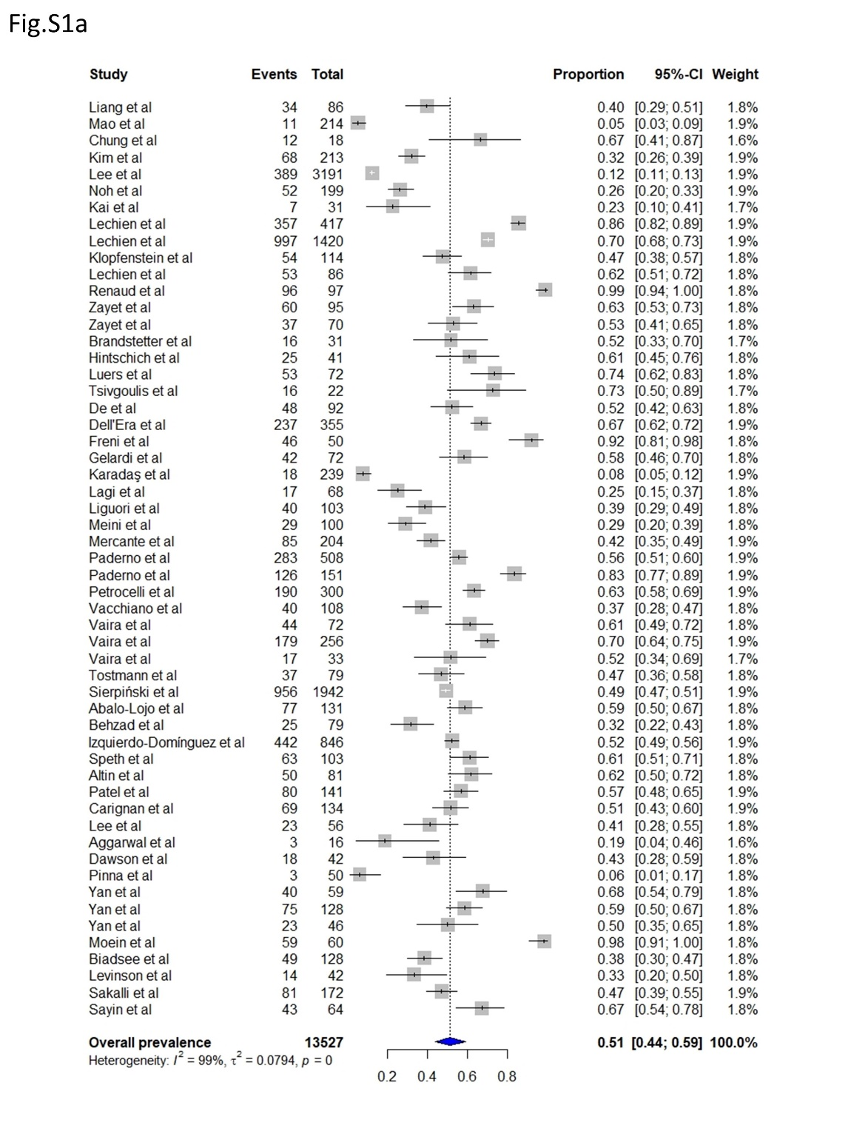
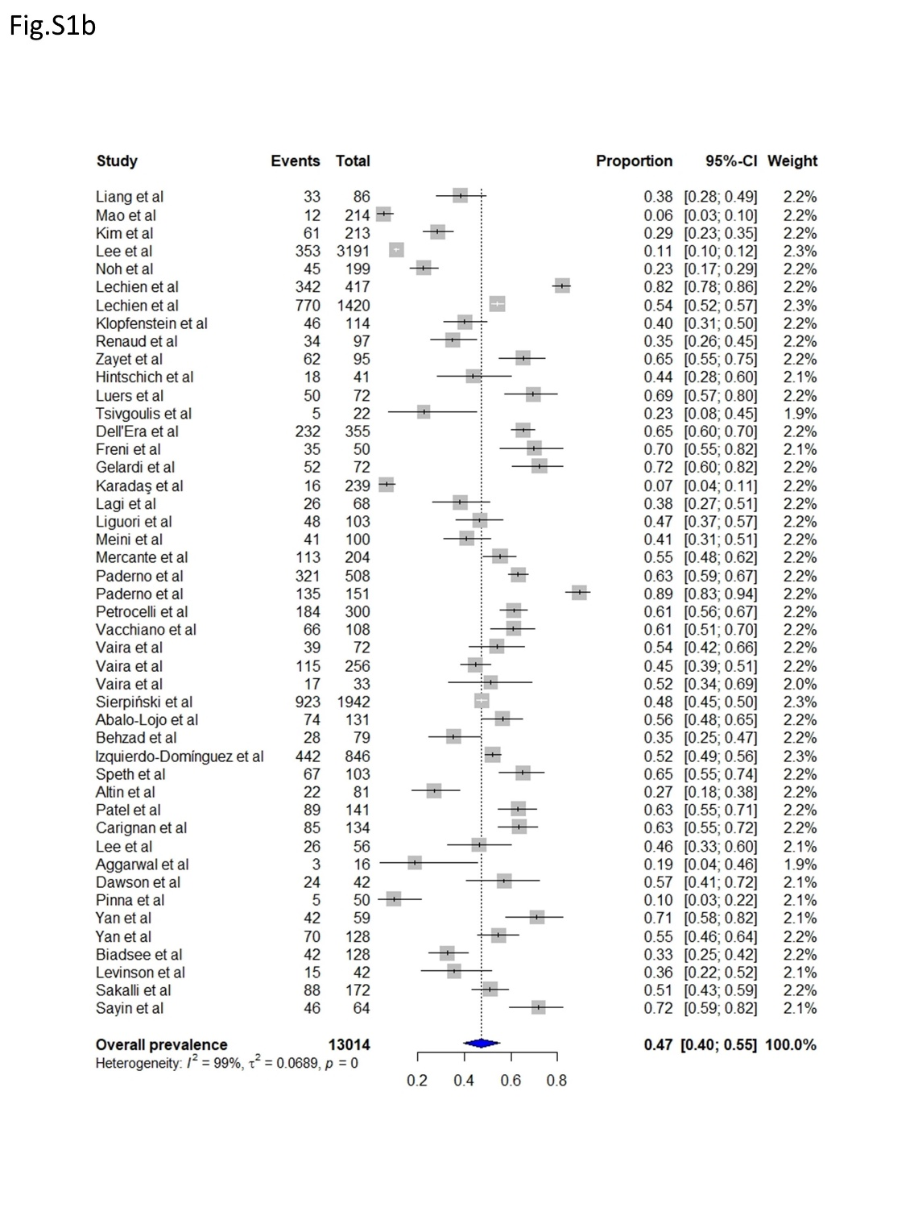

Fig. S2. Subgroup analysis on region, excluding studies in which history taking was used as the evaluation method (a) Forest plot meta-analysis of the prevalences of olfactory dysfunction of four regions (East Asia, Europe, North America, and Middle East) showed 37.3%, 61.0%, 52.7%, and 59.8% pooled subgroup prevalence in random-effect model, respectively (P = 0.005 for subgroup difference). (b) Forest plot meta-analysis of the prevalences of gustatory dysfunction of four regions (East Asia, Europe, North America, and Middle East) showed 32.6%, 56.7%, 58.9%, and 47.9% pooled subgroup prevalence in the random-effect model, respectively (P < 0.001 for subgroup difference). The diamonds represent pooled prevalence with 95% confidence interval, and the estimates of individual studies are represented as squares, with 95% confidence intervals represented as horizontal lines.
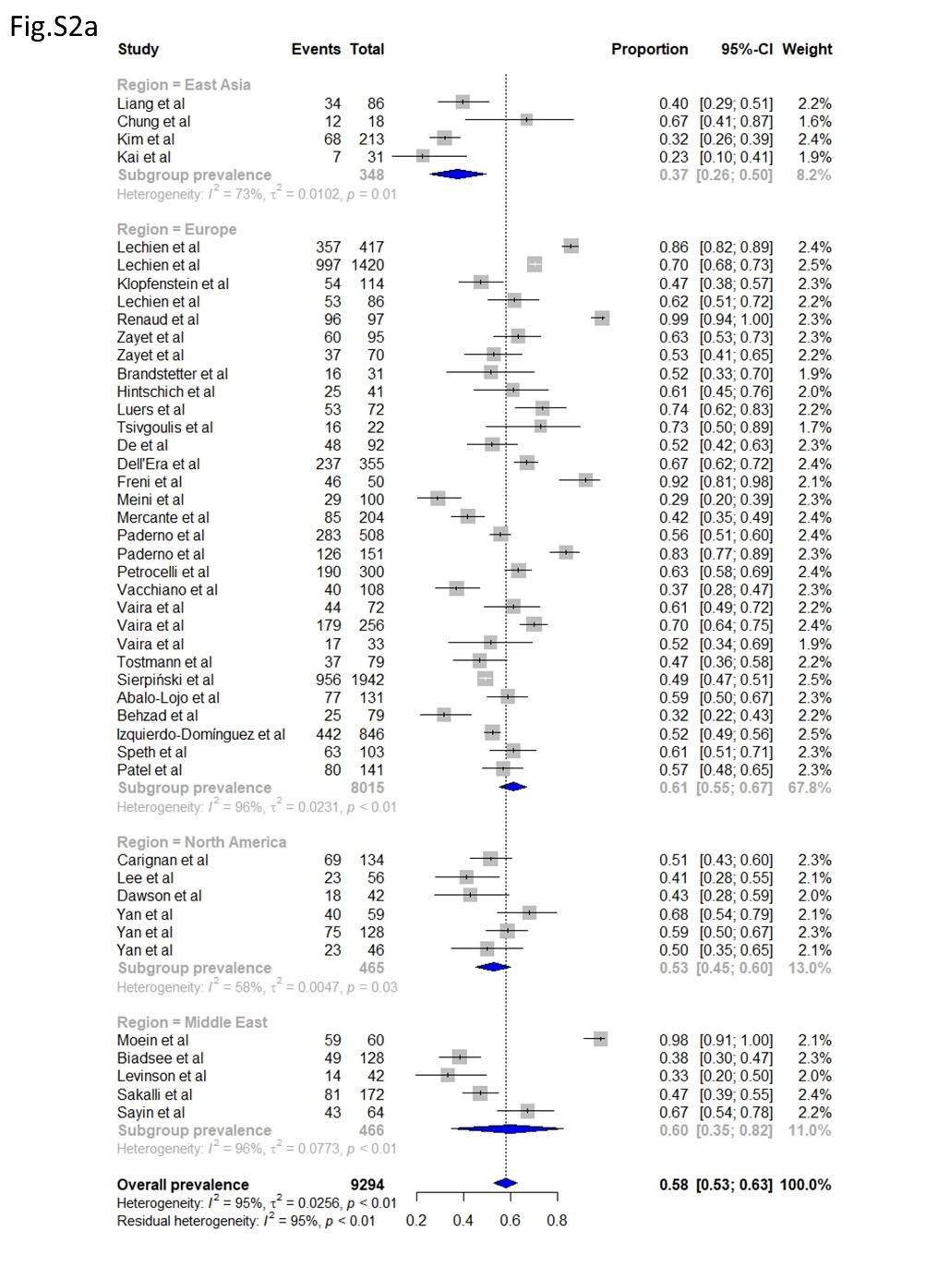
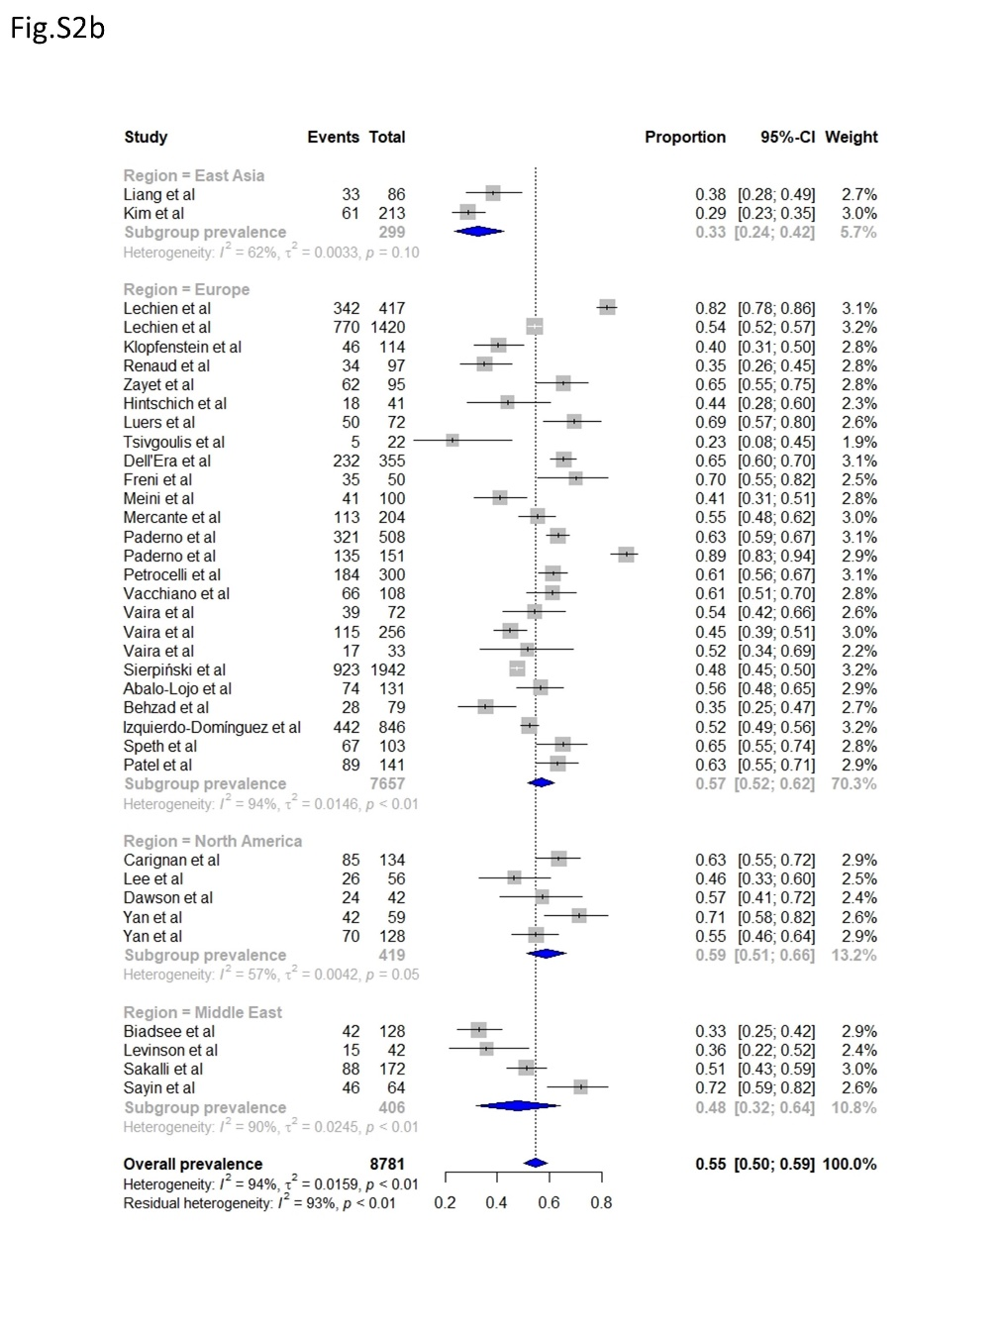

Fig. S3. Subgroup analysis on the time of enrollment, only including studies in which evaluation method using surveys or validated instruments among the studies conducted in Europe The time of enrollment was clarified in 29 out of 55 studies. After calculating the median date (mid-date) between beginning and end date of the time of enrollment, the individual studies were categorized into three groups: 1st period (mid-date February 2, 2020 to March 17, 2020), 2nd period (mid-date March 20, 2020 to March 29, 2020), and 3rd period (mid-date March 30, 2020 to April 9, 2020). Forest plot meta-analysis of the prevalences of olfactory showed 48.7%, 65.4%, and 58.4% pooled subgroup prevalence in the random-effect model, respectively (P = 0.038 for subgroup difference).
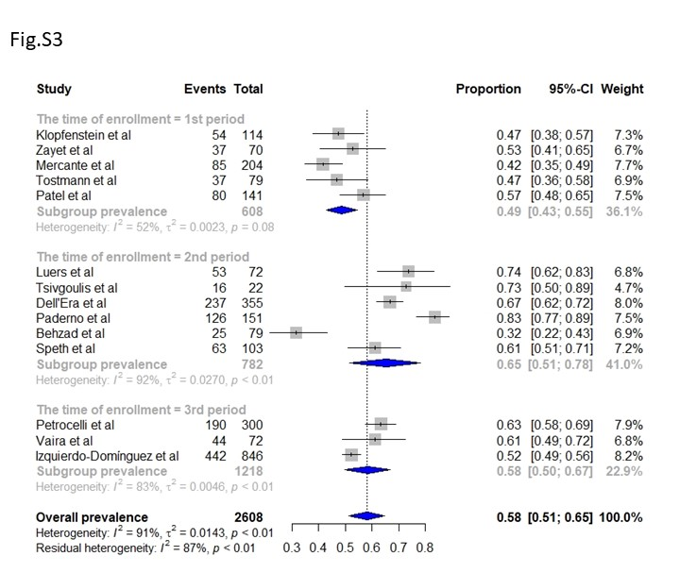

Supplementary Fig. S4 Online. Funnel plot of the prevalences of (a) olfactory and (b) gustatory dysfunction
