Influence of long-term anthropogenic nitrogen inputs and its legacy on riverine output
Min Cao, Wei Gao*, Yanpeng Cai
a Guangdong Basic Research Center of Excellence for Ecological Security and Green Development, School of Ecology, Environment and Resources, Guangdong University of Technology, Guangzhou, China

Part S1 Estimation of NANI

1 Estimation of NANI
Net anthropogenic nitrogen inputs (NANI) can be expressed as the sum of fertilizer nitrogen inputs (N_{chem}), agricultural nitrogen fixation (N_{fix}), atmospheric nitrogen deposition (N_{dep}), and net food/feed nitrogen inputs (N_{im}). Nim refers to the difference between nitrogen intake from food and nitrogen output from products, which includes human nitrogen consumption (HC) and animal nitrogen consumption (AC), as well as grain nitrogen production (GP) and animal nitrogen production (AP). The formula for calculating NANI is shown in Equation (S1):
$$\begin{aligned}NANI=N_{chem}+N_{fix}+N_{dep}+N_{im} \#\left(S1\right)\end{aligned}$$
where all units are expressed in kg·yr⁻¹ or kg·km⁻²·yr⁻¹+.

1.1 Estimation of N_{chem}
N_{chem} can be expressed as the nitrogen input from compound fertilizer (CF) and nitrogen fertilizer (NF) in their pure forms. For this study, fertilizer purity data prior to 1990 were estimated based on the ratio of purity to application rates during the 1990–2000 period. The specific formula for calculating Nchem is shown in Equation (S2):
$$\begin{aligned}N_{chem}=NF+CF×r \#\left(S2\right)\end{aligned}$$
where CF and NF are expressed in kg·yr⁻¹ or kg·km⁻²·yr⁻¹, and r represents the nitrogen content in compound fertilizer, which is set at 32.64% in this study¹.

1.2 Estimation of N_{fix}
N_{fix} represents the amount of nitrogen fixed by crops. This study focuses primarily on three crops: rice, soybeans, and peanuts. The formula for calculating N_{fix} is shown in Equation (S3):
$$\begin{aligned}N_{fix}=\sum_{i=1}^{3}{\left(S_{i}×N_{i}\right)} \#\left(S3\right)\end{aligned}$$
where S represents the planting area of the crops, with units in km², and N represents the nitrogen fixation rate of the crops. In this study, the nitrogen fixation rates for rice, peanuts, and soybeans are set at 3,000, 8,000, and 9,600 kg·km⁻²·yr⁻¹, respectively². The variable i represents the crop type, where i=1, 2, 3 correspond to rice, soybeans, and peanuts, respectively.

1.3 Estimation of N_{im}
N_{im} represents the difference between the nitrogen intake by humans and livestock in the watershed and the nitrogen production from livestock and agricultural products. The specific calculation formula is shown in Equation (S4):
$$\begin{aligned}N_{im}=AC+HC-\left(AP+GP\right)×\left(1-α\right)\#\left(S4\right)\end{aligned}$$
where AC represents animal nitrogen consumption, HC represents human nitrogen consumption, AP represents animal product nitrogen production, and GP represents grain product nitrogen production, all expressed in kg·yr⁻¹ or kg·km⁻²·yr⁻¹. The parameter α denotes the loss of nitrogen during production, processing, and transportation of animal and agricultural products, which is set at 10% in this study³ .The detailed calculation formula is as follows:

1.3.1 Estimation of AC
AC can be expressed as the product of the number of livestock and their nitrogen intake. The number of livestock is calculated using the dynamic assessment method based on both the slaughter rate and the stocking rate provided by Hong et al⁴. The specific calculation formulas are shown in Equations (S5-S6):
$$\begin{aligned}AQ=\left(Inventory×\frac{1}{Cycles}\right)+\left(\frac{Sales}{Cycles}×\frac{Cycles-1}{Cycles} \right)\#\left(S5\right)\end{aligned}$$
$$\begin{aligned}AC=\sum_{k=1}^{K}{{AQ}_{k}×{AN}_{k}} \#\left(S6\right)\end{aligned}$$
where AQ represents the number of livestock, Inventory refers to the stocking number, and Sales refers to the slaughter number, all expressed in units of livestock. Cycles represents the breeding cycles of the livestock, calculated as 365 divided by the number of days in a breeding cycle. AN is the nitrogen intake per livestock unit, expressed in kg·capita⁻¹·yr⁻¹. The variable k represents the livestock type, and this study only considers four categories: pig, cattle, sheep, and poultry. Detailed parameters and data sources can be found in Table S1.

Table S1 The parameters of intake and breeding cycle of livestock
Type | N intake (kg·capita⁻¹·yr⁻¹) | Date source | Breeding cycle/d | Date source
Pig | 8.70 | ⁵ | 199 | ⁶
Cattle | 51.30 | ⁵ | 365 | ⁶
Sheep | 5.97 | ⁵ | 365 | ⁶
Poultry | 0.26 | ⁵ | 155 | ⁶

1.3.2 Estimation of HC
HC can be expressed as the product of the population and the per capita nitrogen intake. Given the long term span of this study, the per capita nitrogen intake is assumed to meet the daily protein intake necessary for normal growth and development, and is converted to nitrogen using a conversion factor of 6.25⁷. The specific calculation formula is shown in Equation (S7)
$$\begin{aligned}HC=HQ×HN \#\left(S7\right)\end{aligned}$$
Where HQ represents the total population, expressed in units of people, and HN represents the per capita nitrogen intake, expressed in kg·person⁻¹. In this study, the value of HN is set at 3.91⁸.

1.3.3 Estimation of AP
AP can be expressed as the product of the livestock product yield and its nitrogen content ⁸. The specific calculation formula is shown in Equation (S8):
$$\begin{aligned}AP=\sum_{m=1}^{M}{\left({AW}_{m}×{APN}_{m}\right)} \#\left(S8\right)\end{aligned}$$
where AW represents the livestock product yield, expressed in kg, and APN represents the nitrogen content of the corresponding livestock product, which is dimensionless. The variable m represents the type of livestock product. Based on data availability, this study considers six categories: pork, beef, mutton, poultry meat, eggs, and aquatic products. Detailed parameters and data sources for this section can be found in Table S2.

Table S2. N contents of livestock and agricultural products
Kinds | Name | Contents | Source |  | Kinds | Names | Contents | Source
Livestock  production | Pork | 2.42% | ⁸ |  | Agricultural  production | Paddy | 1.24% | ⁸
Livestock  production | Beef | 3.20% | ⁸ |  | Agricultural  production | Bean | 5.60% | ⁸
Livestock  production | Mutton | 2.96% | ⁸ |  | Agricultural  production | Peanut | 1.92% | ⁸
Livestock  production | Poultry | 2.81 | ⁸ |  | Agricultural  production | Wheat | 1.90% | ⁸
Livestock  production | Egg | 2.31% | ⁸ |  | Agricultural  production | Vegetables | 0.51% | ⁸
Livestock  production | Aquatic | 2.31% | ⁸ |  | Agricultural  production | Potato | 0.33% | ⁸
 |  |  |  |  |  | Fruits | 0.09% | ⁸
 |  |  |  |  |  | maize | 0.19% | ⁸

1.3.4 Estimation of GP
GP can be expressed as the product of crop yield and its nitrogen content⁹. The calculation formula is shown in Equation (S9):
$$\begin{aligned}GP=\sum_{i=1}^{n}{{(GW}_{i}×{GPN}_{i})} \#\left(S9\right)\end{aligned}$$
Where GW represents the crop yield, expressed in kg, and GPN represents the nitrogen content of the corresponding crop, which is dimensionless. This study considers eight types of crops: rice, soybeans, peanuts, wheat, tubers, vegetables, corn, and fruits. Detailed calculation formulas and data sources for this section can be found in Table S2.

1.4 Estimation of N_{dep}
The N_{dep} dataset for the period from 1996 to 2015 used in this study was obtained from the "A spatial and temporal dataset of atmospheric inorganic nitrogen dry deposition in China (2006–2015) " and the "1996–2015 Dataset of the Spatial-Temporal Patterns of Atmospheric Inorganic Nitrogen Wet Deposition in China," published by the Ecological Data Center of the Chinese Academy of Sciences. The dry deposition data for 1996–2005 were calculated based on the dry-to-wet deposition ratio during the 2006–2015 period. The total nitrogen deposition data for the period from 1949 to 1995 were calculated using the rate of change provided by Lu et al¹⁰. The total atmospheric deposition in this study includes the sum of nitrate nitrogen dry deposition and nitrate nitrogen wet deposition, excluding ammonia nitrogen deposition, ammonia nitrogen deposition in atmospheric nitrogen deposition often comes from the volatilization of chemical fertilizers and manure. Since it lacks the ability for cross-basin transport, it does not need to be considered¹¹.

Part S2 Parameters and source of ECM

Table S3 The parameters and sources of ECM
Non-point | TN（kg·hm⁻²) | Source |  | Point | TN (kg) | Source
Developed-land | --- | ¹² |  | Human | 1.58 | ¹³
Cropland | 10.22 | ¹² |  | Pig | 1.365 | ¹³
Grassland | 5.12 | ¹² |  | Cow | 9.2 | ¹³
Forest | 2.61 | ¹² |  | Sheep | 0.968 | ¹³
otherland | 1.10 | ¹² |  | Poultry | 0.086 | ¹³

Part S3 Estimation of RNE based on remote sensing inversion
For the monthly TN concentration measurements from 2020 to 2024 at the Dongjiang water quality monitoring stations, these values were used as the observed data. Landsat 5 TM and 8 OLI Level-2, Collection 2, Tier 1 imagery data from 1987 to 2024 were obtained via Google Earth Engine. The median value within a 3×3 pixel range was extracted from the corresponding raster data of the remote sensing images as the band reflectance for the station. Six band reflectances were extracted: blue, green, red, near-infrared, shortwave infrared 1, and shortwave infrared 2. The time difference between the measured data and the image acquisition was controlled within ±5 days. Cloud removal techniques were applied to eliminate cloud cover effects. Both the TM and OLI sensors have a spatial resolution of 30 meters (excluding the panchromatic band), with an image swath of 185×185 km. In total, 126 spectral data points matched with in-situ measurements were obtained. For this study, we consider the Boluo Station in the lower Dongjiang River as a representative site for the entire Dongjiang Basin's RNE. The RNE was calculated as the product of the monthly mean concentration and the annual runoff, with the specific calculation formula shown in Equation (S10):
$$\begin{aligned}RNE=\frac{C×Q×{10}^{5}}{S} \#\left(S10\right)\end{aligned}$$
where RNE represents the river nitrogen flux, expressed in kg·km⁻²·yr⁻¹, C is the monthly mean concentration of total nitrogen, expressed in mg·L⁻¹, Q is the annual runoff, expressed in 10⁸ m³, and S is the catchment area of the Boluo Station. Since the Boluo Station is located in the lower Dongjiang River, we consider the total area of the Dongjiang Basin as the catchment area, expressed in km².
The fitting results between the remote sensing inversion of TN concentration (OCTN) and the actual TN concentration (SCTN) are shown in Fig. S1. SCTN explains 46% of the variation in OCTN, indicating that the remote sensing inversion of TN concentration can explain 46% of the variation in the observed TN. The RMSE is 0.19 mg/L. The temporal variation characteristics of the simulated RNE (SRNE) and observed RNE (ORNE) in the Dongjiang Basin from 1987 to 2021 are shown in Fig. S2. Due to the lack of satellite imagery for 2012, ORNE data for that year are missing, but we believe that the absence of data for one year does not affect the overall RNE trend.
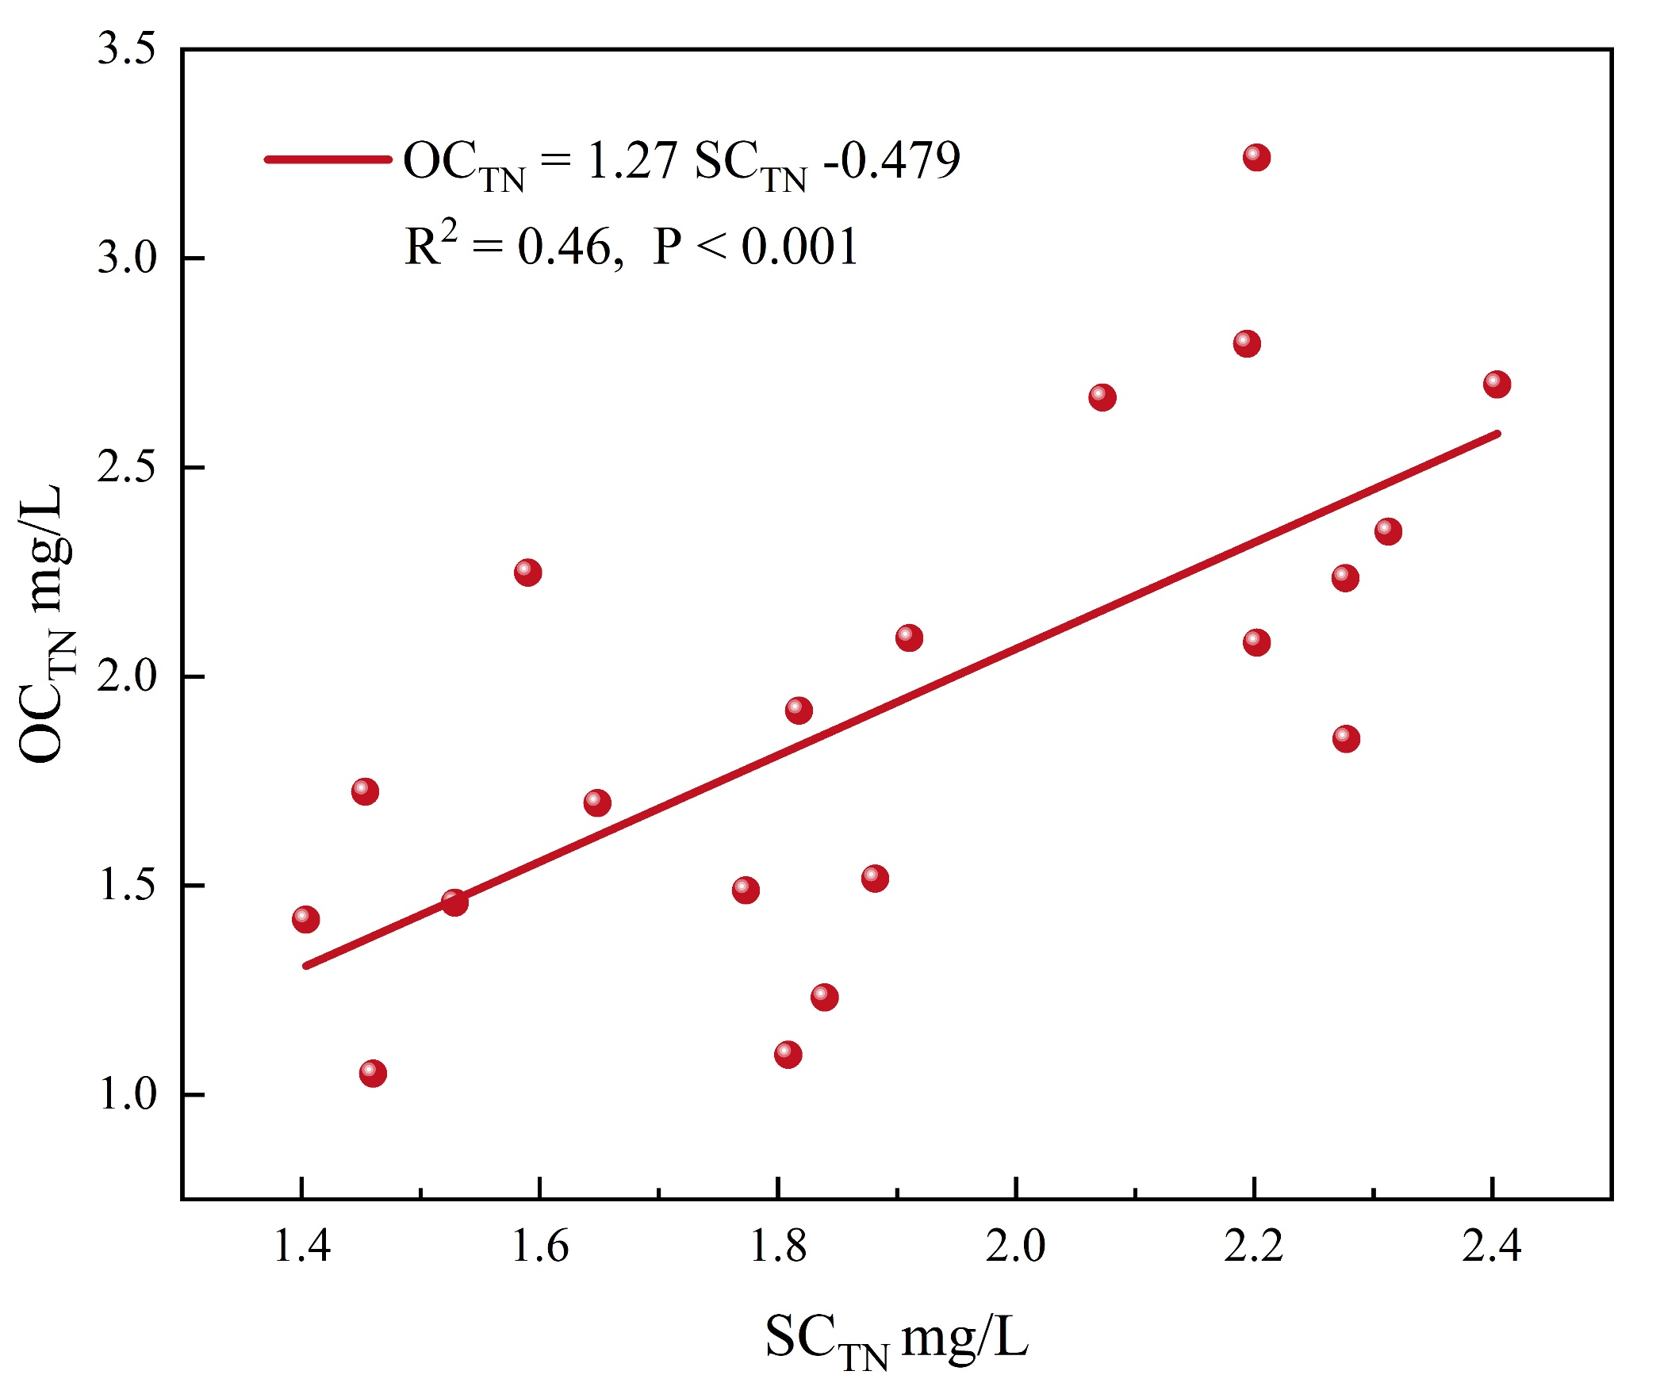
Fig S1. The correlation of simulated and observed TN concentration

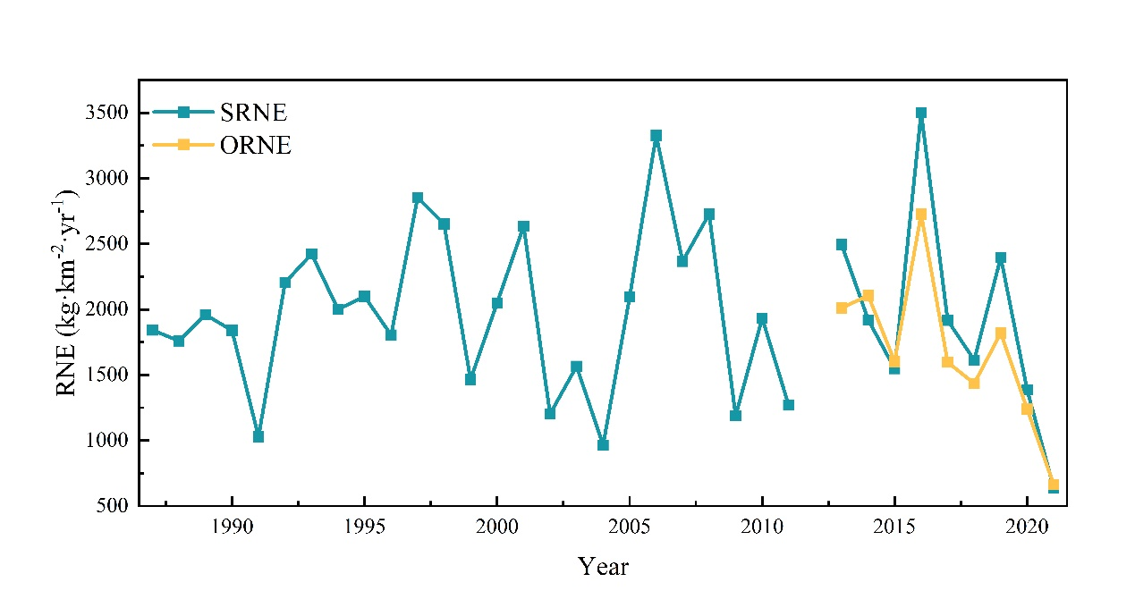
Fig S2. The comparison of observed and simulated RNE in the Dongjiang watershed during 1987 to 2021 (without 2012)
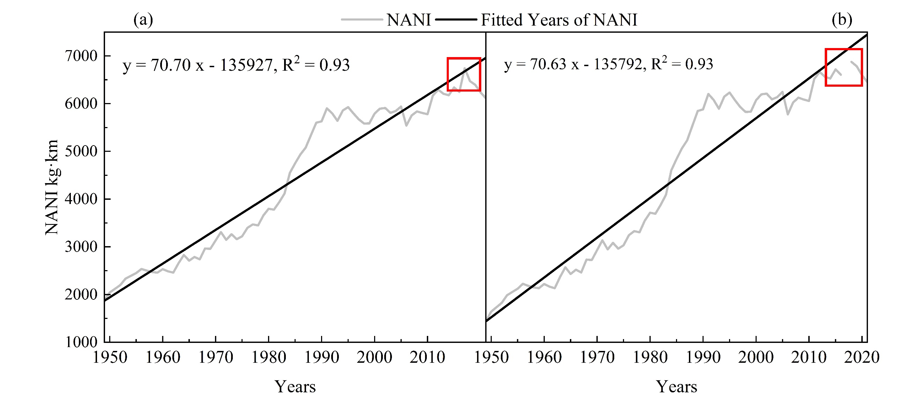
Fig. S3 Comparison of NANI trends: (a) With Outliers, (b) Outliers Removed

References:
1. W. Gao, H. Bai, C. Yan & Y. Chen. Spatiotemporal evolution of natural and anthropogenic nitrogen inputs to Yangtze River Economic Belt from 1952 to 2016. Acta Scientiae Circumstantiae. 39, 3134-3143 (2019).(In Chinese With English Abstract).
2. W. S. Zhang, J. J. Su, X. Z. Du & X. Y. Li. Net anthropogenic nitrogen inputs to Huaihe River Basin, China during 1990 - 2010. 26, 1831-1839 (2015).(In Chinese With English Abstract).
3. Hong, B., Swaney, D. P. & Howarth, R. W. A Toolbox for Calculating Net Anthropogenic Nitrogen Inputs (NANI). Environ Modell Softw. 26, 623-633 (2011).
4. Hong, B., Swaney, D. P. & Howarth, R. W. Estimating Net Anthropogenic Nitrogen Inputs to U.S. Watersheds: Comparison of Methodologies. Environ Sci Technol. 47, 5199-5207 (2013).
5. W. Gao, B. Gao, Z. Yan & Y. Liu. Evolution of anthropogenic nitrogen and phosphorus inputs to Lake Poyang Basin and its' effect on water quality of lake. Acta Scientiae Circumstantiae. 36, 3137-3145 (2016).(In Chinese With English Abstract).
6. F. H. Wang et al. The estimation of the production amount of animal manure and its environmental effect in China. 614-617 (2006).(In Chinese With English Abstract).
7. Zhai, F. Y. et al. The Status and Trends of Dietary Nutrients Intake of Chinese Population. Acta Nutrimenta Sinica. 27, 181-184 (2004).
8. M. Cao et al. Estimating net anthropogenic nitrogen inputs and riverine export in a subtropical watershed： A case study of Dongjiang River. 43, 428-439 (2023).(In Chinese With English Abstract).
9. W. Gao, H. C. Guo & X. K. Hou. Evaluating City-Scale Net Anthropogenic Nitrogen Input (NANI) in Mainland China. 50, 951-959 (2014).(In Chinese With English Abstract).
10. Lu, C. & Tian, H. Half-Century Nitrogen Deposition Increase Across China: A Gridded Time-Series Data Set for Regional Environmental Assessments. Atmos Environ. 97, 68-74 (2014).
11. Howarth, R. W. et al. The Influence of Climate On Average Nitrogen Export From Large Watersheds in the Northeastern United States. Biogeochemistry. 79, 163-186 (2006).
12. T. Gou et al. Analysis of nitrogen and phosphorus emissions from agricultural non-point sources in the source area of Dongjiang River based on output coefficient model. 1-13.(In Chinese With English Abstract).
13. Chen, Y. Spatiotemporal Analysis of Agricultural Non-Point Source Pollution in Jiangxi Province Based On Improved Output Coefficient Model. (2023).

