Additional Material
Table of Contents

Additional file 1……………………………………………………………………………………………..1
Additional file 2……………………………………………………………………………………………..2
Additional file 3……………………………………………………………………………………………..3
Additional file 4……………………………………………………………………………………………..5
Additional file 5……………………………………………………………………………………………..6

Additional file 1. ICD Codes for Focal Segmental Glomerulosclerosis and Kidney Failure with or without Kidney Replacement Therapy
ICD Code | System | Description
Focal Segmental Glomerulosclerosis
N00.1 | ICD10 | Acute nephritic syndrome with focal and segmental glomerular lesions
N01.1 | ICD10 | Rapidly progressive nephritic syndrome with focal and segmental glomerular lesions
N02.1 | ICD10 | Recurrent and persistent hematuria with focal and segmental glomerular lesions
N03.1 | ICD10 | Chronic nephritic syndrome with focal and segmental glomerular lesions
N04.1 | ICD10 | Nephritic syndrome with focal and segmental glomerular lesions
N05.1 | ICD10 | Unspecified nephritic syndrome with focal and segmental glomerular lesions
N06.1 | ICD10 | Isolated proteinuria with focal and segmental glomerular lesions
N07.1 | ICD10 | Hereditary nephropathy, not elsewhere classified with focal and segmental glomerular lesions
Kidney Failure without Kidney Replacement Therapy
N18.5 | ICD10 | Chronic kidney disease, excludes chronic kidney disease, stage 5 requiring chronic dialysis
N19 | ICD10 | Unspecified kidney failure
Kidney Transplant
Procedure
55.69 | ICD9-CM | Other kidney transplantation
0TY00Z0 | ICD10 | Transplantation of Right Kidney, Allogenic, Open Approach
0TY00Z1 | ICD10 | Transplantation of Right Kidney, Syngeneic, Open Approach
0TY10Z0 | ICD10 | Transplantation of Left Kidney, Allogenic, Open Approach
0TY10Z1 | ICD10 | Transplantation of Left Kidney, Syngeneic, Open Approach
BT29ZZZ | ICD10 | CT Scan of Kidney Transplant
BT49ZZZ | ICD10 | Ultrasonography of Kidney Transplant
Diagnosis
T861 | ICD10 | Complications of kidney transplant
T8610 | ICD10 | Unspecified complication of kidney transplant
T8611 | ICD10 | Kidney transplant rejection
T8612 | ICD10 | Kidney transplant failure
T8613 | ICD10 | Kidney transplant infection
T9619 | ICD10 | Other complication of kidney transplant
Z4822 | ICD10 | Encounter for aftercare following kidney transplant
Z940 | ICD10 | Kidney transplant status
Kidney Dialysis
Procedure
39.95 | ICD9-CM | Hemodialysis
54.98 | ICD9-CM | Peritoneal dialysis
Diagnosis
Z99.2 | ICD10 | Dependence on renal dialysis
N18.6 | ICD10 | End stage renal disease
ICD-international classification of diseases; CM-clinical modification

Additional file 2. Cox proportional hazards model summaries of MAKE survival in FSGS
Main Analysis (N=629)
 | No. outcome/No. in group |  | Unadjusted |  |  | Adjusted
Variable | Comparison | Reference | HR | 95% CI | P | HR | 95% CI | P
Age (per - 10 years) | - | - | 0.86 | 0.80-0.92 | <0.001 | 1.12 | 1.02-1.22 | 0.01
Men (reference: women) | 140/342 | 122/287 | 0.97 | 0.76-1.23 | 0.79 | 0.97 | 0.75-1.24 | 0.79
Non-White (reference: White) | 113/302 | 149/327 | 0.85 | 0.66-1.08 | 0.18 | 0.79 | 0.60-1.03 | 0.08
Providence vs UCLA Health | 177/425 | 85/204 | 1.10 | 0.85-1.42 | 0.49 | 0.98 | 0.73-1.33 | 0.91
Noncommercial vs commercial insurance | 135/258 | 127/371 | 2.02 | 1.58-2.57 | <0.001 | 1.78 | 1.36-2.33 | <0.001
eGFR (per - 10 mL/min/1.73 m²) | - | - | 1.25 | 1.19-1.31 | <0.001 | 1.25 | 1.18-1.32 | <0.001
Diabetes (yes/no) | 116/245 | 146/384 | 1.44 | 1.13-1.84 | 0.004 | 1.15 | 0.87-1.52 | 0.34
Hypertension (yes/no) | 233/535 | 29/94 | 1.63 | 1.11-2.40 | 0.01 | 1.13 | 0.75-1.71 | 0.56
ACE inhibitor/ARB (yes/no) | 217/475 | 45/154 | 1.53 | 1.11-2.10 | 0.01 | 1.22 | 0.87-1.71 | 0.25
Corticosteroid (yes/no) | 130/297 | 132/332 | 1.16 | 0.91-1.48 | 0.24 | 0.77 | 0.59-1.02 | 0.07
Other immunomodulator¹ (yes/no) | 43/74 | 219/555 | 1.76 | 1.27-2.44 | 0.001 | 1.87 | 1.32-2.65 | <0.001
Outpatient Visits (average per quarter) | - | - | 1.03 | 1.02-1.05 | <0.001 | 1.03 | 1.01-1.05 | 0.001
Hospitalization (yes/no) | 95/181 | 167/448 | 2.04 | 1.58-2.63 | <0.001 | 1.64 | 1.25-2.15 | <0.001
Exploratory analysis of patients with UACR/UPCR measurements (N=299)
 | No. outcome/No. in group |  | Unadjusted |  |  | Adjusted
Variable | Comparison | Reference | HR | 95% CI | P | HR | 95% CI | P
Age (per - 10 years) | - | - | 0.89 | 0.80-0.98 | 0.02 | 1.08 | 0.94-1.25 | 0.27
Men (reference: women) | 69/165 | 56/134 | 1.04 | 0.73-1.48 | 0.81 | 1.12 | 0.77-1.63 | 0.56
Non-White (reference: White) | 60/157 | 65/142 | 0.94 | 0.66-1.34 | 0.73 | 0.85 | 0.57-1.25 | 0.41
Providence vs UCLA Health | 72/188 | 53/111 | 0.76 | 0.53-1.08 | 0.12 | 0.62 | 0.40-0.96 | 0.03
Noncommercial vs commercial insurance | 61/111 | 64/188 | 1.97 | 1.39-2.81 | <0.001 | 1.72 | 1.13-2.62 | 0.01
eGFR (per - 10 mL/min/1.73 m²) | - | - | 1.23 | 1.15-1.32 | <0.001 | 1.23 | 1.13-1.34 | <0.001
UACR >1430mg/g UPCR >1.6g/g (yes/no) | 91/156 | 34/143 | 3.78 | 2.54-5.63 | <0.001 | 3.46 | 2.28-5.23 | <0.001
Diabetes (yes/no) | 67/140 | 58/159 | 1.38 | 0.97-1.97 | 0.07 | 1.03 | 0.67-1.59 | 0.90
Hypertension (yes/no) | 114/264 | 11/35 | 1.61 | 0.86-2.99 | 0.13 | 0.74 | 0.35-1.54 | 0.42
ACE inhibitor/ARB (yes/no) | 112/237 | 13/62 | 2.61 | 1.47-4.64 | 0.001 | 2.17 | 1.20-3.95 | 0.01
Corticosteroid (yes/no) | 61/139 | 64/160 | 1.15 | 0.81-1.63 | 0.43 | 0.81 | 0.53-1.24 | 0.34
Other immunomodulator¹ (yes/no) | 20/29 | 105/270 | 2.50 | 1.55-4.04 | <0.001 | 2.93 | 1.76-4.86 | <0.001
Outpatient Visits (average per quarter) | - | - | 1.04 | 1.02-1.06 | <0.001 | 1.02 | 1.00-1.05 | 0.10
Hospitalization (yes/no) | 41/73 | 84/226 | 2.12 | 1.46-3.09 | <0.001 | 1.91 | 1.22-2.99 | 0.005
MAKE-major adverse kidney events, FSGS-focal segmental glomerulosclerosis, HR-hazard ratio, CI-confidence interval, UCLA-University of California, Los Angeles, eGFR-estimated glomerular filtration rate, ACE-angiotensin converting enzyme, ARB-angiotensin II receptor blocker, UACR-urine albumin/creatinine ratio, UPCR-urine protein/creatinine ratio.
¹includes biologics, calcineurin inhibitors, cytotoxic agents, mammalian target of rapamycin inhibitors, corticotropin agents, and pyrimidine synthesis inhibitors.

Additional file 3. Characteristics of patients identified with FSGS by eGFR category at baseline
 |  | Baseline eGFR, mL/min/1.73 m²
 | Overall | ≥90 | 60–89 | 45–59 | 30–44 | 15–29
Men, n (%) | 342 (54) | 67 (52) | 84 (55) | 59 (57) | 83 (59) | 49 (47)
Care at Providence, n (%) | 425 (68) | 83 (65) | 91 (59) | 77 (74) | 96 (69) | 78 (75)
Non-White, n (%) | 302 (48) | 70 (55) | 71 (46) | 51 (49) | 57 (41) | 53 (51)
Hypertension, n (%) | 535 (85) | 97 (76) | 125 (82) | 93 (89) | 127 (91) | 93 (89)
Diabetes, n (%) | 245 (39) | 44 (34) | 60 (39) | 36 (35) | 64 (46) | 41 (39)
Hospitalization, n (%) | 181 (29) | 28 (22) | 37 (24) | 30 (29) | 45 (32) | 41 (39)
Non-corticosteroid immunomodulator, n (%) | 74 (12) | 15 (12) | 22 (14) | 14 (13) | 15 (11) | 8 (8)
Non-commercial insurance, n (%) | 258 (41) | 38 (30) | 52 (34) | 44 (42) | 69 (49) | 55 (53)
Corticosteroid, n (%) | 297 (47) | 57 (45) | 74 (48) | 51 (49) | 68 (49) | 47 (45)
ACE inhibitor/ARB, n (%) | 475 (76) | 83 (65) | 117 (76) | 77 (74) | 115 (82) | 83 (80)
Age (decades), mean, SD | 5, 2 | 4, 1 | 5, 2 | 5, 2 | 6, 2 | 6, 2
eGFR, mean, SD | 6.0, 3.0 | 106, 12 | 73, 9 | 51, 5 | 37, 4 | 22, 4
Outpatient visits, mean, SD | 7, 8 | 6, 5 | 8, 8 | 7, 10 | 7, 7 | 5, 6
FSGS-focal and segmental glomerulosclerosis, eGFR-estimated glomerular filtration rate, ACE-angiotensin converting enzyme, ARB-angiotensin II receptor blocker
Additional file 4. Summary of unadjusted Cox P = proportional hazards models by eGFR category
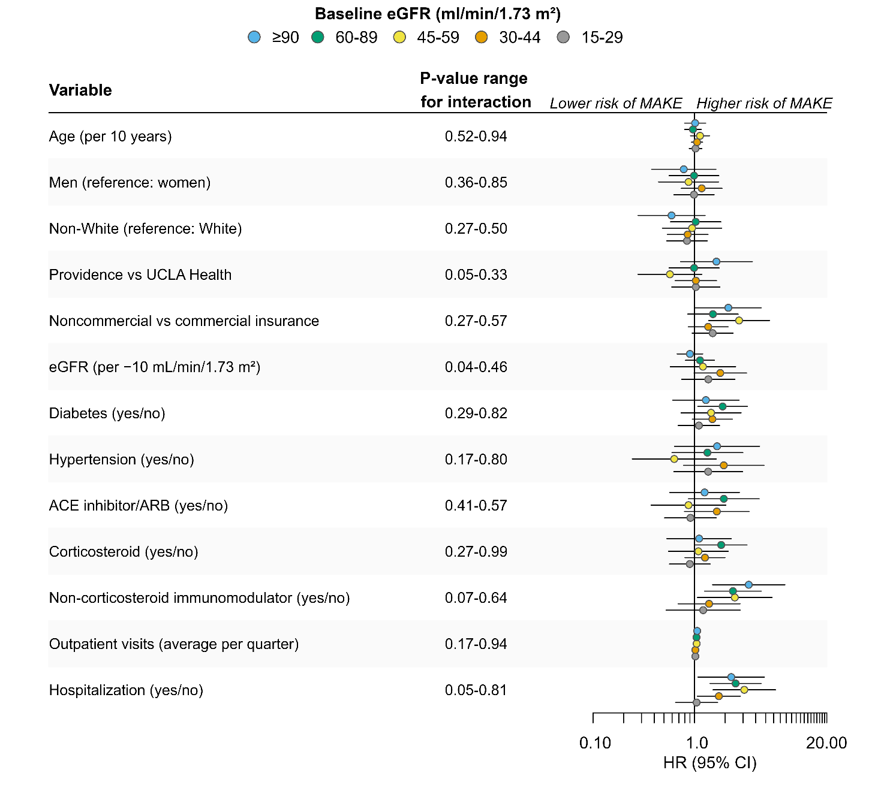
eGFR-estimated glomerular filtration rate, ACE-angiotensin converting enzyme, ARB-angiotensin II receptor blocker,

Additional file 5. Summary of outcomes among patients with FSGS and MAKE by eGFR category
 |  | Baseline eGFR, mL/min/1.73 m²
 | Overall | ≥90 | 60–89 | 45–59 | 30–44 | 15–29
First event, n (%) | 262 (41.7) | 29 (22.7) | 49 (32.0) | 34 (32.7) | 76 (54.3) | 74 (71.2)
eGFR 40% decline, n (% of events) | 133 (50.8) | 22 (75.9) | 40 (81.6) | 25 (73.5) | 41 (53.9) | 5 (6.8)
Kidney failure | 74 (28.2) | 3 (10.3) | 2 (4.1) | 4 (11.8) | 17 (22.4) | 48 (64.9)
Dialysis | 28 (10.7) | 1 (3.4) | 2 (4.1) | 2 (5.9) | 8 (10.5) | 15 (20.3)
Transplant | 13 (5.0) | 2 (6.9) | 4 (8.2) | 2 (5.9) | 2 (2.6) | 3 (4.1)
All-cause death | 14 (5.3) | 1 (3.4) | 1 (2.0) | 1 (2.9) | 8 (10.5)
FSGS-focal and segmental glomerulosclerosis, MAKE-major adverse kidney events, eGFR-estimated glomerular filtration rate

