Supplemental Information

Table 1: Quantification of AAC characteristics
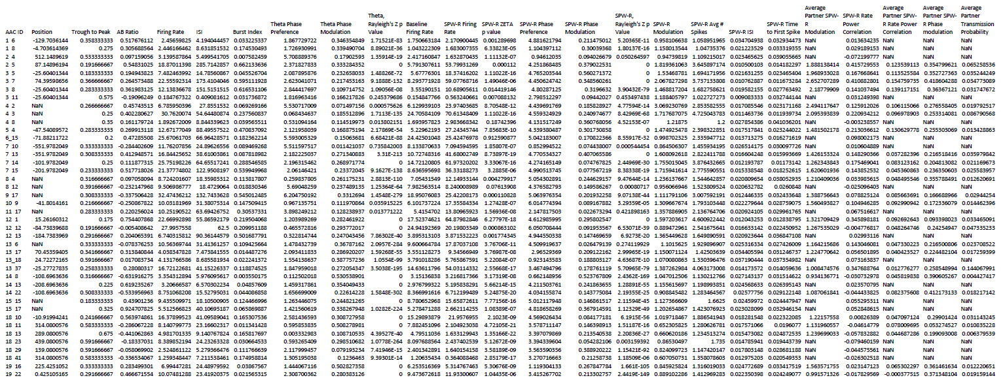
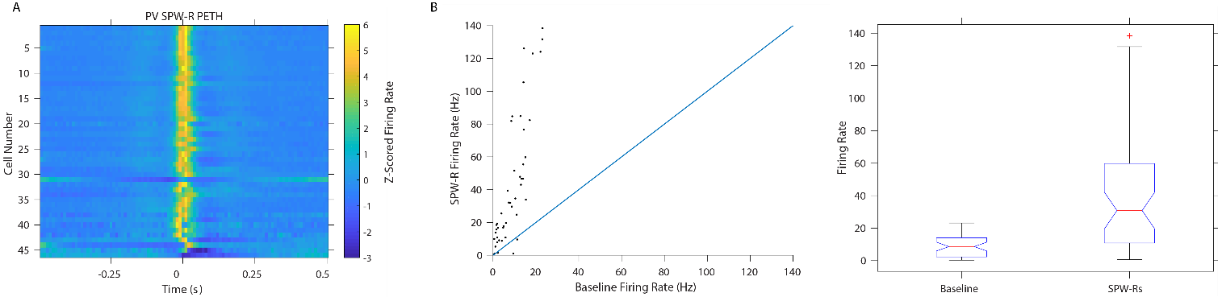
Figure S1: PV+ cells increase their firing rate during SPW-R.
- Peri-event time histogram of PV z-scored firing rate centered on SPW-R peak (n=46 cells, n=6 animals, 11 sessions. 2,031-10,960 SPW-R events, µ= 6,725.6 events)
- Left: Firing rate (Hz) in baseline and within SPW-R. (n=46 cells, n=6 animals, 11 sessions. baseline x̃= 8.63Hz, SPW-R x̃= 30.82Hz, p=3.0939e-4, Wilcoxon signed rank test) Right: Distribution of delta firing rate in and out of SPW-R (n=46 cells).
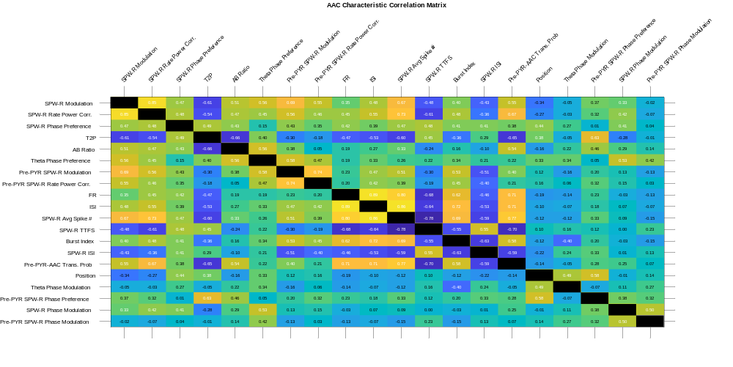
Figure S2: Correlation Matrix of AAC characteristics.
Clustered correlation matrix of AAC characteristics including SPW-R metrics of presynaptic PYRs. Significant correlations are labeled in white text (p<.05, Spearman’s Rho, Circular-Linear Correlation Coefficient, and Circular-Circular Correlation Coefficient, respectively).

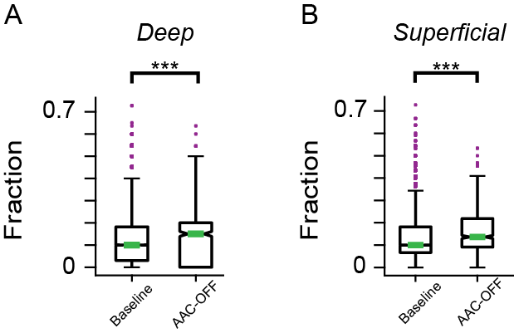
Figure S3: Both the fraction of deep and superficial PYRs participating is increased in
AAC-OFF SPW-R
PYR cell participation separated by soma depth (n=1,495-12,364, total: 37,032 Control SPW-R. n=51-287, total: 868 AAC-OFF SPW-R.)
- Fraction of Deep PYR participating in SPW-R (n=11-32, total: 125 Deep cells, p= 2.4645e-13, Wilcoxon rank-sum test).
- Fraction of Superficial PYR participating in SPW-R (n=5-33, total: 69 Superficial cells. p= 6.5141e-06, Wilcoxon rank-sum test).

