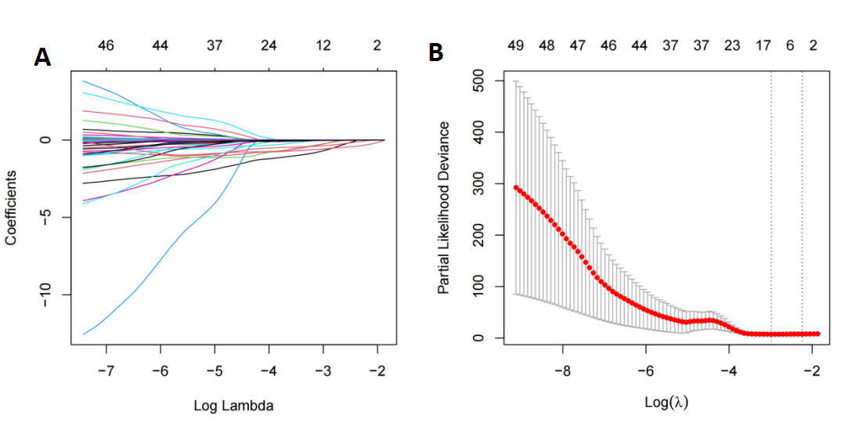
Figure S1.Identification of risk factors for BCLM using Lasso algorithm.(A)Identification of the optimal penalization coefficient lambda (λ) in the LASSO model with 10-fold cross-validation in the training set.(B)LASSO coefficient profiles of 49 features.

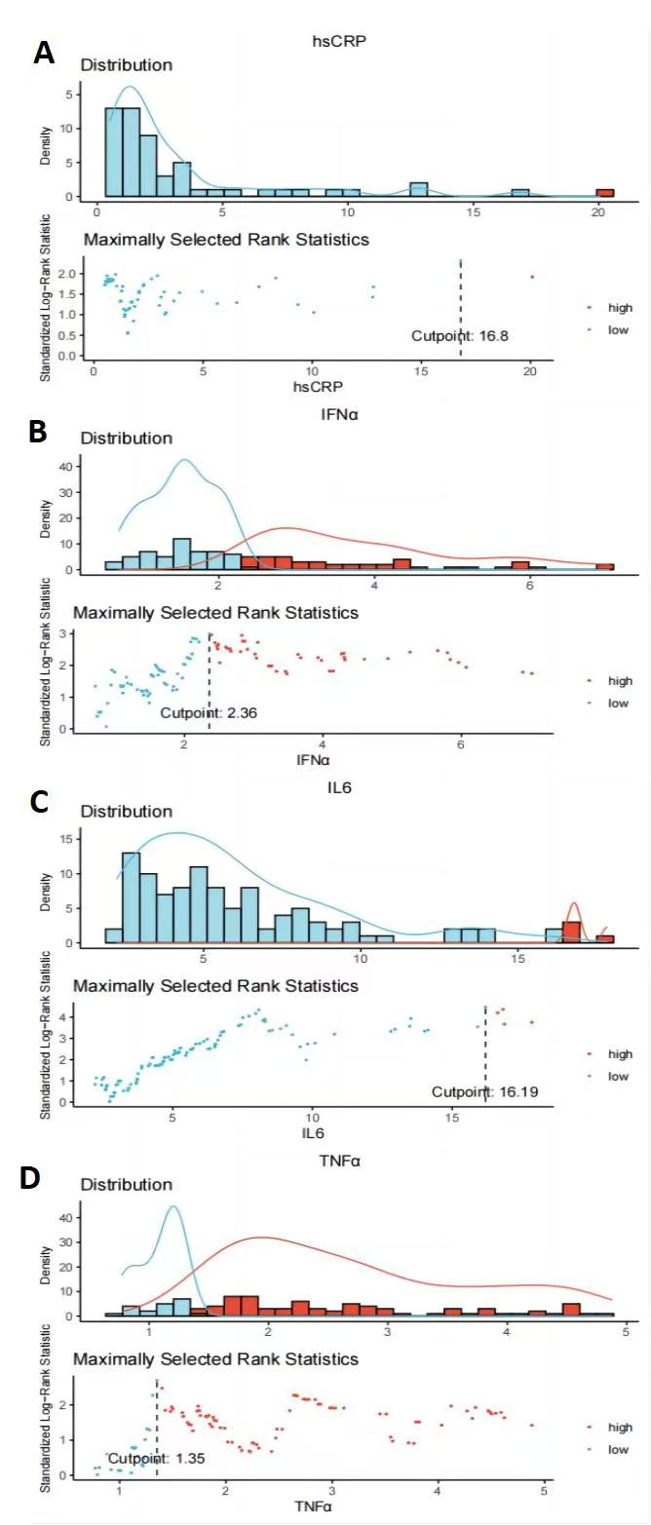
Figure S2 Optimal cut-off values for hsCRP (A), IL6 (B), IFN α (C), and TNFα (D)according to MaxStat.

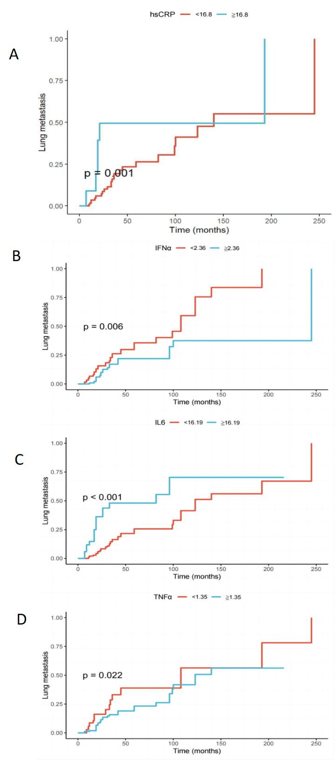
Figure S3 A Kaplane-Meier analysis of future LM stratified by high-risk versus low-risk stratification based on risk factor cut-off values.
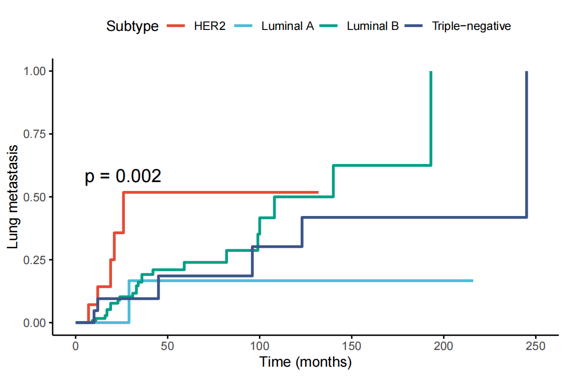
Figure S4 Prediction of BCLM is based on molecular typing.

