Raspberry-derived carbon dots for specific detection of intracellular copper ions
Yalan Xu, Yiwei Liu, Liping Feng, Muhua Wang, Yueyi Xia, Luoxing Yang, and Xiaoli Sun*
Lishui University, Lishui, 323000, China.
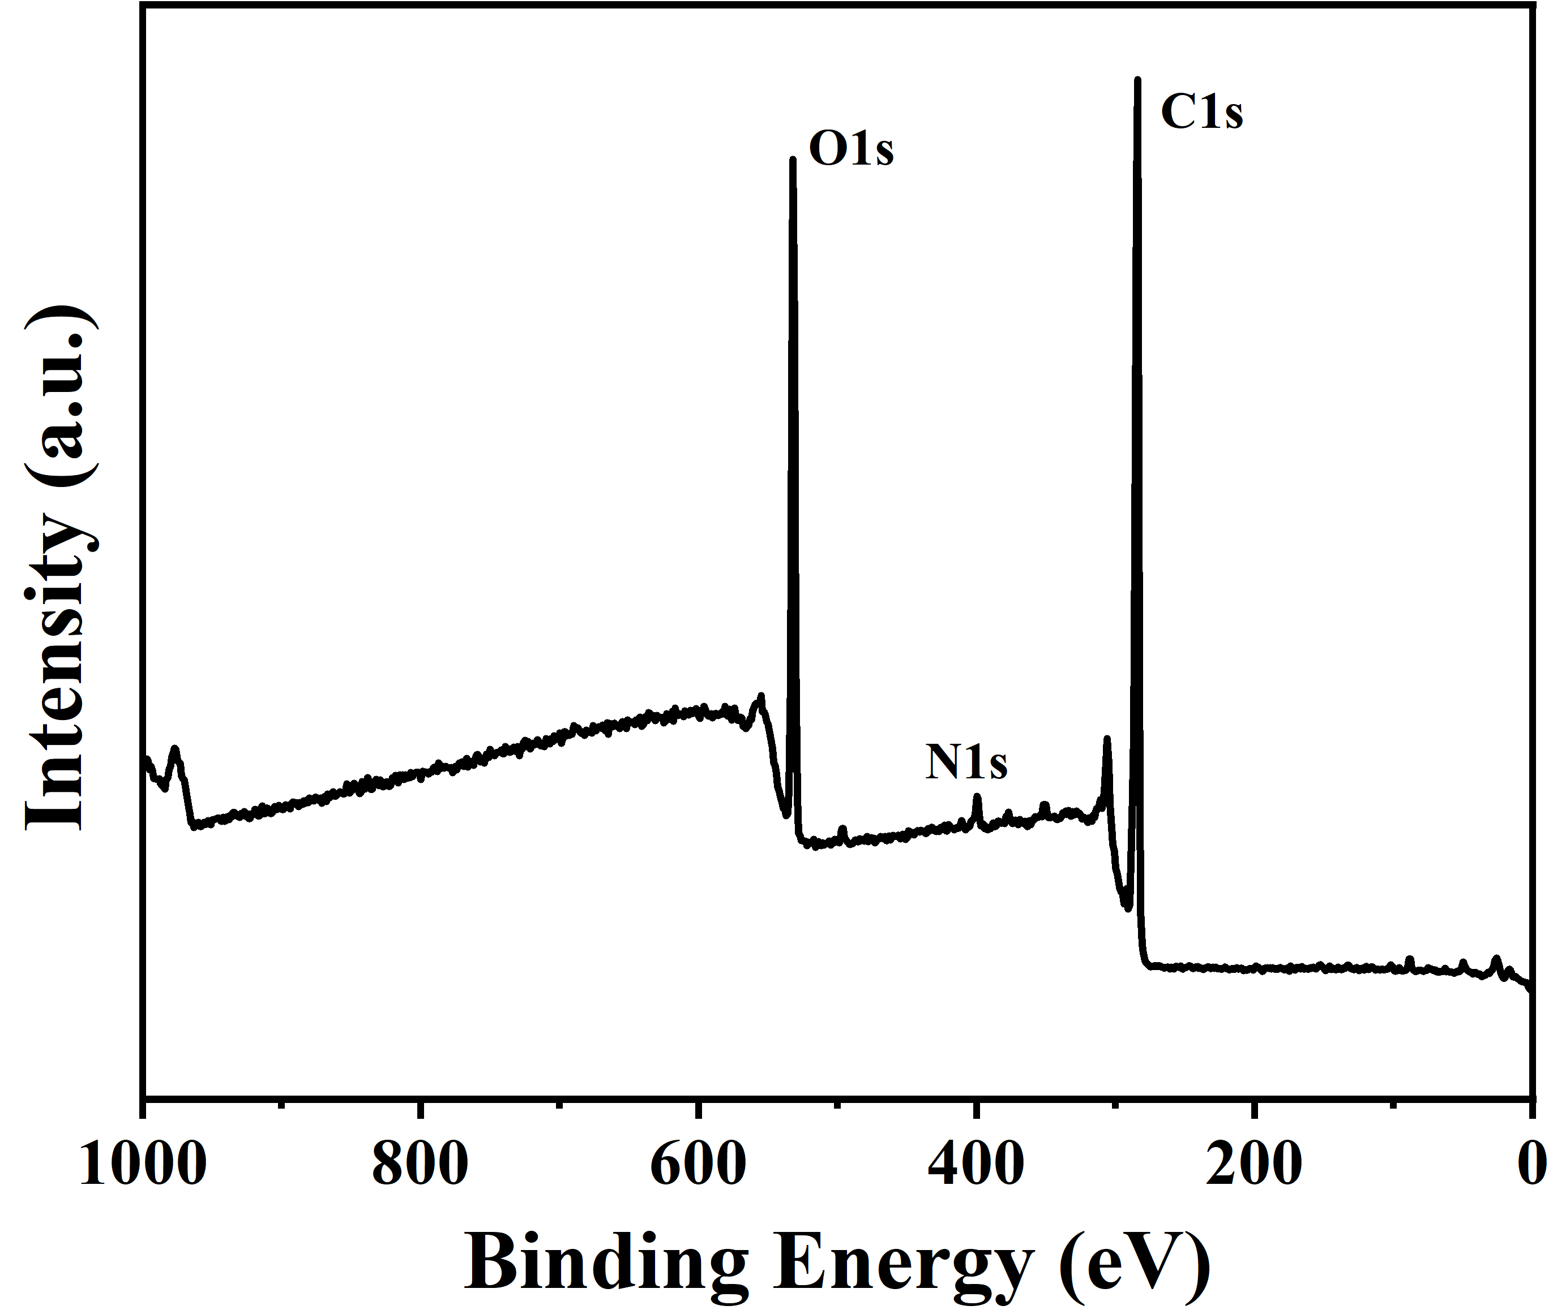
Figure S1. Survey of XPS spectrum of B-CDs.
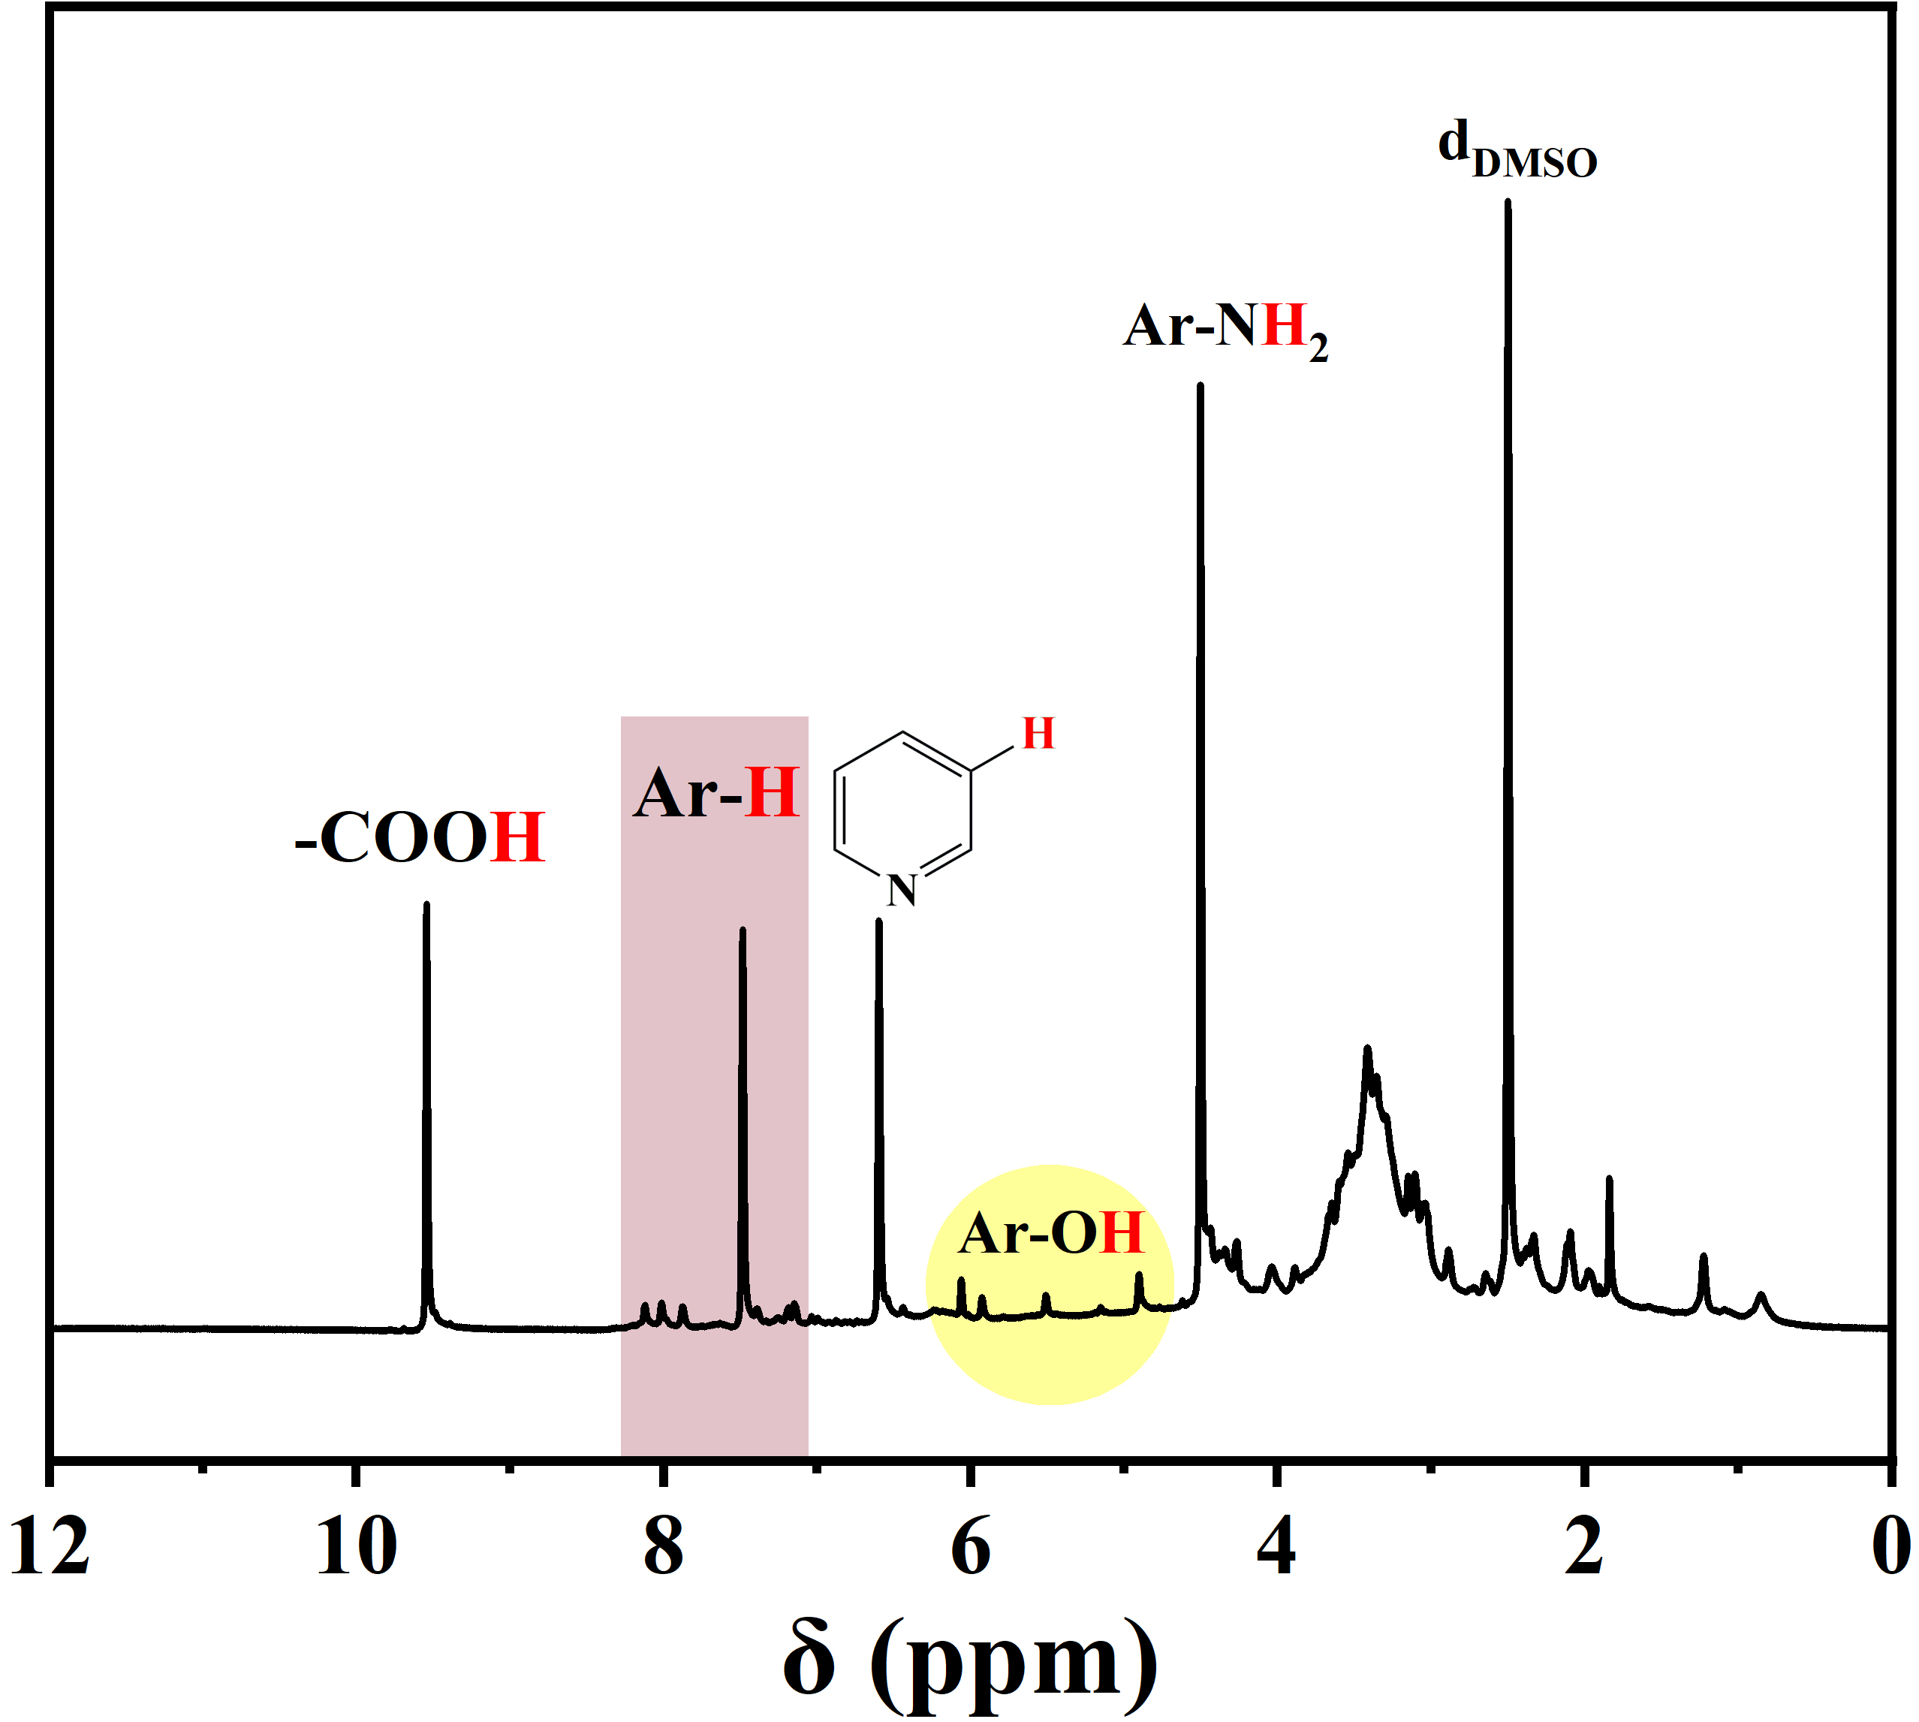
Figure S2. ¹H NMR spectra of B-CDs.
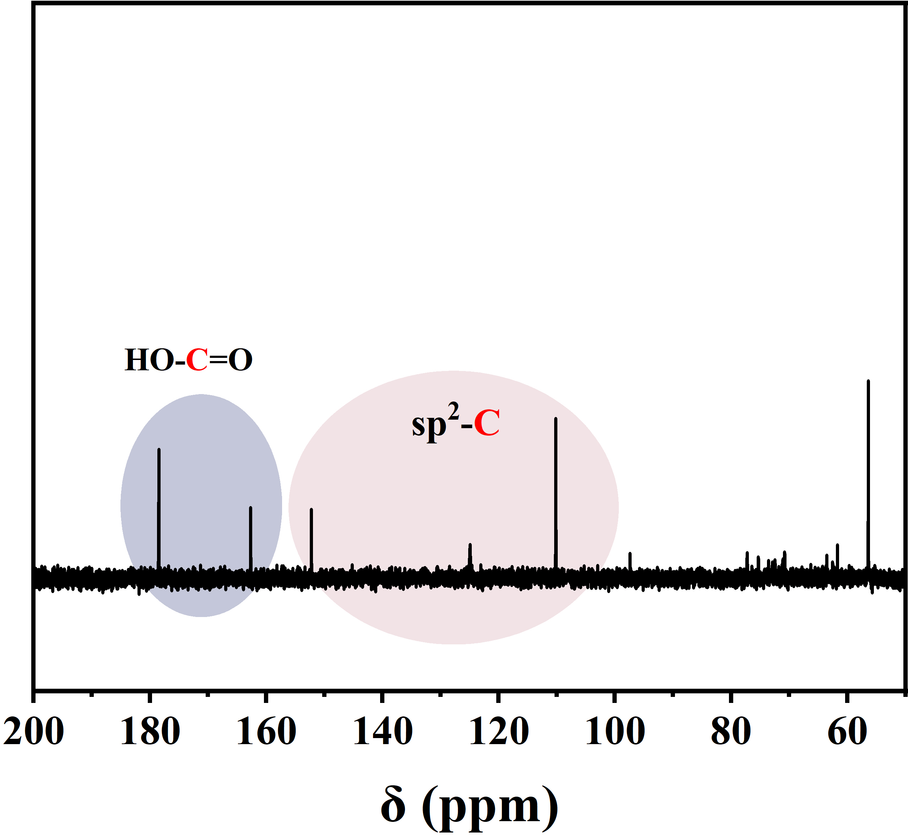
Figure S3. ¹³C NMR spectra of B-CDs.

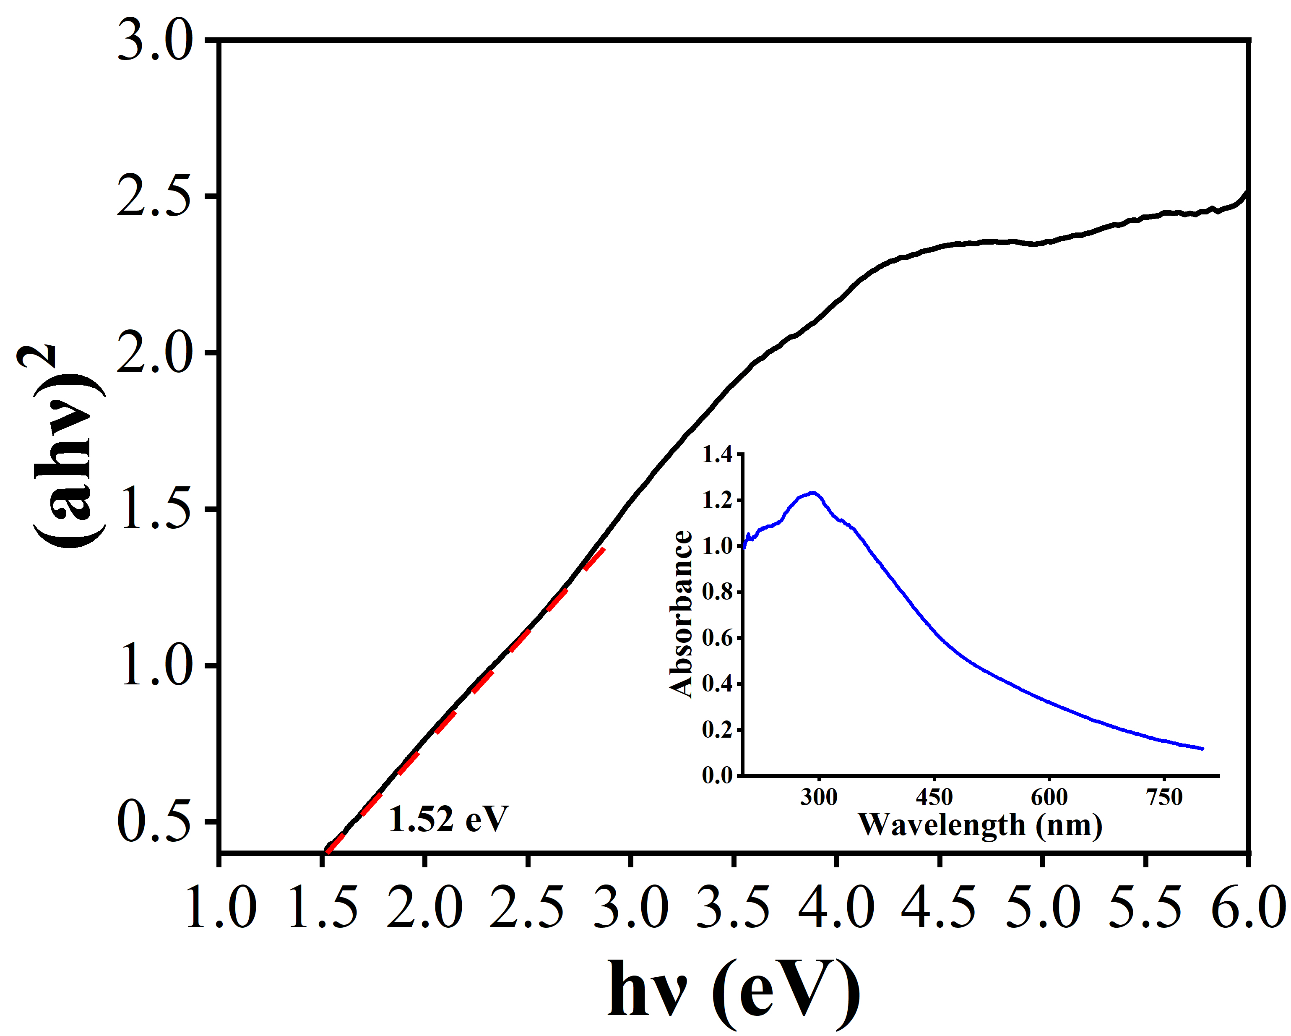
Figure S4. The band gap energy spectrum of B-CDs. Inset: corresponding UV-vis diffuse reflectance spectrum.
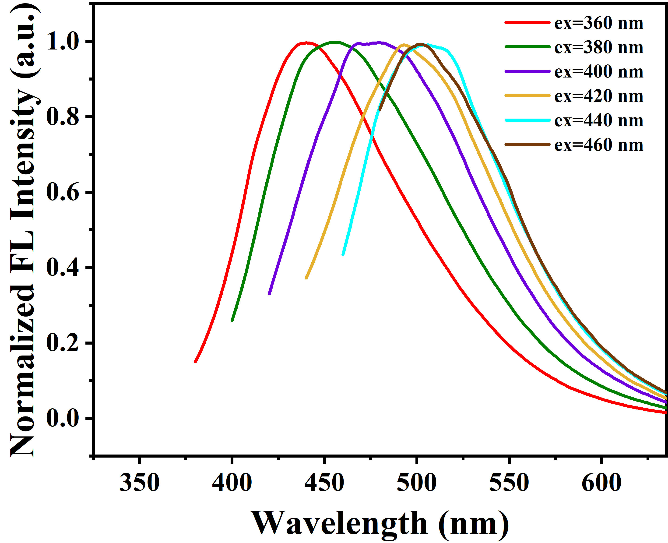
Figure S5. Emission spectrum of B-CDs at different excitation wavelengths (360 nm-460 nm).
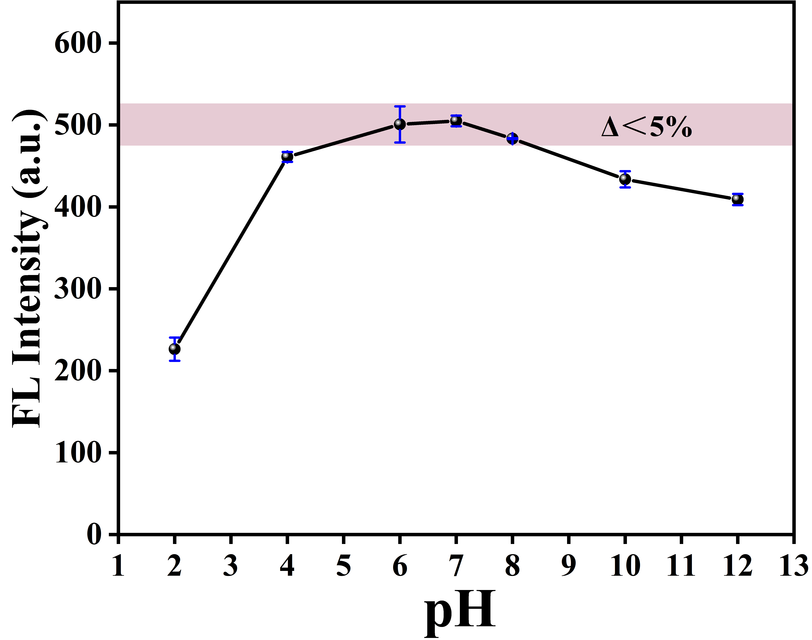
Figure S6. The fluorescence emission intensity of B-CDs at different pH.
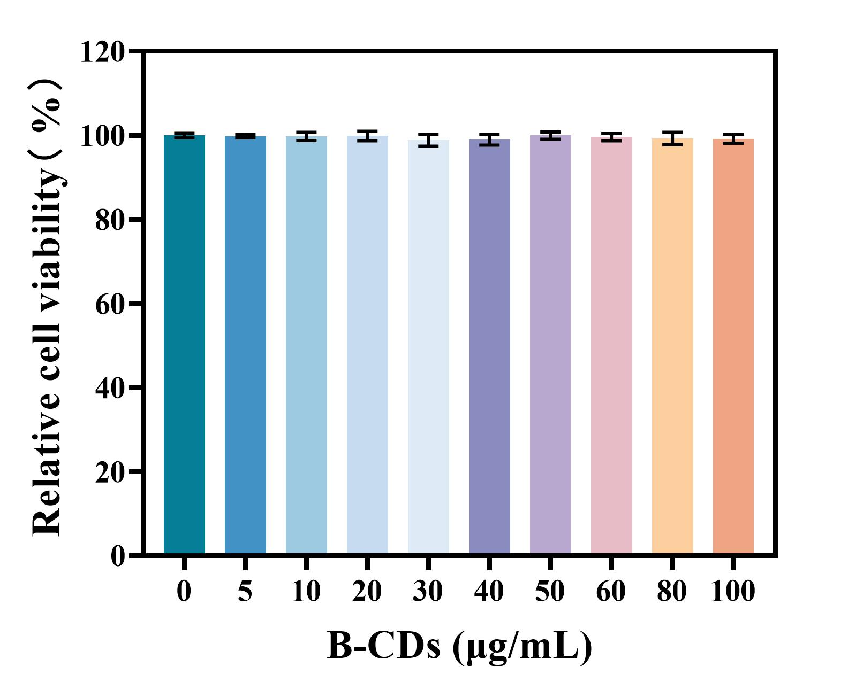
Figure S7. Relative cell viability for HepG2 cells incubated with different concentrations of B-CDs for 24 h.

