Supplemental information

Enhancing Arecanut Quality Grading: A Comparison of Custom CNNs and Transfer Learning Models

Dhanush D Ghate¹, Pramukh S Hegde², Pallavi K N¹, Sudeep D Ghate^{3,4}*

¹Department of Computer Science and Engineering, NMAM Institute of Technology, NITTE deemed to be University, Nitte - 574110, India

²Department of Physiology, KS Hegde Medical Academy NITTE deemed to be University, Mangaluru 575018, India

³Center for Bioinformatics, NITTE deemed to be University, Mangaluru 575018, India

⁴Central Research Laboratory, KS Hegde Medical Academy NITTE deemed to be University, Mangaluru 575018, India

*Corresponding author
E-mail: sudeep1129@gmail.com

Running title: Precision Arecanut Classification with Custom CNN models

Fig S1. Architecture of custom Convolutional Neural Network (CNN) Model for arecanut classification.The algorithm flow for the customized CNN model consists of five parts : a) Input Layer: The input of the model is a 224x224 pixel image of an arecanut. Output the image to the feature extraction network to obtain the corresponding feature; b) Convolutional Layers: The model has a variable number of convolutional layers (determined by the hyperparameter num_layers), each with num_feature_maps and a 3x3 kernel size. These convolutional layers, activated by the ReLU function, extract low-level visual features from the input images; c) Max Pooling Layers: After each convolutional layer, a 2x2 max pooling layer is applied to downsample the feature maps and introduce translation invariance; d) Fully Connected Layers: Three to seven fully connected layers with 512 hidden neurons, respectively, process the flattened features; e) Output Layer: The final output layer is composed of four nodes, each representing one of the four arecanut quality grades.
Fig S2: Confusion matrix for validation performance of CNN models for arecanut classification through transfer learning. (a) DenseNet121 (b) EfficientNetB4 (c) InceptionResNetV2 (d) InceptionV3 (Left Panel: initial models Right Panel: fine-tuned models. The diagonal values represent correctly classified instances, while off-diagonal values indicate misclassifications, with predicted labels on the x-axis and actual labels on the y-axis.)
Fig S3. Confusion matrix for validation performance of CNN models for arecanut classification through transfer learning. (a) MobileNetV2 (b) ResNet50 (c) VGG16 (d) VGG19 (Left Panel: initial models Right Panel: fine-tuned models. The diagonal values represent correctly classified instances, while off-diagonal values indicate misclassifications, with predicted labels on the x-axis and actual labels on the y-axis.)
Fig S4. ROC-AUC curves illustrating the classification performance of untuned final CNN models for arecanut grading

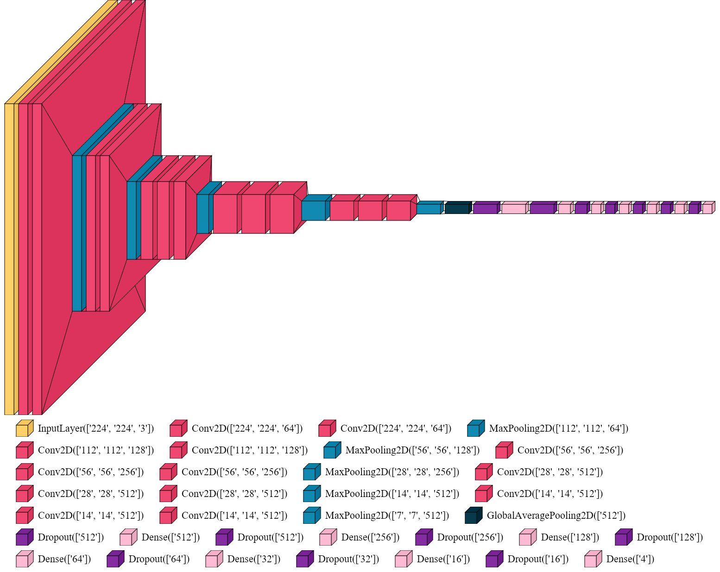

Fig. S1

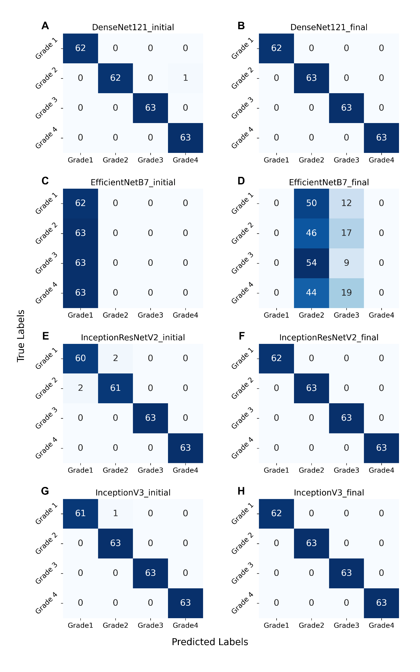

Fig. S2

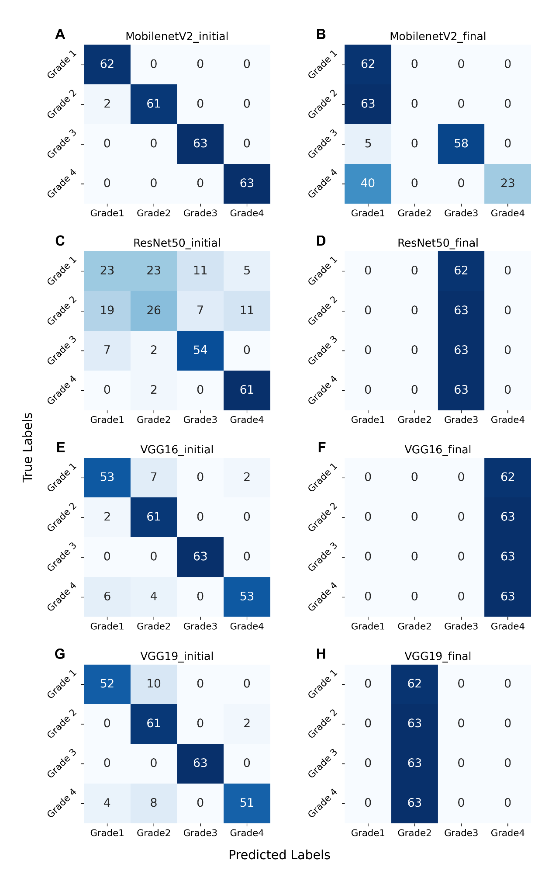

Fig. S3

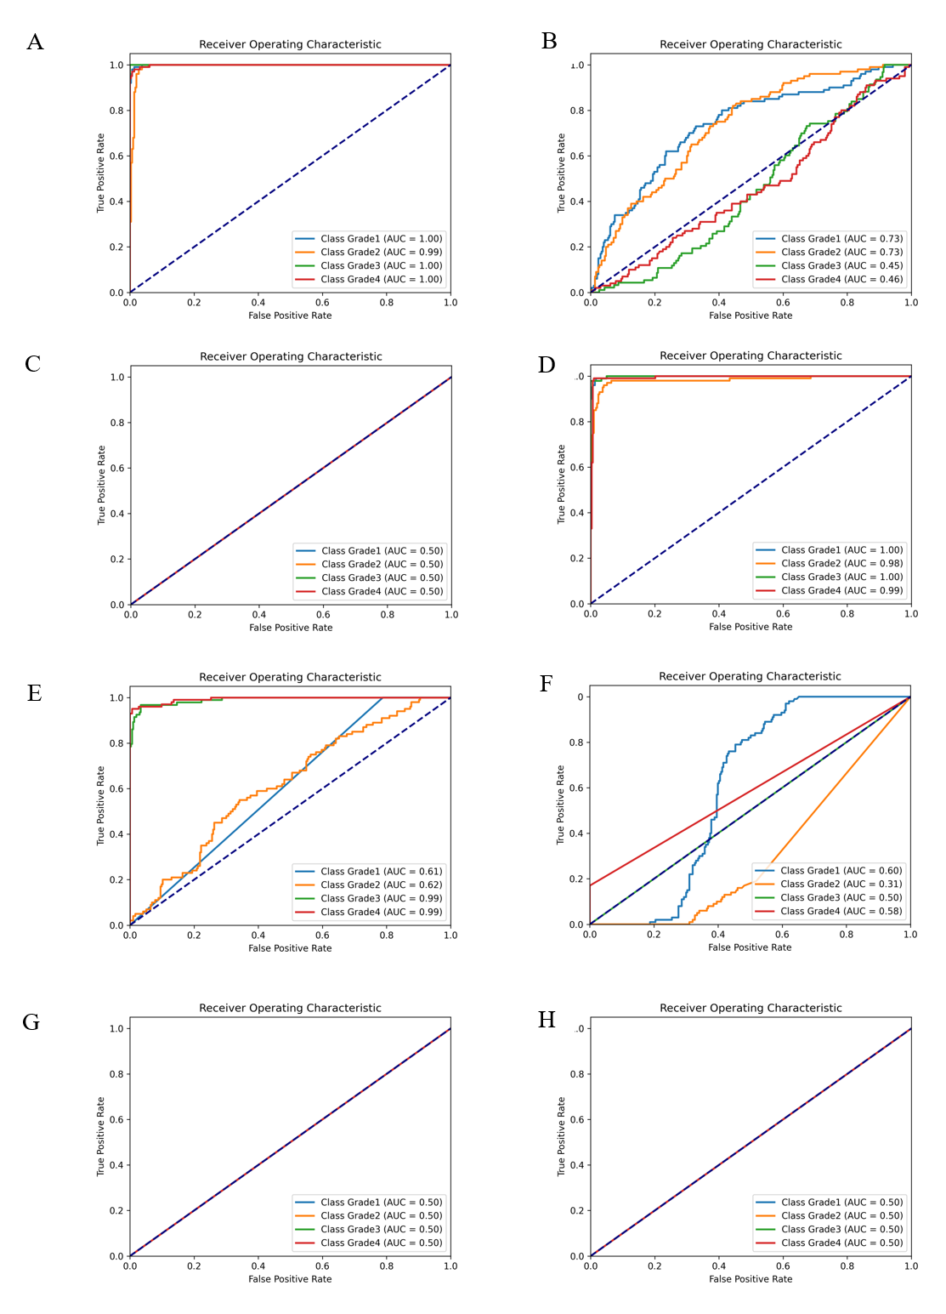

Fig. S4

