Low-cost air quality sensors are suggested to by some research to inaccurately reflect the exact quantity of air pollutants. In order to assess the reliability of our sensor clusters (2 clusters with 10 sensors each), we aimed to calibrate their values against a sensor from the government (Figure 1). Upon assessing the values of the government sensors, we deemed them unreliable (Figure 2, missing values and having negative values). In contrast, our sensors values did not dip below 0, yet we did miss some data at the end of June (Figure 3). Nonetheless, we assessed the correlations between our sensor clusters and the government sensor to assess the level of agreement between the sensors (Figure 4). We ran simple Pearson correlation with increasing temporal averaging (1 – 24 hours) and found high correlations for PM2.5 (r > 0.70, Figure 4). This implies that between our sensor clusters and the government sensors there is agreement on the air quality. After, we visually assessed the sensor clusters to see how well they agree with each other, following we also assessed the correlations (r > 0.98). The resulting figures shows high similarity between the sensors that would be used in the fieldwork, indicating that the sensor can be compared with each other reliably (Figure 5, 6, 7 & 8).

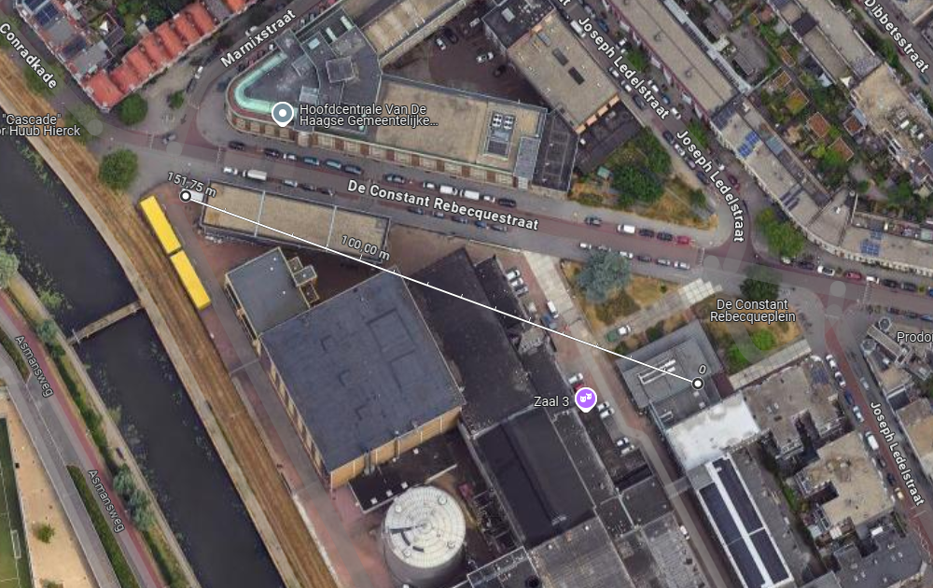
Figure 1. shows a google maps satellite view of the distance from our sensor cluster (right dot) to the RIVM sensor (left dot), indicating a distance of approximately 150 meters between the sensors.

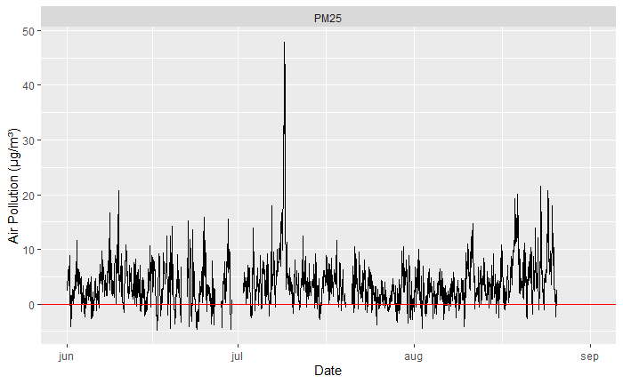Figure 2. Shows the hourly air pollution values retrieved from the governmental sensor. The red line indicates a value of 0 air pollution per cubic meter. Value below the red line indicate a negative value of air pollution and should not be possible. For 142 hours, there is no data from the government sensors, also seen by the lines interrupting at the start of July, mid-July and the ending of August.
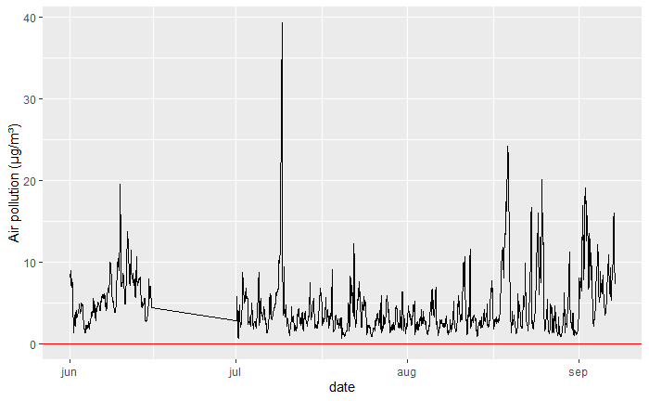
Figure 3. shows the hourly air pollution values retrieved and averaged from the sensor clusters. The red line indicates a value of 0 air pollution per cubic meter. The straight black line from half June to July is missing data.

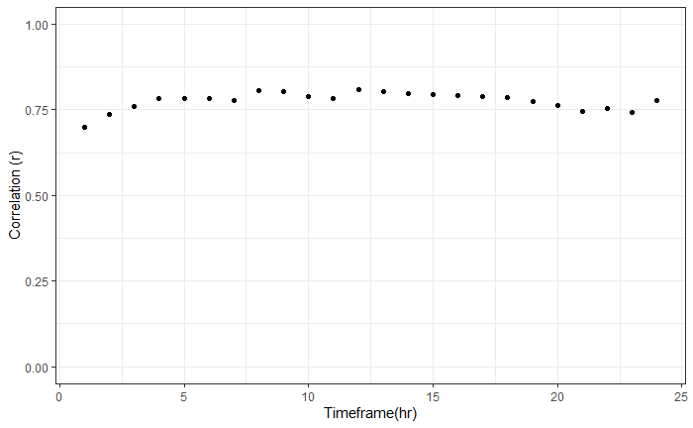
Figure 4. shows the correlation values between the governmental sensor and our sensor clusters for PM2.5, using temporal averaging from 1 – 24 hours. The agreement between the RIVM sensor and our sensor clusters for PM2.5 was quite high.
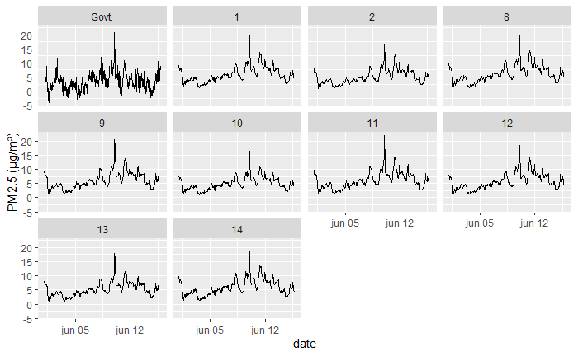
Figure 5. shows the data retrieved from the sensors used in the models, and the governmental sensor data. Panels with numbers are Temtop sensors and the Govt. panel shows the data from the governmental sensor.

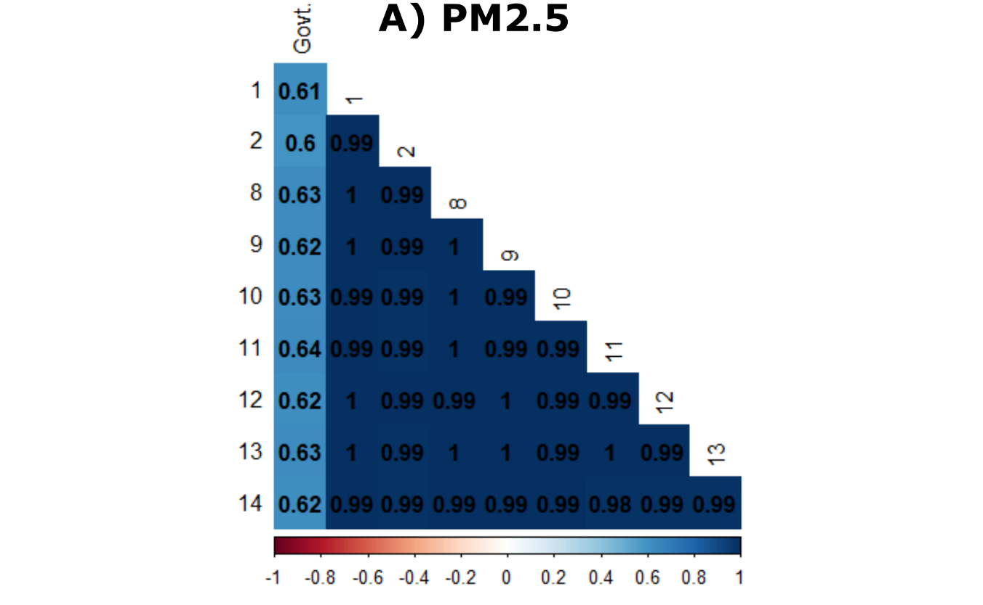

Figure 6. Shows a heatmap of correlations between the sensors used to assess PM2.5 air pollution. Govt. is the governmental sensor data and the numbered rows and columns are the data retrieved from the temtop sensors.

