Supplementary Materials

Table S1. Characteristics of studies on loneliness and network of symptoms of depression
 | A  Study | B  Depression questionnaire | C  Number of scale items | E  Mean age of respondents and/or age range | F  Sample size | G  Country | H  Type of population | I  Centrality rank of the loneliness | J  High correlation of loneliness with …
 | Mullarkey et al., 2019 | CDI | 26 items^{A} | 14.35 ± 0.66  13–19 years | 1,409 | USA | General | 2 | Sadness; Lack of friendship; Feeling unloved
 | D. Kim et al., 2021 | CDI | 27 items | 6–12 years | 10,233 | Korea | General | 1 | Sadness; Crying; Lack of friendship; Suicidality; Somatic concern
 | K. M. Kim et al., 2021 | CDI | 27 items | 14.21 (SD = 2.30)  7–19 years | 455 | Korea | Specific¹ | 13 | Sadness; Crying; Suicidality
 | Li et al., 2021 | CDI | 27 items | 7–17 years | 2,517 | China | Specific² | 5 | Lack of friendship; Crying; Sleep disturbance
 | Xie et al., 2022 | CDI | 27 items | 14.70 ± 1.72 | 571 | China | General | 2 | Lack of friendship; Sadness; Suicidality; Crying
 | Gijzen et al., 2021 | CDI-2 | 28 items | 11–16 years | 5,888 | Netherlands | General | 1 | Lack of friendship; Feeling unimportant to family; Sadness; Feeling unloved; Suicidality
 | Xie et al., 2022 | SMFQ | 13 items | 14.33 ± 3.60 | 2,194 | China | General | 6 | Feeling unloved; Restless; Crying; Sadness
 | Mullarkey et al., 2021 | SMFQ | 13 items | 14.72 ± 1.79  11–19 years | 1,059 | USA | General | 4 | Feeling unloved; Crying; Bad person; Sadness
 | Manfro et al., 2021 | MFQ | 33 items | 14–16 years | 7,772 | Brazil | General | 2 | Feeling unloved; Not enjoy; Not want to see friends
 | Kenny et al., 2021 | CES-D-10 | 10 items | 12.59 (SD = 0.39)  10–15 years | 4,421 | Canada | General | 2 | Depressed; Low energy; Not happy
 | Grygiel et al., 2023 | RCADS-MDD | 10 items^{B} | - (SD = 0.55)  11.61-12.56 | 496 | Poland | General | 11 | Worthlessness, Sadness, Anhedonia
 | Gossage et al., 2022 | CDI-S | 10 items | 17 (SD = 0.35) | 561 | New Zealand | General | 1 | Lack of friendship; Sadness; Belief that will not work out
 | Schlechter et al., 2023^{X} | SMFQ | 13 items | 12.95 (SD = 1.41)  10–15 years | 4,235 | UK | General | 5 | Feeling unloved; Not as good as other kids
 | A  Study | B  Depression questionnaire | C  Number of scale items | E  Mean age of respondents and/or age range | F  Sample size | G  Country | H  Type of population | I  Centrality rank of the loneliness | J  High correlation of loneliness with …
 | Schlechter et al., 2023^{Y} | SMFQ | 13 items | 13.77 (SD = 0.45)  11–17 years | 11,176 | UK | General | 3 | Feeling unloved; Not as good as other kids; Miserable or unhappy; I hated myself
 | Schlechter et al., 2023^{Z} | SMFQ | 13 items | 11.30 (SD = 3.4)  11–17 years | 643 | UK | General | 4 | Feeling unloved; Tired; I hated myself
 | Ramos-Vera et al., 2023 | RADS-2 | 30 items | 15.24 (SD = 1.02)  13–18 years | 917 | Peru | General | 14 | Sadness; Social isolation; Not appreciated; Devalued by parents; Crying
Note: CDI = Children’s Depression Inventory. CDI-2 = Children’s Depression Inventory; CDI-S = Children’s Depression Inventory; SMFQ = Short Mood and Feelings Questionnaire. MFQ = Mood and Feelings Questionnaire. CES-D-10 = Short form of the Center for Epidemiologic Studies Depression Scale. RADS-2 = Reynolds Adolescent Depression Scale (version 2). ^{A} = item related to Suicidality was omitted. ^{B} = The RCADS-MDD scale does not have an item that addresses loneliness. To measure it, both direct and indirect measures of loneliness from sources outside the RCADS scale were used. This explains why loneliness ranks 11th in centrality within the analyzed network, despite the RCADS-MDD scale measuring only 10 symptoms of depression. ^{X} = Mental Health of Children and Young People (MHCYP survey); ^{Y} = UK Millennium cohort study (MCS survey); ^{Z} = LAC survey; ¹ = Clients of the child and adolescent psychiatry clinic; ² = Left-behind children.
Table S2. Descriptive statistics at baseline and follow-up
 | Time 1 |  |  |  |  | Time 2 |  |  |  |  | Difference between Time 1 and Time 2
 | Hardly Ever | Some-times | Often | Mean | SD | Hardly Ever | Some-times | Often | Mean | SD | Paired t test |  |  |  | Marginal homogeneity test
Variables | Percent |  |  | Mean | SD | Percent |  |  | Mean | SD | t | p | Cohen’s d | Sd MH |  | p
Sad and blue | 51.1 | 41.6 | 7.3 | 1.56 | .63 | 53.7 | 38.9 | 7.5 | 1.54 | .63 | 2.03 | .042 | .031 | 2.03 |  | .042
Nervous, tense or on edge | 43.8 | 46.0 | 10.2 | 1.66 | .65 | 43.8 | 46.2 | 10.0 | 1.66 | .65 | .181 | .856 | .003 | .18 |  | .856
Happy | 3.8 | 20.6 | 75.7 | 2.72 | .53 | 3.1 | 23.4 | 73.5 | 2.70 | .52 | 1.50 | .134 | .023 | 1.50 |  | .134
Bored | 12.3 | 53.7 | 34.0 | 2.22 | .65 | 10.4 | 53.4 | 36.2 | 2.26 | .63 | -3.47 | <.001 | -.053 | -3.46 |  | <.001
Lonely | 51.7 | 34.5 | 13.8 | 1.62 | .71 | 55.3 | 33.2 | 11.5 | 1.56 | .69 | 4.53 | <.001 | .069 | 4.52 |  | <.000
Tired or worn out | 24.5 | 52.5 | 23.0 | 1.98 | .69 | 21.9 | 56.6 | 21.5 | 2.00 | .66 | -.87 | .384 | -.013 | -.87 |  | .384
Excited about something that you ' re looking forward to | 5.6 | 28.2 | 66.2 | 2.61 | .59 | 4.8 | 31.0 | 64.2 | 2.59 | .58 | .97 | .334 | .015 | .97 |  | .334
Too busy to get everything done | 33.6 | 47.9 | 18.5 | 1.85 | .71 | 31.8 | 49.7 | 18.5 | 1.87 | .70 | -1.33 | .184 | -.020 | -1.33 |  | .184
Pressured by your mother or father | 58.6 | 28.5 | 12.8 | 1.54 | .71 | 59.8 | 29.0 | 11.2 | 1.51 | .69 | 2.01 | .045 | .031 | 2.01 |  | .045
Note. SD = Standard Deviation; Sd MH = Standardized MH statistics; p = p value.

Table S3. Matrix of rho Spearman correlations between the studied variables
Variable | 1 | 2 | 3 | 4 | 5 | 6 | 7 | 8 | 9 | 10 | 11 | 12 | 13 | 14 | 15 | 16 | 17
- Sad T1 | --
- Nervous T1 | .30** | --
- Happy T1 | -.22** | -.12** | --
- Bored T1 | .15** | .17** | -.07** | --
- Lonely T1 | .31** | .22** | -.19** | .27** | --
- Tired T1 | .14** | .19** | 0.00 | .19** | .15** | --
- Excited T1 | -.06** | .04** | .29** | 0.02 | -.08** | .06** | --
- Busy T1 | .16** | .19** | -.04** | .15** | .18** | .22** | .05** | --
- Pressured T1 | .25** | .23** | -.17** | .18** | .31** | .16** | -.09** | .27** | --
- Sad T2 | .25** | .14** | -.13** | .08** | .17** | .07** | -.06** | .09** | .11** | --
- Nervous T2 | .15** | .18** | -.10** | .08** | .12** | .03* | -0.02 | .06** | .11** | .37** | --
- Happy T2 | -.14** | -.07** | .22** | -.08** | -.13** | -.04* | .11** | -.05** | -.15** | -.28** | -.16** | --
- Bored T2 | .10** | .08** | -.08** | .27** | .11** | .10** | -0.02 | .06** | .07** | .18** | .17** | -.10** | --
- Lonely T2 | .18** | .11** | -.10** | .14** | .26** | .07** | -.06** | .09** | .16** | .39** | .25** | -.21** | .26** | --
- Tired T2 | .05** | .08** | -.04* | .09** | .08** | .13** | -0.01 | .07** | .08** | .14** | .20** | -0.03 | .21** | .17** | --
- Excited T2 | -.06** | 0.00 | .14** | -.05** | -.05** | -0.02 | .14** | 0.01 | -.05** | -.13** | -.03* | .33** | -.04** | -.11** | 0.01 | --
- Busy T2 | .07** | .07** | -0.02 | 0.03 | .08** | .03* | 0.02 | .15** | .08** | .17** | .19** | -.05** | .12** | .19** | .22** | .03* | --
- Pressured T2 | .14** | .10** | -.10** | .08** | .17** | .06** | -.05** | .10** | .22** | .29** | .25** | -.20** | .13** | .27** | .15** | -.10** | .22**
Note. *p < 0.05, **p < 0.01.

Figure S1. Stability of edge centrality in longitudinal (cross-lagged) network
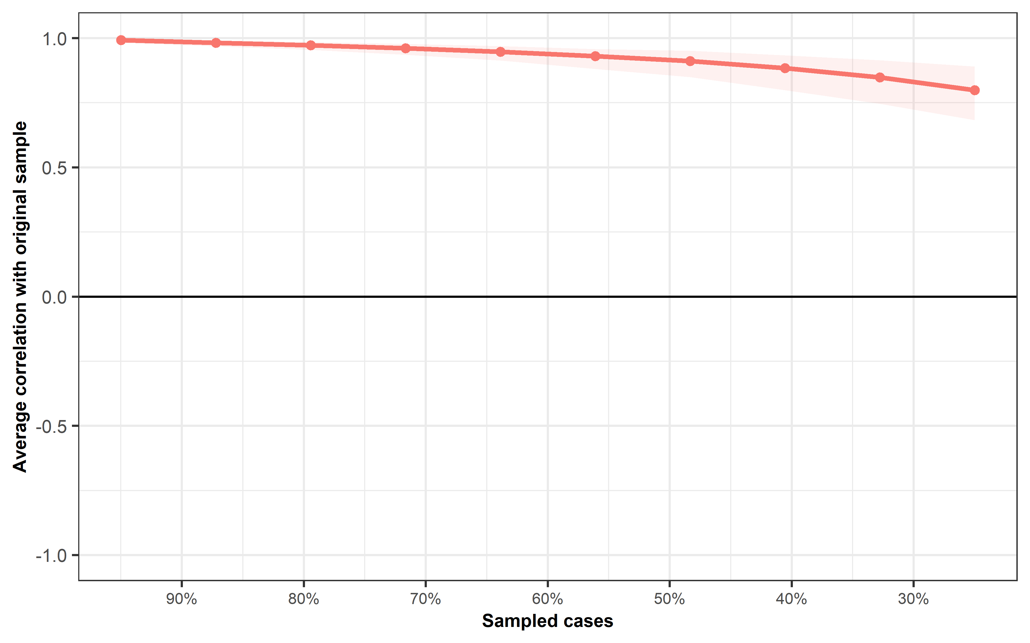

Figure S6. Stability of out-strength and in-strength centrality in longitudinal (cross-lagged) network
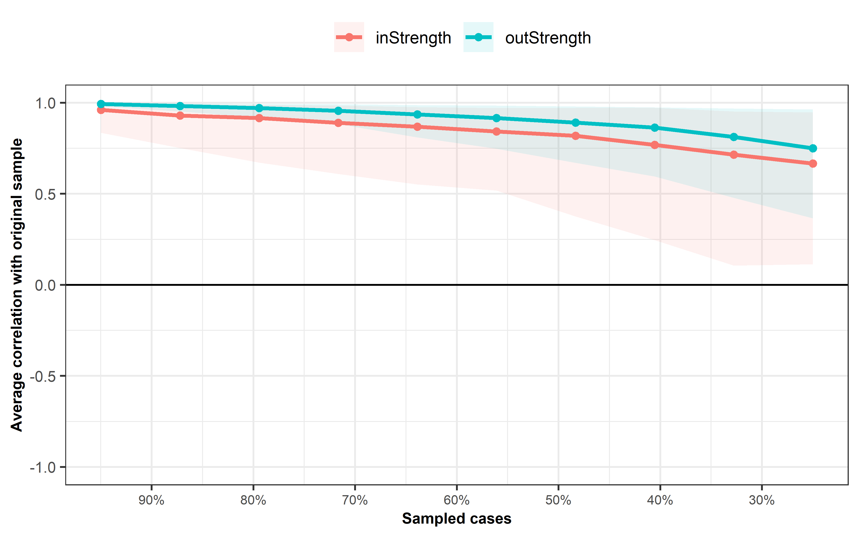

Figure S3. Indices of autoregression (stability) of variables between T1 and T2
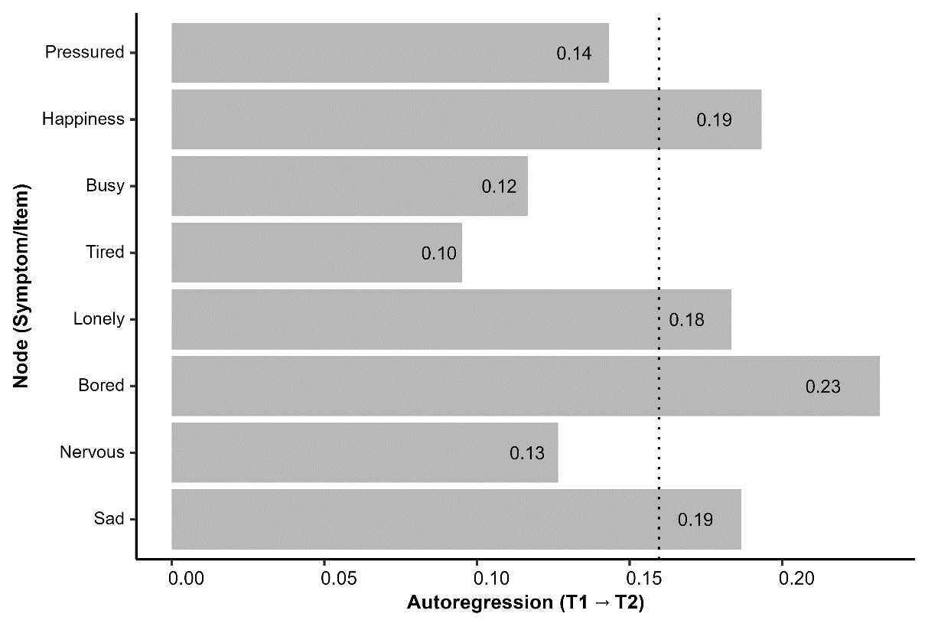

Figure S4. Cross-construct cross-lagged in-prediction and out-prediction (centrality) of variables in the estimated CLPN (T1→T2)
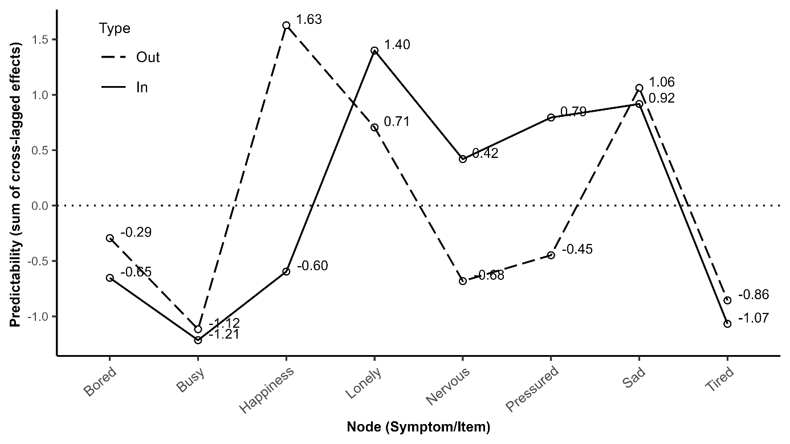

Figure S5. Plot of the bootstrapped difference tests (α = .05) for cross-lagged edge-weights (T1→T2)
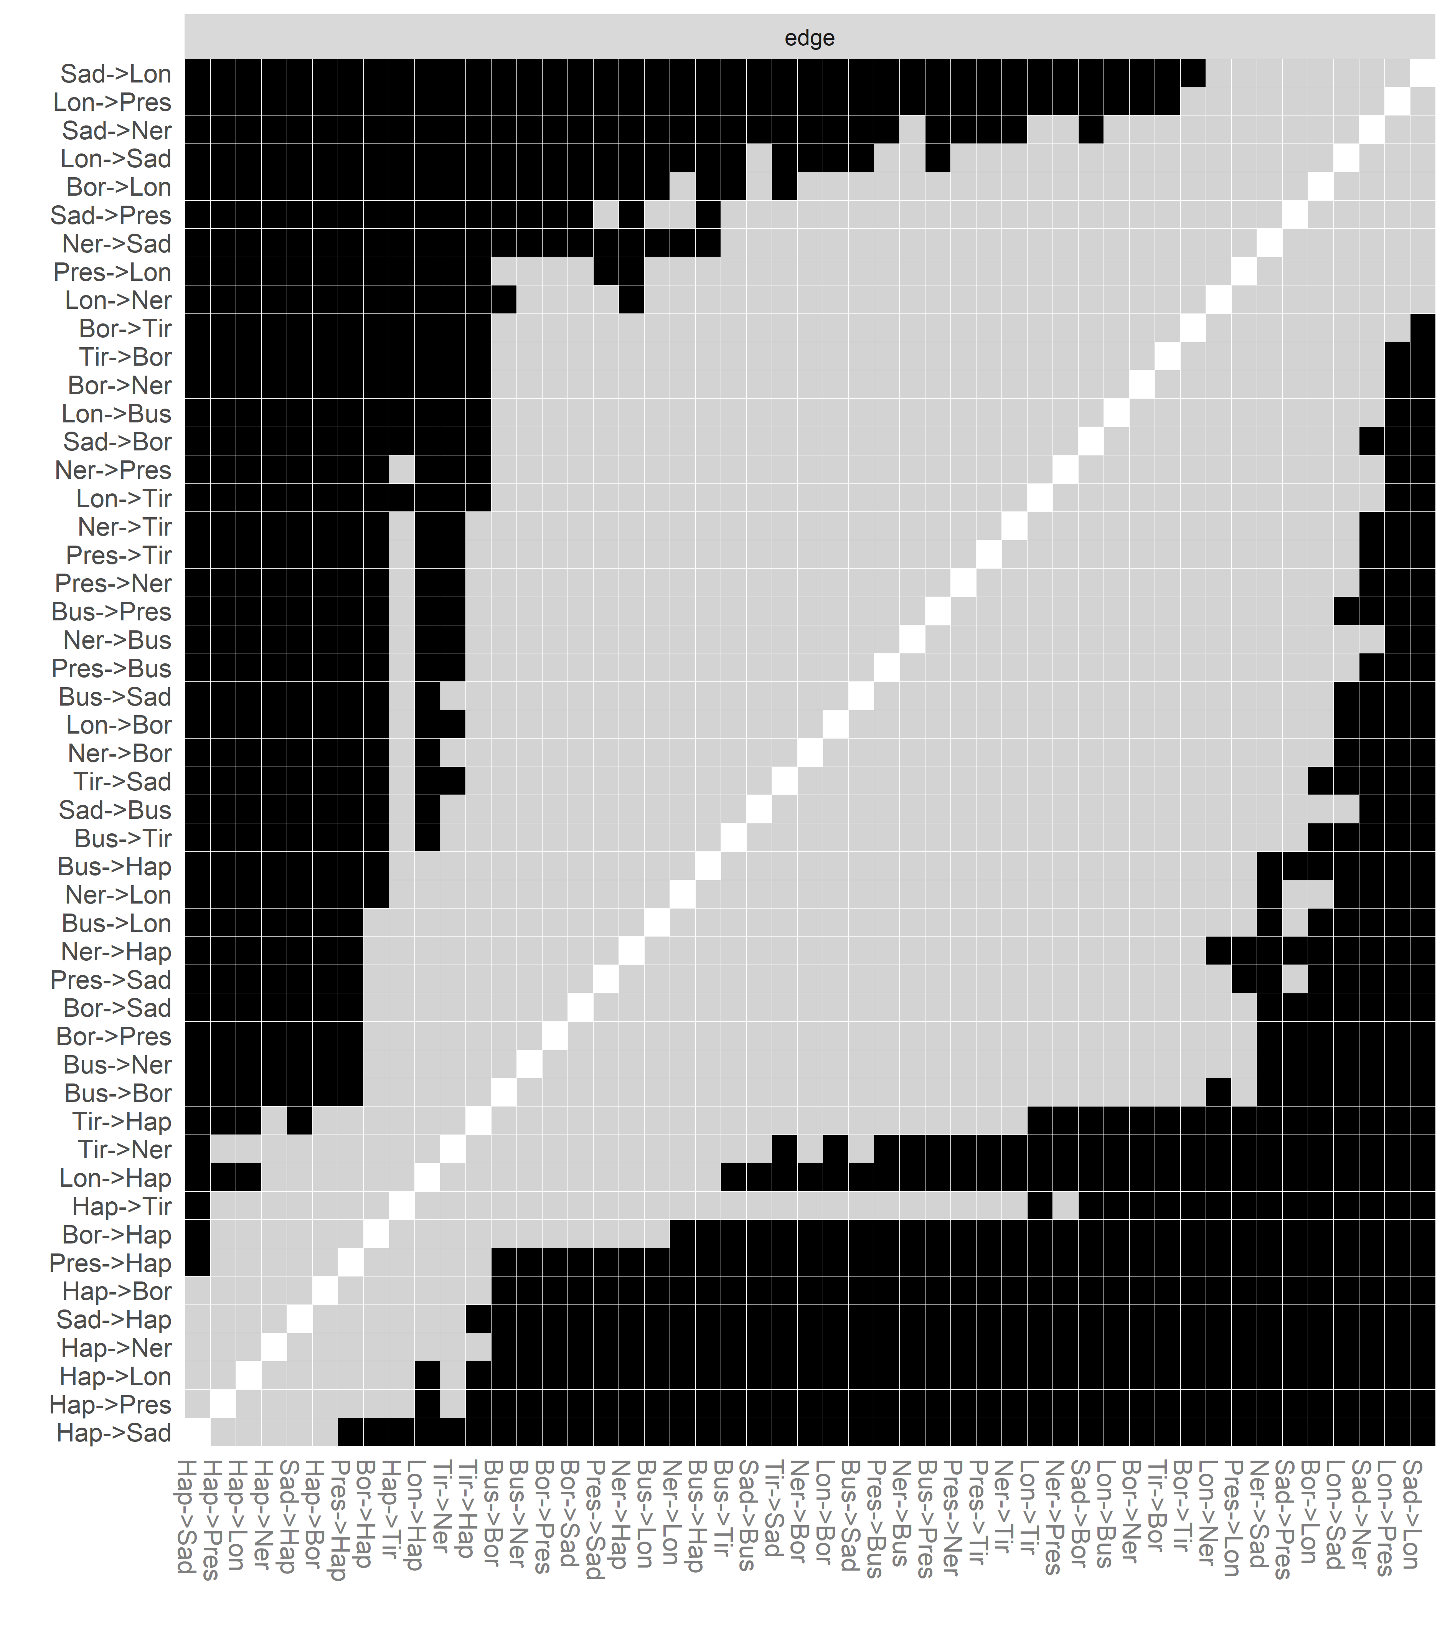
Note. Gray colored boxes represent nonsignificant differences, while black boxes represent significant differences

Figure S6. Accuracy of cross-lagged edge weights (T1→T2) with confidence intervals
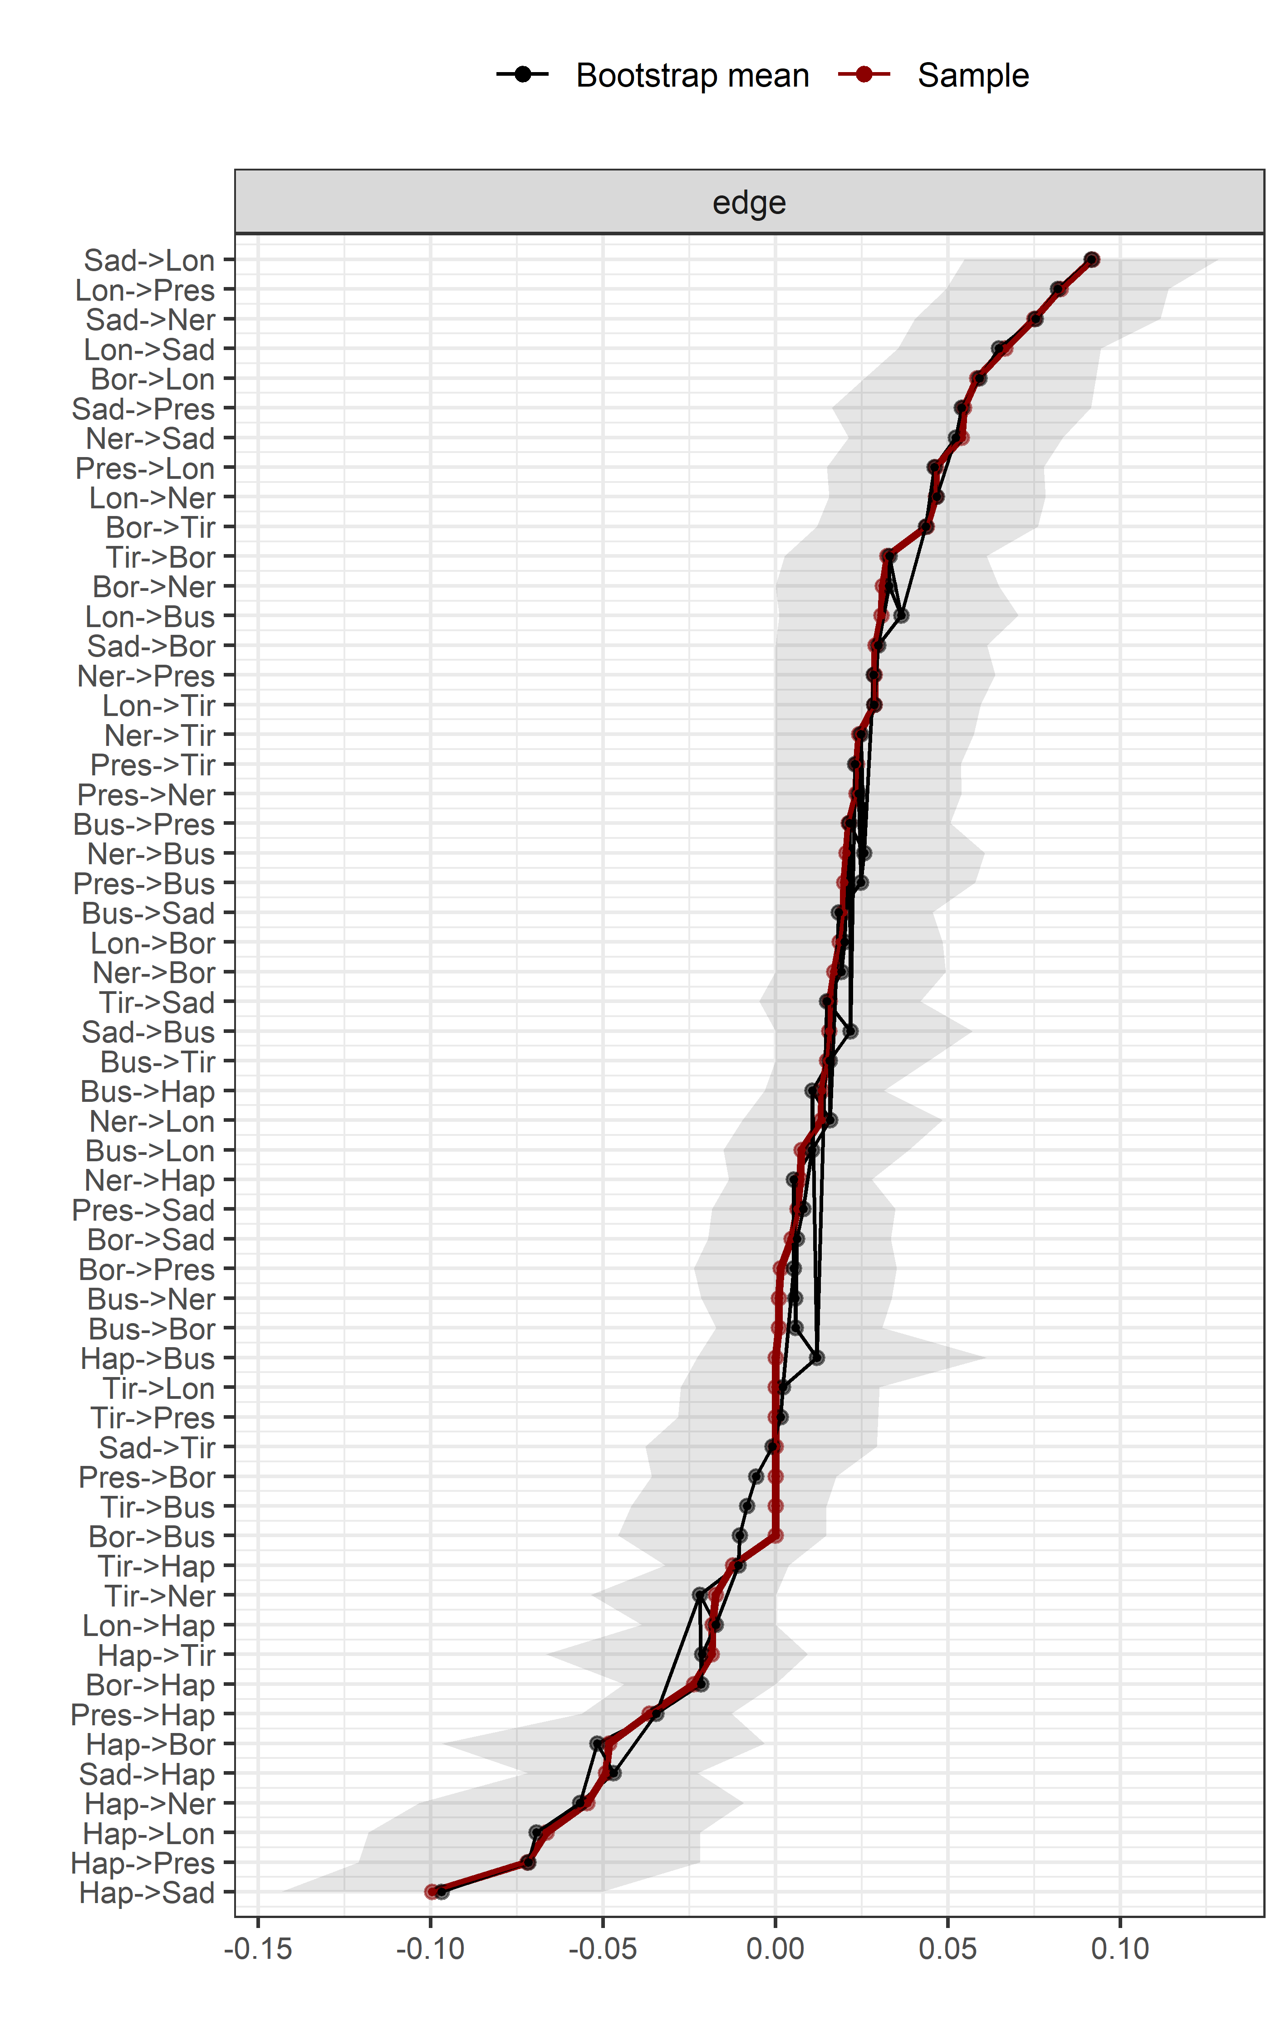
Note. Figure show edge estimate in the sample, the mean edge estimate in the bootstrapped samples and the 95% confidence interval band from the bootstraps edge weights.

References
Gijzen, M. W. M., Rasing, S. P. A., Creemers, D. H. M., Smit, F., Engels, R. C. M. E., & De Beurs, D. (2021). Suicide ideation as a symptom of adolescent depression. A network analysis. Journal of Affective Disorders, 278, 68–77. https://doi.org/10.1016/j.jad.2020.09.029
Gossage, L., Narayanan, A., Dipnall, J. F., Iusitini, L., Sumich, A., Berk, M., Wrapson, W., Tautolo, E.-S., & Siegert, R. (2022). Risk factors for depression in Pacific adolescents in New Zealand: A network analysis. Journal of Affective Disorders, 311, 373–382. https://doi.org/10.1016/j.jad.2022.05.076
Grygiel, P., Dolata, R., Humenny, G., & Muszyński, M. (2023). Depressive symptoms and loneliness among early adolescents: A psychometric network analysis approach. Journal of Child Psychology and Psychiatry, n/a(n/a). https://doi.org/10.1111/jcpp.13876
Kenny, B., Orellana, L., Fuller‐Tyszkiewicz, M., Moodie, M., Brown, V., & Williams, J. (2021). Depression and eating disorders in early adolescence: A network analysis approach. International Journal of Eating Disorders, 54(12), 2143–2154. https://doi.org/10.1002/eat.23627
Kim, D., Kwon, H.-J., Ha, M., Lim, M. H., & Kim, K. M. (2021). Network analysis for the symptom of depression with Children’s Depression Inventory in a large sample of school-aged children. Journal of Affective Disorders, 281, 256–263. https://doi.org/10.1016/j.jad.2020.12.002
Kim, K. M., Kim, H., Kim, D., & Kim, J.-W. (2021). The analysis of network structure among the depressive symptoms in a clinical sample of children and adolescents. Asian Journal of Psychiatry, 62, 102748. https://doi.org/10.1016/j.ajp.2021.102748
Li, K., Guang, Y., Ren, L., Zhan, X., Tan, X., Luo, X., & Feng, Z. (2021). Network analysis of the relationship between negative life events and depressive symptoms in the left-behind children. BMC Psychiatry, 21(1), 429. https://doi.org/10.1186/s12888-021-03445-2
Manfro, P. H., Pereira, R. B., Rosa, M., Cogo-Moreira, H., Fisher, H. L., Kohrt, B. A., Mondelli, V., & Kieling, C. (2021). Adolescent depression beyond DSM definition: A network analysis. European Child & Adolescent Psychiatry. https://doi.org/10.1007/s00787-021-01908-1
Mullarkey, M. C., Marchetti, I., & Beevers, C. G. (2019). Using network analysis to identify central symptoms of adolescent depression. Journal of Clinical Child & Adolescent Psychology, 48(4), 656–668. https://doi.org/10.1080/15374416.2018.1437735
Mullarkey, M. C., Marchetti, I., Bluth, K., Carlson, C. L., Shumake, J., & Beevers, C. G. (2021). Symptom centrality and infrequency of endorsement identify adolescent depression symptoms more strongly associated with life satisfaction. Journal of Affective Disorders, 289, 90–97. https://doi.org/10.1016/j.jad.2021.02.064
Ramos-Vera, C., Quispe Callo, G., Basauri Delgado, M., Vallejos Saldarriaga, J., & Saintila, J. (2023). Factorial and network structure of the Reynolds Adolescent Depression Scale (RADS-2) in Peruvian adolescents. PLOS ONE, 18(5), e0286081. https://doi.org/10.1371/journal.pone.0286081
Schlechter, P., Ford, T., & Neufeld, S. A. S. (2023). Depressive symptom networks in the UK general adolescent population and in those looked after by local authorities. BMJ Mental Health, 26(1), e300707. https://doi.org/10.1136/bmjment-2023-300707
Xie, T., Wen, J., Liu, X., Wang, J., & Poppen, P. J. (2022). Utilizing network analysis to understand the structure of depression in Chinese adolescents: Replication with three depression scales. Current Psychology. https://doi.org/10.1007/s12144-022-03201-z

