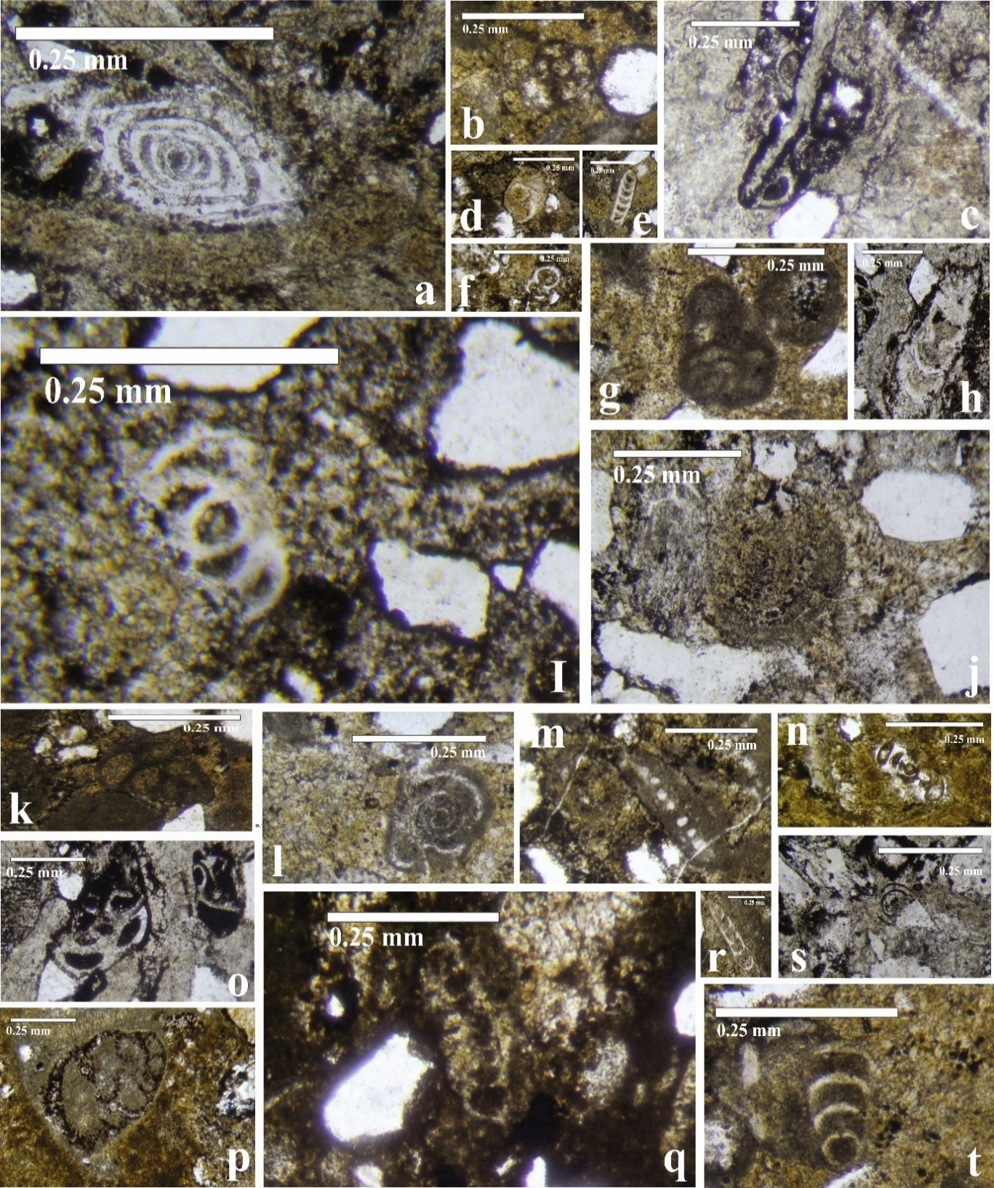
Plate 1
a/ Ophtalmidium exiguum, in examples no. 5,8, 9, 18 Axial section in ig. 3
b/ Duostomina alta, 16,18 Transvers section c/ Planiinvoluta regularis, 6, 9, 15 Longitudinal section
d,t/ Lenticulina sabquadrata, 2, 10, 17, 18 Axial and Tangential section
e/ Nodosaria sumatrensis, 9,11,18 and f/ Nodosaria nitidana, and
r/ Nodosaria shablensis, 16,17, 18 Longitudinal section h/ Rectoglandulina tenuis, 1,7 Longitudinal section
g/ Glomospira sinensis., 18 Axial section m/ Permodiscus planidiscoides, 4,6 Axial section
j/ Triassina hantkeni, 2,10 Transvers section s/ Urnulinella andrusovi 6,7 Axial section in ig. 3
k/ Tetrataxis nana, 5,18 Axial section m/ Permodiscus planidiscoides, 4,6 Axial section
l/ Turrispirillina minima, 6,9,10,18 Axial section i,n,o/ Angulodiscus communis, 6,7 Axial section
p/ Trochammina almtalensis, 18 Axial section q/ Involutina liassica, 9,10 Axial section

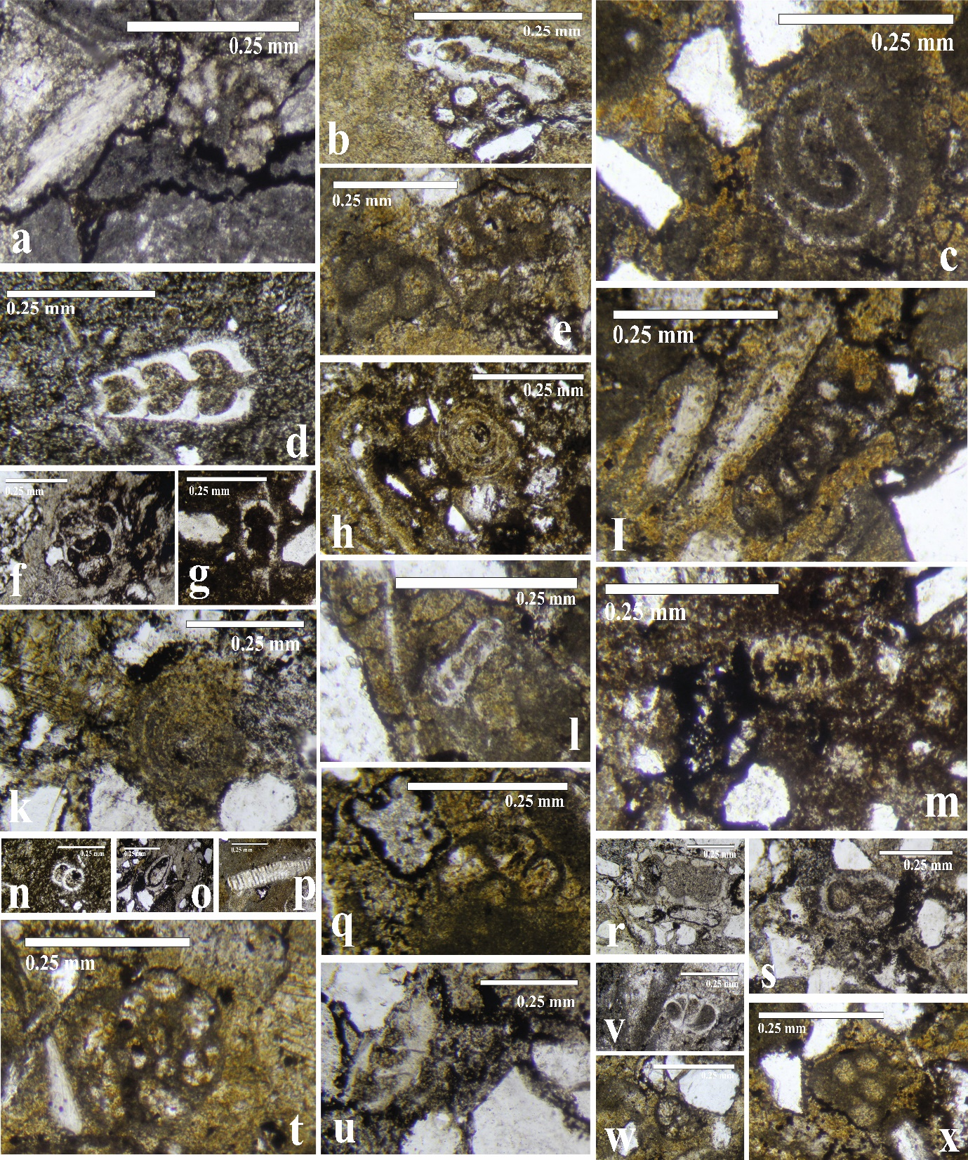
Plate 2
a,t,q / Duostomina alta, Transvers section in examples no. 16,18 in ig. 3
c/ Turrispirillina minima, 6,9,10,18 Axial section d/ Nodosaria dipartitan, and
s,r/ Nodosaria nitidana, Longitudinal section e,w,x/ Tetrataxis nana, 5,18 Longitudinal section f/ Angulodiscus communis Axial section 6,7 g,u/ Rectoglandulina tenuis, 6,7 Longitudinal section k,h/ Triassina hantkeni, Transvers section p/ Algae debries (Acicularia sp.), Longitudinal section
b,l/ Permodiscus minutus, 1,10,17,18 Axial section m/ Involutina liassica, Axial section 9,10
i/ Glomospirella facilis, 18 Axial section v/ Lenticulina sabquadrata, 2,10,17,18 in ig. 3
o/ Double valved bivalve, Axial section

