Supplementary Materials for
Exceptional High-temperature Strength in an Additively Manufactured Al-based Superalloy with Stable Nanoscale Eutectic Cellular Network

Siming Ma^{1,2}, Zhe Chen¹*, Haixing Fang³, Gang Ji⁴, Mingliang Wang¹*, Yuchi Cui¹, Yang Li⁵*, Shengyi Zhong⁵, Han Chen¹, Yi Wu¹, Ying Zhou⁶, Shixin Nie⁶, Jian Lu⁷

¹ School of Materials Science and Engineering, Shanghai Jiao Tong University, Shanghai, People’s Republic of China.
²School of Mechanical Engineering, Shanghai Jiao Tong University, Shanghai, People’s Republic of China.
³European Synchrotron Radiation Facility, 71 Avenue des Martyrs, Grenoble 38043, France.
⁴Univ. Lille, CNRS, INRA, ENSCL, UMR 8207–UMET–Unité Matériaux et Transformations, Lille, France
⁵ SJTU Paris Elite Institute of Technology, Shanghai Jiao Tong University, Shanghai, People’s Republic of China.
⁶Acc Material Technology (Jiangsu) Co., Ltd, Jiangsu, People’s Republic of China.
⁷Center for Advanced Structural Materials, Department of Mechanical Engineering, City University of Hong Kong, Kowloon, Hong Kong, People’s Republic of China.

* To whom correspondence should be addressed. zhe.chen@sjtu.edu.cn (Z. Chen), mingling_wang@sjtu.edu.cn (M.L. Wang), and liyang772@sjtu.edu.cn (Y. Li)

This file includes:
Supplementary Text
Figs. S1 to S8
Tables S1 to S6
References

Supplementary Text
DFT calculations for interfacial properties
Based on the convergence test of the DFT calculations proposed in the Method, six-layer Al(001) slabs, six-layer Al-terminated Al₃Sc (001) slabs, and six-layer Al₁₁La₃(100) slabs were used to construct Al(001)//Al₁₁La₃(100) and Al₃Sc (001)//Al₁₁La₃(100) interface supercell models.

The work of adhesion (W_{ad}) was calculated as ¹

$$W_{ad}=\frac{1}{A}(E_{Al\left({Al}_{3}Sc\right)}+E_{{Al}_{11}{La}_{3}}-E_{interface})$$ | (S1)

where $E_{Al\left({Al}_{3}Sc\right)}$ and $E_{{Al}_{11}{La}_{3}}$ denote the total energies of a six-layer Al(001) surface (or Al₃Sc (001) surface) and a six-layer Al₁₁La₃(100) surface with the same lattice parameters as the interface models, respectively. $E_{interface}$ refers to the total energy of the fully relaxed interface model. $A$ is the total area of interface regions.

The interfacial energy (γ) was determined as ¹

$$γ=σ_{{Al}_{11}{La}_{3}}+σ_{Al\left({Al}_{3}Sc\right)}-W_{ad}$$ | (S2)

where $σ_{Al\left({Al}_{3}Sc\right)}$ and $σ_{{Al}_{11}{La}_{3}}$ denote the surface energies of Al, Al₃Sc and Al₁₁La₃ according to their ORs, respectively.

Calculations for phase lattice strain and stress partitioning from in-situ SXRD test
To estimate the phase lattice strain and stress partitioning during the uniaxial tensile loading, only lattice deformation along the loading direction (LD) was analysed, with transverse strain effects considered negligible, as assumed in related works^{2,3}. For integration, 10° cake segments positioned with an azimuthal angle of 0° ± 5° and 180° ± 5° (Fig. S5c) on the 2D diffraction images were used to produce intensity–2θ diffraction spectra along the LD ⁴.

For the Al₁₁La₃ phase, the crystallographic orientation-dependent strains were calculated using Eq. S3, and the three strongest peaks (101), (130), and (132) were considered as references.

$$ε_{hkl}=\frac{{\sin{θ}}_{hkl,0}}{{\sin{θ}}_{hkl}}-1$$ | (S3)

where $ε_{hkl}$ is the {hkl} lattice strain of Al₁₁La₃, $θ_{hkl}$ is the peak position angle, and subscript 0 indicates the reference condition at zero applied stress.

The average phase strain of α-Al was determined by Rietveld refinement, estimated as ^{3,5}

$$ε_{Al}=\frac{a^{Al}}{a_{0}^{Al}}-1$$ | (S4)

where $a_{0}^{Al}$ is the reference lattice parameter measured after the holding time prior to loading at the target temperature. Assuming uniaxial deformation, the axial phase stress of α-Al was estimated as ^{3,5}

$$σ_{Al}=E_{Al}ε_{Al}$$ | (S5)

where $E_{Al}$ is the elastic diffraction modulus, considered approximately equal to the Young’s modulus of Al (70 GPa at RT and 60 GPa at 300 °C ⁶).

Given the low lattice symmetry of the Al₁₁La₃ crystal (orthorhombic, group: Immm) and its relatively low diffraction intensity, especially at elevated temperatures, precise lattice strain determination is challenging. Therefore, we estimated the average phase stress of the Al₁₁La₃ phase based on the rule of mixtures, as shown in Eq. S6 ²:

$$σ_{{Al}_{11}{La}_{3}}=\frac{σ_{apply}-σ_{Al}f_{Al}}{f_{{Al}_{11}{La}_{3}}}$$ | (S6)

where $σ_{apply}$ is the applied stress, and $f_{Al}$ and $f_{{Al}_{11}{La}_{3}}$ denote the phase volume fractions. As La exists mainly in the form of Al₁₁La₃ phase, $f_{{Al}_{11}{La}_{3}}$ was calculated from the chemical composition of the LPBF AlLaScZr alloy as 11.9%. Neglecting the minor alloying of Sc and Zr, $f_{Al}$ was determined to be approximately 88.1%.

Work-hardening behaviours described using the K–M model
The Kocks–Mecking (K–M) model is used to derive the evolution equation of the total dislocation density ρ derived from the storage and dynamic recovery effects of dislocations, as indicated in Eq. S7 ^{7–9}.

$$\frac{dρ}{dε}=k_{1}\sqrt{ρ}-k_{2}ρ$$ | (S7)

$θ$ is the work hardening rate:

$$θ=\frac{dσ}{dε}$$ | (S8)

$θ_{0}$ refers to the initial work hardening rate, determined as the intersection of the extension of the linear portion of the strain hardening curve with the y-axis

$$θ_{0}=\frac{αGbM^{2}k_{1}}{2}$$ | (S9)

The slope of the work hardening rate curve can be calculated as

$$\frac{dθ}{dσ}=-\frac{θ_{0}}{σ_{s}}=-\frac{Mk_{2}}{2}$$ | (S10)

where $θ_{0}$ is the initial work hardening rate, and $σ_{s}$ is the saturated stress. The experimental tensile stress–strain curves are subjected to quintic polynomial fitting, as shown in Fig. S7a. Subsequently, the work hardening rate is calculated as a function of the true plastic strain and flow stress, as shown in Figs. S7b and S7c, respectively, to determine the values of parameters $k_{1}$ and $k_{2}$ from Eqs. S9 and S10.

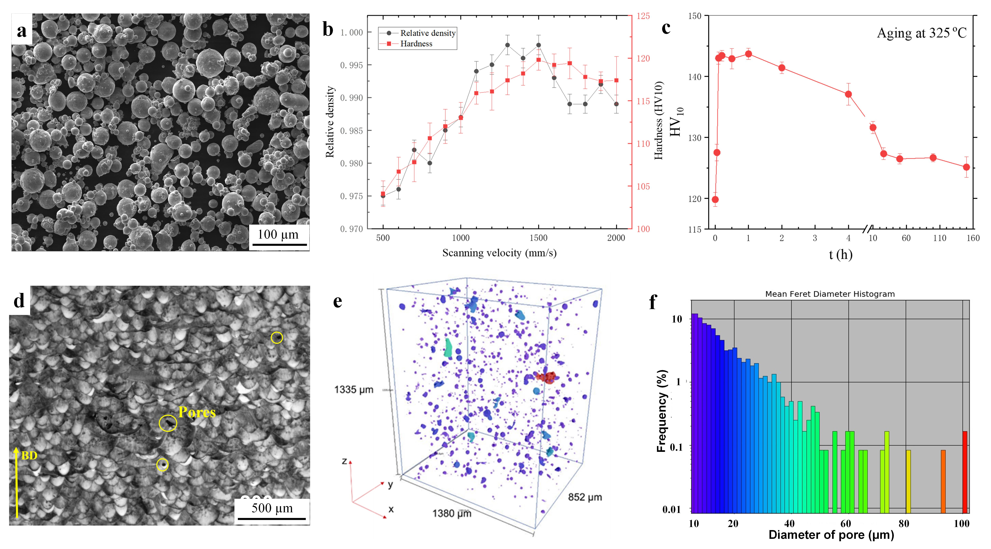Fig. S1. a SEM image of AlLaScZr alloy feedstock powders; b Relative density and hardness of the as-built samples with different scanning velocities under a laser power of 190 W; c Hardness evolution of the LPBF AlLaScZr alloy at different ageing times at a constant temperature of 325 °C; d OM image showing the microstructure from the cross-section of the LPBF AlLaScZr alloy; e Micro-CT scan showing the internal pores of the LPBF AlLaScZr alloy (z-axis indicates the BD); f Diameter distribution of the pores.

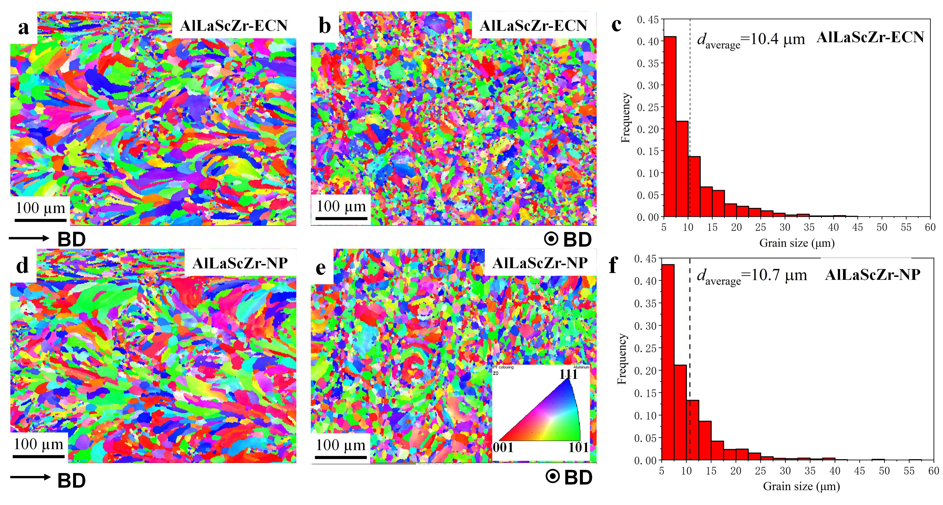
Fig. S2. EBSD IPF images of the AlLaScZr-ECN alloy a along BD and b perpendicular to BD with c the grain size distribution. EBSD IPF images of the AlLaScZr-NP alloy d along BD and e perpendicular to BD with f the grain size distribution

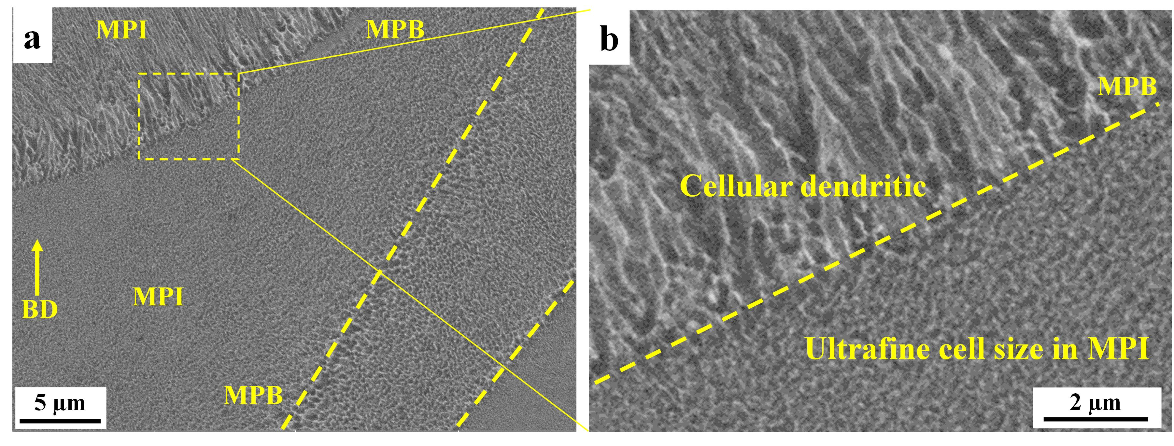
Fig. S3. a BSE image revealing the subgrain ECN across several MPBs and b locally magnified view of the rectangular region in a.
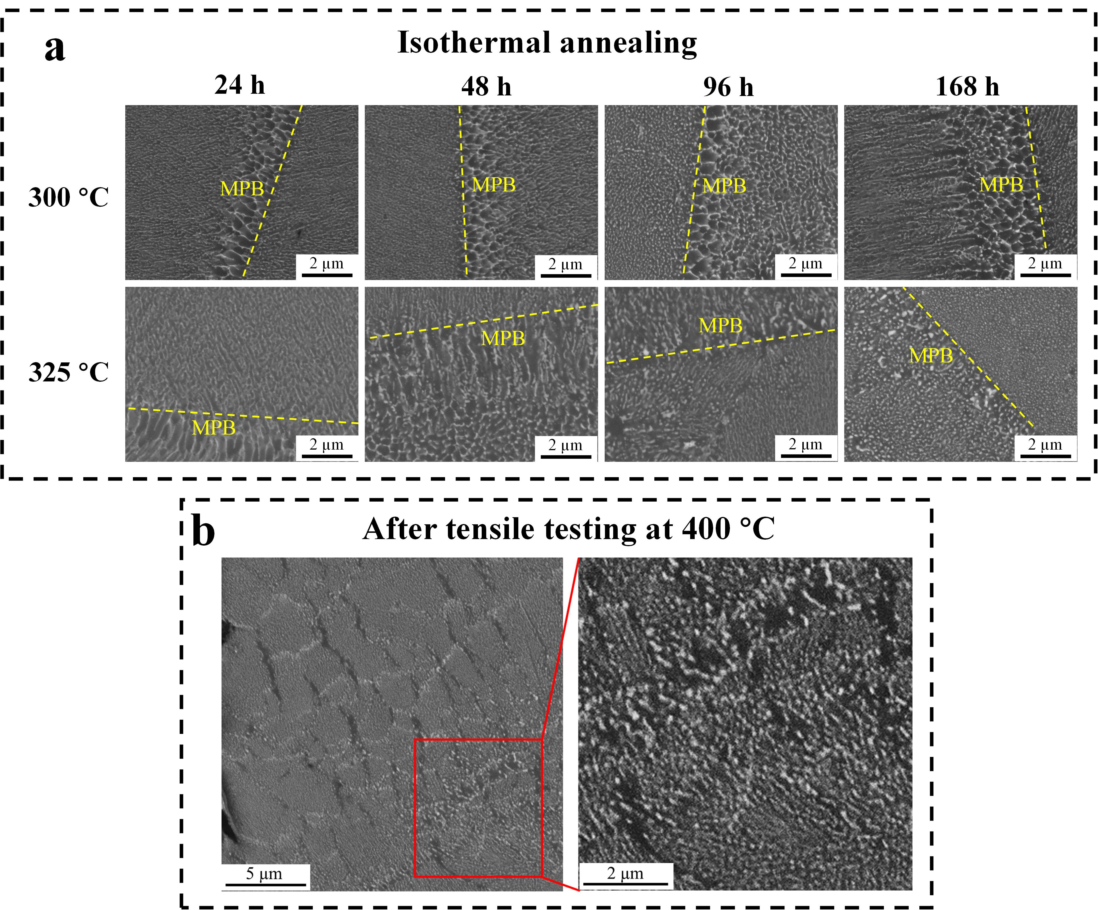
Fig. S4. a Evolution of the ECN upon isothermal annealing of the AlLaScZr-ECN alloy for different times at 300 °C and 325 °C; b Microstructure near the fracture surface of the AlLaScZr-ECN alloy after tensile testing at 400 °C, along with the locally magnified region.

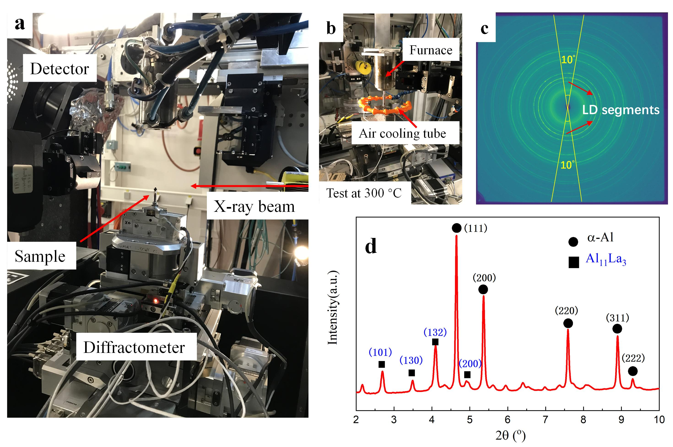
Fig. S5. a SXRD facilities with b the furnace and air-cooling tube for tests at elevated temperatures; c 2D diffraction image of the SXRD; d corresponding intensity–2θ diffraction spectrum integrated from the LD segment in c.

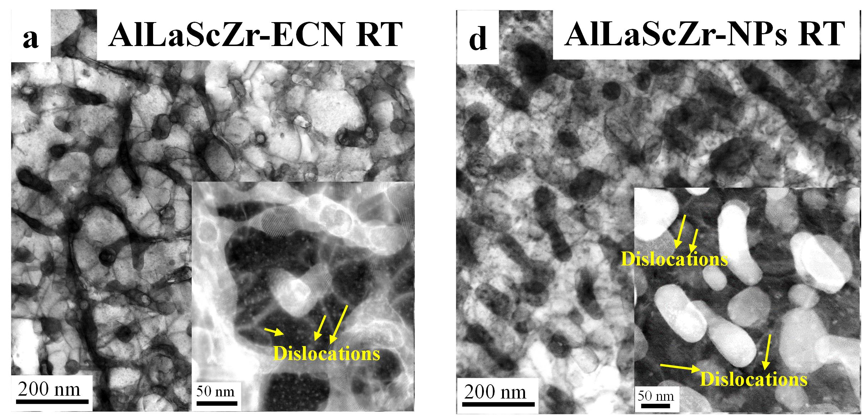
Fig. S6. STEM-BF image showing the dislocations in the α-Al cells in the a AlLaScZr-ECN and b AlLaScZr-NP alloys under RT tensile testing at ε = 2 %; inset shows the corresponding higher-magnification STEM-HAADF image.

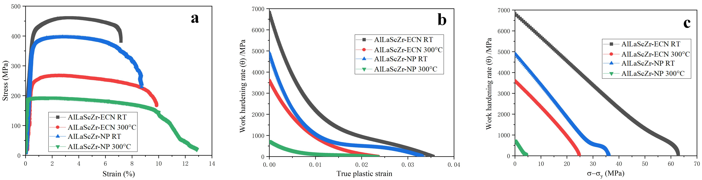
Fig. S7. a Comparisons of tensile stress–strain curves of the AlLaScZr-ECN and AlLaScZr-NP alloys at RT and 300 °C; b, c Corresponding work hardening rate versus the true plastic strain and flow stress for these samples, respectively.

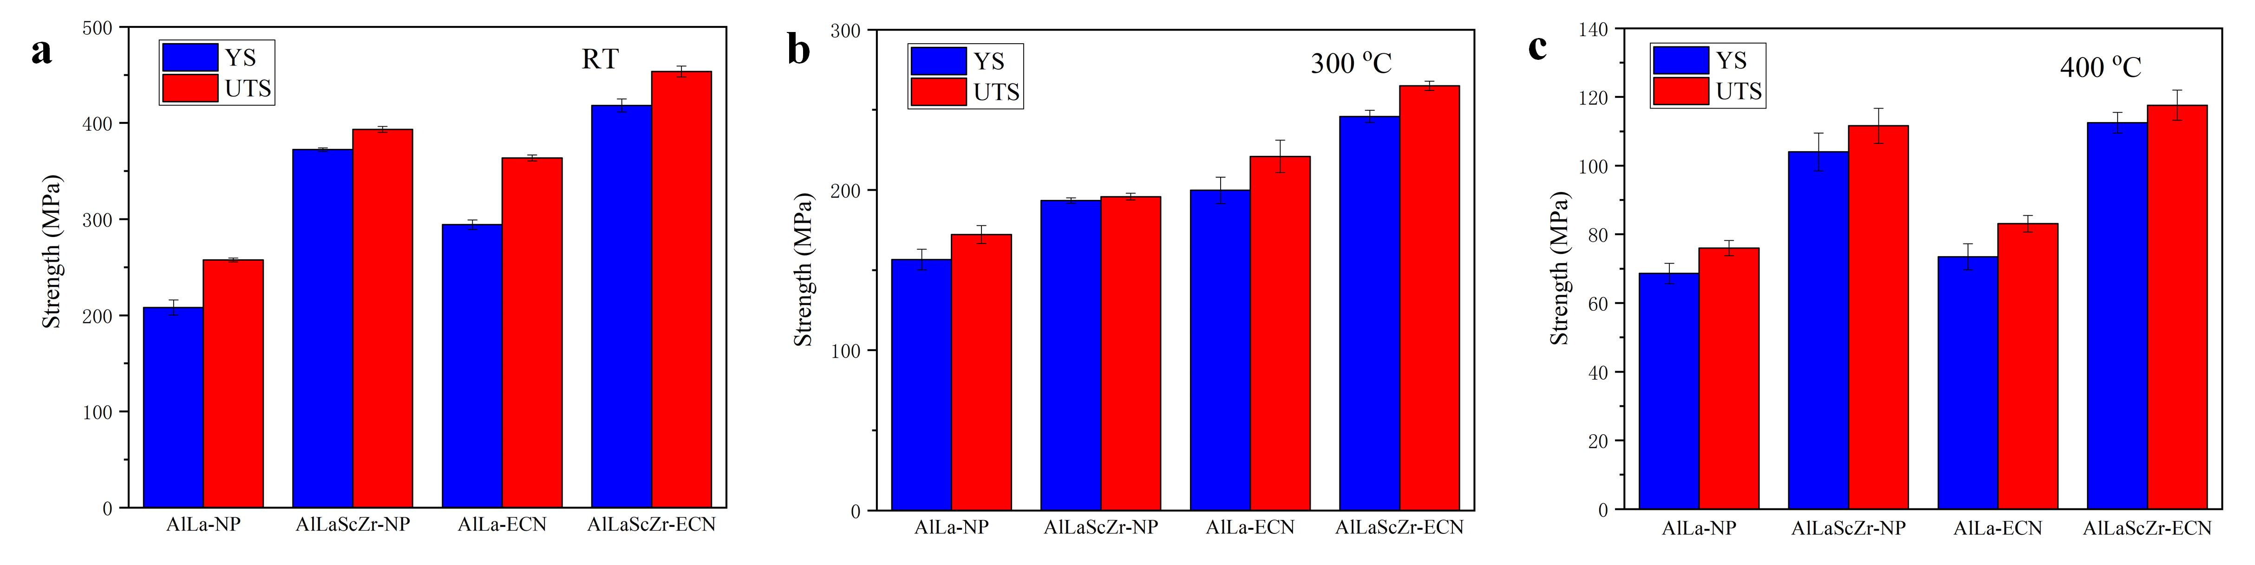
Fig. S8. Comparison of tensile YS and UTS for the LPBF AlLaScZr and AlLa alloys at a RT, b 300 °C, and c 400 °C.

Table S1. Chemical composition of the feedstock powders and LPBF-printed bulk samples of AlLaScZr and AlLa alloys.

Wt.% |  | La | Sc | Zr | Al
AlLaScZr | Powder | 9.77 | 0.456 | 0.258 | Bal.
AlLaScZr | LPBF bulk sample | 9.78 | 0.460 | 0.259 | Bal.
Al-La | Powder | 9.83 | 0.003 | <0.001 | Bal.
Al-La | LPBF bulk sample | 9.85 | 0.004 | <0.001 | Bal.

Table S2. Orientation relationships and interface coherency of α-Al, Al₃Sc, and Al₁₁La₃ in the LPBF AlLaScZr alloy by DFT calculations.

ORs | Al (or Al₃Sc) slab |  | Al₁₁La₃ slab |  | Lattice  mismatch | Coherency
ORs | Lattice vector | Length/Å | Lattice vector | Length/Å | Lattice  mismatch | Coherency
Al[001] // Al₁₁La₃ [010]  Al(200) // Al₁₁La₃ (200) | (0 0 5) | 20.19 | (0 2 0) | 20.29 | +0.0050 | High
Al₃Sc[001] // Al₁₁La₃ [010]  Al₃Sc(200) // Al₁₁La₃ (200) | (0 0 5) | 20.54 | (0 2 0) | 20.29 | -0.0122 | High

Table S3. Work of adhesion (W_{ad}) and interfacial energy (γ) between α-Al, Al₃Sc, and Al₁₁La₃ phases by DFT calculations according to the ORs in Table S2.

Interfaces | $$E_{{Al}_{11}{La}_{3}/Al\left({Al}_{3}Sc\right)}$$ | $$E_{{Al}_{11}{La}_{3}}$$ | $$E_{Al\left({Al}_{3}Sc\right)}$$ | $$A$$ | $$W_{ad}$$ | $$σ_{{Al}_{11}{La}_{3}}$$ | $$σ_{Al\left({Al}_{3}Sc\right)}$$ | $$γ$$
Unit | eV | eV | eV | Å² | J·m⁻² | J·m⁻² | J·m⁻² | J·m⁻²
Al₁₁La₃/Al | -1368.31 | -702.94 | -641.22 | 255.63 | 1.51 | 0.99 | 0.97 | 0.45
Al₁₁La₃/Al₃Sc | -1551.92 | -703.02 | -821.93 | 259.90 | 1.66 | 0.99 | 1.33 | 0.66

Table S4. Parameters for the CLS and F–R models indicated in Eqs. 1 and 2^{10,11} in the main text.

Parameter | Symbol | Value
Taylor factor | M | 3.06
Magnitude of Burgers vector | b | 0.286 nm
Poisson ratio | υ | 0.33
Core cut-off parameter | α | 0.2

Table S5. Fitting results of the K–M dislocation models based on the experimental tensile stress–strain curves in Fig. S7a.

Sample | $$θ_{0}$$ | $k_{1}$ (10⁸ m⁻¹) | $$k_{2}$$
RT tensile | 6823.97 | 6.69 | 74.82
Anneal-RT tensile | 4910.78 | 4.81 | 96.01
300 °C tensile | 3602.55 | 4.15 | 80.33
Anneal-300 °C tensile | 720.91 | 0.83 | 123.77

Table S6. Mechanical properties of LPBF AlLaScZr and LPBF AlLa alloys without Sc, Zr micro-alloying at different conditions and testing temperatures.

Sample | Testing temperature /°C | YS /MPa | UTS /MPa | El. /%
AlLaScZr-ECN | RT | 418.2 ± 6.9 | 453.5 ± 5.7 | 6.9 ± 0.6
AlLaScZr-ECN | 300 | 245.9 ± 3.8 | 265.0 ± 2.9 | 7.0 ± 2.0
AlLaScZr-ECN | 400 | 112.5 ± 3.0 | 117.6 ± 4.4 | 4.3 ± 0.6
AlLaScZr-NP | RT | 372.3 ± 1.9 | 393.4 ± 3.1 | 10.2 ± 1.5
AlLaScZr-NP | 300 | 193.4 ± 1.7 | 195.8 ± 2.1 | 13.6 ± 0.9
AlLaScZr-NP | 400 | 104.0 ± 5.5 | 111.6 ± 5.1 | 8.7 ± 1.7
AlLa-ECN | RT | 294.2 ± 5.0 | 363.6 ± 3.1 | 5.4 ± 0.4
AlLa-ECN | 300 | 199.8 ± 8.2 | 220.9 ± 10.1 | 2.5± 0.3
AlLa-ECN | 400 | 73.5 ± 3.8 | 83.1 ± 2.4 | 4.8± 1.1
AlLa-NP | RT | 208.1 ± 8.0 | 257.5 ± 2.0 | 14.7 ± 2.6
AlLa-NP | 300 | 156.6 ± 6.4 | 172.2 ± 5.6 | 5.1 ± 0.8
AlLa-NP | 400 | 68.6 ± 3.0 | 76.0 ± 2.2 | 6.6 ± 0.8

References
1. Zhang, W. & Smith, J. Stoichiometry and adhesion. Phys. Rev. B - Condens. Matter Mater. Phys. 61, 16883–16889 (2000).
2. Sims, Z. C. et al. High performance aluminum-cerium alloys for high-temperature applications. Mater. Horizons 4, 1070–1078 (2017).
3. Yi, M. et al. Atomic-scale compositional complexity ductilizes eutectic phase towards creep-resistant Al-Ce alloys with improved fracture toughness. Acta Mater. 276, 120133 (2024).
4. Zhang, X. X. et al. Evolution of microscopic strains, stresses, and dislocation density during in-situ tensile loading of additively manufactured AlSi10Mg alloy. Int. J. Plast. 139, 1–22 (2021).
5. Bahl, S. et al. An additively manufactured near-eutectic Al-Ce-Ni-Mn-Zr alloy with high creep resistance. Acta Mater. 268, 119787 (2024).
6. Seidman, D. N., Marquis, E. A. & Dunand, D. C. Precipitation strengthening at ambient and elevated temperatures of heat-treatable Al(Sc) alloys. Acta Mater. 50, 4021–4035 (2002).
7. Estrin, Y. & Mecking, H. A unified phenomenological description of work hardening and creep based on one-parameter models. Acta Metall. 32, 57–70 (1984).
8. Kocks, U. F. Laws for Work-Hardening and Low-Temperature Creep. J. Eng. Mater. Technol. 98, 76–85 (1976).
9. Chen, X. et al. Insights into flow stress and work hardening behaviors of a precipitation hardening AlMgScZr alloy: Experiments and modeling. Int. J. Plast. 172, 1–24 (2024).
10. Fuller, C. B., Seidman, D. N. & Dunand, D. C. Mechanical properties of Al(Sc,Zr) alloys at ambient and elevated temperatures. Acta Mater. 51, 4803–4814 (2003).
11. Misra, A., Hirth, J. P. & Hoagland, R. G. Length-scale-dependent deformation mechanisms in incoherent metallic multilayered composites. Acta Mater. 53, 4817–4824 (2005).

