Supplementary

Preserving exposed hydrophilic bumps on multi-bioinspired slippery surface arrays unlocks high-efficiency fog collection and cleaning
Junda Wu, Chunxiang Li, Jiangdong Dai*, Yan Yan*
Institute of Green Chemistry and Chemical Technology, School of Chemistry and Chemical Engineering, Jiangsu University, Zhenjiang, 212013, China

*Corresponding Authors:
Dr. Jiangdong Dai: daijd@ujs.edu.cn
Prof. Yan Yan : dgy5212004@163.com

This file includes:
Supplementary Figures 1-30
Supplementary Tables 1-2
Supplementary Videos 1-4
Supplementary References

Supplementary Figures
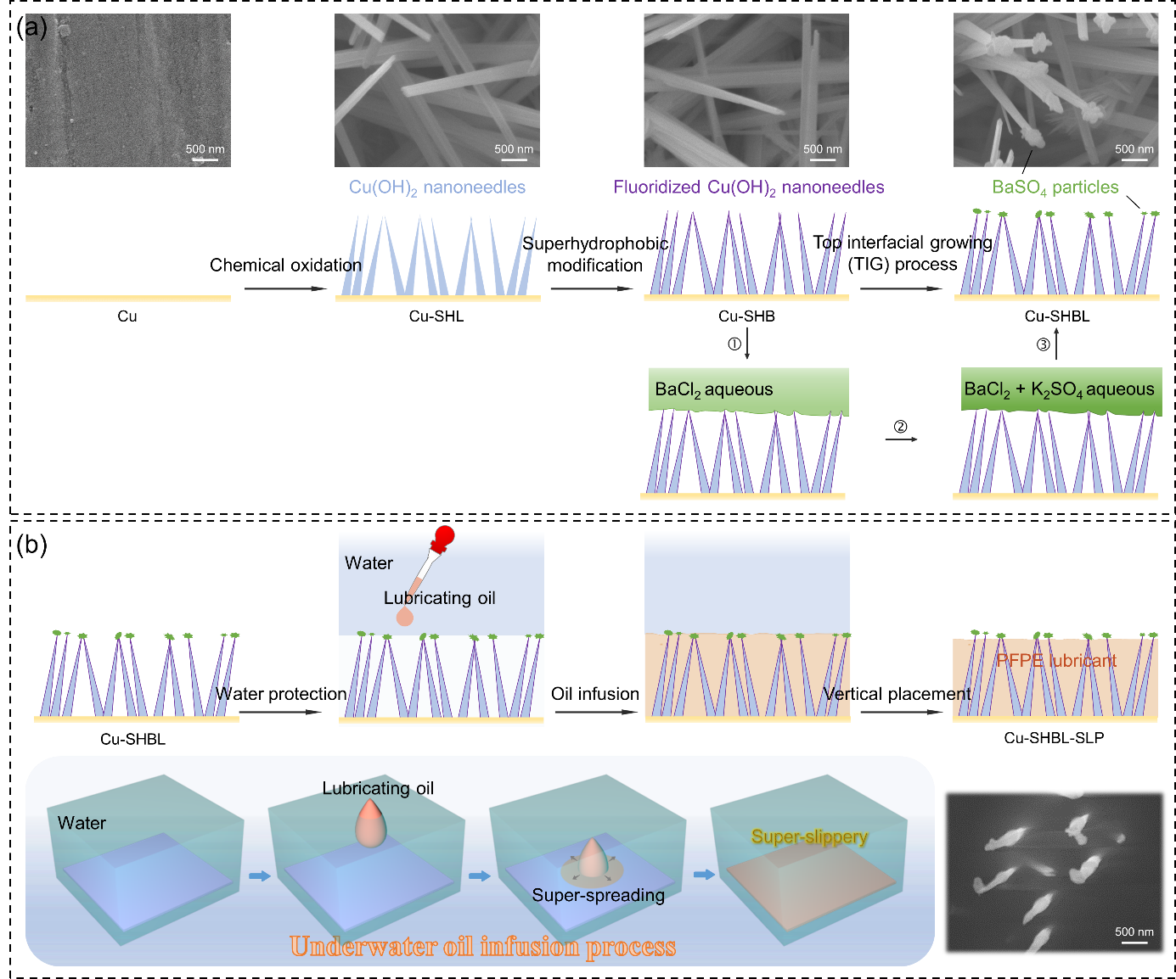
Supplementary Figure S1. Schematic illustration of the sample preparation process. (a) Preparation of Cu-SHBL film substrate. (b) Underwater PFPE lubricating oil infusion of Cu-SHBL film. The whole fabrication process was based on the unique surface wettability of the sample surface. Cu sheet was as the substrate and chemical oxidated and fluorinated to obtain the superhydrophobic Cu/Cu(OH)₂ nanorods (Cu-SHB). Take the advantage of strong water repellence of Cu-SHB, top interfacial growing (TIG) process was first proposed. The prepared BaCl₂ aqueous was firstly poured onto the surface of Cu-SHB film within a glass tube, enabled the aqueous could only contact the top of nanorods due to the high superhydrophobic of Cu(OH)₂ nanorods. Then K₂SO₄ solution was gently introduced to realize the growth of BaSO₄ precipitate on the top of superhydrophobic nanorods. This process was conducted within a maximum of eight cycles to obtain Cu-SHBL film with various Ba contents (characterized by the EDS analysis in Supplementary Table S1). Subsequently, the prepared Cu-SHBL was forced underwater and conducted the PFPE lubricating oil infusion process. The hydrophilic components could attract water molecules in aqueous environment, and performed superoleophobicity underwater¹. Therefore, during the underwater lubricant infusion process, the lubricating oil could be repelled by BaSO₄ hydrophilic bumps and kept spherical underwater, which provided maximal Laplace pressure (P_{L}) driven by the beneath nanorods (Scheme 1b). Meanwhile, compared to conventional oil infusion in air, the proposed underwater lubricating oil infusion could provide additional water hydrostatic pressure (P_{H}) underwater. Once the total force of P_{L} and P_{H} larger than the intrusion pressure (P_{I}), the lubricating oil could contact to the superoleophilic nanorods below, and rapidly permeate and spread among the nanorod arrays, which was mainly subjected to the capillary pressure (P_{C}) additionally, contributed to the stable and impacted SLIPS.

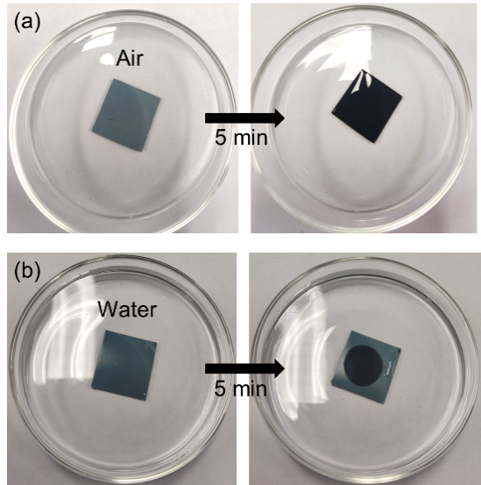
Supplementary Figure S2. Optimal images comparation. (a) The Cu-SHBL as the substrate and conducted the PFPE lubricating oil infusion tests in air and (b) in water conditions, respectively. After infusing a small and equivalent amount of PFPE lubricating oil, the oil could spread among the surface layer in air condition, while only wet and spread on the limited area in water condition. This phenomenon explained that more lubricating oil could be obtained when infusing sufficient PFPE lubricating oil in water condition compared to the air-infusion counterpart.

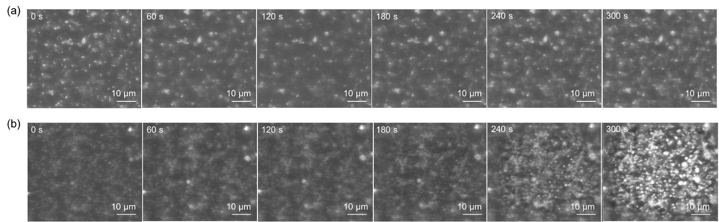
Supplementary Figure S3. Fog capture process observed by ESEM. (a) E-SEM images of Cu-SHB-SLP and (b) Cu-SHBL-SLP film (details of the process see Supplementary Movie S1 and 2). The temperature was reduced to –1 ± 0.5°C, and the pressure was set as 600 Pa during the ESEM tests. All the images and videos were captured at the same temperature and pressure conditions. The water droplets could be condensed and captured on the Cu-SHBL-SLP film surface at around 240 s. As a comparation, there was no obvious change on the Cu-SHB-SLP film surface, which indicated that the hydrophilic BaSO₄ component was liable to capture tiny water droplets in such conditions.

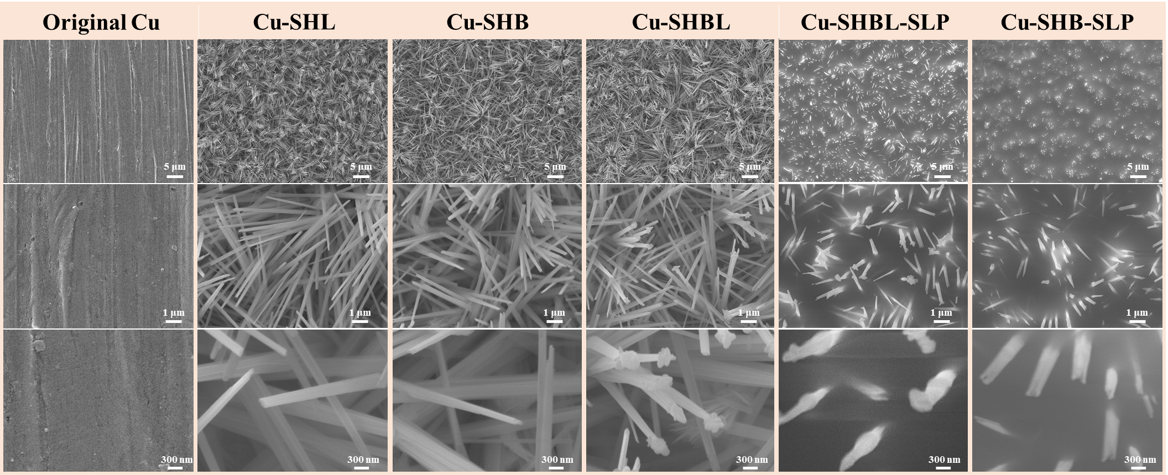
Supplementary Figure S4. Surface morphology analysis. The surface of the original Cu sheet was smooth. After the chemical etching, the Cu(OH)₂ nanorod arrays could be formed and named as Cu-SHL film. The PFTS superhydrophobic modification could not change the surface morphology and remained the shape of nanorods, which was named as Cu-SHB film. Through TIG process, the BaSO₄ nanoparticles could be formed on the top of Cu(OH)₂ nanorods, and named as Cu-SHBL film. After the underwater PFPE lubricating oil infusion, the interspace of nanorod arrays were filled with oil, while the hydrophilic BaSO₄ nanoparticles were intact and remained well on the top of nanorods, and named as Cu-SHBL-SLP. As a comparation, the Cu-SHB film without BaSO₄ particles was also infused lubricant underwater, and named as Cu-SHB-SLP film.

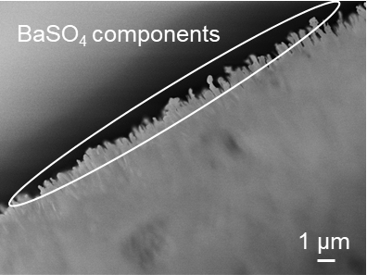
Supplementary Figure S5. Cross-sectional morphology of the Cu-SHBL film. The BaSO₄ particles components were successfully deposited onto the top of fluorinated Cu(OH)₂ nanorods via proposed TIG process..
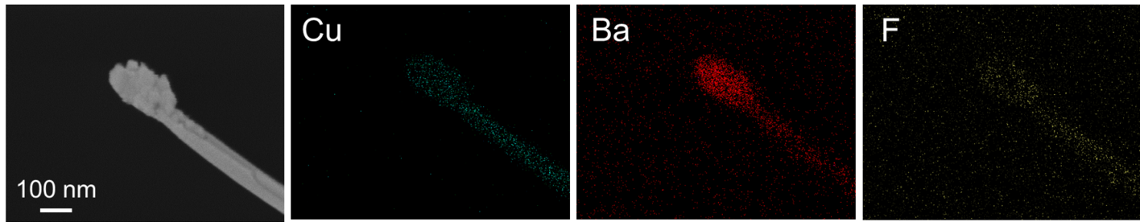
Supplementary Figure S6. EDS mapping images of Cu-SHBL film. The Ba element was concentrate on the top of fluorinated Cu(OH)₂ nanorod, indicated that the BaSO₄ component was successfully fabricated on the top via TIG process.

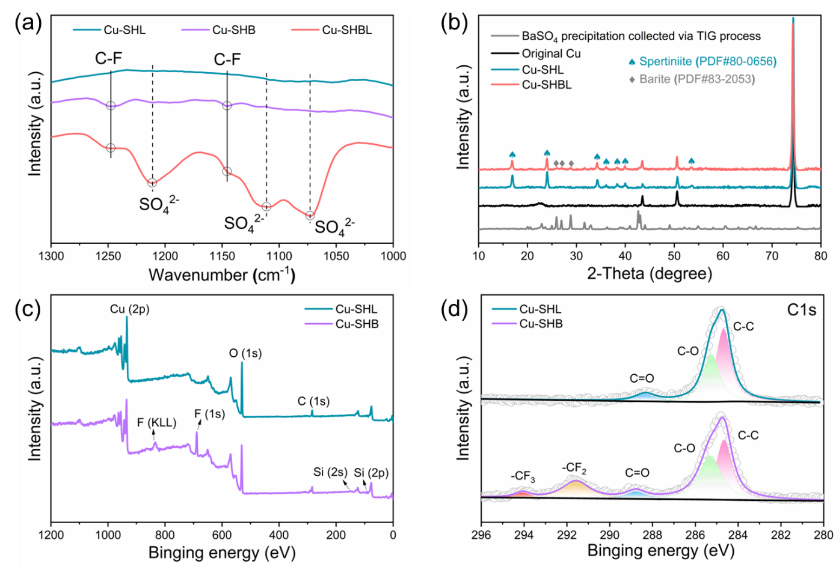
Supplementary Figure S7. Chemical components analysis. (a) FTIR spectrums of Cu-SHL, Cu-SHB and Cu-SHBL film, (b) XRD patterns of BaSO₄ deposition, original Cu, Cu-SHL and Cu-SHBL film, (c) XPS spectra of Cu-SHL and Cu-SHB film, (d) C1s spectra of Cu-SHL and Cu-SHB film. The peaks at 1247.43 and 1145.28 cm⁻¹ were attributed to the stretching vibration of C-F. The peaks at 1211.44, 1109.51 and 1072.96 cm⁻¹ were ascribed to the symmetrical vibrations of sulfate radical² (Supplementary Figure S7a). Meanwhile, the abundant characteristic peaks of hydroxyl groups in the FTIR spectrum might be the main reason of the superhydrophilic and underwater superoleophobic property of BaSO₄ sediment particles (Supplementary Figure S8 and S9). The C1s XPS spectra of Cu-SHL film could be deconvoluted into three peaks at 284.68, 285.25 and 288.34 eV, which was assigned to the C-C, C-O and C=O groups, respectively. On the contrast, two additional peaks at 291.58 and 294.07 eV in C1s XPS spectrum of Cu-SHB film were ascribed to the -CF₂ and -CF₃ groups, indicated that the Cu/Cu(OH)₂ film was successfully modified by PFTS³. In the X-ray diffraction (XRD) patterns (Supplementary Figure S7b), the peaks at 43.5, 50.6 and 74.3° were assigned to the characteristic peaks of the original Cu sheet. The peaks located at 16.9, 24.0, 34.3, 36.1, 38.4, 40.0 and 53.6° were ascribed to the Spertiniite (PDF#80-0656) of Cu(OH)₂ nanorods, indicated that the Spertiniite crystal could be formed via chemical etching of red copper. Meanwhile, the peaks at 26.1, 27.0 and 28.6° were attributed to the Barite crystal (PDF#83-2053), confirmed the BaSO₄ component was successfully constructed on the Cu(OH)₂ nanorods top surface. These surface chemical characterization results indicated that the BaSO₄ deposition was successfully fabricated on the top of fluoroalkylated Cu(OH)₂ nanorods.
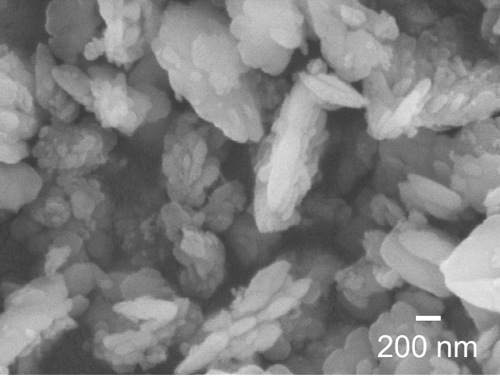
Supplementary Figure S8. Morphology of BaSO₄ precipitation particles. The BaSO₄ precipitation was collected in the solution during the TIG process, and the size was coincidence with the prepared BaSO₄ component particles on the nanorods top.

Supplementary Figure S9. FTIR spectrum of BaSO₄ precipitation particles. BaSO₄ precipitation particles was collected during the TIG process. The abundant hydroxyl group was the main reason for its hydrophilic.

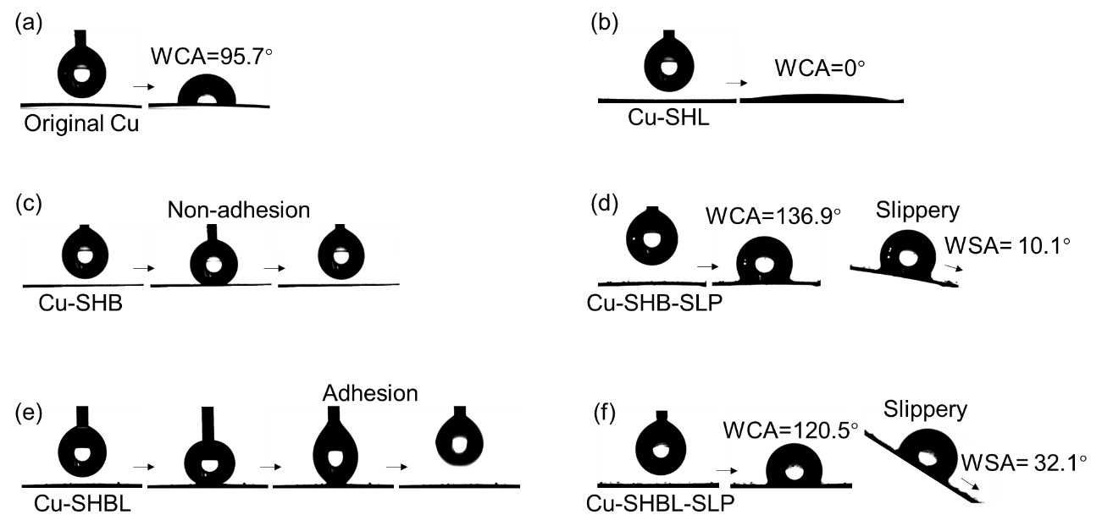
Supplementary Figure S10. Surface wettability analysis. The water contact angle (WCA) and water sliding angle (WSA) of the prepared samples: (a) original Cu, (b) Cu-SHL, (c) Cu-SHB, (d) Cu-SHB-SLP, (e) Cu-SHBL and (f) Cu-SHBL-SLP film. The original Cu sheet was hydrophobic with the WCA at 95.7°. Then the WCA changed from 95.7° to 0° owing to the high surface energy and nanosized roughness of Cu(OH)₂ nanorod arrays. The modification of PFTS transformed the superhydrophilic Cu-SHL to superhydrophobic Cu-SHB film while the surface remained intact, which was mainly ascribed to the molecular scale interaction between Cu(OH)₂ and PFTS components (Supplementary Figure S11). The water droplet even could not adhere onto the surface under external force, performed lotus-like superhydrophobic state. As a contrast, the water adhesion phenomenon on the Cu-SHBL surface was obvious under the external force, and the surface transformed to the rose petal-like superhydrophobic state. And its reflective state also could be observed underwater (Supplementary Figure S12). After the infusion of PFPE lubricating oil underwater, the WCA and WSA of Cu-SHBL-SLP were 120.5° and 32.1°, respectively. As for the Cu-SHB-SLP, there was no hydrophilic bumps on the top of nanorods, and the corresponding WCA and WSA were 136.9° and 10.1°, respectively, indicated that the design of hydrophilic bumps and SLIPS could be realized via unique underwater oil infusion process.

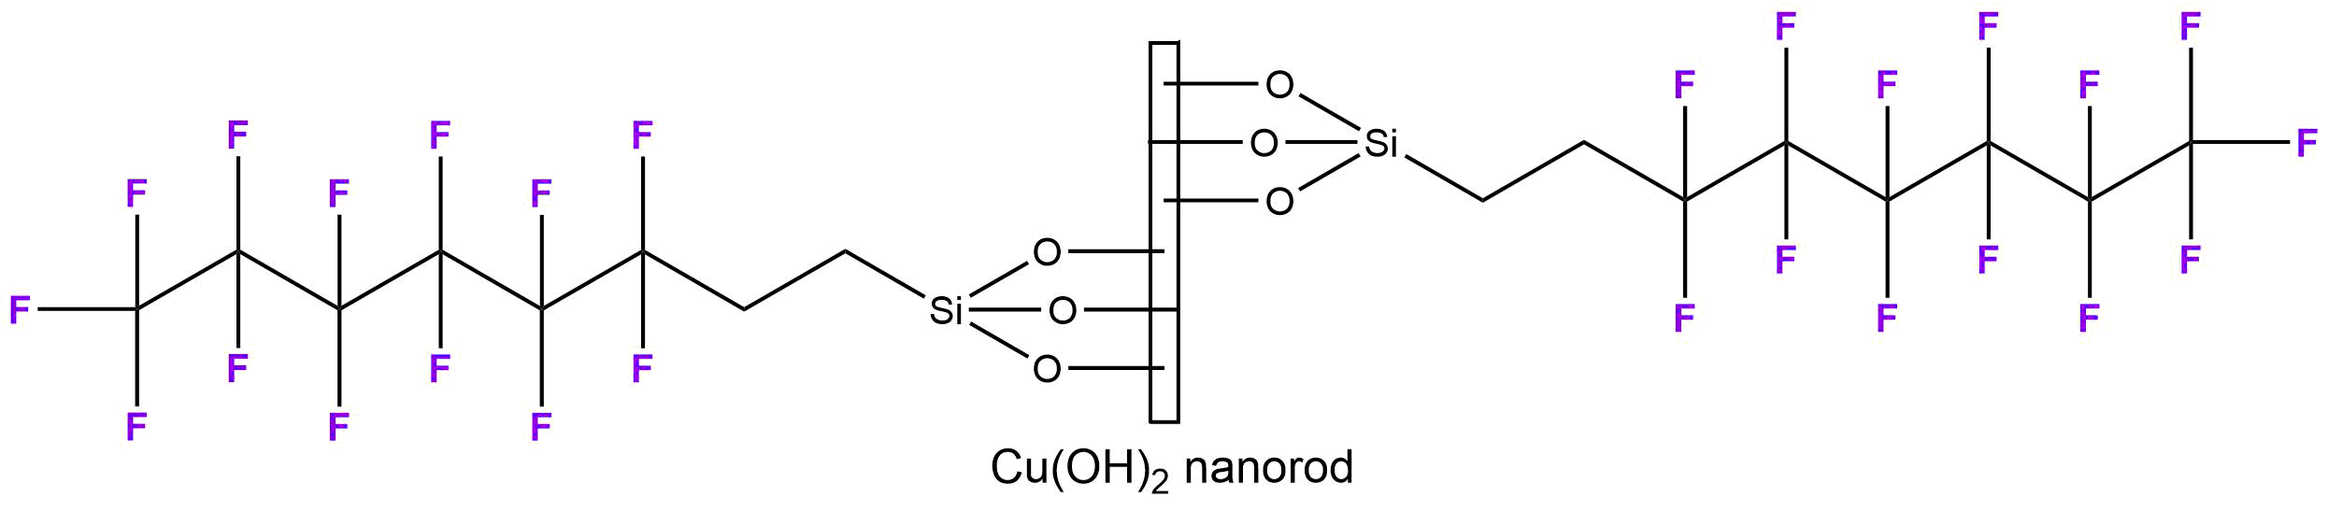
Supplementary Figure S11. Chemical molecular structure of the fluorinated Cu(OH)₂ nanorod. The modification of PFTS could endow the Cu(OH)₂ nanorods with superhydophobicity while remained the morphology intact.

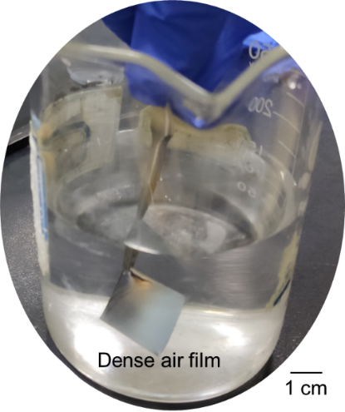
Supplementary Figure S12. Images of Cu-SHBL film forced into water condition. It could be seen that the surface of the Cu-SHBL film was reflective underwater, which was mainly ascribed to the wrapped dense air film by the superhydrophobic Cu(OH)₂ nanorods.

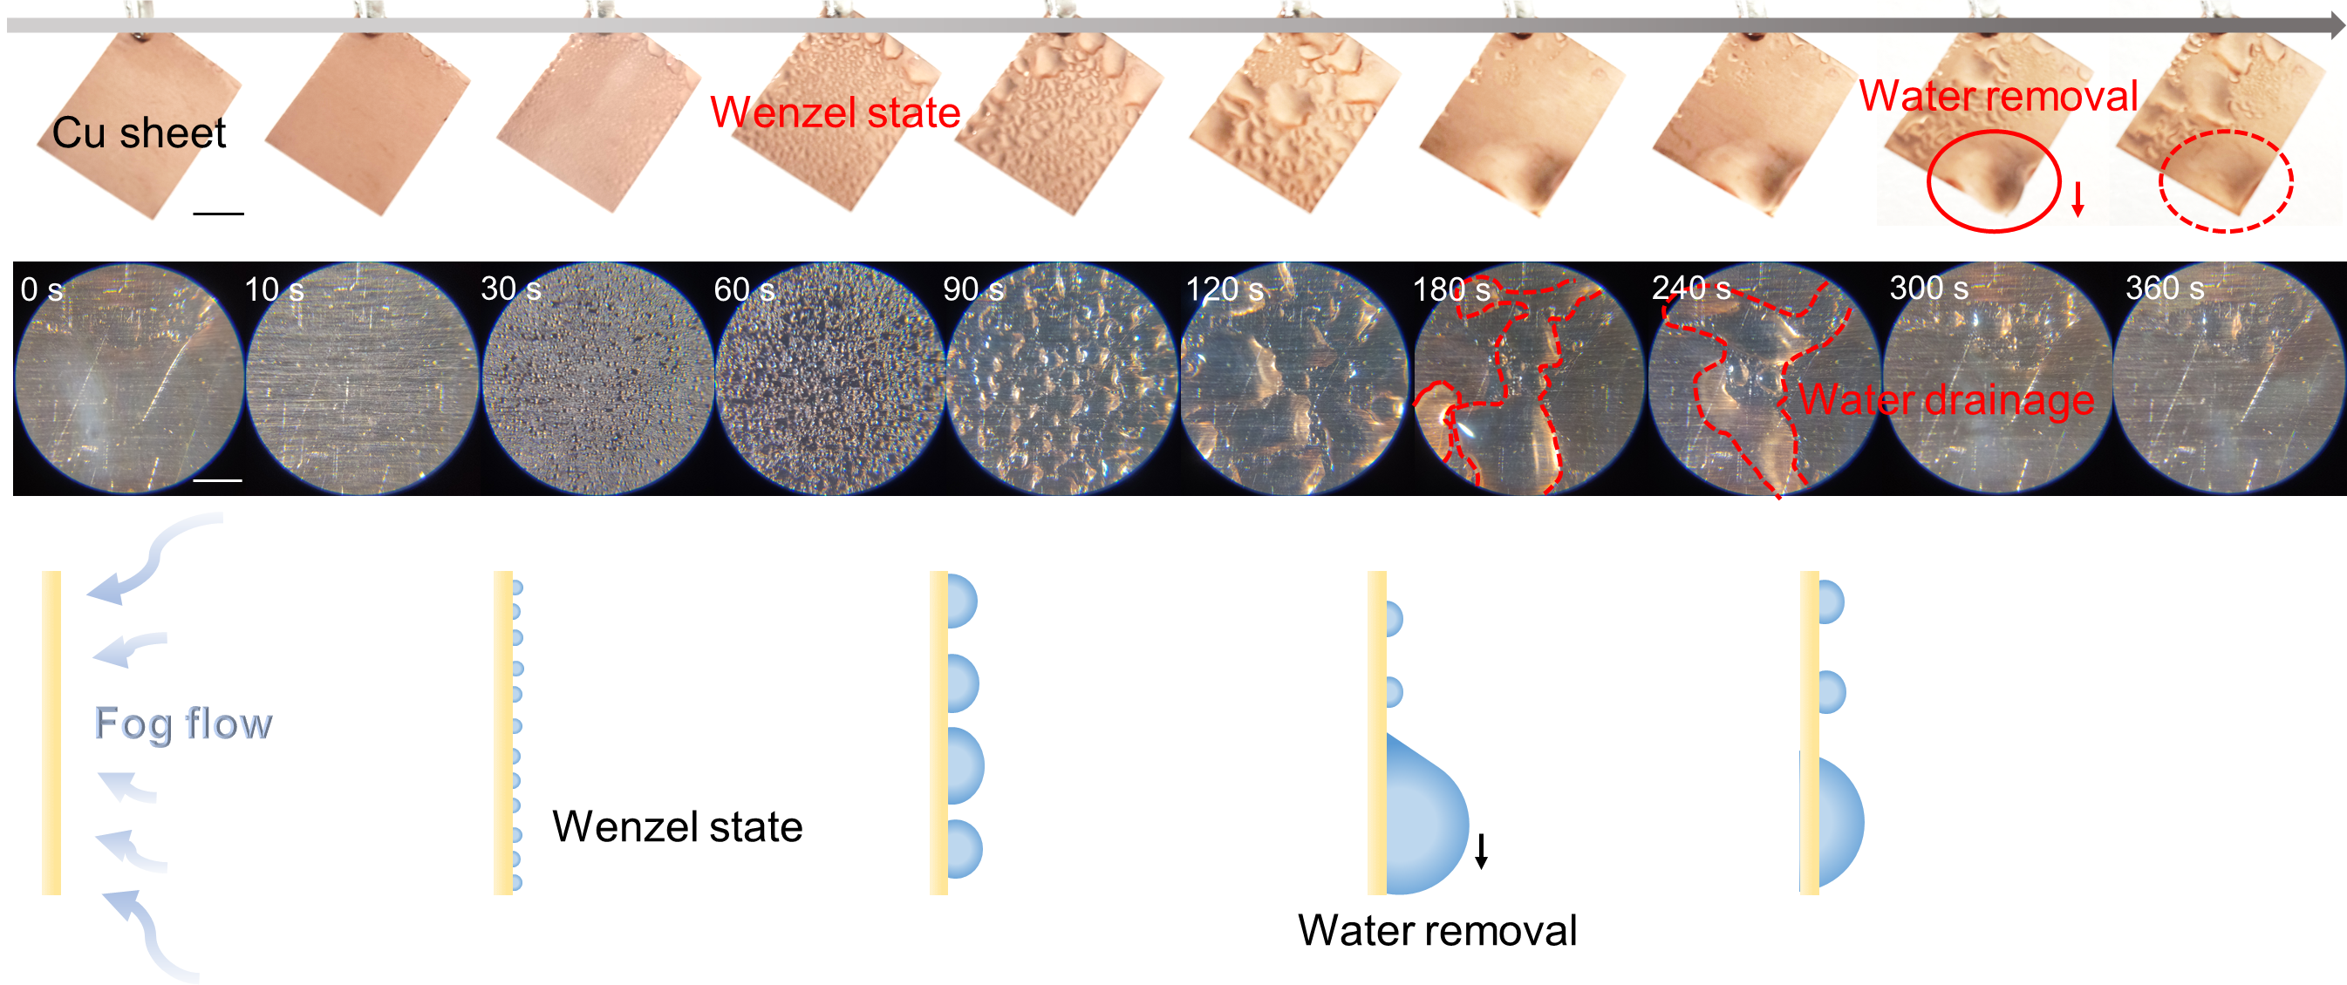
Supplementary Figure S13. Water collection process of original Cu sheet. The actual images, magnified images and process schematic diagram of Cu sheet during fog collection.

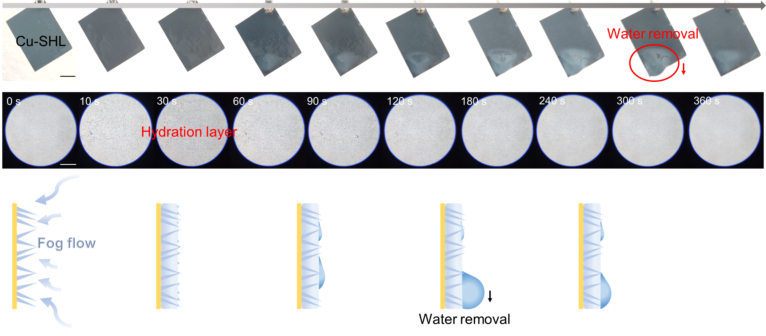
Supplementary Figure S14. Water collection process of Cu-SHL film. The actual images, magnified images and process schematic diagram of Cu-SHL film during fog collection.

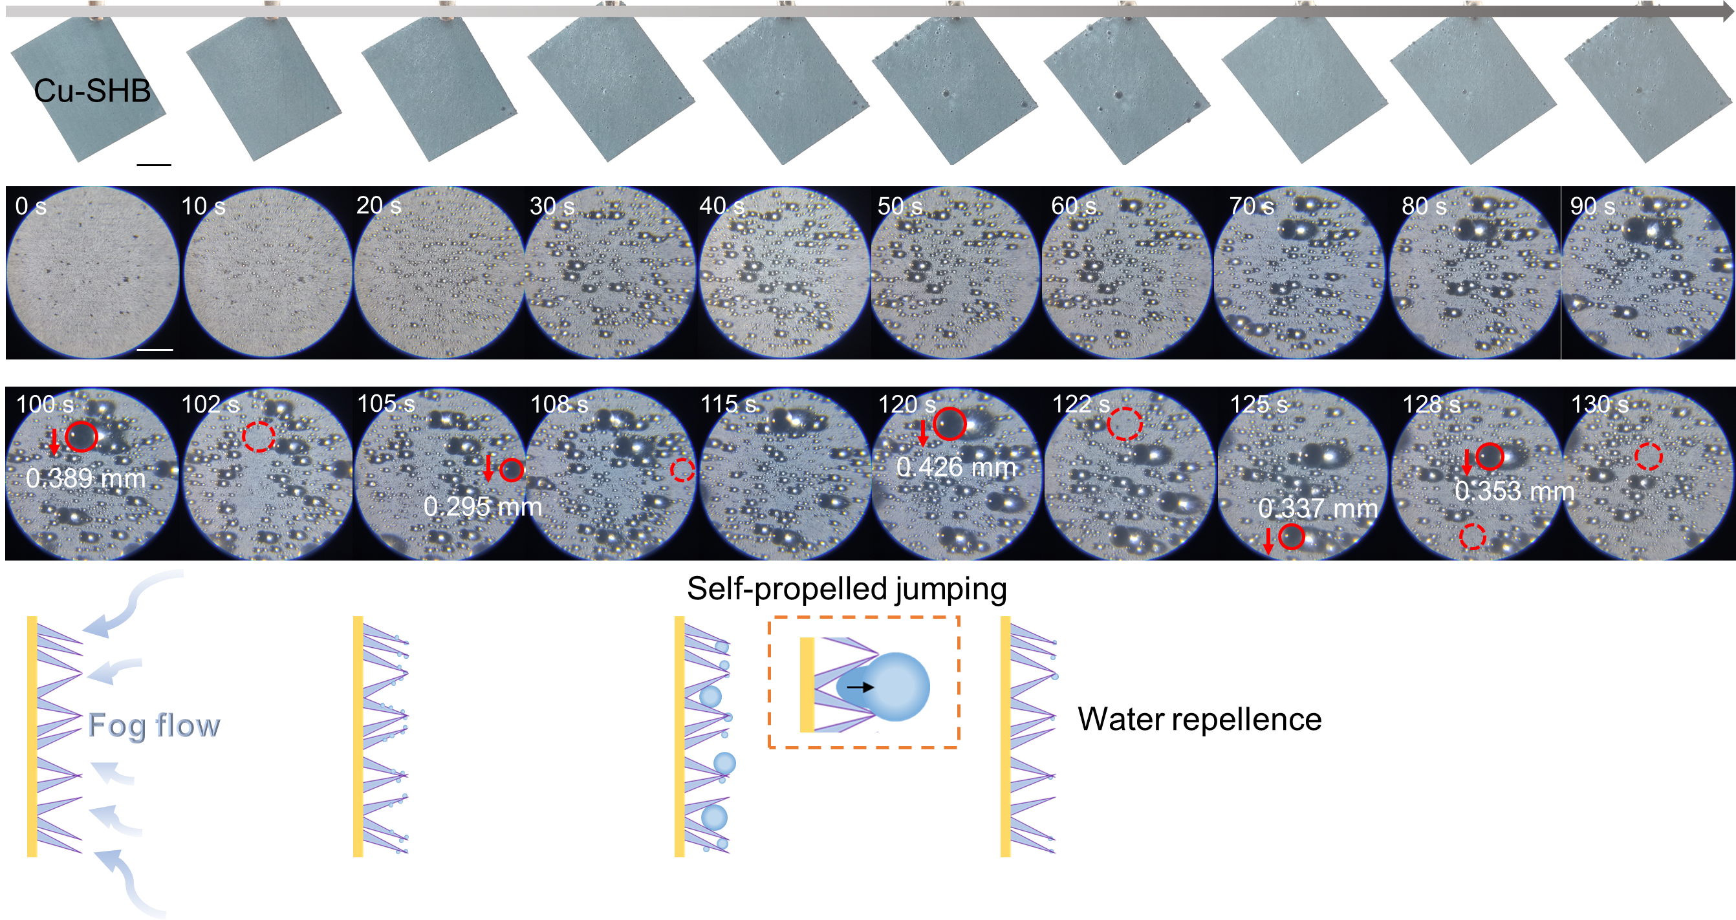
Supplementary Figure S15. Water collection process of original Cu-SHB film. The actual images, magnified images and process schematic diagram of Cu-SHB film during fog collection. The critical water droplet removal diameter could be observed in the magnified images, and were measured around 0.389, 0.295 and 0.426 mm. Due to the non-wetted property of the superhydrophobic surface, the water droplets removed from the surface could regard as spherical. And the weight could be calculated as following equation:
$m_{w}=\frac{4}{3}×π×{\left(\frac{d_{w}}{2}\right)}^{3}×ρ_{w}$ (1)
Where the m_{w} (g) was the calculated droplet weight, d_{w} (cm) was the measured water droplet diameter, ρ_{w} (g/cm⁻³) was the density of water.

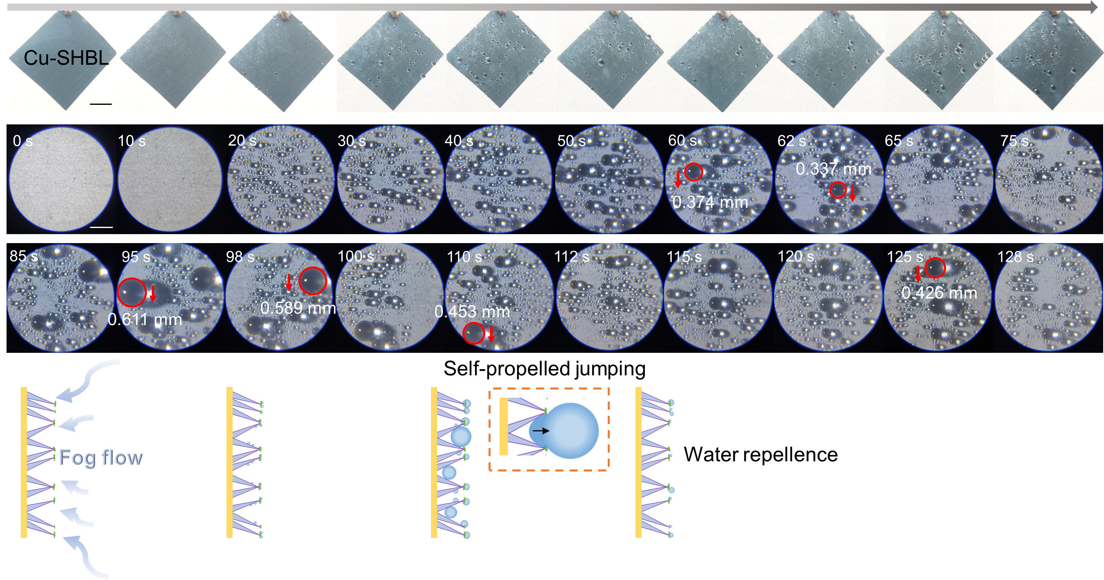
Supplementary Figure S16. Water collection process of Cu-SHBL film. The actual images, magnified images and process schematic diagram of Cu-SHBL film during fog collection. The critical water droplet removal diameter could be observed in the magnified images, and were measured around 0.374, 0.337 and 0.611 mm, and the corresponding weight could be calculated as aforementioned equation (1).

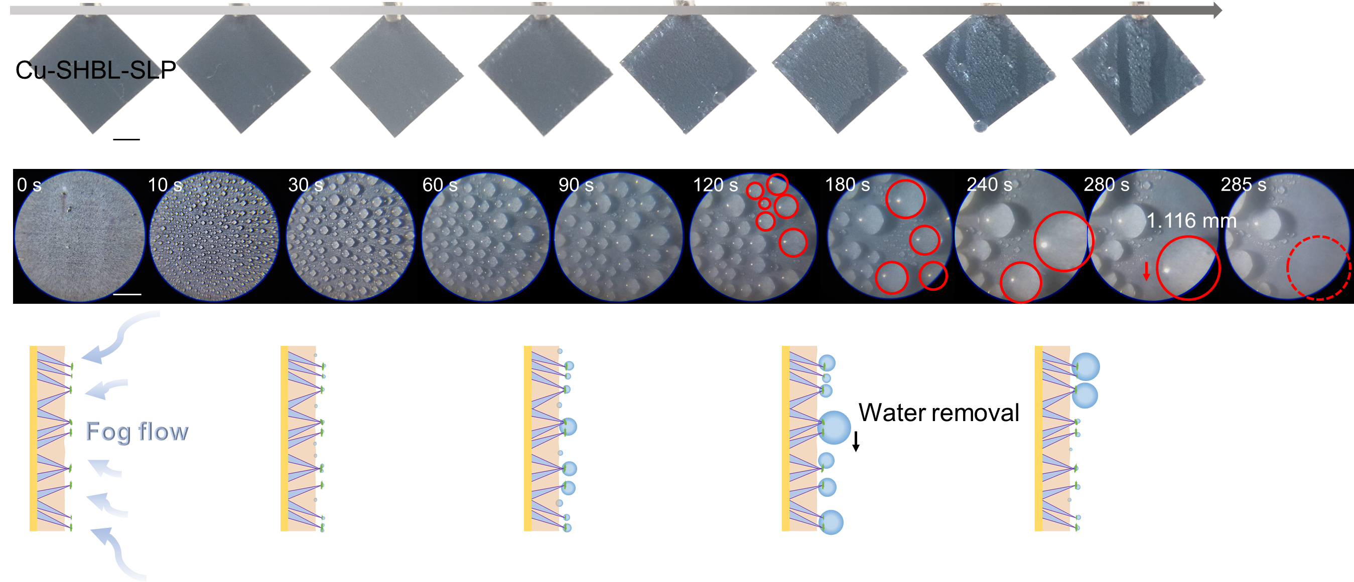
Supplementary Figure S17. Water collection process of Cu-SHBL-SLP film. The actual images, magnified images and process schematic diagram of Cu-SHBL-SLP film during fog collection.

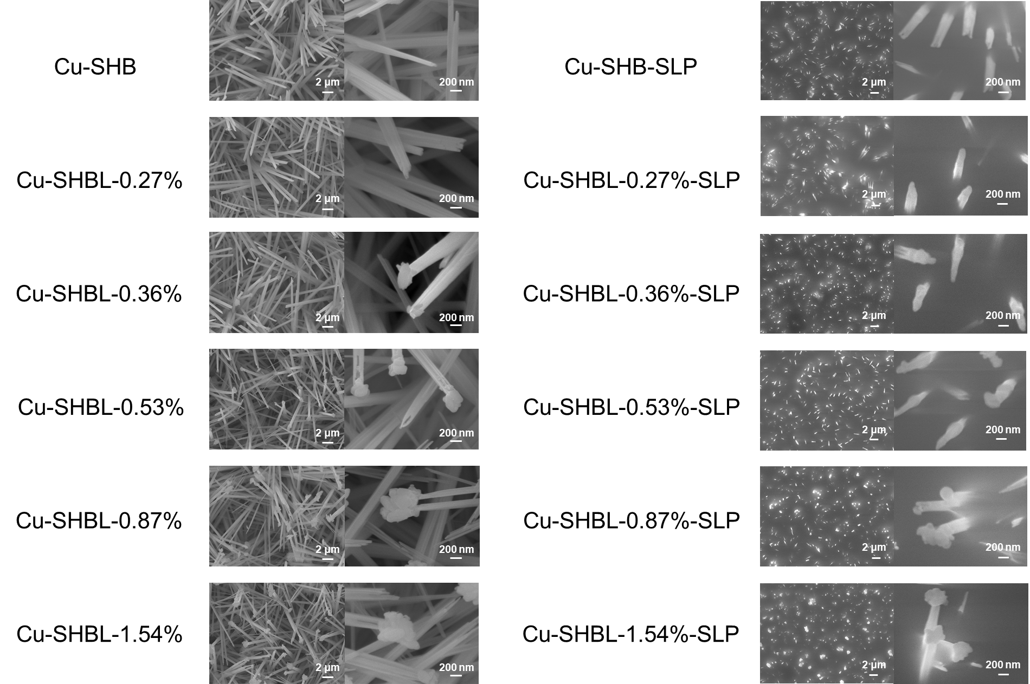
Supplementary Figure S18. Hydrophilic BaSO₄ bumps controllable construction. Surface morphology of Cu-SHB, Cu-SHBL-0.27%, Cu-SHBL-0.36%, Cu-SHBL-0.53%, Cu-SHBL-0.87%, Cu-SHBL-1.54% and its corresponding lubricating oil infused sheets.

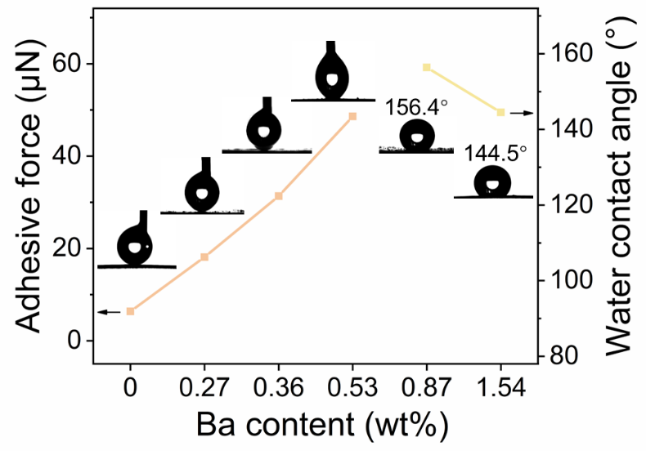
Supplementary Figure S19. Surface wettability of the samples. Water adhesive force and water contact angle of the Cu-SHBL with different Ba contents. With the Ba contents increased, the film surface become more hydrophobic.

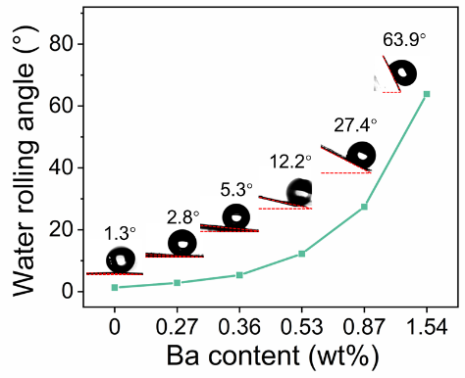
Supplementary Figure S20. Water rolling angle of the samples. With the Ba contents increased, the film surface become more hydrophobic.

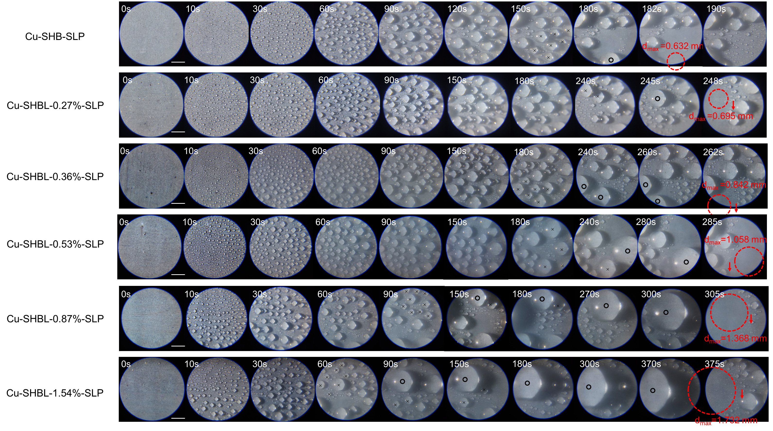
Supplementary Figure S21. Enlarged images of water collection process. Actual images of the fog collection process of a serious of Cu-SHBL-SLP films. The critical water droplet removal time were around 182, 248, 262, 285, 305 and 375 s, and the corresponding droplet diameter were 0.632, 0.695, 0.842, 1.058, 1.368 and 1.732 mm as for the Cu-SHB-SLP, Cu-SHBL-0.27%-SLP, Cu-SHBL-0.36%-SLP, Cu-SHBL-0.53%-SLP, Cu-SHBL-0.87%-SLP and Cu-SHBL-1.54%-SLP film, respectively.

Supplementary Figure S22. Water droplets distribution analysis. Distribution of water droplets on the Cu-SHB, Cu-SHBL-0.27%-SLP, Cu-SHBL-0.36%-SLP, Cu-SHBL-0.53%-SLP, Cu-SHBL-0.87%-SLP and Cu-SHBL-1.54%-SLP film surface at 10 s during fog collection process. The average droplet increased with the hydrophilic bumps increased.

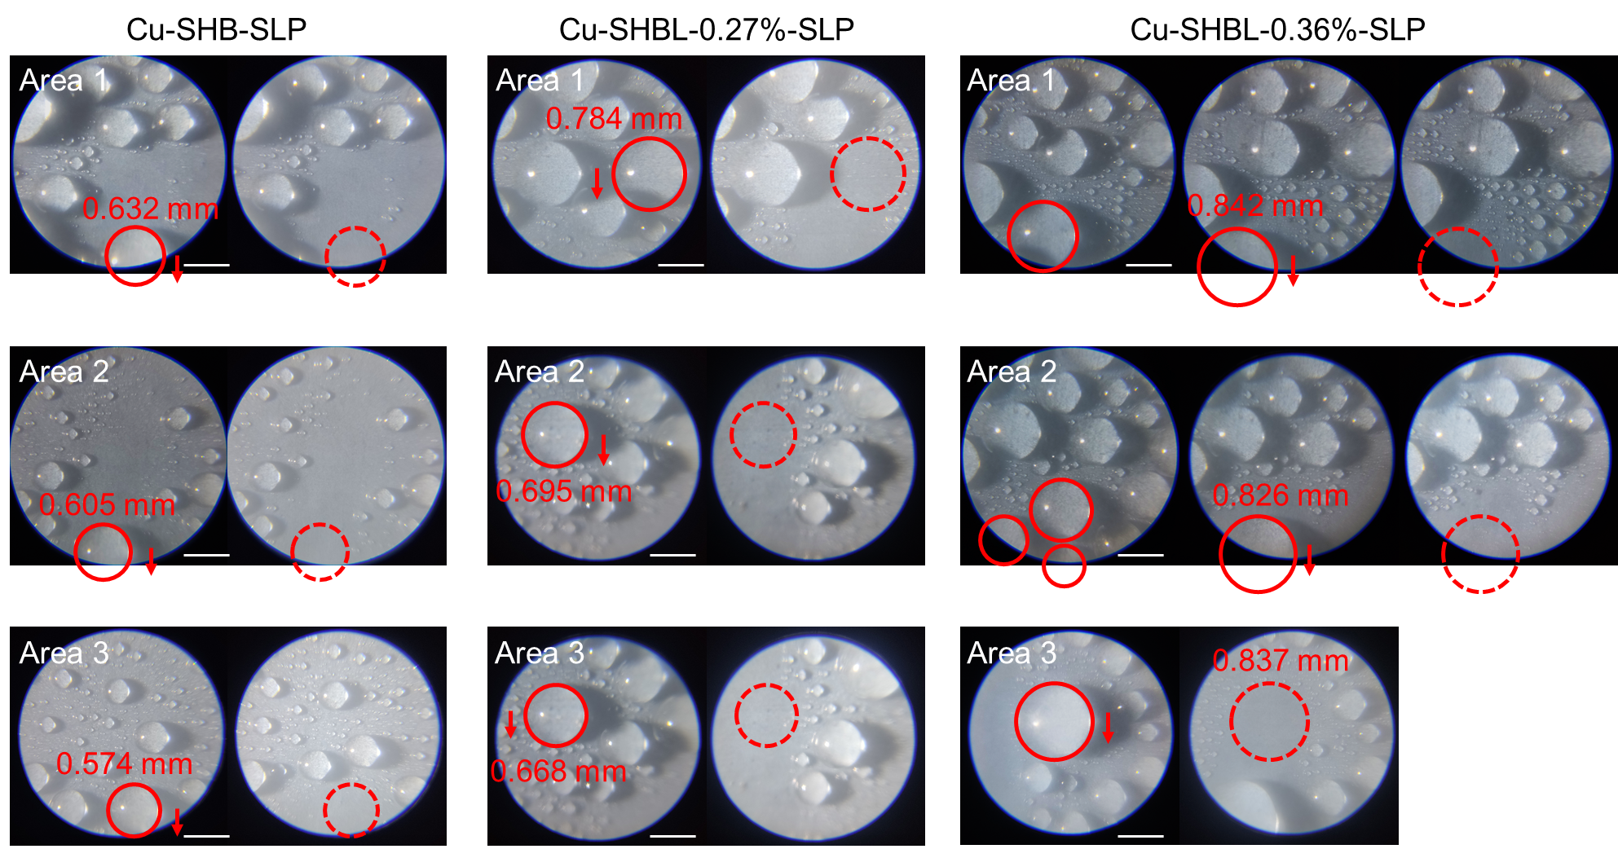
Supplementary Figure S23. Enlarged images of water collection process on different samples. Water droplet critical removal size at three random areas of Cu-SHB-SLP, Cu-SHBL-0.27%-SLP and Cu-SHBL-0.36%-SLP films. Due to the non-wetted property of the SLIPS, the water droplet was in the shape of spherical on the SLIPS, and the water adhesion force could be calculated as following equation:
$F_{h}=G_{w}=m_{w}×g=\frac{4}{3}×π×{\left(\frac{d_{w}}{2}\right)}^{3}×ρ_{w}$ (2)
Where F_{h} (N) was the adhesion force of the water droplet on SLIPS, d_{w} (m) was the measured water droplet diameter, ρ_{w} (g/cm⁻³) was the density of water.

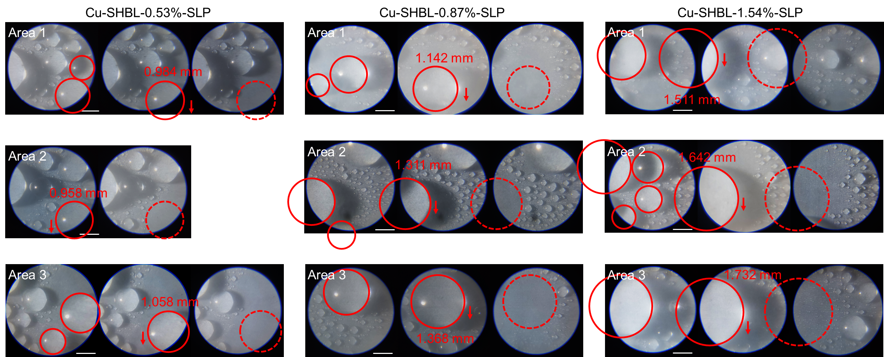
Supplementary Figure S24. Enlarged images of water collection process on different samples. Water droplet critical removal size at three random areas of Cu-SHBL-0.53%-SLP, Cu-SHBL-0.87%-SLP and Cu-SHBL-1.54%-SLP films. The water droplet adhesion force could be calculated as equation (2) according to the water droplet critical removal size.

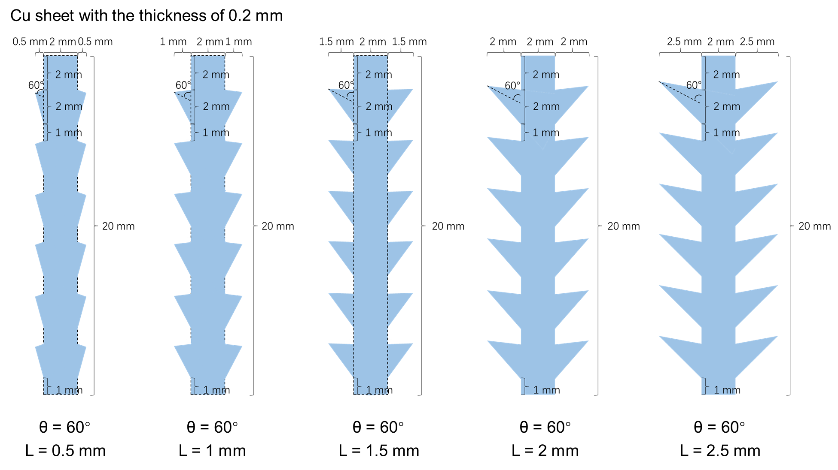
Supplementary Figure S25. Detail parameters of patterned fog collectors for laser ablation. Design of patterned fog collector with the uniform θ values and different L values.

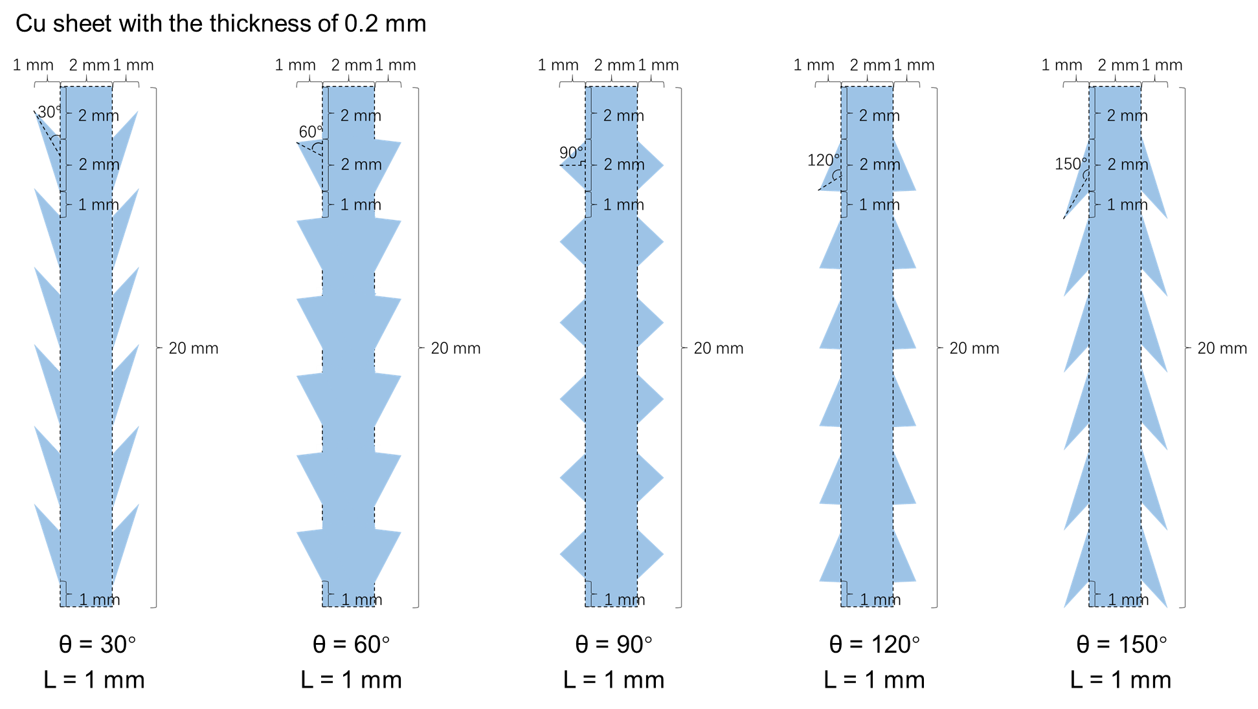
Supplementary Figure S26. Detail parameters of patterned fog collectors for laser ablation. Design of patterned fog collector with the uniform θ values and different L values.

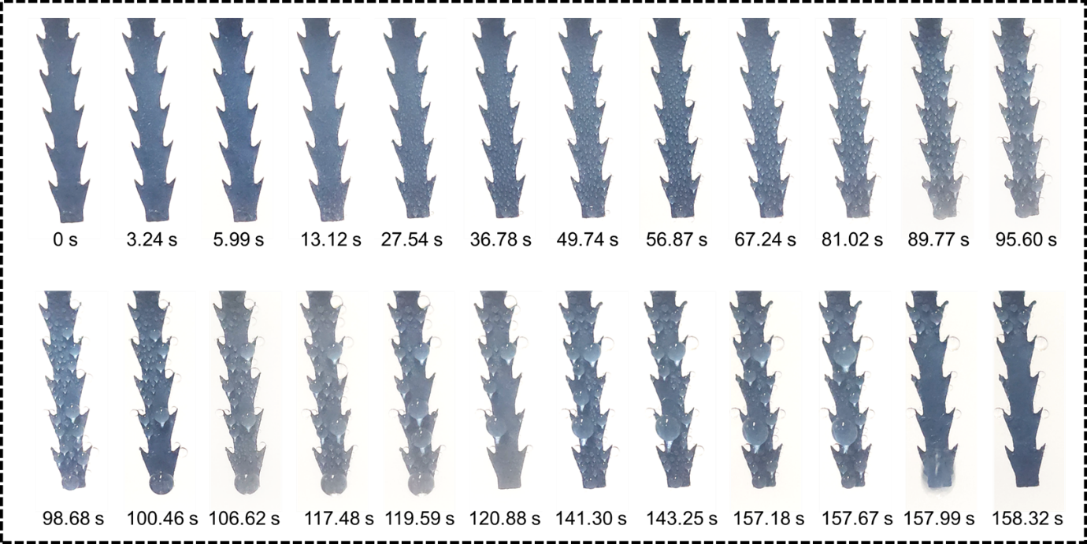
Supplementary Figure S27. Observation of the water collection process. Actual water collection process of patterned Cu-SHBL-SLP with L=1 and θ=30°.

Supplementary Figure S28. Water collection rate comparation. There was no significant decline of the WCR after introducing TiO₂ particles on Cu-SHBL-SLP film.

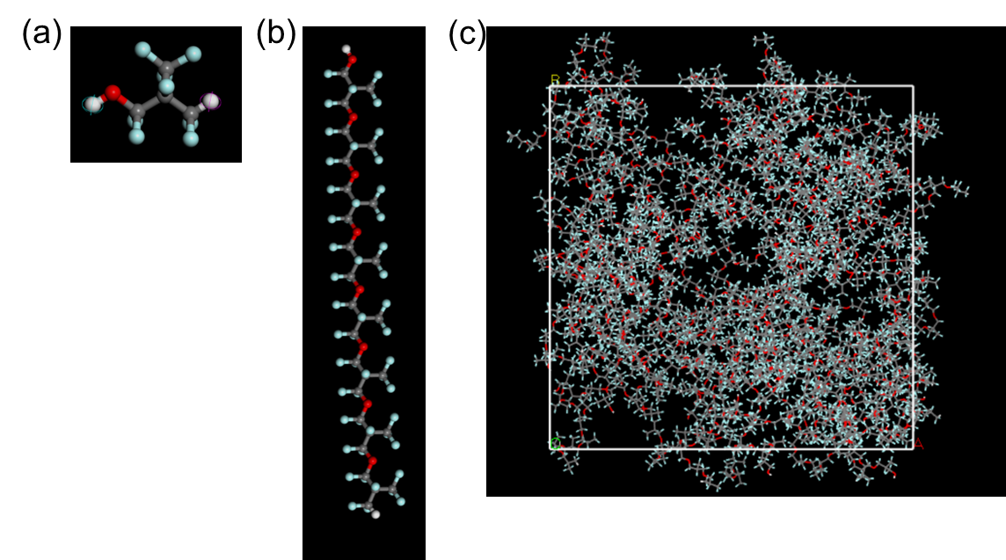
Supplementary Figure S29. Constructed molecular structure in MD simulations. Molecular structure of PFPE monomer unit (a), PFPE molecule consisting of eight minimum repeating units (b) and the constructed substrate contains 100 PFPE molecules (c).

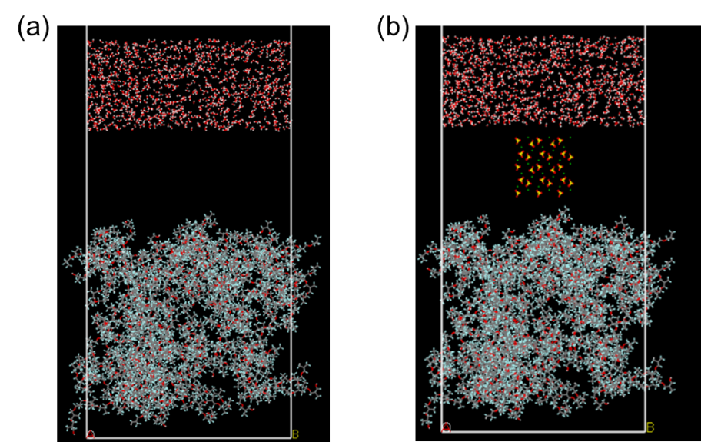
Supplementary Figure S30. Constructed two systems in MD simulations. The system contains randomly placed 1000 water molecules above the constructed substrate without (a) and with BaSO₄ component (b).

Supplementary Table S1. EDS analysis of the samples. Surface elements distribution of the prepared a serious of Cu-SHBL films measured by EDS.
Samples | Cu | O | Ba | F | Si
1 | 79.47 | 20.14 | 0.27 | 0 | 0.13
2 | 80.24 | 19.18 | 0.36 | 0 | 0.23
3 | 84.88 | 14.36 | 0.53 | 0.01 | 0.22
4 | 78.12 | 20.62 | 0.87 | 0.01 | 0.38
5 | 77.58 | 20.25 | 1.54 | 0.11 | 0.53

Supplementary Table S2. Working comparation of fog collector without external energy input.
Label | Material categories | Name | Fog flow (mL/h) | WCR (mg m⁻² h⁻¹) | Ref.
1 | 3D structure | MN-HB/HL | 40 | 3050 | ⁴
2 | 3D structure | CP-HL-SLIPS | 100 | 4400 | ⁵
7 | 3D structure | Conical CS-EVA | 225 | 10400 | ⁶
10 | 3D structure | SLP-SHL@SP-Cu | 300 | 7421 | ⁷
15 | 3D structure | Bioinspired cactus kirigami | 400 | 4000 | ⁸
3 | 2D membrane | CM@PDMS-PS | 200 | 907 | ⁹
4 | 2D membrane | PP@pTA/SNFs/PFDT | 230 | 2130 | ¹⁰
6 | 2D membrane | Cu₂O/ZrO₂ hybrid surface | 252 | 1707 | ¹¹
11 | 2D membrane | AWF-6 | 350 | 1538 | ¹²
16 | 2D membrane | FSLC | 1080 | 1930 | ¹³
19 | 2D membrane | A-HH-LIS | 1800 | 9600 | ¹⁴
5 | Janus structure | WCJM | 252 | 1100 | ¹⁵
9 | Janus structure | S-Z-STA | 300 | 2479 | ¹⁶
17 | Janus structure | PFC | 1080 | 4210 | ¹⁷
18 | Janus structure | J-LV devices | 1200 | 1230 | ¹⁸
8 | Harps | PNIPAm-PVDF harps | 300 | 1415 | ¹⁹
12 | Harps | Janus-PAN harp | 350 | 1775 | ²⁰
13 | Harps | PAN-TO harp | 350 | 4035 | ²¹
14 | Harps | PVDF-TiO₂ yarns | 400 | 400 | ²²
 | Our work | Cu-SHBL-SLP | 300 | 5081
 | Our work | Cu-SHBL-SLP | 420 | 11238
 | Our work | Cu-SHBL-SLP | 900 | 25207
 | Our work | Cu-SHBL-SLP | 1500 | 61588

Supplementary Video 1
Fog collection process of Cu-SHB-SLP film observed by ESEM.

Supplementary Video 2
Fog collection process of Cu-SHBL-SLP film observed by ESEM.

Supplementary Video 3
Actual images of the fog collection process on the 2D patterned Cu-SHBL-SLP film.

Supplementary Video 4
Actual images of the fog collection process on the 2D patterned Cu-SHBL-SLP film with the θ=30°.

Supplementary References
1 Su, B., Tian, Y. & Jiang, L. Bioinspired Interfaces with Superwettability: From Materials to Chemistry. J Am Chem Soc 138, 1727-1748, doi:10.1021/jacs.5b12728 (2016).
2 Hu, D. et al. Multifunctional UV-shielding nanocellulose films modified with halloysite nanotubes-zinc oxide nanohybrid. Cellulose 27, 401-413, doi:10.1007/s10570-019-02796-0 (2019).
3 Liu, Y. Q. et al. Laser-structured Janus wire mesh for efficient oil-water separation. Nanoscale 9, 17933-17938, doi:10.1039/c7nr06110b (2017).
4 Zhou, W. et al. High‐Performance Freshwater Harvesting System by Coupling Solar Desalination and Fog Collection with Hierarchical Porous Microneedle Arrays. Advanced Functional Materials 32, doi:10.1002/adfm.202113264 (2022).
5 Maji, K., Das, A., Dhar, M. & Manna, U. Synergistic chemical patterns on a hydrophilic slippery liquid infused porous surface (SLIPS) for water harvesting applications. J. Mater. Chem. A 8, 25040-25046, doi:10.1039/d0ta09271a (2020).
6 Deng, K. et al. A conical shaped self-healing slippery film for enhanced fog harvesting in windy environment. Chemical Engineering Science 292, doi:10.1016/j.ces.2024.119980 (2024).
7 Yu, Z. et al. Bio‐inspired Copper Kirigami Motifs Leading to a 2D–3D Switchable Structure for Programmable Fog Harvesting and Water Retention. Advanced Functional Materials 33, doi:10.1002/adfm.202210730 (2022).
8 Bai, H. et al. Cactus kirigami for efficient fog harvesting: simplifying a 3D cactus into 2D paper art. J. Mater. Chem. A 8, 13452-13458, doi:10.1039/d0ta01204a (2020).
9 Zhang, Y. et al. Lizard-Skin-Inspired Nanofibrous Capillary Network Combined with a Slippery Surface for Efficient Fog Collection. ACS Appl Mater Interfaces 13, 36587-36594, doi:10.1021/acsami.1c10067 (2021).
10 Zhang, J., Li, B., Zhou, Z. & Zhang, J. Durable Superhydrophobic Surfaces with Self‐Generated Wenzel Sites for Efficient Fog Collection. Small 20, doi:10.1002/smll.202312112 (2024).
11 Feng, J., Zhong, L. & Guo, Z. Sprayed hieratical biomimetic superhydrophilic-superhydrophobic surface for efficient fog harvesting. Chemical Engineering Journal 388, doi:10.1016/j.cej.2020.124283 (2020).
12 Ji, Y. et al. Thermodynamically Induced Interfacial Condensation for Efficient Fog Harvesting. Small 19, doi:10.1002/smll.202304037 (2023).
13 Ma, J., Zhang, C., Zhang, P. & Song, J. One-step synthesis of functional slippery lubricated coating with substrate independence, anti-fouling property, fog collection, corrosion resistance, and icephobicity. Journal of Colloid and Interface Science 664, 228-237, doi:10.1016/j.jcis.2024.03.027 (2024).
14 Gou, X. & Guo, Z. Reed leaf-inspired anisotropic slippery lubricant-infused surface for water collection and bubble transportation. Chemical Engineering Journal 411, doi:10.1016/j.cej.2021.128495 (2021).
15 Tang, X., Zhang, F., Huang, J. & Guo, Z. Multifuctional Janus Materials for Rapid One-Way Water Transportation and Fog Collection. Langmuir 37, 13778-13786, doi:10.1021/acs.langmuir.1c02625 (2021).
16 Wu, J., Yan, Z., Yan, Y., Li, C. & Dai, J. Beetle-Inspired Dual-Directional Janus Pumps with Interfacial Asymmetric Wettability for Enhancing Fog Harvesting. ACS Applied Materials & Interfaces 14, 49338-49351, doi:10.1021/acsami.2c14808 (2022).
17 Yan, D., Chen, Y., Liu, J. & Song, J. Super‐Fast Fog Collector Based on Self‐Driven Jet of Mini Fog Droplets. Small 19, doi:10.1002/smll.202301745 (2023).
18 Zhou, Y., Fu, S., Ai, S., Pei, K. & Guo, Z. In-situ dual-MOF functionalized quasi-fractal networks with Janus wettability for high-efficient fog harvesting and intelligent interface materials. Chemical Engineering Journal 498, doi:10.1016/j.cej.2024.155489 (2024).
19 Parisi, G., Szewczyk, P. K., Narayan, S. & Stachewicz, U. Thermoresponsive nanofiber yarns for water harvesting enhanced by harp system. Chemical Engineering Journal 499, doi:10.1016/j.cej.2024.155874 (2024).
20 Ji, Y. et al. A Molecular Confine-Induced Charged Fiber for Fog Harvesting. Advanced Fiber Materials, doi:10.1007/s42765-024-00474-w (2024).
21 Ji, Y. et al. Nanoscale Drag Reduction Effect Enables Efficient Fog Harvesting. Advanced Functional Materials, doi:10.1002/adfm.202411083 (2024).
22 Parisi, G., Szewczyk, P. K., Narayan, S. & Stachewicz, U. Wettability gradient of photoresponsive electrospun yarns for harp-based fog water harvesting. Cell Reports Physical Science 5, doi:10.1016/j.xcrp.2024.102176 (2024).

