Supplementary Figures

Supplementary Figures 1
Figure S1. Causal effects for Low caloric food liking on Non-Hodgkin's lymphoma 4
Figure S2. Causal effects for Low caloric food liking on Bladder cancer 5
Figure S3. Causal effects for Low caloric food liking on Non-small cell lung cancer 6
Figure S4. Causal effects for Low caloric food liking on Hepatocellular carcinoma 7
Figure S5. Causal effects for Low caloric food liking on Malignant melanoma 8
Figure S6. Causal effects for Low caloric food liking on Thyroid cancer 9
Figure S7. Causal effects for Low caloric food liking on Colon cancer 10
Figure S8. Causal effects for Low caloric food liking on Ovarian cancer 11
Figure S9. Causal effects for Low caloric food liking on Chronic Lymphocytic
Leukemia 12
Figure S10. Causal effects for Low caloric food liking on Brain cancer 13
Figure S11. Causal effects for Low caloric food liking on Prostate cancer 14
Figure S12. Causal effects for Low caloric food liking on Breast cancer 15
Figure S13. Causal effects for Low caloric food liking on Kidney cancer 16
Figure S14. Causal effects for Low caloric food liking on Esophagus cancer 17
Figure S15. Causal effects for Low caloric food liking on Gastric cancer 18
Figure S16. Causal effects for Low caloric food liking on Pancreatic cancer 19
Figure S17. Causal effects for Low caloric food liking on Rectal cancer 20
Figure S18. Causal effects for Low caloric food liking on Cervical cancer 21
Figure S19. Causal effects for Savour/caloric food liking on Non-Hodgkin's lymphoma 22
Figure S20. Causal effects for Savour/caloric food liking on Bladder cancer 23
Figure S21. Causal effects for Savour/caloric food liking on Non-small cell lung
cancer 24
Figure S22. Causal effects for Savour/caloric food liking on Hepatocellular carcinoma 25
Figure S23. Causal effects for Savour/caloric food liking on Malignant melanoma 26
Figure S24. Causal effects for Savour/caloric food liking on Thyroid cancer 27
Figure S25. Causal effects for Savour/caloric food liking on Colon cancer 28
Figure S26. Causal effects for Savour/caloric food liking on Ovarian cancer 29
Figure S27. Causal effects for Savour/caloric food liking on Chronic Lymphocytic Leukemia 30
Figure S28. Causal effects for Savour/caloric food liking on Brain cancer 31
Figure S29. Causal effects for Savour/caloric food liking on Prostate cancer 32
Figure S30. Causal effects for Savour/caloric food liking on Breast cancer 33
Figure S31. Causal effects for Savour/caloric food liking on Kidney cancer 34
Figure S32. Causal effects for Savour/caloric food liking on Esophagus cancer 35
Figure S33. Causal effects for Savour/caloric food liking on Gastric cancer 36
Figure S34. Causal effects for Savour/caloric food liking on Pancreatic cancer 37
Figure S35. Causal effects for Savour/caloric food liking on Rectal cancer 38
Figure S36. Causal effects for Savour/caloric food liking on Cervical cancer 39
Figure S37. Causal effects for cooking vegetables liking on prostate cancer 40
Figure S38. Causal effects for Dairy liking on prostate cancer 41
Figure S39. Causal effects for Fish liking on prostate cancer 42
Figure S40. Causal effects for Fruit liking on prostate cancer 43
Figure S41. Causal effects for Salad vegetables liking on prostate cancer 44
Figure S42. Causal effects for Strong vegetable liking on prostate cancer 45
Figure S43. Causal effects for Vegetarian liking on prostate cancer 46
Figure S44. Causal effects for Cake/biscuits liking on Non-Hodgkin's lymphoma 47
Figure S45. Causal effects for Cake/biscuits liking liking on Non-small cell lung
cancer 48
Figure S46. Causal effects for Cake/biscuits liking on Hepatocellular carcinoma 49
Figure S47. Causal effects for Cake/biscuits liking on Gastric cancer 50
Figure S48. Causal effects for Carbohydrate liking on Non-Hodgkin's lymphoma 51
Figure S49. Causal effects for Carbohydrate liking on Non-small cell lung cancer 52
Figure S50. Causal effects for Carbohydrate liking on Hepatocellular carcinoma 53
Figure S51. Causal effects for Carbohydrate liking on Gastric cancer 54
Figure S52. Causal effects for Cheese liking on Non-Hodgkin's lymphoma 55
Figure S53. Causal effects for Cheese liking on Non-small cell lung cancer 56
Figure S54. Causal effects for Cheese liking on Hepatocellular carcinoma 57
Figure S55. Causal effects for Cheese liking on Gastric cancer 58
Figure S56. Causal effects for Deep fried food liking on Non-Hodgkin's lymphoma 59
Figure S57. Causal effects for Deep fried food liking on Non-small cell lung cancer 60
Figure S58. Causal effects for Deep fried food liking on Hepatocellular carcinoma 61
Figure S59. Causal effects for Deep fried food liking on Gastric cancer 62
Figure S60. Causal effects for Dessert liking on Non-Hodgkin's lymphoma 63
Figure S61. Causal effects for Dessert liking on Non-small cell lung cancer 64
Figure S62. Causal effects for Dessert liking on Hepatocellular carcinoma 65
Figure S63. Causal effects for Dessert liking on Gastric cancer 66
Figure S64. Causal effects for Fatty/salty food liking on Non-Hodgkin's lymphoma 67
Figure S65. Causal effects for Fatty/salty food liking on Non-small cell lung cancer 68
Figure S66. Causal effects for Fatty/salty food liking on Hepatocellular carcinoma 69
Figure S67. Causal effects for Fatty/salty food liking on Gastric cancer 70
Figure S68. Causal effects for Oily fish liking on Non-Hodgkin's lymphoma 71
Figure S69. Causal effects for Oily fish liking on Non-small cell lung cancer 72
Figure S70. Causal effects for Oily fish liking on Hepatocellular carcinoma 73
Figure S71. Causal effects for Oily fish liking on Gastric cancer 74

Figure S1. Causal effects for Low caloric food liking on Non-Hodgkin's lymphoma
(a)Scatter plots, (b) Funnel plot , (c) Leave-one-out analysis , (d) Forest plots

Figure S2. Causal effects for Low caloric food liking on Bladder cancer
(a)Scatter plots, (b) Funnel plot , (c) Leave-one-out analysis , (d) Forest plots

Figure S3. Causal effects for Low caloric food liking on Non-small cell lung cancer
(a)Scatter plots, (b) Funnel plot , (c) Leave-one-out analysis , (d) Forest plots

Figure S4. Causal effects for Low caloric food liking on Hepatocellular carcinoma
(a)Scatter plots, (b) Funnel plot , (c) Leave-one-out analysis , (d) Forest plots

Figure S5. Causal effects for Low caloric food liking on Malignant melanoma
(a)Scatter plots, (b) Funnel plot , (c) Leave-one-out analysis , (d) Forest plots

Figure S6. Causal effects for Low caloric food liking on Thyroid cancer
(a)Scatter plots, (b) Funnel plot , (c) Leave-one-out analysis , (d) Forest plots.

Figure S7. Causal effects for Low caloric food liking on Colon cancer
(a)Scatter plots, (b) Funnel plot , (c) Leave-one-out analysis , (d) Forest plots.

Figure S8. Causal effects for Low caloric food liking on Ovarian cancer
(a)Scatter plots, (b) Funnel plot , (c) Leave-one-out analysis , (d) Forest plots.

Figure S9. Causal effects for Low caloric food liking on Chronic Lymphocytic Leukemia
(a)Scatter plots, (b) Funnel plot , (c) Leave-one-out analysis , (d) Forest plots.

Figure S10. Causal effects for Low caloric food liking on Brain cancer
(a)Scatter plots, (b) Funnel plot , (c) Leave-one-out analysis , (d) Forest plots.

Figure S11. Causal effects for Low caloric food liking on Prostate cancer
(a)Scatter plots, (b) Funnel plot , (c) Leave-one-out analysis , (d) Forest plots.

Figure S12. Causal effects for Low caloric food liking on Breast cancer
(a)Scatter plots, (b) Funnel plot , (c) Leave-one-out analysis , (d) Forest plots.

Figure S13. Causal effects for Low caloric food liking on Kidney cancer
(a)Scatter plots, (b) Funnel plot , (c) Leave-one-out analysis , (d) Forest plots.

Figure S14. Causal effects for Low caloric food liking on Esophagus cancer
(a)Scatter plots, (b) Funnel plot , (c) Leave-one-out analysis , (d) Forest plots.

Figure S15. Causal effects for Low caloric food liking on Gastric cancer
(a)Scatter plots, (b) Funnel plot , (c) Leave-one-out analysis , (d) Forest plots.
.

Figure S16. Causal effects for Low caloric food liking on Pancreatic cancer
(a)Scatter plots, (b) Funnel plot , (c) Leave-one-out analysis , (d) Forest plots.

Figure S17. Causal effects for Low caloric food liking on Rectal cancer
(a)Scatter plots, (b) Funnel plot , (c) Leave-one-out analysis , (d) Forest plots.

Figure S18. Causal effects for Low caloric food liking on Cervical cancer
(a)Scatter plots, (b) Funnel plot , (c) Leave-one-out analysis , (d) Forest plots.

Figure S19. Causal effects for Savour/caloric food liking on Non-Hodgkin's lymphoma
(a)Scatter plots, (b) Funnel plot , (c) Leave-one-out analysis , (d) Forest plots

Figure S20. Causal effects for Savour/caloric food liking on Bladder cancer
(a)Scatter plots, (b) Funnel plot , (c) Leave-one-out analysis , (d) Forest plots

Figure S21. Causal effects for Savour/caloric food liking on Non-small cell lung cancer
(a)Scatter plots, (b) Funnel plot , (c) Leave-one-out analysis , (d) Forest plots

Figure S22. Causal effects for Savour/caloric food liking on Hepatocellular carcinoma
(a)Scatter plots, (b) Funnel plot , (c) Leave-one-out analysis , (d) Forest plots

Figure S23. Causal effects for Savour/caloric food liking on Malignant melanoma
(a)Scatter plots, (b) Funnel plot , (c) Leave-one-out analysis , (d) Forest plots

Figure S24. Causal effects for Savour/caloric food liking on Thyroid cancer
(a)Scatter plots, (b) Funnel plot , (c) Leave-one-out analysis , (d) Forest plots.

Figure S25. Causal effects for Savour/caloric food liking on Colon cancer
(a)Scatter plots, (b) Funnel plot , (c) Leave-one-out analysis , (d) Forest plots.

Figure S26. Causal effects for Savour/caloric food liking on Ovarian cancer
(a)Scatter plots, (b) Funnel plot , (c) Leave-one-out analysis , (d) Forest plots.

Figure S27. Causal effects for Savour/caloric food liking on Chronic Lymphocytic Leukemia
(a)Scatter plots, (b) Funnel plot , (c) Leave-one-out analysis , (d) Forest plots.

Figure S28. Causal effects for Savour/caloric food liking on Brain cancer
(a)Scatter plots, (b) Funnel plot , (c) Leave-one-out analysis , (d) Forest plots.

Figure S29. Causal effects for Savour/caloric food liking on Prostate cancer
(a)Scatter plots, (b) Funnel plot , (c) Leave-one-out analysis , (d) Forest plots.

Figure S30. Causal effects for Savour/caloric food liking on Breast cancer
(a)Scatter plots, (b) Funnel plot , (c) Leave-one-out analysis , (d) Forest plots.

Figure S31. Causal effects for Savour/caloric food liking on Kidney cancer
(a)Scatter plots, (b) Funnel plot , (c) Leave-one-out analysis , (d) Forest plots.

Figure S32. Causal effects for Savour/caloric food liking on Esophagus cancer
(a)Scatter plots, (b) Funnel plot , (c) Leave-one-out analysis , (d) Forest plots.

Figure S33. Causal effects for Savour/caloric food liking on Gastric cancer
(a)Scatter plots, (b) Funnel plot , (c) Leave-one-out analysis , (d) Forest plots.
.

Figure S34. Causal effects for Savour/caloric food liking on Pancreatic cancer
(a)Scatter plots, (b) Funnel plot , (c) Leave-one-out analysis , (d) Forest plots.

Figure S35. Causal effects for Savour/caloric food liking on Rectal cancer
(a)Scatter plots, (b) Funnel plot , (c) Leave-one-out analysis , (d) Forest plots.

Figure S36. Causal effects for Savour/caloric food liking on Cervical cancer
(a)Scatter plots, (b) Funnel plot , (c) Leave-one-out analysis , (d) Forest plots.

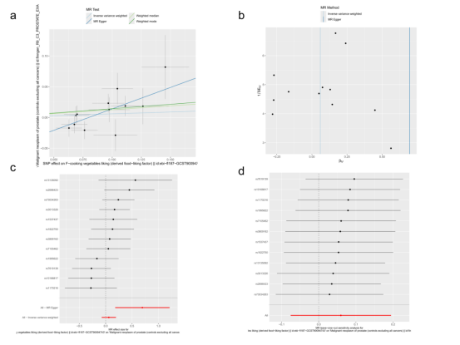

Figure S37. Causal effects for cooking vegetables liking on prostate cancer
(a)Scatter plots, (b) Funnel plot , (c) Leave-one-out analysis , (d) Forest plots

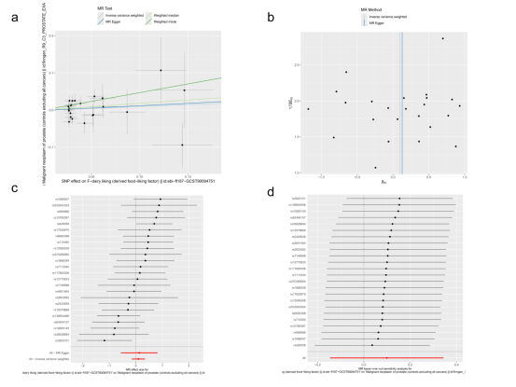

Figure S38. Causal effects for Dairy liking on prostate cancer
(a)Scatter plots, (b) Funnel plot , (c) Leave-one-out analysis , (d) Forest plots

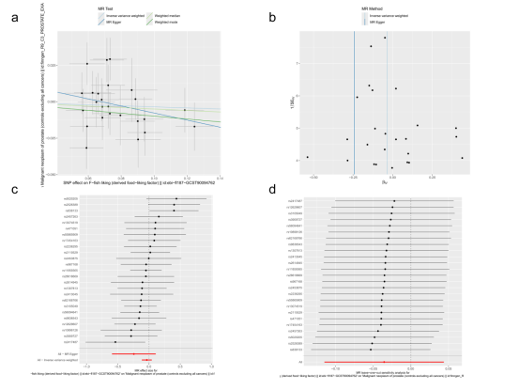

Figure S39. Causal effects for Fish liking on prostate cancer
(a)Scatter plots, (b) Funnel plot , (c) Leave-one-out analysis , (d) Forest plots

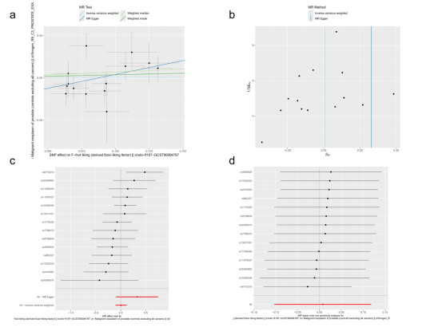

Figure S40. Causal effects for Fruit liking on prostate cancer
(a)Scatter plots, (b) Funnel plot , (c) Leave-one-out analysis , (d) Forest plots

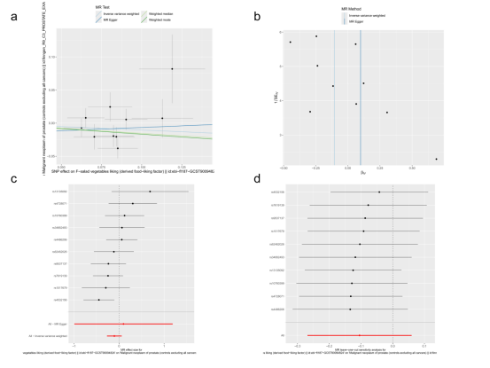

Figure S41. Causal effects for Salad vegetables liking on prostate cancer
(a)Scatter plots, (b) Funnel plot , (c) Leave-one-out analysis , (d) Forest plots

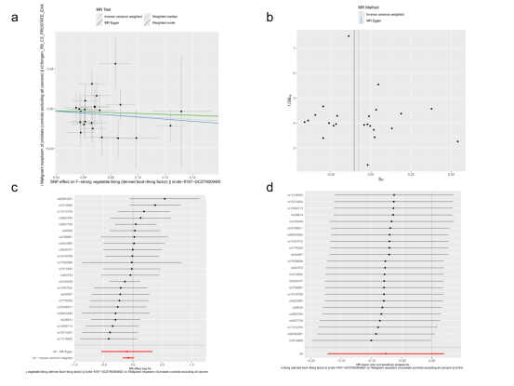

Figure S42. Causal effects for Strong vegetable liking on prostate cancer
(a)Scatter plots, (b) Funnel plot , (c) Leave-one-out analysis , (d) Forest plots.

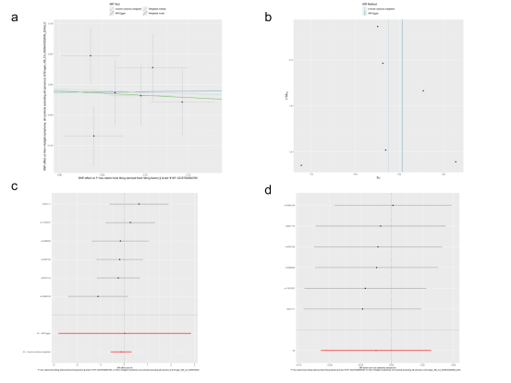

Figure S43. Causal effects for Vegetarian liking on prostate cancer
(a)Scatter plots, (b) Funnel plot , (c) Leave-one-out analysis , (d) Forest plots.

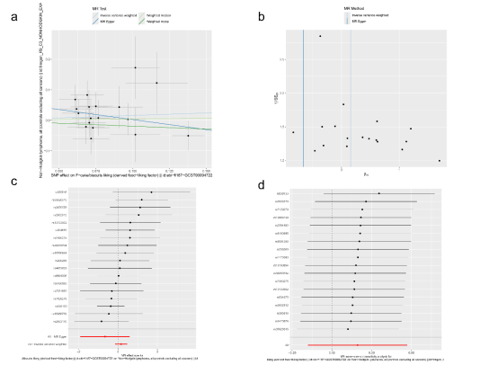

Figure S44. Causal effects for Cake/biscuits liking on Non-Hodgkin's lymphoma
(a)Scatter plots, (b) Funnel plot , (c) Leave-one-out analysis , (d) Forest plots

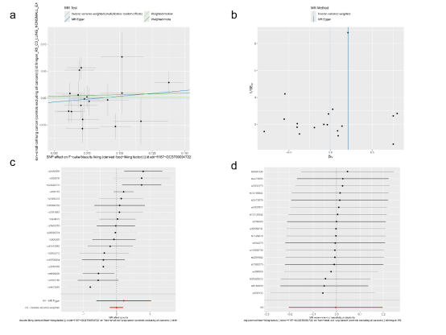

Figure S45. Causal effects for Cake/biscuits liking liking on Non-small cell lung cancer
(a)Scatter plots, (b) Funnel plot , (c) Leave-one-out analysis , (d) Forest plots

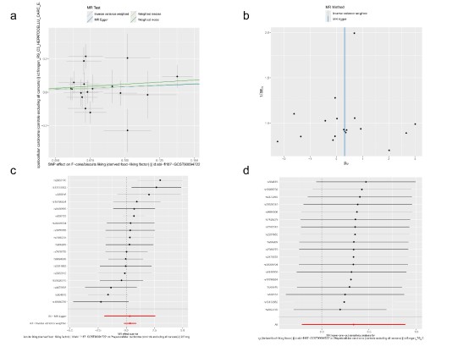

Figure S46. Causal effects for Cake/biscuits liking on Hepatocellular carcinoma
(a)Scatter plots, (b) Funnel plot , (c) Leave-one-out analysis , (d) Forest plots

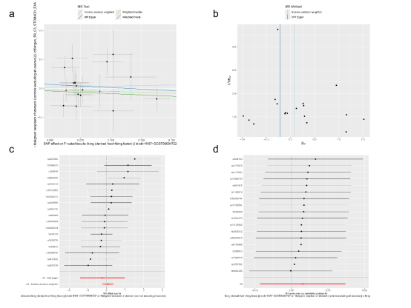

Figure S47. Causal effects for Cake/biscuits liking on Gastric cancer
(a)Scatter plots, (b) Funnel plot , (c) Leave-one-out analysis , (d) Forest plots

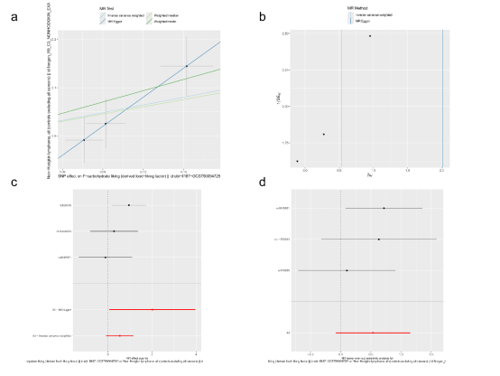

Figure S48. Causal effects for Carbohydrate liking on Non-Hodgkin's lymphoma
(a)Scatter plots, (b) Funnel plot , (c) Leave-one-out analysis , (d) Forest plots

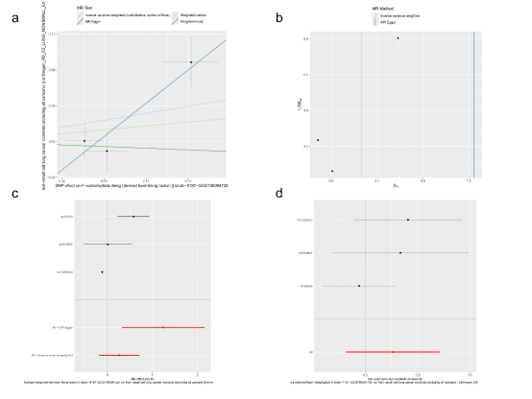

Figure S49. Causal effects for Carbohydrate liking on Non-small cell lung cancer
(a)Scatter plots, (b) Funnel plot , (c) Leave-one-out analysis , (d) Forest plots

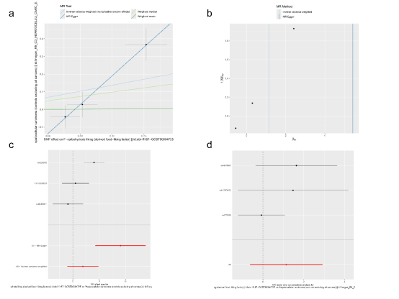

Figure S50. Causal effects for Carbohydrate liking on Hepatocellular carcinoma
(a)Scatter plots, (b) Funnel plot , (c) Leave-one-out analysis , (d) Forest plots

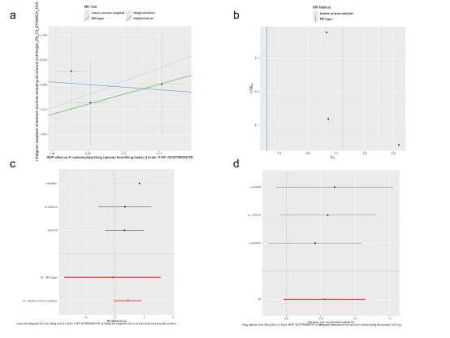

Figure S51. Causal effects for Carbohydrate liking on Gastric cancer
(a)Scatter plots, (b) Funnel plot , (c) Leave-one-out analysis , (d) Forest plots

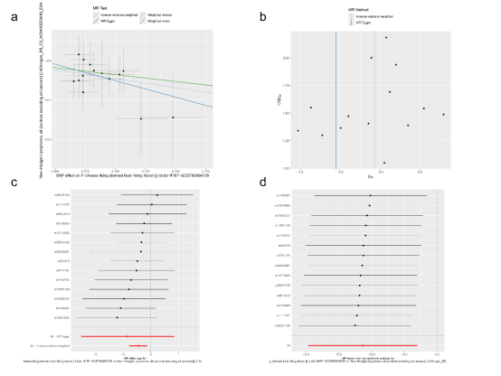

Figure S52. Causal effects for Cheese liking on Non-Hodgkin's lymphoma
(a)Scatter plots, (b) Funnel plot , (c) Leave-one-out analysis , (d) Forest plots

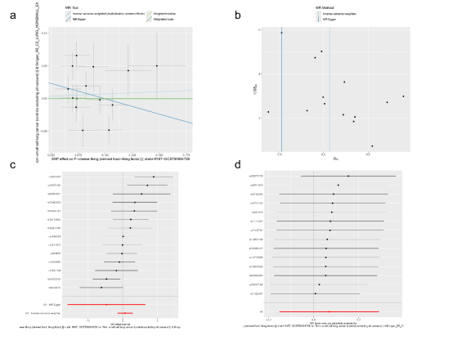

Figure S53. Causal effects for Cheese liking on Non-small cell lung cancer
(a)Scatter plots, (b) Funnel plot , (c) Leave-one-out analysis , (d) Forest plots

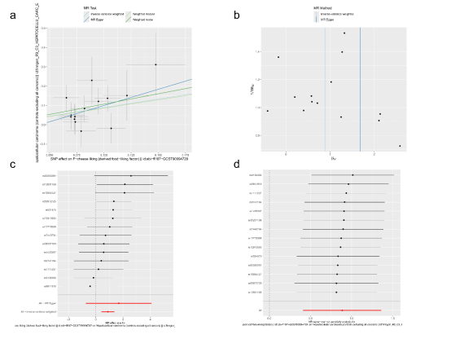

Figure S54. Causal effects for Cheese liking on Hepatocellular carcinoma
(a)Scatter plots, (b) Funnel plot , (c) Leave-one-out analysis , (d) Forest plots

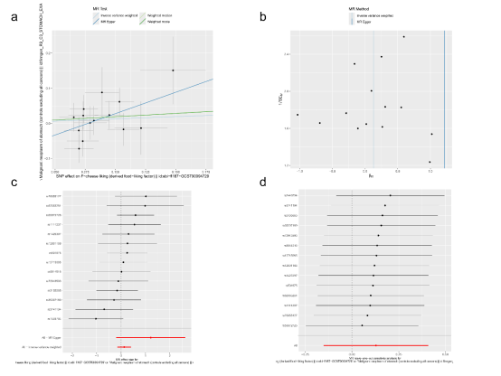

Figure S55. Causal effects for Cheese liking on Gastric cancer
(a)Scatter plots, (b) Funnel plot , (c) Leave-one-out analysis , (d) Forest plots

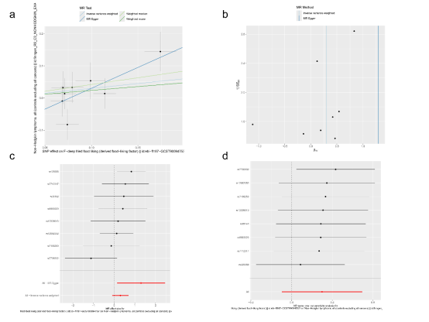

Figure S56. Causal effects for Deep fried food liking on Non-Hodgkin's lymphoma
(a)Scatter plots, (b) Funnel plot , (c) Leave-one-out analysis , (d) Forest plots

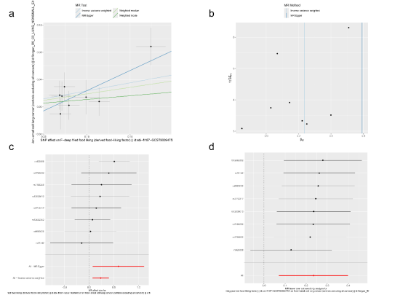

Figure S57. Causal effects for Deep fried food liking on Non-small cell lung cancer
(a)Scatter plots, (b) Funnel plot , (c) Leave-one-out analysis , (d) Forest plots

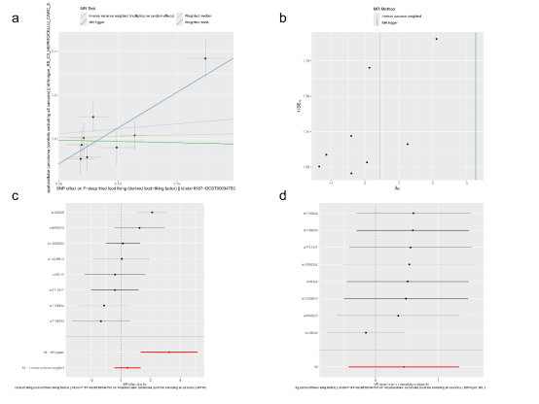

Figure S58. Causal effects for Deep fried food liking on Hepatocellular carcinoma
(a)Scatter plots, (b) Funnel plot , (c) Leave-one-out analysis , (d) Forest plots

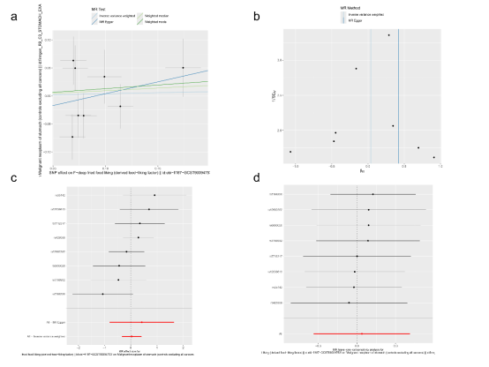

Figure S59. Causal effects for Deep fried food liking on Gastric cancer
(a)Scatter plots, (b) Funnel plot , (c) Leave-one-out analysis , (d) Forest plots

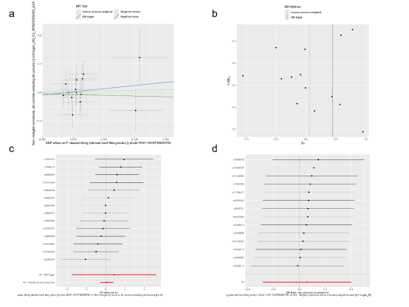

Figure S60. Causal effects for Dessert liking on Non-Hodgkin's lymphoma
(a)Scatter plots, (b) Funnel plot , (c) Leave-one-out analysis , (d) Forest plots

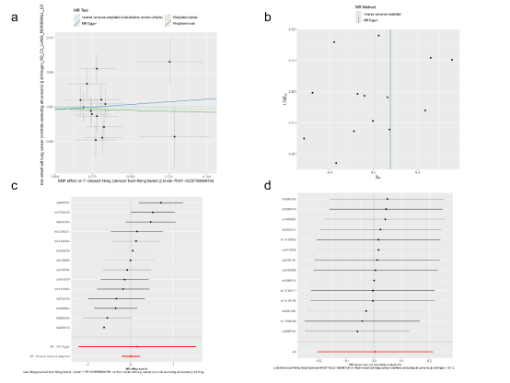

Figure S61. Causal effects for Dessert liking on Non-small cell lung cancer
(a)Scatter plots, (b) Funnel plot , (c) Leave-one-out analysis , (d) Forest plots

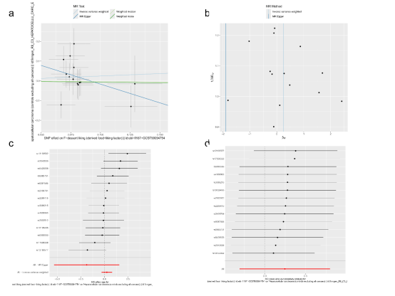

Figure S62. Causal effects for Dessert liking on Hepatocellular carcinoma
(a)Scatter plots, (b) Funnel plot , (c) Leave-one-out analysis , (d) Forest plots

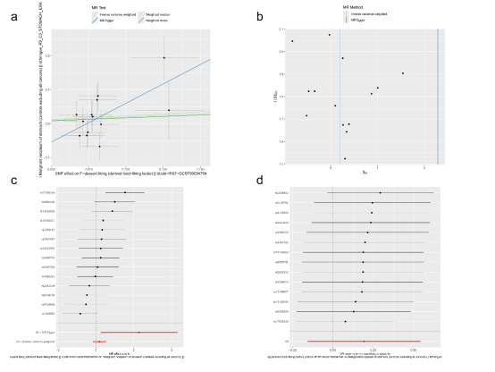

Figure S63. Causal effects for Dessert liking on Gastric cancer
(a)Scatter plots, (b) Funnel plot , (c) Leave-one-out analysis , (d) Forest plots

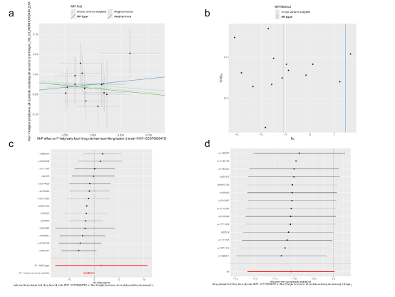

Figure S64. Causal effects for Fatty/salty food liking on Non-Hodgkin's lymphoma
(a)Scatter plots, (b) Funnel plot , (c) Leave-one-out analysis , (d) Forest plots

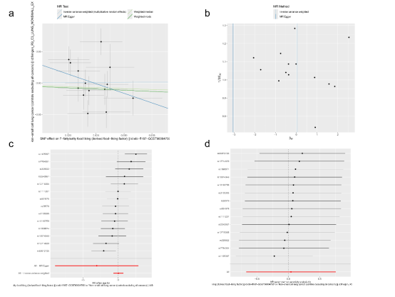

Figure S65. Causal effects for Fatty/salty food liking on Non-small cell lung cancer
(a)Scatter plots, (b) Funnel plot , (c) Leave-one-out analysis , (d) Forest plots

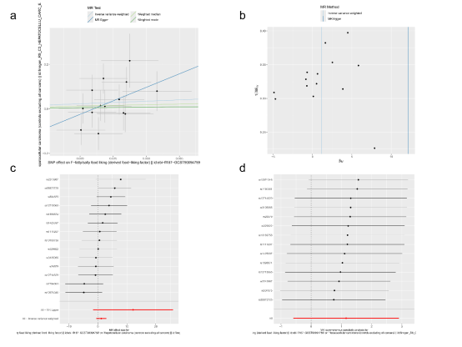

Figure S66. Causal effects for Fatty/salty food liking on Hepatocellular carcinoma
(a)Scatter plots, (b) Funnel plot , (c) Leave-one-out analysis , (d) Forest plots

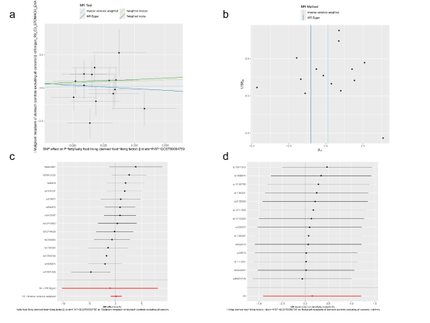

Figure S67. Causal effects for Fatty/salty food liking on Gastric cancer
(a)Scatter plots, (b) Funnel plot , (c) Leave-one-out analysis , (d) Forest plots

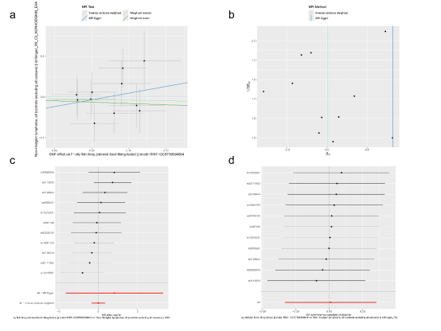

Figure S68. Causal effects for Oily fish liking on Non-Hodgkin's lymphoma
(a)Scatter plots, (b) Funnel plot , (c) Leave-one-out analysis , (d) Forest plots

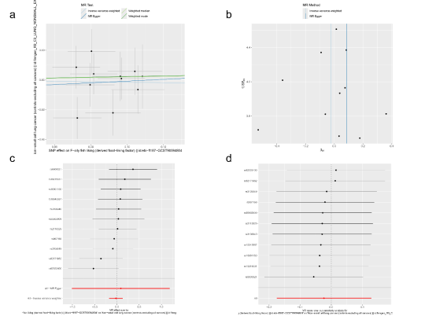

Figure S69. Causal effects for Oily fish liking on Non-small cell lung cancer
(a)Scatter plots, (b) Funnel plot , (c) Leave-one-out analysis , (d) Forest plots

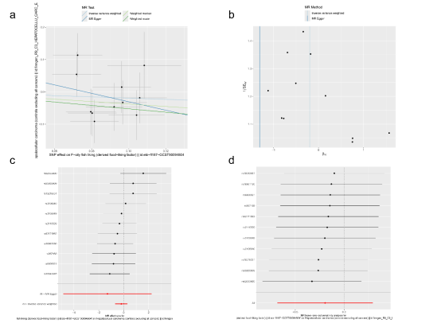

Figure S70. Causal effects for Oily fish liking on Hepatocellular carcinoma
(a)Scatter plots, (b) Funnel plot , (c) Leave-one-out analysis , (d) Forest plots

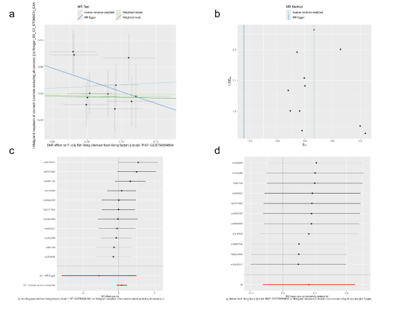

Figure S71. Causal effects for Oily fish liking on Gastric cancer
(a)Scatter plots, (b) Funnel plot , (c) Leave-one-out analysis , (d) Forest plots

