A Lyophilizable LNP Vaccine Enables STING-Reinforced Postoperational Adjuvant Immunotherapy

Yi Yang^{1,5}, Jiaxin Guo^{1,5}, Jialong Qi^{2,5}, Wenxia Deng¹, Jialin Hu¹, Muhammad Waqqas Hasan¹, Fei Deng³, You Zhou¹, Zhengji Song^{2*}, Wei Deng^{4*}, Wenjie Chen^{1*}
¹Guangdong Province & NMPA & State Key Laboratory, School of Pharmaceutical Sciences, Guangzhou Medical University, Guangzhou, 511436, P.R. China.
²Yunnan Digestive Endoscopy Clinical Medical Center, Department of Gastroenterology, The First People's Hospital of Yunnan Province, Affiliated Hospital of Kunming University of Science and Technology, Kunming 650032, P.R. China.
³Graduate School of Biomedical Engineering, ARC Centre of Excellence in Nanoscale Biophotonics, Faculty of Engineering, UNSW Sydney, NSW 2052, Australia.
⁴School of Biomedical Engineering, University of Technology Sydney, Ultimo, NSW, 2007, Australia.
⁵Authors contributed equally to this work.

Correspondence to:
W. Chen (wenjie.chen1@hdr.mq.edu.au); W. Deng (wei.deng@uts.edu.au); Z. Song (song4715@163.com)

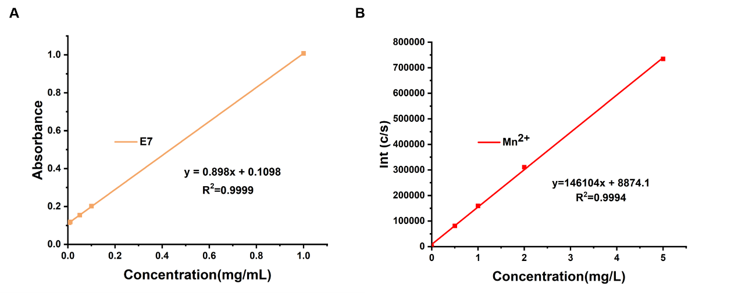
Figure S1 Drug standard curve. (A) Standard curve for E7 absorption VS concentration. (B) Standard curve of spectral intensity for Mn²⁺ using ICP-MS.

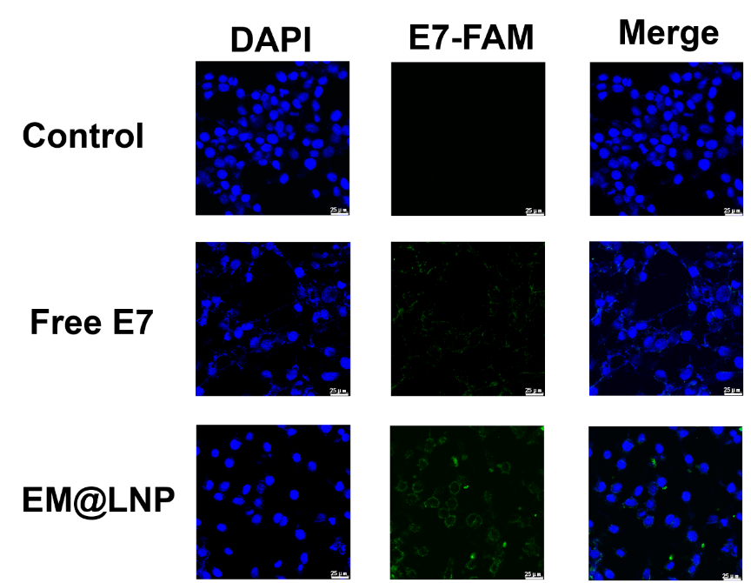
Figure S2 Representative CLSM images of cellular uptake of BMDCs cells treated with EM@LNP for 0.5 h (Scale bar: 25 μm).

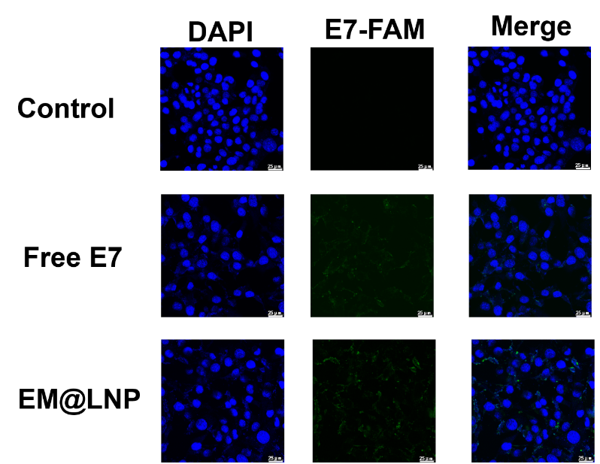
Figure S3 Representative CLSM images of cellular uptake of BMDCs cells treated with EM@LNP for 6 h (Scale bar: 25 μm).

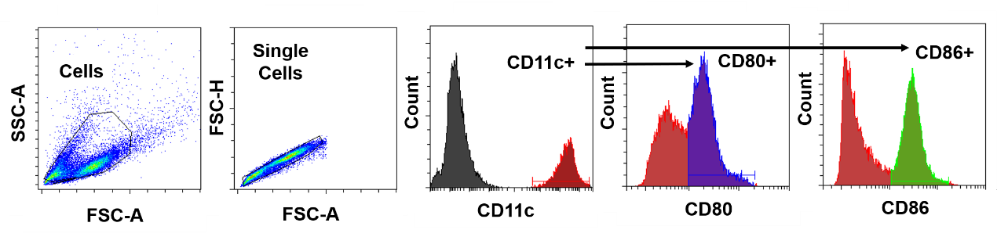
Figure S4 The gating strategy of BMDCs maturation (CD80+ and CD86+).
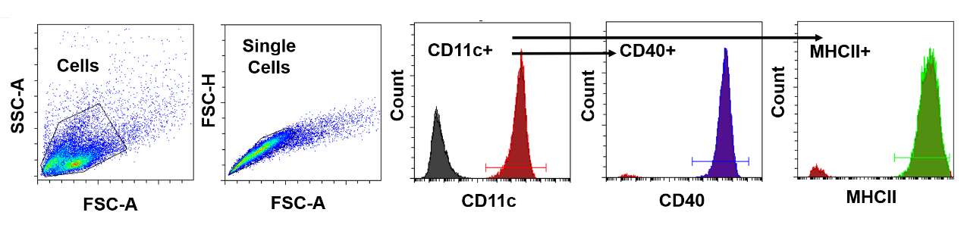
Figure S5 The gating strategy of BMDCs maturation (CD40⁺ and MHCII⁺).

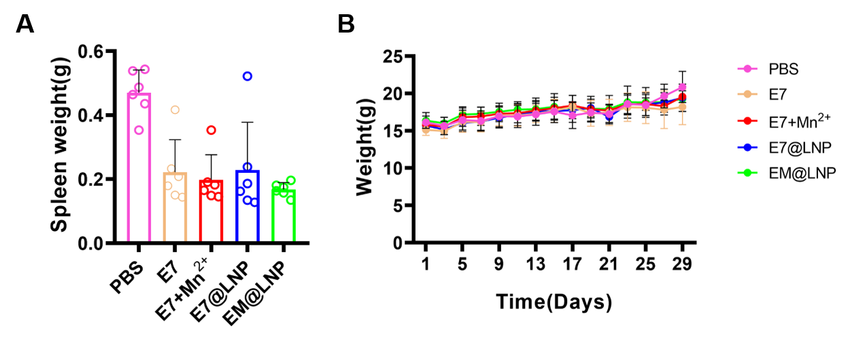
Figure S6 (A)Weight of mice spleen. (B)Body weight of mice in the EM@LNP treated mice under preventive vaccination scheme.

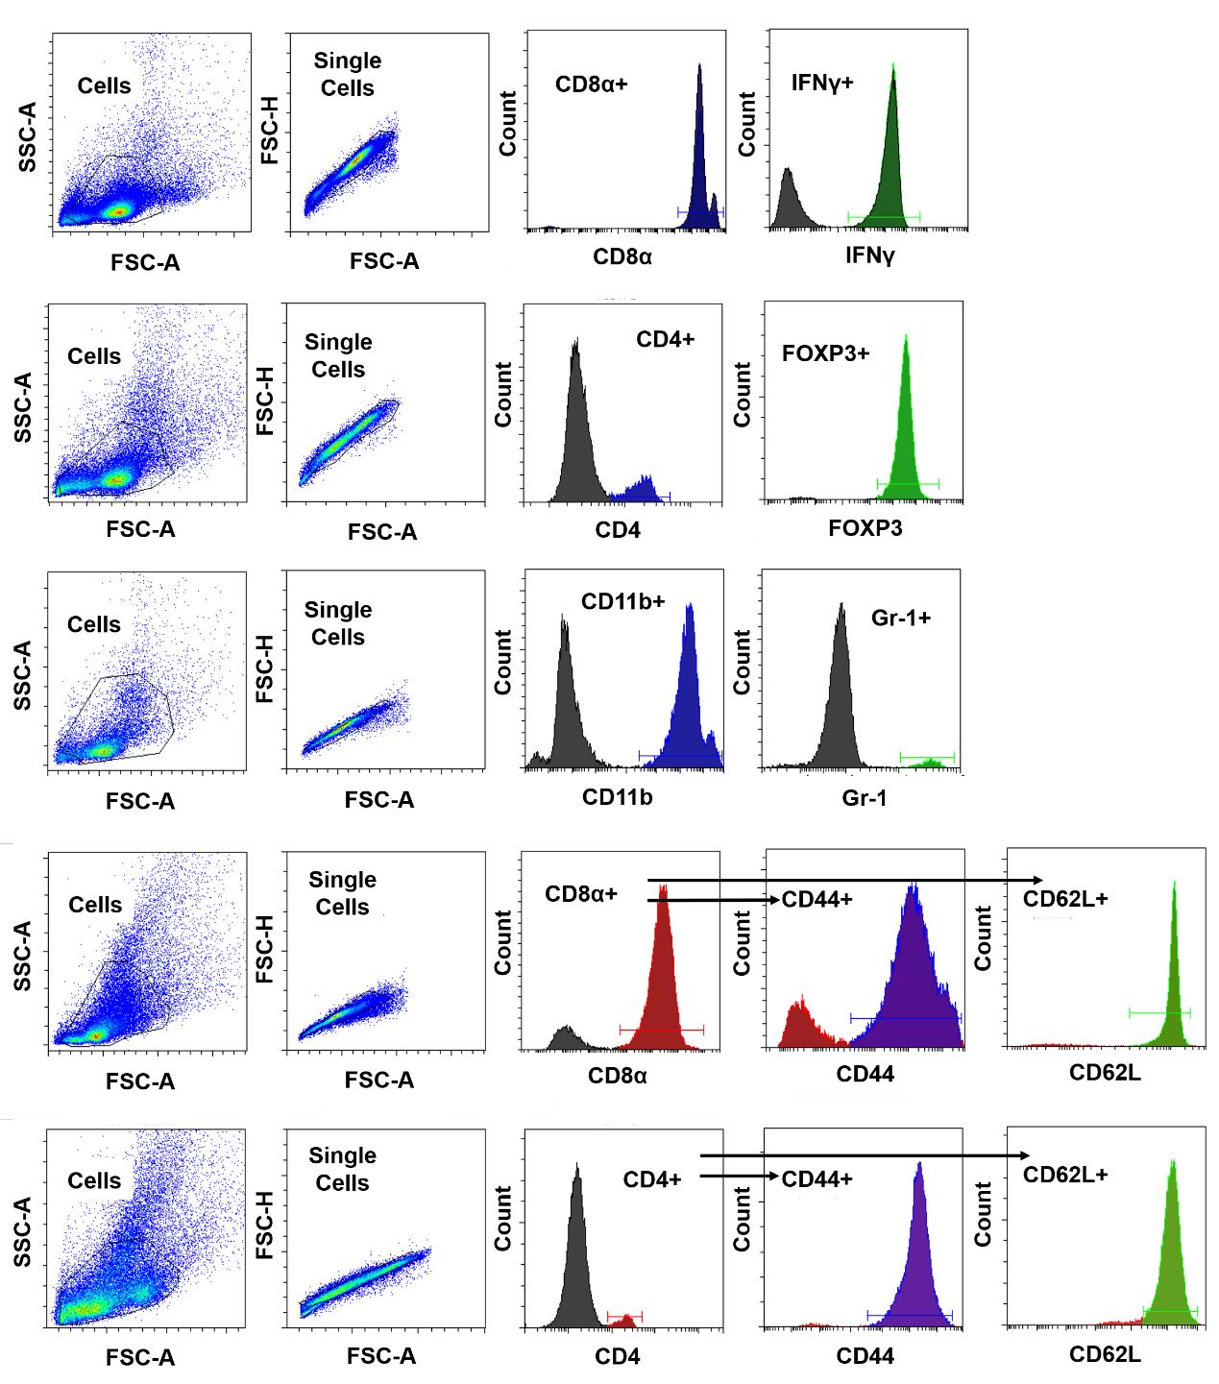
Figure S7 The gating strategy of the flow cytometry assay of mouse splenic lymphocytes.

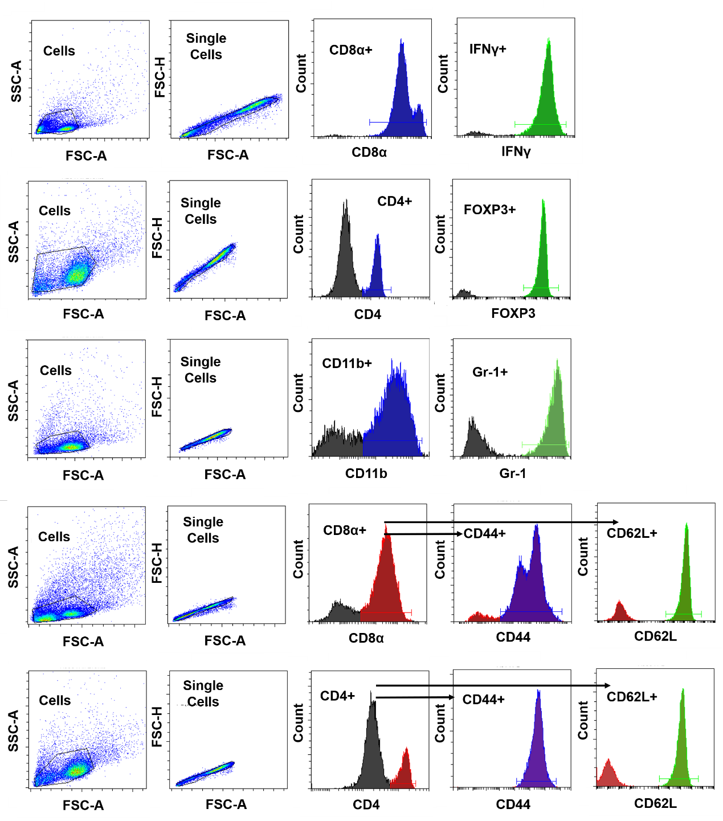
Figure S8 The gating strategy of the flow cytometry assay of mouse lymphocytes in lymph nodes.

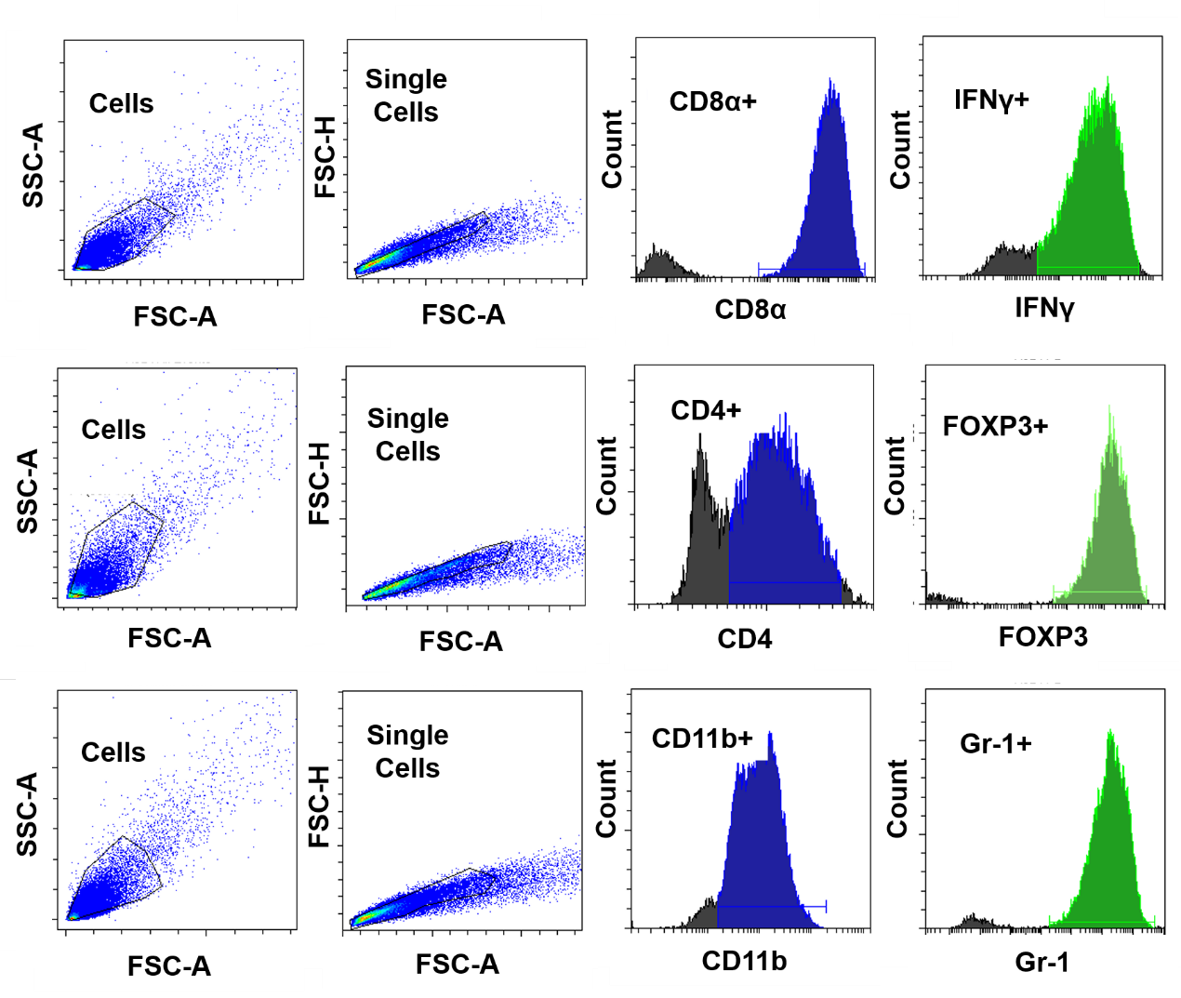
Figure S9 The gating strategy of the flow cytometry assay of lymphocytes in mouse tumors.

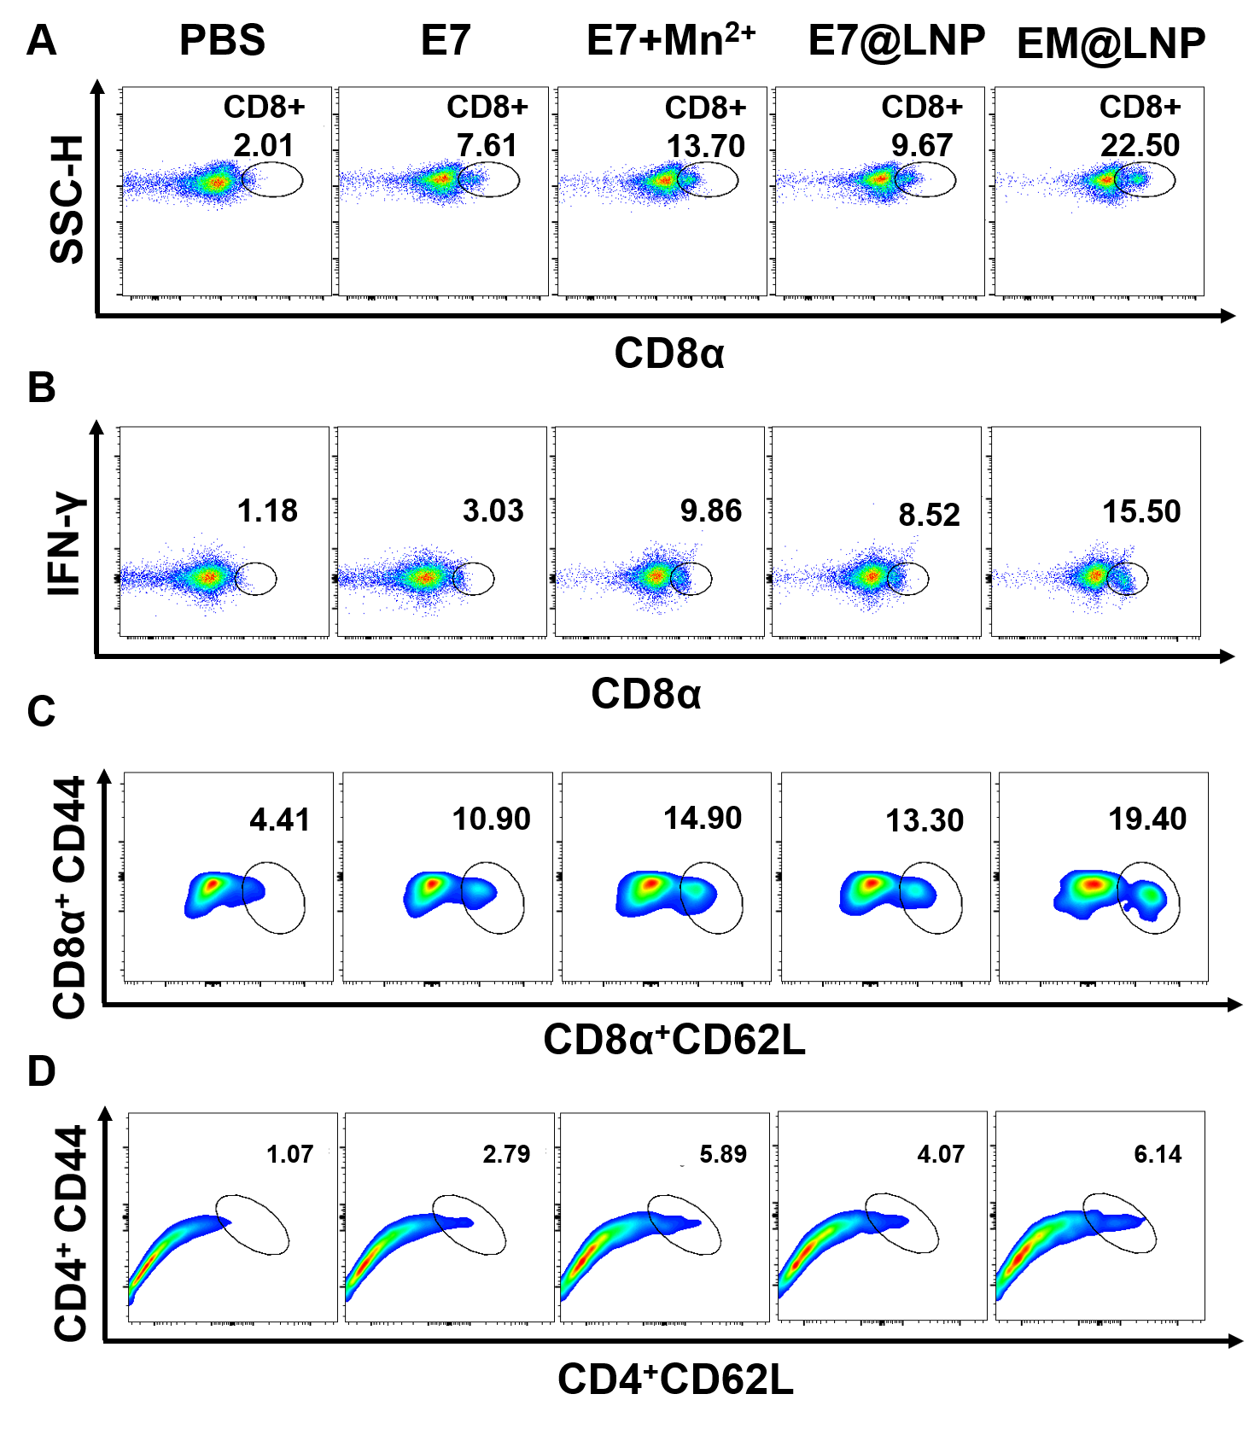
Figure S10 Flow cytometry analysis of immune response in spleen of mice receiving prophylactic immunization. (A)Representative flow cytometry plot of CD8⁺ T cells. (B)Representative flow cytometry plot of CD8⁺IFNγ⁺ T cells. (C)Representative flow cytometry plot of CD8⁺CD62⁺CD44⁺ T cells. (D) Representative flow cytometry plot of CD4⁺CD62⁺CD44⁺ T cells.

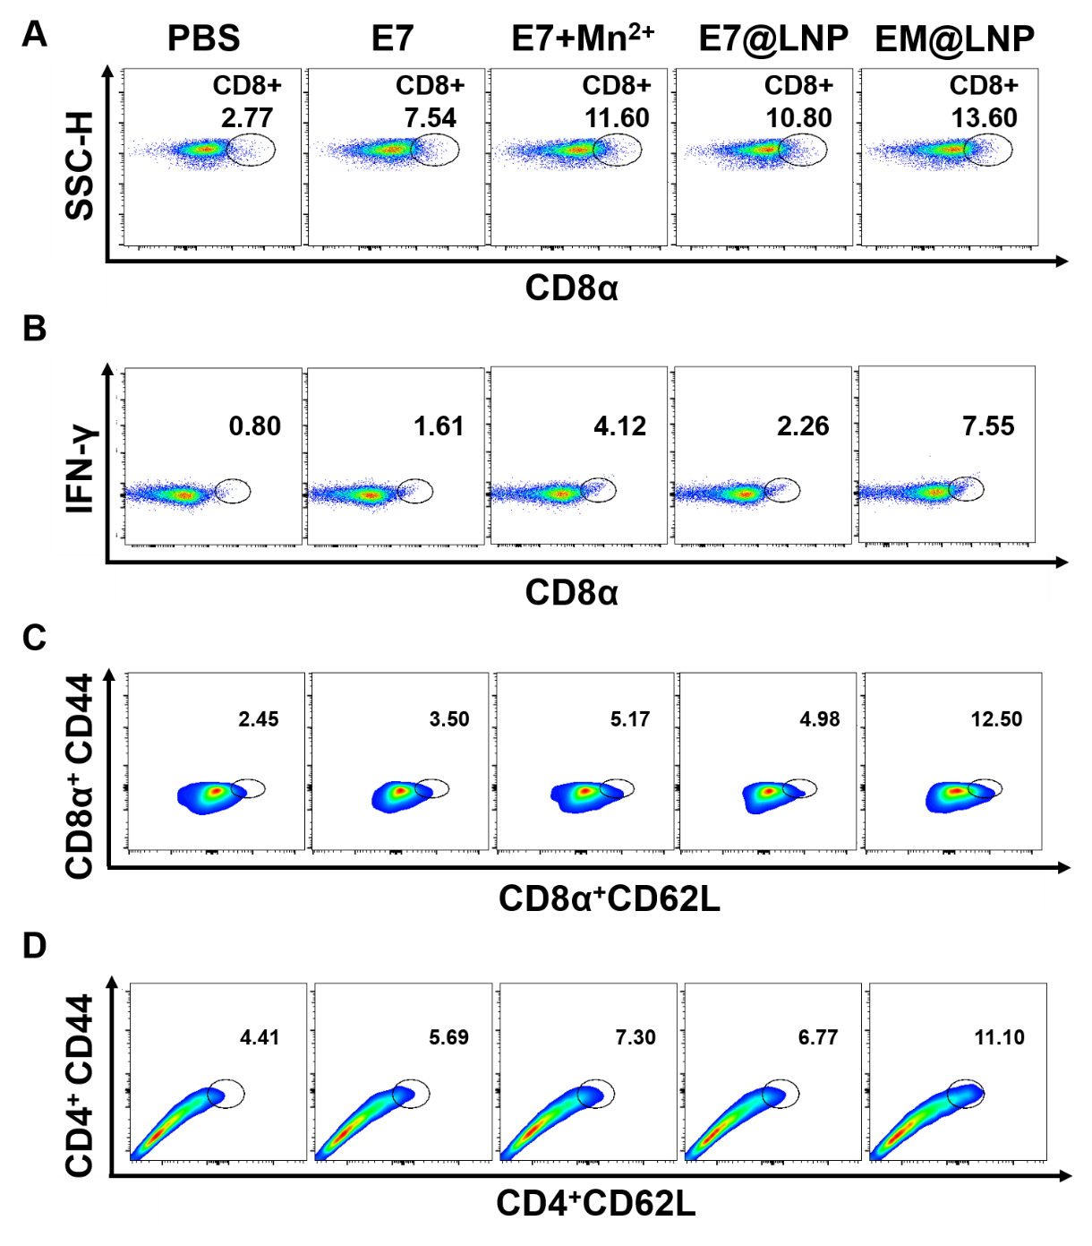
Figure S11 Flow cytometry analysis of immune response in lymph nodes of mice receiving prophylactic immunization. (A)Representative flow cytometry plot of CD8⁺ T cells. (B)Representative flow cytometry plot of CD8⁺IFNγ⁺ T cells. (C)Representative flow cytometry plot of CD8⁺CD62⁺CD44⁺ T cells. (D) Representative flow cytometry plot of CD4⁺CD62⁺CD44⁺ T cells.

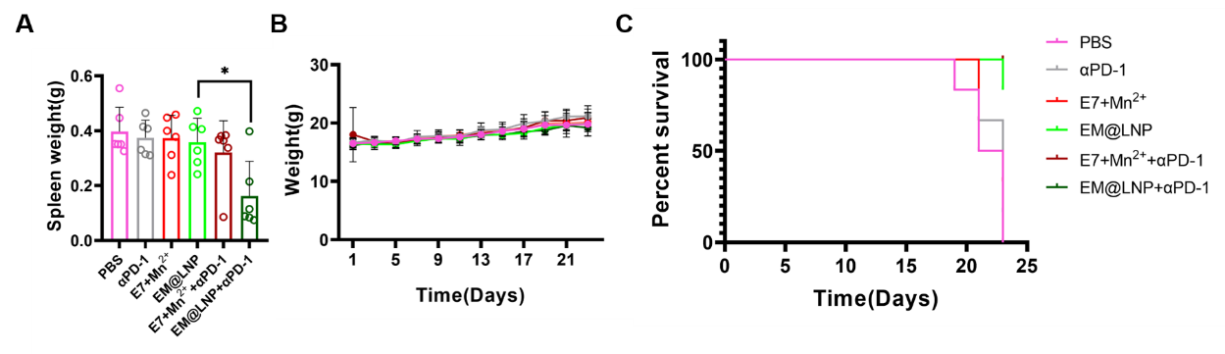
Figure S12 EM@LNP in combination with ICB significantly inhibits subcutaneous TC-1 cervical cancer. (A)Weight of mice spleen. (B) Body weight of mice. (C) Survival curve of mice.

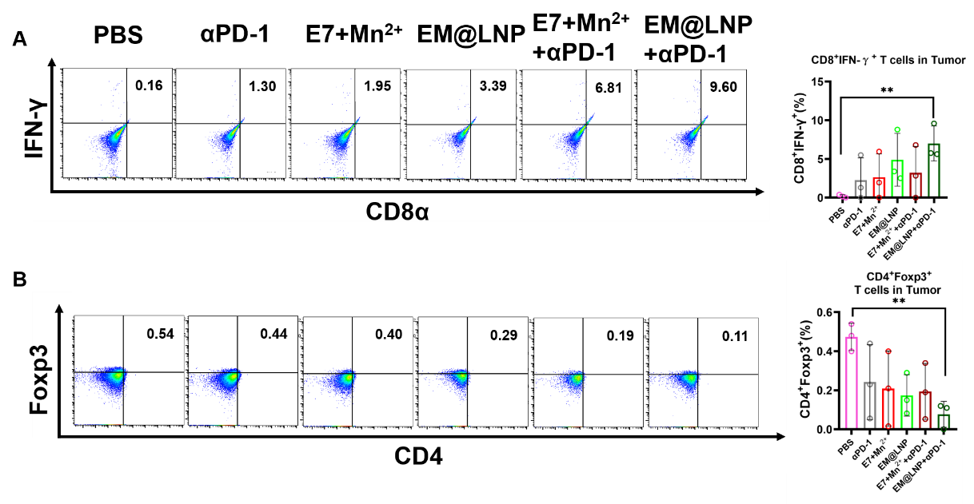
Figure S13 FACS in mice tumor treated with EM@LNP combined with αPD-1. (A) Representative flow cytometry and statistical charts of CD8⁺IFNγ⁺ T cells. (B) Representative flow cytometry and statistical charts of CD4⁺Foxp3⁺ T cells.

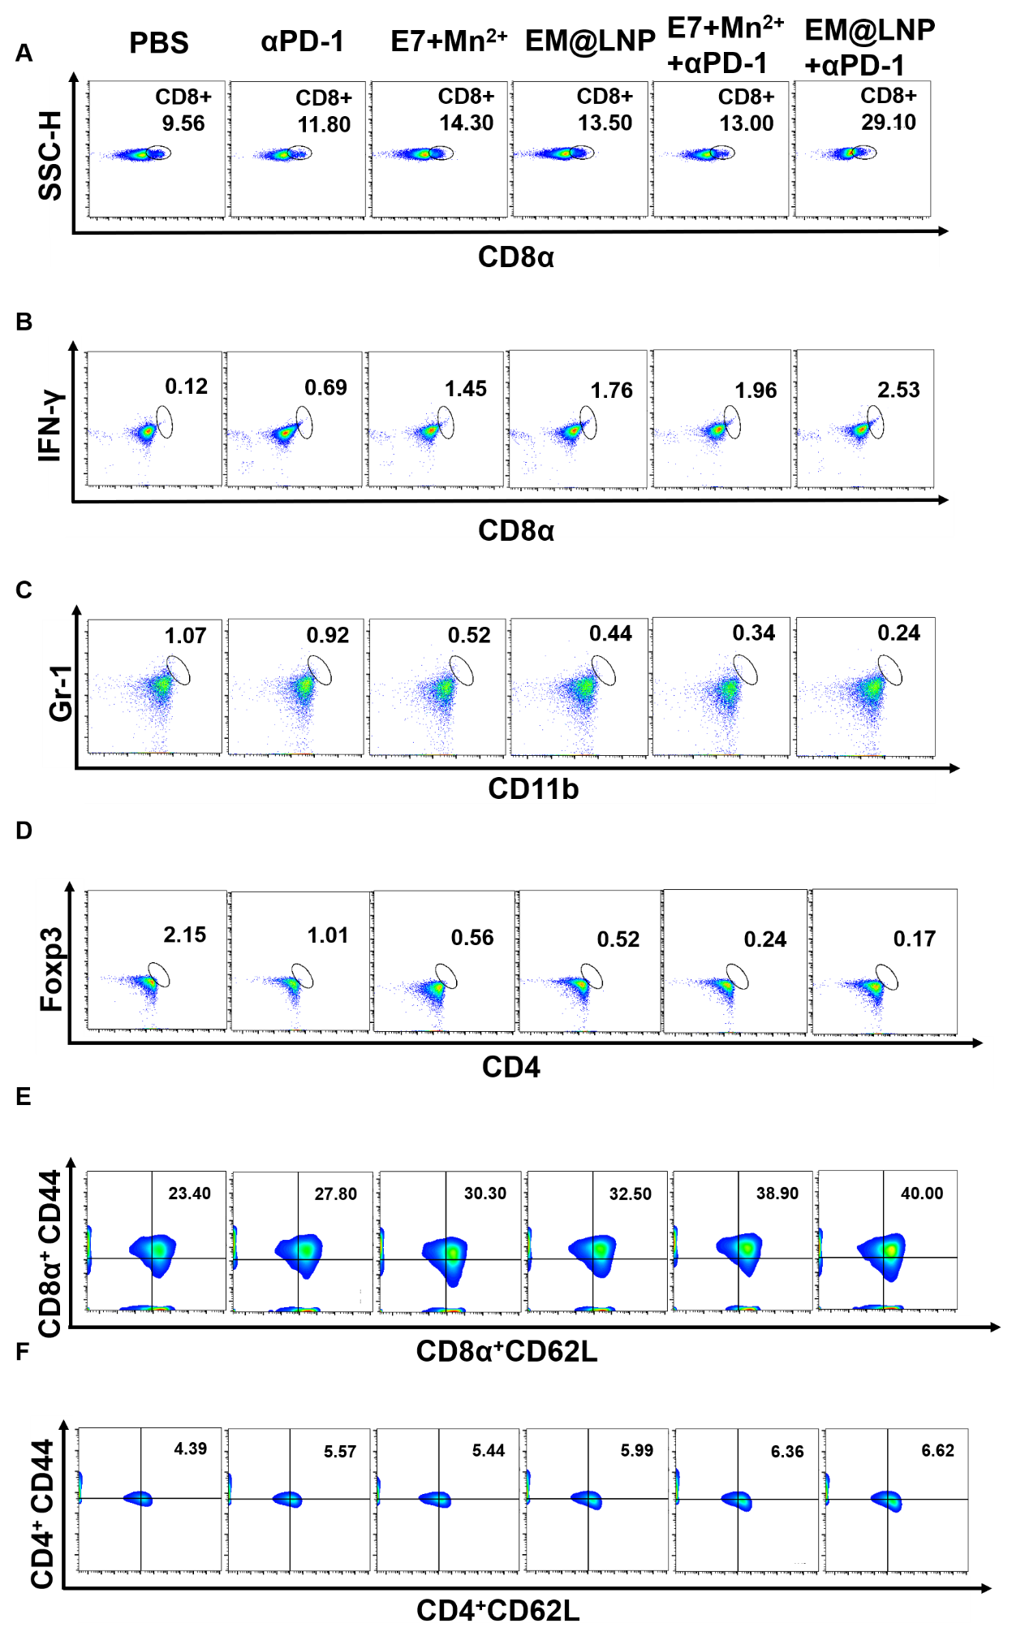
Figure S14 FACS of spleen lymphocytes of mice treated with EM@LNP combined with αPD-1. (A) Representative flow cytometry plot of CD8⁺ T cells. (B) Representative flow cytometry plot of CD8+IFNγ⁺ T cells. (C) Representative flow cytometry plot of CD11b⁺Gr-1⁺ T cells. (D) Representative flow cytometry plot of CD4⁺Foxp3⁺ T cells. (E) Representative flow cytometry plot of CD8⁺CD62⁺CD44⁺ T cells. (F) Representative flow cytometry plot of CD4⁺CD62⁺CD44⁺ T cells.

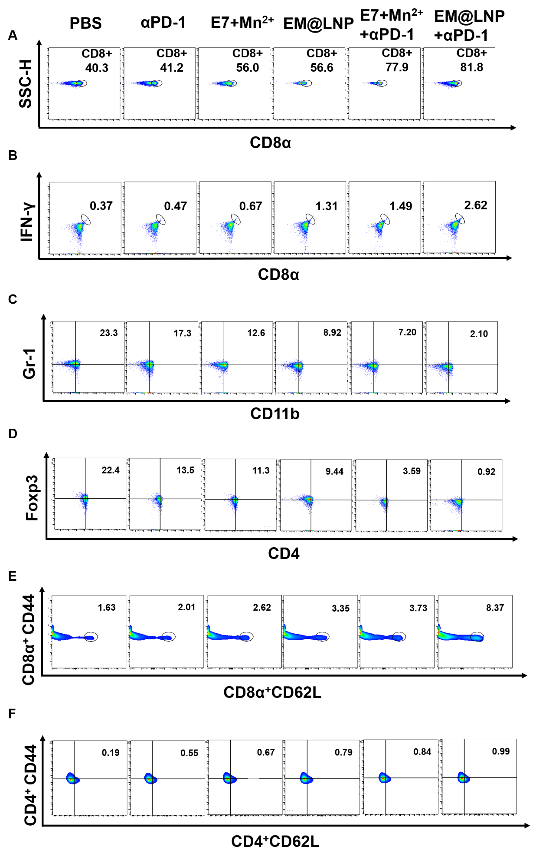
Figure S15 FACS of lymphocytes in lymph nodes of mice treated with EM@LNP combined with αPD-1. (A) Representative flow cytometry plot of CD8⁺ T cells. (B) Representative flow cytometry plot of CD8⁺IFNγ⁺ T cells. (C) Representative flow cytometry plot of CD11b⁺Gr-1⁺ T cells. (D) Representative flow cytometry plot of CD4⁺Foxp3⁺ T cells. (E) Representative flow cytometry plot of CD8⁺CD62⁺CD44⁺ T cells. (F) Representative flow cytometry plot of CD4⁺CD62⁺CD44⁺ T cells.

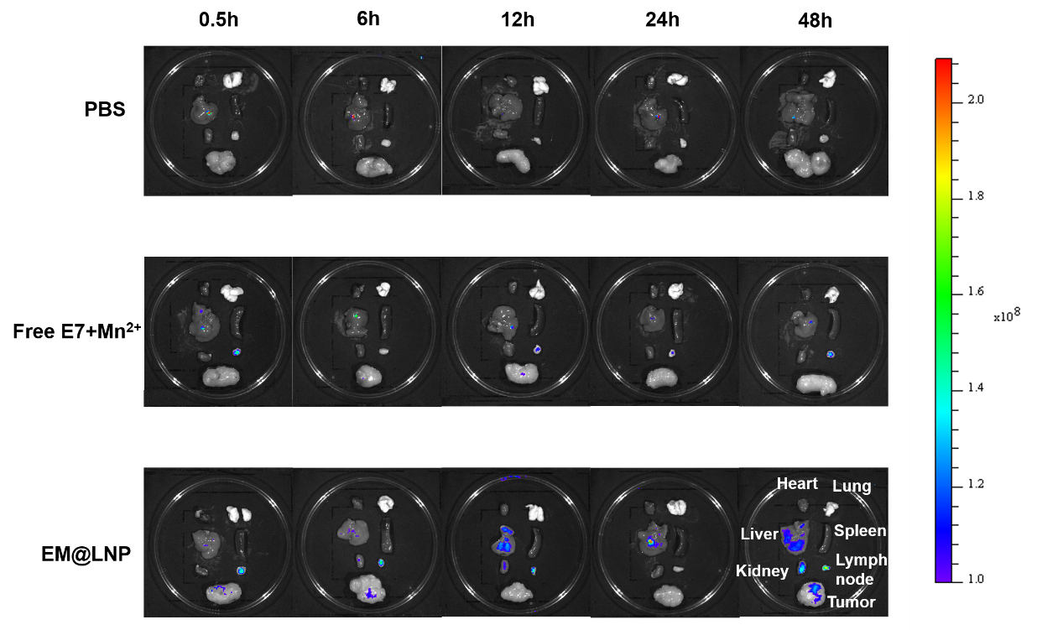
Figure S16 The in vivo distribution of PBS, E7+Mn²⁺, and EM@LNP.

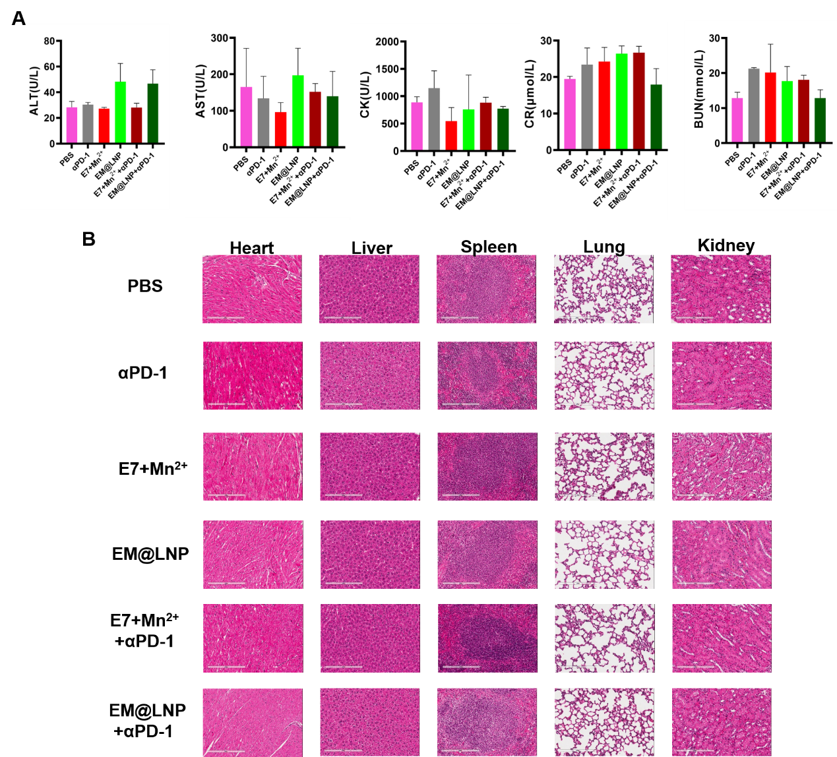
Figure S17 Biosafety study of nanoveccines. (A) In vivo evaluation of systemic toxicity after treatment. Variations of ALT (Alanine aminotransferase), AST (Aspartate aminotransferase), CK (Creatine Kinase), CR (Creatinine), BUN (Blood urea nitrogen) in blood samples were analyzed. (B) H&E staining of major organs (heart, liver, spleen, lung, and kidney) of mice treated with PBS, αPD-1, E7+Mn²⁺, EM@LNP, E7+Mn²⁺+αPD-1, EM@LNP+αPD-1. Scale bars =200 μm.

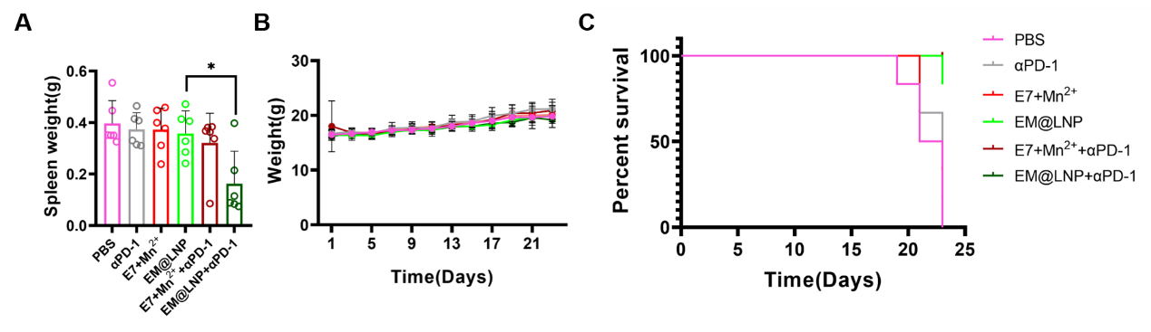
Figure S18 EM@LNP combined with ICB for the treatment of postoperative recurrent tumors. (A) Weight of mice spleen. (B) Body weight of mice. (C) Survival curve of mice.

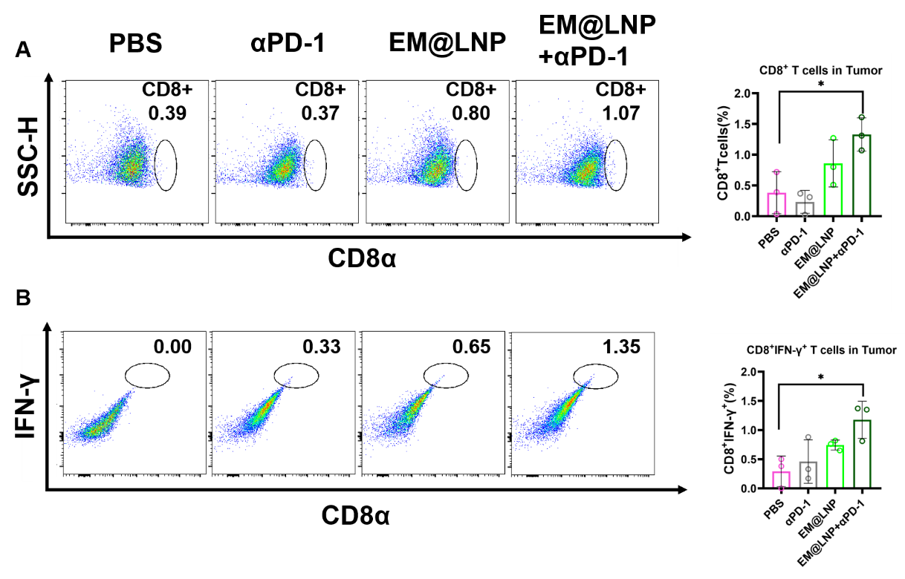
Figure S19 FACS of postsurgical recurrent tumors treated with EM@LNP combined with αPD-1. (A) Representative flow cytometry and statistical charts of CD8⁺ T cells. (B) Representative flow cytometry and statistical charts of CD8⁺IFNγ⁺ T cells.

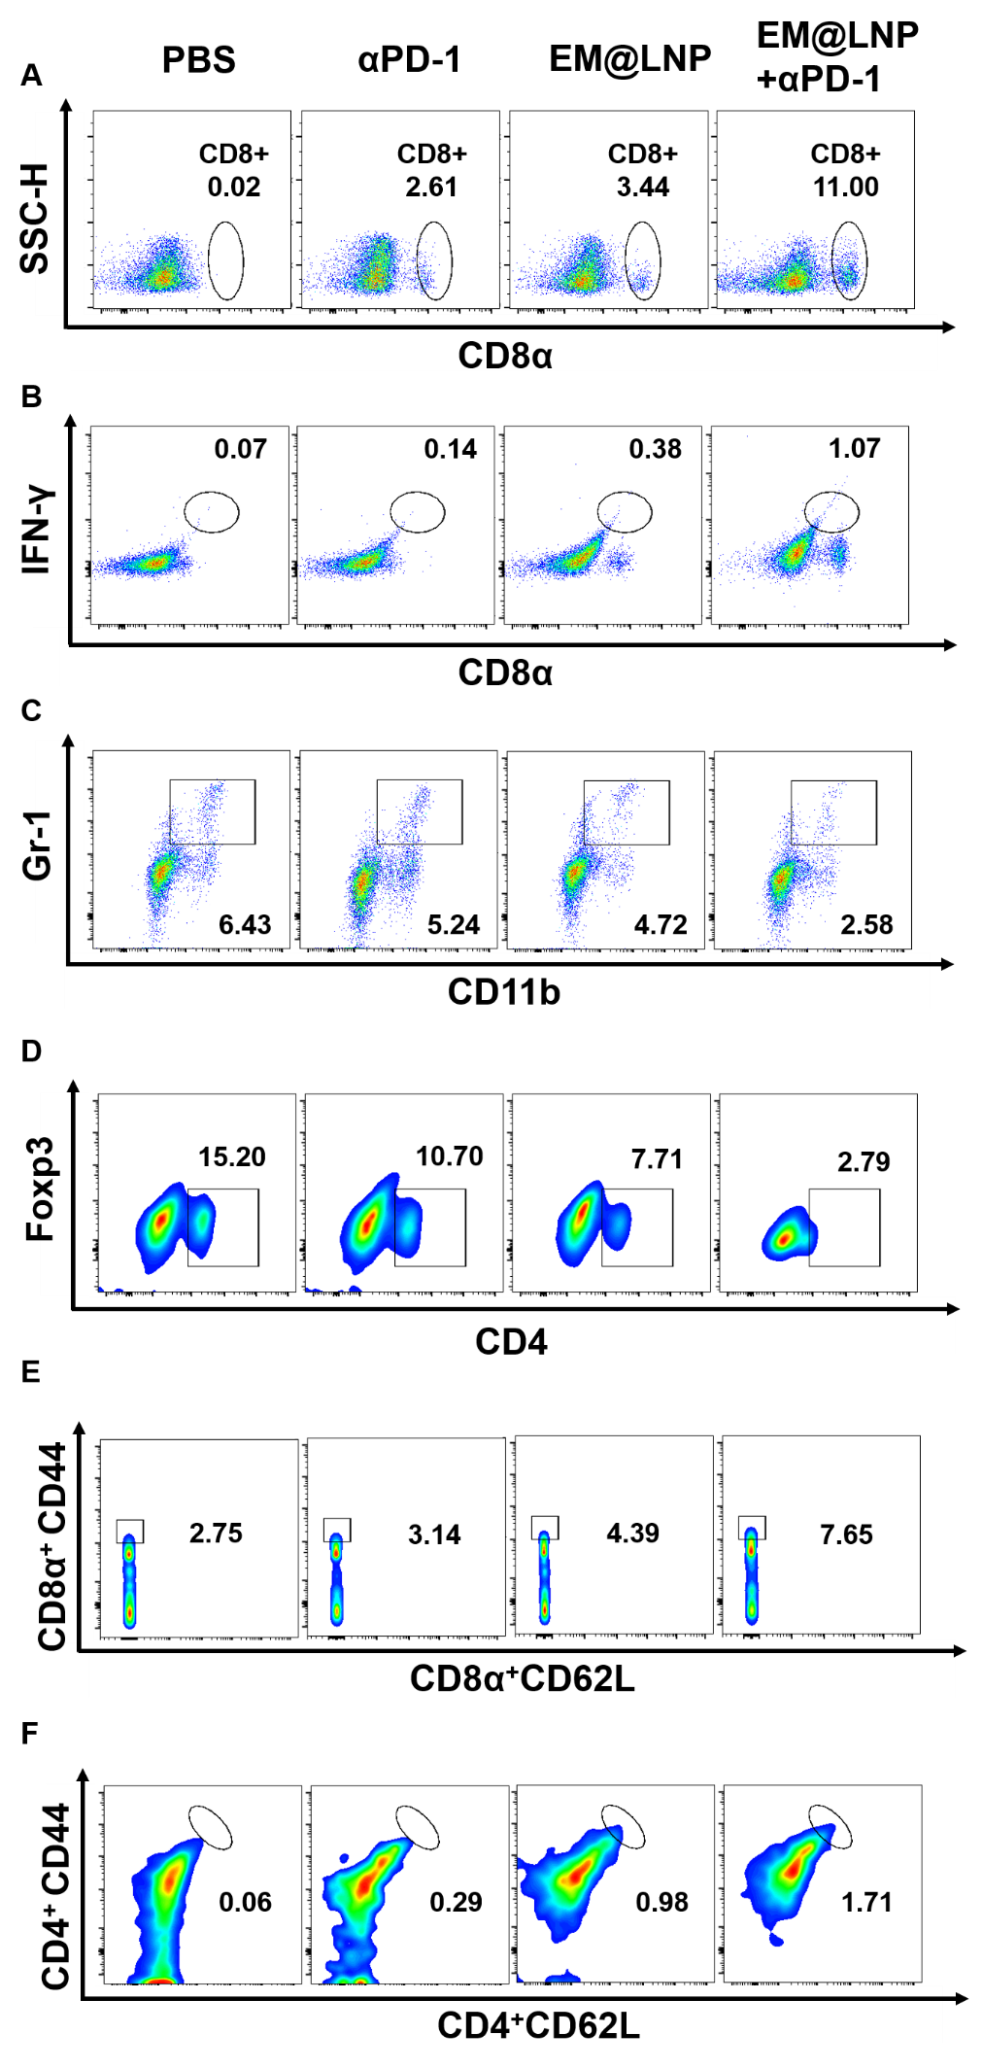
Figure S20 FACS of splenic lymphocytes of tumor recurrence model treated with EM@LNP combined with αPD-1. (A)Representative flow cytometry plot of CD8⁺ T cells. (B) Representative flow cytometry plot of CD8⁺IFNγ⁺ T cells. (C) Representative flow cytometry plot of CD11b⁺Gr-1⁺ T cells. (D) Representative flow cytometry plot of CD4⁺Foxp3⁺ T cells. (E) Representative flow cytometry plot of CD8⁺CD62⁺CD44⁺ T cells. (F) Representative flow cytometry plot of CD4⁺CD62⁺CD44⁺ T cells in tumor recurrence mice spleen DCs.

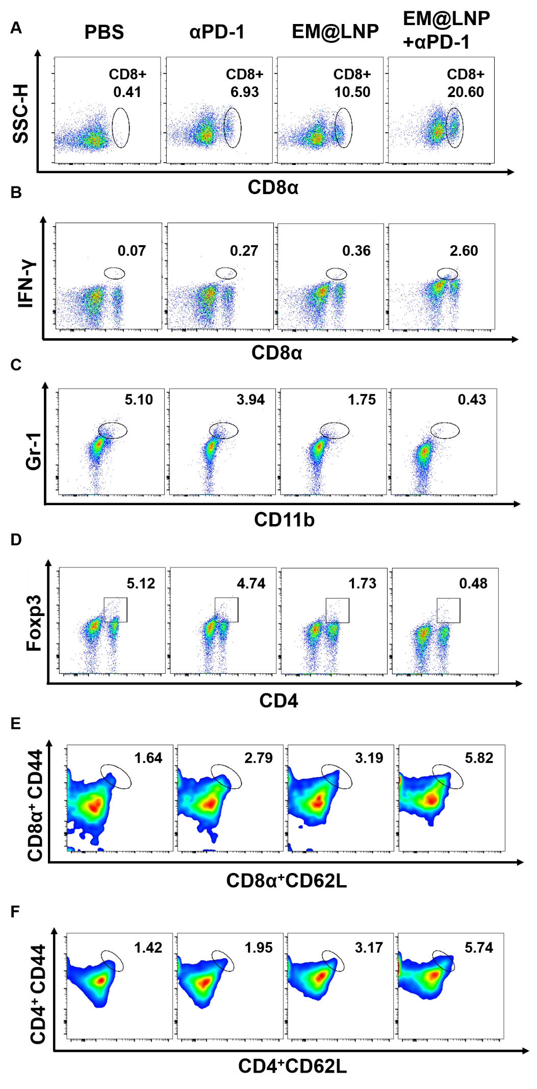
Figure S21 FACS in lymph nodes of tumor recurrence model treated with EM@LNP combined with αPD-1. (A) Representative flow cytometry plot of CD8⁺ T cells. (B) Representative flow cytometry plot of CD8⁺IFNγ⁺ T cells. (C) Representative flow cytometry plot of CD11b⁺Gr-1⁺ T cells. (D) Representative flow cytometry plot of CD4⁺Foxp3⁺ T cells. (E) Representative flow cytometry plot of CD8⁺CD62⁺CD44⁺ T cells. (F) Representative flow cytometry plot of CD4⁺CD62⁺CD44⁺ T cells.

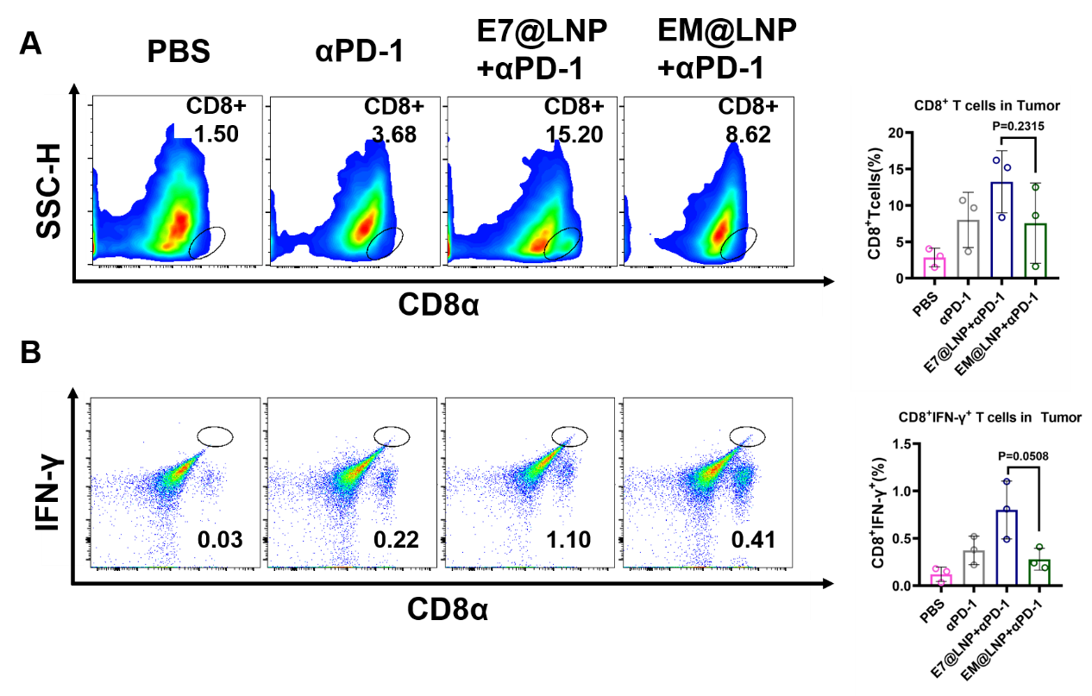
Figure S22 FACS in tumors of STING^{-/-} mouse treated with EM@LNP combined with αPD-1. (A) Representative flow cytometry and statistical charts of CD8⁺ T cells. (B) Representative flow cytometry and statistical charts of CD8⁺IFNγ⁺ T cells.

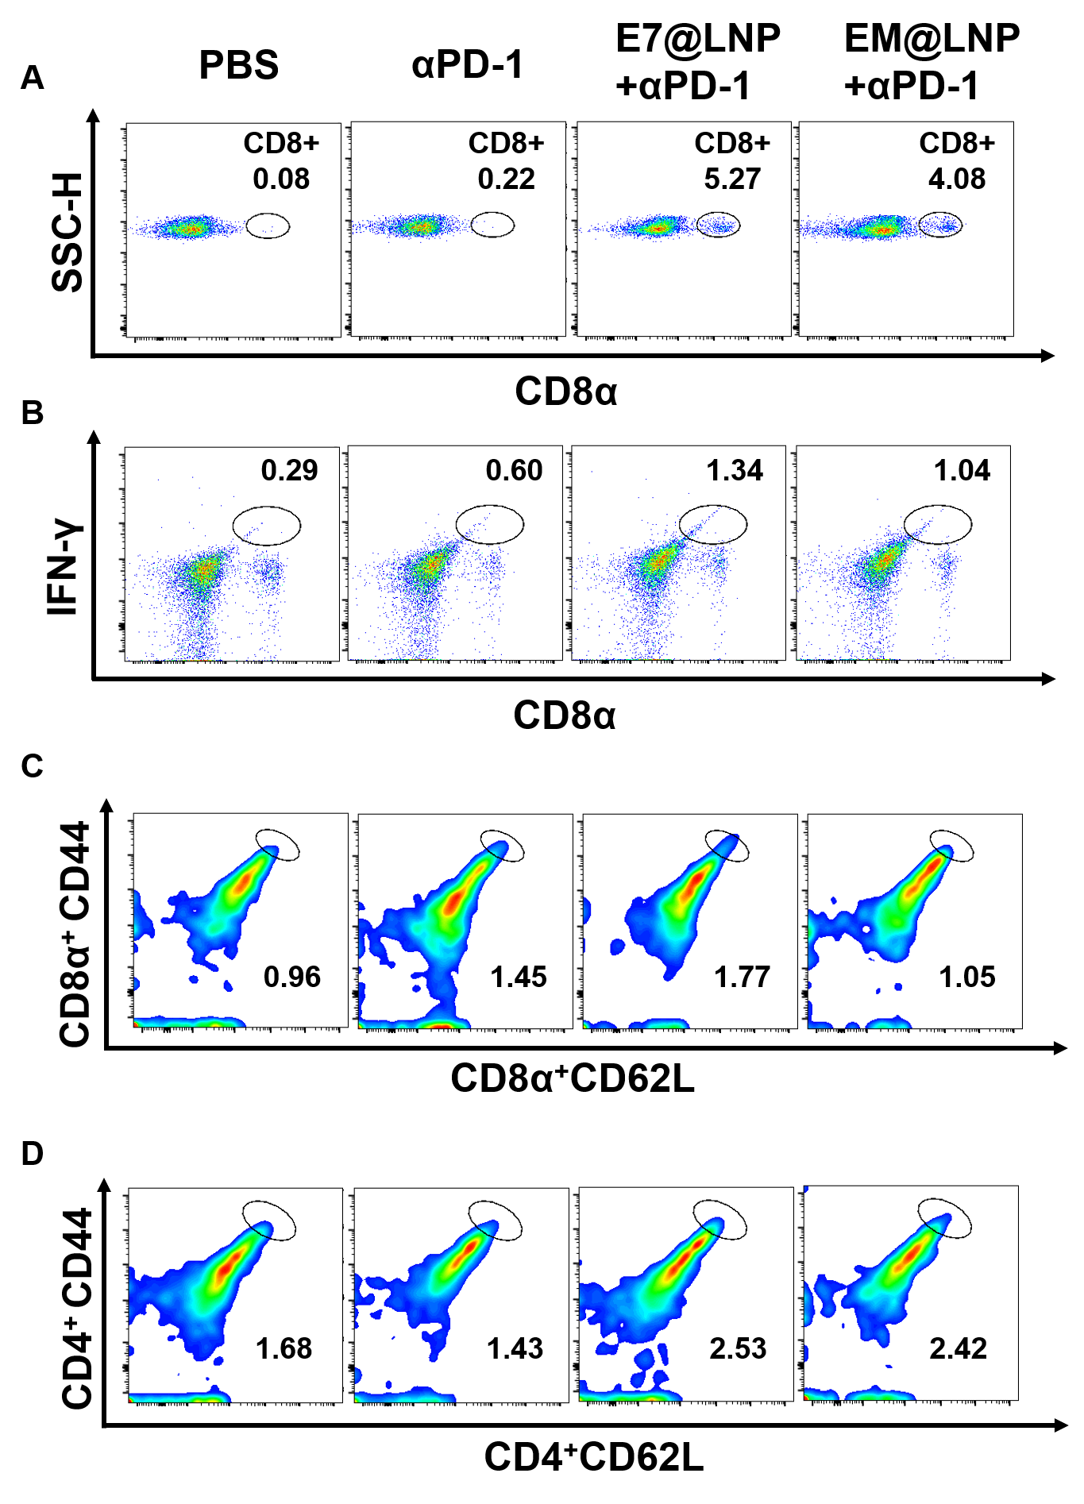
Figure S23 FACS of splenic lymphocytes of tumor-bearing STING^{-/-} mouse model treated with EM@LNP combined with αPD-1. (A) Representative flow cytometry plot of CD8⁺ T cells. (B) Representative flow cytometry plot of CD8⁺IFNγ⁺ T cells. (C) Representative flow cytometry plot of CD8⁺CD62⁺CD44⁺ T cells. (D) Representative flow cytometry plot of CD4⁺CD62⁺CD44⁺ T cells.

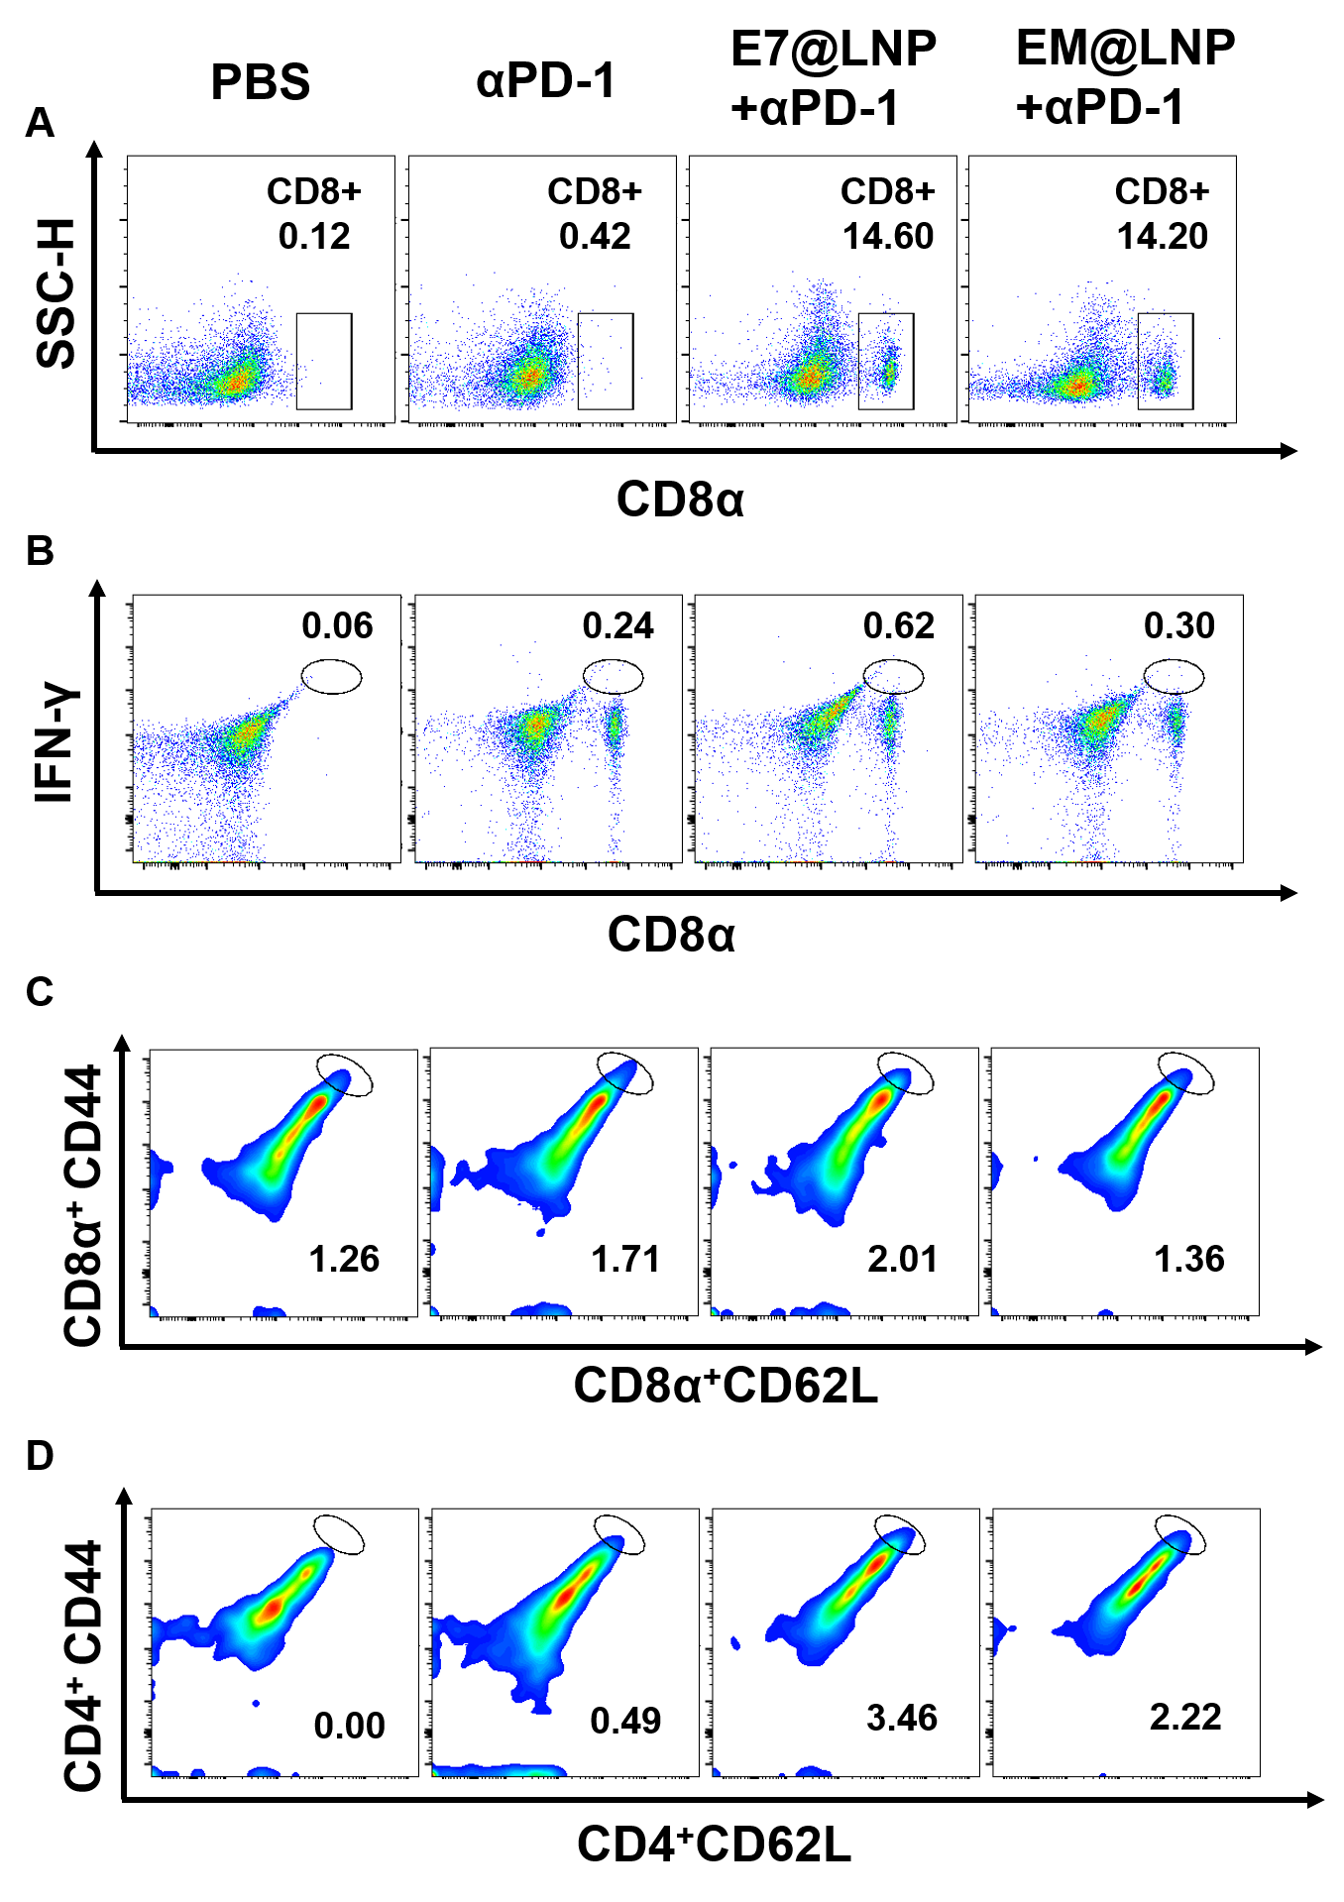
Figure S24 FACS in lymph nodes of STING^{-/-} mice bearing tumors treated with EM@LNP combined with αPD-1. (A) Representative flow cytometry plot of CD8⁺ T cells. (B) Representative flow cytometry plot of CD8⁺IFNγ⁺ T cells. (C) Representative flow cytometry plot of CD8⁺CD62⁺CD44⁺ T cells. (D) Representative flow cytometry plot of CD4⁺CD62⁺CD44⁺ T cells.

Table S1 Primer sequence for qPCR
Name | Forward 5’-3’ | Reverse 5’-3’
TNFa | GGTGCCTATGTCTCAGCCTCTT | GCCATAGAACTGATGAGAGGGAG
IL6 | GAGGATACCACTCCCAACAGACC | AAGTGCATCATCGTTGTTCATACA
CXCL10 | ATCATCCCTGCGAGCCTATCCT | GACCTTTTTTGGCTAAACGCTTTC
IFNB1 | GGTACCTTTGCACCCTCCAG | AACTCCACCAGCAGACAGTG
β-actin | GGCTGTATTCCCCTCCATCG | CCAGTTGGTAACAATGCCATGT

Uncropped Gels and Blots image(s)

