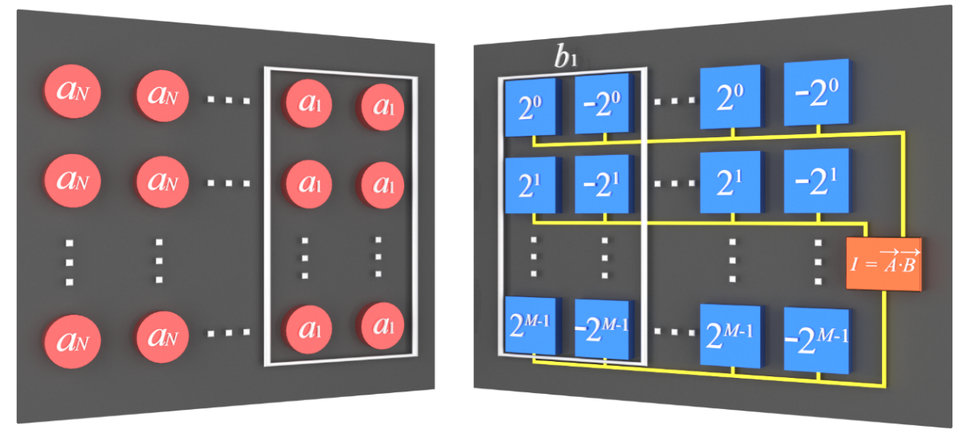
Extended Data Fig.1 | The mechanism to perform signed vector inner product A$\text{∙}$B with N sets of 2×M BEADs.

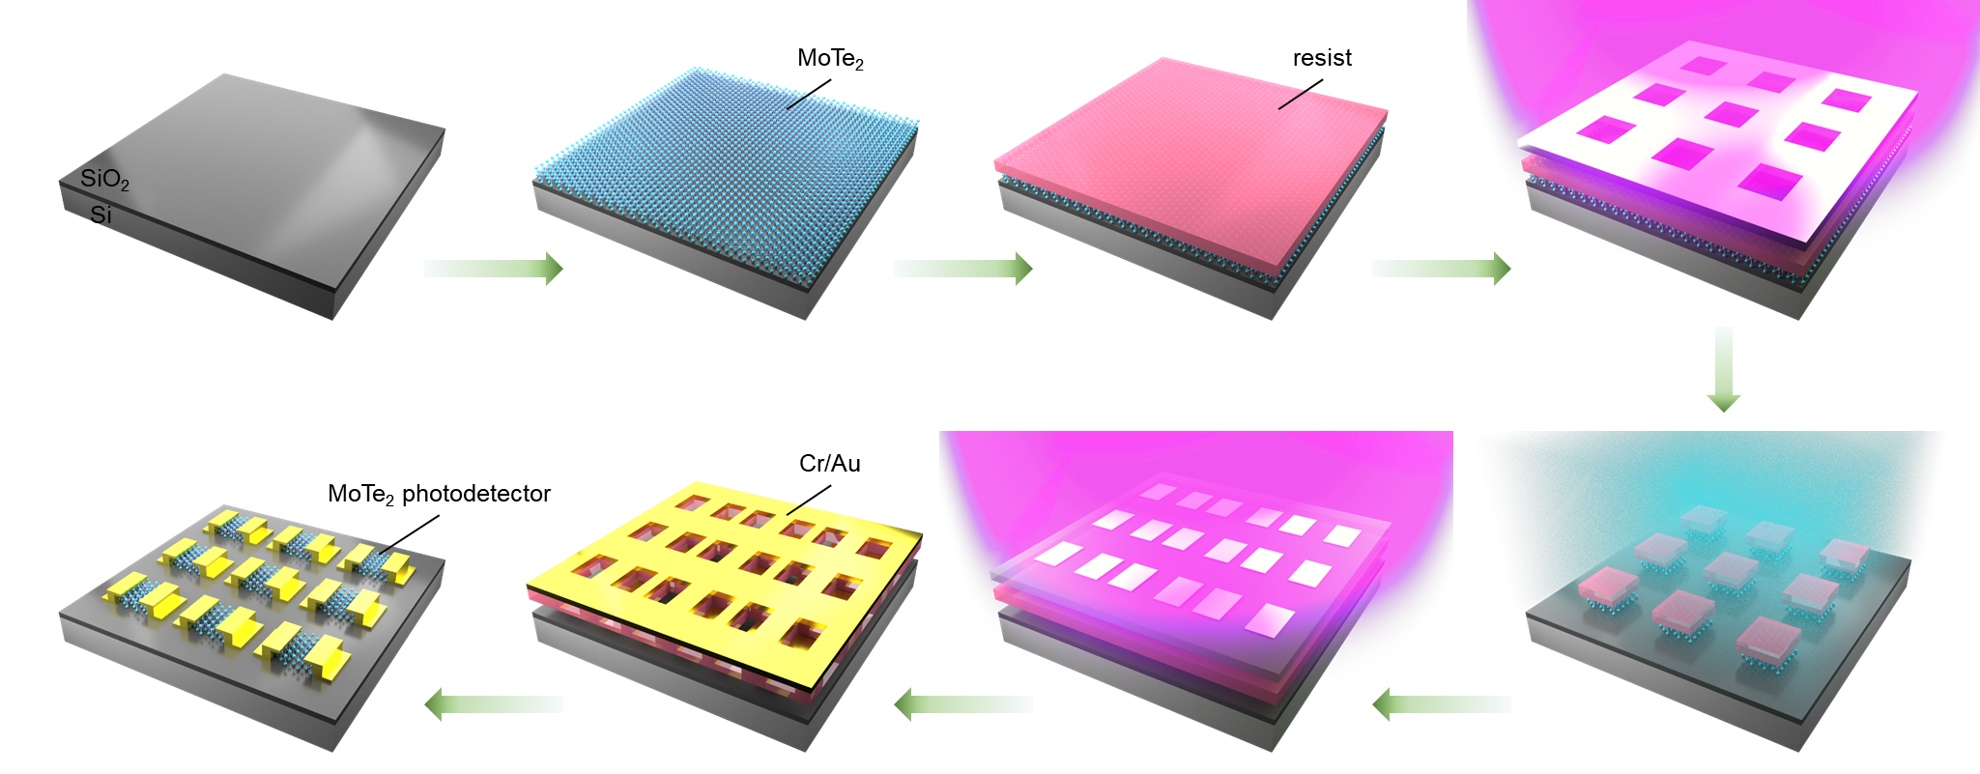
Extended Data Fig.2 | Schematic fabrication process of MoTe₂ PD array.

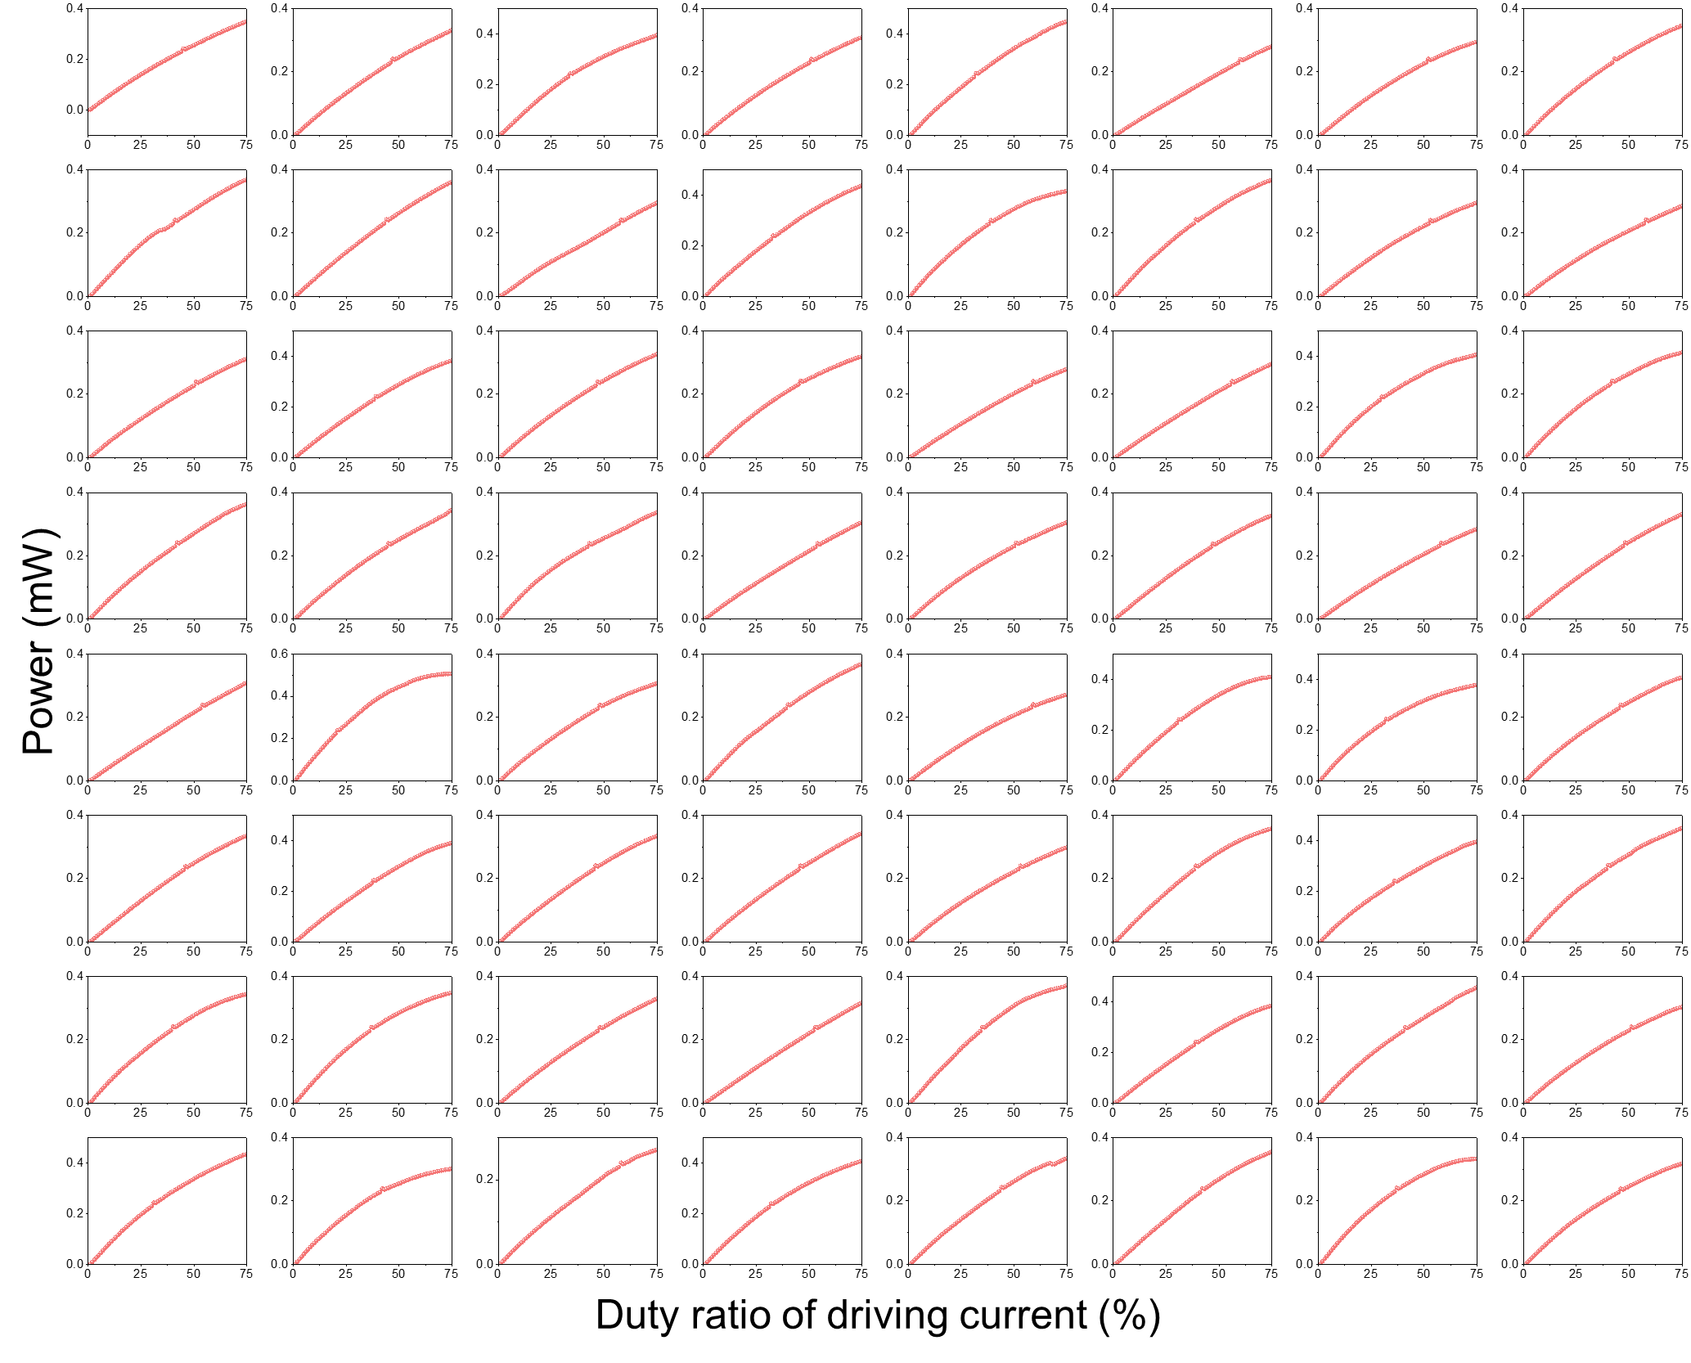
Extended Data Fig.3 | Output intensity of each VCSEL.

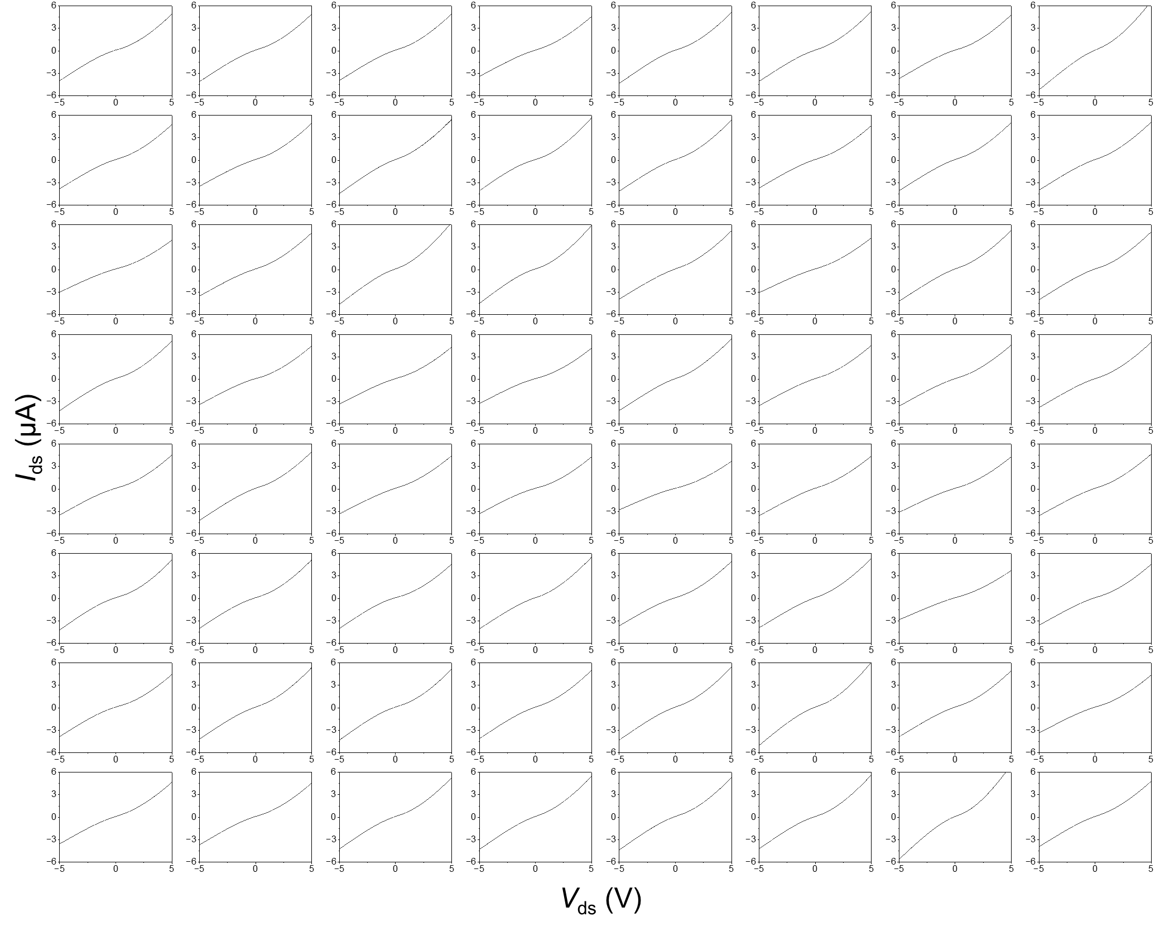
Extended Data Fig.4 | I-V curve of each MoTe₂ PD.

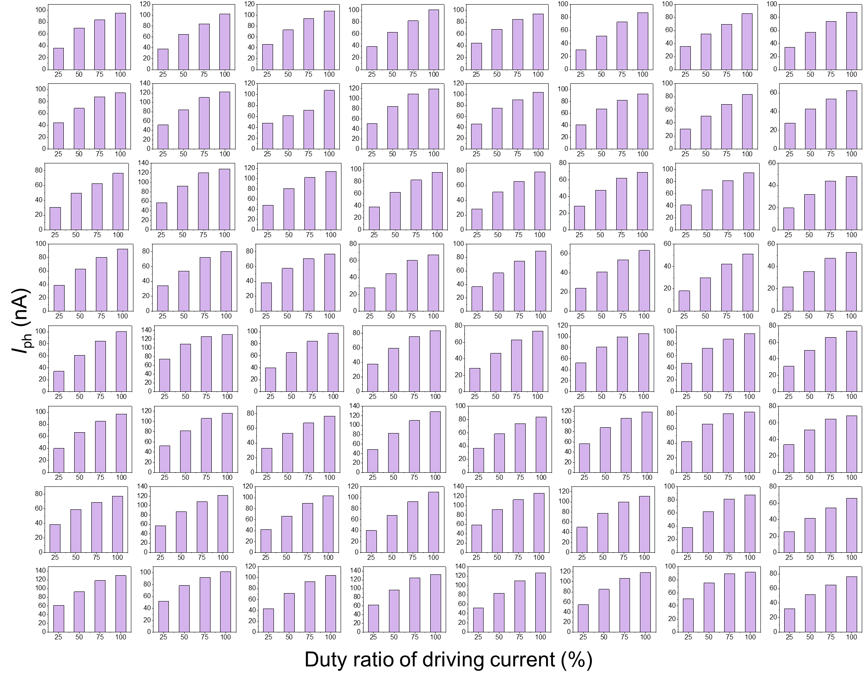
Extended Data Fig.5 | Photocurrents of each MoTe₂ PD at a=25, 50, 75 and 100. For each detector, the bias voltage is 2 V. For each VCSEL, the duty ratio of driving current is 25%, 50%, 75% and 100%.

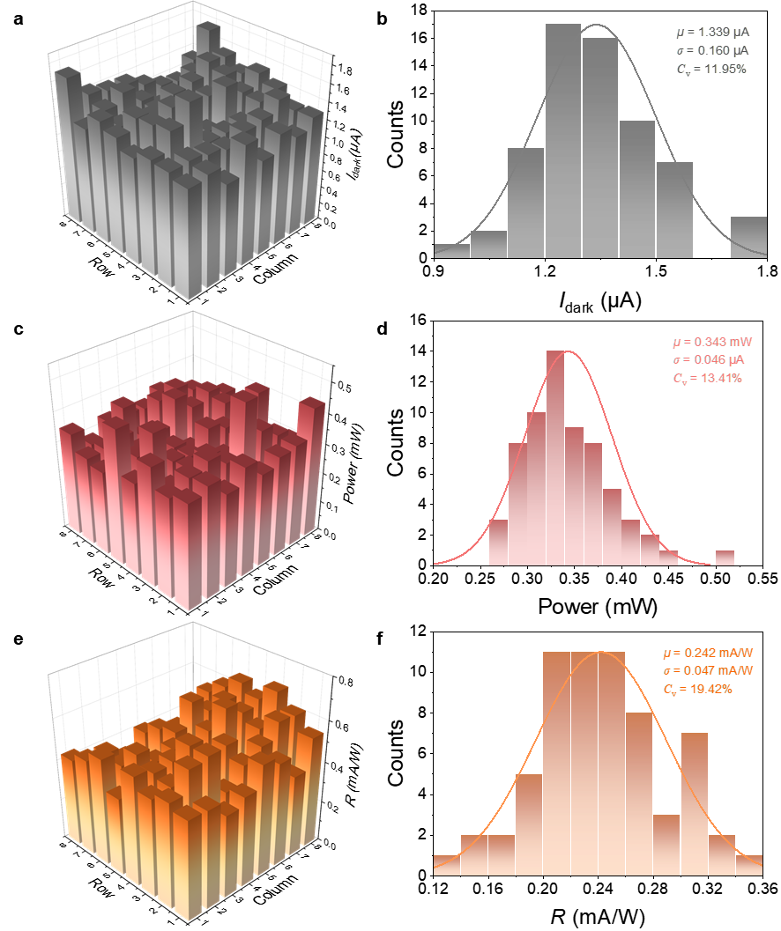
Extended Data Fig.6 | Statistical Uniformity of the VCSEL array and MoTe₂ PD array. a-b, The hold-state current mapping and statistical analysis of 8×8 MoTe₂ PD array without illumination at 2 V bias voltage. c-d, The hold-state output intensity mapping and statistical analysis of 8×8 VCSEL array at 75% duty ratio driving current. e-f, The hold-state responsivity mapping and statistical analysis of 8×8 MoTe₂ PD array at 2 V bias-voltage.

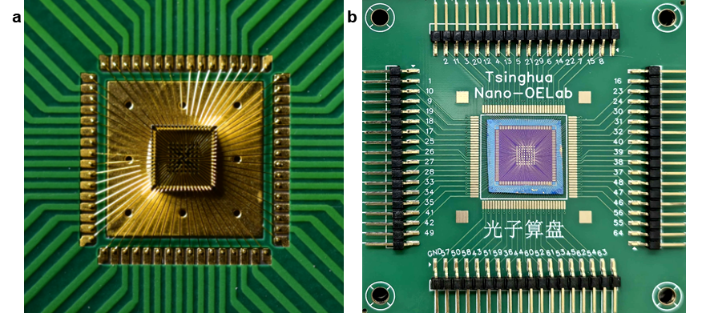
Extended Data Fig.7 | The VCSEL array (a) and MoTe₂ PD array (b) are connected to self-designed printed circuit boards using wire-bonding technology.

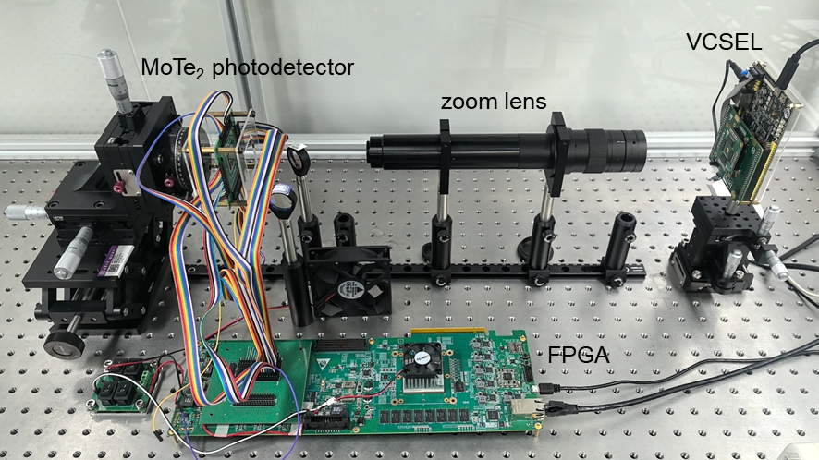
Extended Data Fig.8 | Optical image of the experimental setup.

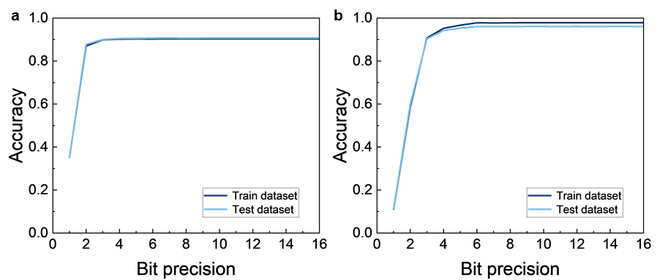
Extended Data Fig.9 | The quantization of ANN. a, The classification accuracies of single-layer ANN with various bit precisions. 4-bit precision is utilized in the experiment of single-layer ANN. b, The classification accuracies of double-layer ANN with various bit precisions. 6-bit precision is utilized in the experiment of double-layer ANN.

Extended Data Table1 | The parameters of Ising machine.
 | Initial temperature | Annealing rate | Iterations
30-dimensional Ising machine | 10 | 0.99 | 500
1024-dimensional Ising machine | 50 | 0.995 | 5000

