Evaluating the impacts and decision-making of smallholder farmers in Senegal in response to iSAT climate-informed agro-advisories

Jacob Emanuel Joseph^{1,7}, Anthony M. Whitbread⁷, Folorunso M. Akinseye^{2,4}, Ram Dhulipala⁸, Omonlola Nadine Worou³, Aliou Faye⁴, Ndeye Amy Kebe⁹, Babacar seck⁹, Oumar Konte⁵, Reimund P. Rötter^{1,6}
1. University of Göttingen, Tropical Plant Production and Agrosystems Modelling (TROPAGS), Grisebachstrasse 6, 37077 Göttingen, Germany
2. International Crop Research Institute for the Semi-Arid Tropics (ICRISAT), Dakar, Senegal
3. International Livestock Research Institute (ILRI), Dakar, Senegal
4. Centre d'étude régional pour l'amélioration de l'adaptation à la sécheresse (CERAAS), Thies 3320 - Senegal
5. Agence Nationale de l’Aviation Civile et de la Météorologie, Senegal
6. The University of Göttingen, Center of Biodiversity and Sustainable Land Use (CBL), Buesgenweg 1, 37077 Göttingen, Germany
7. International Livestock Research Institute (ILRI), Dar es salaam, Tanzania
8. International Livestock Research Institute (ILRI), Nairobi, Kenya
9. Jokalante Sarl, Dakar, Senegal

Description of Study Area
Table S1: Description of the villages in the study area.
Region | Arrondissement | Commune | Village | Latitude | Longitude
Louga | Barkedji | Thiel | Thiel | 14.9391 | -15.0599
Louga | Barkedji | Thiel | Thiel Serere | 15.0346 | -15.0077
Louga | Barkedji | Thiel | Darou Nahim Danedji | 14.8908 | -15.1501
Louga | Barkedji | Thiel | Touba Danedji | 14.8926 | -15.1244
Louga | Barkedji | Thiel | Mola | 14.8816 | -15.0776
Louga | Barkedji | Thiel | Touba Ndiagne | 14.9051 | -15.0961
Louga | Barkedji | Thiel | Hodiolde | 15.0448 | -14.9173
Thies | Meouane | Meouane | Meouane Meghor | 15.0725 | -16.7667
Thies | Meouane | Meouane | Ndiane | 15.0788 | -16.7891
Thies | Meouane | Meouane | Mborine | 15.0971 | -16.6805
Thies | Meouane | Meouane | Ainoumane | 15.0893 | -16.7222
Thies | Meouane | Meouane | Ndombil | 15.1926 | -16.7179
Thies | Meouane | Meouane | Ndiouffene | 15.0571 | -16.7669
Kaffrine | Mabo | Ndjognik | Nandjigui | 13.98827 | -15.5322
Kaffrine | Mabo | Ndjognik | Darou Nandjigui | 13.98513 | -15.5181
Kaffrine | Katokel | Ndjognik | Keur Sawely | 13.88962 | -15.1355
Kaffrine | Mabo | Ndjognik | Simbara | 13.95775 | -15.6369
Kaffrine | Mabo | Ndjognik | Mbeuleup | 13.93618 | -15.5426
Kaffrine | Mabo | Ndjognik | Diatta Fakha | 13.93606 | -15.5115
Kaffrine | Mabo | Ndjognik | Dagaballa | 13.95229 | -15.6099

Climate analytics of the study area
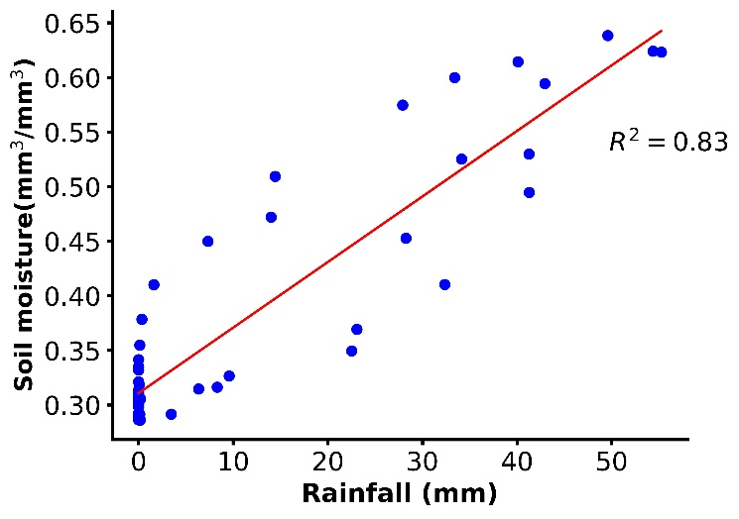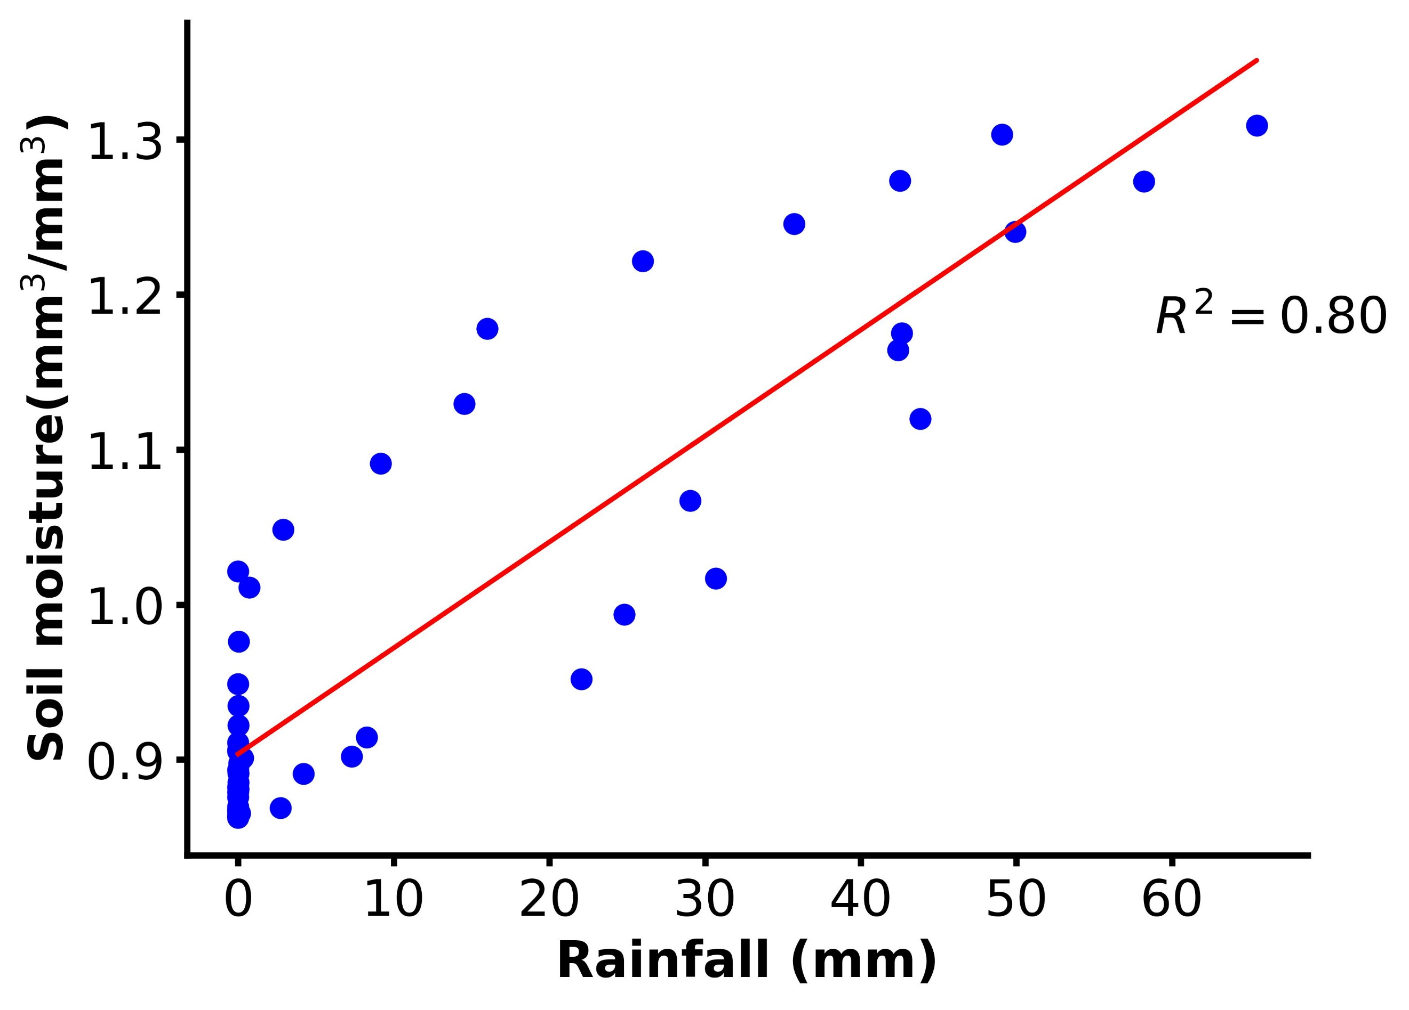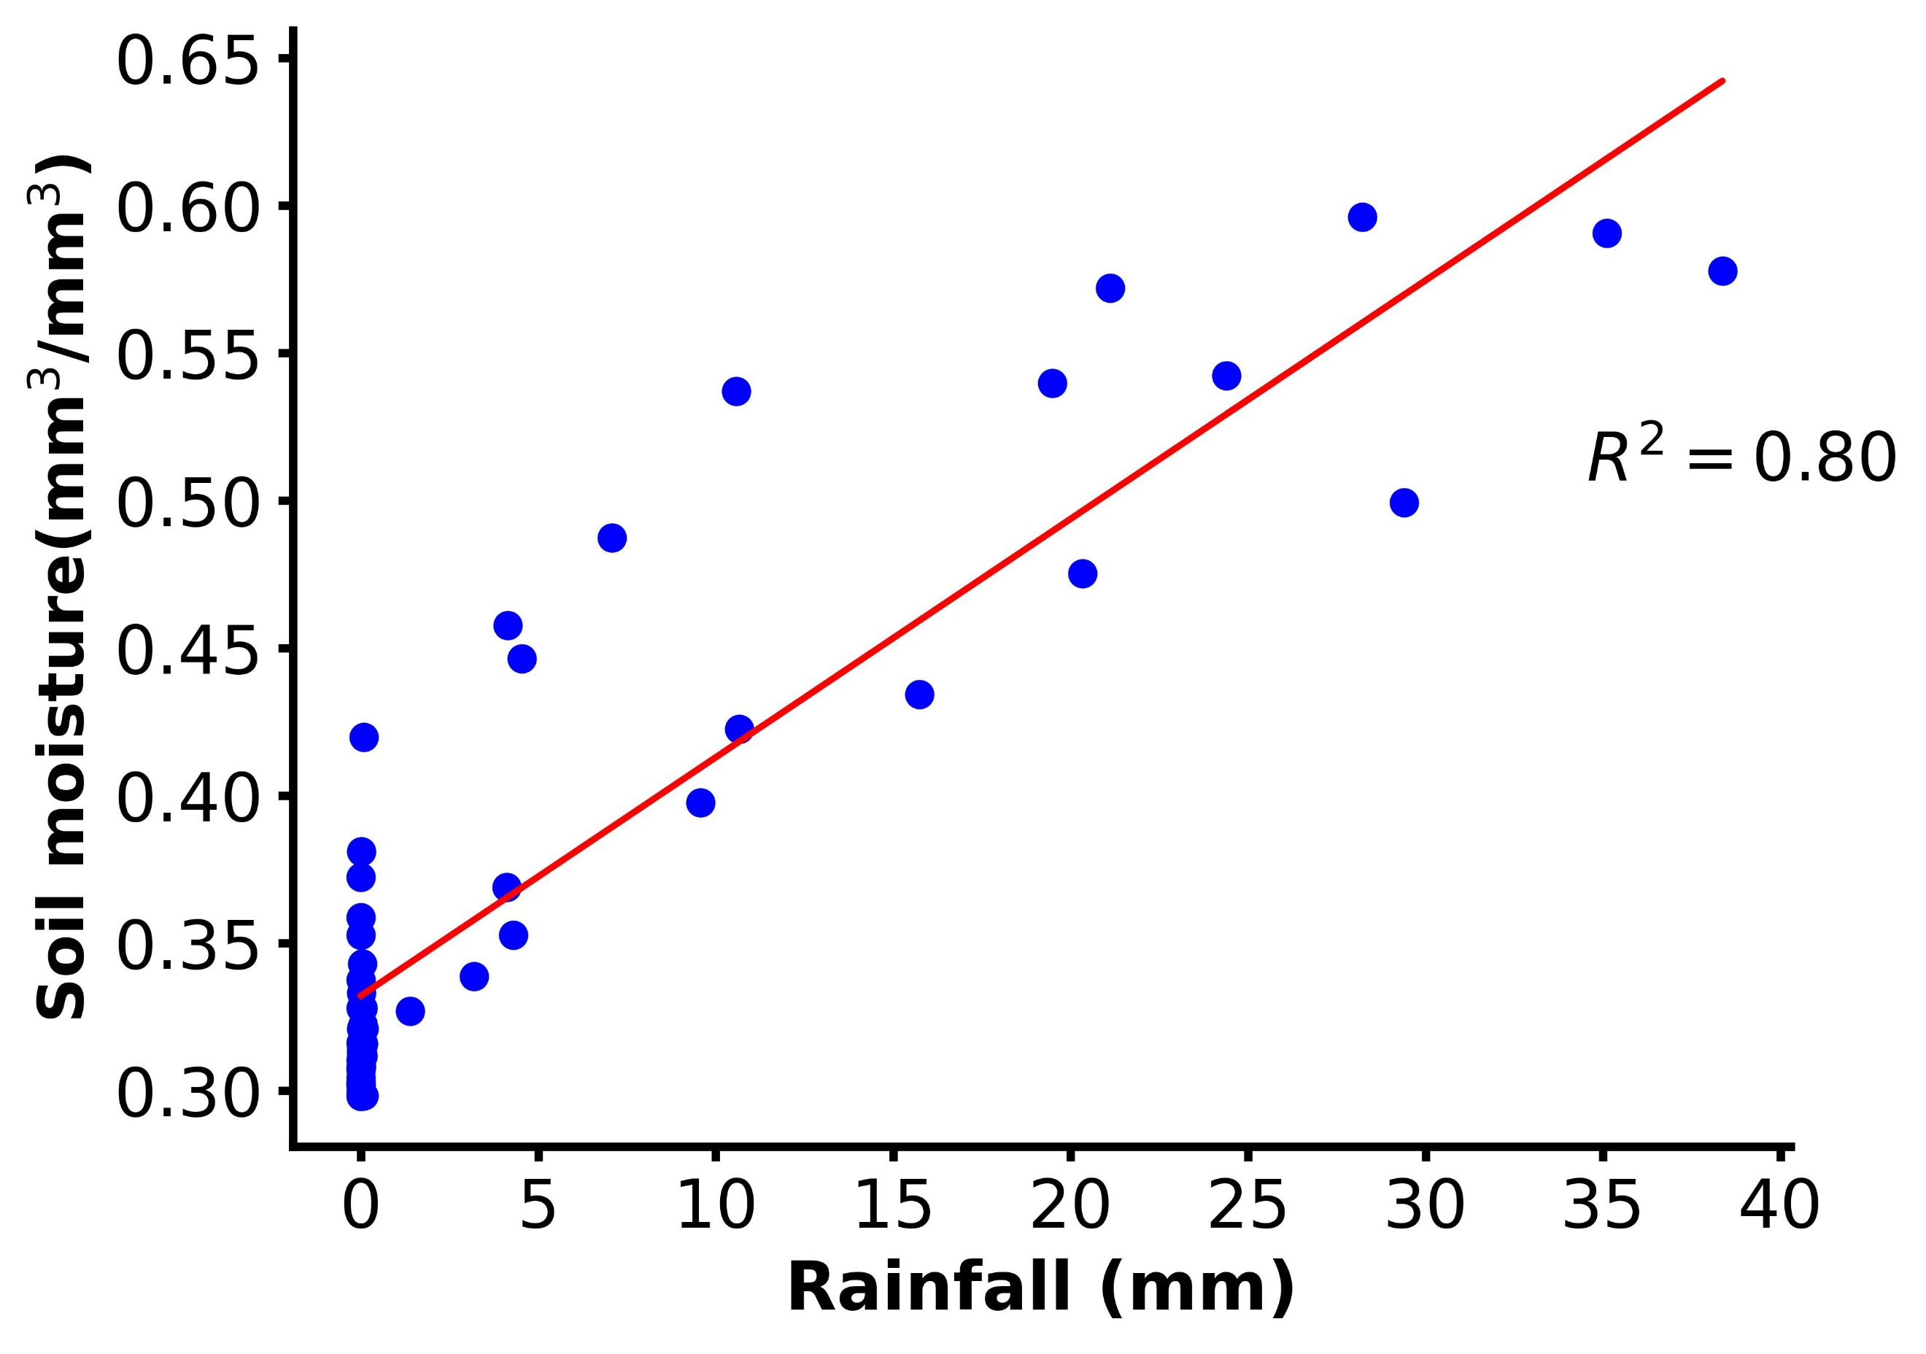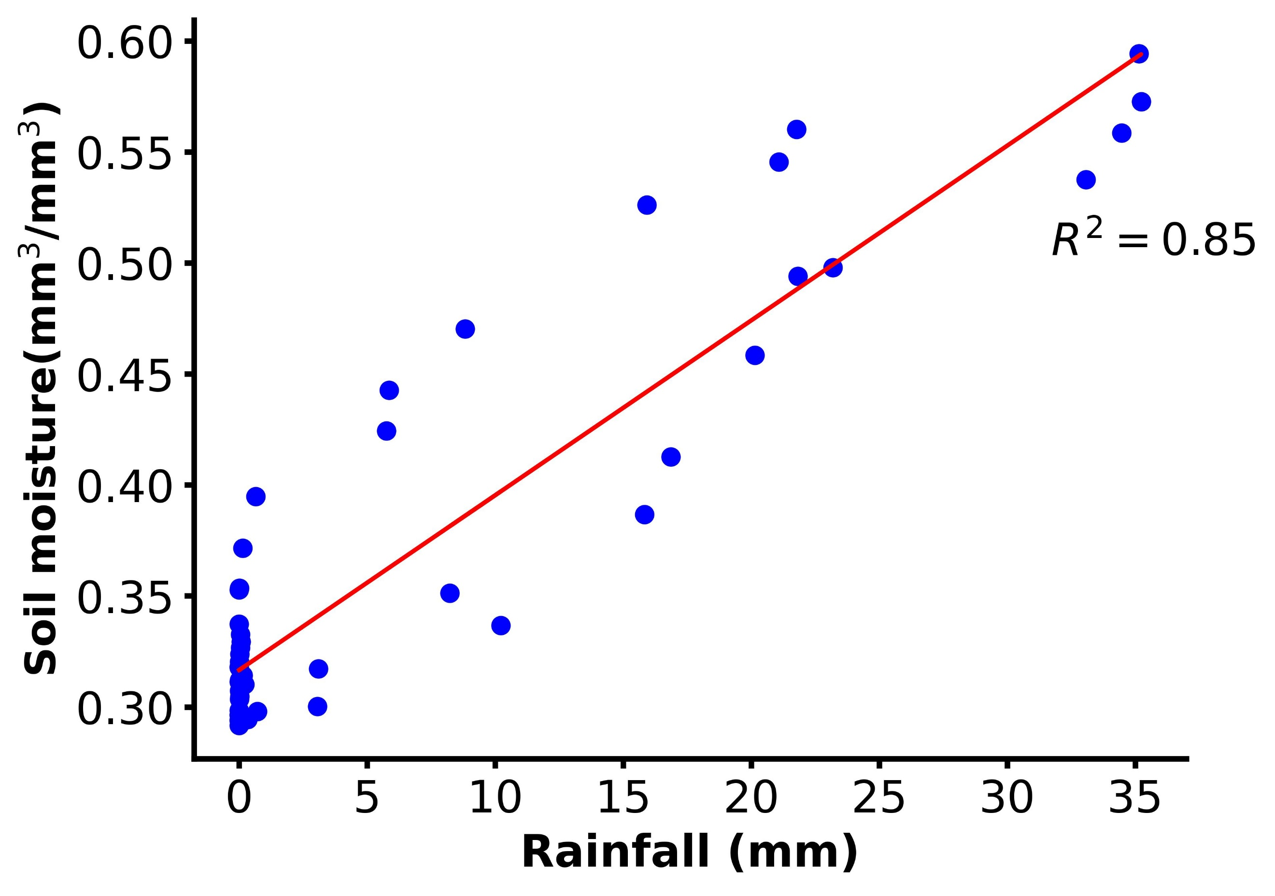
a.
b.
d.
c.
Figure S1: Correlation between soil moisture and weekly rainfall in four distinct arrondissements: Katokel (a) and Mabo (b) in the Kaffrine region, Méouane (c) in the Thies region, and Barkedji (d) in the Louga region. The correlation between these two variables is quantified by the coefficient of determination, R², providing a measure of how well the variations in rainfall predict the changes in soil moisture.

Table S2: Analysis of variance (ANOVA) summary Table for the pre-season decision-making among the farmers in clusters as influenced by iSAT advisories
Source of variation | DF | Sum Sq | Mean Sq | F value | P(>F)
Between clusters | 2 | 121.4 | 60.70 | 3.768 | 0.036
Residuals | 27 | 434.9 | 16.11
Total | 29 | 556.3

Table S3: Tukey multiple comparisons of means 95% family-wise confidence level summary Table for the three clusters.
Onset Definition | Difference | 95.% CI of diff. | P adjusted
Meouane vs. Thiel | 2.900 | -1.550 to 7.350 | 0.2564
Meouane vs. Daga Birame | 4.900 | 0.4498 to 9.350 | 0.0287
Thiel vs. Daga Birame | 2.000 | -2.450 to 6.450 | 0.5137

Table S4: Analysis of variance (ANOVA) summary Table for the In-season decision-making among the farmers in clusters as influenced by iSAT advisories
Source of variation | DF | Sum Sq | Mean Sq | F value | P(>F)
Between clusters | 2 | 2.571 | 1.286 | 0.609 | 0.555
Residuals | 18 | 38.00 | 2.111
Total | 20 | 40.57

Statistical analyses of the main determinants of the adoption of Climate-Smart Agriculture in the study area
Table S5. The general linear model ANOVA table for the determinants of drivers of adoption of climate-smart agriculture.
 | coef | std err | z | P>|z| | [0.025 | 0.975]
Intercept | 2.0823 | 0.386 | 5.398 | 0.000 | 1.326 | 2.838
Age_group | -0.1897 | 0.056 | -3.395 | 0.001 | -0.299 | -0.08
Gender | 0.0563 | 0.081 | 0.694 | 0.488 | -0.103 | 0.215
Crop production | -0.2468 | 0.086 | -2.853 | 0.004 | -0.416 | -0.077
Organization | -0.9302 | 0.148 | -6.269 | 0.000 | -1.221 | -0.639
iSAT | -0.66 | 0.129 | -5.126 | 0.000 | -0.912 | -0.408
Dep. Variable: CSA, No. Observations: 3805, Model: GLM, Model Family: Binomial, Df Residuals:3799, Df Model: 5, AIC: 3963, BIC: 4001, Deviance:3951

Statistical analyses of crop yield i.e., millet, cowpeas, and groundnuts in the study area.
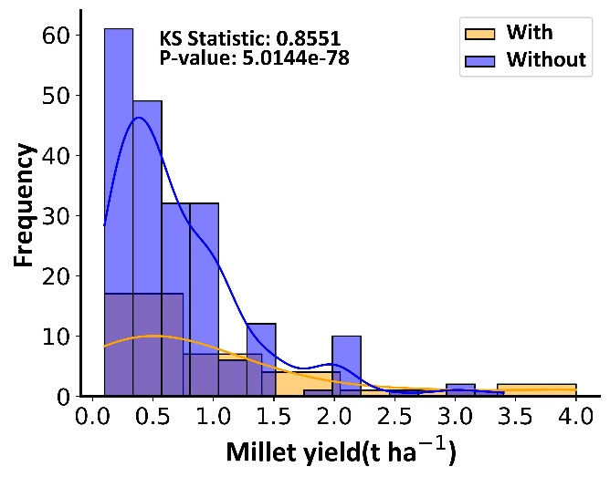
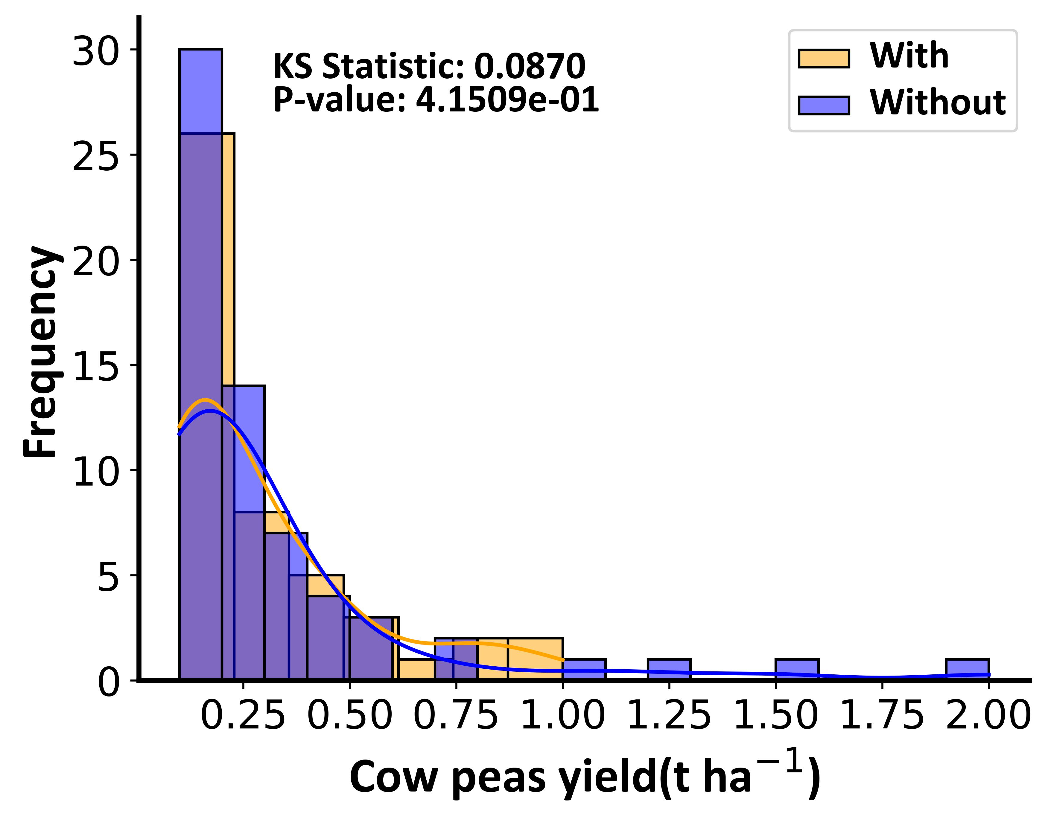
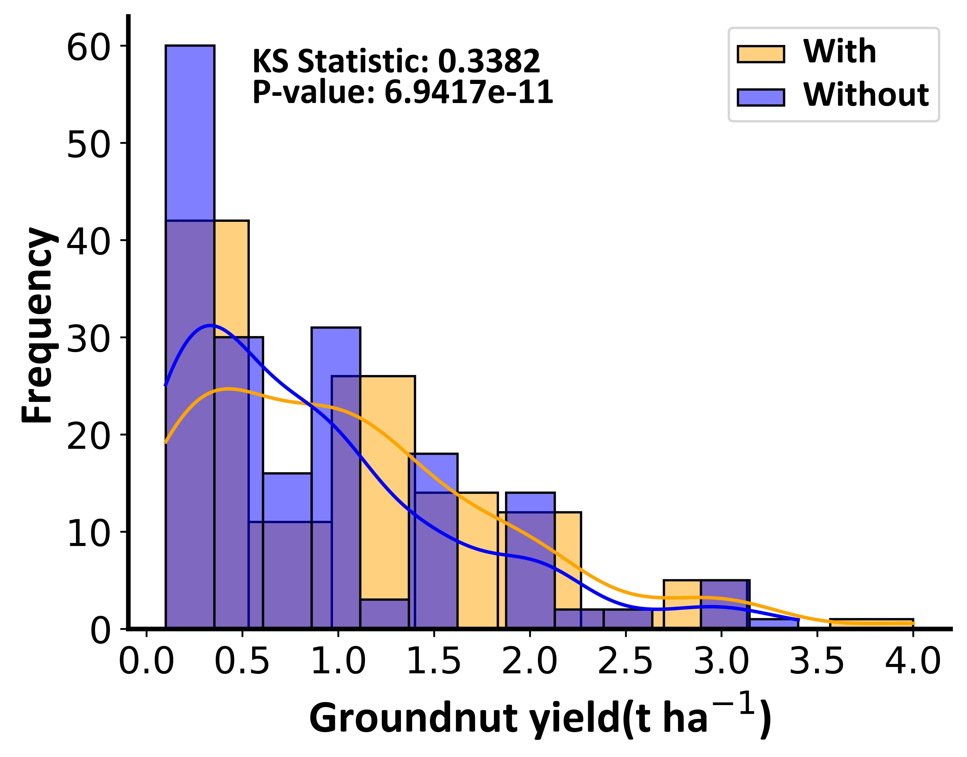
a.
b.
c.

Figure S2: Distribution of Millet, cowpeas, and groundnut yields among farmers utilizing iSAT agro-advisories compared to those who do not. Statistical significance is indicated by the provided p-values and KS statistics.

Cost-benefit analyses of millet, cowpeas, and groundnuts in the study area.
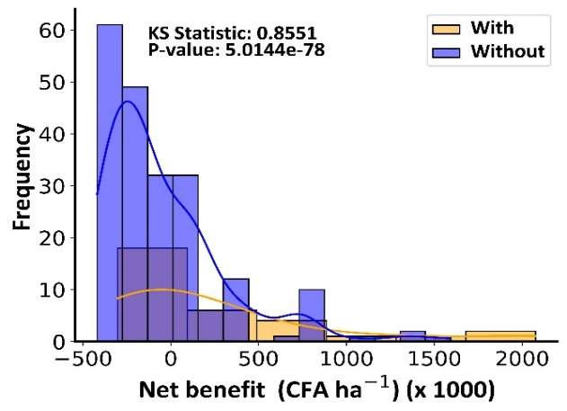
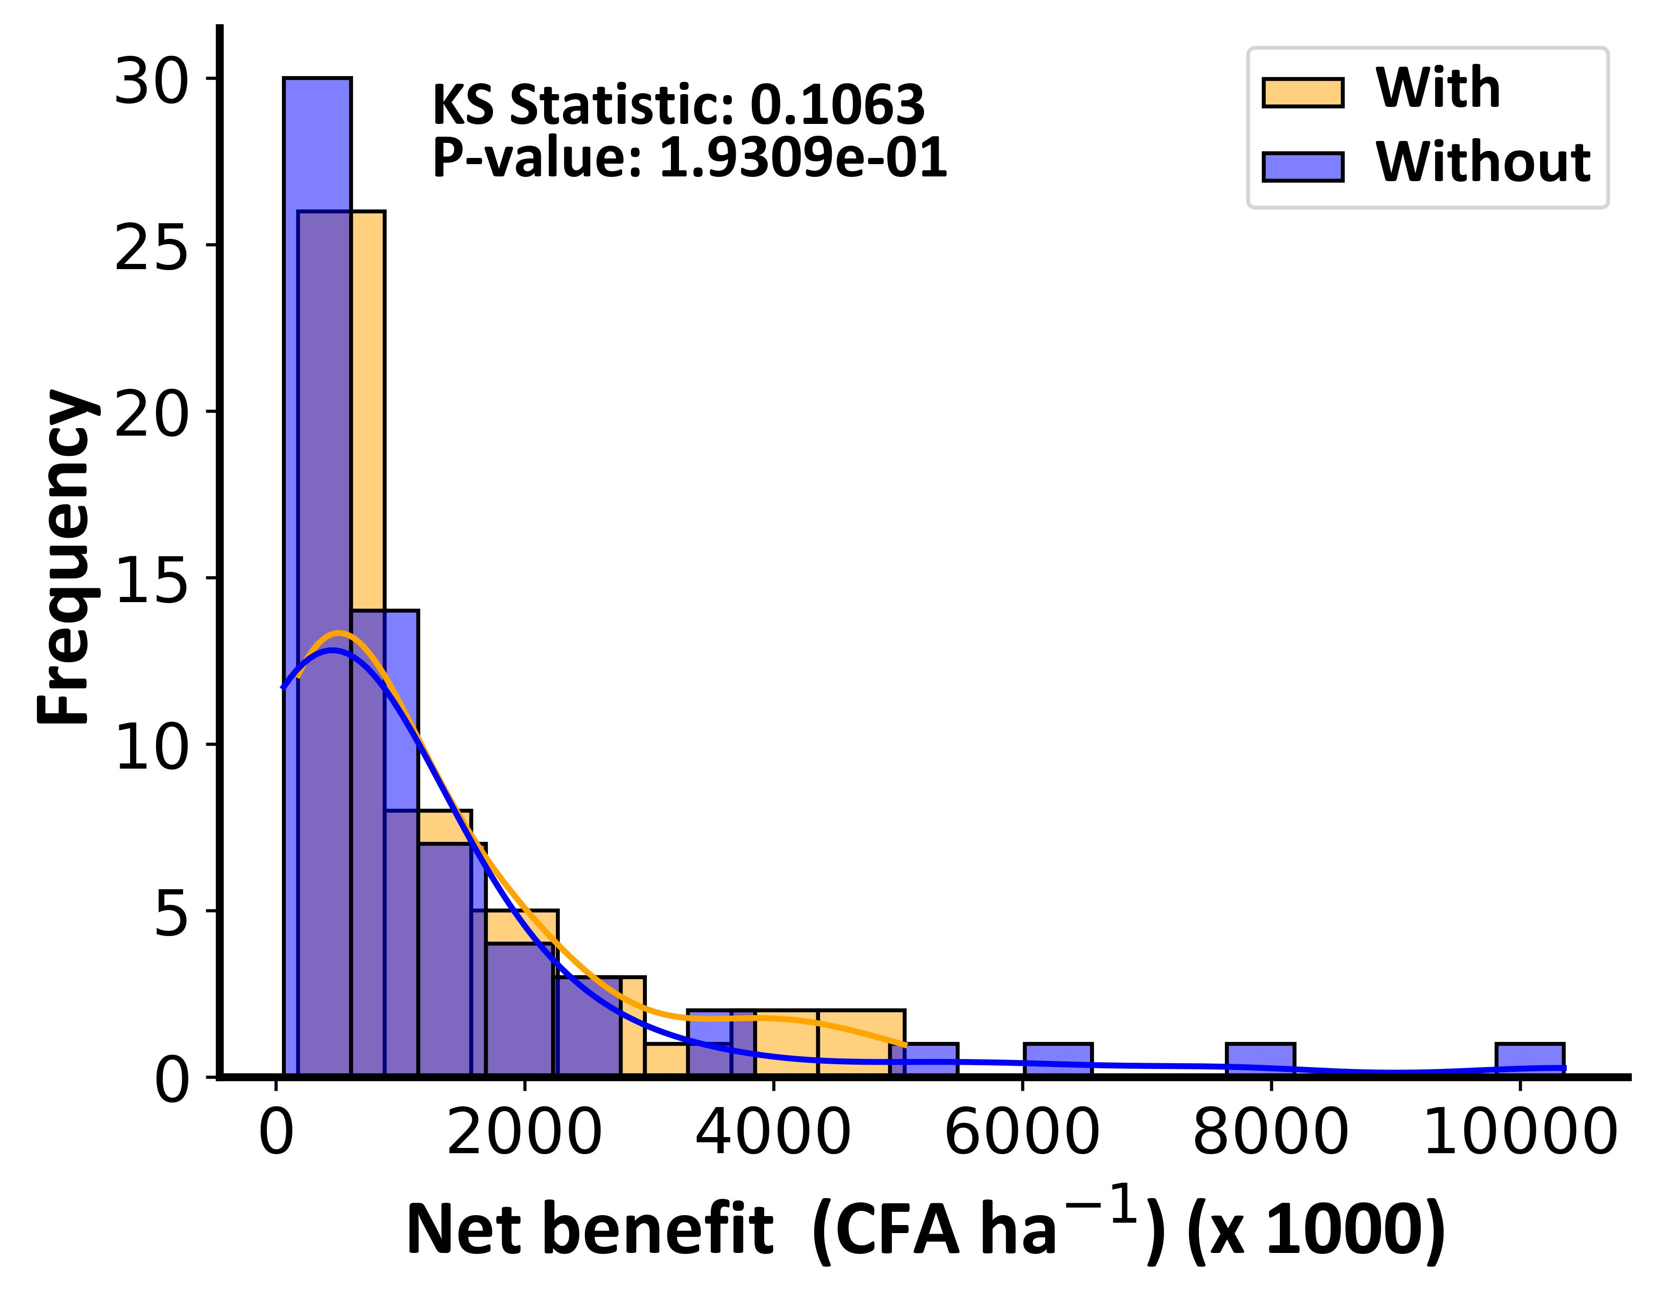
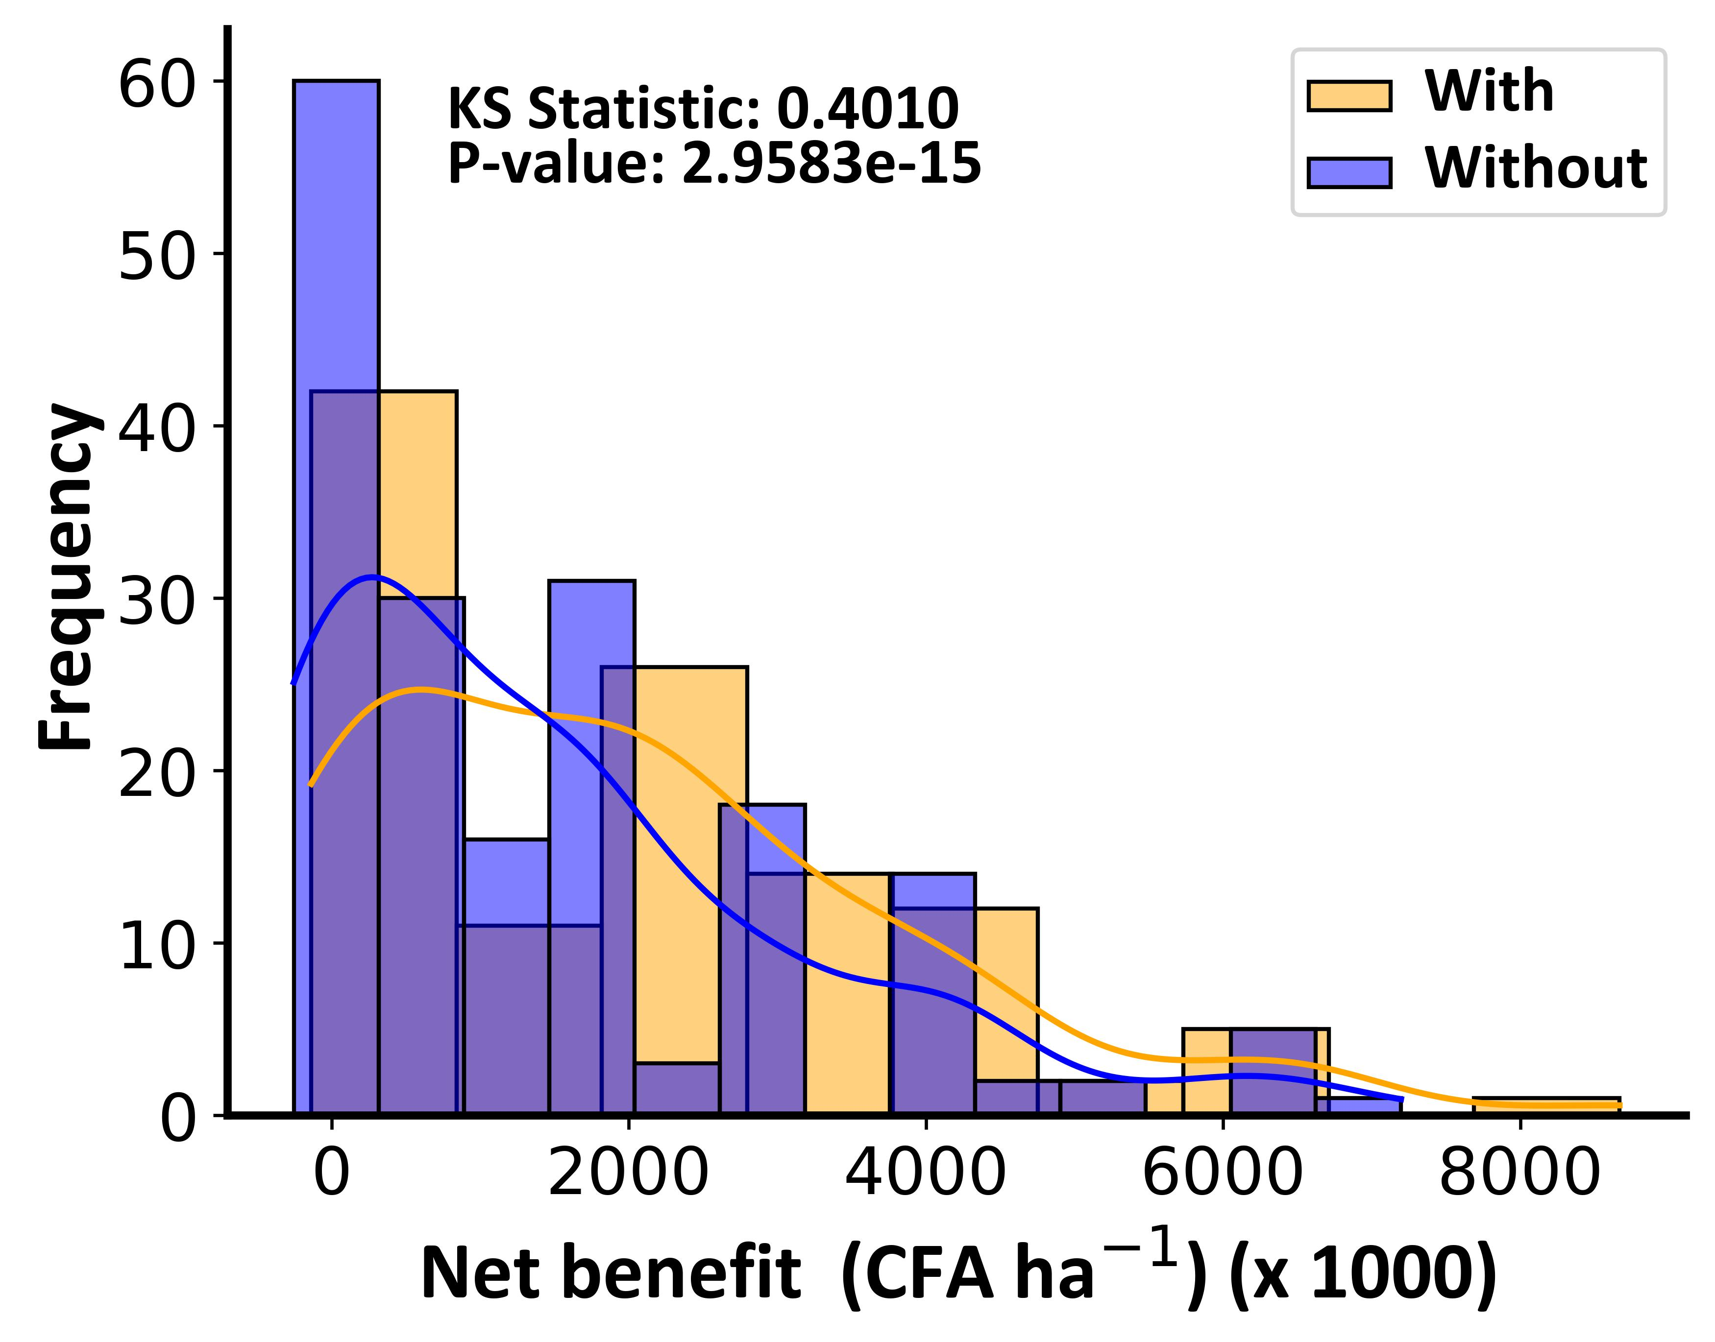
a.
b.
c.

Figure S3: Net benefit in CFA of millet, cowpeas, and groundnut yields among farmers utilizing iSAT agro-advisories compared to those who do not. Statistical significance is indicated by the provided p-values and KS statistics.
Example of pre-season advisories in Mbeuleup village in Kaffrine region.
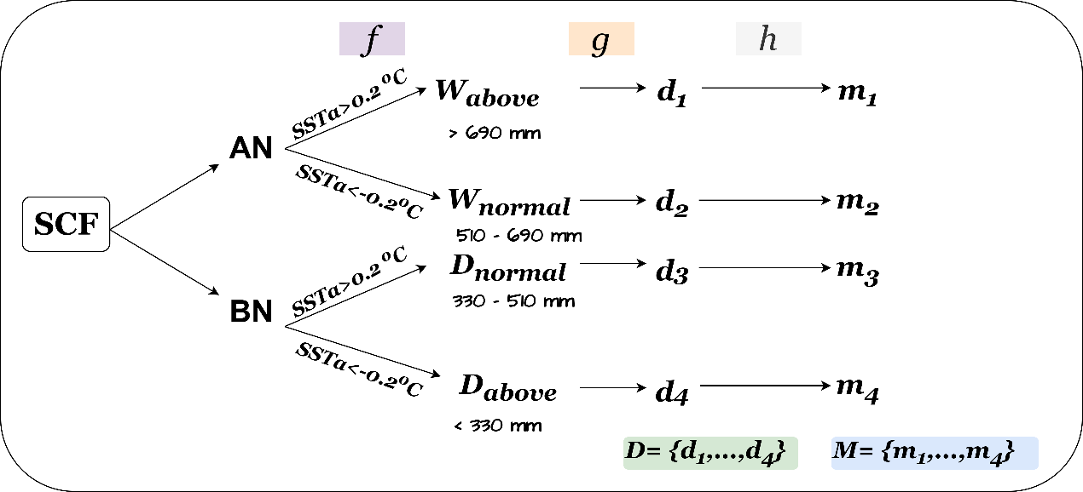
Figure S4: Example of pre-season advisories in Mbeuleup village in Kaffrine
The decision and corresponding messages are given in the table below:
Table S2: Pre-season decisions with their corresponding messages based on the expected seasonal conditions.
Decision | Message
d₁: Crop selection: medium duration maize (50,000 plants/ha), groundnuts, pearl millet.  Early window: 15/06 to 15/07.  Late crops: Cowpeas, short-duration groundnuts in late planting window.  Late window: 15/07 to 30/07. | m₁: High probability of high rainfall, at least 600 mm. The season is the potential to grow medium maize, pearl millet, groundnuts, and cowpeas in the 15 June to 31 July planting windows
d₂: Crop selection: short to medium duration maize (50,000 plants/ha), peanut, pearl millet.  Early window: 15/06 to 15/07.  Late crops: Cowpeas, short-duration groundnuts in late planting window.  Late window: 15/07 to 30/07. | m₂: Good rain is expected, at least 500 mm. The season is the potential to grow short to medium maize, pearl millet, ground nuts, and cowpeas in the 15 June to 31 July planting windows
d₃: Crop selection: short-duration maize (30,000 plants/ha), peanut, pearl millet, groundnut.  Planting window: 22/06 to 25/07 | m₃: Low rainfall expected. Plan for short to medium maize, pearl millet, groundnuts, and cowpeas in the 22 June to 25 July planting window.
d₄: Crop selection: short-duration varieties of groundnuts, pearl millet, groundnut.  Planting window: 25/06 to 25/07 | m₄: Very low rainfall expected. Plan for drought-torelant varieties of pearl millet, ground nuts, and cowpeas in the 25 June to 25 July planting window.

Table S3: Pre-season decisions with their corresponding messages based on the expected seasonal conditions.
Cluster | Crop | Control | Treatment | p-value
Kaffrine | Millet | 532 | 700 | 0.001
Kaffrine | Peanut | 500 | 658 | 0.0086
Kaffrine | Cowpea | 1918 | 427 | 0.000
Thies | Millet | 58 | 111 | 0.000
Thies | Peanut | 82 | 104 | 0.0036
Thies | Cowpea | 83 | 228 | 0.000
Louga | Millet | 424 | 402 | 0.5245
Louga | Peanut | 581 | 597 | 0.7847
Louga | Cowpea | 1147 | 1200 | 0.5479

Benefits and impacts of iSAT in the study area

Improved seasonal planning and crop management.
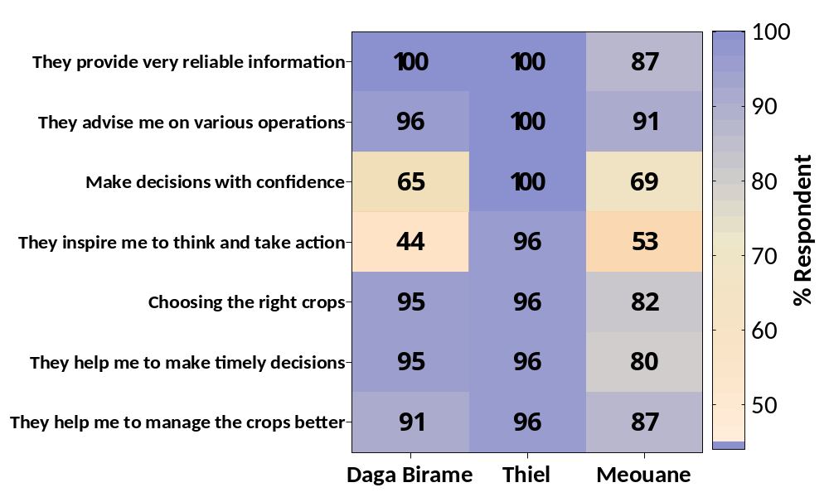
Figure S5: Farmers' ratings assessing the usefulness of agro-advisories in guiding on-farm level decisions and crop management throughout the season. The ratings are derived from feedback collected across all three clusters of intervention i.e., Daga Birame, Thiel, and Méouane.

Climate risk management.
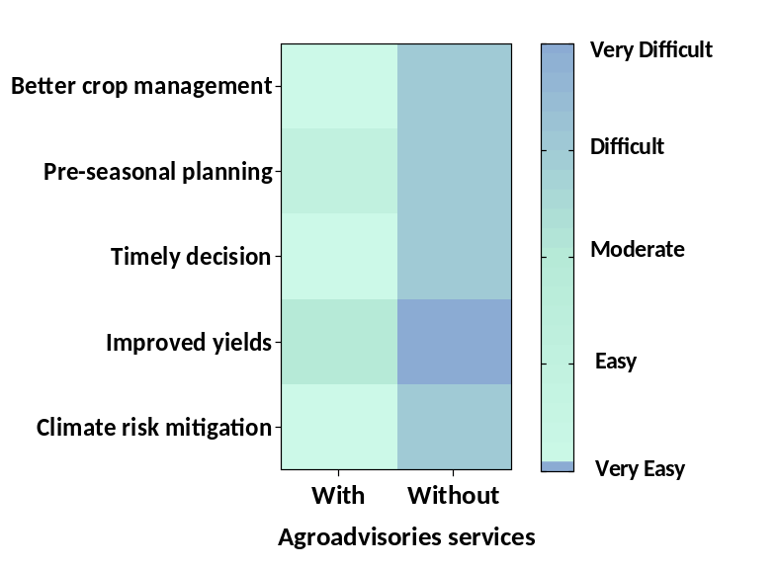
Figure S6: A comparison of the management of climate risks in crop production between farmers who utilized iSAT technology (labeled as ‘With’) and those who did not (labeled as ‘Without’).



Accelerating the Impact of CGIAR Climate Research
for Africa

Post-season survey: Farmers’ feedback about the agro-advisory services






SECTION A: General Information

Name: _______________________________________
Gender: _______________________________________
Education: _____________________________________
Head of the household: Yes No
If not relationship with head: _______________________
Total land owned: ________________
Area cultivated: __________________
- Which among the following crops were grown:
Crop Area (hactare)
- Pearl Millet _____
- Groundnut _____
- Maize _____
- Cowpea _____
- Other crops _____
- How much yield was achieved in the following crops:
Crop Yield (kg)
Pearl Millet _____
Groundnut _____
Maize _____
Cowpea _____
- a. Did you receive advisories on weather and crop management practices for the past season through Jokalante?
- Yes
- No
b. Could you recall when did you receive the last advisory?
______________________________
c. Do you want to continue receiving them?
- Yes
- No
- How clear and easy to understand were the language and explanations in the agro-advisories?
- Very easy to understand
- Easy to understand
- Difficult to understand
- Very difficult to understand.
- a. Are there any technical terms or concepts you found confusing or difficult to grasp?
- Yes
- No

b. if yes, can you mention example(s)
_____________________________________________________________________

SECTION B: Usefulness of the agro-advisories in pre-season decisions

  - Choose the decisions that you typically consider during pre-season preparation from the following:
A. Crop and Planting Decisions:
- Crop selection based on climate suitability, household, and market demand.
- Crops diversification for risk management.
- Select specific crop varieties or hybrids suitable to your local climate and soil conditions.
- Planning various planting strategies e.g., intercropping, suitable to your local conditions and demand.
B. Resource Allocation Decisions:
- Allocating land for different crops or rotations based on soil health, previous yields, and seasonal climate forecast.
- Deciding on the allocation of labour for various pre-season activities.
- Allocating budget for seeds, fertilizers, pesticides, and other inputs.
C. Soil Preparation and Fertilization Decisions:
- Choosing soil preparation techniques, such as ploughing, tilling, or minimum tillage.
- Deciding on the application of organic matter, compost, or cover crops to improve soil fertility.
- Determining the type and quantity of fertilizers.
D. Climate and Weather Considerations:
- Anticipate potential weather risks based on weather information you have received or traditional knowledge and plan accordingly.
- Deciding on planting dates that align with your local climate patterns, growing seasons behaviours, and seasonal climate forecast.
E. Pest and Disease Management Decisions:
- Develop a pre-season pest management plan, including preventive measures, based on experience or information from local extension service.
- Deciding on the selection and timing of pesticide applications based on anticipated pest risks.
- Identifying potential disease-prone crops and planning disease prevention strategies.
F. Financial and Budgeting Decisions:
- Creating a budget for the upcoming season, accounting for operational costs and investments.
- Allocating funds for purchasing new equipment, machinery, or technologies.
- Deciding on the allocation of funds for marketing and distribution efforts.
G. Marketing and Sales Decisions:
- Identifying target markets and planning crop quantities accordingly.
- Deciding on packaging and labeling strategies to enhance marketability.
- Allocating resources for transportation and distribution to reach markets efficiently.
H. Risk Management Decisions:
- Anticipating potential risks, such as extreme weather events or market volatility.
- Creating contingency plans for unexpected challenges that may arise during the season.
- Deciding on insurance options or risk-reduction strategies.
I. Long-Term Sustainability Decisions:
- Planning for sustainable practices, such as crop rotation, cover cropping, and reduced chemical inputs.
- Allocating resources for conservation efforts, such as soil erosion prevention and water management.
- Deciding on the integration of agroecological principles into pre-season planning.
J. Operational and Timing Decisions:
- Deciding on the timing of various pre-season operations, such as soil preparation, and planting.
- Allocating time for monitoring and early detection of pest and disease issues.
- Planning the timing of post-season activities, such as harvest and post-harvest processing.
  - For the above-selected decisions state which ones were influenced by the agro-advisories you received during the campaign.
  - Rate, on a scale of 1 to 5, how satisfied are you with the agro-advisories in your pre-season decision-making.

SECTION C: Usefulness of the agro-advisories in in-season decisions
  - Choose the decisions that you typically consider in your in-season crop management practices from the following:
A. Crop management Decisions:
- Applying fertilizers to address nutrient deficiencies.
- Deciding on weed control methods such as mechanical cultivation or herbicide and time of application.
- Applying pesticides or biopesticides to manage pest outbreaks.
B. Environmental and Climate-Related Decisions:
- Implementing protective measures for crops during extreme weather conditions.
- Making quick decisions in response to unexpected weather events such as storms.
- Taking actions to mitigate heat stress on crops through shading, and cooling.
- Modifying cultivation practices to reduce heat stress impacts.
C. Harvest and Post-Harvest Decisions:
- Deciding on the optimal timing for crop harvest to achieve desired yield and quality.
- Monitoring crop maturity indicators to determine when to begin harvesting.
- Deciding on post-harvest handling methods such as sorting, grading, and washing.
- Choosing appropriate storage conditions and packaging materials.
- Deciding when and where to send produce to markets to maximize freshness and value.
- Making decisions on transportation logistics and distribution routes.
D. Resource Management Decisions:
- Adjusting labor allocation for activities such as harvesting, weeding, and pest control.
- Making decisions to manage labor shortages or unexpected needs.
- Deciding when and how to use farm machinery, such as tractors and harvesters.
- Prioritizing equipment use based on urgency and efficiency.

E. Risk Management Decisions:
- Regularly inspecting crops for pests and disease symptoms to make timely decisions.
- Deciding on further intervention or letting natural predators control pest populations.
F. Continuous Monitoring and Observation:
- Regularly observing crop health and responding to signs of stress or disease.
- Making decisions to address issues that arise during the growing season.
- Monitoring crop growth and estimating potential yield based on plant health and development.
- Making decisions on resource allocation based on yield expectations.
F. Overall Strategy and Adaptation:
- Adapting strategies in response to evolving conditions e.g., market demand
- Incorporating lessons learned from previous decisions into ongoing management strategies.
- Making continuous improvements based on the outcomes of previous choices.
  - For the above-selected decisions state which ones were influenced by the agro-advisories you received during the campaign.
  - Rate, on a scale of 1 to 5, how satisfied are you with the agro-advisories in your pre-season decision-making.

SECTION D: Overall assessment of the advisories and dissemination system
  - a. I found the advisories were useful because (mark all that apply):
- They provide highly reliable information.
- They advise me about various operations.
- They improve my confidence in making decisions.
- They make me think and act in making decisions.
b. The advisories helped me in (mark all that apply):
- Selecting the right crops
- Making timely decisions
- Doing better management
- Achieving better yield
- Reduced input costs and labor
- How much money do you normally use for inputs and labor? __________CFA
- How much did you use in the wet season?__________CFA

c. My overall rating of the advisories i.e., content, language, and length:
- 
- ,
- ,,
- ,,,
- ,,,,
d. My overall rating of the dissemination system:
- ,
- ,,
- ,,,
- ,,,,

