Table S1. Detailed information of datasets used in the present study.
Exposure or outcome | PMID/Database | Ancestry | Participants | Web source
Data used in MR
Sleep duration | 30846698/UK Biobank | European ancestry | 446,118 individuals | /
Sleep disorder(combined) | FinnGen database | European ancestry | 377,277 individuals | https://www.finngen.fi/en/access_results
Bone mineral density | 26367794/GEFOS Consortium | European ancestry | 53,236 individuals | http://www.gefos.org/

Table S2. Detailed information of genetic variants used in the present study
Traits | SNP | Chr:position  (NCBI Build 37) | Closest gene | Effect allele | Other allele | β | SE | P-value
Short sleep duration | rs11763750 | 7:2080114 | MAD1L1 | G | A | 0.035367144 | 0.006052001 | 5.1E-09
Short sleep duration | rs12518468 | 5:7249696 | ADCY2, POLS, LOC100130063 | C | T | 0.031498667 | 0.005470199 | 8.5E-09
Short sleep duration | rs12567114 | 1:98527951 | DPYD | G | A | 0.036331929 | 0.006178787 | 4.1E-09
Short sleep duration | rs12661667 | 6:41792545 | USP49 | T | C | 0.027615167 | 0.004972567 | 2.8E-08
Short sleep duration | rs12963463 | 18:53099093 | TCF4 | C | T | 0.028587457 | 0.004258199 | 1.9E-11
Short sleep duration | rs1380703 | 2:57941287 | VRK2, LOC647016, LOC100131953 | G | A | 0.035367144 | 0.005248498 | 1.6E-11
Short sleep duration | rs1607227 | 11:28808617 | METT5D1, OR2BH1P | G | T | 0.030529205 | 0.005050854 | 1.5E-09
Short sleep duration | rs17388803 | 15:48027204 | SEMA6D | C | A | 0.05259245 | 0.008513132 | 6.5E-10
Short sleep duration | rs2014830 | 3:50172397 | RBM5, AMT, APEH, RHOA, DAG1, GNAI2, GNAT1, GPX1, HYAL1, MST1, MST1R, SEMA3F, TCTA, UBA7 USP4, IFRD2, SEMA3B, HYAL3 HYAL2, BSN, CACNA2D2, IP6K1, RBM6, TRAIP, NPRL2, SLC38A3, CYB561D2, TMEM115, RASSF1, TUSC2, NAT6, GMPPB, ZMYND10, RNF123, CAMKV, NICN1, MON1A, LSMEM2, AMIGO3 FAM212A, ACTBP13 | C | T | 0.029558802 | 0.005316471 | 2.7E-08
Short sleep duration | rs205024 | 17:11227352 | SHISA6 | C | T | 0.030529205 | 0.005491008 | 2.7E-08
Short sleep duration | rs2820313 | 1:201870221 | LMOD1, IPO9, NAV1, SHISA4 | G | A | 0.030529205 | 0.005109436 | 2.3E-09
Short sleep duration | rs2863957 | 2:114089551 | PAX8, LOC100130100 | C | A | 0.054488185 | 0.006243162 | 2.6E-18
Short sleep duration | rs3776864 | 5:102327868 | PAM, PPIP5K2, GIN1, c5orf30 | A | C | 0.031498667 | 0.00558482 | 1.7E-08
Short sleep duration | rs5757675 | 22:39838892 | MGAT3, SYNGR1, TAB1 | G | T | 0.034401427 | 0.005782851 | 2.7E-09
Short sleep duration | rs60882754 | 8:52886619 | PCMTD1, PXDNL | A | T | 0.055434707 | 0.009845956 | 1.8E-08
Short sleep duration | rs7524118 | 1:34736052 | CSMD2, C1orf94, GJB5 | C | T | 0.029558802 | 0.00541876 | 4.9E-08
Short sleep duration | rs7939345 | 11:47980568 | PTPRJ, NDUFS3, PSMC3, RAPSN, CELF1, NUP160, FNBP4, MTCH2, KBTBD4, AGBL2, C1QTNF4 | T | G | 0.035367144 | 0.006441103 | 4E-08
Short sleep duration | rs9321171 | 6:129848635 | LAMA2, ARHGAP18 | C | T | 0.031498667 | 0.005745595 | 4.2E-08
Sleep duration | rs10483350 | 14:29816155 | MIR548AI, LOC100128215, PRKD1 | G | A | 1.042 | 0.172 | 1.5E-09
Sleep duration | rs10761674 | 10:64618340 | EGR2, ADO | C | T | 0.74 | 0.136 | 4.2E-08
Sleep duration | rs10973207 | 9:37100525 | EBLN3, ZCCHC7 | T | G | 1.226 | 0.187 | 6E-11
Sleep duration | rs11190970 | 10:103128332 | BTRC, FGF8, NFKB2, PITX3, PSD, FBXW4, GBF1, LDB1, NOLC1, NPM3, MGEA5, PPRC1 POLL, KCNIP2 CUEDC2, FBXL15, C10ORF76, HPS6, C10orf95, ELOVL3 | G | A | 0.923 | 0.169 | 4.6E-08
Sleep duration | rs112230981 | 3:55879269 | ERC2 | A | G | 1.892 | 0.314 | 2.2E-09
Sleep duration | rs113113059 | 6:43160375 | CUL9, MEA1, PPP2R5D, SMAD5-AS2, SRF, CUL7, DNPH1, MRPL2, TTBK1, RRP36, KLC4, KLHDC3 | T | C | 0.968 | 0.164 | 8.4E-09
Sleep duration | rs11567976 | 5:137654218 | CDC25C, EGR1, ETF1, GFRA3, HSPA9, NME5, CDC23, KIF20A, BRD8, FAM53C, REEP2, KDM3B | T | C | 0.768 | 0.137 | 2.1E-08
Sleep duration | rs11602180 | 11:48162453 | PTPRJ, OR4X2, OR4B1, OR4S1, OR4X1 | C | T | 1.095 | 0.184 | 2.3E-09
Sleep duration | rs11621908 | 14:78495761 | ADCK1, FRDAP | C | T | 1.446 | 0.25 | 5.6E-09
Sleep duration | rs11643715 | 16:23909538 | PRKCB | G | C | 0.834 | 0.15 | 3.2E-08
Sleep duration | rs11885663 | 2:166944004 | SCN1A, GALNT3, TTC21B | T | C | 0.973 | 0.157 | 8.6E-10
Sleep duration | rs12246842 | 10:21830580 | MLLT10, DNAJC1, SKIDA1 | A | G | 0.804 | 0.136 | 3.9E-09
Sleep duration | rs12567114 | 1:98527951 | DPYD | A | G | 0.89 | 0.152 | 4.3E-09
Sleep duration | rs12607679 | 18:53059748 | TCF4 | T | C | 1.208 | 0.156 | 8.3E-15
Sleep duration | rs12791153 | 11:80685181 | LOC729790, LOC646195 | T | A | 1.413 | 0.253 | 1.9E-08
Sleep duration | rs13088093 | 3:135838598 | PPP2R3A, PCCB, STAG1, MSL2 | G | T | 0.976 | 0.144 | 7E-12
Sleep duration | rs13109404 | 4:102896591 | BANK1 | T | G | 1.872 | 0.264 | 1.4E-12
Sleep duration | rs151014368 | 5:176751059 | LMAN2, FGFR4, SLC34A1, RGS14, PRELID1, NSD1, MXD3 | A | G | 0.966 | 0.169 | 9.1E-09
Sleep duration | rs1517572 | 11:28829882 | METT5D1, OR2BH1P | C | A | 0.879 | 0.138 | 1.5E-10
Sleep duration | rs1553132 | 11:88297740 | GRM5 | G | A | 0.87 | 0.155 | 2.5E-08
Sleep duration | rs17427571 | 4:82254908 | PRKG2 | A | G | 0.83 | 0.146 | 1.3E-08
Sleep duration | rs1776776 | 9:140497072 | ARRDC1, MRPL41, EHMT1, ARRDC1-AS1, DPH7, ZMYND19 | T | C | 1.198 | 0.205 | 4.9E-09
Sleep duration | rs1939455 | 11:101520886 | TRPC6 | G | T | 1.226 | 0.214 | 1.2E-08
Sleep duration | rs205024 | 17:11227352 | SHISA6 | T | C | 0.83 | 0.14 | 3.9E-09
Sleep duration | rs2079070 | 7:114126432 | FOXP2 | C | G | 1.053 | 0.154 | 7.5E-12
Sleep duration | rs2192528 | 4:18327896 | LCORL, LOC645174 | A | G | 0.802 | 0.136 | 2.7E-09
Sleep duration | rs2231265 | 6:89790201 | PNRC1 | G | A | 0.897 | 0.162 | 2.7E-08
Sleep duration | rs3095508 | 16:6550400 | RBFOX1 | C | A | 0.921 | 0.138 | 3.1E-11
Sleep duration | rs34354917 | 12:38764559 | ALG10B, CPNE8 | C | A | 0.825 | 0.15 | 3.9E-08
Sleep duration | rs34556183 | 6:28584775 | ZBED9, SCAND3, LOC646160, | A | G | 1.015 | 0.151 | 2.3E-11
Sleep duration | rs34731055 | 7:2106928 | MAD1L1 | T | C | 1.168 | 0.177 | 3.7E-11
Sleep duration | rs35531607 | 4:92533225 | CCSER1 | C | T | 0.77 | 0.136 | 1.5E-08
Sleep duration | rs365663 | 5:1428883 | SLC6A3 | A | G | 0.878 | 0.137 | 1E-10
Sleep duration | rs374153 | 2:40382712 | SLC8A1 | C | T | 1.057 | 0.186 | 9.1E-09
Sleep duration | rs4128364 | 2:147612734 | PABPCP2, LOC100133235 | C | T | 0.876 | 0.143 | 1.4E-09
Sleep duration | rs4592416 | 11:43800474 | HSD17B12 | G | A | 0.881 | 0.136 | 9.3E-11
Sleep duration | rs4767550 | 12:117951150 | KSR2 | G | A | 0.858 | 0.139 | 6.3E-10
Sleep duration | rs55658675 | 14:65554638 | MAX, FNTB, GPX2, CHURC1, RAB15 | C | T | 0.788 | 0.142 | 2E-08
Sleep duration | rs56372231 | 5:102321905 | PAM, PPIP5K2, GIN1, C5ORF30 | T | C | 1.017 | 0.144 | 2.2E-12
Sleep duration | rs61796569 | 1:66476437 | PDE4B | T | C | 0.927 | 0.154 | 1.5E-09
Sleep duration | rs61985058 | 14:60233841 | RTN1 | T | C | 1.116 | 0.194 | 1.3E-08
Sleep duration | rs62120041 | 2:9185564 | MBOAT2 | T | C | 1.567 | 0.274 | 9.6E-09
Sleep duration | rs6575005 | 14:26954078 | NOVA1 | T | C | 0.934 | 0.159 | 4.4E-09
Sleep duration | rs72804080 | 2:59358659 | LINC01122, LOC101927285 | G | A | 1.068 | 0.192 | 2.9E-08
Sleep duration | rs73219758 | 8:14279446 | SGCZ | G | A | 0.984 | 0.15 | 5.6E-11
Sleep duration | rs75539574 | 2:58871658 | VRK2, LINC01122 | C | A | 2.175 | 0.244 | 6.9E-19
Sleep duration | rs7556815 | 2:114085785 | PAX8, LOC100130100 | A | G | 2.443 | 0.164 | 1.3E-49
Sleep duration | rs7644809 | 3:107564459 | BBX, LOC285205 | T | C | 0.784 | 0.138 | 1.6E-08
Sleep duration | rs7806045 | 7:132610266 | CHCHD3 | T | C | 0.887 | 0.158 | 1.4E-08
Sleep duration | rs7915425 | 10:125016501 | BUB3, LOC100131719, GPR26 | T | C | 1.144 | 0.179 | 2E-10
Sleep duration | rs8038326 | 15:47989799 | SEMA6D | A | G | 0.955 | 0.152 | 2.8E-10
Sleep duration | rs915416 | 1:34731984 | CSMD2, C1orf94, GJB5 | C | G | 1.156 | 0.15 | 9.9E-15
Sleep duration | rs9345234 | 6:93162639 | LOC100129847, LOC100128159 | C | A | 0.781 | 0.138 | 1.8E-08
Sleep duration | rs9382445 | 6:54937974 | FAM83B | T | C | 0.872 | 0.14 | 4.8E-10
Sleep duration | rs10173260 | 2:210377845 | MAP2 | C | T | 0.77 | 0.139 | 2.9E-08
Sleep duration | rs1991556 | 17:44083402 | MAPT, STH, KANSL1, LOC644157, LOC644172 | G | A | 0.994 | 0.163 | 1E-09
Sleep disorder(combined) | rs10095135 | 8:9943733 | MSRA | T | A | 0.0451 | 0.008 | 1.69E-08
Sleep disorder(combined) | rs10270616 | 7:70082480 | AUTS2 | C | G | 0.0416 | 0.0076 | 4.95E-08
Sleep disorder(combined) | rs10507084 | 12:97359374 | NEDD1 | T | C | 0.0584 | 0.0094 | 5.21E-10
Sleep disorder(combined) | rs114106239 | 3:132779050 | NPHP3-ACAD11 | T | C | -0.111 | 0.0199 | 2.28E-08
Sleep disorder(combined) | rs12636366 | 3:169916106 | SAMD7 | T | C | -0.092 | 0.016 | 7.38E-09
Sleep disorder(combined) | rs1959185 | 14:83646605 | FLRT2 | A | G | 0.0635 | 0.0105 | 1.54E-09
Sleep disorder(combined) | rs1964272 | 19:45687010 | SNRPD2 | A | G | -0.042 | 0.0073 | 8.89E-09
Sleep disorder(combined) | rs2064558 | 22:41116605 | EP300 | A | G | 0.0413 | 0.0074 | 2.81E-08
Sleep disorder(combined) | rs6484367 | 11:28365912 | METTL15 | A | G | 0.0418 | 0.0073 | 8.14E-09
Sleep disorder(combined) | rs76229479 | 2:102507453 | SLC9A4 | C | A | -0.069 | 0.0123 | 2.24E-08
Sleep disorder(combined) | rs8020365 | 14:79470873 | NRXN3 | A | T | 0.0459 | 0.0084 | 4.6E-08
Sleep disorder(combined) | rs925966 | 2:136049389 | DARS | G | C | 0.0437 | 0.0078 | 2.14E-08
Sleep disorder(combined) | rs9940278 | 16:53766288 | FTO | T | C | 0.071 | 0.0073 | 2.12E-22

Table S3. The results of weighted median in MR analysis.
Exposure | outcome | N of SNPs | Method | β | 95% CI | P value
Sleep disorder | FN-BMD | 13 | Weigh median | -0.080 | (-0.215, 0.056) | 0.249
 |  |  | MR Egger | -0.052 | (-0.454, 0.350) | 0.804
 |  |  | Simple mode | -0.070 | (-0.327, 0.187) | 0.603
 |  |  | Weighted mode | -0.129 | (-0.302, 0.044) | 0.168
 | LS-BMD | 13 | Weigh median | -0.054 | (-0.229, 0.121) | 0.547
 |  |  | MR Egger | -0.095 | (-0.676, 0.485) | 0.753
 |  |  | Simple mode | -0.120 | (-0.454, 0.214) | 0.495
 |  |  | Weighted mode | 0.054 | (-0.214, 0.321) | 0.702
Sleep duration | FN-BMD | 56 | Weigh median | -0.001 | (-0.004, 0.003) | 0.659
 |  |  | MR Egger | -0.006 | (-0.014, 0.003) | 0.201
 |  |  | Simple mode | -0.002 | (-0.010, 0.005) | 0.540
 |  |  | Weighted mode | -0.002 | (-0.008, 0.004) | 0.482
 | LS-BMD | 55 | Weigh median | -0.003 | (-0.007, 0.001) | 0.159
 |  |  | MR Egger | -0.010 | (-0.020,-1.514E-05) | 0.055
 |  |  | Simple mode | -0.001 | (-0.010,0.007) | 0.810
 |  |  | Weighted mode | -0.003 | (-0.009,0.003) | 0.392
Short sleep duration | FN-BMD | 18 | Weigh median | 0.036 | (-0.125, 0.197) | 0.664
 |  |  | MR Egger | -0.431 | (-0.998, 0.136) | 0.156
 |  |  | Simple mode | 0.012 | (-0.258, 0.282) | 0.933
 |  |  | Weighted mode | 0.027 | (-0.222, 0.276) | 0.832
 | LS-BMD | 18 | Weigh median | -0.023 | (-0.208, 0.163) | 0.811
 |  |  | MR Egger | -0.112 | (-0.921, 0.695) | 0.788
 |  |  | Simple mode | -0.167 | (-0.574, 0.241) | 0.433
 |  |  | Weighted mode | -0.148 | (-0.529, 0.233) | 0.457
FN-BMD, the bone mineral density at the femoral neck; LS-BMD, the bone mineral density at the lumbar spine.

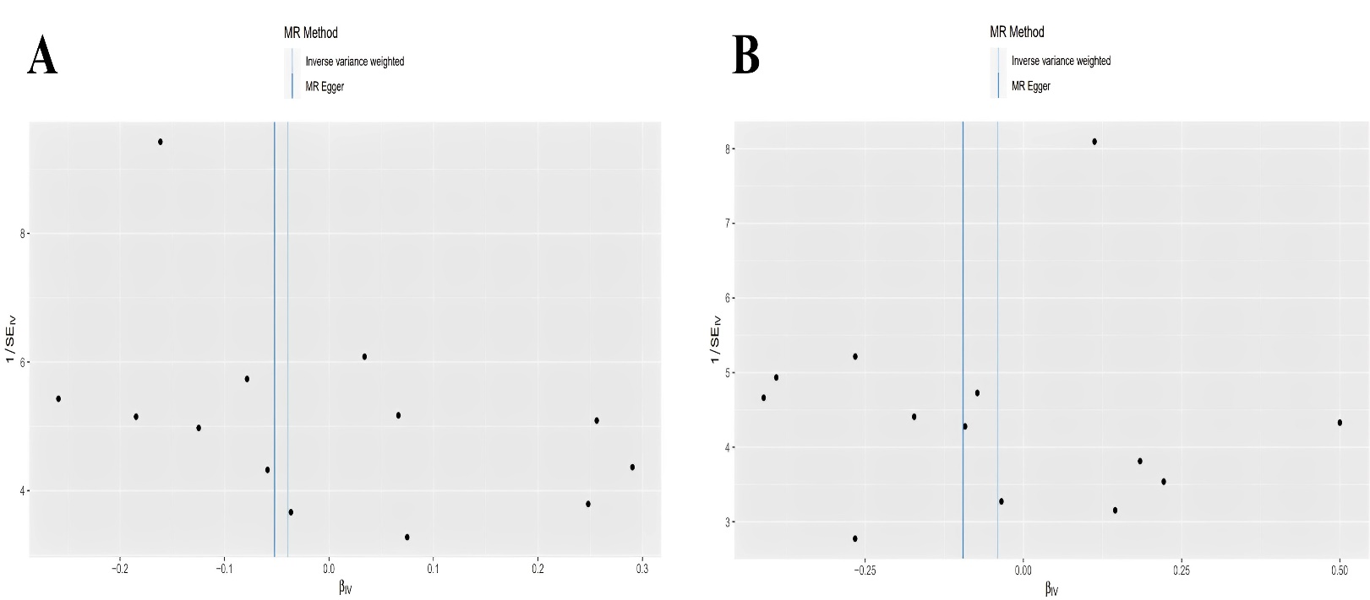
Figure S1. The funnel plot for MR analyses of the causal effect of sleep disorder on BMDs. A) femoral neck; B) lumbar spine.

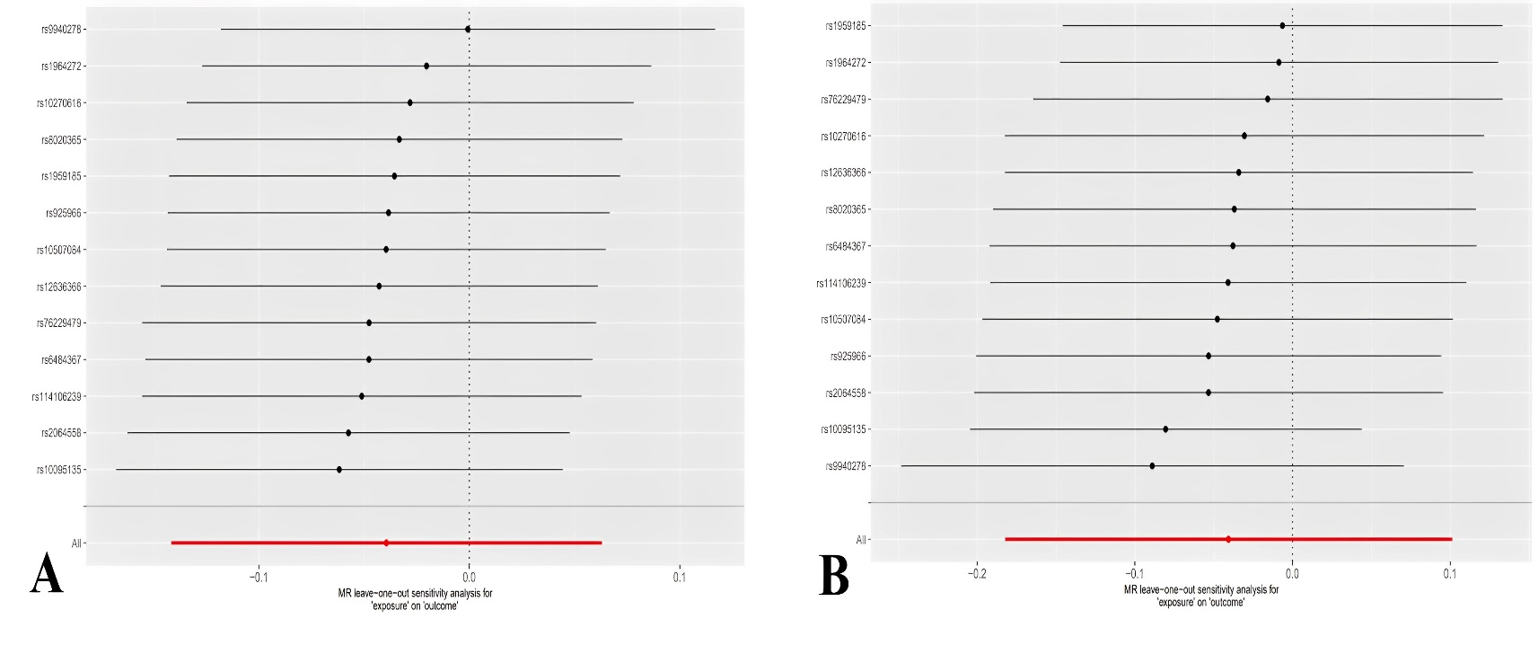
Figure S2. The leave-one-out plot for MR analyses of the causal effect of sleep disorder on BMDs. A) femoral neck; B) lumbar spine.

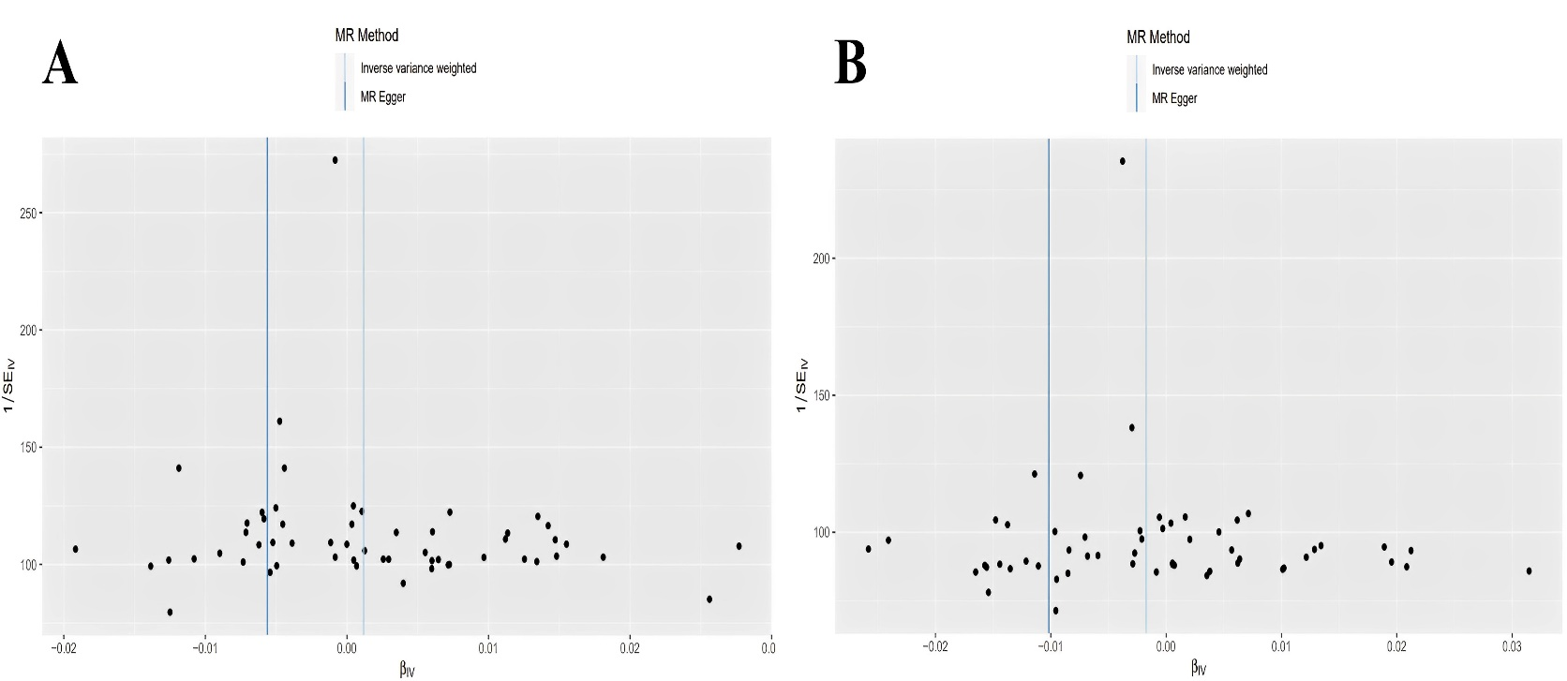
Figure S3. The funnel plots for MR analyses of the causal effect of sleep duration on BMDs. A) femoral neck; B) lumbar spine.

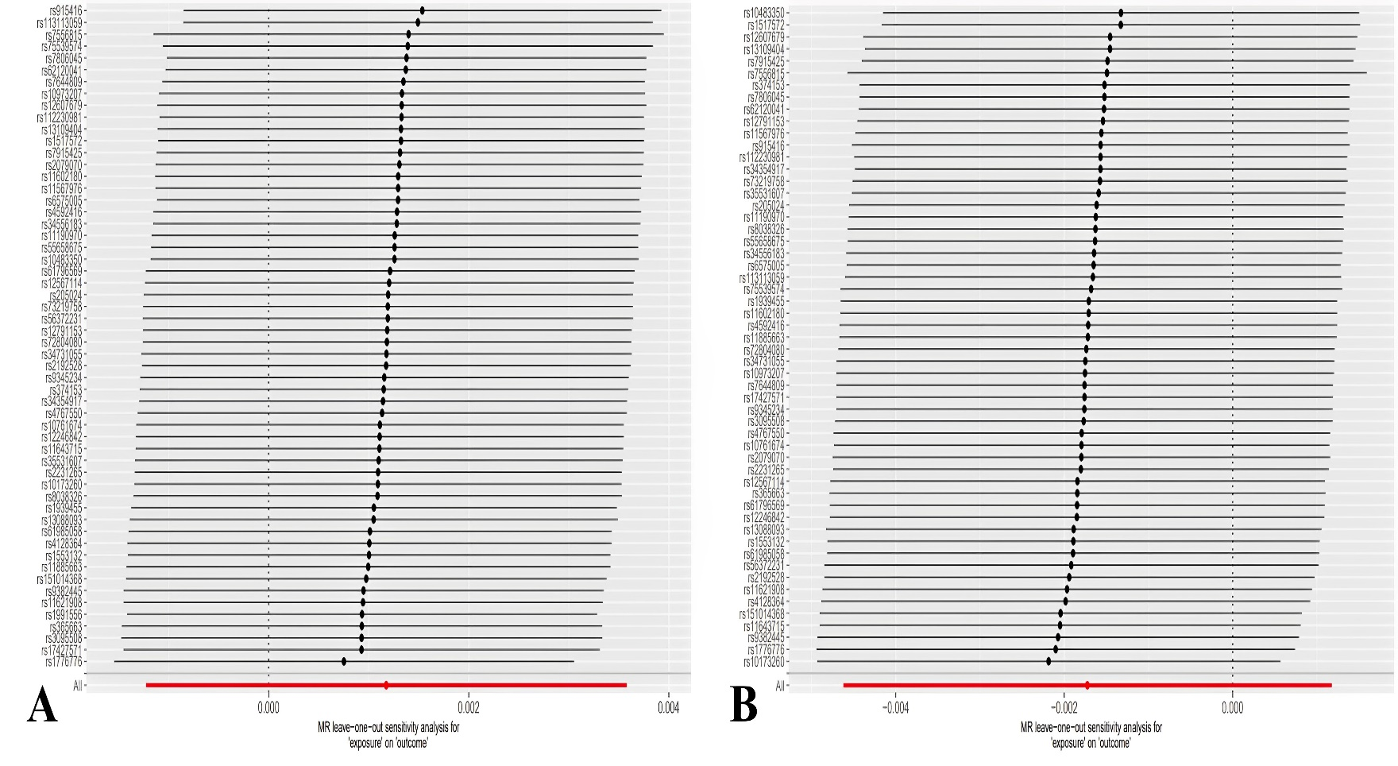
Figure S4. The leave-one-out plots for MR analyses of the causal effect of sleep duration on BMDs. A) femoral neck; B) lumbar spine.

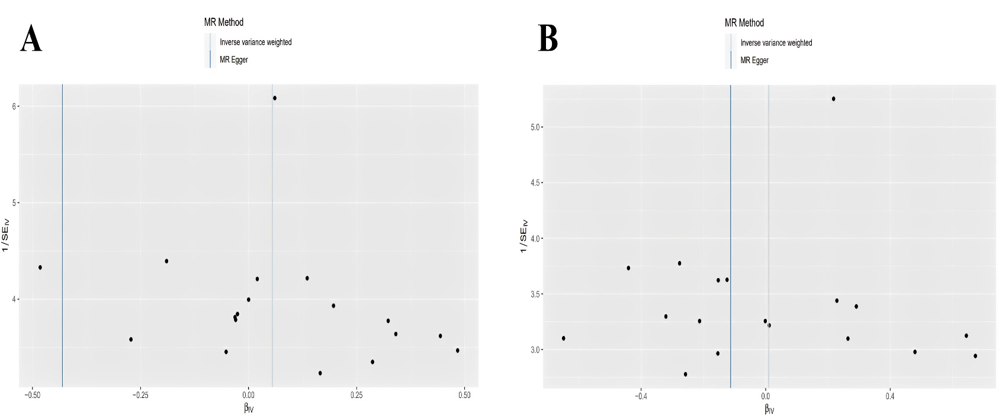
Figure S5. The funnel plots for MR analyses of the causal effect of short sleep duration on BMDs. A) femoral neck; B) lumbar spine.

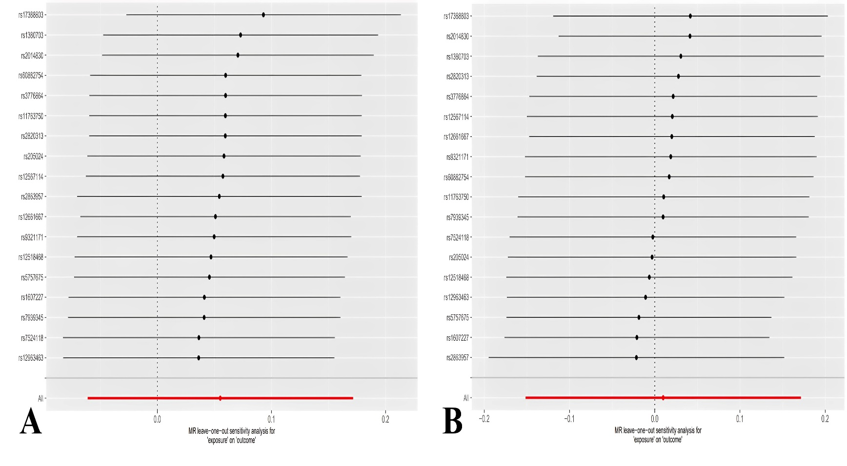
Figure S6. The leave-one-out plots for MR analyses of the causal effect of short sleep duration on BMDs. A) femoral neck; B) lumbar spine.

